Supplemental Figures: Figure S1, S2, S3, S4 and S5.

Figure S1. Bar chart diagram showing frequency distributions of all twelve categorical combinations of Plant Color (purple and tan), Seed Color (white, yellow and red), and Awns (awned vs. not awned) traits. The abbreviation of each category explains as, P = purple, T = tan, R = red, Y = yellow and W = white, A = awned and N = not awned.

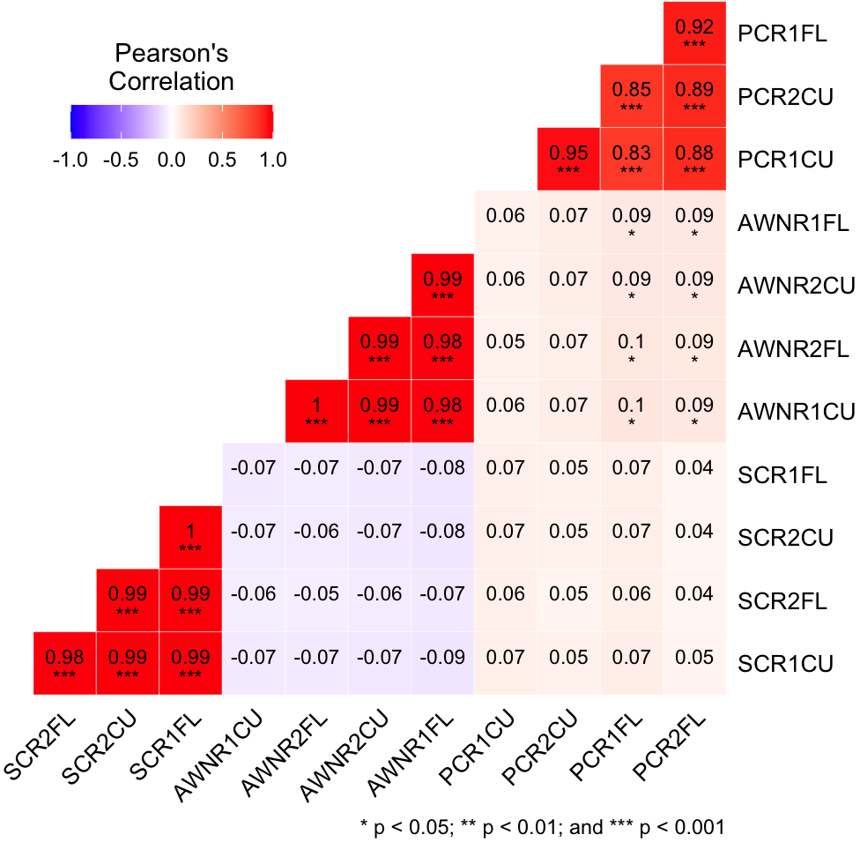
Figure S2. Pearson’s correlation coefficients of each replicated data of the three phenotypic traits (SC, PC and awns). SCR1CU; seed color of replication 1 of Clemson University, SCR2CU; seed color of replication 2 of Clemson University, SCR1FL; seed color of replication 1 of Florence, SCR2FL; seed color of replication 2 of Florence, PCR1CU; plant color of replication 1 of Clemson University, PCR2CU; plant color of replication 2 of Clemson University, PCR1FL; plant color of replication 1 of Florence; PCR2FL; plant color of replication 2 of Florence; AWNR1CU; awns of replication 1 of Clemson University, AWNR2CU; awns of replication 2 of Clemson University, AWNR1FL; awns of replication 1 of Florence, AWNR2FL; awns of replication 2 of Florence.

Figure S3. Genetic linkage maps (Chr1 to Chr10) of MBL, F6 RIL population. The names of the SNPs are listed to the right of the corresponding chromosomes; the position of the SNP is located on the left in centimorgan (cM).

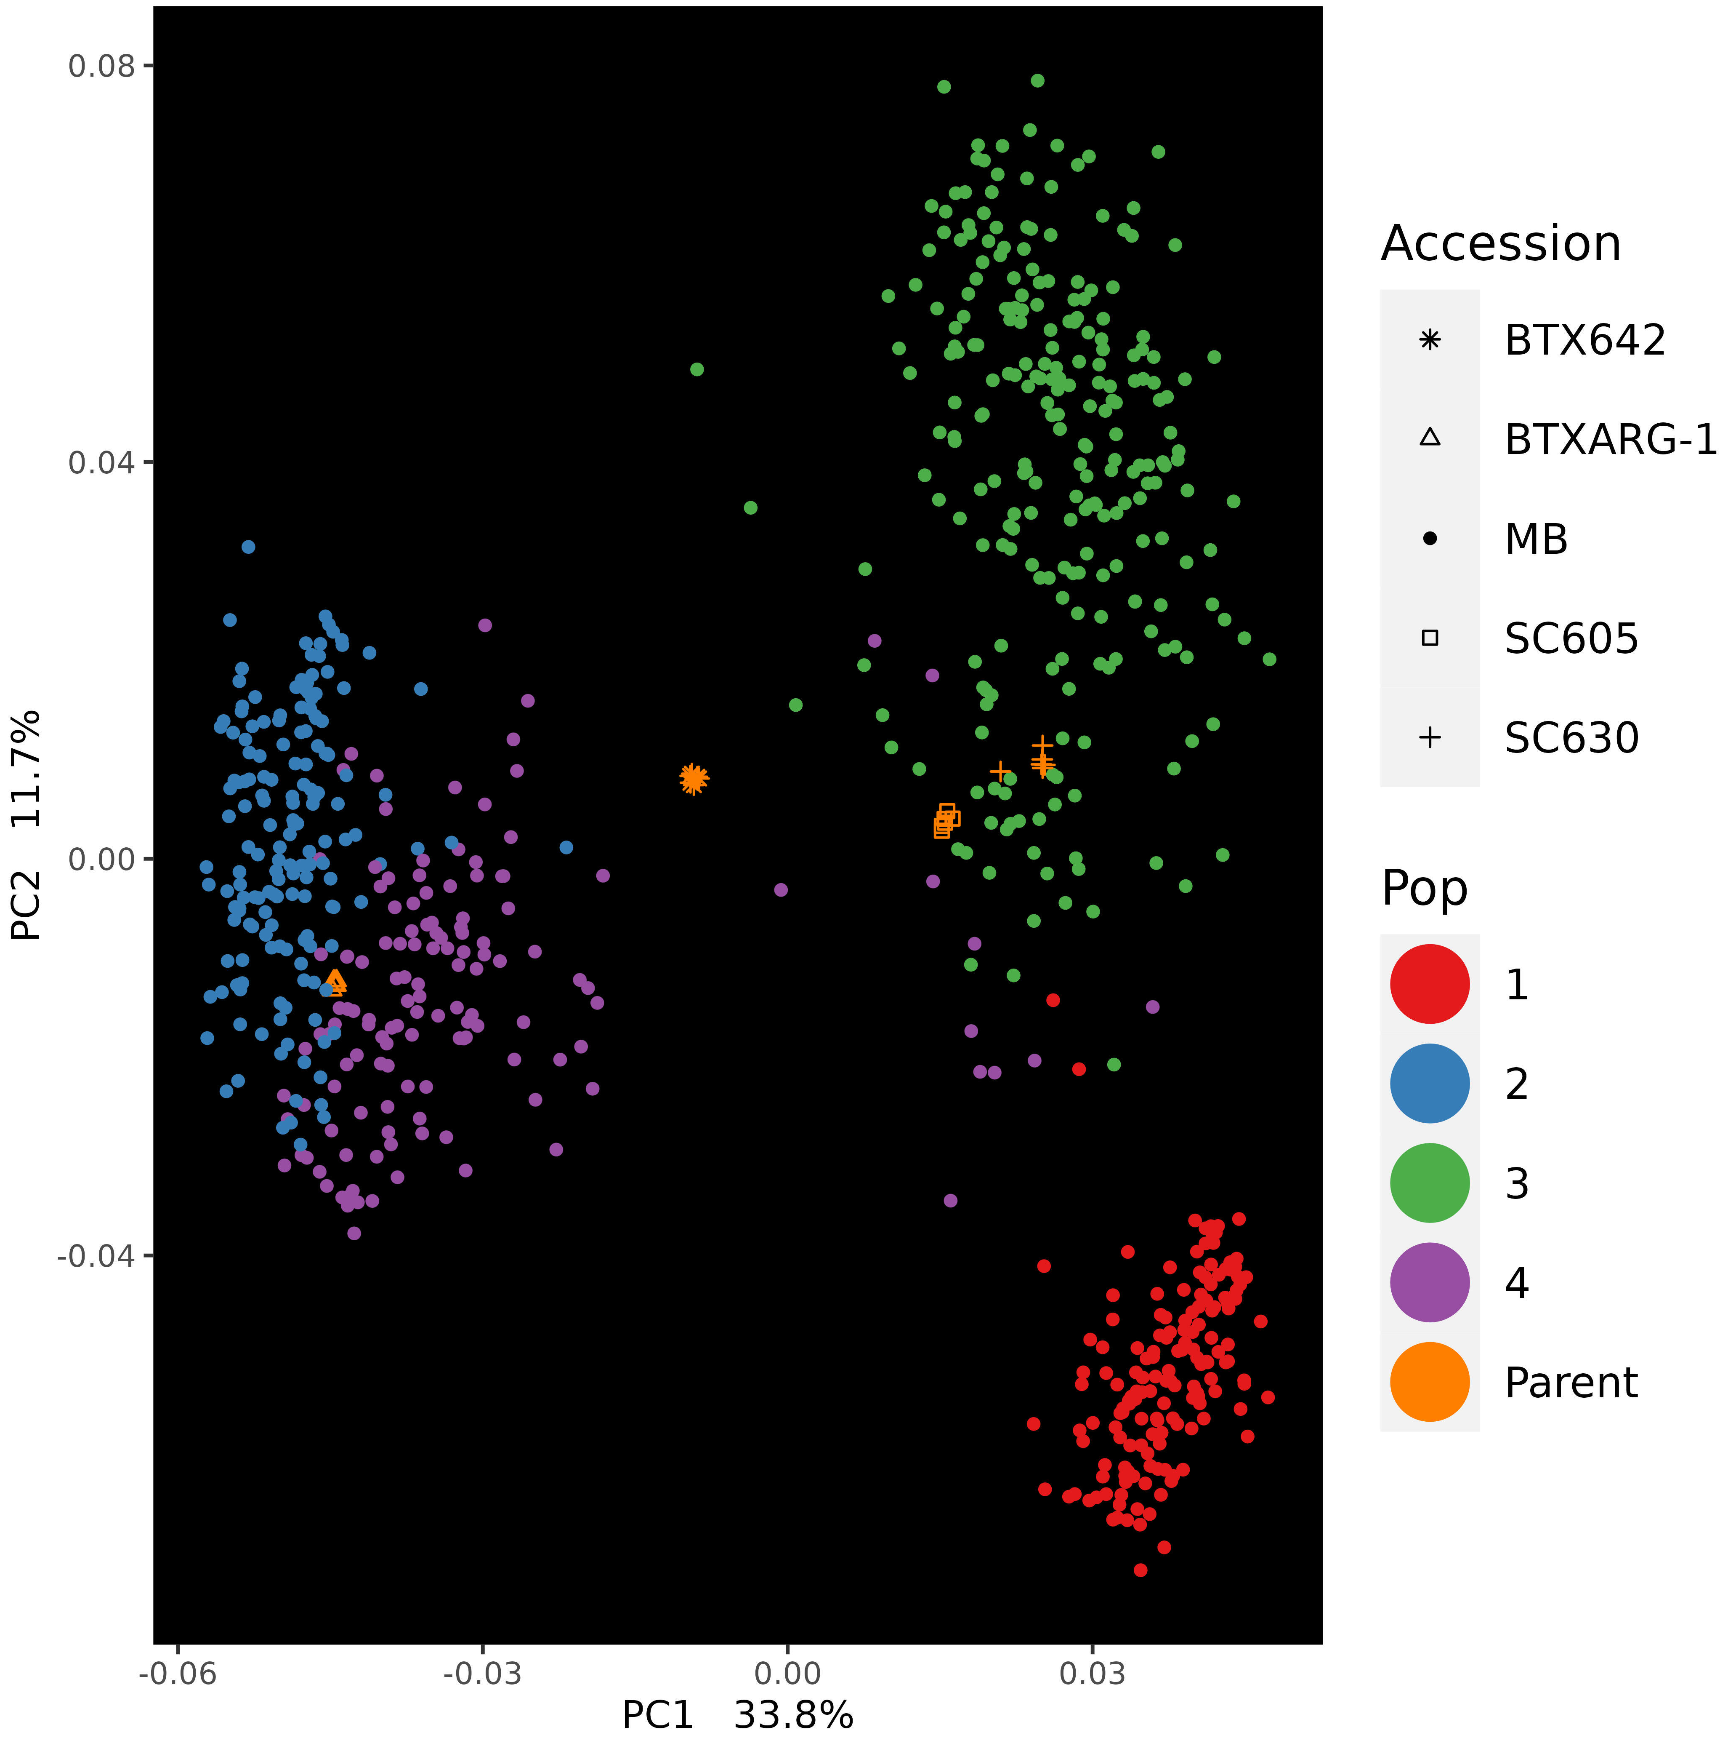
(A)
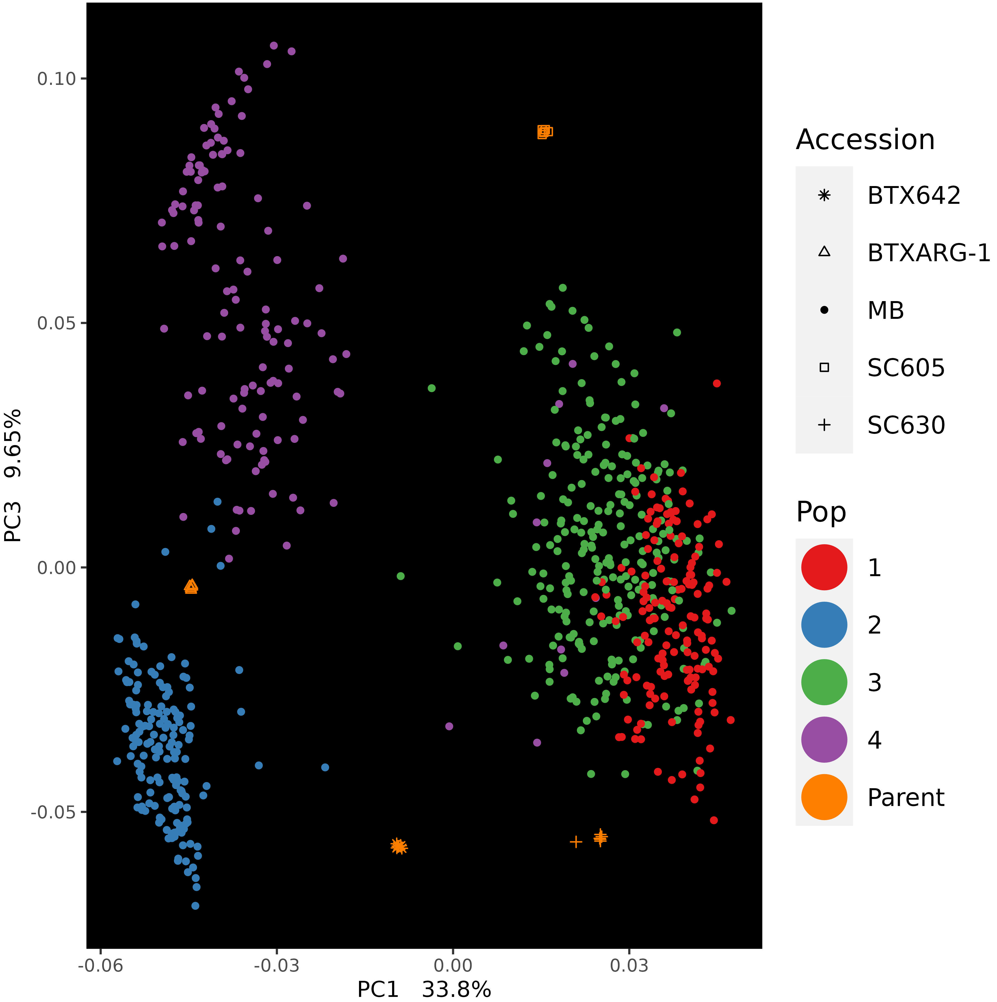

(B)
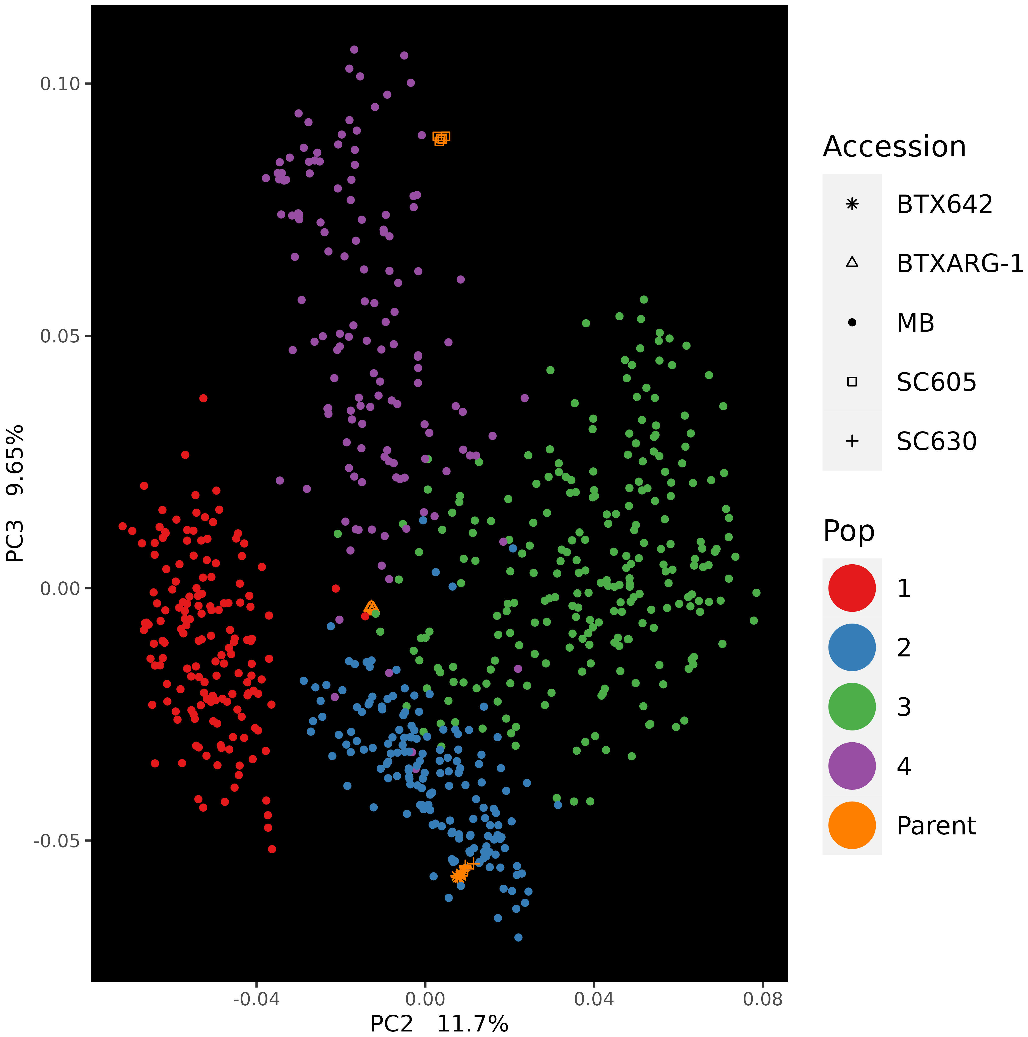

(C)

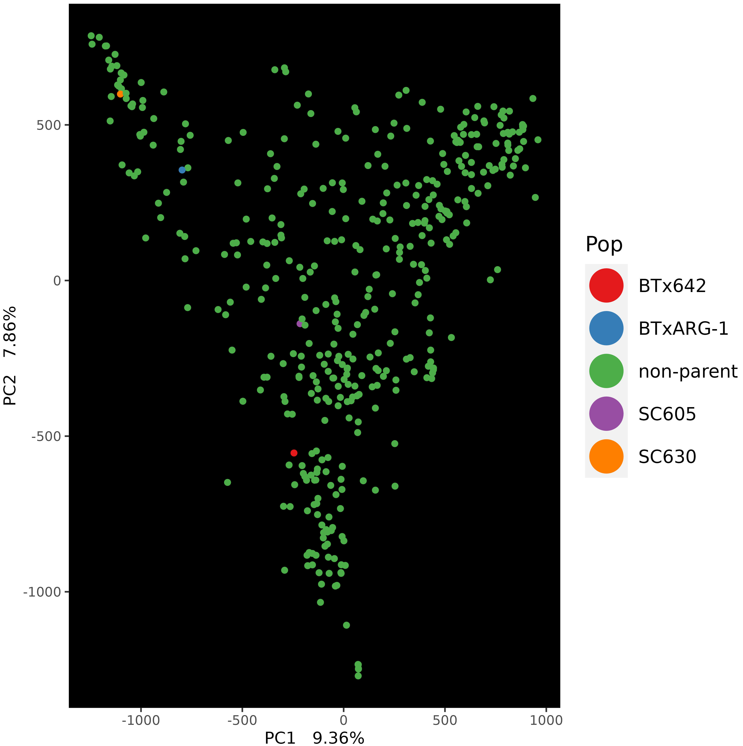
(D)

Figure S4. Principal component analysis (PCA) analysis of the sorghum MBL population and their founders, that includes three Principal Components (PC1, PC2 and PC3). (A) PC1 and PC2 (B) PC1 and PC3 and (C) PC2 and PC3 (D) Highlighted founders of MBL (PC1 and PC2) along with the non-parent as sorghum association panel (SAP) using large set of SNPs (43,983,694). MBL population RILs (MB) and the four founders are labelled with different shapes. The colors represent the four admixed groups identified in the population and the parents (orange).

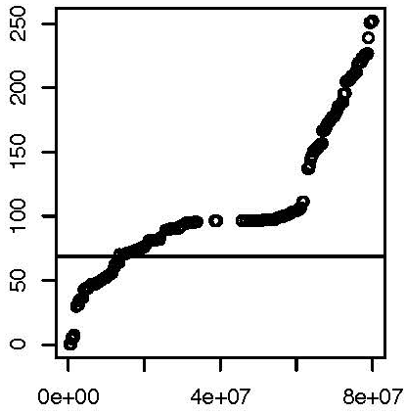
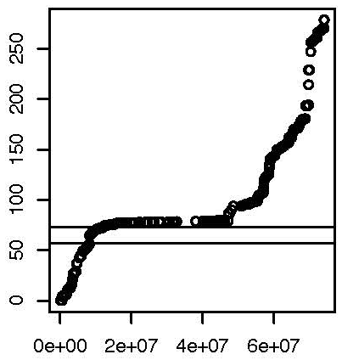
Genetic Distance (cM)
Physical Distance (bp)
Chromosome 1
Physical Distance (bp)
Genetic Distance (cM)
Chromosome 3

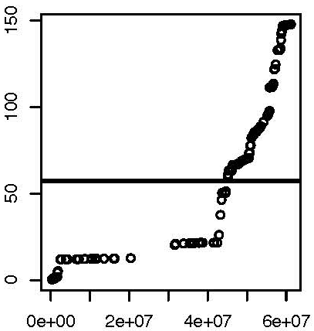
Physical Distance (bp)
Genetic Distance (cM)

Figure S5. Linear maps of chromosome 1, 3 and 6 representing genetic distance (cM) and physical distance (bp). Horizontal continuous line showing the location of quantitative trait loci (QTL) to the corresponding chromosome.
Chromosome 6

