Table S1. Homogeneity test values for the Divide × PI 272527 (DP527) population when grown under greenhouse environments.
Trait | Bartlett’s | P-value | Levene’s | P-value
DTHª | 10.03 | <0.05 | 3.64 | <0.05
DTH2018 | 0.05 | 0.83 | <0.05 | 0.87
DTH2019 | <0.05 | 0.90 | 0.10 | 0.75
PHT | 0.33 | 0.95 | 0.98 | 0.40
SPS | 12.05 | <0.05 | 2.05 | 0.11
KPS | 1.37 | 0.71 | 0.17 | 0.92
GWSª | 24.95 | <0.05 | 5.73 | <0.05
GWS2018 | <0.05 | 0.97 | <0.05 | 0.98
GWS2019 | <0.05 | 0.94 | 0.06 | 0.80
TKW | 3.62 | 0.31 | 1.49 | 0.22
KA | 7.12 | 0.07 | 0.50 | 0.68
KW | 22.46 | <0.05 | 0.80 | 0.49
KL | 7.50 | 0.06 | 0.50 | 0.68
KC | 5.39 | 0.15 | 2.40 | 0.07
KLW | 1.72 | 0.63 | 0.56 | 0.64
ªyear/trait combinations that could not be combined based on either Bartlett’s or Levene’s tests

Table S2. Bartlett’s Chi-squared values for the Divide × PI 272527 (DP527) population when grown under field environments.
Trait | Year | Bartlett’s | P-value | Levene’s^{b} | P-value
SPS | 2017 | 3.74 | 0.15
KPS | 2017 | 4.93 | 0.09
GWS | 2017 | 5.56 | 0.06
TKW | 2017 | 4.57 | 0.10
DTH | 2017 | 4.77 | 0.09
PHT | 2017 | 0.53 | 0.77
KA | 2017 | 0.90 | 0.64
KW | 2017 | 1.19 | 0.55
KL | 2017 | 0.12 | 0.94
KC | 2017 | 0.44 | 0.80
KLW | 2017 | 0.65 | 0.72
SPS | 2019 | 0.49 | 0.78
DTH | 2019 | 0.79 | 0.67
PHT | 2019 | 3.30 | 0.19
SPS | 2020 | 11.58 | <0.05 | 0.71 | 0.49
KPS | 2020 | 1.99 | 0.37
GWS | 2020 | 1.00 | 0.61
TKWª | 2020 | 15.76 | <0.05 | 4.01 | <0.05
DTH | 2020 | 11.64 | <0.05 | 2.88 | 0.06
PHT | 2020 | 1.71 | 0.43
KA | 2020 | 1.76 | 0.41
KW | 2020 | 1.79 | 0.41
KL | 2020 | 1.61 | 0.45
KC | 2020 | 0.31 | 0.86
KLW | 2020 | 0.45 | 0.80
ªyear/trait combinations that could not be combined based on either Bartlett’s or Levene’s tests
^{b}Traits that were not homogeneous based on Bartlett’s test were evaluated for homogeneity using Levene’s test

Table S3. Correlation coefficients for the Divide × PI 272527 (DP527) population grown under greenhouse conditions between the mean values of the traits days to heading (DTH), plant height (PHT), spikelets per spike (SPS), kernels per spike (KPS), grain weight per spike (GWS), thousand kernel weight (TKW), kernel area (KA), kernel width (KW), kernel length (KL), kernel circularity (KC), and kernel length:width ratio (KLW).
 | DTH18ª | DTH19ª | PHT | SPS | KPS | GWS18ª | GWS19ª | TKW | KA | KW | KL | KC | KLW
DTH18ª | 1.00
DTH19ª | 0.64*** | 1.00
PHT | -0.01 | 0.07 | 1.00
SPS | 0.19** | 0.24*** | 0.43*** | 1.00
KPS | -0.25*** | -0.11 | 0.42*** | 0.39*** | 1.00
GWS18ª | -0.56*** | -0.32*** | 0.40*** | 0.22** | 0.71*** | 1.00
GWS19ª | -0.23*** | -0.31*** | 0.35*** | 0.22** | 0.73*** | 0.43*** | 1.00
TKW | -0.59*** | -0.56*** | 0.30*** | -0.02 | 0.26*** | 0.65*** | 0.51*** | 1.00
KA | -0.45*** | -0.43*** | 0.24*** | -0.04 | 0.10 | 0.47*** | 0.39*** | 0.88*** | 1.00
KW | -0.16* | -0.22** | 0.19** | 0.01 | 0.33*** | 0.23*** | 0.51*** | 0.42*** | 0.43*** | 1.00
KL | -0.31*** | -0.26*** | 0.26*** | -0.02 | 0.11 | 0.36*** | 0.33*** | 0.66*** | 0.87*** | 0.33*** | 1.00
KC | 0.09 | 0.13 | 0.12 | 0.04 | 0.05 | -0.03 | 0.06 | -0.02 | 0.22*** | 0.01 | 0.65*** | 1.00
KLW | 0.04 | 0.10 | 0.12 | 0.03 | 0.05 | 0.00 | 0.09 | 0.02 | 0.25*** | -0.04 | 0.67*** | 0.96*** | 1.00
*P < 0.05
**P < 0.01
***P < 0.001
ªReplicates across environments were not statistically homogeneous but replicates in each environment were homogenous and therefore were combined within that environment for analysis.

Table S4. Correlation coefficients for the Divide × PI 272527 (DP527) population grown under field conditions in 2017 between the mean values of the traits days to heading (DTH), plant height (PHT), spikelets per spike (SPS), kernels per spike (KPS), grain weight per spike (GWS), thousand kernel weight (TKW), kernel area (KA), kernel width (KW), kernel length (KL), kernel circularity (KC), and kernel length:width ratio (KLW).
 | SPSavg | KPSavg | GWSavg | TKWavg | DTHavg | PHTavg | KAavg | KWavg | KLavg | KCavg | KLWavg
SPSavg | 1.00
KPSavg | 0.46*** | 1.00
GWSavg | 0.46*** | 0.85*** | 1.00
TKWavg | 0.07 | -0.11 | 0.43*** | 1.00
DTHavg | 0.51*** | 0.28*** | 0.18** | -0.17* | 1.00
PHTavg | 0.36*** | 0.13 | 0.31*** | 0.37*** | 0.24*** | 1.00
KAavg | 0.08 | -0.16* | 0.34*** | 0.88*** | -0.09 | 0.32*** | 1.00
KWavg | -0.01 | -0.12 | 0.24*** | 0.66*** | -0.04 | 0.29*** | 0.61*** | 1.00
KLavg | 0.17* | -0.12 | 0.27*** | 0.67*** | -0.05 | 0.27*** | 0.86*** | 0.19** | 1.00
KCavg | 0.19** | -0.08 | 0.06 | 0.21** | -0.01 | 0.12 | 0.42*** | -0.28*** | 0.77*** | 1.00
KLWavg | 0.16* | -0.05 | 0.09 | 0.21** | -0.02 | 0.03 | 0.42*** | -0.40*** | 0.79*** | 0.87*** | 1.00
*P < 0.05
**P < 0.01
***P < 0.001

Table S5. Correlation coefficients for the Divide × PI 272527 (DP527) population grown under field conditions in 2019 between the mean values of the traits days to heading (DTH), plant height (PHT), and spikelets per spike (SPS).
 | SPSavg | DTHavg | PHTavg
SPSavg | 1.00
DTHavg | 0.17* | 1.00
PHTavg | 0.18** | -0.21** | 1.00
*P < 0.05
**P < 0.01
***P < 0.001

Table S6. Correlation coefficients for the Divide × PI 272527 (DP527) population grown under field conditions in 2020 between the mean values of the traits days to heading (DTH), plant height (PHT), spikelets per spike (SPS), kernels per spike (KPS), grain weight per spike (GWS), thousand kernel weight (TKW), kernel area (KA), kernel width (KW), kernel length (KL), kernel circularity (KC), and kernel length:width ratio (KLW).
 | SPSavg | KPSavg | GWSavg | TKWrep1ª | TKWrep2ª | TKWrep3ª | DTHavg | PHTavg | KAavg | KWavg | KLavg | KCavg | KLWavg
SPSavg | 1.00
KPSavg | 0.30*** | 1.00
GWSavg | 0.14* | 0.73*** | 1.00
TKWrep1ª | -0.08 | 0.08 | 0.59*** | 1.00
TKWrep2ª | -0.09 | 0.13 | 0.61*** | 0.55*** | 1.00
TKWrep3ª | -0.11 | 0.12 | 0.62*** | 0.56*** | 0.59*** | 1.00
DTHavg | 0.14* | -0.37*** | -0.40*** | -0.47*** | -0.36*** | -0.36*** | 1.00
PHTavg | 0.37*** | 0.18** | 0.29*** | 0.12 | 0.19** | 0.20** | 0.21** | 1.00
KAavg | -0.19** | -0.14* | 0.40*** | 0.66*** | 0.67*** | 0.71*** | -0.25*** | 0.11 | 1.00
KWavg | -0.12 | -0.06 | 0.39*** | 0.60*** | 0.54*** | 0.64*** | -0.14* | 0.14* | 0.72*** | 1.00
KLavg | -0.11 | -0.10 | 0.22** | 0.37*** | 0.43*** | 0.41*** | -0.20** | 0.09 | 0.75*** | 0.12 | 1.00
KCavg | 0.02 | -0.06 | -0.19** | -0.24*** | -0.13 | -0.22** | 0.04 | -0.01 | 0.07 | -0.56*** | 0.70*** | 1.00
KLWavg | 0.00 | -0.05 | -0.13 | -0.15* | -0.07 | -0.13 | -0.04 | -0.03 | 0.07 | -0.62*** | 0.70*** | 0.96*** | 1.00
*P < 0.05
**P < 0.01
***P < 0.001
ªFor TKW, replicates were not statistically homogeneous and therefore were analyzed separately.

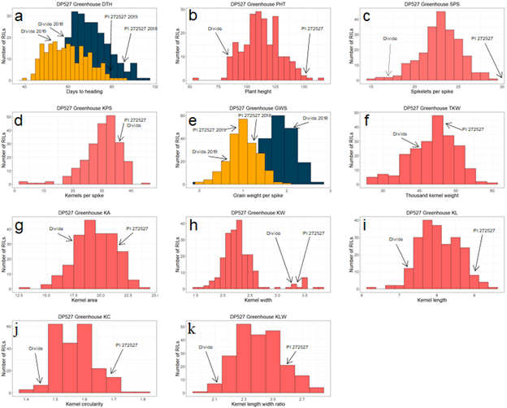
Figure S1. Histograms of the DP527 population under greenhouse conditions for the traits a) days to heading (DTH), b) plant height (PHT), c) spikelets per spike (SPS), d) kernels per spike (KPS), e) grain weight per spike (GWS), f) thousand kernel weight (TKW), g) kernel area (KA), h) kernel weight (KW), i) kernel length (KL), j) kernel circularity (KC), k) kernel length:width ratio (KLW). The values in pink are those environments that were homogenous and combined across environments. For panels a and e, those in blue are from the 2018 environment and yellow from the 2019 environment.

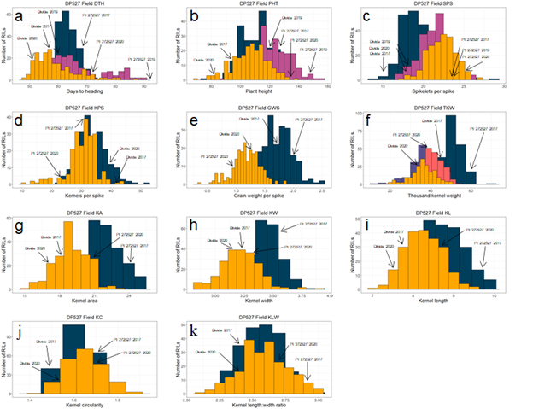
Figure S2. Histograms of the DP527 population under field conditions for the traits a) days to heading (DTH), b) plant height (PHT), c) spikelets per spike (SPS), d) kernels per spike (KPS), e) grain weight per spike (GWS), f) thousand kernel weight (TKW), g) kernel area (KA), h) kernel weight (KW), i) kernel length (KL), j) kernel circularity (KC), k) kernel length:width ratio (KLW). The values in blue are from the 2017 environment, pink from 2019, and yellow from 2020. For panel f, dark blue was 2017 and purple, coral, and yellow were 2020 replicates.

