Supplemental Information

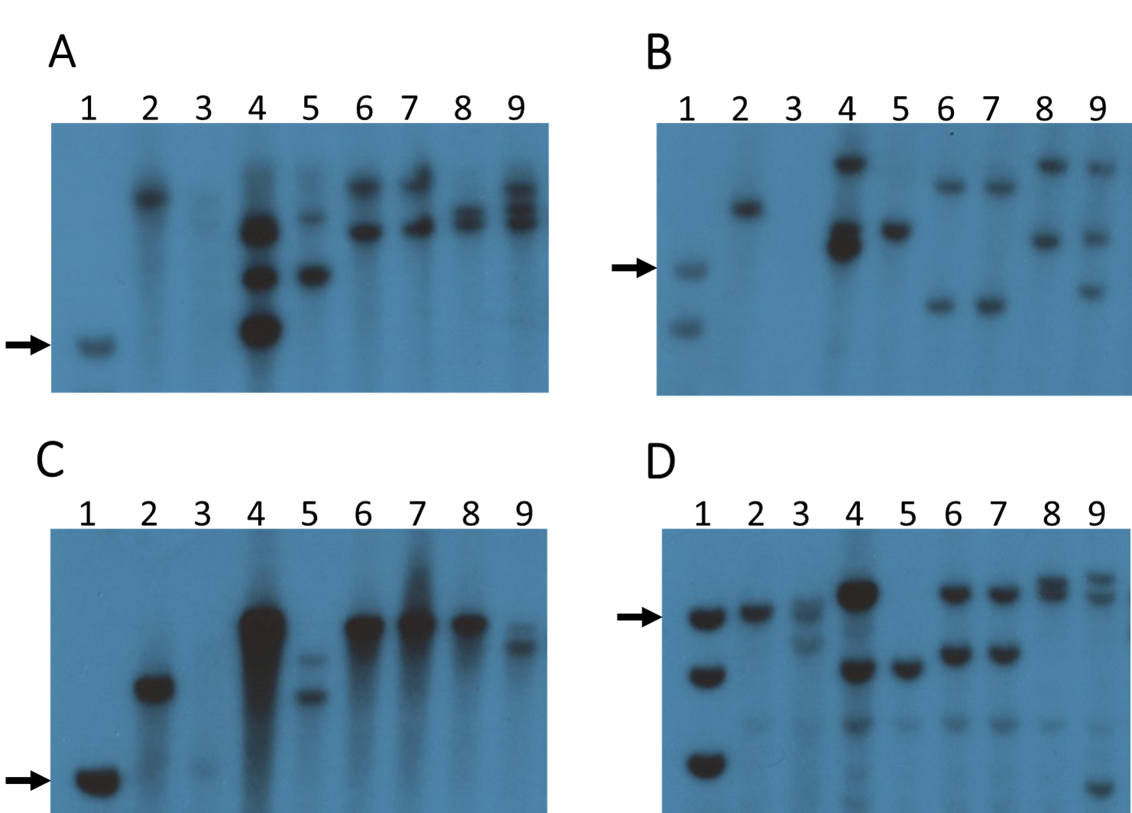

Figure S1: Southern blot gel images. A) HpaI, B) KpnI, C) EcoRI, and D) KpnI and EcoRI double digest. Lane 1, DNA ladder, black arrow points to 10 kb fragment on each gel; Lane 2, p1-wwB54; Lane 3, B54-CI; Lane 4, SP-97; Lane 5, SP-97M1; Lane 6, SP-6; Lane 7, SP-7; Lane 8, SP-12; and Lane 9, SP-11. Blots were hybridized with p1 Fragment 15 which detects the p1 enhancer (Lechelt et al., 1989).

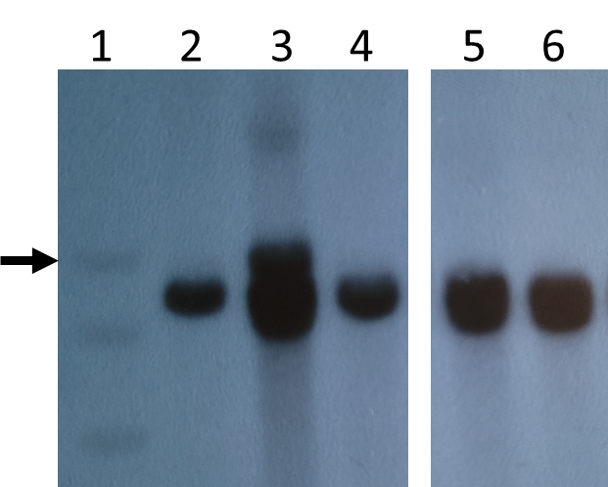
Figure S2: Southern blot image using BglII restriction enzyme. Lane 1, DNA ladder, black arrow points to 10 kb fragment; Lane 2, p1-wwB54; Lane 3, 97; Lane 4, SP-97M1; Lane 5, SP-6; Lane 6, SP-7. Blots were hybridized with p1 Fragment 15 which detects the p1 enhancer (Lechelt et al., 1989).

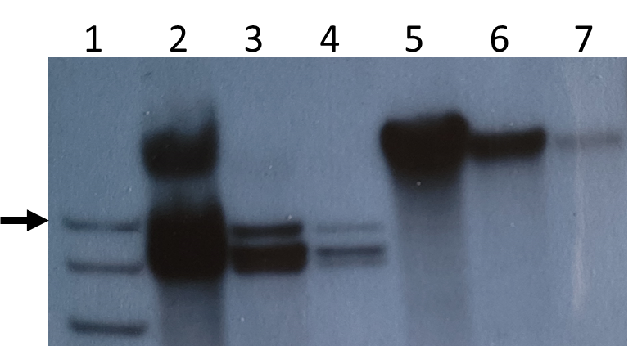
Figure S3: Southern blot image with sample SP-97. Lane 1, DNA ladder, black arrow points to 10 kb fragment; Lanes 2, 3, and 4 have DNA digested with BglII and Lanes 5, 6, and 7 have DNA digested with EcoRI. Both digests loaded in decreasing order of DNA quantity in each well to see individual bands. Blots were hybridized with p1 Fragment 15 which detects the p1 enhancer (Lechelt et al., 1989).

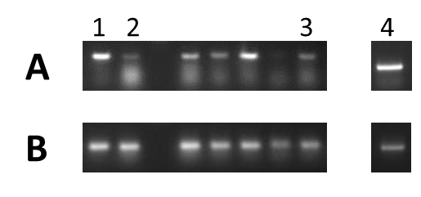
Figure S4: RT-PCR using RNA extracted from pericarp tissue and reverse transcribed to cDNA. Agarose gel image showing results of RT-PCR with primers from (A) p2 exons 1 and 3, (B) GAPDH as an internal control. Lane 1, SP-6; Lane 2, SP-7; Lane 3, SP-12; and Lane 4, SP-11. Other cases were not discussed.

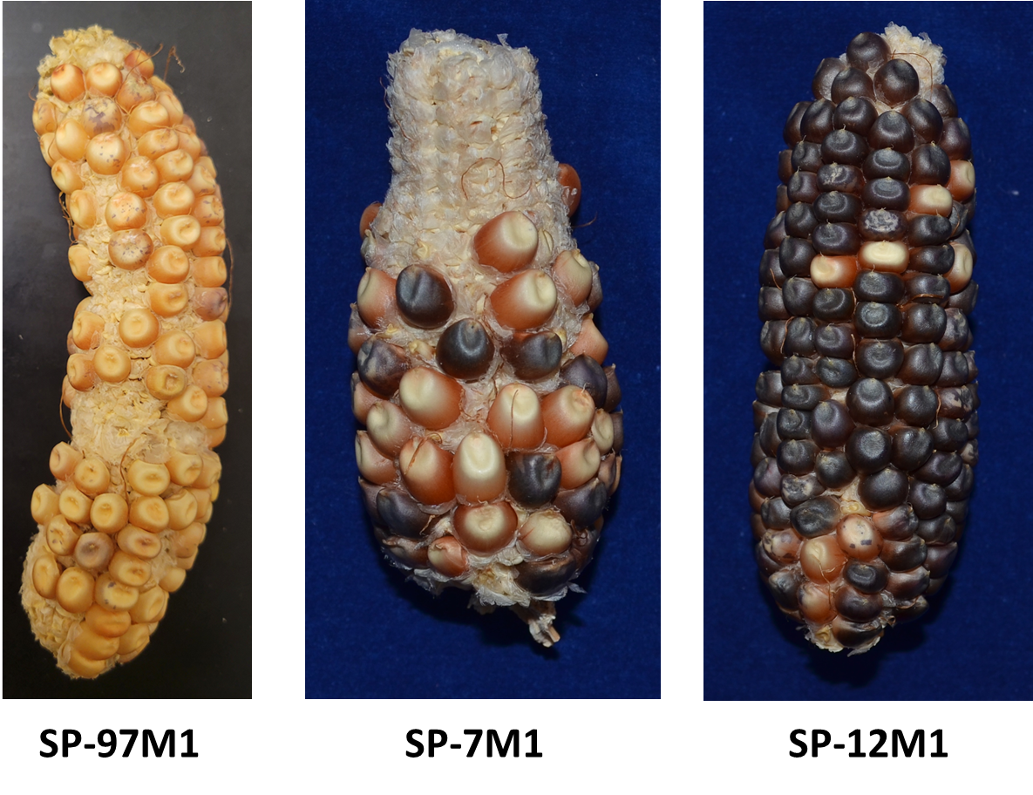
Figure S5: CI excision mutant ears SP-97M1, SP-7M1, and SP-12M1. SP-97M1 has a much lighter color in pericarp compared to the other alleles.
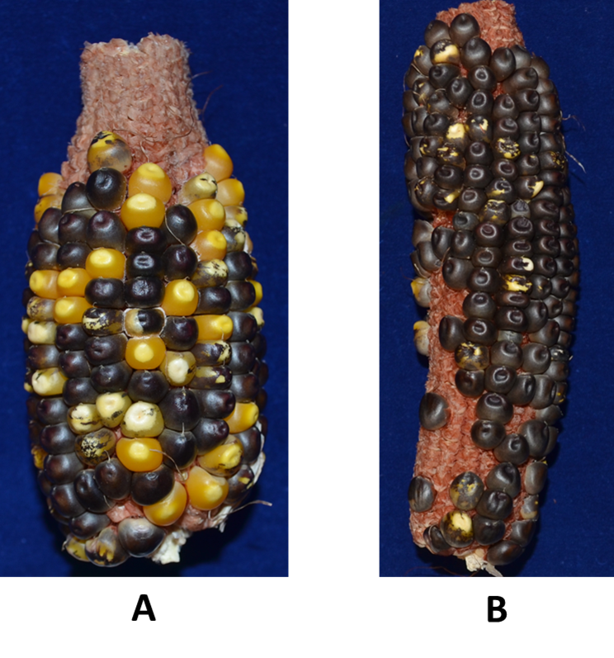
Figure S6: Ears resulting from dek1/+ tester line crossed with pollen from A) SP-97 and B) SP-12. The frequency of chromosome breakage is Grade 4 (highest) in SP-97 and Grade 2 in SP-12 compared to standards in Yu et al. 2010. Kernels containing a functional Dek1 gene develop solid purple aleurone color; chromosome breakage at the proximal p1/p2 locus results in loss of Dek1 and colorless aleurone sectors.

Table S1: Primers used for sites x/y, a/b, c/d, and e in different alleles

Sites with Ac element
Common Ac primer: GAGTCGCGAGCAGTGGAG
Endpoint ‘x’ in SP-6 and SP-7 | GTGCAAATACGGAGTCTGCT
Endpoint ‘x’ in SP-12 | TCTTTTGGCCATACGTCTCC
Endpoint ‘x’ in SP-97 | TGTGATGATGAGACCCCTGA
Site ‘a’ of common CI | CTGCAACAGCACACGCTTTTAT
Site ‘c’ in SP-11 | TTATACTTGCGACGCTGTGG
Deletion in SP-11 | CACCTAAAGCAGAAGCGAAC

Sites with fAc element
Common fAc primer: CCTCTCCATGAGCAATGTGTCTTAT
Endpoint ‘y’ in SP-6 and SP-7 | GAACCGAGCGAGCAGAGCAGA
Endpoint ‘y’ in SP-12 | GCAGCCTTTTCTTGCAGTCA
Endpoint ‘y’ in SP-97 | GGAGGTGGTCCAACAAAATG
Site ‘b’ of common CI | AATCGAAAGGAAACCAGAGATCG
Site ‘d’ in SP-11 | GCAGCCTTTTCTTGCAGTCA
Junction ‘e’ in SP-97 | CAGAACGAGTCGGACAGGAG

Primer pairs used for CI

Internal junction of common CI | TGGTCTCTAATATCCGCCTTGT and TGCTGTCCAGGGCTCTGCTCTCCACTTC
CI excision at site a/b | AATCGAAAGGAAACCAGAGATCG and CTGCAACAGCACACGCTTTTAT

Table S2: Primers for RT-PCR

P2 | GCGGAGGAGGACCAGTTAC and CTGAGGTGCGAGTTCCAGTAG
GAPDH | CCATCACTGCCACACAGAAAAC and AGGAACACGGAAGGACATACCAG

Table S3: Sequences of different sites in rearrangement alleles

TSDs at inversion endpoints x/y in different alleles

SP-6 | CGTGGCCC
SP-7 | AACCCACC
SP-12 | CGTGAGGC
SP-97 | CTAACTTA

Composite Insertion related sequences

Internal junction of common CI (microhomology highlighted) | TGGTACAGCTACAGATCCGAGTTTATATCTCTATCAAGCT
TSD at site c/d in SP-11 | CAGGCACA
Duplication junction ‘e’ in SP-97 (fAc sequence highlighted) | AGCAGCAGCAGCAGCAGCAACTTCCAGCTAGGGATGAAAACGGTCGGTAACGGTCGGTA
TSD at site a/b | GATTGCAT
TSD in SP-97M1 (modified bases highlighted) | GATTGCAATATTGCAT
TSD in SP-7M1 (modified bases highlighted) | GATTGCAATATTGCAT

Table S4: Primers used for 3C experiment

Fragment number (Figure 7, main text) | Primer sequence
VIII and X (Anchor) | CTGAAGGAGCTACACGTAATGG
I | GGAAAGGTATTCGCCTCCTC
II | TTTTCTTGGACGAACGAAGC
III | AGACGTATGGCCAAAAGAGC
IV | CGGTACGGATCGGACTGAG
V | CGCAGGTCATTTCACACACT
VI | AGGCAGATCCCAACAAACAC
VII | GCAATTCACGTGCCAGAAC
Internal Control (Sam gene) | TCGGTTTTTCTTGTCTCAGC and TGGATCGCATTCATGGAGTA

