Appendix S4: Life stage-specific expression patterns
These plots show gene expression patterns across embryonic and larval life stages for each of the 19 essential genes of interest identified in this study. The data originate from RNA-seq experiments from the modENCODE project (Hillier et al. 2009; Gerstein et al. 2010, 2014; Boeck et al. 2016) and the figures were retrieved from GExplore (genome.sfu.ca/gexplore; Hutter et al. 2009; Hutter and Suh 2016). Three groups with similar gene expression patterns are presented: (A) maternal gene expression (elevated expression in the early embryo, adult, and hermaphrodite gonad); (B) maternal and zygotic gene expression (maternal gene expression with additional peaks of expression at other developmental time points); and (C) male gene expression (elevated expression in males). Some genes belong to more than one group.
(A) Maternal gene expression: gene expression elevated in the early embryo, adult, and hermaphrodite gonad.

atg-7  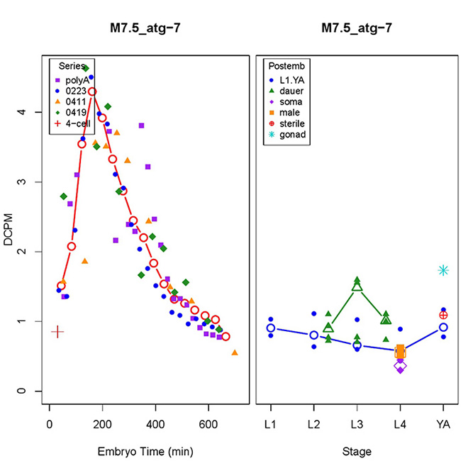 |  | C34D4.4  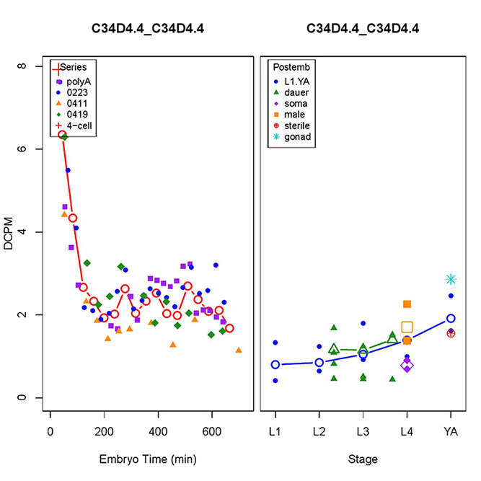
C56A3.8  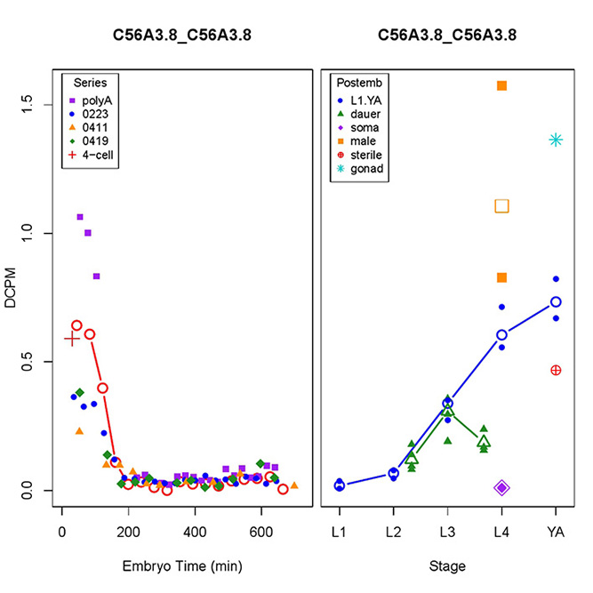 |  | cept-2  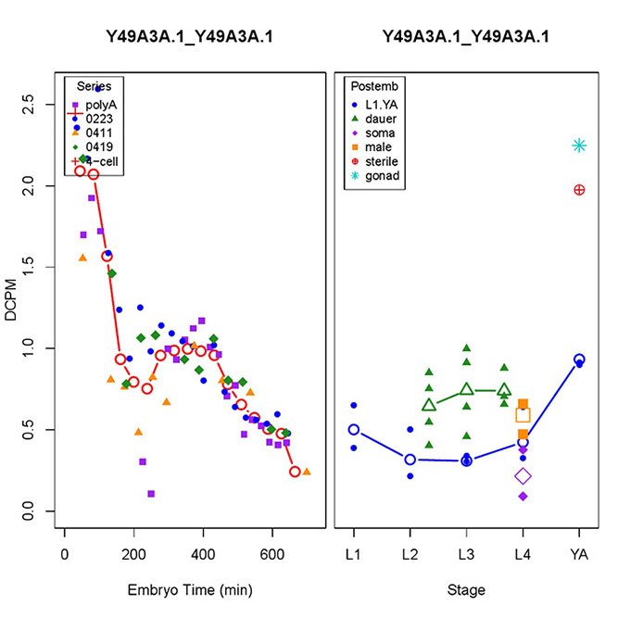
D2096.12  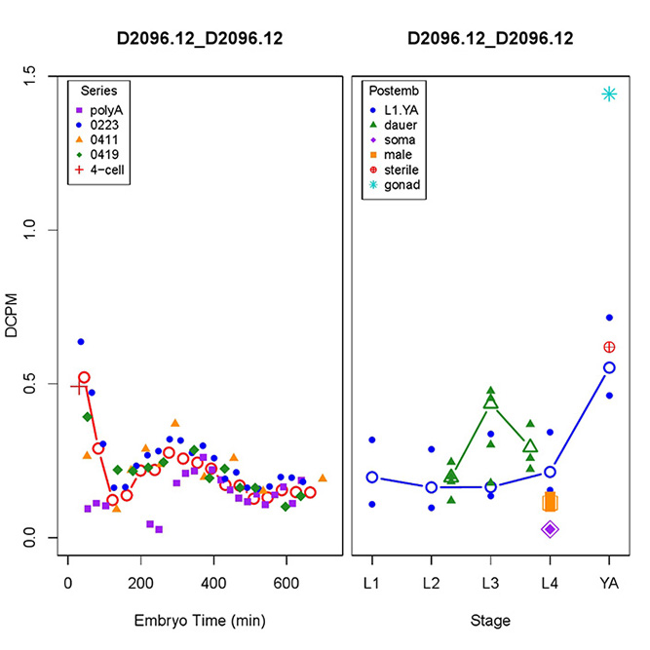 |  | dgtr-1  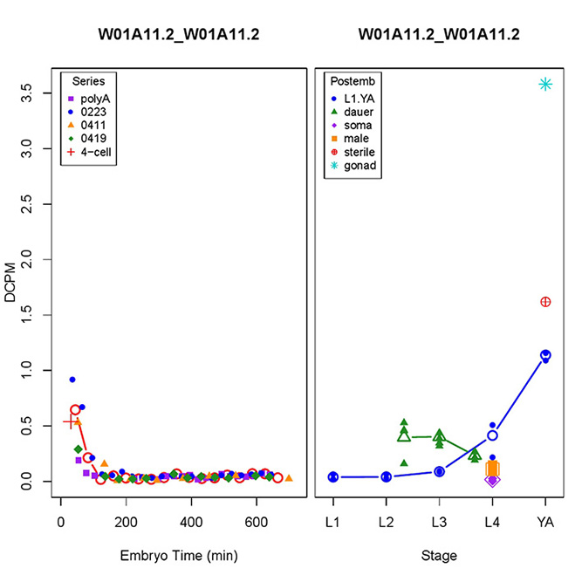
F21D5.1  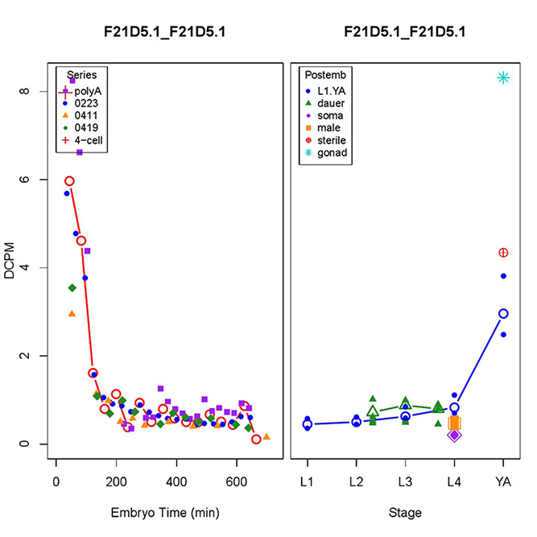 |  | top-3  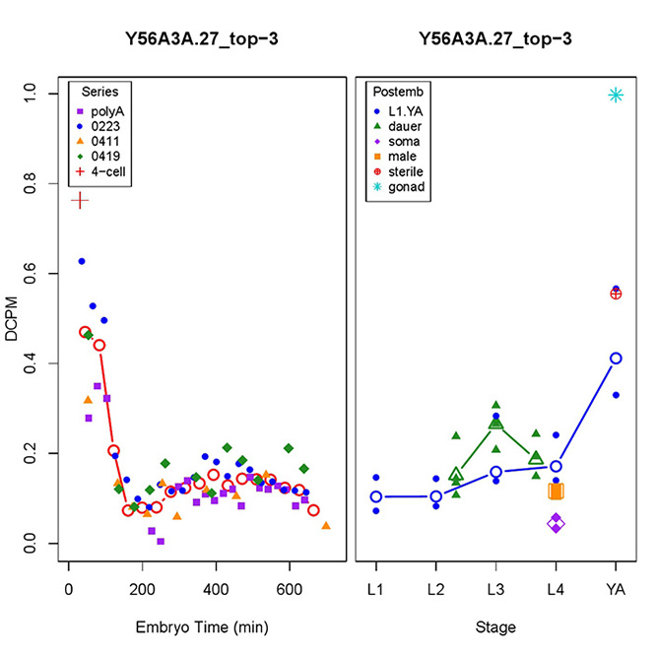
trcs-1  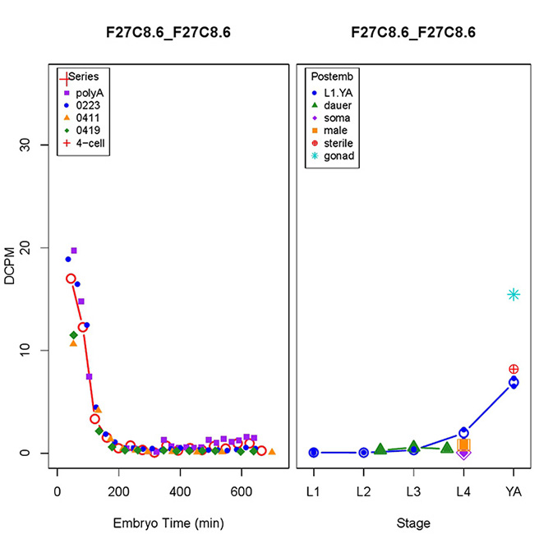 |  | ZK688.9  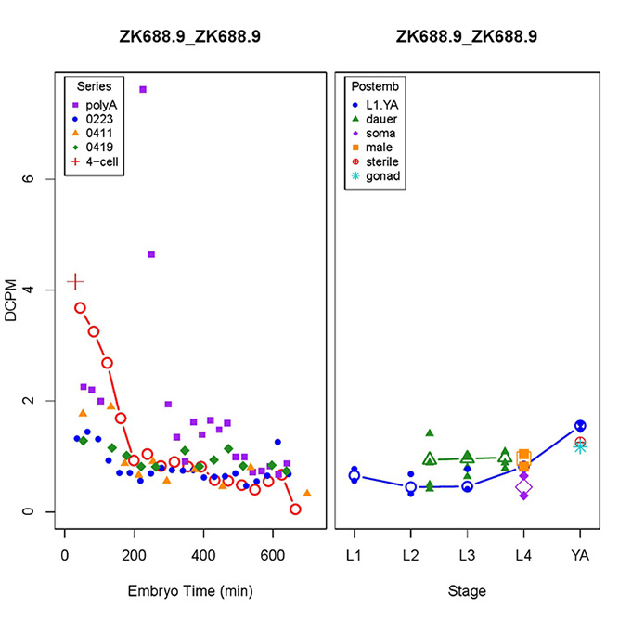

(B) Maternal and zygotic gene expression: maternal gene expression pattern with additional peaks of expression throughout other developmental time points.

bckd-1A  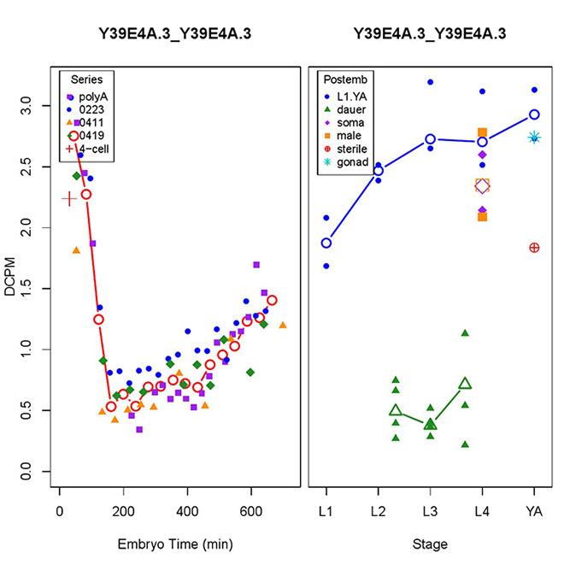 |  | cls-2  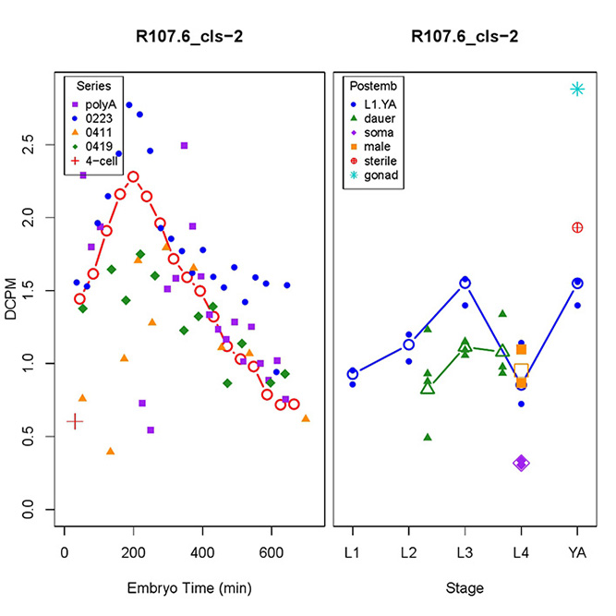
cpt-2  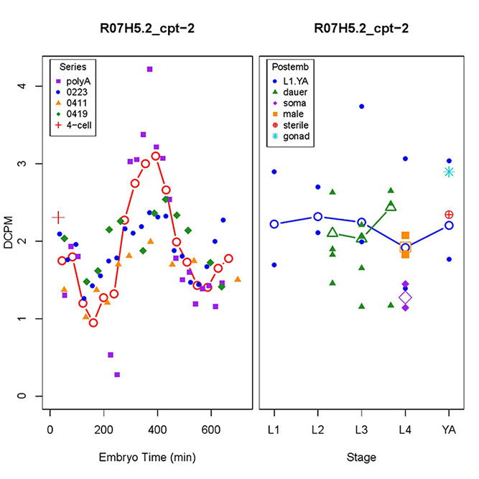 |  | dlat-1  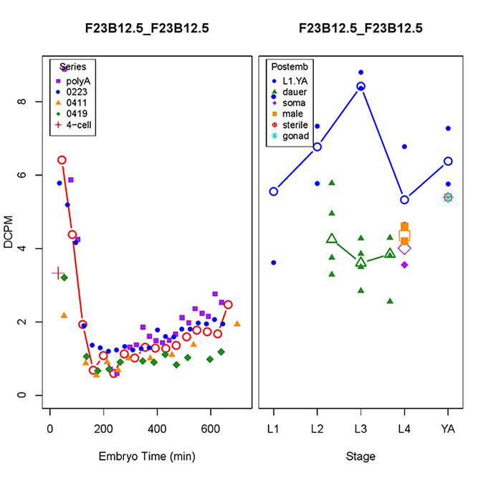
perm-5
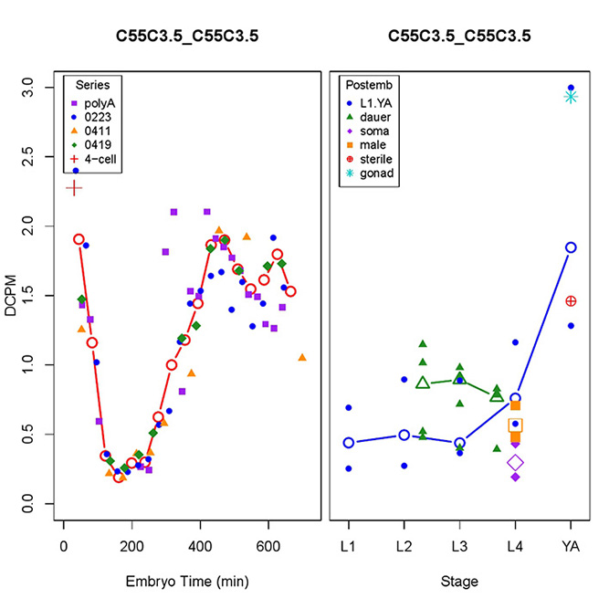

(C) Male gene expression: elevated expression in males.

bckd-1A |  | C34D4.4
C56A3.8 |  | F56D5.2  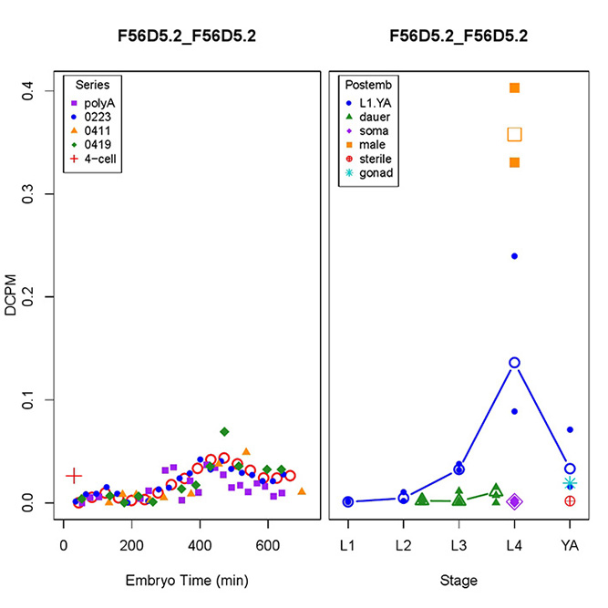
nstp-2  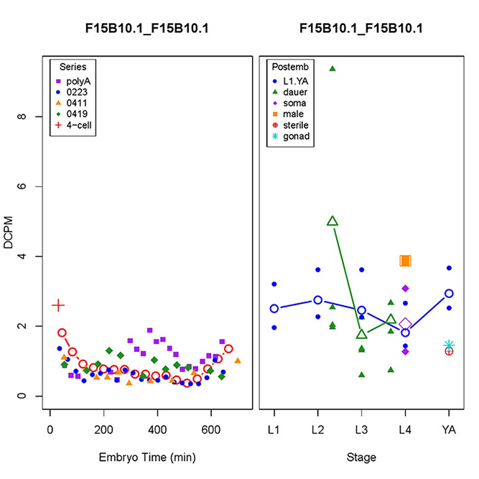 |  | T22B11.1  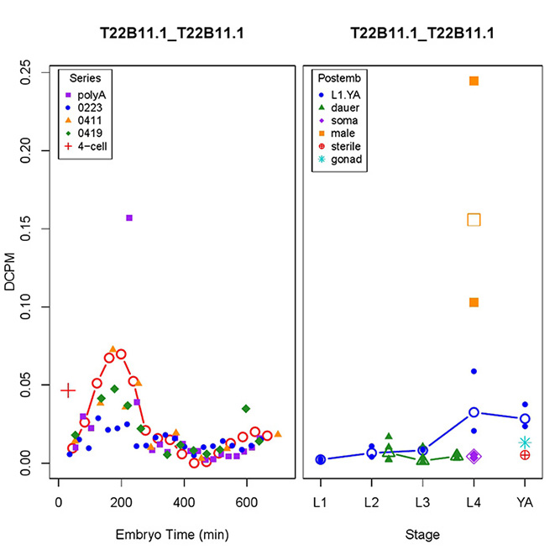
Y54G2A.73 (Figure from wormbase.org; not available from GExplore)
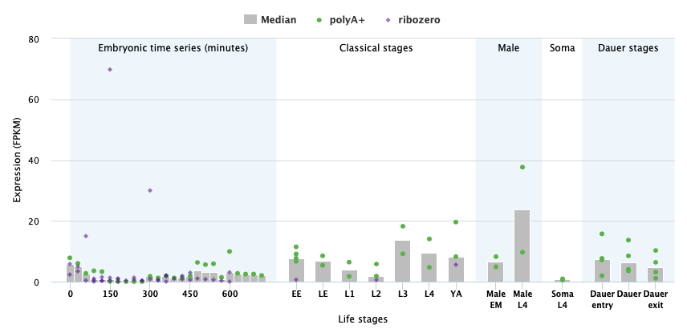

References

Boeck, M. E., C. Huynh, L. Gevirtzman, O. A. Thompson, G. Wang et al., 2016 The time-resolved transcriptome of C. elegans. Genome Res. 26: 1441-1450.
Gerstein, M. B., J. Rozowsky, K. Yan, D. Wang, C. Cheng et al., 2014 Comparative analysis of the transcriptome across distant species.
512: 445-448.
Gerstein, M. B., Z. J. Lu, E. L. Van Nostrand, C. Cheng, B. I. Arshinoff et al., 2010 Integrative analysis of the Caenorhabditis elegans genome by the modENCODE project. Science 330: 1775-1787.
Hillier, L. W., V. Reinke, P. Green, M. Hirst, M. A. Marra et al., 2009 Massively parallel sequencing of the polyadenylated transcriptome of C. elegans. Genome Res. 19: 657-666.
Hutter, H., and J. Suh, 2016 GExplore 1.4: An expanded web interface for queries on Caenorhabditis elegans protein and gene function. Worm 5: e1234659.
Hutter, H., M. Ng and N. Chen, 2009 GExplore: A web server for integrated queries of protein domains, gene expression and mutant phenotypes. BMC Genomics 10: 529.

