Supplementary File S1

Descriptions of mutagenesis, outcrossing, mapping, and complementation analysis methods from Feichtinger (1995).

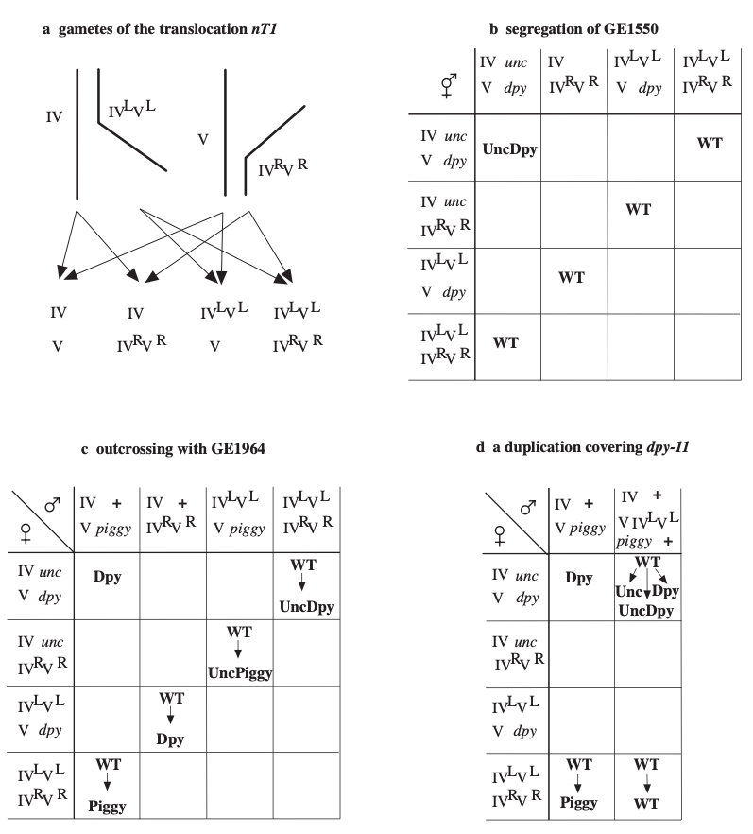
Figure S1. Genetics of the balancer nT1. a.— nT1 consists of the translocation IVLVL, which segregates from IV, and the reciprocal translocation IVRVR, which segregates from V. Gametes inherit one of four possible combinations of chromosomes. The chromosomes are not drawn to scale. b.— Punnett square diagram of self-fertilised zygotes of hermaphrodites heterozygous for nT1, marked on IV with unc-24(e138) and marked on V with dpy-11(e224). The strain segregates 4/16 WT of parental genotype, 1/16 DpyUnc, homozygous for the balanced region and screened for nonconditional maternal-effect lethal mutations. All empty boxes denote unviable eggs due to aneuploidy or the lethal mutation m435 in case of the homozygous nT1, respectively. c.— Cross progeny of matings with males with a WT chromosome IV and another, shorter (piggish) mutation in dpy-11(e1180). The four WT are of different genotypes as revealed by their segregated markers (beneath WT, not shown) due to different inheritance of maternal (mutagenised) and paternal (unmutagenised) chromosomes, that is used for outcrossing and chromosome mapping. d.— Unexpected results during outcrossing suggested that occasionally males appear which are homozygous for an unmarked chromosome IV and a IVLVL translocation attached to chromosome V which are WT and indistinguishable from nT1 heterozygous males. When mated to a mutant strain WT progeny without a balancer, segregating unlinked markers, and WT progeny segregating no visible markers are obtained. They are useless for outcrossing and chromosome mapping and could have been avoided if chromosome IV would have been marked, too.
GE1550, the strain used in EMS mutagenesis: him-9(e1487) produces 5% males (Hodgkin et al. 1979) and was used in the background to facilitate the generation of male stocks. The combination of the markers unc-24(e138) and dpy-11(e224) was used because it is healthy and fertile, producing on average 9 2 eggs at 25°C in two days. GE1550 was constructed by crossing him-9 males to dpy-13(e184)/nT1[let(m435)](IV); unc-42(e270)/nT1[let(m435)](V) and crossing male cross progeny to unc-24; dpy-11. Singled progeny was scored for segregation of pseudolinked DpyUncs and WT progeny of several of them were singled to find him-9 homozygotes. One strain that produced some males was kept as GE1550: him-9(e1487)II; unc-24(e138)/nT1[let(m435)](IV); dpy-11(e224)/nT1[let(m435)](V).

Mutagenesis: The mutagen EMS was used as described by Brenner (1974), except that the temperature was controlled to 20°C and the dose or duration were increased in some batches (Table 1). Different genetic methods were used in the various screens. Screen 1: GE1550 L4 hermaphrodites were mutagenised, after a few hours of regeneration 20 healthy worms plated on a medium sized petri dish (parental plate) and WT L4 F1 singled to small petri dishes. The parental plates were numbered to check later for independence of the mutations. All F1 plates were numbered and kept at 17°C, after 6 days about 5 DpyUncs (if any) of the F2 were transferred to an unseeded small petri dish with the same number and incubated at 25°C. Strains without homozygous markers were scored again in the next generation. If the DpyUncs produced only dead eggs after two days at 25°C, the strain plate with the same number was retested for about 15 DpyUncs and successful candidates were kept as bearing a maternal-effect embryonic lethal mutation. Screen 2: as above but the F1 strains were incubated at 15°C for 14 days and scored only once (in the F3 generation). Screen 3b: mutagenised GE1550 males were crossed to him-9 ( e1487)II; unc-24(e138)/nT1[unc(n754)let](IV); dpy-11(e224)/nT1[unc(n754)let](V) hermaphrodites on the parental plates, Unc progeny singled and then continued as in screen 2. However, self-progeny was a problem since it cannot be distinguished from cross progeny and therefore this method was not further used. Screen 3a were the hermaphrodites of the same mutagenesis and treated as in screen 2. Screen 4: GE1550 was mutagenised and homozygous DpyUncs were crossed with unmutagenised GE1550 males, WT F1 hermaphrodites singled and proceeded as in screen 2. Most of the mutagenised DpyUncs were very sick, so an overnight regeneration before crossing is advisable.

Outcrossing and mapping to LG: Several methods were tried, the one which worked with sufficient efficiency and used for most of the mutant strains is given (Fig. 1). Hermaphrodites of the mutant strains were crossed with males of GE1964: him -9(e1487)II; +/ nT1[let(m 435)](IV);dpy-11(e1180)/ nT1[let(m 435)](V). While e224 is a somewhat long Dpy, e1180 is a very short Dpy or Piggy. The heterozygous e224/e1180 is a normal short Dpy and all WT progeny of the above cross is heterozygous for the balancer nT1. However, there are four different genotypes of WT hermaphrodite cross progeny as revealed by their segregation of markers: 1. unc/ nT1;dpy/ nT1, 2. unc/ nT1;piggy/ nT1, 3. +/ nT1;dpy/ nT1, and 4. +/ nT1;piggy/ nT1 (where unc denotes unc-24(e138), dpy denotes dpy-11(e224), piggy denotes dpy-11(e1180), nT1 denotes nT1[let(m435)] and him-9 (e1487) is present in all strains, see fig. 1c). Strain 1 is a n outcrossed version of the mutant with the balancer and one homologue of each of the other four chromosomes exchanged. If the tested DpyUncs still did not produce viable progeny it was kept as a n outcrossed mutant strain. To test the LG of the mutation UncPiggys of strain 2 and Dpys of strain 3 were tested and the ones producing no viable offspring determine the respective chromosome of the mutation. In some mutant strains it seemed worthwhile to replace the other mutagenised chromosome, the one without the maternal-effect mutation of interest. In these cases strain 2 or 3 was kept and crossed to GE1990: him -9(e1487)II; +/ nT1[let(m 435)](IV); dpy-11(e224)/ nT1[let(m 435)](V) or GE1989: him -9(e1487)II; unc-24(e138)/ nT1[let(m 435)](IV); dpy-11(e1180)/ nT1[let(m 435)](V), respectively. In all cases about 15 to 20 strains were established and at least 2 of each genotype tested, if possible.

Spontaneous attachment of IVLVL to chromosome V:
Sometimes strangely behaving strains arose, hiding the dpy-11 marker, which may be due to a duplication. Once they appear, they appear in a patchy way, i.e. the duplication bearing worms can be quite abundant, suggesting that they grow at least as well as the balancer heterozygotes. Three lines of evidences suggest that they have a compound chromosome consisting of the IVLVL balancer adjoined to chromosome V: 1. The strain GE1550, normally segregating DpyUncs, sometimes segregates also Uncs in the patchy way mentioned. These Uncs segregate Uncs and DpyUncs. Since a wild type copy of dpy-11 is on the IVLVL part of the balancer chromosome, this balancer half chromosome — or part of it — has to be present as a duplication. 2. In the course of the outcrossing and linkage group mapping strains missing a balancer frequently turned up, as inferred by their high growth rate and loss of marker pseudolinkage (Fig. 1d). All cross progeny without a balancer should normally be Dpy, therefore again a duplication covering dpy-11 has to be assumed. 3. From the same cross that segregates hermaphrodites without a balancer also hermaphrodites segregating no markers at all are always derived in about the same amount (Fig. 1d). This is consistent with the duplication being physically attached to the normal chromosome V. The generation of such compound chromosomes has been observed already in the translocation balancer szT1 (McKim et al. 1988). The problem that a compound chromosome bearing worm is WT is avoided if both chromosomes, IV and V, are marked.

Mapping to deficiencies: The deficiencies were linked or pseudolinked to one of the two markers to make use of deficiency mapping efficiently. The following heterozygous deficiency strains were usable, i.e. their marker cross progeny produced a sufficient amount of eggs:
mDf6 unc-24(e138)/nT1[let(m435)]; +/nT1[let(m435)] (unstable), nDf41/nT1[let(m435)]; dpy-11(e224)/nT1[let(m435)], stDf7/nT1[let(m435)]; +/nT1[let(m435)], (deletes unc-24) eDf19/nT1[let(m435)]; dpy-11(e224)/nT1[let(m435)] (somewhat unstable), sDf2/nT1[let(m435)]; dpy-11(e224)/nT1[let(m435)], sDf21/nT1[let(m435)]; dpy-11(e224)/nT1[let(m435)], +/eT1; sDf28 unc-46(e177) dpy-11(e224)/eT1 let-500(s2165), unc-24(e138)/nT1[let(m435)]; nDf32/nT1[let(m435)] o r +/nT1[let(m435)]; nDf32/nT1[let(m435)] (unstable, deletes dpy-11), dpy-18(e364)/eT1; unc-46(e177) sDf20/eT1 let-500(s2165), +/nT1[let(m435)]; unc-60(e677) dpy-11(e224) sDf35/nT1[let(m435)] (somewhat unstable), unc-24(e138)/nT1[let(m435)]; ctDf1/nT1[let(m435)], unc-24(e138)/nT1[let(m435)]; arDf1/nT1[let(m435)] and unc-24(e138)/nT1[let(m435)]; itDf2/nT1[let(m435)].

Complementation analysis: 10 males of one mutant strain were crossed to 4 hermaphrodites of another strain on small petri dishes. Presence of DpyUnc males indicated successful crossing and DpyUnc hermaphrodites were transferred to an unseeded plate a t 25°C. Viable offspring determined complementation of the two mutations. Failure of complementation was checked further by transferring additional DpyUncs from the same cross (in the meantime kept at 10°C) and/or by repeating the cross and/or by consistency within a larger complementation matrix.

References
Feichtinger, R. E., 1995 Quantitative Analysis of Maternal Gene Functions of Caenorhabditis Elegans. Ph.D. Thesis, University of Vienna, Austria.
Hodgkin, J., H. R. Horvitz, and S. Brenner, 1979 Nondisjunction mutants of the nematode Caenorhabditis elegans. Genetics 91: 67-94.
McKim, K. S., A. M. Howell and A. M. Rose, 1988 The effects of translocations on recombination frequency in Caenorhabditis elegans. Genetics 120: 987-1001.

