**Table 1**

The **table 1** below describes the 16 parents and tester that were used to develop the “Balance” population.

|  |  |  |  |  |  |  |
| --- | --- | --- | --- | --- | --- | --- |
| **Name** | **Status** | **Year of release** | **Pedigree or population from which it was extracted** | **Group** | **Sub-group** | **Familly** |
| A632 | founder line | 1964 | (Mt42xB14)xB14^3 | dent | BSSS | B14 |
| A654 | founder line | 1969 | A116xWf9 | dent | Miscellaneous | - |
| B73 | founder line | 1974 | BSSS C5 | dent | BSSS | B73 |
| B96 | founder line | 1958 | Maize Amargo from Argentina | flint | - | - |
| C103 | founder line | 1974 | Lancaster Sure Crop | dent | Lancaster | C103 |
| Co255 | founder line | 1978 | (F7xEp1)x(F115xW33) | miscellaneous (50% flint, 50% Minnesota 13) |  | - |
| D(K)105 | founder line | 2003 | Gelber Badischer Landinario population | european flint | - | - |
| D(K)63 | founder line | 1991 | unknown (BSSS x Iodent) | dent | Miscellaneous | - |
| EP1 | founder line | 1974 | Lizargarote population (Spain) | european flint | - | - |
| F2 = Fv2 | founder line | 1965 | Lacaune population (France) | european flint | - | F2 |
| F252 = Fv252 | founder line | 1980 | F186xCo125 | dent | Miscellaneous |  |
| F492 | founder line | 1980 | F556xF575 | dent | Miscellaneous | - |
| ND245 | founder line | 1979 | W755 * W771 | dent | - | - |
| OH43 | founder line | 1961 | V8xOH40b | dent | Lancaster | OH40b |
| Va85 | founder line | 1977 | Virginia long ear synthetic population | dent | M14:Oh43 | - |
| W117 | founder line | 1968 | W643 x Minnesota 13 | dent | M13 | - |
| Mbs847 | tester line | 1983 | developed from a commercial variety | dent | Iodent (unexpectedly related to D63 at the beginning of the project !) | - |

The **table 2** below describes the crossing scheme that was used to develop the synthetic population from which 3 generations of mixing were performed to end up with the so-called “Balance” population.

**Table 2**

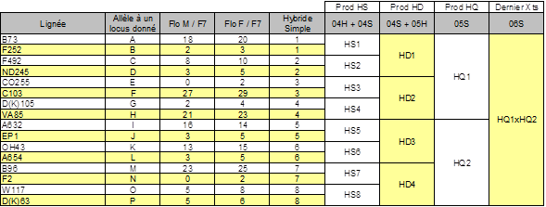

Dernier = latest

**1st generation**: Production of the F1 hybrids. Eight F1 hybrids involving the 16 parental lines were produced. Pairs of parental lines were chosen to preferentially cross an early line with a late line. The objective was to reduce the difference for flowering date among the F1 hybrids (see the column “Prod HS” in the **table 2** to identify the parental lines involved in the 8 single hybrids; the column FloM/F7 is the difference in days between the male flowering date of the parental lines and that of the F7 line used here as a reference; The column FloF/F7 is the difference between the parental line and F7 for female flowering date)

**2nd generation**: Production of double-cross hybrids (4 hybrids). Pairs of F1 hybrids were chosen to reduce the variation of flowering time among the genotypes from a same cross (see column” Prod HD” in the **table 2** to identify the F1 hybrids crossed to obtain the double-cross hybrids).

**3rd generation**: Production of 8-way hybrids (see the column “Prod HQ” in the **table 2**): The experimental design allowed to make crosses between plants with different flowering dates (sowing at different dates to be able to mimic panmixia). The objective was to harvest at **least 60 ears per 8-way hybrids** to produce the next generation. The **table 3** includes the number of crosses made for each type of cross described below and the total number of crosses made for each 8-way hybrid.

The 5 types of cross considered

P-P = early genotype x early genotype,

M-M = genotype with intermediate precocity x genotype with intermediate precocity,

T-T = late genotype x late genotype,

P-T = early genotype x late genotype,

T-P = late genotype x early genotype

**Table3**

Crossing Group Number Group codification Number crosses performed Total



**4th generation (last generation of the funnel crossing scheme)**: The 2 populations from the previous generation were crossed together (see the column “Dernier Xts” in the **table 2** below). We estimated that at least 300 genotypes sampled from the first 8-way hybrid crossed to 300 genotypes sampled from the second 8-way hybrid would be enough to **prevent a detrimental genetic drift** (see paper from Crossa et al., 1992 and Wang et al., 2004). The **table 4** reports the number of kernels per ear and per type of cross (in the previous generation; column 5) that were sampled in each 8-way hybrid, the total number of kernels used per type of cross (column 6) and the total number of kernels for each 8-way hybrid (column 7)

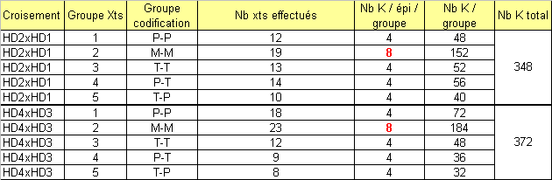**Table 4**

Each plant from the first 8-way hybrid was crossed with a plant from the second 8-way hybrid (pair-crosses) and each plant was used only once either as a male or a female to maximize the effective size of the population. More than 300 crosses were made to obtain the synthetic population. Kernels were sown at 2 dates to be able to cross early with late genotypes and not only early with early and late with late, as illustrated by the diagram below.

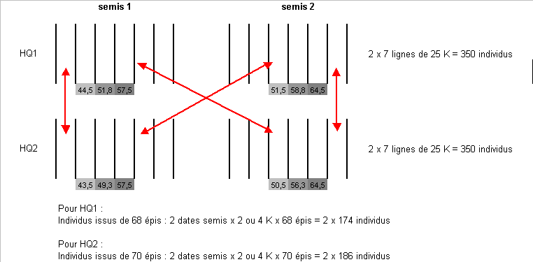

HQ1 = first 8-way hybrid; HQ2 = second 8-way hybrid;

Semis 1 = sowing date 1; Semis 2 = sowing date 2

The **table 5** below reports the number of successful crosses per type of cross (P= early flowering genotypes, M = genotypes with a intermediate flowering date and T= late flowering genotypes). You will notice that crosses between early and late genotypes are underepresented. In total **288 crosses were harvested**.

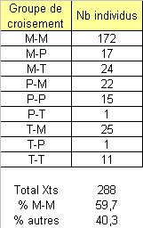**Table 5**

**5th generation (1st generation of mixing)**

For the 3 generations of mixing we used 4 blocks of 550 plants each. Two blocks were sown at a given date and the two others some days later (don’t remember how many). For each date of sowing one block included the plants used as female and the other the plants used as male. This experimental design was used to make it possible to cross early genotypes to late ones.

In the **table 6** below you will find the number of crosses made to obtain the first generation of mixing. In total **801 ears were harvested** to start the second generation of mixing. Since each plant was used only once either as a male or a female (pair-crosses), ~ 1600 genotypes were used to produce the next generation.

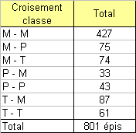**Table 6**

**6th generation (2nd generation of mixing)**

The generation was obtained using pair-crosses involving ~ 1600 plants (from 2 kernels per ear of the previous generation). We got **838 ears** to start the 3rd generation.

The table 7 below includes the figures corresponding to the different crosses made

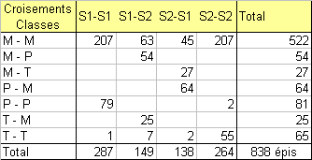**Table 7**

S1: sowing at date 1; S2: sowing at date 2; M-M, … are the type of crosses: early x early, late x late, and so on.