Supplemental Material

Environment-Specific Genomic Prediction Ability in Maize Using Environmental Covariates Depends on Environmental Similarity To Training Data

Anna R. Rogers and James B. Holland

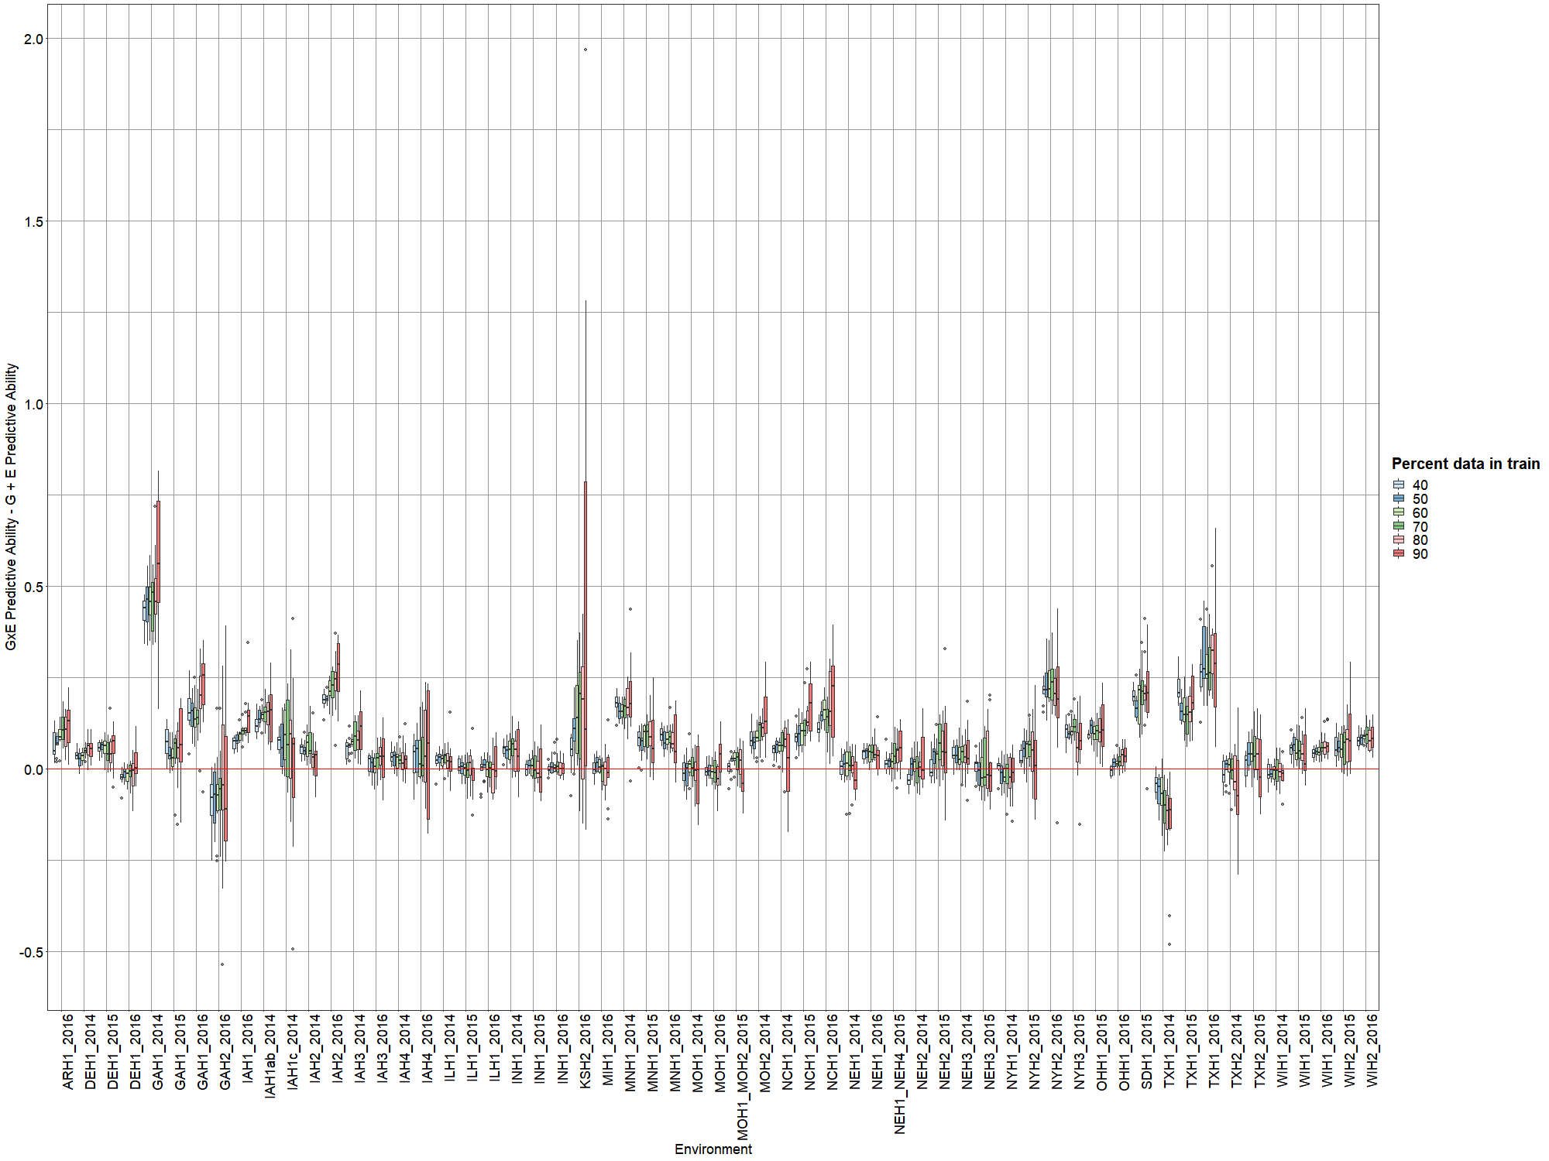
Figure S1. Increase in prediction ability within environments by adding G×E effects using the PCA(Markers)* Env GxE term to a model with 10,154 marker dominance coefficients and 5-day window weather variable summaries. Prediction abilities are compared within training sets including 40% to 90% of the full data set, sampled at random.

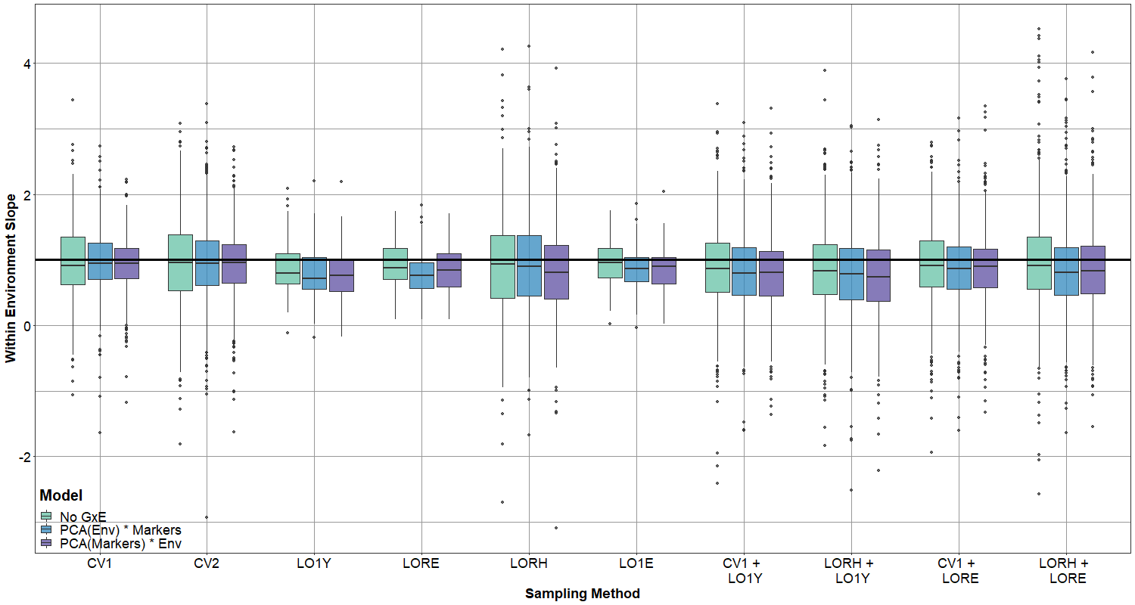
Figure S2. Distributions of slopes of regression of observed values on predicted values within each environment and test set for models including 10,153 marker dominance coefficients and 377 environmental covariates, along with no G×E effects or G×E effects computed using principal components of the environmental data (PCA(Env)*Markers) or using principal components of the marker data (PCA(Markers)*Env). Each model was evaluated in test sets selected by random sampling (CV1), partial replication across environments (CV2), leaving out a single year of data (LO1Y), stratification by environment clusters (LORE), by hybrid clusters (LORH), leaving out single environments (LO1E), and bidirectional censoring schemes leaving out both a year and 10% of hybrids (CV1 + LO1Y), a year and related hybrids (LORH + LO1Y), environment clusters with 10% of hybrids (CV1 + LORE), and environment and hybrid clusters (LORH + LORE).

Table S1. Descriptions of soil parameters taken from SSURGO metadata column descriptions
Parameter | Description
slope_r | Slope gradient of field
tfact | Soil loss tolerance factor, denoting the maximum amount of erosion where the soil can be considered a medium for plant growth
sieveno40_r | Fraction of soil that passes through a number 40 sieve (0.42 mm square opening)
sieveno200_r | Fraction of soil that passes through a number 200 sieve (0.074 mm square opening)
sandvc_r | Percentage of very coarse sand (1.0-2.0 mm diameter) in sample
sandco_r | Percentage of coarse sand (0.5-1.0 mm diameter) in sample
sandmed_r | Percentage of medium sand (0.25-0.5 mm diameter) in sample
sandfine_r | Percentage of fine sand (0.10-0.25 mm diameter) in sample
sandvf_r | Percentage of very fine sane (0.05-0.10 mm diameter) in sample
siltco_r | Percentage of coarse silt (0.02-0.05 mm diameter) in sample
siltfine_r | Percentage of fine silt (0.002-0.02 mm diameter) in sample
claytotal_r | Percentage of clay (particle size < 0.002 mm diameter) in sample
ksat_r | Amount of water that moves through a unit area of saturated soil in unit time
awc_r | Amount of water available to plants, adjusted
wthirdbar_r | Volumetric content of soil water retained at a 1/3 bar tension
wfifteenbar_r | Volumetric content of soil water retained at a 15 bar tension
kwfact | Quantification of susceptibility of soil particles to detachment and movement by water to measure erosion factors
caco3_r | Quantity of Carbonate ($CO_{3}$) expressed as $CaCO_{3}$
gypsum_r | Percent by weight of hydrated calcium sulfate in sample
sar_r | Relative amount of Sodium to Calcium and Magnesium extracted from water saturated soil sample
cec7_r | Amount of exchangeable cations at pH 7.0
sumbases_r | The sum of $NH_{4}OAc$ extractable bases at pH 7.0
extracid_r | Measure of soil exchangeable hydrogen ions
resdepb_r | Distance from soil surface to lower boundary of restrictive layer

Table S2. Training and test set sample sizes, minima, maxima, and quantiles of the distribution of genetic similarities and environmental covariable similarities between training and test sets for each fold of each cross validation scheme. See “Table_S2_Train_Test_Relationships.xlsx”
Table S3. Across-environment prediction accuracy computed as correlation between BLUEs and predicted values for models including 10,153 marker dominance coefficients and 377 environmental covariates, along with no G×E effects or G×E effects computed using principal components of the environmental data (PCA(Env)* Markers) or using principal components of the marker data (PCA(Markers) * Env) for each sampling method. Bidirectional schemes are shaded grey.
Method | G + E | PC(Env) * Markers | PC(Markers) * Env
CV1 | 0.777 | 0.794 | 0.808
CV2 | 0.786 | 0.803 | 0.819
LO1Y | 0.286 | 0.267 | 0.262
LORE | 0.216 | 0.207 | 0.203
LORH | 0.734 | 0.743 | 0.750
LO1E | 0.476 | 0.480 | 0.470
CV1 + LO1Y | 0.246 | 0.275 | 0.236
LORH + LO1Y | 0.252 | 0.205 | 0.237
CV1 + LORE | 0.161 | 0.171 | 0.173
LORH + LORE | 0.167 | 0.158 | 0.175

Table S4. Mean within-environment prediction accuracies for models including 10,153 marker dominance coefficients and 377 environmental covariates, along with no G×E effects or G×E effects computed using principal components of the environmental data (PCA(Env)* Markers) or using principal components of the marker data (PCA(Markers) * Env) for each sampling method. Bidirectional schemes are shaded grey.
Method | G + E | PC(Env) * Markers | PC(Markers) * Env
CV1 | 0.436 | 0.482 | 0.517
CV2 | 0.464 | 0.510 | 0.547
LO1Y | 0.363 | 0.365 | 0.353
LORE | 0.452 | 0.430 | 0.439
LORH | 0.296 | 0.311 | 0.307
LO1E | 0.476 | 0.480 | 0.470
CV1 + LO1Y | 0.347 | 0.352 | 0.340
LORH + LO1Y | 0.252 | 0.258 | 0.234
CV1 + LORE | 0.401 | 0.380 | 0.386
LORH + LORE | 0.285 | 0.278 | 0.269

