Supplementary Tables and Figures

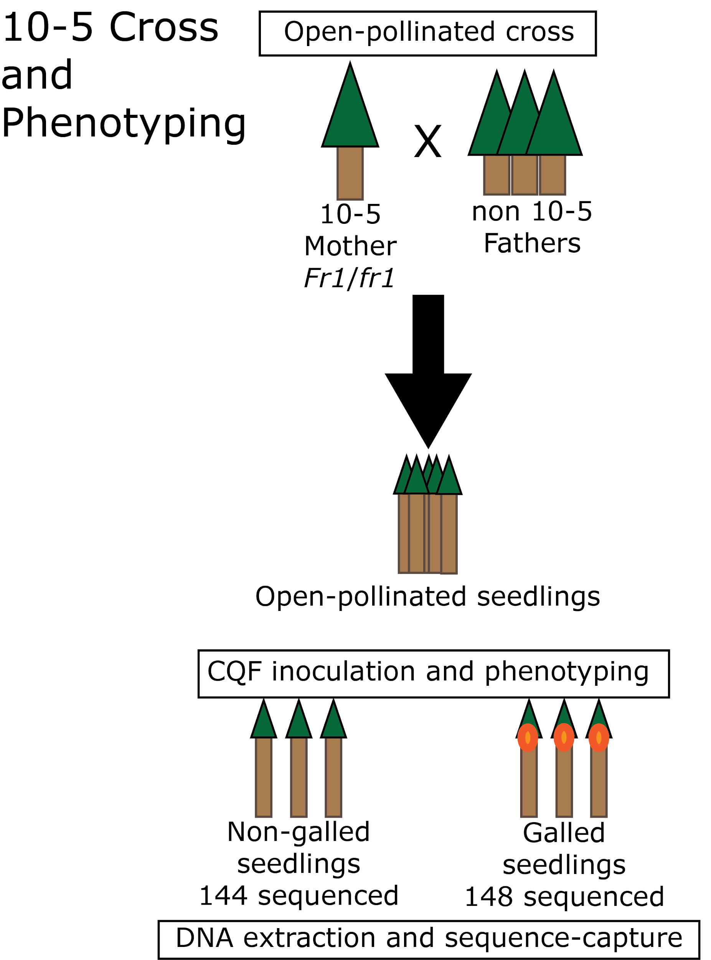

Supplementary Figure S1. Flowchart of 10-5 cross, phenotyping and sequencing. The 10-5 mother tree was open-pollinated (O.P.). The Resistance Screening Center (RSC) in Asheville, North Carolina inoculated the O.P. seedlings with the Cqf SC20-21 spores. Rapid Genomics sequenced DNA from 144 of the non-galled seedlings and 148 of the galled seedlings with targeted genome resequencing. Additionally, megagametophytes from thirty-two 10-5 OP seedlings were dissected and targeted resequenced, along with other samples (see Table 1).

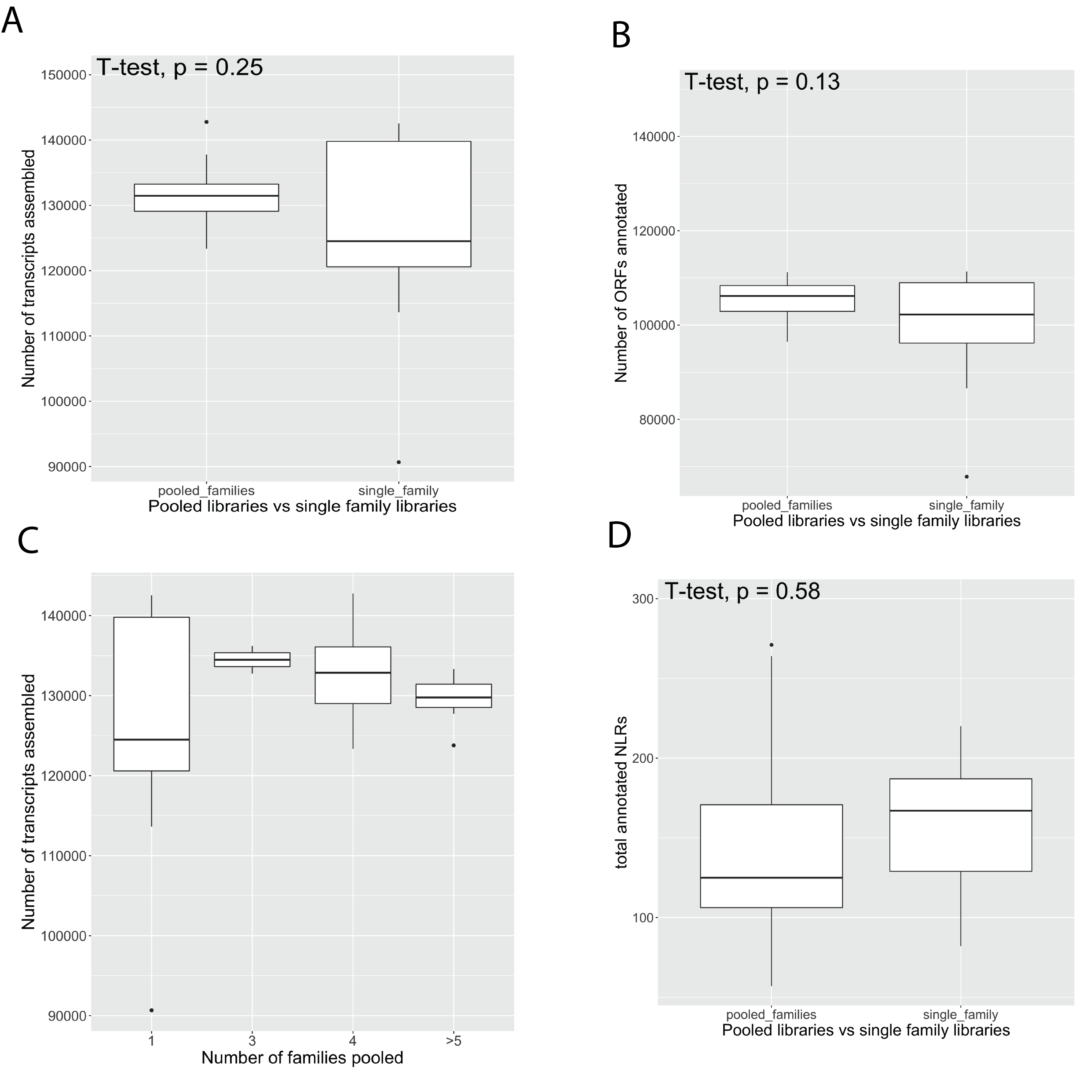

Supplementary Figure S2. Number of Transcripts Assembled, ORFs Identified, and NLR Transcripts Annotated. a) Number of Transcripts Assembled, Single vs Pooled Families, 1b) Number of ORFs Identified, Single vs Pooled Families, 1c) Number of Transcripts Assembled 1 vs 3 vs 4 vs 5 or More Families Pooled, 1d) Number of NLR Transcripts Annotated by NLRTracker in Pooled vs Single Family Libraries

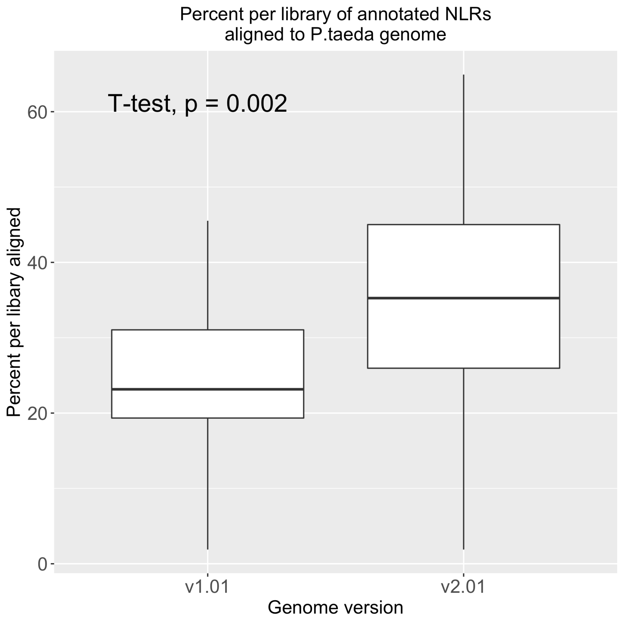

Supplementary Figure S3. Alignment of annotated NLR transcripts to Ptaeda Ref Genomes

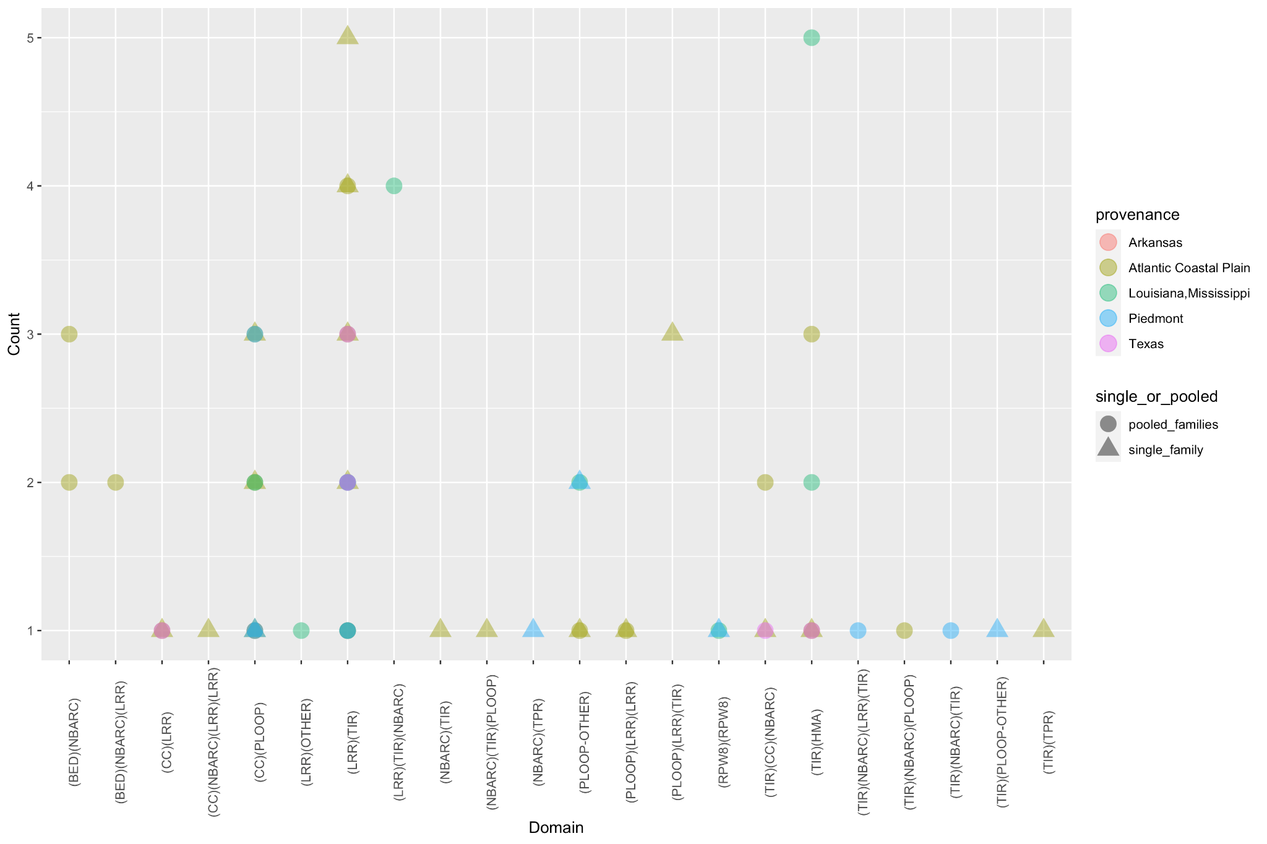Supplementary Figure S4. Domain Architectures Not Found in the Reference Genome
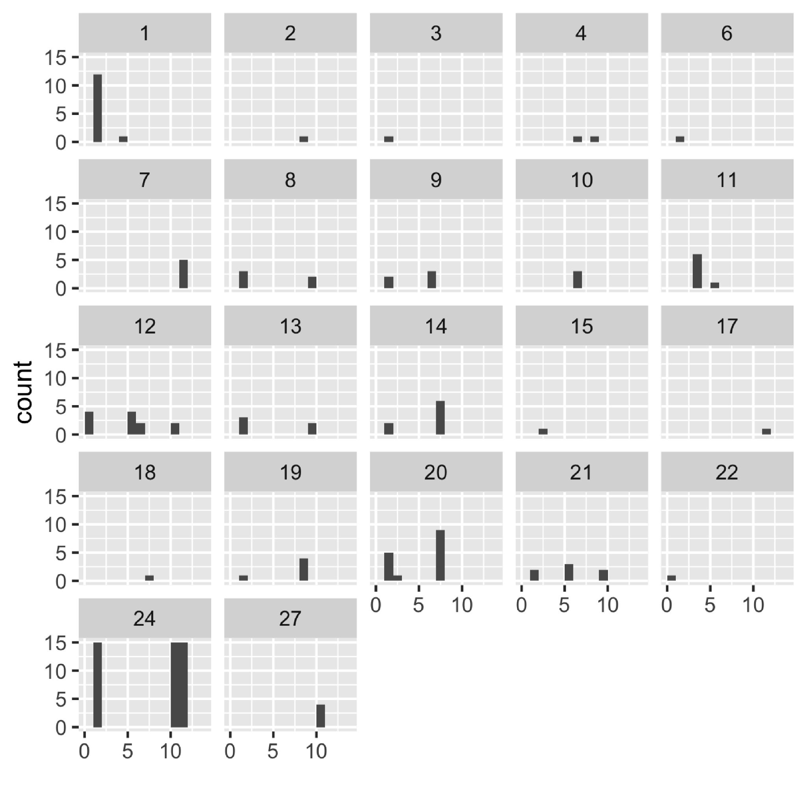

Supplementary Figure S5. Assignment of scaffolds to LGs in 10-5 megagametophytes. Arbitrary linkage group numbers are shown as separate histograms, 1-27. LGs from Westbrook et al 2015 are presented on the x-axis of each histogram (LG1-LG12).

