Supplementary Materials

The genome sequence of the avian vampire fly (Philornis downsi), an invasive nest parasite of Darwin’s finches

Supplementary Table 1: Genome Statistics of P. downsi estimated from short-sequencing reads

Property min max
Heterozygosity 1.40879% 1.42194%
Genome Haploid Length 796,797,589 bp 799,050,413 bp
Genome Repeat Length 232,405,721 bp 233,062,812 bp
Genome Unique Length 564,391,869 bp 565,987,600 bp
Model Fit 95.7713% 98.7012%
Read Error Rate 1.228% 1.228%

Supplementary Table 2: Busco statistics of P. downsi genome

Categories | Number | % of total
Complete BUSCOs | 3147 | 95.80
Complete and single-copy BUSCOs | 3059 | 93.12
Complete and duplicated BUSCOs | 88 | 2.68
Fragmented BUSCOs | 71 | 2.17
Missing BUSCOs | 67 | 2.03
Total BUSCO groups searched | 3285 | 100%

Supplementary Table 2: Repeat statistics in P. downsi genome
sequences: 41,176
total length: 971,6346,46 bp
GC level: 35.10 %
bases masked: 502,200,627 bp (51.69 %)
==================================================
number of length percentage
elements* occupied of sequence
--------------------------------------------------
Retroelements 224657 90253146 bp 9.29 %
SINEs: 58 6761 bp 0.00 %
Penelope 3187 661022 bp 0.07 %
LINEs: 196268 74550945 bp 7.67 %
CRE/SLACS 0 0 bp 0.00 %
L2/CR1/Rex 43733 18550153 bp 1.91 %
R1/LOA/Jockey 15852 7502835 bp 0.77 %
R2/R4/NeSL 834 673762 bp 0.07 %
RTE/Bov-B 102395 29493616 bp 3.04 %
L1/CIN4 1415 94740 bp 0.01 %
LTR elements: 28331 15695440 bp 1.62 %
BEL/Pao 12565 7084057 bp 0.73 %
Ty1/Copia 1561 775084 bp 0.08 %
Gypsy/DIRS1 9951 7481940 bp 0.77 %
Retroviral 2481 143387 bp 0.01 %

DNA transposons 621139 227262774 bp 23.39 %
hobo-Activator 8749 1542960 bp 0.16 %
Tc1-IS630-Pogo 576750 212960682 bp 21.92 %
En-Spm 0 0 bp 0.00 %
MuDR-IS905 0 0 bp 0.00 %
PiggyBac 1280 395680 bp 0.04 %
Tourist/Harbinger 4060 1924044 bp 0.20 %
Other 275 11451 bp 0.00 %

Rolling-circles 19653 4597029 bp 0.47 %

Unclassified: 828801 166508339 bp 17.14 %

Total interspersed repeats: 484024259 bp 49.82 %

Small RNA: 7148 2907047 bp 0.30 %

Satellites: 796 124775 bp 0.01 %
Simple repeats: 213281 8909635 bp 0.92 %
Low complexity: 34278 1638267 bp 0.17 %

Supplementary Table 3: Number of shared orthogroups among various dipteran species and their outgroup

 | H.melpomene | A.aegypti | C.capitata | S.calcitrans | M.domestica | P.downsi | G.morsitans | D.melanogaster
H.melpomene |  | 6,978 | 6,874 | 6,883 | 6,910 | 6,800 | 6,337 | 6,859
A.aegypti | 6,978 |  | 8,015 | 8,008 | 8,018 | 7,796 | 7,228 | 7,995
C.capitata | 6,874 | 8,015 |  | 9,123 | 9,186 | 8,855 | 8,014 | 9,096
S.calcitrans | 6,883 | 8,008 | 9,123 |  | 9,650 | 9,197 | 8,087 | 9,041
M.domestica | 6,910 | 8,018 | 9,186 | 9,650 |  | 9,295 | 8,144 | 9,117
P.downsi | 6,800 | 7,796 | 8,855 | 9,197 | 9,295 |  | 8,103 | 8,770
G.morsitans | 6,337 | 7,228 | 8,014 | 8,087 | 8,144 | 8,103 |  | 7,940
D.melanogaster | 6,859 | 7,995 | 9,096 | 9,041 | 9,117 | 8,770 | 7,940

Supplementary Table 4: Gene families unique only to P. downsi

EGT47331 | hypothetical protein CAEBREN_08836 [Caenorhabditis brenneri]
GBO13109 | hypothetical protein AVEN_233885-1 [Araneus ventricosus]
GBP44057 | PiggyBac transposable element-derived protein 4 [Eumeta japonica]
KMQ83311 | transposable element tc3 transposase [Lasius niger]
KNC20639 | hypothetical protein FF38_06891, partial [Lucilia cuprina]
KNC20966 | hypothetical protein FF38_09018 [Lucilia cuprina]
KNC26906 | hypothetical protein FF38_10930 [Lucilia cuprina]
KXJ68891 | hypothetical protein RP20_CCG001210 [Aedes albopictus]
OAF68034 | hypothetical protein A3Q56_04227 [Intoshia linei]
PCG68510 | hypothetical protein B5V51_5157, partial [Heliothis virescens]
XP_011295145 | PREDICTED: tigger transposable element-derived protein 6-like isoform X2 [Musca domestica]
XP_011295374 | PREDICTED: tigger transposable element-derived protein 6 [Musca domestica]
XP_013109704 | PREDICTED: uncharacterized protein LOC106088638 [Stomoxys calcitrans]
XP_017475229 | PREDICTED: uncharacterized protein LOC108365650 [Rhagoletis zephyria]
XP_017478109 | PREDICTED: uncharacterized protein LOC108367917 [Rhagoletis zephyria]
XP_017478991 | PREDICTED: uncharacterized protein LOC108368617 [Rhagoletis zephyria]
XP_017479715 | PREDICTED: uncharacterized protein LOC108369194 [Rhagoletis zephyria]
XP_017481195 | PREDICTED: RNA-directed DNA polymerase from mobile element jockey-like [Rhagoletis zephyria]
XP_019891578 | PREDICTED: ATP-binding cassette sub-family A member 3-like [Musca domestica]
XP_019894716 | PREDICTED: uncharacterized protein LOC105262305 isoform X1 [Musca domestica]
XP_021704105 | protein ALP1-like [Aedes aegypti]
XP_022823959 | piggyBac transposable element-derived protein 4-like [Spodoptera litura]
XP_022834134 | uncharacterized protein LOC111361914 [Spodoptera litura]
XP_033325321 | uncharacterized protein LOC117219890 [Megalopta genalis]
XP_036214104 | trypsin zeta-like [Bactrocera oleae]
XP_036337749 | uncharacterized protein LOC118747737 isoform X3 [Rhagoletis pomonella]
XP_036342696 | uncharacterized protein LOC118751975 [Rhagoletis pomonella]

Supplementary Table 5: Number of genes in Fibrinogen C-Terminal Domain-Containing gene family and SCP domain-containing gene family

Species | Fibrinogen C-Terminal Domain-Containing gene family | SCP domain-containing gene family
H.melpomene | 1 | 2
A.aegypti | 33 | 20
C.capitata | 10 | 6
S.calcitrans | 45 | 17
M.domestica | 32 | 25
P.downsi | 5 | 7
G.morsitans | 7 | 7
D.melanogaster | 11 | 15

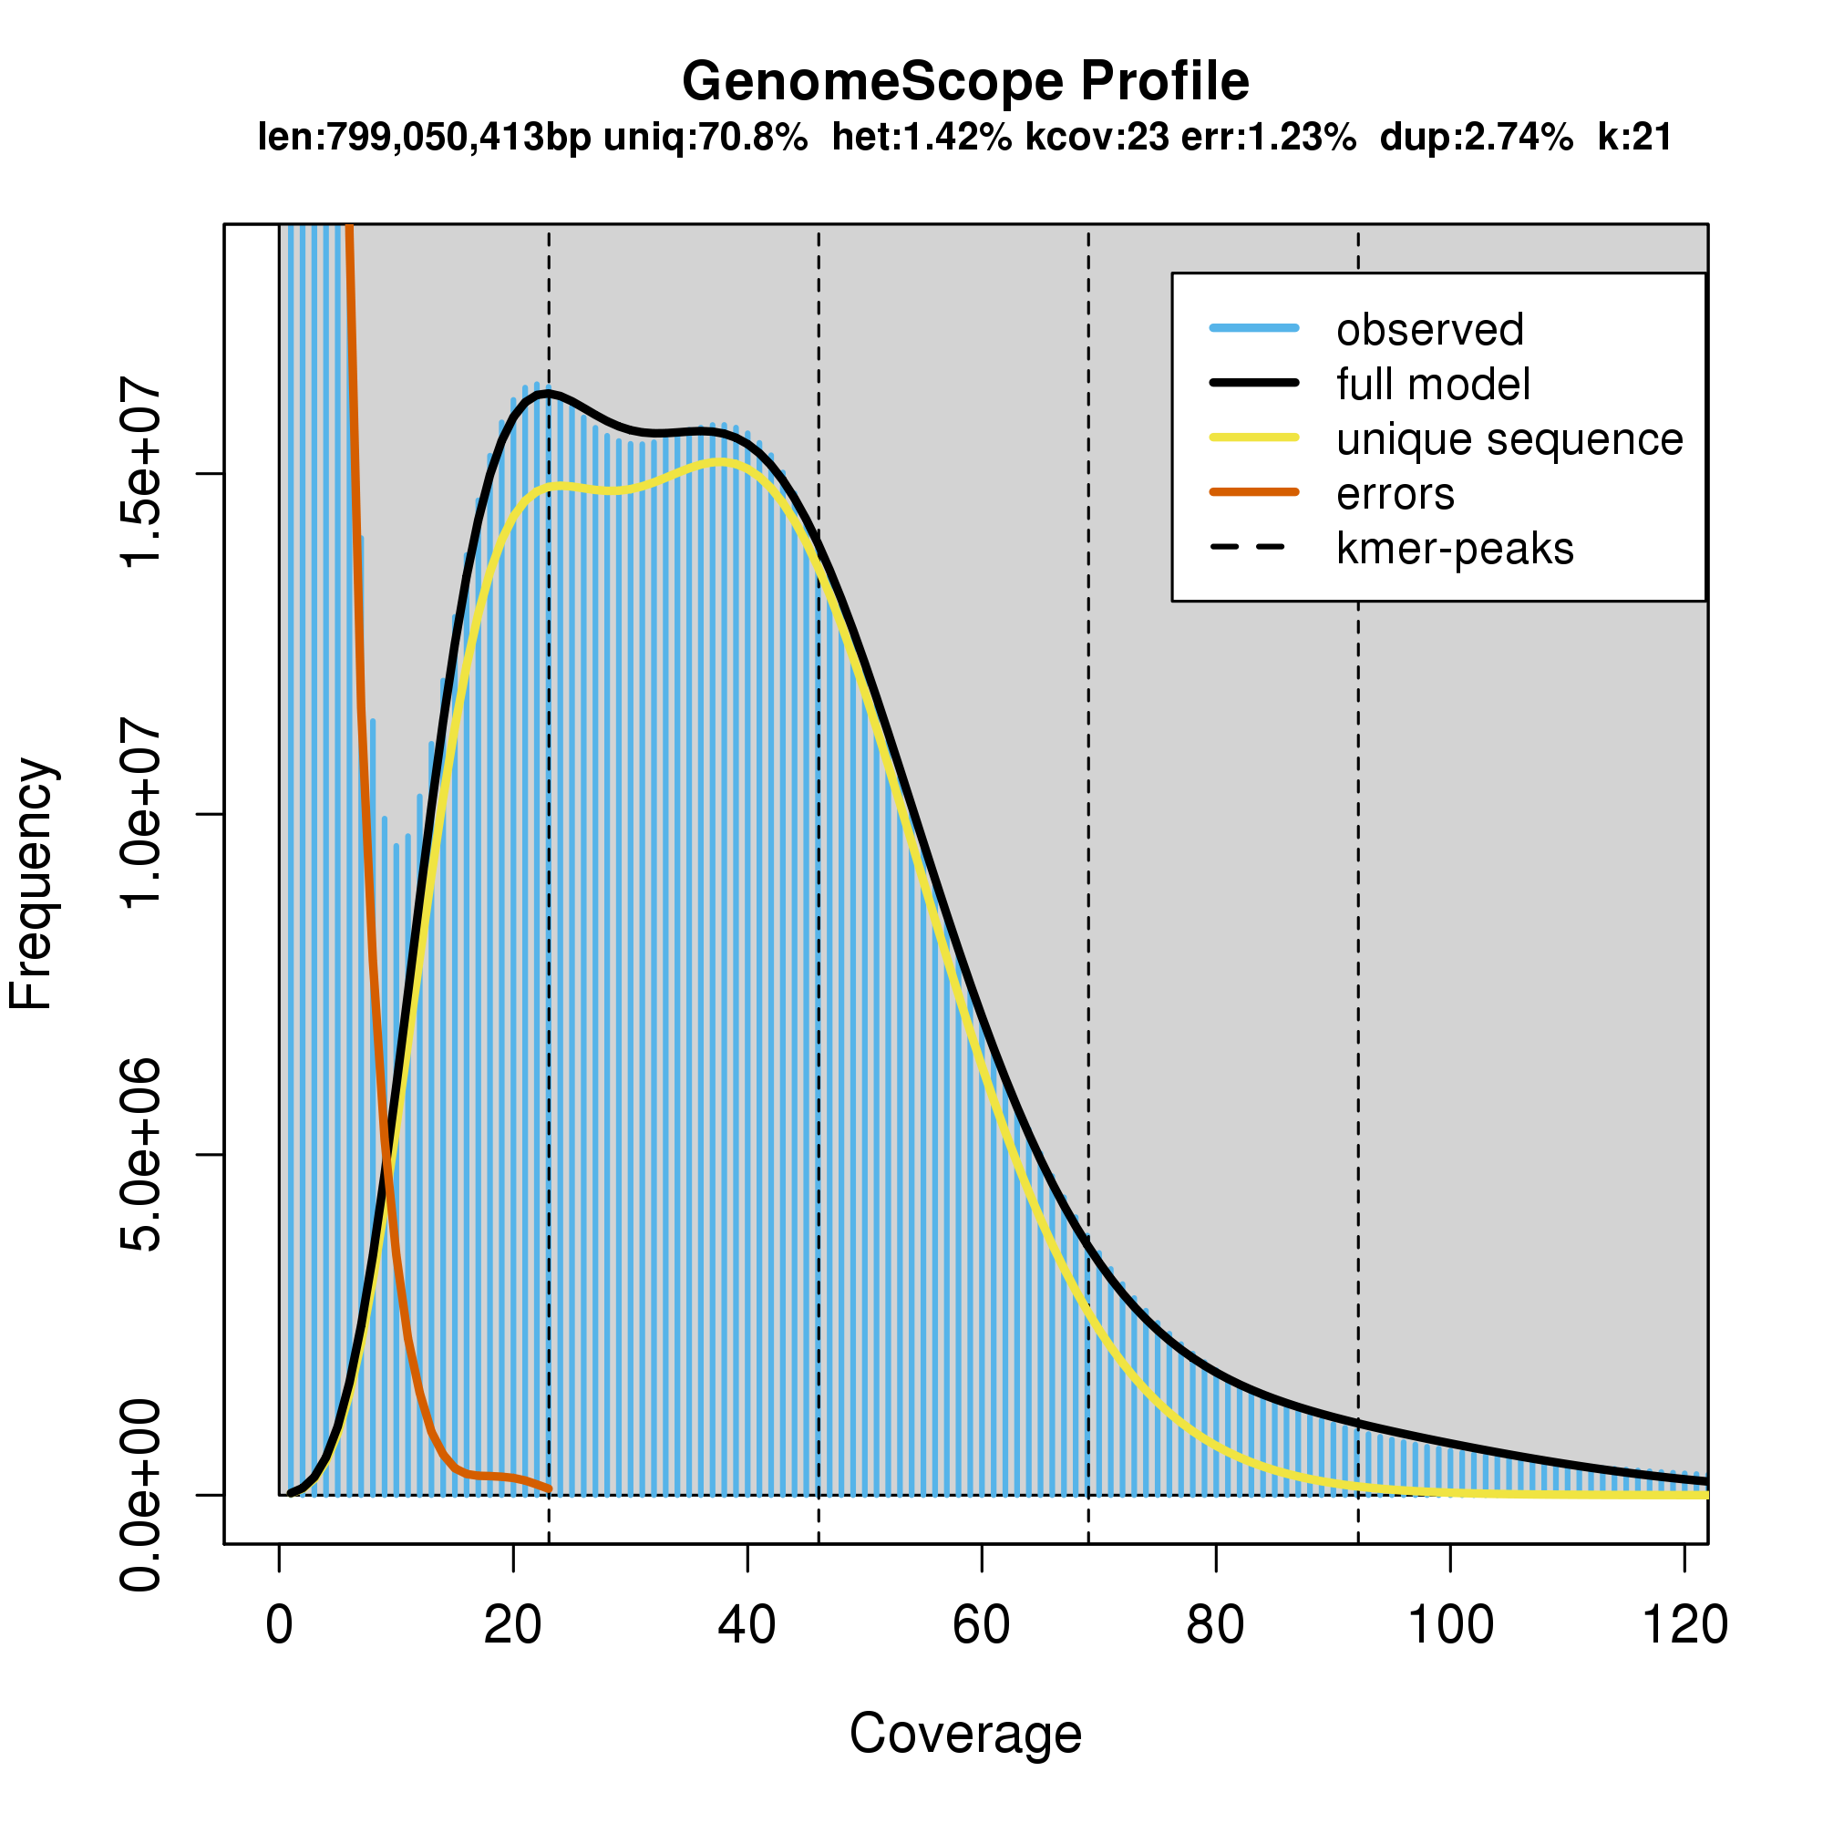
Supplementary Figure 1: k-mer spectrum and fitted modelling used for estimating genome parameters of P. downsi from short sequencing reads

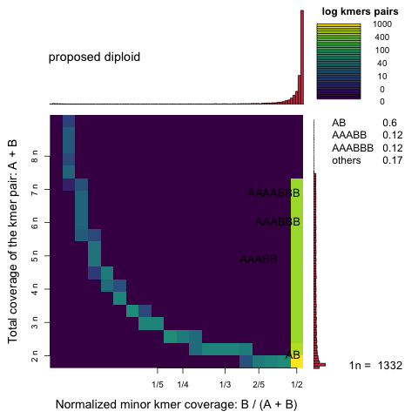
Supplementary Figure 2: Distribution of the total coverage of the k-mer pair (y-axis) against relative minor k-mer coverage (x-axis) providing evidence of diploidy in P. downsi.

