Supplemental information for manuscript:

**Environment-driven reprogramming of gamete DNA methylation occurs during maturation and is transmitted intergenerationally in Atlantic Salmon**

Kyle Wellband1,2,3,*, David Roth3,4, Tommi Linnansaari2,3,4, R. Allen Curry2,3,4, Louis Bernatchez1

1. Institut de Biologie Intégrative et des Systèmes  
   Université Laval  
   Québec, QC, Canada, G1V 0A6
2. Department of Biology  
   University of New Brunswick  
   Fredericton, NB, Canada, E3B 5A3
3. Canadian Rivers Institute  
   University of New Brunswick  
   Fredericton, NB, Canada, E3B 5A3
4. Faculty of Forestry and Environmental Management  
   University of New Brunswick  
   Fredericton, NB, Canada, E3B 5A3

* Corresponding author:

Kyle Wellband

Pacific Science Enterprise Centre, Fisheries and Oceans Canada

4160 Marine Dr. West Vancouver, BC, V7V 1N6

kyle.wellband@gmail.com



**Supplemental Figure 1:** Distribution of methylation proportion (# methylated bases / read coverage) for 16.4 million CpG sites from adult sperm samples.



**Supplemental Figure 2:** Distribution of methylation proportion (# methylated bases / read coverage) for 23.1 million CpG sites from juvenile liver samples.



**Supplemental Figure 3:** Differential methylated regions (DMR) between SAS (yellow) and wild (blue) salmon that overlapped (A-B) or targeted the same gene (C) between sperm (solid lines) and juvenile liver tissues (dashed lines). Grey boxes highlight the extent of DMRs and the lower tracks indicate annotated genes.



**Supplemental Figure 4:** Heatmap of methylation – phenotype correlations for all modules (represented by color names on the y-axis) with at least one significant correlation. Colors and values in the cells represent the magnitude and direction of the correlation coefficient (blue = negative correlation, red = positive correlation) with the statistical significance of the correlation coefficient in parentheses (p-value). Phenotypes on the x-axis: WT = weight in g, FL and TL = fork length and total length in mm, and CF = condition factor (105 * WT / FL^3).

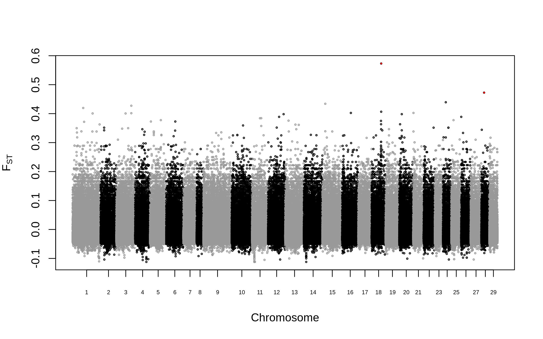

**Supplemental Figure 5:** Distribution of genetic divergence (FST) between SAS and wild salmon for 974,219 single nucleotide polymorphisms. The genome-wide average divergence (FST) did not differ from zero (AMOVA; 1000 permutations: p = 0.77). Outliers (FDR < 0.01) identified by OutFLANK are highlighted in red. Neither BayeScan, nor a polygenic framework (RDA, R2 = 0, p = 0.71) identified any outliers.