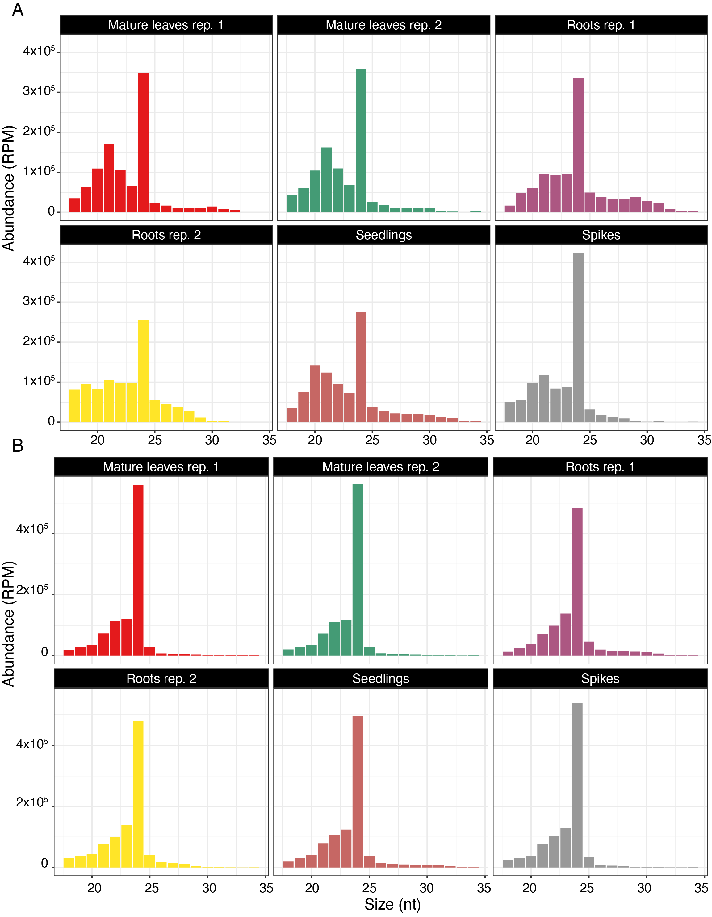

**Figure S1** Size distribution of sRNA reads in *Ae. tauschii.* **A** All reads. **B** Distinct reads. The following tissues were sampled: mature leaves (2 replicates), roots (2 replicates), seedlings, and spikes. The *x*-axis is read size in nucleotides and the *y*-axis is the normalized abundance in reads per million (RPM).

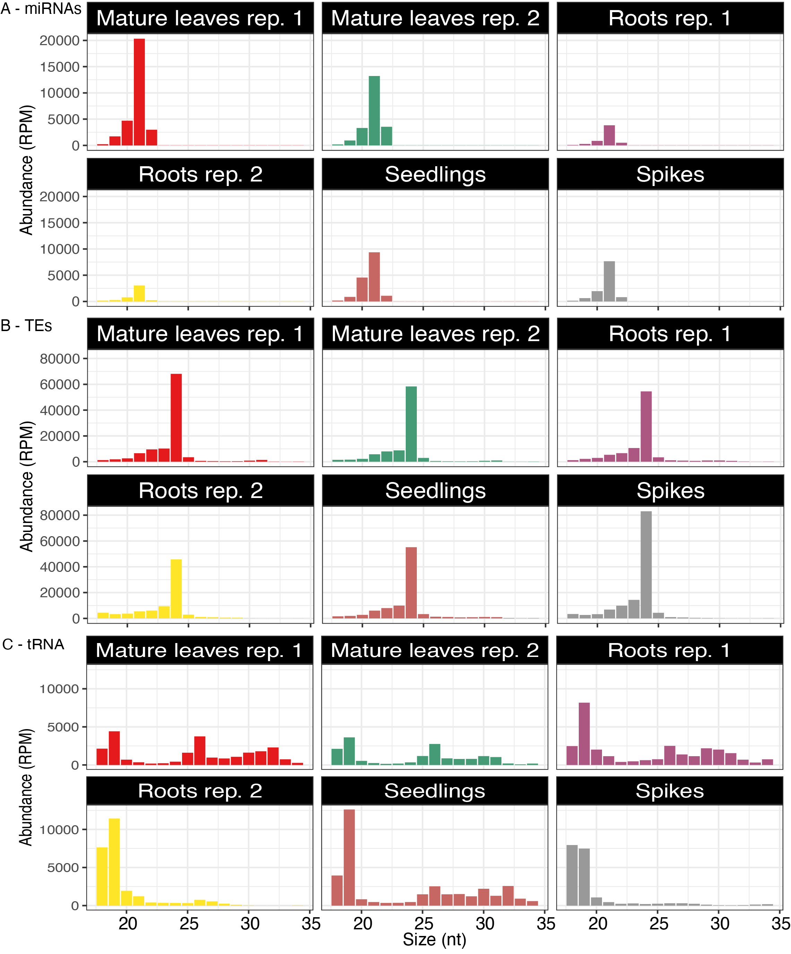

**Figure S2** Theabundance of sizes of sRNAs (per million, RPM). (**A)** miRNAs, (**B)** TE-derived sRNAs, and (**C**) tRNA-derived sRNAs. The following *Ae. tauschii* tissues were sampled: mature leaves (2 replicates), roots (2 replicates), seedlings, and spikes.

**Figure S3**. Structure of potential polycistronic miRNAs in *Ae. tauschii*. The secondary structure of miR9674ab precursor and miR5200abc precursor. The colored regions indicate the mature miRNA of miR9674ab and miR5200abc.