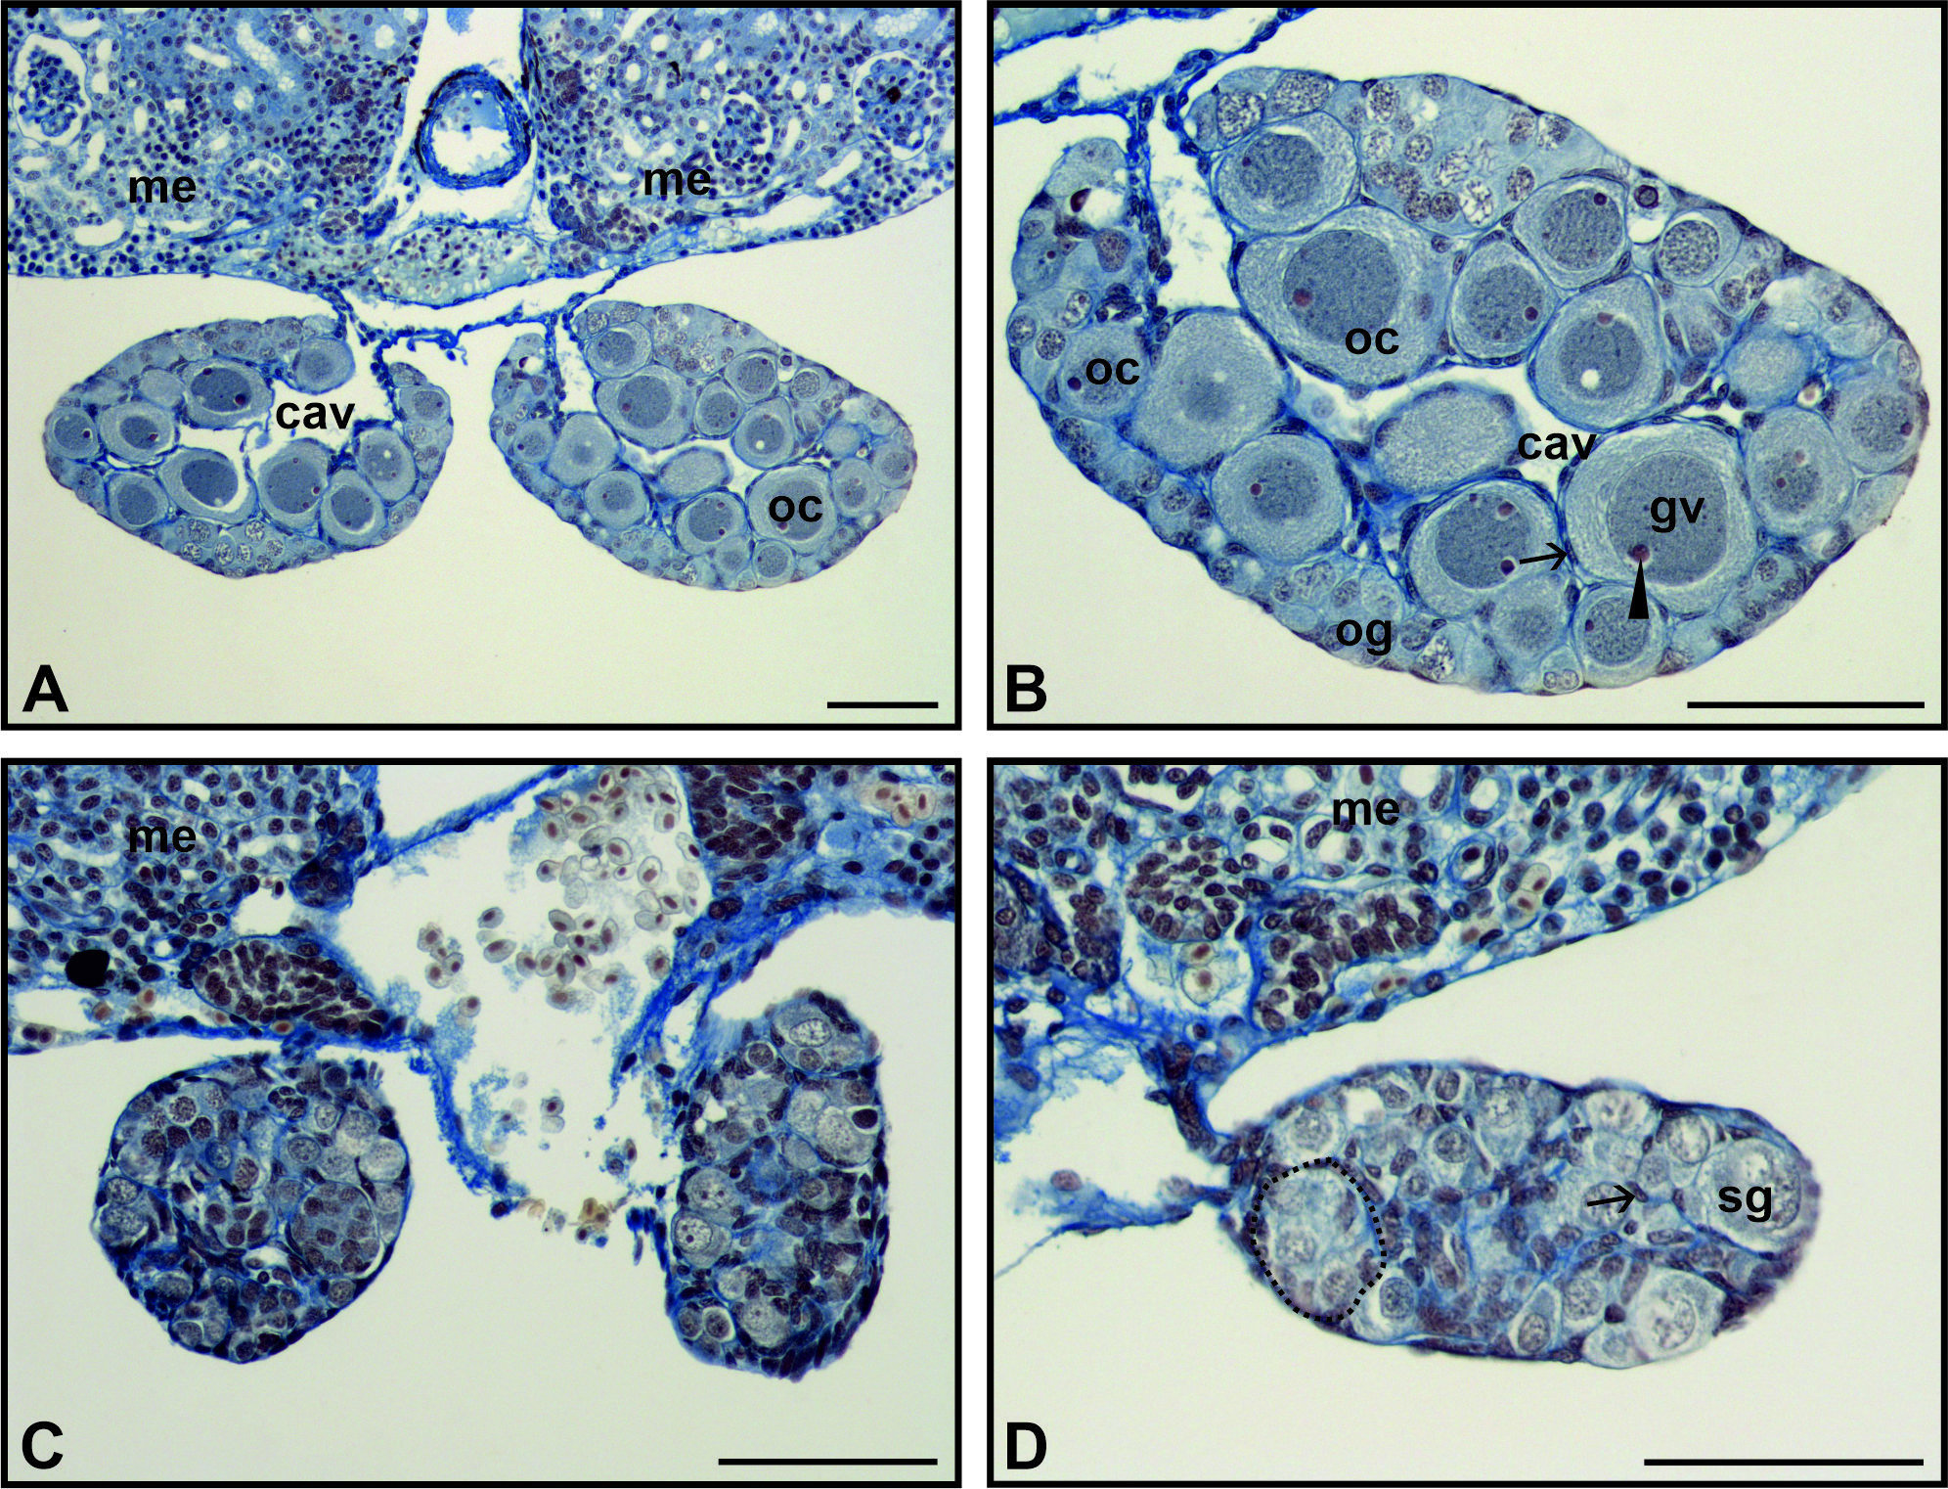
Figure S1. Gonad morphology in metamorphosing Bombina tadpoles (tail resorption stage). The gonads of both sexes are distinct at this stage and located at the ventral surface of the mesonephroi (me, panels A, C, D). The ovaries (A, B) are recognised by the ovarian cavity (cav) and numerous oocytes (oc) at different stages of growth. Oocytes are large and have a germinal vesicle (gv) with large nucleoli (arrowhead, B). They are enveloped by a monolayer of follicular cells (arrow). Groups of oogonia (og) are visible at the periphery. Testes (C, D) lack a central cavity. Groups of spermatogonia (sg, D) have characteristically pale cytoplasm and nuclei. They form the testis cords (dotted circle). Spermatogonia are enclosed by differentiating Sertoli cells (arrow, D) with small, dark nuclei. Scale bar 100 μm.

