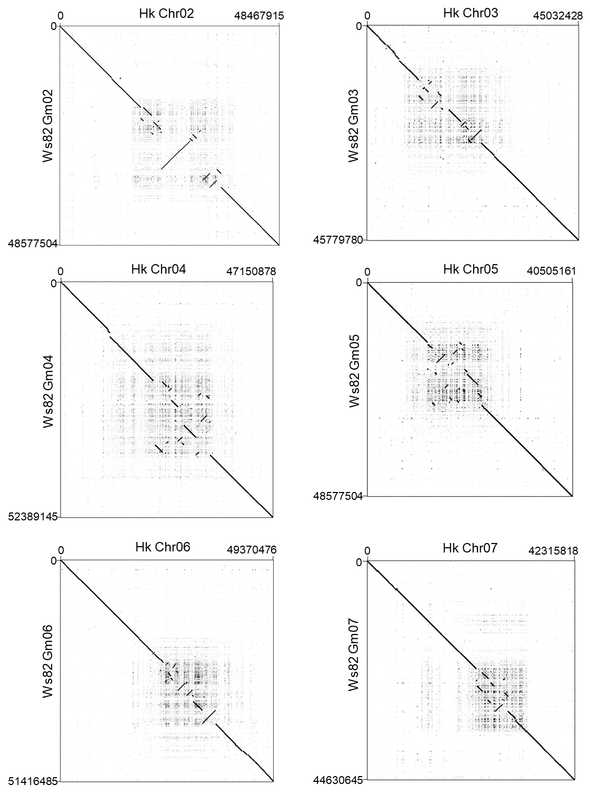
Figure S1 (continued)
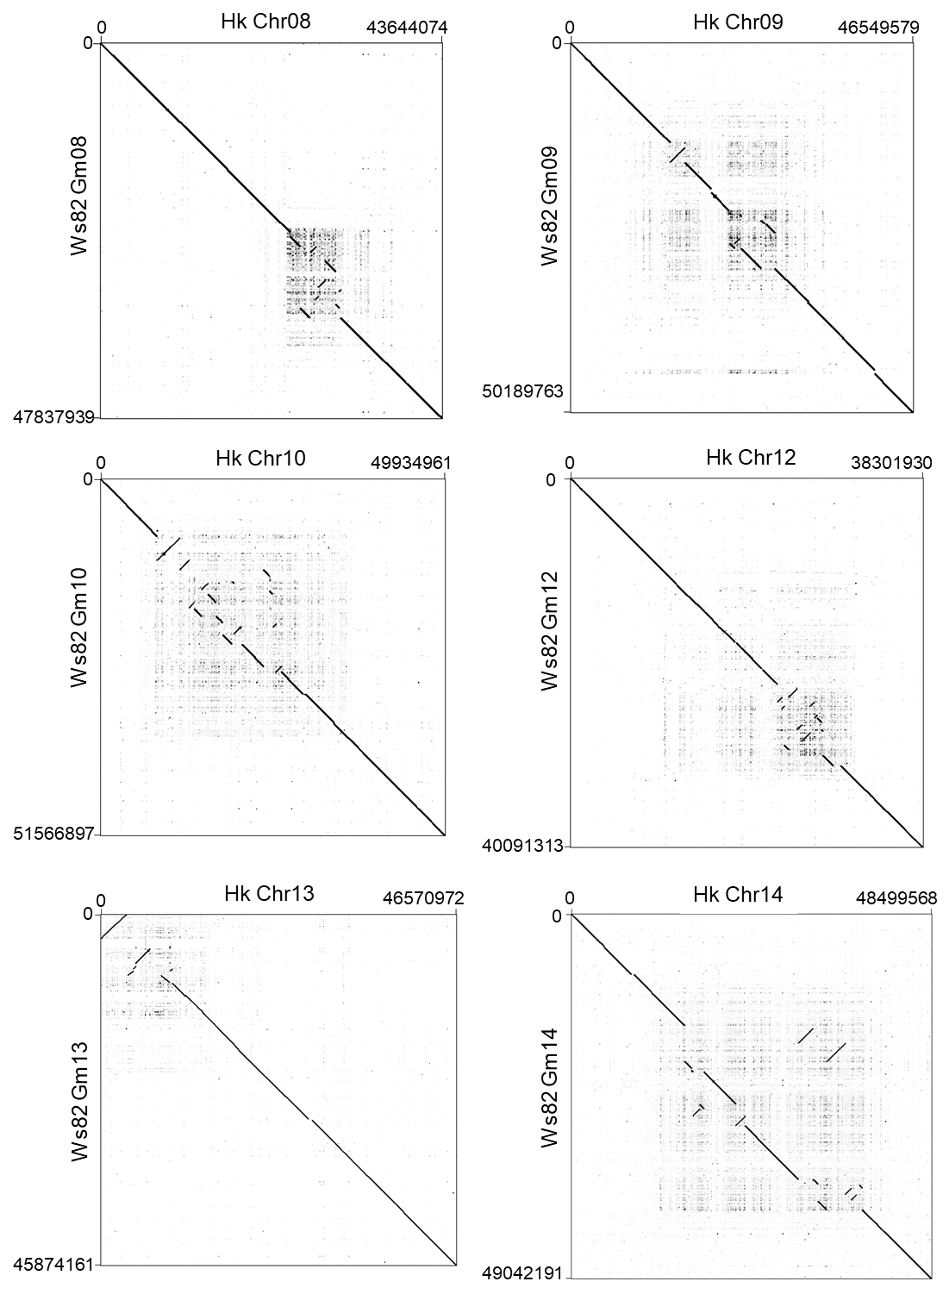

Figure S1 (continued)
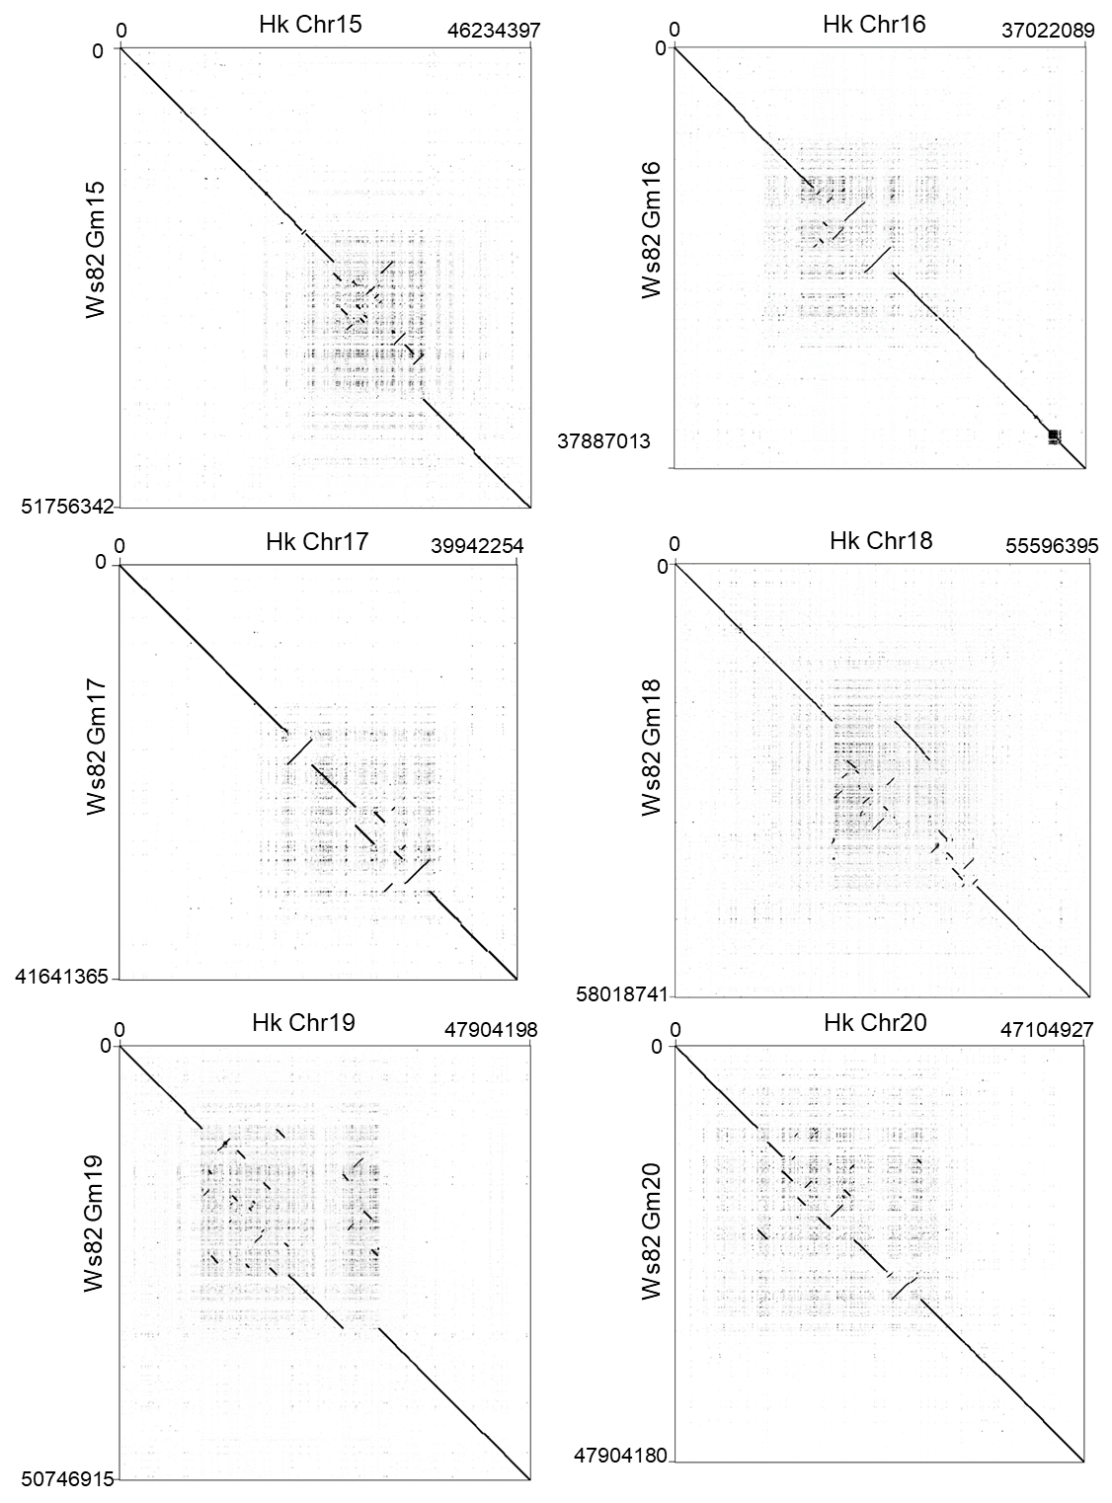
Figure S1. Dot plots showing alignments of corresponding chromosomes between the Hwangkeum and Williams 82 assemblies.
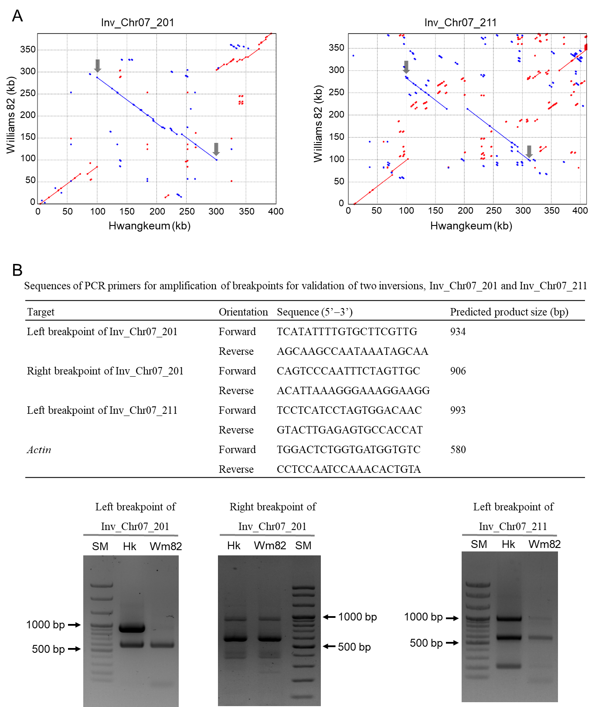
Figure S2. Validation of two large inversions. A. Alignments between Hwangkeum and Williams 82 sequences of two large inversions, Inv_Chr07_201 (201 kb) and Inv_Chr07_211 (211 kb). Sequences including inversions and their 100-kb flanking sequences were aligned. Sequence coordinates of Inv_Chr07_201 are Chr07:31792160-32192735 for the Hwangkeum assembly and Gm07:34127441-34515006 for the Williams 82 assembly. Sequence coordinates of Inv_Chr07_211 are Chr07:32165100-32575725 for the Hwangkeum assembly and Gm07:34505863-34888807 for the Williams 82 assembly. Forward maximum unique matches (MUMs) are plotted as red lines/dots while reverse MUMs are plotted as blue lines/dots. Breakpoints of inversions are indicated by gray arrows. B. Multiplex PCR for validation of breakpoints of inversions. PCR primer targets and sample names (SM, a 100-bp DNA ladder, Bioneer, Daejeon, Korea; Hk, Hwangkeum; Wm82, Williams 82) are indicated. Of the three PCR targets attempted, only one target gave a specific product. A common 580-bp band PCR-amplified from the actin gene is shown. Because sequence alignment of right breakpoint of Inv_Chr07_211 showed complicated repeat structure, we did not attempt any specific PCR amplification. Although the alignment at the right breakpoint of Inv_Chr07_201 appeared to be specific, there is a possibility of non-specific PCR product amplification because this breakpoint contains sequence of a member of a serine/threonine-protein phosphatase multi-gene family.

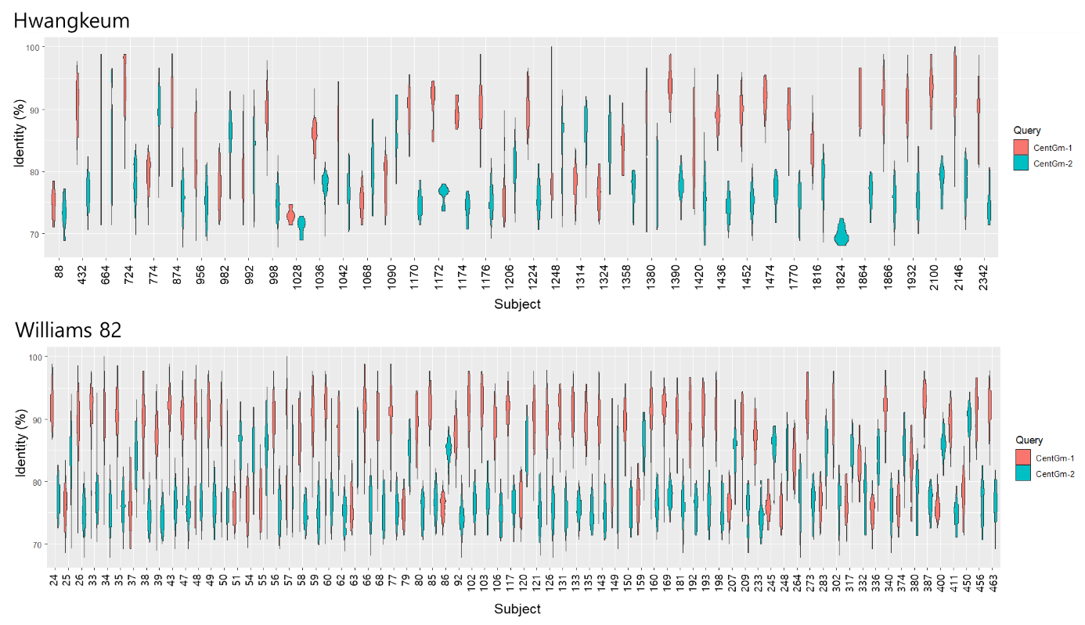
Figure S3. Violin plot distributions of the percent identity of centromeric repeats hit by BLAST searches with CentGm-1 and CentGm-2, respectively, along the unanchored contigs or scaffolds, as sampled in the Hwangkeum and Williams 82 assemblies.

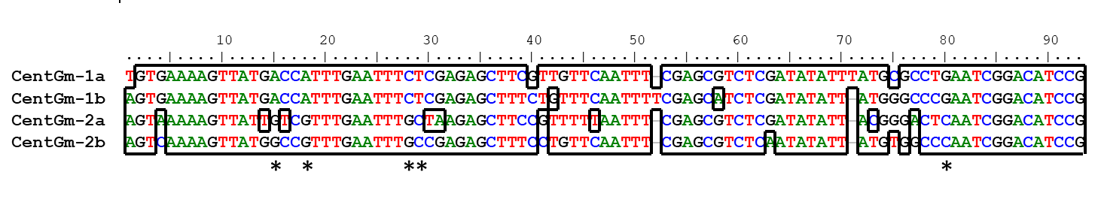
Figure S4. ClustalW alignment of consensus DNA sequences of four CentGm consensus repeats extracted in this study. Asterisks indicate nucleotide positions that distingush between CenGm-1a and -1b and CenGm-2a and -2b. CenGm-1a and CentGm-1b are 92 bp and CenGm-2a and CentGm-2b are 91 bp.

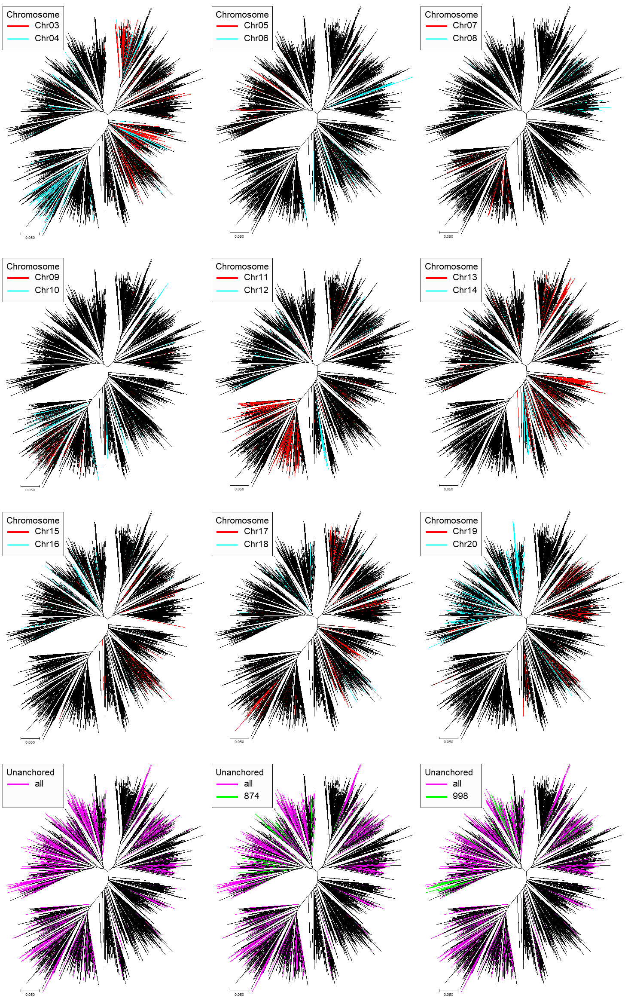
Figure S5. Neighbor-joining phylogenetic tree of centromeric repeat sequences in the Hwangkeum assembly to show clustering of the sequences located on each of chromosome and unanchored contigs. Nine of 4478 sequences are publicly available representative sequences. Sequences on odd number of chromosomes are indicated by red branches and those on even number of chromosomes by light blue branches. Sequences on unanchored contigs are indicated by pink branches and sequences on unanchored contigs Contig_Un0874 and Contig_Un0998 are highlighted by green branches to show how repeat sequences of each contig spread over among repeat groups.

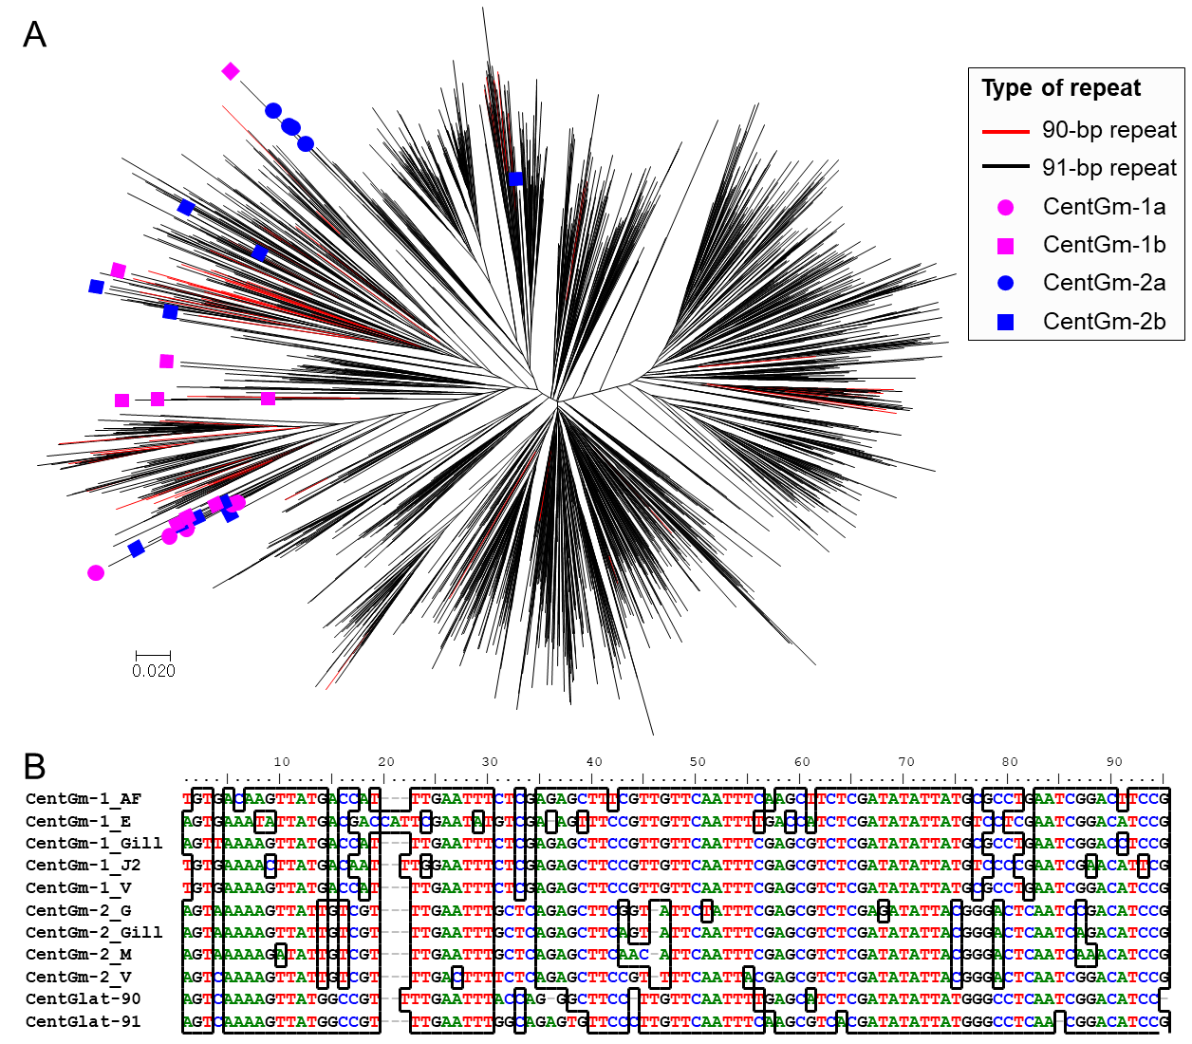
Figure S6. Evolution of centromeric satellite repeats in Glycine latifolia. A. Neighbor-joining tree of 3046 satellite repeats consisting of 3107 repeat sequences from G. latifolia, five CentGm-1 representative sequences, four CentGm-2 representative sequences, and ten sequences from each of the CentGm-1b and CentGm-2b groups extracted from the Hwangkeum assembly. B. ClustalW alignment of consensus DNA sequences of the publicly available 9 representative consensus CentGm repeats (Findley et al. 2010 and Valliyodan et al. 2019) and two CentGlat consensus repeats extracted in this study.

Table S1. Summary statistics of initial contig assemblies of Hwangkem sequencing data generated by the PacBio SMRT and Nanopore PromethION sequencing platforms
Platform | PacBio SMRT | Nanopore PromethION
Assembler | Falcon_unzip | Shasta | Wtdbg2
Number of contigs | 1,436 | 847 | 7,063
Total length | 963,125,854 | 925,186,764 | 931,302,713
Longest length | 11,577,401 | 24,079,308 | 7,739,327
Min length | 1,391 | 1,008 | 462
Average length | 670,700 | 1,092,310 | 131,856
N50 | 1,713,290 | 6,946,143 | 524,993
L50 | 154 | 37 | 403
N60 | 1,235,573 | 4,325,963 | 365,676
L60 | 219 | 55 | 615
N70 | 895,603 | 2,725,692 | 231,968
L70 | 311 | 81 | 936
N80 | 597,197 | 1,558,438 | 132,392
L80 | 443 | 126 | 1,467
N90 | 341,281 | 838,475 | 56,109
L90 | 652 | 205 | 2,553

Table S2. Summary statistics of primary assembly and scaffolding of Hwangkem sequencing data generated by the PacBio SMRT sequencing
Step | Falcon-Unzip | Error correction | Scaffolding with mate-pair reads | Gap filling with mate-pair reads | Second scaffolding and gap filling with paired-end reads
Number of  contigs or scaffolds | 1,436 | 1,331 | 850 | 850 | 730
Total length | 963,125,854 | 966,112,314 | 966,246,010 | 966,655,439 | 966,246,105
N50 | 1,713,290 | 1,753,420 | 2,342,200 | 2,342,263 | 2,540,268
Max length | 11,577,401 | 11,715,299 | 11,715,299 | 11,715,299 | 11,715,299
Min length | 1,391 | 3,916 | 4,588 | 4,588 | 4,588
Average length | 670,700 | 725,854 | 1,136,760 | 1,137,241 | 1,323,624
Gap | - | - | 477 | 467 | 594
N’s | - | - | 133,964 | 119,969 | 134,173

Table S3. Summary statistics of chromosome-scale pseudomolecule generation with ALLMAPS for each of the two genetic component maps (HI and WH with equal weights) and final consensus anchoring (‘Anchored’) in the FALCON-Unzip SMRT and Shasta PromethION assemblies
 | HI | WH | Anchored | Oriented | Unplaced
FALCON-Unzip SMRT assembly
Linkage Groups | 20 | 20 | 20 | NA | NA
Markers (unique) | 50,867 | 23,708 | 63,267 | 52,204 | 5
Markers per Mb | 54.2 | 28.3 | 67 | 94.3 | 0.2
N50 Scaffolds | 116 | 110 | 116 | 90 | 0
Scaffolds | 627 | 474 | 640 | 201 | 90
Scaffolds with 1 marker | 46 | 68 | 37 | 0 | 0
Scaffolds with 2 markers | 22 | 31 | 22 | 0 | 1
Scaffolds with 3 markers | 26 | 17 | 19 | 0 | 1
Scaffolds with >=4 markers | 533 | 358 | 562 | 201 | 0
Total bases (Mb) | 937.94 | 837.63 | 944.02 | 553.39 | 22.32
(Percent of total assembly) | 97.10% | 86.70% | 97.70% | 57.30% | 2.30%
Shasta PromethION assembly
Linkage Groups | 20 | 20 | 20 | NA | NA
Markers (unique) | 48,075 | 23,587 | 60,412 | 54,154 | 9
Markers per Mb | 53 | 28.4 | 66.5 | 85.3 | 0.5
N50 Scaffolds | 37 | 37 | 37 | 37 | 0
Contigs | 387 | 288 | 399 | 90 | 448
Contigs with 1 marker | 55 | 50 | 45 | 0 | 5
Contigs with 2 markers | 29 | 24 | 24 | 0 | 2
Contigs with 3 markers | 24 | 10 | 19 | 0 | 0
Contigs with >=4 markers | 279 | 204 | 311 | 90 | 0
Total bases (Mb) | 906.63 | 829,.60 | 907.9 | 634.65 | 19.74
(Percent of total assembly) | 97.70% | 89.40% | 97.90% | 68.40% | 2.10%
Markers and scaffolds that failed to be incorporated into the final pseudomolecule assembly are presented in the “unplaced” column. NA represents “not applicable”.

Table S4. BUSCO assessment of the Hwangkeum genome assembly with eukaryota_odb10 and embryophyta_odb10 databases
 | eukaryota_odb10 |  |  | embryophyta_odb10
 | Count | Ratio (%) |  | Count | Ratio (%)
Complete BUSCOs (C) | 250 | 98.1 |  | 1,590 | 98.5
Complete and single-copy BUSCOs (S) | 56 | 22 |  | 778 | 48.2
Complete and duplicated BUSCOs (D) | 194 | 76.1 |  | 812 | 50.3
Fragmented BUSCOs (F) | 3 | 1.2 |  | 9 | 0.6
Missing BUSCOs (M) | 2 | 0.7 |  | 15 | 0.9
Total BUSCO groups searched | 255 | 100 |  | 1,614 | 100

Table S5. Number and distributions of 91-bp and 92-bp satellite repeats on chromosomes and unanchored contigs extracted using the Tandem Repeat Finder
Chromosome | Number of 91-bp CentGm-2 repeats | Number of 92-bp CentGm-1 repeats
Chr01 | 29 | 0
Chr02 | 90 | 226
Chr03 | 910 | 386
Chr04 | 483 | 557
Chr05 | 39 | 883
Chr06 | 147 | 4
Chr07 | 183 | 0
Chr08 | 65 | 157
Chr09 | 141 | 2
Chr10 | 442 | 4
Chr11 | 1756 | 7
Chr12 | 114 | 603
Chr13 | 1028 | 446
Chr14 | 207 | 130
Chr15 | 80 | 62
Chr16 | 20 | 353
Chr17 | 697 | 70
Chr18 | 16 | 273
Chr19 | 284 | 138
Chr20 | 48 | 3363
Unanchored contigs | 2987 | 7429
Total | 9766 | 15093

Table S6. Single nucleotide polymorphisms (SNPs), ratios of transition (ts) to transversion (tv), and insertions and deletions per chromosome called from the Hwangkeum assembly against the Williams 82 reference genome sequence Wm82.a2.v1
Chromosome | SNPs | ts/tv | Insertions | Deletions
Chr01 | 77,278 | 1.64 | 12,555 | 14,586
Chr02 | 85,453 | 1.656 | 12,601 | 12,879
Chr03 | 131,879 | 1.76 | 16,501 | 15,932
Chr04 | 41,628 | 1.337 | 8,574 | 9,718
Chr05 | 71,763 | 1.378 | 11,327 | 11,520
Chr06 | 124,611 | 1.722 | 16,053 | 16,782
Chr07 | 91,435 | 1.727 | 13,194 | 13,548
Chr08 | 63,758 | 1.459 | 11,541 | 11,891
Chr09 | 78,989 | 1.61 | 13,055 | 13,694
Chr10 | 92,479 | 1.749 | 12,871 | 13,432
Chr11 | 44,146 | 1.486 | 8,461 | 8,341
Chr12 | 61,231 | 1.62 | 9,625 | 9,434
Chr13 | 116,657 | 1.614 | 15,895 | 16,600
Chr14 | 60,871 | 1.457 | 11,523 | 11,502
Chr15 | 76,964 | 1.576 | 12,770 | 13,893
Chr16 | 148,807 | 1.779 | 15,968 | 16,471
Chr17 | 33,118 | 1.488 | 6,565 | 7,481
Chr18 | 166,090 | 1.77 | 18,072 | 18,907
Chr19 | 134,212 | 1.76 | 14,565 | 15,202
Chr20 | 86,951 | 1.665 | 12,121 | 12,257
Total | 1,788,320 | 1.61265 | 253,837 | 264,070

Table S7. Summary statistics of repeat sequences extracted from the Hwangkeum genome assembly
Categories |  |  | Number of elements | Length occupied (bp) | Percentage of  sequence
Transposable elements
 | Retroelements |  | 469,447 | 392,305,565 | 42.04%
 |  | LINEs | 5,464 | 3,396,297 | 0.36%
 |  | L1/CIN4 | 3,135 | 1,574,793 | 0.17%
 |  | LINEs/Ukn | 2,329 | 1,821,504 | 0.19%
 |  | LTR elements | 463,983 | 388,909,268 | 41.68%
 |  | Ty1/Copia | 187,387 | 123,338,797 | 13.22%
 |  | Gypsy/DIRS1 | 276,596 | 265,570,471 | 28.46%
 | DNA transposons |  | 32,279 | 5,984,207 | 0.64%
 |  | hobo-Activator | 1129 | 371,523 | 0.04%
 |  | Tourist/Harbinger | 31,150 | 5,612,684 | 0.60%
 | Unclassified |  | 164,370 | 61,003,472 | 6.54%
 | Total interspersed repeats |  |  | 453,309,037 | 48.58%
Other repeats
 | Simple repeats: |  | 257,256 | 11,803,751 | 1.26%
 | Low complexity: |  | 59,297 | 3,074,160 | 0.33%
Total repeat sequence |  |  |  | 468,186,948 | 50.17%

Table S8. BUSCO assessment of the Hwangkeum gene annotation with eukaryota_odb10 and embryophyta_odb10 databases
 | eukaryota_odb10 |  |  | embryophyta_odb10
 | Count | Ratio (%) |  | Count | Ratio (%)
Complete BUSCOs (C) | 247 | 96.9 |  | 1,562 | 96.8
Complete and single-copy BUSCOs (S) | 55 | 21.6 |  | 545 | 33.8
Complete and duplicated BUSCOs (D) | 192 | 75.4 |  | 1,017 | 63.0
Fragmented BUSCOs (F) | 1 | 0.4 |  | 12 | 0.7
Missing BUSCOs (M) | 7 | 2.7 |  | 40 | 2.5
Total BUSCO groups searched | 255 | 100 |  | 1,614 | 100

Table S9. EggNOG functional categories of 79,870 transcripts annotated in the Hwangkeum assemblyª
Eggnog | Description | Count | Ratio (%)
J | Translation, ribosomal structure and biogenesis | 1785 | 2.2882
A | RNA processing and modification | 393 | 0.5038
K | Transcription | 4375 | 5.6083
L | Replication, recombination and repair | 2614 | 3.3509
B | Chromatin structure and dynamics | 378 | 0.4846
D | Cell cycle control, cell division, chromosome partitioning | 650 | 0.8332
Y | Nuclear structure | 4 | 0.0051
V | Defense mechanisms | 569 | 0.7294
T | Signal transduction mechanisms | 4122 | 5.2839
M | Cell wall/membrane/envelope biogenesis | 873 | 1.1191
N | Cell motility | 21 | 0.0269
Z | Cytoskeleton | 825 | 1.0576
W | Extracellular structures | 0 | 0.0000
U | Intracellular trafficking, secretion, and vesicular transport | 2177 | 2.7907
O | Posttranslational modification, protein turnover, chaperones | 4273 | 5.4775
C | Energy production and conversion | 969 | 1.2421
G | Carbohydrate transport and metabolism | 2727 | 3.4957
E | Amino acid transport and metabolism | 1662 | 2.1305
F | Nucleotide transport and metabolism | 507 | 0.6499
H | Coenzyme transport and metabolism | 541 | 0.6935
I | Lipid transport and metabolism | 1037 | 1.3293
P | Inorganic ion transport and metabolism | 1044 | 1.3383
Q | Secondary metabolites biosynthesis, transport and catabolism | 877 | 1.1242
R | General function prediction only | 8368 | 10.7268
S | Function unknown | 37219 | 47.7105
Total | - | 78010 | 100
ªOf the total of 79,870 transcripts encoding proteins, 76,823 transcripts matched with EggNOG database proteins and 3,047 had no hit. Of the 76,823 transcripts, 75,930 hit a single EggNOG category and 893 hit multi EggNOG categories.

Table S10. Chromosomal locations of markers generated from genes that regulate anthocyanin biosynthesis in soybean
Gene name | Marker name | Chrom-osome number | Genetic coordinate (cM) | Coordinate in the Hwangkeum assembly | Coordinate in the Williams 82 assembly
Anthocyanidin reductase | SN013 | 8 | 27.1 | 4817677..4817467 | 4785962..4785752
Inverted chalcone synthase repeats | SM303 | 8 | 45.5 | 8617633..8617482 | 8592707..8592572
 | SM304 | 8 | 45.5 | 8613615..8613501 | 8588701..8588587
 | SM305 | 8 | 45.5 | 8563616..8558593 | 8540116..8539975
 | SM306 | 8 | 45.4 | 8404420..8404567 | 8373162..8373309
ANS1 (anthocyanidin synthetase) | SL015 | 11 | 11.0 | 1982052..1981948 | 1992791..1992687
 | SN014 | 11 | 11.0 | 1981809..1981549 | 1992548..1992288
ANS2 (anthocyanidin synthetase) | SN015 | 1 | 95.4 | 52648583..52648680 | 54530733..54530830
DFR1 (dihydroflavonol 4-reductase) | SN016 | 14 | 34.2 | 6082559..6082738 | 6113325..6113504
DFR1 (dihydroflavonol 4-reductase) | SM004 | 14 | 34.2 | 6083857..6083758 | 6114626..6114525
DFR3 (dihydroflavonol 4-reductase) | SM005 | 2 | 90.2 | 17236640..17236730 | 17456018..17456109
DFR3 (dihydroflavonol 4-reductase) | SM325 | 2 | 90.2 | 17235364..17235623 | 17454763..17455001
DFR2 (dihydroflavonol 4-reductase) | SL016 | 17 | 114.3 | 38956879..38956683 | 40656269..40656072
MYB transcription factor | SL017 | 14 | 60.6 | 28468784..28468965 | 33570807..33570988
F3'H (flavonoid 3' hydroxylase) | SL305 | 6 | 75.6 | 18724624..18725117 | 18736389..18736620
F3'H (flavonoid 3' hydroxylase) | SN317 | 6 | 76.2 | 18725846..18726153 | 18737347..18737655
Anthocyanidin 3-O-glucosyltransferase | SM326 | 1 | 84.0 | 50469162..50468914 | 52336730..52336496
Anthocyanidin 3-O-glucosyltransferase | SM327 | 1 | 84.0 | 50461429..50461167 | 52329012..52328770
Anthocyanidin 3-O-glucosyltransferase | SM328 | 2 | 51.7 | 9855395..9855588 | 9883176..9883371
Anthocyanidin 3-O-glucosyltransferase | SM329 | 13 | 29.6 | 29578077..29578217 | 28779222..28779416
Anthocyanidin 3-O-glucosyltransferase | SN017 | 16 | 70.5 | 32906717..32906332 | 33683515..33683130
Anthocyanidin 3-O-glucosyltransferase | SN018 | 16 | 70.9 | 32939624..32939937 | 33726307..33726620
F3H1 (flavanone 3-hydroxylase) | SN318 | 2 | 24.0 | 4406535..4406182 | 4441693..4441339
F3H2 (flavanone 3-hydroxylase) | SN319 | 2 | 24.0 | 4415087..4414979 | 4450328..4450212
F3'5'H (flavonoid 3'5' hydroxylase) | SN019 | 13 | 14.5 | 17697484..17697766 | 17313589..17313871
F3'5'H (flavonoid 3'5' hydroxylase) | SL018 | 13 | 14.5 | 17696620..17697213 | 17312724..17313319
F3'5'H (flavonoid 3'5' hydroxylase) | SN020 | 13 | 14.5 | 17700675..17700903 | 17316832..17317060
F3'5'H (flavonoid 3'5' hydroxylase) | SL019 | 13 | 14.5 | 17700710..17700408 | 17316867..17316512

