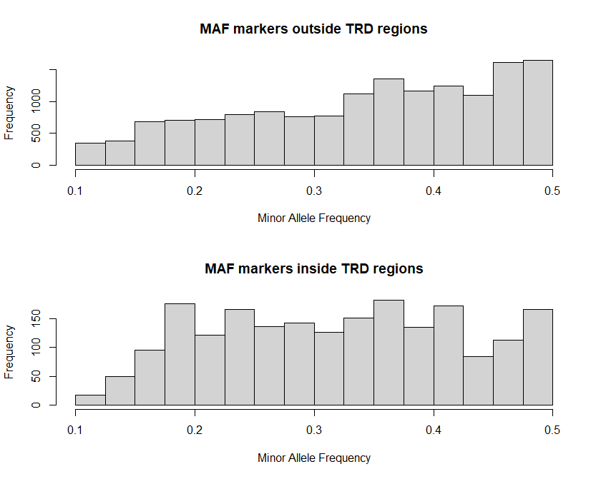
Minor allele frequency comparison of markers inside and outside of TRD regions. We observed that average allele frequencies are slightly but significantly (p_{(wilcox)} < 1x10⁻¹⁶) reduced for markers inside TRD regions (0.319) compared to markers outside of TRD regions (0.342)

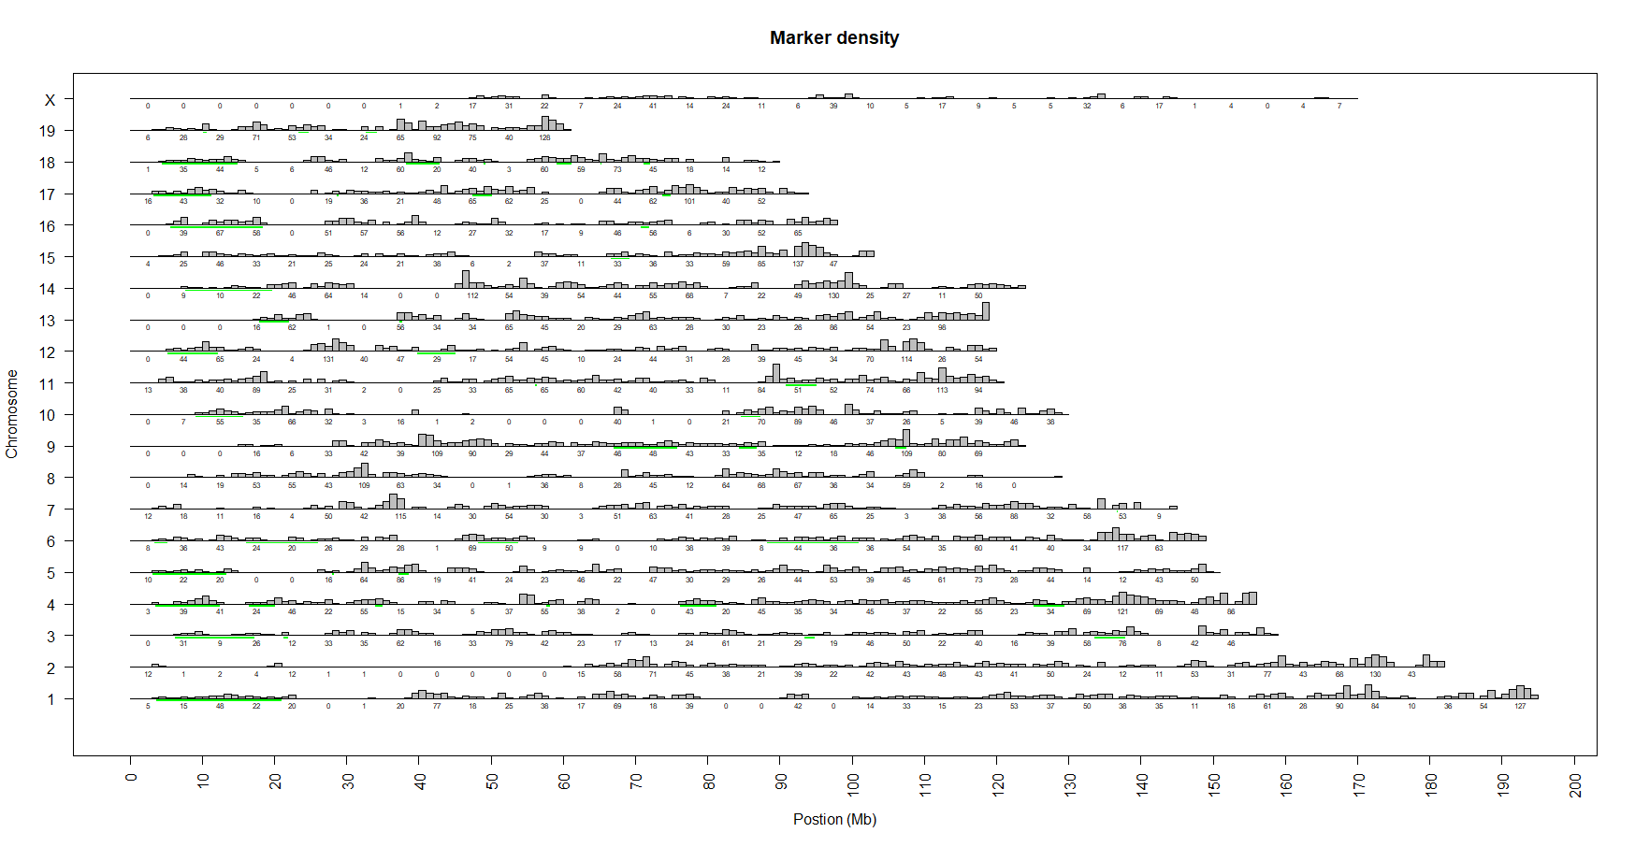
SNP marker density of SNPs at which TRD testing is possible across the genome using a window of 500kb, every 5 Mb, starting at 2.5 Mb the number of SNP markers in a 5Mb window is shown underneath. Green regions are regions for which TRD was detected.

