Appendix S2: Life stage-specific expression patterns
These plots show gene expression patterns across embryonic and larval life stages for each of the 20 essential genes of interest identified in this study. The data originate from RNA-seq experiments from the modENCODE project (Hillier et al. 2009; Gerstein et al. 2010, 2014; Boeck et al. 2016) and the figures were retrieved from GExplore (genome.sfu.ca/gexplore; Hutter et al. 2009; Hutter and Suh 2016). Short descriptions of the gene expression patterns indicate genes with characteristic maternal gene expression (high expression in the early embryo and hermaphrodite gonad), zygotic expression (additional peaks of gene expression at developmental time points other than the maternal ones), and high expression in males.

Figure S2.1 atg-7  Early zygotic expression.  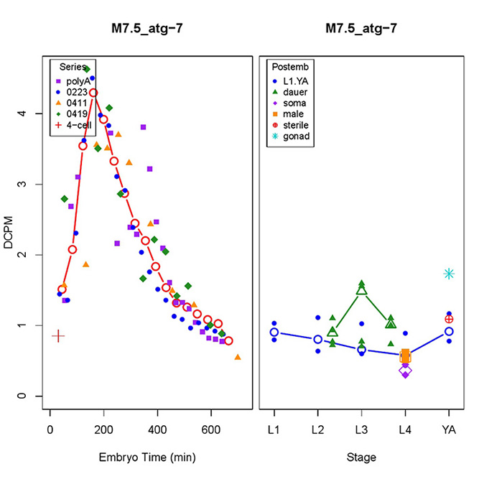 |  | Figure S2.2 bckd-1A  Characteristic maternal, zygotic, and male expression.  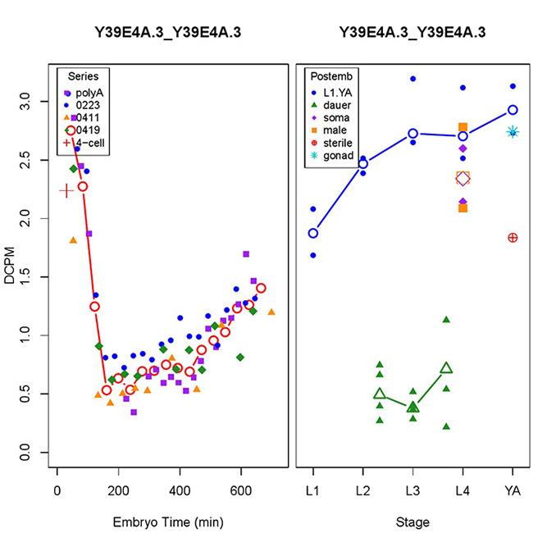
Figure S2.3 C34D4.4  Characteristic maternal and some male expression.  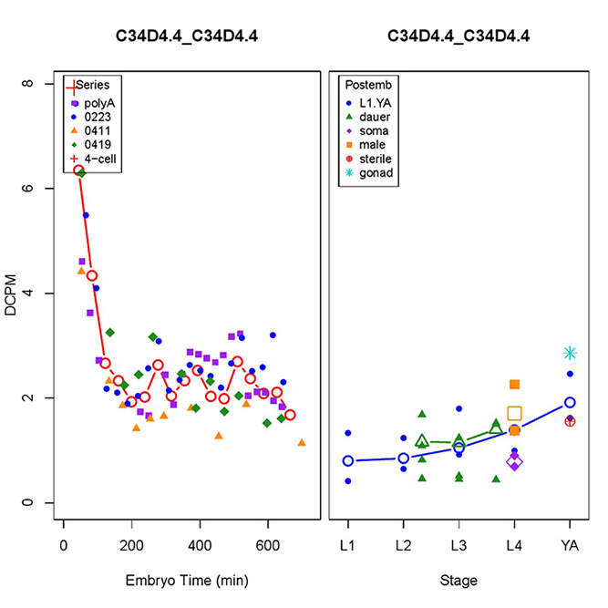 |  | Figure S2.4 C56A3.8  Characteristic maternal and high male expression.  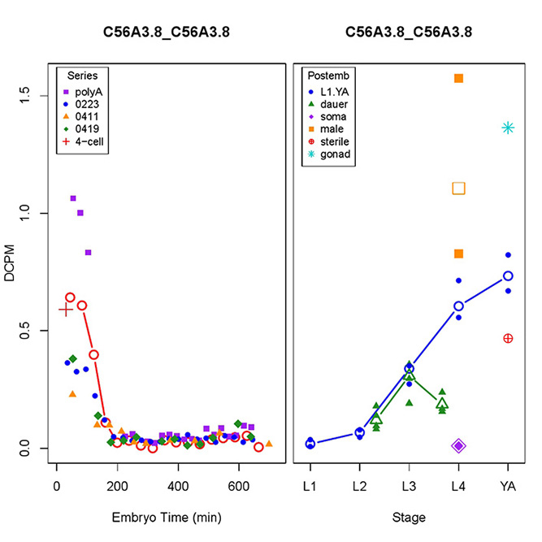
Figure S2.5 cept-2  Characteristic maternal expression.  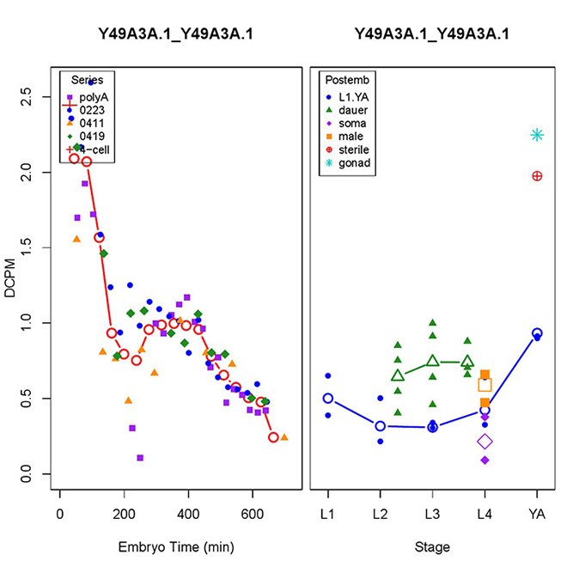 |  | Figure S2.6 cls-2  Characteristic maternal and zygotic expression.  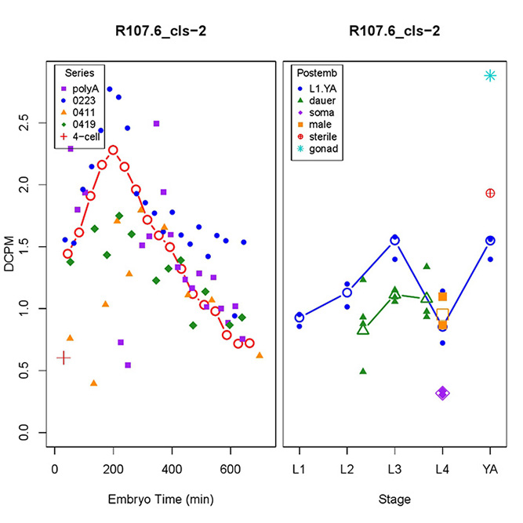
Figure S2.7 cpt-2  Characteristic maternal and zygotic as well as some male expression.  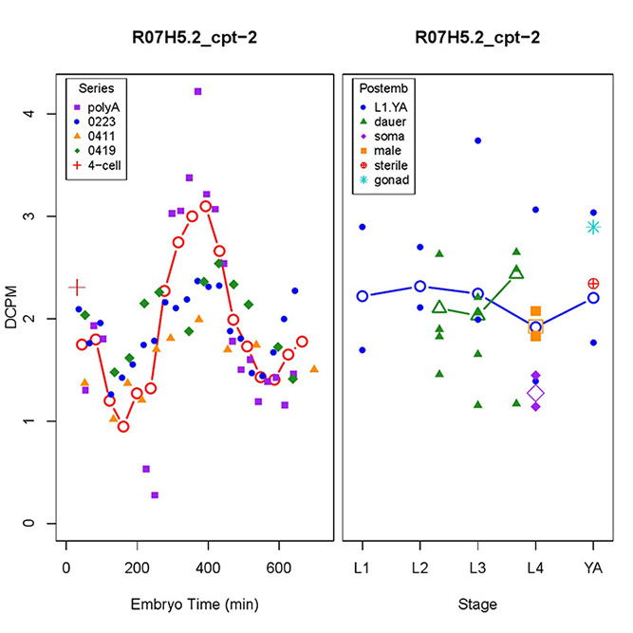 |  | Figure S2.8 D2096.12  Characteristic maternal expression.  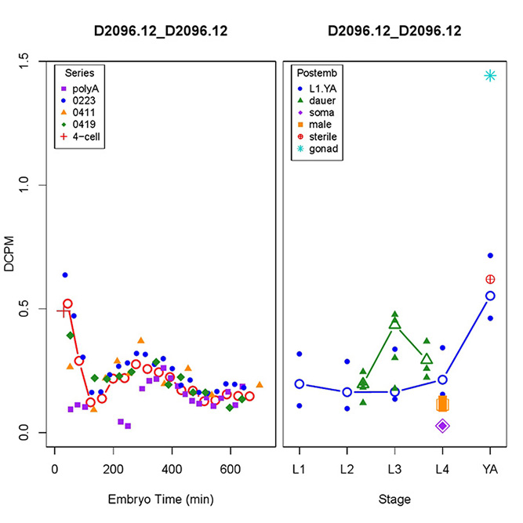
Figure S2.9 dgtr-1  Characteristic maternal expression.  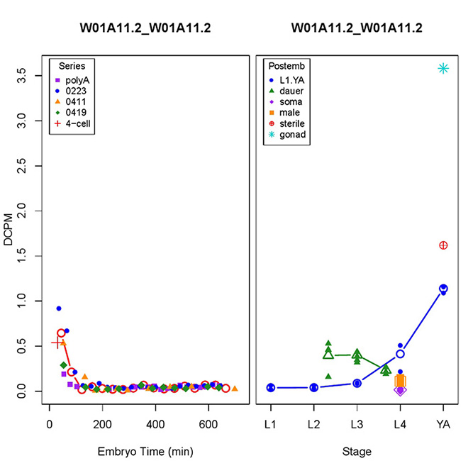 |  | Figure S2.10 dlat-1  Characteristic maternal and zygotic as well as some male expression.  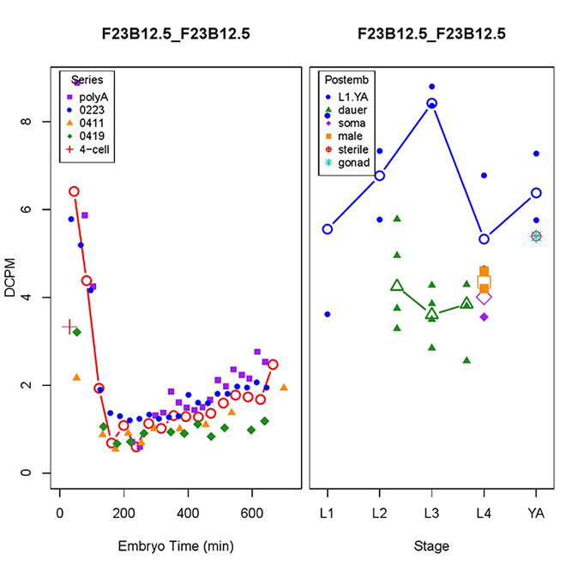
Figure S2.11 F21D5.1  Characteristic maternal expression.  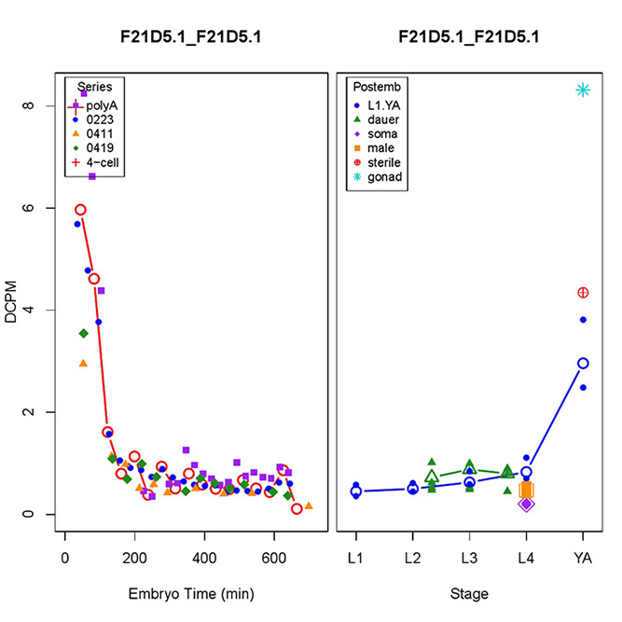 |  | Figure S2.12 F56D5.2  High expression in males.  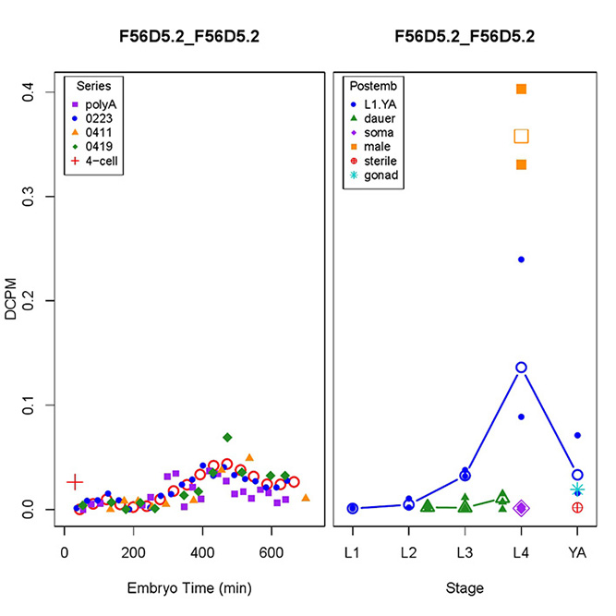
Figure S2.13 nstp-2  High expression in males and zygotic expression.  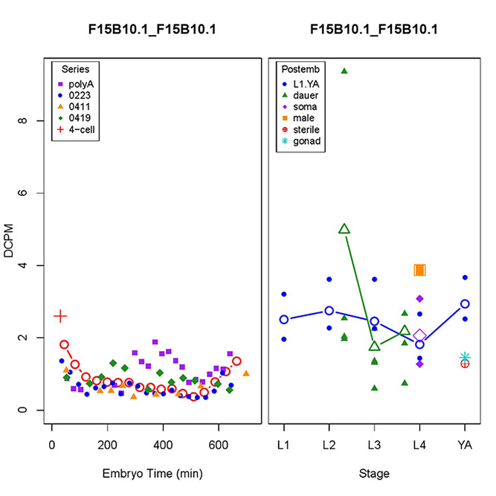 |  | Figure S2.14 perm-5  Characteristic maternal and zygotic expression.  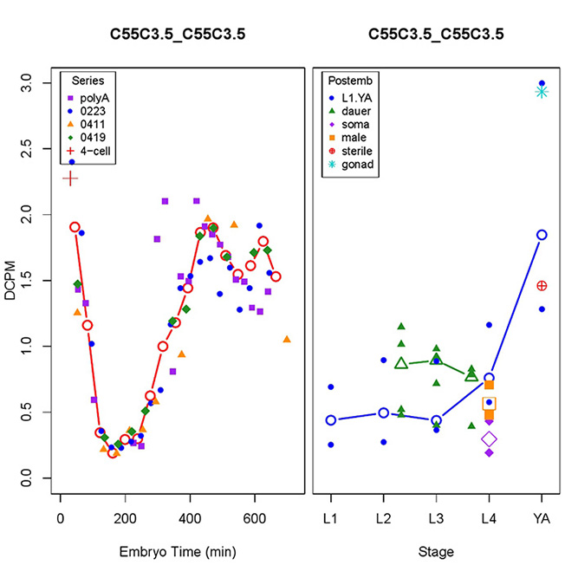
Figure S2.15 T22B11.1  High expression in males.  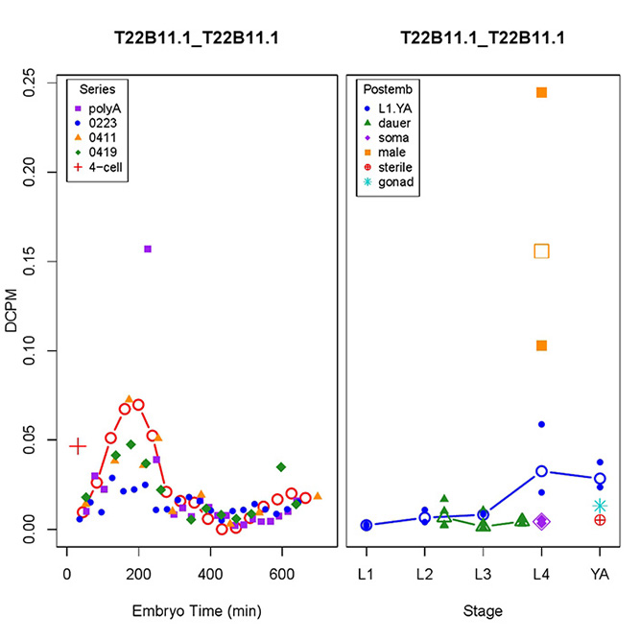 |  | Figure S2.16 top-3  Characteristic maternal expression.  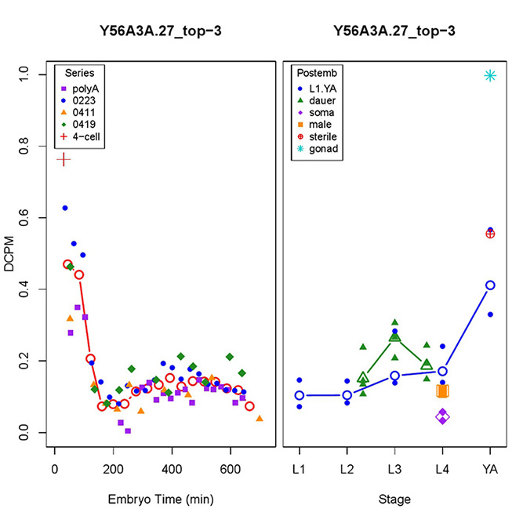
Figure S2.17 trcs-1  Characteristic maternal expression.  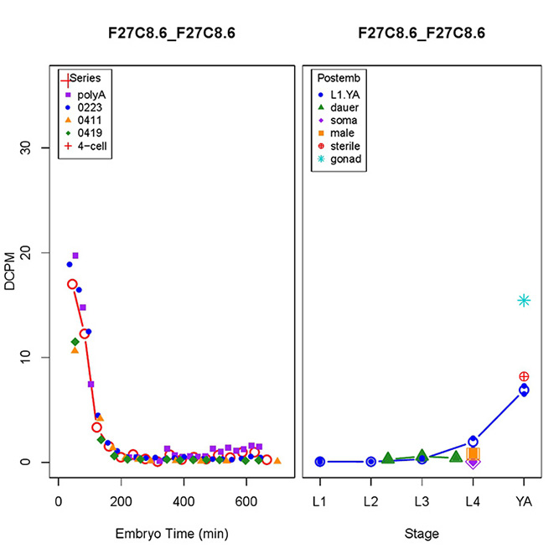 |  | Figure S2.19 ZK688.9  Characteristic maternal expression.  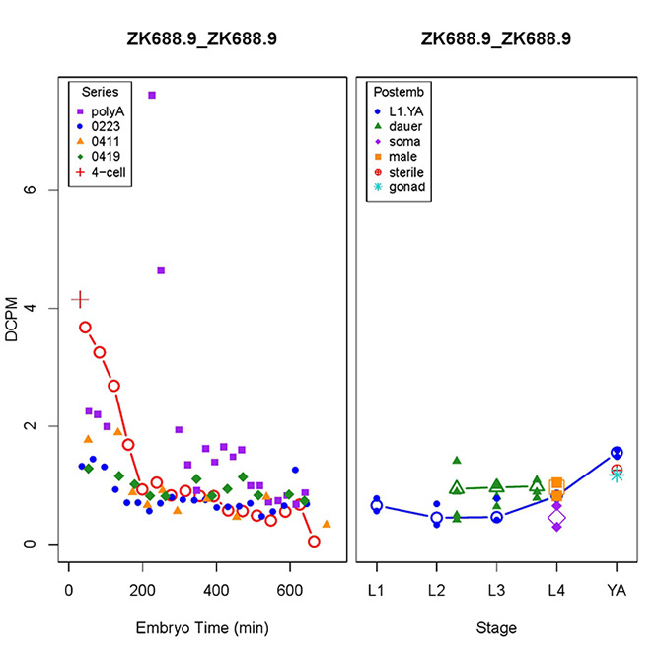
Figure S2.18 Y54G2A.73 (Figure from wormbase.org; not available from GExplore)
High expression in males.

