Frazee, LJ, J Rifkin, DC Maheepala, A-G Grant, S Wright, S Kalisz, A Litt, and RB Spigler. (2021) New genomic resources and comparative analyses reveal differences in floral gene expression in selfing and outcrossing Collinsia sister species. G3: Genes, Genetics, Genomes

Supplementary Figures [pp. 2-7]

Figure S1 Flower size and shape differ between sister species. (a) Collinsia rattanii and (b) C. linearis.

Figure S2 Excerpts from the de novo genome sequencing and assembly draft report for Collinsia rattanii, created 25 June 2017 by Dovetail Genomics (Santa Cruz, CA, USA).

Figure S3 Photos of dissected flower buds of Collinsia rattanii and C. linearis illustrating the three bud stages occurring prior to anthesis.

Figure S4 Whole-genome Hi-C chromatin contact matrix for Collinsia rattanii, with seven sub-matrices, bounded by blue lines, representing the seven chromosomes

Figure S5 Venn diagram showing intersection of gene sets resulting from all analyses.

Figure S6 Collinsia rattanii and C. linearis expression profiles for 27 contrast effect genes related to GO of interest and showing significant changes in expression.

Supplementary Tables [pp. 8-13]

Table S1 Eighteen whole bud RNAseq.fastq file sample names and experimental design.

Table S2 FastQC and mapping results for RNAseq.

Table S3 REVIGO reduction and qualification of gene ontology enrichment analysis results for ‘interaction’ effect gene set of 855 genes.

Table S4 REVIGO reduction and qualification of gene ontology enrichment analysis results for the 569 contrast effect genes.

Table S5 REVIGO reduction and qualification of gene ontology enrichment analysis results for the 1,022 shared pattern DEGs.

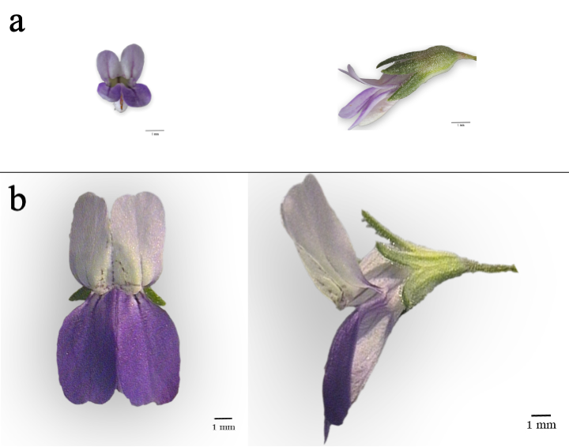

Figure S1 Flower size and shape differ between sister species. (a) Collinsia rattanii and (b) C. linearis. Relative size differences between species are drawn to scale; all scale bars (1 mm) are the same actual length. (a) C. rattanii has a 4-8 mm long corolla (purple and white) that is < 2 times as long as the calyx (green). (b) C. linearis has an 8-15 mm long corolla that is > 2 times as long as the calyx; the upper tubular part of the corolla and the calyx also meet one another at an angle (Jepson Flora Project 2020). Photos by Thomas Harper. See Figure 2 in Kalisz et al. (2012) for reproductive organ positions.

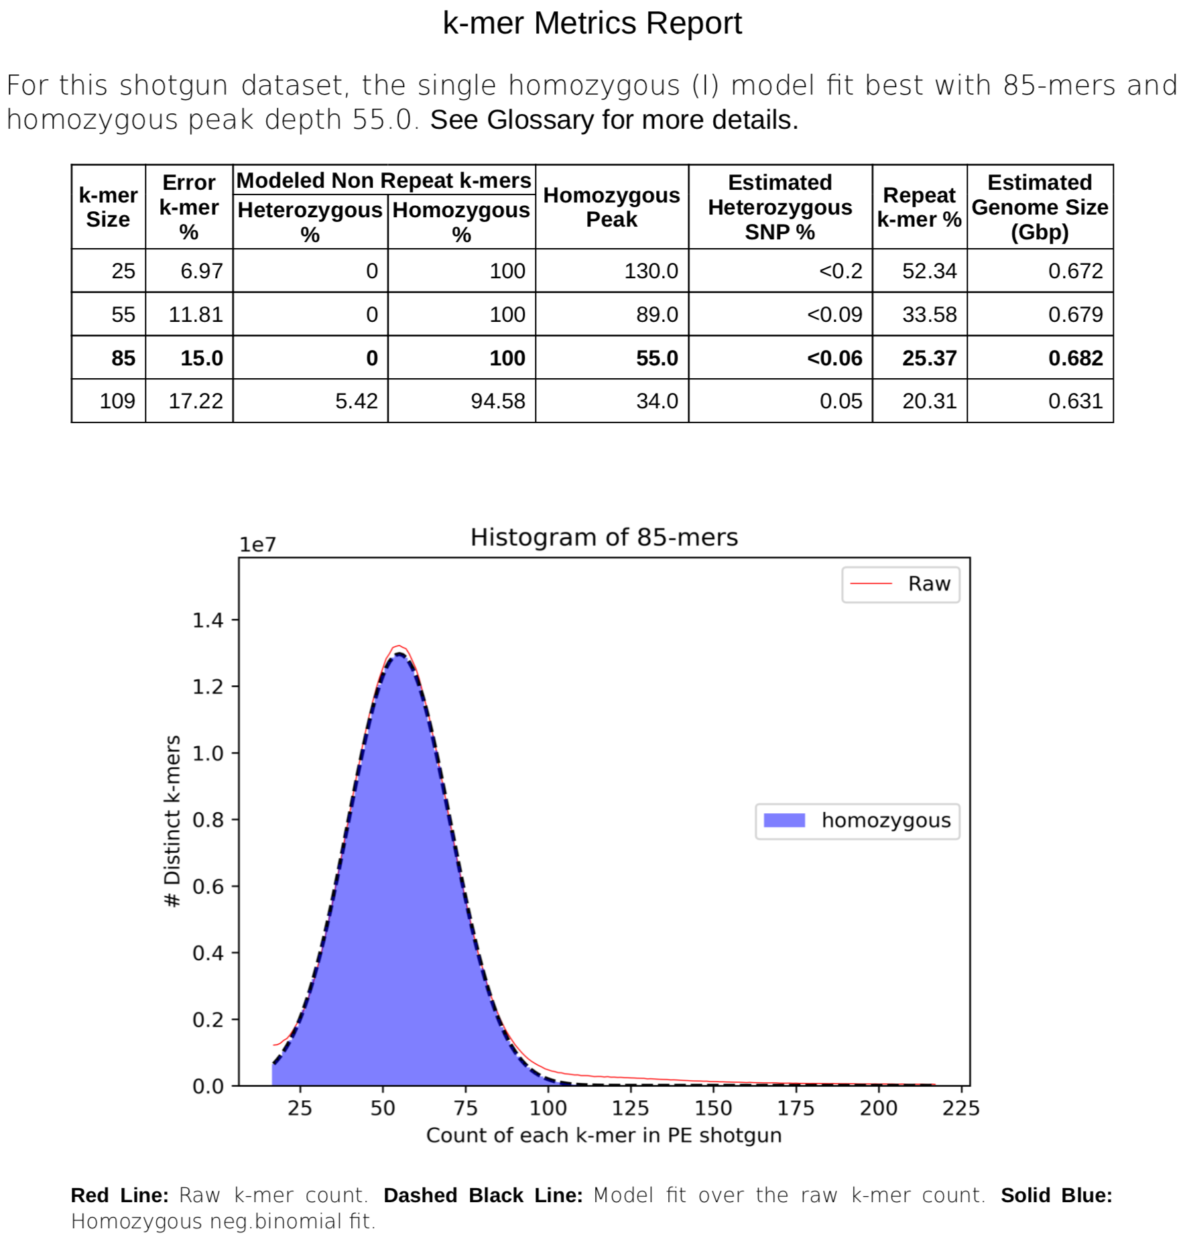
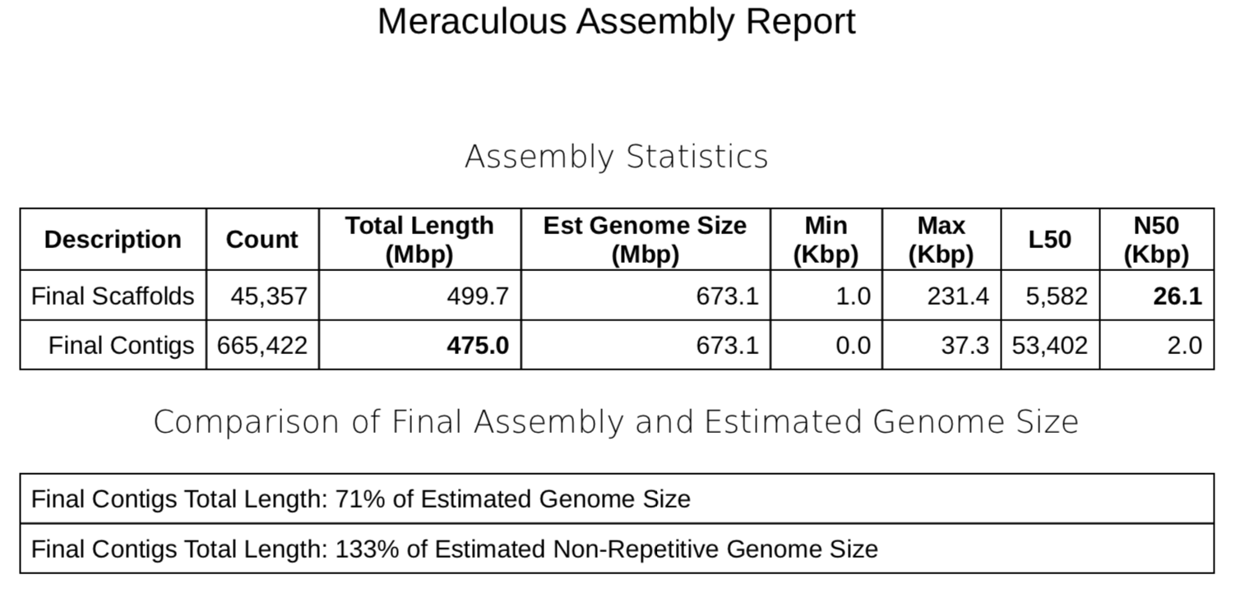

Figure S2 Excerpts from the de novo genome sequencing and assembly draft report for Collinsia rattanii, created 25 June 2017 by Dovetail Genomics (Santa Cruz, CA, USA).
Figure S3 Photos of dissected flower buds of Collinsia rattanii (top panel) and C. linearis (bottom panel) illustrating the three bud stages occurring prior to anthesis (left to right: B1, B2, B3) selected for the transcriptome analyses (see Table 2 in main paper). The photos show only a partial view, with petals separated as needed during dissection to reveal floral organs. Note different scale bars on each photo.

Figure S4 Whole-genome Hi-C chromatin contact matrix for Collinsia rattanii, with seven sub-matrices, bounded by blue lines, representing the seven chromosomes (by Phase Genomics). The full length of the chromosome-level genome assembly (~506Mb) is represented along both the vertical and horizontal axes (1 pixel = 1Mb). The intensity of the color of each pixel within the matrix indicates the frequency with which reads from those genomic regions were found in close proximity in the nucleus (red = highest frequency; white = lowest frequency).

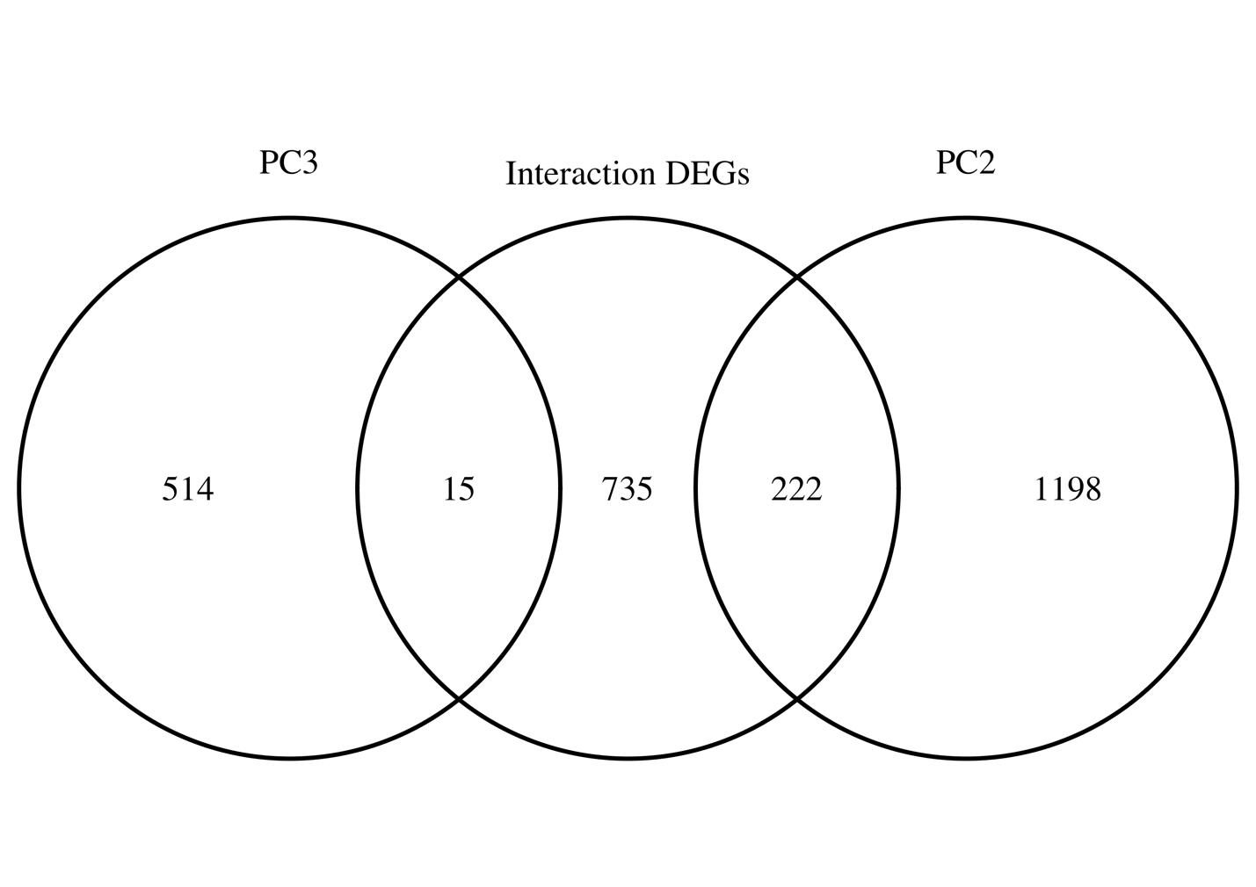

Figure S5 Venn diagram showing intersection of gene sets resulting from all analyses.
The gene sets analyzed in this paper are largely distinct in gene composition. PC2 = genes correlated (r > 0.7) with principal component 2 (Figure 3). PC3 = genes correlated (r > 0.7) with principal component 3 (Figure 3). Interaction DEGs = union of contrast and interaction effect gene sets.
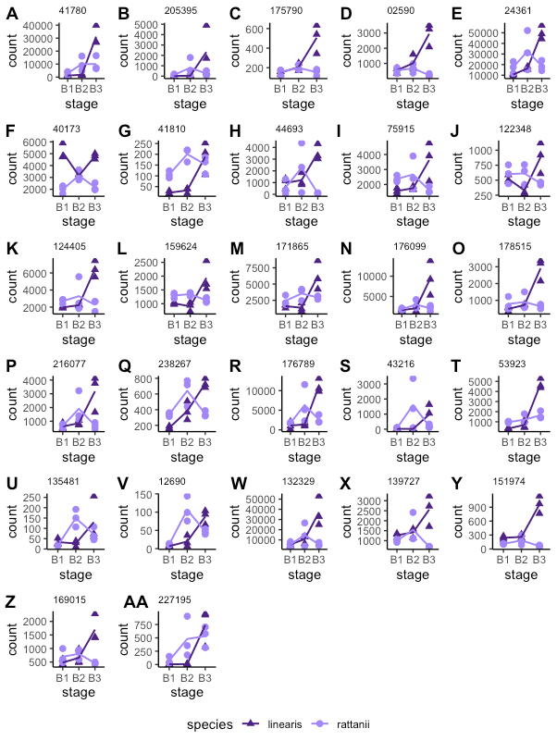
Figure S6 Collinsia rattanii and C. linearis expression profiles for 27 contrast effect genes showing significant changes in expression during late floral development (LD) that are also associated with the GO terms for xyloglucan metabolism (plots A-B), transcription (plot C), glycerol-3-phosphate catabolism (plot D), regulation of transcription (plots E-S), and lipid metabolism (plots T-AA). Counts (shown as points) are RNA-seq read counts as modeled in DESeq2; lines are species-specific count means. Each plot represents one gene’s full expression profile as compared between species; gene identification numbers are the title of each plot.

Table S1: Eighteen whole bud RNAseq.fastq file sample names and experimental design. N=3 for each species-stage combination.
 | Species | Stage | Plant | File name prefix
1 | Collinsia rattanii | 1 | 1 | rat1-1
2 | Collinsia rattanii | 1 | 2 | rat1-2
3 | Collinsia rattanii | 1 | 3 | rat1-3
4 | Collinsia rattanii | 2 | 1 | rat2-1
5 | Collinsia rattanii | 2 | 2 | rat2-2
6 | Collinsia rattanii | 2 | 3 | rat2-3
7 | Collinsia rattanii | 3 | 1 | rat3-1
8 | Collinsia rattanii | 3 | 2 | rat3-2
9 | Collinsia rattanii | 3 | 3 | rat3-3
10 | Collinsia linearis | 1 | 1 | lin1-1
11 | Collinsia linearis | 1 | 2 | lin1-2
12 | Collinsia linearis | 1 | 3 | lin1-3
13 | Collinsia linearis | 2 | 1 | lin2-1
14 | Collinsia linearis | 2 | 2 | lin2-2
15 | Collinsia linearis | 2 | 3 | lin2-3
16 | Collinsia linearis | 3 | 1 | lin3-1
17 | Collinsia linearis | 3 | 2 | lin3-2
18 | Collinsia linearis | 3 | 3 | lin3-3

Table S2: FastQC and mapping results for RNAseq.
Sample (species, bud stage-plant) | Total  sequences | Poor quality sequences | Sequence length | % GC | % Uniquely mapped sequences
rat1-1 | 40,869,018 | 0 | 125 | 42 | 83.80
rat1-2 | 39,258,484 | 0 | 125 | 42 | 84.74
rat1-3 | 36,638,654 | 0 | 125 | 42 | 86.88
rat2-1 | 35,064,631 | 0 | 125 | 42 | 82.52
rat2-2 | 40,704,682 | 0 | 125 | 42 | 84.01
rat2-3 | 42,756,521 | 0 | 125 | 42 | 84.75
rat3-1 | 38,579,677 | 0 | 125 | 42 | 80.93
rat3-2 | 29,995,619 | 0 | 125 | 42 | 85.96
rat3-3 | 38,387,132 | 0 | 125 | 42 | 80.15
lin1-1 | 38,408,814 | 0 | 125 | 42 | 84.86
lin1-2 | 38,893,560 | 0 | 125 | 42 | 83.97
lin1-3 | 27,247,795 | 0 | 125 | 42 | 87.60
lin2-1 | 47,940,579 | 0 | 125 | 41 | 87.09
lin2-2 | 41,344,735 | 0 | 125 | 42, 41** | 82.97
lin2-3 | 41,216,357 | 0 | 125 | 42, 41** | 84.48
lin3-1 | 31,629,936 | 0 | 125 | 42 | 82.10
lin3-2 | 38,028,987 | 0 | 125 | 42, 41** | 87.28
lin3-3 | 33,940,662 | 0 | 125 | 42 | 81.29
**R1 and R2, respectively, differed in % GC

Table S3: REVIGO (Supek et al. 2011) reduction and qualification of gene ontology enrichment analysis results for ‘interaction’ effect gene set of 855 genes. Significance (P < 0.01) determined via the Fisher statistic. REVIGO (http://revigo.irb.hr/) settings: Small (0.5) semantic similarity threshold; Database Arabidopsis thaliana; Semantic similarity measure SimRel. Frequency = proportion of term in the A. thaliana protein annotation database. Uniqueness = high values indicate that the term is an outlier; calculated as (1-[average semantic similarity of a term to all other terms]). Dispensability = semantic similarity value for the term, at which redundancy for the term was determined or not, based on chosen threshold (Supek et al. 2011). Redundant GO categories are indented and presented in gray font.
term ID |  | description | frequency | redundant? | log₁₀ p-value | uniqueness | dispensability
GO:0002237 |  | response to molecule of bacterial origin | 0.12% |  | -2.4685 | 0.81 | 0
GO:0010584 |  | pollen exine formation | 0.12% |  | -5.699 | 0.5 | 0
 | GO:0080110 | sporopollenin biosynthetic process | 0.03% | Y | -2.4685 | 0.46 | 0.86
 | GO:0052543 | callose deposition in cell wall | 0.12% | Y | -2.1805 | 0.54 | 0.53
GO:0010411 |  | xyloglucan metabolic process | 0.26% |  | -2.5086 | 0.58 | 0.03
GO:0046168 |  | glycerol-3-phosphate catabolic process | 0.02% |  | -2.4685 | 0.74 | 0.06
GO:0032196 |  | transposition | 0.01% |  | -2.4685 | 0.69 | 0.14
GO:0010366 |  | negative regulation of ethylene biosynthetic process | 0.02% |  | -2.4685 | 0.58 | 0.15
GO:0006629 |  | lipid metabolic process | 4.68% |  | -2.0757 | 0.64 | 0.24
GO:0006355 |  | regulation of transcription, DNA-templated | 11.23% |  | -2.4685 | 0.62 | 0.34
GO:0046373 |  | L-arabinose metabolic process | 0.01% |  | -2.1805 | 0.61 | 0.39

Table S4: REVIGO (Supek et al. 2011) reduction and qualification of gene ontology enrichment analysis results for the 569 contrast effect genes. Significance (P < 0.01) determined via the Fisher statistic. REVIGO (http://revigo.irb.hr/) settings: Small (0.5) similarity; Database Arabidopsis thaliana; Semantic similarity measure SimRel. Frequency = proportion of term in the A. thaliana protein annotation database. Uniqueness = high values indicate that the term is an outlier; calculated as (1-[average semantic similarity of a term to all other terms]). Dispensability = semantic similarity value for the term, at which redundancy for the term was determined or not, based on chosen threshold (Supek et al. 2011). Redundant GO categories are indented and presented in gray font.
term ID |  | description | frequency | redundant? | log₁₀ p-value | uniqueness | dispensability
GO:0010584 |  | pollen exine formation | 0.12% |  | -6.8861 | 0.3 | 0
 | GO:0080110 | sporopollenin biosynthetic process | 0.03% | Y | -2.8861 | 0.3 | 0.86
GO:0046835 |  | carbohydrate phosphorylation | 0.14% |  | -2.0809 | 0.58 | 0.03
GO:0032012 |  | regulation of ARF protein signal transduction | 0.04% |  | -2.1938 | 0.55 | 0.07
GO:0032196 |  | transposition | 0.01% |  | -2.8861 | 0.49 | 0.14
GO:0016123 |  | xanthophyll biosynthetic process | 0.04% |  | -2.1938 | 0.48 | 0.15

Table S5: REVIGO (Supek et al. 2011) reduction and qualification of gene ontology enrichment analysis results for the 1,022 shared pattern DEGs. Significance (P < 0.01) determined via the Fisher statistic. REVIGO (http://revigo.irb.hr/) settings: Small (0.5) similarity; Database Arabidopsis thaliana; Semantic similarity measure SimRel. Frequency = proportion of term in the A. thaliana protein annotation database. Uniqueness = high values indicate that the term is an outlier; calculated as (1-[average semantic similarity of a term to all other terms]). Dispensability = semantic similarity value for the term, at which redundancy for the term was determined or not, based on chosen threshold (Supek et al. 2011). Redundant GO categories are indented and presented in gray font.
term ID |  | description | frequency | redundant? | log₁₀ p-value | uniqueness | dispensability
GO:0007018 |  | microtubule-based movement | 0.281 % |  | -6.6990 | 0.69 | 0.00
 | GO:0060236 | regulation of mitotic spindle organization | 0.043 % | Y | -5.0000 | 0.59 | 0.69
GO:0009733 |  | response to auxin | 1.709 % |  | -2.8665 | 0.83 | 0.00
GO:0045490 |  | pectin catabolic process | 0.423 % |  | -2.5638 | 0.77 | 0.00
GO:0000103 |  | sulfate assimilation | 0.060 % |  | -2.0809 | 0.94 | 0.04
GO:0042545 |  | cell wall modification | 0.561 % |  | -2.6676 | 0.77 | 0.04
GO:0009942 |  | longitudinal axis specification | 0.039 % |  | -3.2840 | 0.69 | 0.07
GO:0003333 |  | amino acid transmembrane transport | 0.337 % |  | -3.5086 | 0.80 | 0.09
GO:0032147 |  | activation of protein kinase activity | 0.134 % |  | -2.3546 | 0.75 | 0.10
GO:0071249 |  | cellular response to nitrate | 0.017 % |  | -2.2644 | 0.79 | 0.29
GO:0007142 |  | male meiosis II | 0.004 % |  | -2.3706 | 0.62 | 0.30
GO:0048441 |  | petal development | 0.065 % |  | -2.8386 | 0.70 | 0.38
GO:0006355 |  | regulation of transcription, DNA-templated | 11.234 % |  | -4.9586 | 0.73 | 0.39
GO:0042744 |  | hydrogen peroxide catabolic process | 0.380 % |  | -2.3098 | 0.76 | 0.42
GO:0009835 |  | fruit ripening | 0.043 % |  | -2.2644 | 0.69 | 0.46

