Supplemental Material

Tables

Table S1. Primers used in this study
Primer Number | Sequence | Description
UK9789 | ACCTTGAATTCCGTACGCTGCAGGTCGAC | natNT2
UK9790 | ACCTTGAATTCATCGATGAATTCGAGCTCG | natNT2
UG5953 | TCTAAGCTTCGGACGATTGCCAACCGCCGAA | SUP17
VB2609 | TCTAAGCTTCGCGGAAATTAGCACGGCCTC | SUP17

Table S2. Number of peptides identified in mass spectrometry-based analysis of mistranslation rates.
Strain | Mistranslation Type | Replicate | # peptides containing WT residue | # peptides with mistranslated residue | % mistranslated  peptides
CY8611 | Pro→Ala | 1 | 9664 | 23 | 0.24
(Control) |  | 2 | 8866 | 19 | 0.21
 |  | 3 | 9438 | 27 | 0.29
 |  | 4 | 7747 | 24 | 0.31
 |  | 5 | 7653 | 15 | 0.20
CY8612 | Pro→Ala | 1 | 9540 | 312 | 3.27
(tRNA^{Pro}_{G3:U70}) |  | 2 | 9790 | 341 | 3.48
 |  | 3 | 9070 | 287 | 3.16
 |  | 4 | 6879 | 200 | 2.91
 |  | 5 | 6729 | 185 | 2.75
CY8614 | Pro→Ala | 1 | 7787 | 15 | 0.19
(tRNA^{Ser}_{UCU, G26A}) |  | 2 | 7626 | 18 | 0.24
 |  | 3 | 7687 | 20 | 0.26
 |  | 4 | 7290 | 9 | 0.12
 |  | 5 | 6496 | 10 | 0.15
CY8611 | Arg→Ser | 1 | 7184 | 12 | 0.17
(Control) |  | 2 | 5991 | 5 | 0.08
 |  | 3 | 6686 | 15 | 0.22
 |  | 4 | 5084 | 8 | 0.16
 |  | 5 | 4930 | 9 | 0.18
CY8612 | Arg→Ser | 1 | 7185 | 13 | 0.18
(tRNA^{Pro}_{G3:U70}) |  | 2 | 7471 | 8 | 0.11
 |  | 3 | 6699 | 6 | 0.09
 |  | 4 | 4135 | 6 | 0.14
 |  | 5 | 4007 | 8 | 0.20
CY8614 | Arg→Ser | 1 | 5142 | 158 | 3.07
(tRNA^{Ser}_{UCU, G26A}) |  | 2 | 4894 | 149 | 3.04
 |  | 3 | 5005 | 157 | 3.14
 |  | 4 | 5053 | 127 | 2.51
 |  | 5 | 4009 | 129 | 3.22

Table S3. Percent of arginine and proline content in the RNA processing and transport genes identified to have negative genetic interactions with tRNA^{Ser}_{UCU, G26A} or tRNA^{Pro}_{G3:U70.}

Protein | Arginine  Content | Proline  Content
Sen1 | 4.93 | 4.84
Sad1 | 3.79 | 4.24
Sof1 | 7.77 | 2.86
Rna1 | 2.46 | 2.70
Crm1 | 3.51 | 3.23
Fip1 | 3.36 | 8.26
Nop2 | 5.34 | 4.37
Cus1 | 5.73 | 5.05
Rpr1 | 5.76 | 2.52
Rpr4 | 5.57 | 3.06
Prp3 | 7.46 | 4.26
Prp18 | 4.78 | 4.78
Prp4 | 5.59 | 2.37
Srm1 | 3.94 | 4.77
Pwp1  Snm1 | 3.13  3.54 | 3.47  3.54
Whole Genome | 4.42 | 4.39

Figures

GCGGCCGC ATCGCGAAAA TTCATGTCAT GTCCACATTA ACATCATTGC AGAGCAACAA TTCATTTTCA TAGAGAAATT TGCTACTATC ACCCACTAGT ACTACCATTG GTACCTACTA CTTTGAATTG TACTACCGCT GGGCGTTATT AGGTGTGAAA CCACGAAAAG TTCACCATAA CTTCGAATAA AGTCGCGGAA AAAAGTAAAC AAGCTTATAT GAATTCATGC TTTCTG AAAACACGAC TATTCTGATG GCTAACGGTG AAATTAAAGA CATCGCAAAC GTCACGGCTA ACTCTTACGT TATGTGCGCA GATGGCTCCG CTGCCCGCGT CATAAATGTC ACACAGGGCT ATCAGAAAAT CTATAATATA CAGCAAAAAA CCAAACACAG AGCTTTTGAA GGTGAACCTG GTAGGTTAGA GCGGCCGC

Figure S1. Synthetic HO DNA. Underlined sequences are engineered restriction sites used for cloning. Bold sequence is the start codon of the HO gene.

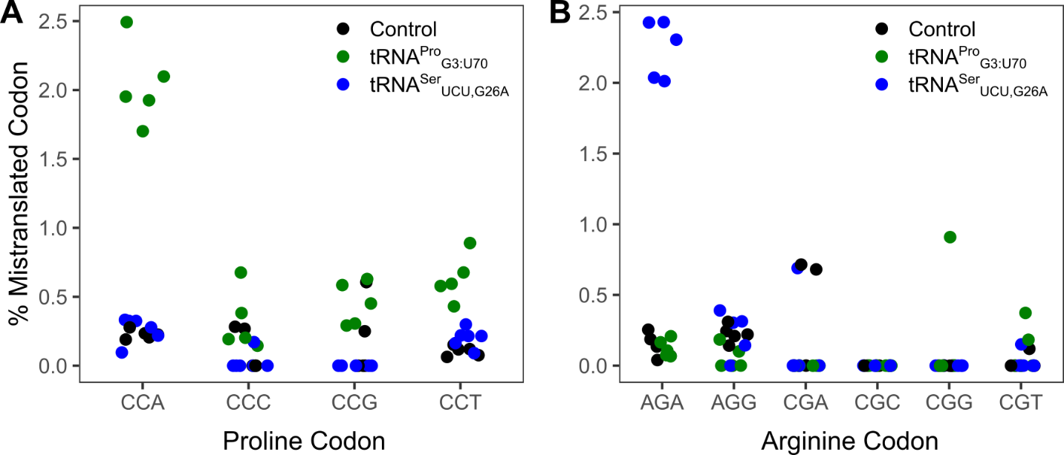

Figure S2. Mass spectrometry analysis of the cellular proteome was performed on a wild-type control strain (CY8611) or strains expressing the mistranslating tRNA tRNA^{Pro}_{G3:U70} (CY8612) or tRNA^{Ser}_{UCU, G26A} (CY8614). Mistranslation of alanine at proline codons (A) or serine at arginine codons (B) at their respective codons.

