Supplementary Figures

Fig S1. Egg-to-adult viability for the ancestral range warm-adapted population (ZI) and the cold-adapted populations (EF, FR and SD) at different temperatures. * indicates the survival is significantly different (p < 0.05). Error bars show the standard error based on three strains.

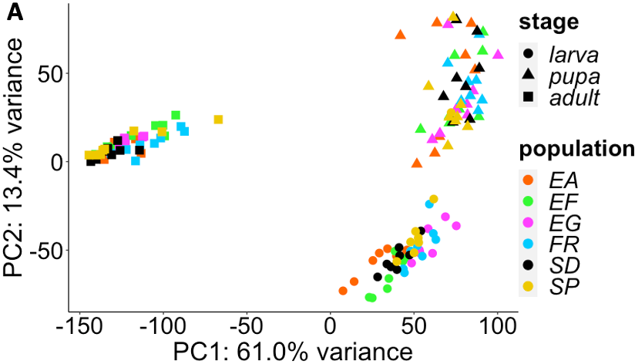

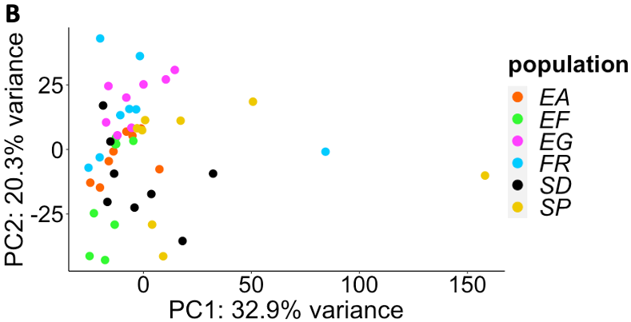
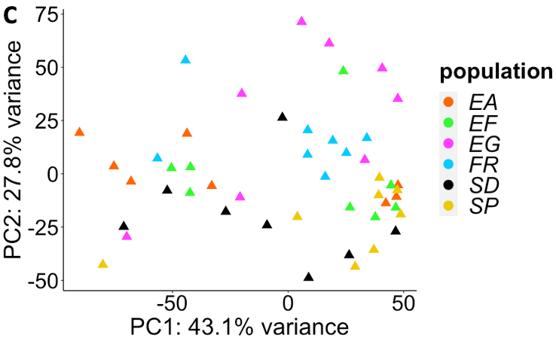

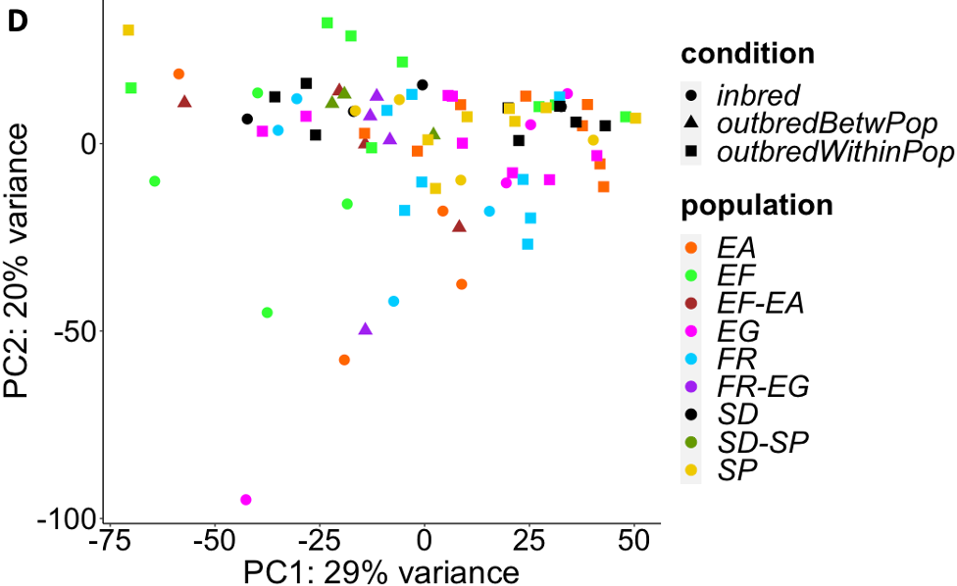

Fig. S2. The PCA plots for transcriptome abundance. (A) The PC1 and PC2 for F1 samples from within-population crosses at three developmental stages. (B) The first two PCs for larva samples. (C) The first two PCs for pupa samples. (D) The first two PCs for adult samples, including F1 from within population crosses, F1 from between population crosses and parental inbred lines.

Fig S3. P_{ST} quantiles based on all crosses (x-axis) versus P_{ST} quantiles based on data excluding extreme samples (y-axis) in different population pairs and developmental stages for expression abundance (A) and intron usage (B).

Fig. S4. The effects of correcting for transcriptome-wide skew are illustrated. Panels show the number of genes for different cold-derived population expression proportion levels at three developmental stages across populations. The orange triangle indicates the number for the uncorrected values and the blue dot indicates the number for the values corrected by mean expression ratio between cold- and warm-derived populations.

Fig. S5. Ethiopian populations were paired with South African counterparts to assess which population was most responsible for ETH transcriptome-wide skew. These comparisons suggest the transcriptome-wide shift in expression for the adult stage in ETH was mainly caused by the EF population while the shift for pupal stage was mainly caused by the EA population. Distributions of the cold-derived population expression proportion for EF-SP comparisons and SD-EA comparisons are shown. For the adult stage, because EF-EA (Fig. S4) and EF-SP comparisons showed the expression shift while SD-SP (Fig. S4) and SD-EA comparison did not, the EF population probably causes the shift for this stage. Similarly, EA is likely to cause the shift observed for the pupal stage.

Fig. S6. Fractions of co-directional gene expression changes between two pairs for the top 2.5% or top 10% P_{ST} outliers identified in one of the pairs. The dashed error bars indicate the 95% confidence interval for the fraction of co-directional expression changes in permuted data. If the real data is outside the range of the error bar, it indicates the fraction is significantly different from random expectation (p < 0.05, two-side test based on permuted distribution).

Fig. S7. Fractions of co-directional intron usage changes in two population pairs for the P_{ST} outliers identified in one of the pairs. The dashed error bar indicates 95% confidence interval for the fraction of co-directional expression changes in permuted data. If the real data is outside the range of the error bar, it indicates the fraction is significantly different from random expectation (p < 0.05, two-side test based on permuted distribution).

Fig. S8. The cis- and trans-effects within each population pair for expression abundance (upper panel) and intron usage (lower panel).

Fig. S9. Trans-regulatory changes show greater parallelism than cis- changes. Here the “parallel” category is the shared outliers with co-directional changes between pairs. The “non-parallel” category includes the shared outliers with anti-directional changes and the non-shared outliers (outliers in only one pair). The fraction of genes with significant cis-/trans-effect in at least one of the two pairs in each category for each comparison is shown. The number above the bar shows the denominator of the fraction. The demonminators are the same for cis-effects and trans-effects. * indicates the fractions are significantly different between P_{ST} outliers and non-outliers (p < 0.005, Fisher's Exact Tests).

Fig S10. Window F_{ST} values (black dots) between the cold- and warm-derived population for the MED, ETH and SAF pairs, across five major chromosome arms. The triangles on top of the plots show the locations of the P_{ST} outliers for larva (orange), pupa (red) and adult (blue).

Supplementary Tables and Legends

Table S1. The inversion information for the lines used in this experiment.

Table S2. The numbers of reads (75bp paired-end) generated for each sample.

Table S3. The egg-to-adult viability for ZI and cold-derived populations in warm and cold environments.

Table S4. The P_{ST} values and the expression values in each population for all genes for different developmental stages in different population pairs.
Table S5. The adjusted P_{ST} quantiles for all intron usages and the genes they belong to for different developmental stages in different population pairs.

Table S11. The Pearson correlation coefficients (upper triangular matrix) of gene expression among eight outbred samples between pairwise outliers for each cold-derived population. The corresponding cells in the lower triangular matrix are the p-values based on random permutations.

Pair | MED |  | ETH |  | SAF
Population | warm | cold | warm | cold | warm | cold
V_{inbred} | 10507 | 6235 | 20863 | 16998 | 6010 | 8656
V_{outbred} | 2482 | 3284 | 2311 | 8256 | 1446 | 9689
P_{ST_inbred} | 0.14 |  | 0.21 |  | 0.10
P_{ST_outbred} | 0.17 |  | 0.11 |  | 0.21
Table S6. Average expression variance among the inbred and outbred samples in warm- and cold-derived populations and the average P_{ST} for the inbred and outbred samples between populations.

2.5% cutoff | larva |  | pupa |  | adult
Population pairs | MED | SAF | MED | SAF | MED | SAF
ETH | 1.7%  (1.7%) | 2.5%  (1.7%) | 3.9%  (1.6%) | 0%  (0.8%) | 2.4%  (1.2%) | 5.9%  (1.2%)
SAF | 5.9%  (1.7%) |  | 0%  (0.8%) |  | 2.9%  (1.2%)

10% cutoff | larva |  | pupa |  | adult
Population pairs | MED | SAF | MED | SAF | MED | SAF
ETH | 5.5%  (5.8%) | 8.7%  (7.0%) | 5.7%  (5.3%) | 3.3% (4.3%) | 5.3%  (4.7%) | 13.1%  (6.2%)
SAF | 11.9%  (6.2%) |  | 0.4%  (4.1%) |  | 10.9%  (5.0%)
Table S7. The percentages of genes with parallel expression abundance changes for the top 2.5% and top 10% P_{ST} cutoff. The random expectation is the median of the permuted proportions (in brackets). The majority of proportions were higher than the expectation, with larva and adult stages showing stronger patterns than the pupa. Those that were significantly different from the random expectation are in bold (permutation test, p < 0.01).

Population pairs | MED |  | ETH |  | SAF
stages | Larva (235) | Pupa (255) | Larva (235) | Pupa (255) | Larva (235) | Pupa (255)
Adult (229) | 0.9%  (1.3%) | 0.3%  (1.3%) | 3.8%  (1.5%) | 0.6% (1.2%) | 1.5%  (1.5%) | 1.2%  (1.8%)
Pupa (255) | 11.4%  (2.7%) |  | 1.6%  (2.4%) |  | 0.4%  (1.2%)
Table S8. The percentages of genes with parallel expression changes between pairwise developmental stages. The numbers of outlier genes used in the comparison are indicated next to the stage names (in brackets). The random expectation is the median of the permuted proportions (in brackets). Those that were significantly different from the random expectation are in bold (permutation test, p < 0.01).

Expression abundance | MED | ETH | SAF
larva | CG14830  Irk1  D1  AMPdeam  Idh3a  ATPsynCF6  Cftr  smash  Ufd4  Hrb87F  CG17841  Ran  Ntf-2  S2P  CG15308  blw  onecut  CG8223  CG1673  UbcE2M | Cds  Tango11  Kap3  Srp54k  ari-1  CG30394  Nrd1  ClpX  Spn43Aa  CG17385  Hph  TMEM216  CG45049  Cftr  mbf1  unc-45  Tbce  cu  Ns2  lqfR | cpa  Best2  yip2  lncRNA:cherub  twr  mus201  Irp-1B  pros  alphaCOP  CG6024  parvin  Hsc70-3  toy  klg  CG6409  Myo61F  msi  Aef1  unc-119  FBgn0015323
pupa | Pex19  Sgt  frac  aru  Ugt50B3  CG2233  kat80  Mondo  Diap2  dbr  CG11902  srl  CG11970  CG9795  Vps13D  chico  IscU  CG5112  Grip163  CG4603 | pdgy  RtGEF  PhKgamma  Herc4  Tsp42Ef  trbd  7SLRNA:CR42652  AcCoAS  lncRNA:CR42862  CG3308  Nhe3  Nak  Nep3  Vinc  galectin  Opa1  CG31064  Diap2  LpR2  CG32486 | CG12268  CG32687  Edg91  Swim  Hayan  Lcp65Ad  cdc14  Jafrac1  CG4615  Bili  dmGlut  fend  ths  cpo  PGRP-LC  Aef1  Prosbeta7  CG6409  Arpc5  Nadsyn
adult | CG14834  Muc12Ea  yellow-g2  Egm  Cp7Fc  CG5989  Tsp96F  CG8034  Fis1  CG10407  yellow-g  CG14615  CG33714  CG33713  CG6724  Nox  CG4009  CG1550  CG2003  slmo | CR42195  CG8818  CG12025  lute  CG7148  CG13907  18SrRNA-Psi:CR45861  stmA  CG42354  mfrn  CR41607  CG3719  CG33199  l(1)G0136  VhaPPA1-1  CG4230  CG11699  jagn  CG30345  CG7120 | DIP-alpha  Iml1  CG7484  Bruce  CG4615  Vps13  JHDM2  CG12991  CG45092  chk  CG7966  lncRNA:CR44779  GstT3  CG32581  CG10939  CG42514  Khc-73  cwo  gammaSnap1  PhKgamma
Intron usage | Med | Eth | SAf
larva | tyf  CG16758  CG10508  chk  Mhc  Ald1  chic  CG11873  Nmda1  wake  wrd  stumps  Cul3  CG8929  Ndae1  tou  Jupiter  His3.3B  Lipringamma  CG18809 | mgl  CG42674  Aldh-III  ena  CG17549  Dab  l(2)gl  Ndf  Pten  Sec31  Samuel  SclB  Ars2  Trxr-1  Saf-B  CG32137  plx  GstT3  Mf  sdk | Fur1  fwe  Dscam1  Synd  Tpi  Eip75B  wge  sals  sfl  Sap47  Arf51F  Btk29A  LRR  Task6  zormin  Usp47  mud  Dab  kmr  bbc
pupa | CG31639  CG31650  ArfGAP1  sws  promL  Pitslre  Sod3  Sf3b3  DIP2  Ucp4A  smog  MFS17  stai  nmo  ATPCL  Cht10  hbs  Gbeta13F  Acsl  B52 | mgl  Hsf  Ube4B  Hnf4  CG40498  gammaCOP  CG14767  Uck  E2f1  mfas  Trim9  Shab  Sec16  Nost  salto  Mical  DOR  CG5877  CG11597  lig | Dgp-1  Rpn13  Rgk3  CG17376  CG34398  Lmpt  Rab14  Pde1c  rl  chb  obst-E  CG42671  CG45081  GLaz  dia  yuri  CG1275  Mlp84B  fwd  vri
adult | whd  wls  Mlc1  Prip  PGRP-LC  Fbl6  bark  NK7.1  CG9812  GramD1B  gwl  Gβ13F  Rb97D  CG17715  cu  Tm1  CG4199  UQCR-11  Chc  mthl10 | CG34148  raw  CG1440  Spn  ATPsynE  lncRNA:CR43144  CG40498  teq  CG11309  cu  CG18135  CG1637  CG32549  Fak  Dab  Sap47  lig  Sclp  mtgo  GLS | CG2911  CkIIβ  Vdup1  Girdin  Pep  CG13921  AnxB9  CG9044  Papss  CG1146  cmb  tzn  Sesn  grp  CG15514  CG17544  mu2  Slik  wnd  dikar
Table S9. Top 20 P_{ST} outliers (showing gene symbols) for each population/stage for expression abundance and for intron usage. The highlighted ones are shared between population pairs.

 | MED | ETH | SAF
Genes expression outliers
larva | 1.envelope  2.mitochondrial inner membrane  3.mitochondrial membrane  4.mitochondrial membrane part  5.mitochondrial part  6.mitochondrial protein complex  7.mitochondrion  8.organelle inner membrane  9.proton-transporting ATP synthase  complex | NA | 1.aminoacyl-tRNA ligase activity  2.extracellular space  3.hydrolase activity,  acting on glycosyl bonds  4.ligase activity, forming  aminoacyl-tRNA  and related compounds  5.microtubule associated complex
pupa | 1.ATP metabolic process  2.ATP synthesis coupled electron  transport  3.cellular respiration  4.cytosolic large ribosomal subunit  5.electron carrier activity  6.lectron transport chain  7.energy derivation by oxidation of  organic compounds  8.glycosyl compound metabolic process  9.inner mitochondrial membrane  protein complex  10.large ribosomal subunit  11.mitochondrial ATP synthesis  coupled electron transport  12.mitochondrial envelope  13.mitochondrial inner membrane  14.mitochondrial membrane  15.mitochondrial protein complex  16.mitochondrial respiratory chain  17.mitochondrion  18.negative regulation of developmental  process  19.nucleoside metabolic process  20.nucleoside triphosphate metabolic  process  21.organelle inner membrane  22.oxidative phosphorylation  23.oxidoreductase complex  24.purine nucleoside metabolic process  25.purine ribonucleoside metabolic  process  26. respiratory chain  27.respiratory chain complex  28.respiratory electron transport chain  29.ribosome  30. ribonucleotide metabolic process | 1.cellular chemical homeostasis  2.cellular homeostasis  3.cellular ion homeostasis  4.coenzyme biosynthetic process  5.cofactor biosynthetic process  6.ion homeostasis  7.monovalent inorganic cation  homeostasis  8.regulation of pH | 1.anion:cation symporter activity  2.endopeptidase activity  3.extracellular matrix  4.extracellular region  5.inorganic anion transmembrane  transporter activity  6.inorganic anion transport  7.peptidase activity  8.proteasome complex  9.proteasome core complex  10.secondary active  transmembrane transporter activity  11.solute:cation symporter activity  12.structural constituent of  chitin-based cuticle  13.structural constituent of cuticle  14.symporter activity  15.threonine-type endopeptidase  activity
adult | 1.anatomical structure formation  involved in morphogenesis  2.cellular component assembly  involved in morphogenesis  3.chorion  4.chorion-containing eggshell formation  5.columnar/cuboidal epithelial cell  differentiation  6.egg coat formation  7.eggshell chorion assembly  8.epithelial cell development  9.external encapsulating structure  10.extracellular matrix assembly  11.fatty acid biosynthetic process  12.glycosyl compound metabolic process  13.lipid particle  14.mitochondrion  15.monocarboxylic acid biosynthetic  process  16.monocarboxylic acid metabolic  process  17.nucleoside metabolic process  18.ovarian follicle cell development  19.oxidation-reduction process  20.purine nucleoside metabolic process  21.pyruvate metabolic process  22.ribonucleoside metabolic process  23.structural molecule activity  24.vitelline membrane formation | 1.ATP hydrolysis coupled  transmembrane transport  2.ATP metabolic process  3.ATP synthesis coupled electron  transport  4.calmodulin binding  5.carbohydrate derivative metabolic  process  6.cell adhesion molecule binding  7.cellular respiration  8.electron transport chain  9.energy coupled proton  transmembrane transport,  against electrochemical gradient  10.energy derivation by oxidation of  organic compounds  11.envelope  12. glycosyl compound metabolic  process  13.hydrogen transport  14.hydrogen-exporting ATPase activity  15.inner mitochondrial membrane  protein complex  16.mitochondrial ATP synthesis  coupled electron transport  17.mitochondrial envelope  18.mitochondrial inner membrane  19.mitochondrial membrane  20.mitochondrial part  21.mitochondrial respiratory chain  22.vacuolar membrane  23.mitochondrion  24.NADH dehydrogenase activity  25.NADH dehydrogenase complex  26.negative regulation of  transmembrane receptor protein serine  /threonine kinase signaling pathway  27.nucleobase-containing small  molecule metabolic process  28.nucleoside metabolic process  29.nucleoside phosphate metabolic  process  30.organelle envelope  31.organelle membrane  32.organophosphate metabolic process  33.oxidation-reduction process  34.oxidative phosphorylation  35.oxidoreductase complex  36.phosphorylation  37.proton transport  38.proton-transporting V-type ATPase  complex  39.purine nucleoside metabolic process  40.purine ribonucleoside metabolic  process  41. respiratory chain  42.respiratory electron transport chain  43.response to oxidative stress  44.ribonucleoside metabolic process  45.ribose phosphate metabolic process | NA
Genes with exon usage outlier
larva | NA | NA | 1. meiotic cell cycle
pupa | NA | NA | NA
adult | NA | NA | NA
Table S10. The significant GO terms for expression and intron usage P_{ST} outliers for different population pairs at three developmental stages. The highlighted GO terms are shared between the MED and ETH pairs.

pair | Intron type | Total tests | Cis only | Trans only | Both co-dir | Both anti-dir | Neither
MED | P_{ST} outliers | 5 | 0 | 0 | 0 | 1 (20%) | 4 (80%)
 | Non-outliers | 57 | 0 | 7 (12%) | 0 | 6 (11%) | 44 (77%)
ETH | P_{ST} outliers | 7 | 1 (14%) | 1 (14%) | 0 | 0 | 5 (71%)
 | Non-outliers | 35 | 3 (9%) | 2 (6%) | 0 | 9 (26%) | 20 (57%)
SAF | P_{ST} outliers | 5 | 1 (20%) | 1 (20%) | 0 | 1 (20%) | 2 (40%)
 | Non-outliers | 76 | 3 (4%) | 6 (8%) | 1 (1%) | 13 (17%) | 51 (67%)
Table S12. Numbers of intron usage traits showing different regulatory effects for P_{ST} outliers and non-outliers. The percentage in parentheses indicates the fraction of introns in each category relative to the total introns in the tests.

SUPPLEMENTARY TEXT:

Simulations to test the resampling based approach for testing cis- and trans-regulatory divergence
For gene expression, we simulated a gene of 500bp with five fully linked informative SNPs; each of them was located randomly in a 100bp interval. Because of the of heterozygosity within our inbred lines (Lack et al. 2015), we simulated two simple situations: 1. All five SNPs were fixed differences between parents; 2. All five SNPs were heterozygous (50% allele frequency) and fully linked in one parent and fixed in the other. Then the expression level of the two parents (E_{c} and E_{w}) was simulated based on different values of r_{F0} (the ratio of the cold parental strain expression to the total expression of both parental strains. r_{F0} = E_{c}’/(E_{c}’+ E_{w}) and average read number using binomial sampling. The read number was set as 200 or 500 for expression; and 20 or 50 for splicing. The r_{F0} was set as 0.6, 0.7 and 0.8 for both expression and splicing. Because the splicing frequency is bounded between 0 and 1, for simplicity, we assume the sum of splicing frequency in cold strain and warm strain is 1. Then from each of those parents, 30 alleles (as in our experimental design) or 300 alleles were randomly sampled to generate 60 or 600 F1. For the parents with a fixed SNP difference, the F1 offspring were always heterozygous (50% allele frequency). For splicing, we simulated an exon-junction region of 100bp with one informative SNP.

Next, we simulated the reads for the F1 offspring and two parental strains based on two simple conditions: the expression/intron usage difference between parents was only due to a cis-effect or only due to a trans-effect. The reads were 75 bp paired reads. For cis-effect only simulations, the effect size of each allele was calculated based on the r_{F0} we set (e.g., if r_{F0}=0.7, the effect size of a T allele is 0.15 and a C allele is 0.55). Then we randomly sampled the reads with different alleles, weighted by the allele frequencies and effect sizes in F1 offspring as well as in the parents (for parents with a fixed SNP difference, the frequency of reads with certain alleles were unaffected by sampling). For trans-effect only simulations, because the expression difference between the parents was due to unlinked background effects, the alleles did not have an effect size. Reads with certain alleles were sampled randomly weighted by their frequencies in F1 offspring and parents. For each of the combinations of r_{F0}, read numbers, F1 individuals and cis/trans-regulatory condition, we generated 1000 simulations.

To test our analysis approach using the simulated data, we mapped the simulated reads to the gene/intron in F1 and parental individuals. For the case of parents with fixed SNP differences, we sampled randomly with replacement for the F1 reads mapped to each gene/intron to calculate the median average allele frequency for all sites p_{F1}’. To account for the measurement uncertainty in F1 expression, we repeated the process 1000 times to get a distribution of p_{F1}’. If the 95% confidence interval of the distribution did not overlap with 0.5, this was deemed a significant cis-effect. For trans-effects, we further accounted for the uncertainty in estimating the expression level in parental strains by sampling reads with a probability based on the proportion of reads for that gene/intron relative to total reads (100,000 reads per sample in the simulation). Using the new level of expression for the parental strains we calculated the updated r_{F0}’. We repeated the sampling and calculation 1000 times. Each time the r_{F0}’ was paired with a p_{F1}’ described above to calculate the difference between them (D’). If a 95% confidence interval of D’ did not overlap with 0, a significant trans-effect was called.

To examine the sensitivity and specificity of the analysis approach, we applied it on our 1000 cis-only simulations and 1000 trans-only simulations. For cis-only simulations, the proportion that did not show a significant cis-effect is the cis false negative rate; the proportion that showed a significant trans-effect is the trans false positive rate. For trans-only simulations, the proportion that did not show a significant trans-effect is the trans false negative rate; the proportion that showed a significant cis-effect is the cis false positive rate. For gene expression, we found the false positive rates were generally < 5%, but the false negative rate was quite high, especially for trans-effects (Table S13). These results suggested that our approach has lower power for trans-effects than cis-effects. Similarly, for splicing, the trans-effects had a higher false negative rate, although it showed a slightly higher false positive rate than the cis-effect and above 5% (Table S14), indicating our approach has different specificity for different traits.

fixed parental SNP difference |  | cis-only simulation |  | trans-only simulation
reads | r_{F0} | False cis negative | False trans positive | False trans negative | False cis positive
200 | 0.6 | 0.44 | 0.002 | 0.956 | 0.024
200 | 0.7 | 0.028 | 0 | 0.359 | 0.027
200 | 0.8 | 0.001 | 0.002 | 0.007 | 0.019
500 | 0.6 | 0.141 | 0.002 | 0.705 | 0.018
500 | 0.7 | 0 | 0.007 | 0.003 | 0.025
500 | 0.8 | 0 | 0.011 | 0 | 0.025
Table S13. The false positive and negative rate for detecting cis- and trans-effect of our method based on the simulated datasets for gene expression.

fixed parental SNP difference |  | cis-only simulation |  | trans-only simulation
reads | r_{F0} | False cis negative | False trans positive | False trans negative | False cis positive
20 | 0.6 | 0.885 | 0.054 | 0.905 | 0.033
20 | 0.7 | 0.575 | 0.061 | 0.764 | 0.036
20 | 0.8 | 0.047 | 0.101 | 0.485 | 0.045
50 | 0.6 | 0.760 | 0.066 | 0.834 | 0.034
50 | 0.7 | 0.251 | 0.063 | 0.511 | 0.054
50 | 0.8 | 0.023 | 0.090 | 0.177 | 0.042
Table S14. The false positive and negative rates for detecting cis- and trans-effects of our method based on the simulated datasets for splicing.

To generalize our approach to using heterozygous informative SNPs, we used a parental ancestry proportion statistic (f) to study allele-specific expression. The parental proportion in gene expression level/intron usage in the F1 RNA-seq sample was estimated as
f = (p_{F1} – p_{w})/(p_{c} – p_{w})
where p_{F1} is the allele frequency in the RNA reads for the F1 sample. To test for a cis-effect, p_{c} and p_{w} are the allele frequencies in the genomic reads for the cold- and warm-adapted parental lines respectively. To test for a trans-effect, p_{c} and p_{w} are the allele frequencies in the expression reads for the parents. The parental proportion for each candidate gene was the average f for all sites located in the gene ($\underline{\overline{f}}$).

We attempted to account for different types of uncertainty on estimating f. The first factor was the uncertainty in estimating parental strain frequencies p_{c} and p_{w} from the genomic or expression data. For each SNP used in the calculation, we resampled 30 alleles from the heterozygous parent until reaching the set read number, representing the 30 F1 individuals. Then we recalculated the p_{c}’ and p_{w}’. To account for the measurement uncertainty in F1 expression, we sampled with replacement for the F1 reads mapped to each gene until we reached the total numbers of mapped reads. Then we recalculated the p_{F1}’ for each SNP and together with p_{c}’ and p_{w}’ calculated the $\overline{f}$’ for each gene. We repeated the above process 1000 times to get a distribution of $\overline{f}$’. A 95% confidence interval of the distribution not overlapping with 0.5 suggested the existence of a cis-effect.

Similar to the approach based on SNPs with a fixed difference, for trans-effects, the uncertainty on estimating the expression level in parental strains needs to be accounted for. We resampled reads with a probability based on the proportion of reads for that gene/intron relative to total reads (100,000 reads per sample in the simulation). Using the new level of expression for the parental strains we calculated the updated r_{F0}’. We repeated the sampling and calculation 1000 times. Each time the r_{F0}’ was paired with a $f$’ to calculate the difference between them (D’). A 95% confidence interval of the D’ distribution not overlapping with 0 suggested the significance of trans-effect.

However, we found the approach using within-strain polymorphic sites resulted in very high false positive rates for both gene expression and splicing (Table S15; Table S17). A major reason is that producing F1 offspring from the heterozygous parent causes random deviations from the expected F1 genotype frequency. Since we only included 30 F1 individuals in the experiment, there is a strong sampling effect. If we increased the number of F1 individuals to 300, the false positive rates were reduced significantly (Table S16; Table S18). Therefore, in order to use within-strain polymorphic sites to study cis- and trans-effects in this type of experiment, we recommend collecting RNA-seq data from a large number of F1 individuals.

30 alleles |  | cis-only simulation |  | trans-only simulation
reads | r_{F0} | False cis negative | False trans positive | False trans negative | False cis positive
200 | 0.6 | 0.202 | 0.087 | 0.859 | 0.1
200 | 0.7 | 0.005 | 0.109 | 0.643 | 0.102
200 | 0.8 | 0 | 0.097 | 0.389 | 0.103
500 | 0.6 | 0.122 | 0.161 | 0.78 | 0.133
500 | 0.7 | 0 | 0.185 | 0.447 | 0.121
500 | 0.8 | 0 | 0.193 | 0.205 | 0.153
Table S15. The false positive and negative rates for detecting cis- and trans-effects using a within-parent polymorphic site based on 30 F1 individuals for gene expression.

300 alleles |  | cis-only simulation |  | trans-only simulation
reads | r_{F0} | False cis negative | False trans positive | False trans negative | False cis positive
200 | 0.6 | 0.088 | 0.025 | 0.848 | 0.036
200 | 0.7 | 0 | 0.019 | 0.454 | 0.038
200 | 0.8 | 0 | 0.025 | 0.132 | 0.043
500 | 0.6 | 0.012 | 0.055 | 0.635 | 0.028
500 | 0.7 | 0 | 0.042 | 0.108 | 0.033
500 | 0.8 | 0 | 0.029 | 0.006 | 0.022
Table S16. The false positive and negative rates for detecting cis- and trans-effects using a within-parent polymorphic site based on 300 F1 individuals for gene expression.

30 alleles |  | cis-only simulation |  | trans-only simulation
reads | r_{F0} | False cis negative | False trans positive | False trans negative | False cis positive
200 | 0.6 | 0.755 | 0.254 | 0.855 | 0.067
200 | 0.7 | 0.435 | 0.191 | 0.793 | 0.080
200 | 0.8 | 0.026 | 0.218 | 0.728 | 0.082
500 | 0.6 | 0.651 | 0.202 | 0.884 | 0.068
500 | 0.7 | 0.158 | 0.166 | 0.812 | 0.064
500 | 0.8 | 0.013 | 0.192 | 0.650 | 0.068
Table S17. The false positive and negative rates for detecting cis-and trans-effects using a within-parent polymorphic site based on 30 F1 individuals for splicing.

300 alleles |  | cis-only simulation |  | trans-only simulation
reads | r_{F0} | False cis negative | False trans positive | False trans negative | False cis positive
200 | 0.6 | 0.720 | 0.264 | 0.830 | 0.050
200 | 0.7 | 0.465 | 0.167 | 0.779 | 0.059
200 | 0.8 | 0.019 | 0.189 | 0.708 | 0.057
500 | 0.6 | 0.667 | 0.110 | 0.883 | 0.032
500 | 0.7 | 0.077 | 0.131 | 0.813 | 0.019
500 | 0.8 | 0.010 | 0.134 | 0.716 | 0.041
Table S18. The false positive and negative rates for detecting cis-and trans-effects using a within-parent polymorphic site based on 300 F1 individuals for splicing.

