Insect High FiveTM cell line development using site-specific flipase recombination technology
Mafalda M Dias^{1,2}, João Vidigal^{1,2}, Daniela P Sequeira^{1,2,§}, Paula M Alves^{1,2}, Ana P Teixeira^{1,2,#*}, António Roldão^{1,2,*}

¹ IBET, Instituto de Biologia Experimental e Tecnológica, 2780-901 Oeiras, Portugal;
² Instituto de Tecnologia Química e Biológica António Xavier, Universidade Nova de Lisboa, 2780-901 Oeiras, Portugal;
§ Present address: Department of Molecular Life Sciences, University of Zurich, 8057 Zurich, Switzerland;
# Present address: ETH Zurich, Department of Biosystems Science and Engineering, Mattenstrasse 26, 4058 - Basel, Switzerland;
* Corresponding authors: aroldao@ibet.pt; anapa@ethz.ch

Supplementary Material
Figure S1. Genomic PCR analysis of Hi5-RMCE clones #11, #18, #38 and #44 - uncut gel image. L - Ladder. Target cassette - 5691 bp. Tagging cassette - 2951 bp.
Figure S2. Cell growth kinetics and protein expression of Hi5-RMCE master clone and producer cells. Cell growth and viability profiles of Hi5-RMCE master clone and producer cells (A), and identification of eGFP (B) and iCherry (C) in culture samples collected over time by Western blot. Ctl (-): Negative control - Parental cells. L – Ladder. Expected MW of eGFP and iCherry protein is 27 kDa.
Figure S3. Identification of HA (A) and M1 (B) influenza proteins in culture supernatant samples of Hi5-RMCE producer cells by Western blot - uncut membrane image. Ctl (-): Negative control - Parental cells. L – Ladder. Expected MW of influenza HA and M1 proteins are 68 kDa and 28 kDa, respectively.

Figure S1
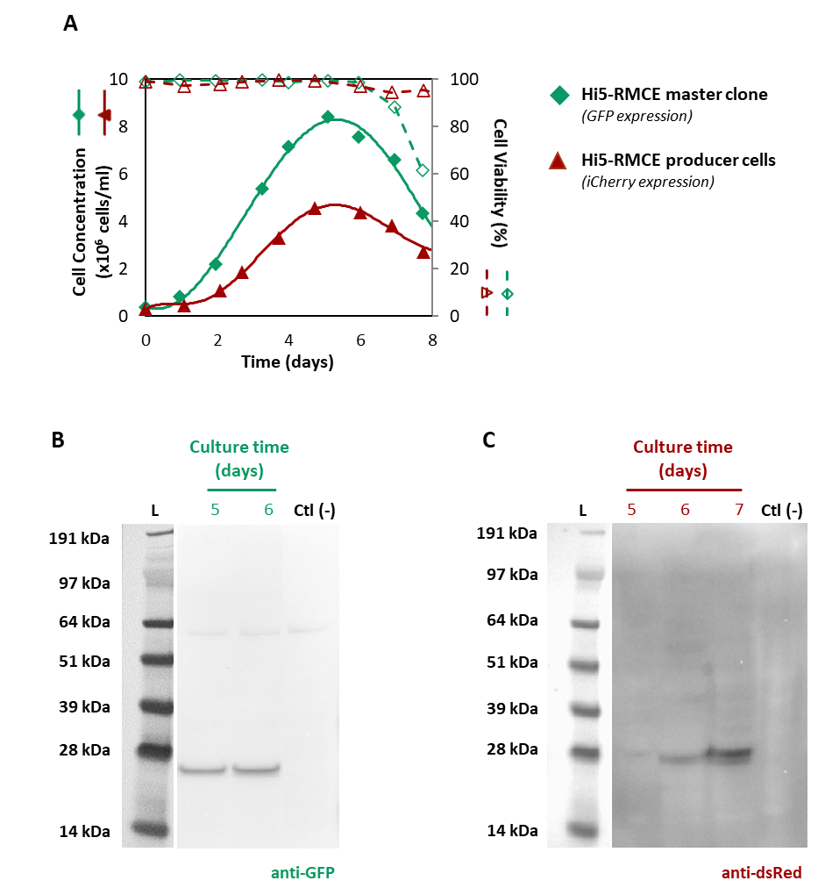
Figure S2
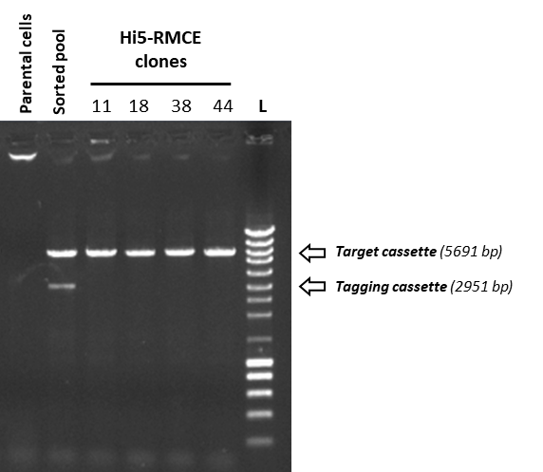
Figure S3
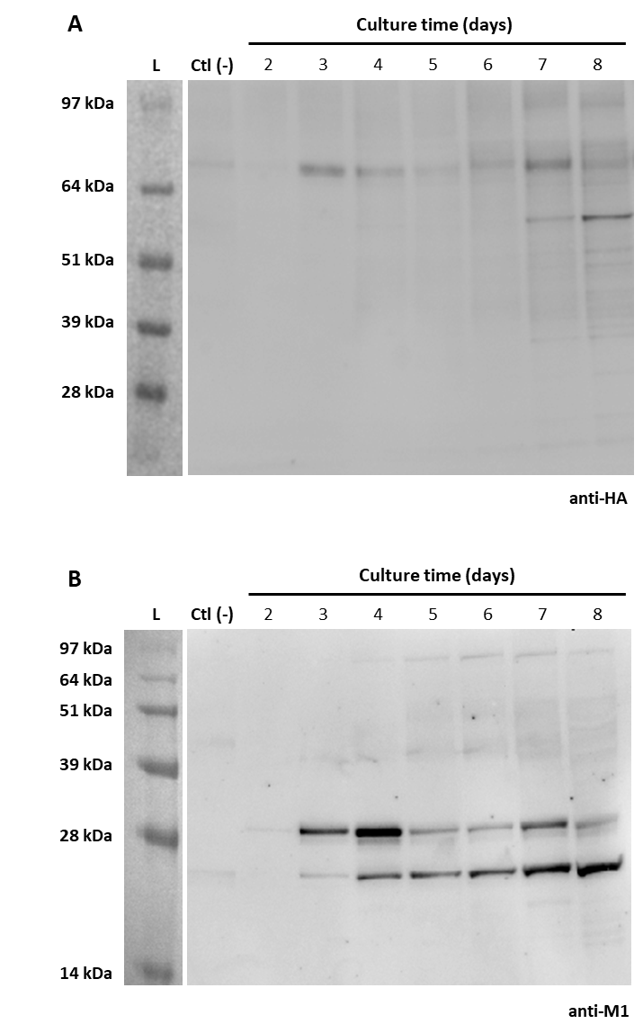

Table S1: Primers used to amplify the fragments for plasmid constructions and restriction enzymes used for vector digestion.
Final construct | Vector template | Primers used in vector amplification/ Restriction enzyme used for vector digestion | Insert template | Primers used for insert amplification
pTagging-iCherry-hyg (GenBank MW246024)
pTagging-iCherry-hyg | pTagging-iCherry  (GenScript, USA; GenBank MW246023) | NheI | hygromycin and SV40 polyA fragment from in-house pTag-OpIE2dsRed cassette | Fw: TTGCGAATTCGCTAGCCATGAAGAAACCTGAACTGACA  Rv: TCTCACGTGAGCTAGCCCATACCACATTTGTAGAGGTTT
phr5-AcIE1-iFlp (GenBank MW246025)
phr5-IE1-iFlp | pIEx™-10 (Novagen, EMD Millipore) | BamHI/HindIII | iflp gene from OpIE2-iFlp-IEterm plasmid (GenBank MG051710) | Fw: ACAAGGTACCGGATCCGCTCCCATGGCTCCCAAGAAA  Rv: CTGCGGCCGCAAGCTTTCTAGTCGACGATACGACGGTTGA
pTarget-eGFP-neo (GenBank MW246027)
pTarget-eGFP-neo | backbone containing F₅ and F_{wt} from pTag-OpIE2dsRed cassette | Fw: CCATGGAGAAGTTCCTATTCCGA  Rv: CGTGGGATCGATGCTCACTCGA | egfp with OpIE2 polyA fragment from pTarget-OpIE2eGFP cassette | Fw: CGCTCACTGACTCGCCGATCCCACGCGCTTGAAAG  Rv: AGCATCGATCCCACGACCATGGTGAGCAAGGGCGA
 |  |  | neomycin with polyA fragment from pTag-OpIE2dsRed cassette | Fw: GGAACTTCTCCATGGATGATTGAACAAGATGGATTGCACG  Rv: GCGAGTCAGTGAGCGAGGAA
pTarget-eGFP-iFlp-neo (GenBank MW246026)
pTarget-eGFP-iFlp-neo | pTarget-eGFP-neo | SfiI/PacI | hr5-AcIE1 promoter, iflp gene and IE1 term fragment from phr5-AcIE1-iFlp vector | Fw: AGCGGAAGGCCCATGAACAATTTCACACAGGAAACAGC  Rv: TTTTTTGTGTTTAATGCATTTATCAGGGTTATTGTCTCA
pTarget-iCherry-zeo (GenBank MW246028)
pTarget-iCherry-neo | pTarget-eGFP-neo | NdeI/NotI | iCherry gene from pTagging-iCherry-hyg vector | Fw: TGAGAGTGCACCATATGTCTACCATGGTGTCCAAGGGTG  Rv: GCTAGCTTTGCGGCCGCGCCTTACTTGTACAGCTCGTCC
pTarget-iCherry-zeo | pTarget-iCherry-neo | Fw: CCATGGAGAAGTTCCTATTCCGAA  Rv: GCGGGACTCTGGGGTTCGAAAT | zeocin gene from pIZT/V5-His vector | Fw: ACCCCAGAGTCCCGCCGTCGGTCAGTCCTGCTCCT  Rv: GGAACTTCTCCATGGATGGCCAAGTTGACCAGTGCCGT
pFluTarget
pIZT-M1 | pIZT/V5-His (Invitrogen) | SacI | M1 gene (from Redbiotech bacmid) | Fw: GCTTGGTACCGAGCTATGAGCCTGCTGACCGAGGT  Rv: GGACTAGTGGATCCGGATCACTTGAACCGCTGCAT
pIZT-HA | pIZT/V5-His (Invitrogen) | NotI | HA gene (H3-4II, from Redbiotech bacmid) | Fw: agcacagtggcggccaaactcgtcaaagccaccatga  Rv: TAGACTCGAGCGGCCGACGCCAGAAAGGGGATTAGATAC
pIZT-M1-HA | pIZT-M1 | Fw: caggaaagaacatgtgagcaaaag  Rv: TTGAGTGAGCATCGATCCCACG | OpIE2 promoter, HA gene, polyA fragment from pIZT-HA | Fw: tcgatgctcactcaagatcatgatgataaacaatgtatgg  Rv: ACATGTTCTTTCCTGCGTTATCCCCTGATTCTGTGGATAACCGTATTA
pFluTarget | pTarget-iCherry-zeo | NdeI/PacI | OpIE2 promoter, M1 gene, polyA, OpIE2 promoter, HA gene, polyA fragment from pIZT-M1-HA | Fw: TGAGAGTGCACCATAaaacttgtttattgcagcttataatggttacaaataaagcaa  Rv: ggttttttgtgtttaTTGAGTGAGCATCGATCCCACG

