The alignments of the amino acid sequences and subsequent IQ-TREE analyses generated phylogenetic trees for CNL-TNL, RLP and RLK RGA classes (Figure S1a-c). Some clusters of orthologous resistance genes among the six species were identified, especially for RLP and RLKs, while more Quercus-specific clusters were identified for CNL-TNL. To explore the evolutionary relationships among NLRs, a phylogenetic tree was constructed using the CNL and TNL proteins identified together with 39 known plant resistance (R) proteins. As expected, the TNL clade branched out, although 20 predicted CNL genes were nested within the TNL clade. The CNL genes belonging to G4, G7 and G10 subgroups were clearly clustered in separated groups, with G4 and G7 mainly containing CNLs of Q. suber. Finally, several putative RGAs were identified and showed missing domains: besides genes belonging to types TN, TX and CN, several NL genes (NBS-LRR lacking coiled-coil or Toll/Interleukin-1 receptor) were found.
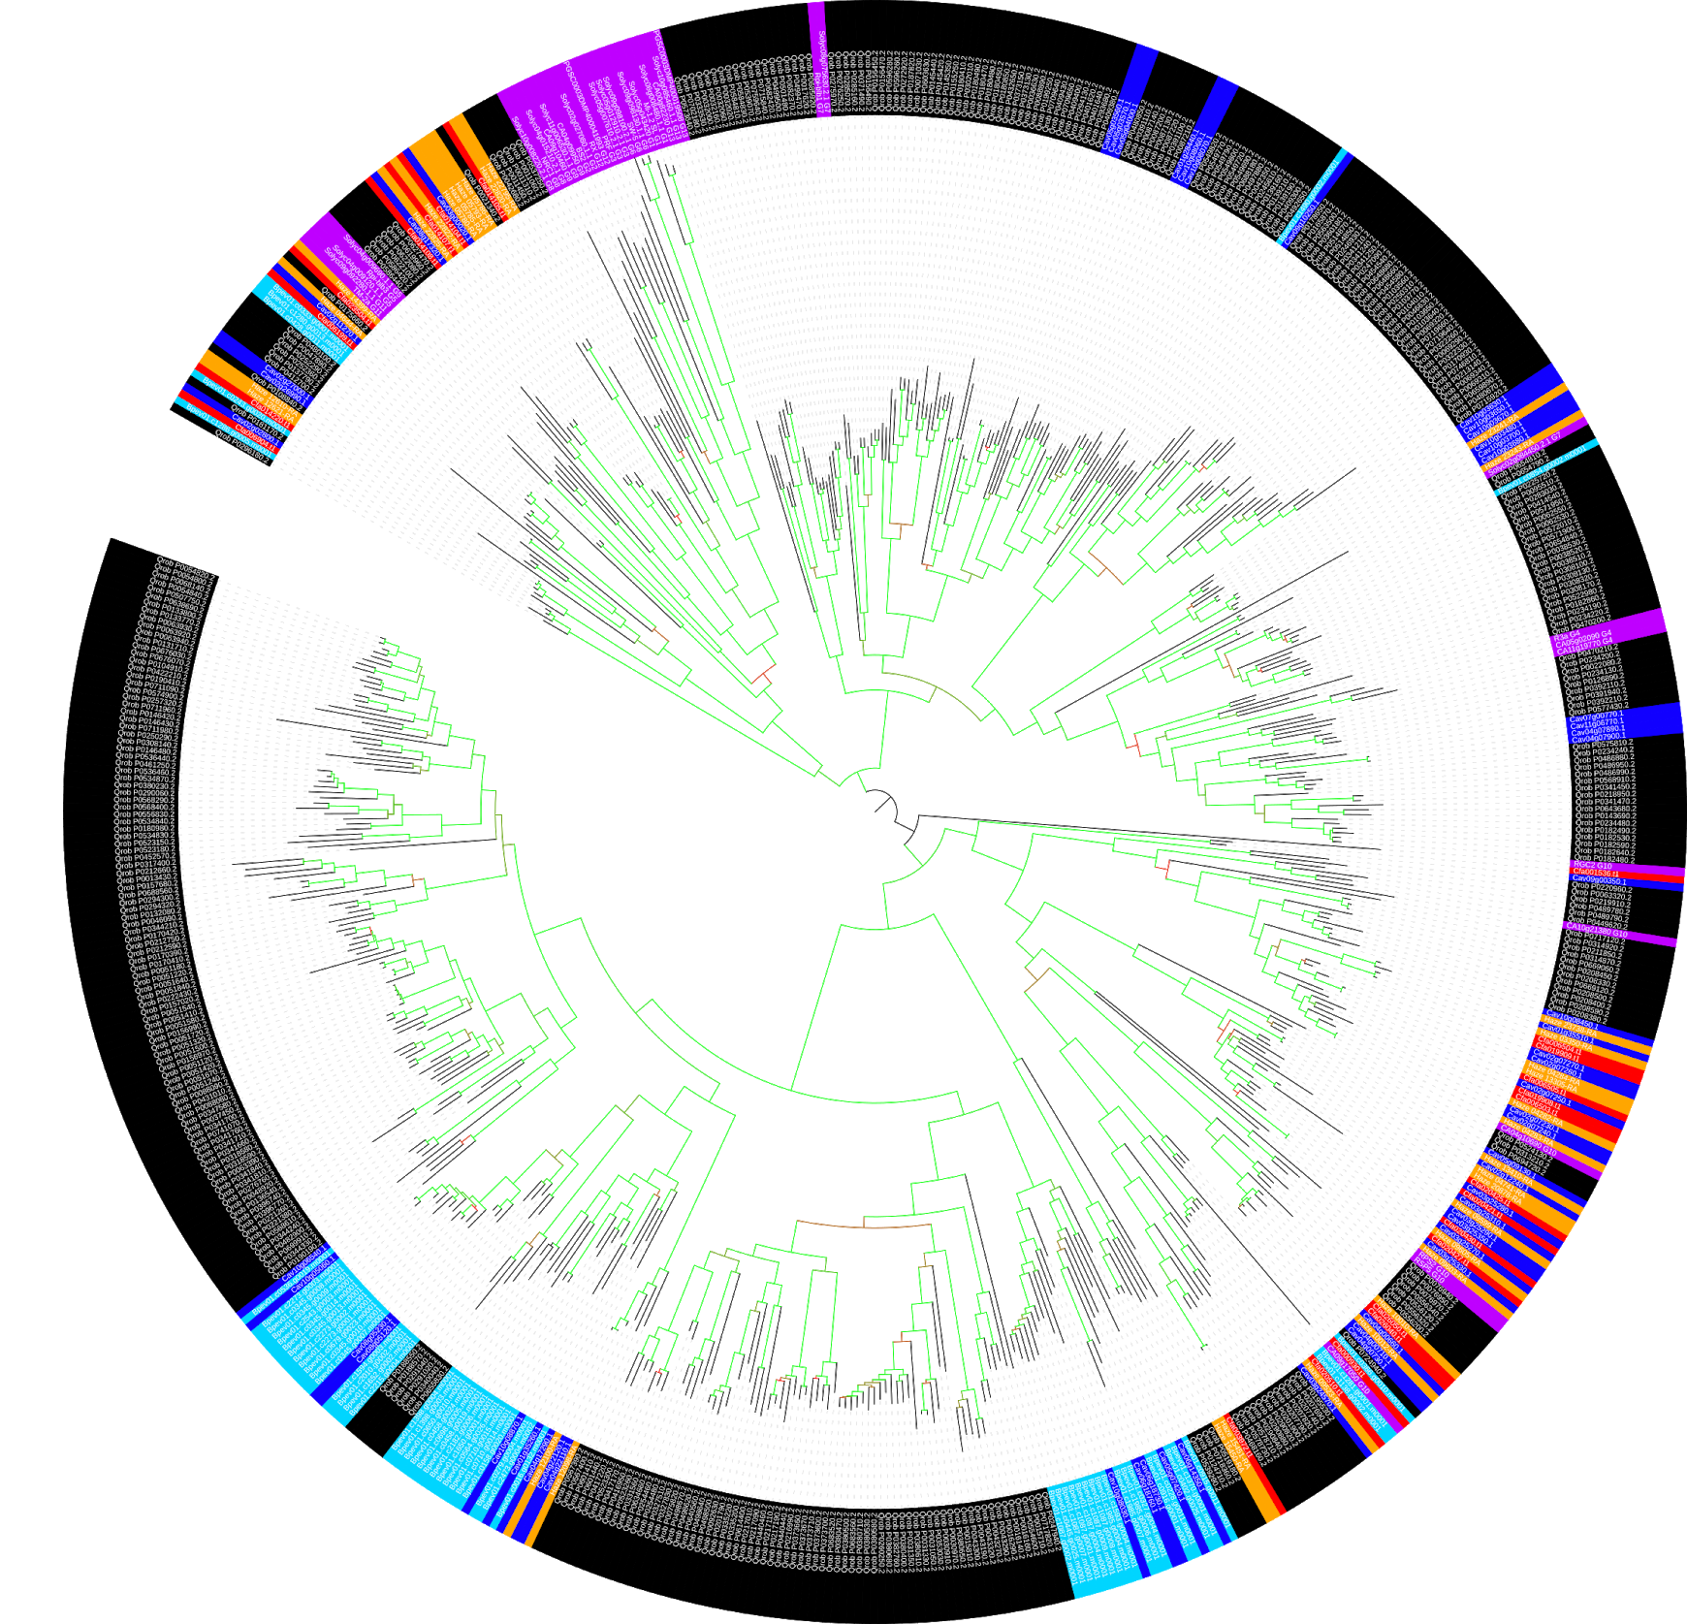
Figure S1a: CNL/TNLs tree. CNL/TNL identified in the different genome sequences are depicted with different colors: blue for ‘Tombul’, orange for ‘TGdL’, light blue for Betula pendula, red for Carpinus fangiana, black for Quercus suber; reference genes are colored in purple. No CNL and TNL were identified in ‘Jefferson’.
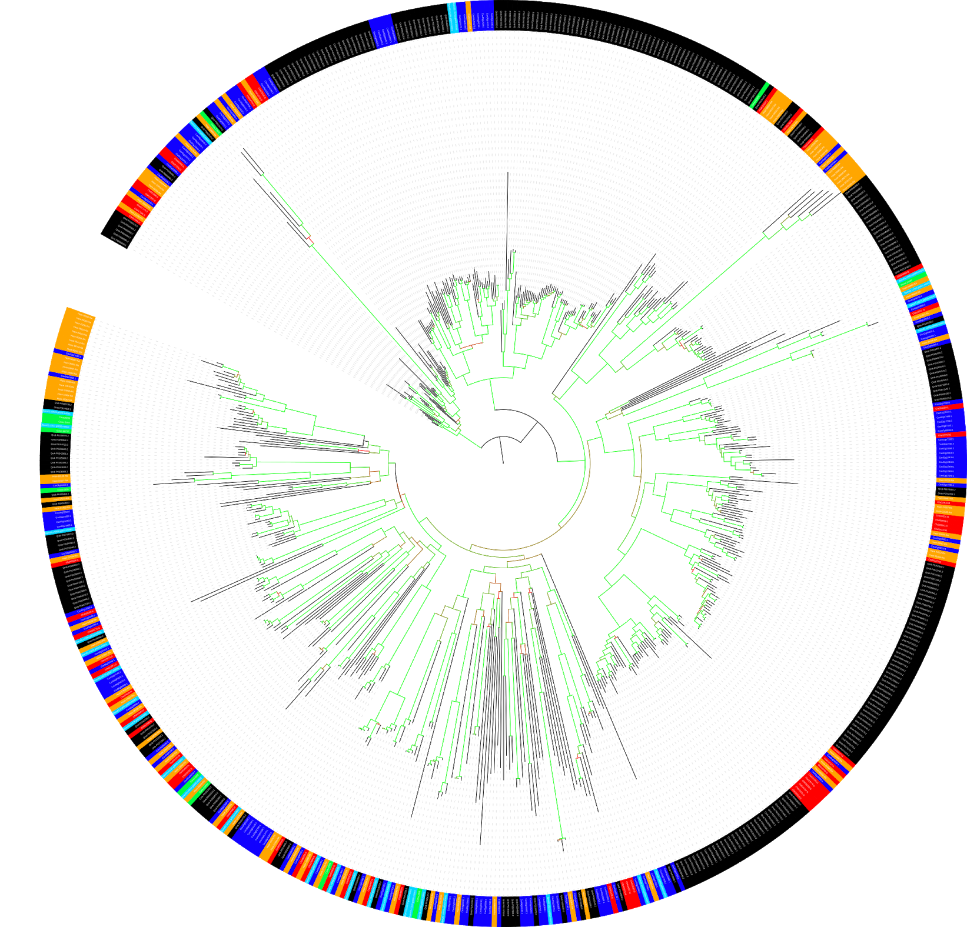
Figure S1b: RLPs tree. RLPs identified in the different genotypes are depicted with different colors: blue for ‘Tombul’, orange for ‘TGdL’, light blue for Betula pendula, red for Carpinus fangiana, black for Quercus suber and green for ‘Jefferson’.
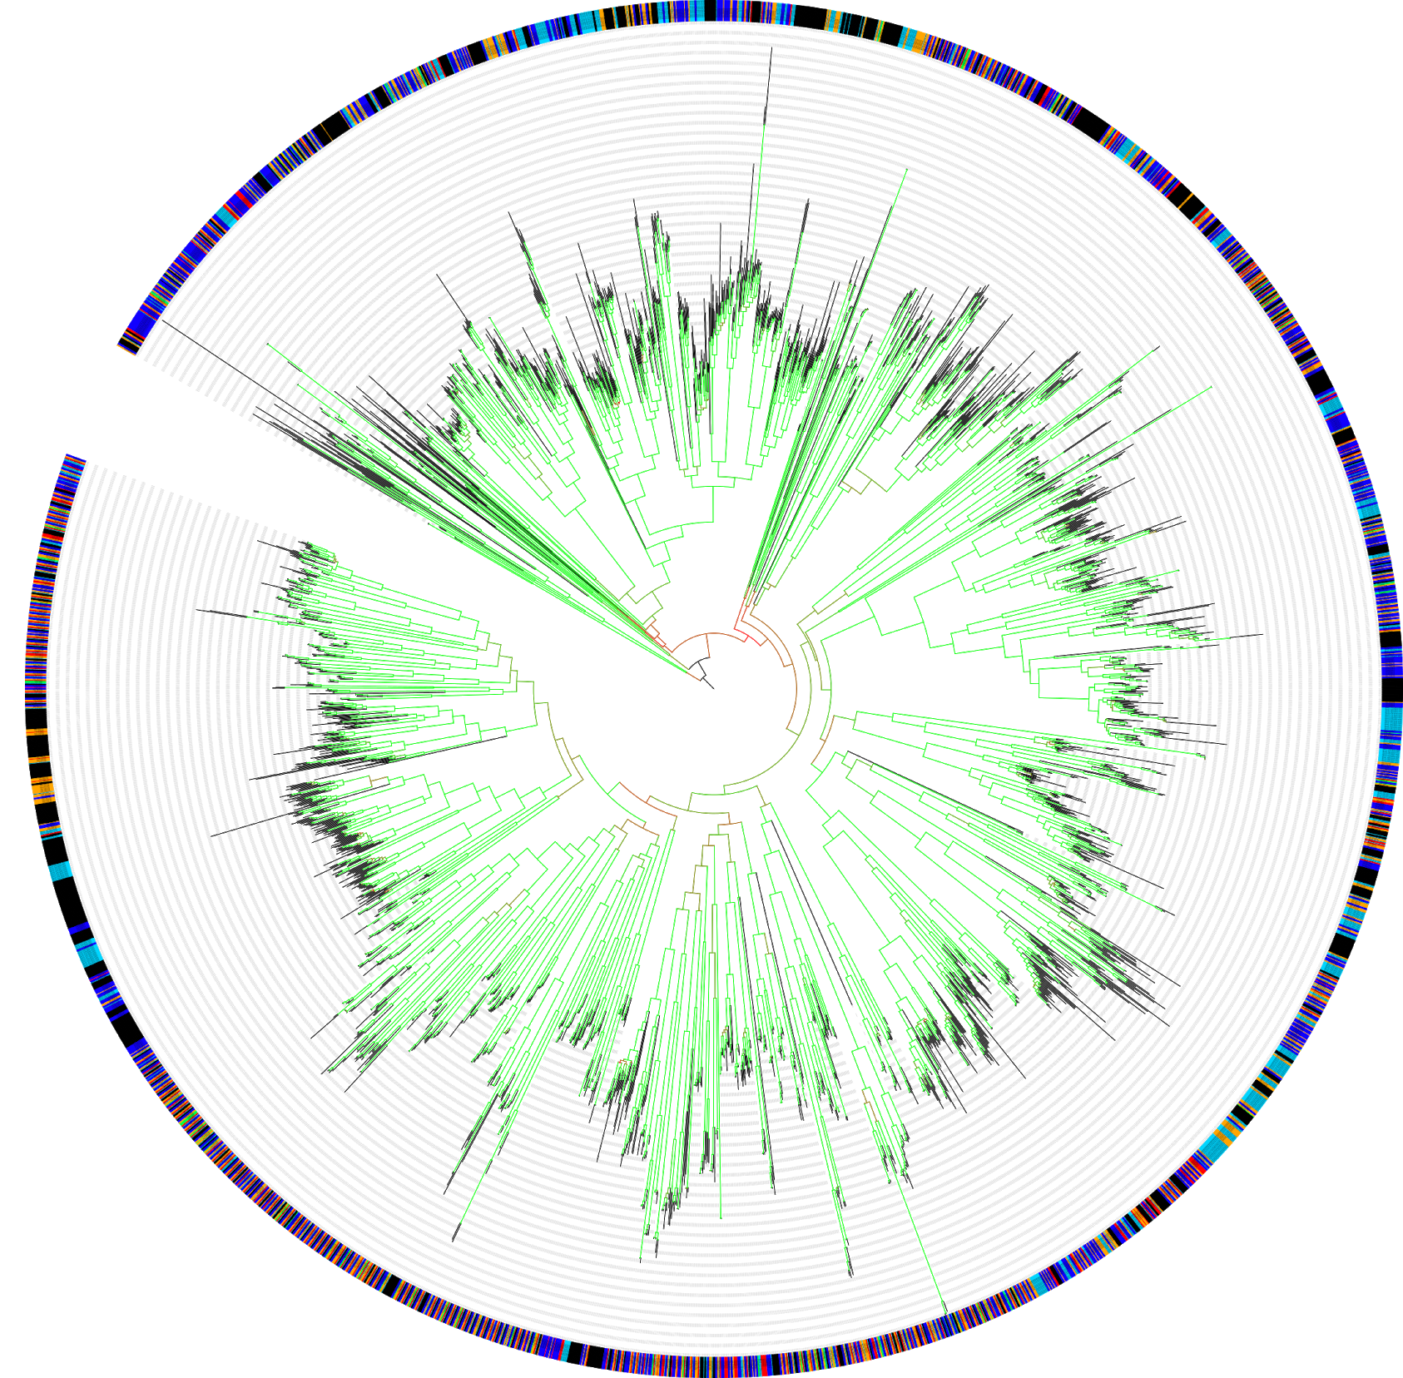
Figure S1c: RLKs tree. RLKs identified in the different genotypes are depicted with different colors: blue for ‘Tombul’, orange for ‘TGdL’, light blue for Betula pendula, red for Carpinus fangiana, black for Quercus suber and green for ‘Jefferson’.

