Transposon-induced inversions activate gene expression in Maize pericarp
Sharu Paul Sharma*, Tao Zuo* and Thomas Peterson*†

Supplemental Information

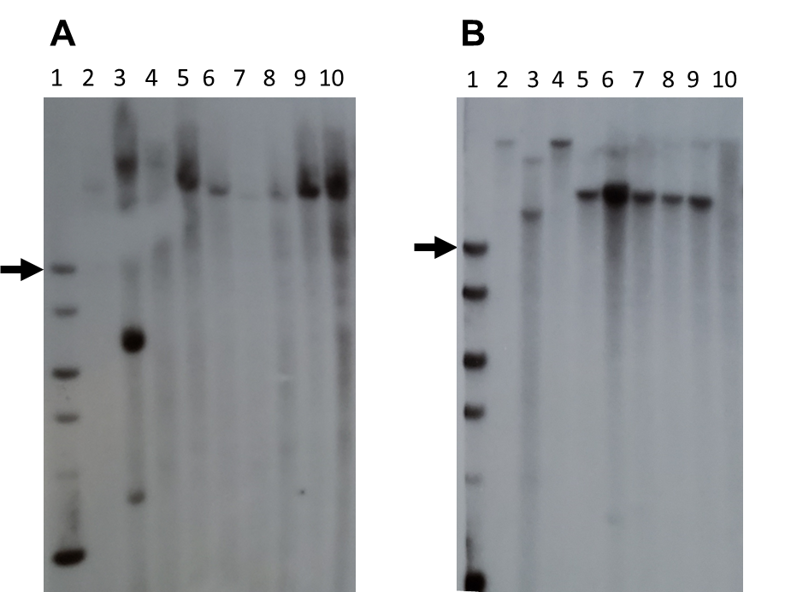

Figure S1: Southern Blot gel images using A) HpaI and B) EcoRV restriction enzymes with fragment-15 (within the p1 enhancer) as a probe. Lane 1, DNA ladder, black arrow points to 10 kb fragment on each gel; Lane 2, J (p1-ww); Lane 3, P1-rr4B2; Lane 4, p1-wwB54; Lane 5, 140; Lane 6, E1; Lane 7, TZ3-4; Lane 8, SP1-18; Lane 9, S25; and Lane 10, TZ2-7.

Figure S2: RT-PCR sequence aligned to p1 and p2 exons 1, 2 and 3. The middle sequence is RT-PCR product from E1 (one of the inversions), the upper sequence is from p1 and the lower sequence is from p2. At three sites, SNPs in the RT-PCR product match p2 (lower) but not p1 (upper). Two additional SNPs in the RT-PCR product likely represent amplification or sequencing artefacts.
Exon 1
381 GCGGA-AGAGGACCAGTTACTTGCCAACTACATTGCGGAGCACGGCGAGGGGTCCTGGAG
||||| |||||||||||||||||||||||||||||||||||||||||||||||||||||
3 GCGGATGGAGGACCAGTTACTTGCCAACTACATTGCGGAGCACGGCGAGGGGTCCTGGAG
||||| ||||||||||||||||||||||||||||||||||||||||||||||||||||||
279 GCGGA-GGAGGACCAGTTACTTGCCAACTACATTGCGGAGCACGGCGAGGGGTCCTGGAG

GTCGCTGCCCAAGAATGCAG 459
||||||||||||||||||||
GTCGCTGCCCAAGAATGCAG 82
||||||||||||||||||||
GTCGCTGCCCAAGAATGCAG 357

Exon 2
580 GCCTGCTCCGGTGCGGCAAGAGCTGCCGGCTCCGGTGGATCAACTACCTTCGGG
||||||||||||||||||||||||||||||||||||||||||||||||| ||||
83 GCCTGCTCCGGTGCGGCAAGAGCTGCCGGCTCCGGTGGATCAACTACCTCCGGG
||||||||||||||||||||||||||||||||||||||||||||||||||||||
475 GCCTGCTCCGGTGCGGCAAGAGCTGCCGGCTCCGGTGGATCAACTACCTCCGGG

CGGACGTCAAGAGGGGGAACATCTCCAAGGAGGAAGAAGACATCATCATCAAGCTCCACG
||||||||||||||||||||||||||||||||||||||||||||||||||||||||||||
CGGACGTCAAGAGGGGGAACATCTCCAAGGAGGAAGAAGACATCATCATCAAGCTCCACG
||||||||||||||||||||||||||||||||||||||||||||||||||||||||||||
CGGACGTCAAGAGGGGGAACATCTCCAAGGAGGAAGAAGACATCATCATCAAGCTCCACG

CCACCCTCGGCAACAG 709
|||||||||| |||||
CCACCCTCGGGAACAG 212
||||||||||||||||
CCACCCTCGGGAACAG 610

Exon 3
5309 GTGGTCCCTGATCGCCAGCCACCTCCCC-GGCCGAAC 5344
|||||||||||||||||||||||||||| ||||||||
213 GTGGTCCCTGATCGCCAGCCACCTCCCCCGGCCGAAC 249
|||||||||||||||||||||||||||| ||||||||
4425 GTGGTCCCTGATCGCCAGCCACCTCCCC-GGCCGAAC 4460

Table S1: Primers used for screening for inversions

Set 1 | GAACAGTGATGGGAATGTTG | CTGCTAGCTGCTAGCTGTTAGGCTC
Set 2 | GAGTCGCGAGCAGTGGAG | CTGCTAGCTGCTAGCTGTTAGGCTC
fAc-p1 junction | GACCGTGACCTGTCCGCTC | TGCCATCTTCCACTCCTCGGCTTTAG
Nested | GGCATAGTGAGACCCATTCCTCCTTC | CCTCTCCATGAGCAATGTGTCTTAT

Table S2: Primers for sequencing inversion endpoints

Primers for Ac side

Ac primer: GCTCTACCGTTTCCGTTTCCGTTTACCG
140, E1, TZ3-4, SP1-18 | TTATACTTGCGACGCTGTGG
S25​ | TCTTTTGGCCATACGTCTCC
TZ2-7​ | CTTGGAGGACGAGGGATGGCAATGGG

Primers for fAc side

fAc primer: CTGCTAGCTGCTAGCTGTTAGGCTC
140, E1, TZ3-4, SP1-18 | GCAGCCTTTTCTTGCAGTCA
S25​ | CCCTCGTCCTCCAAGATTCTCCCCCTG
TZ2-7​ | GATTGGCTGAACCGTGACGT

Table S3: Primers used for RT-PCR

p2 | GCGGAGGAGGACCAGTTAC | CTGAGGTGCGAGTTCCAGTAG
Beta-tubulin | CTACCTCACGGCATCTGCTATGT | GTCACACACACTCGACTTCACG

Table S4: Inversion alleles, Target Site Duplications, and relevant distances (in basepairs)

Name | Target Site Duplication | Distance from TSS | E-P distance | Size of Inverted fragment
140 | CCGGTGGC | 3505 | 8235 | 81800
E1​ | CAGCCAGG​ | 3387 | 8117 | 81682
TZ3-4​ | TGTGTAGT | 3376 | 8106 | 81671
SP1-18 | GTCGGGGC​ | 3203 | 7933 | 81498
S25​ | CTCGTCGA​ | 3070 | 7800 | 81365
TZ2-7​ | ATCTCTTC | 2692 | 7422 | 80987

