Supplemental Materials

Figure S1.
2D-SFS before and after ascertainment. Top row shows 2D-SFS before ascertainment and the bottom row shows ones after ascertainment. SNPs with a minor allele frequency lower than 20% were filtered in ascertainment. The horizontal and vertical axes are derived allele frequency in population-Ⅰ and Ⅱ, respectively. Highly diverged variants in top row (or almost segregating variants, found in red at the corners) are removed by the effect of ascertainment. The fraction of eliminated variants is larger when the migration is low.

Figure S2.
Comparison of the deviations of $\hat{π_{w}}$ and $\hat{π_{b}}$. The horizontal axis means the threshold frequency of the minor allele frequency for SNP marker selection and the vertical axis means the per site deviation from the true value.

Figure S3.
Deviation of $\hat{F_{ST}}$ when calibrated by true $F_{ST}$ under the symmetric migration and split model. The migration rate and divergence time were calibrated to have the same $F_{ST}$. The horizontal axis means the threshold frequency of the minor allele frequency for SNP marker selection and the vertical axis means the deviation of $\hat{F_{ST}}$.

Figure S4.
2D-SFS before and after ascertainment under each demographic model with three populations. SNPs with a minor allele frequency lower than 20% were filtered in ascertainment. The horizontal and vertical axes are derived allele frequency in population-Ⅰ and Ⅱ, respectively.

Figure S5.
Deviation of $\hat{F_{ST}}$ when a population for a discovery panel was different from population-Ⅰ. Results when the discovery panel was sampled from population-Ⅱ and Ⅲ are shown in left and right column, respectively.

Figure S6.
2D-SFS before ascertainment under the three-island and split models considered in this study. Model parameters were the same as those in Figure 4.

Figure S7.
2D-SFS before ascertainment when calibrated by $π_{b}$. Compared populations correspond to population-Ⅰ and Ⅱ in Figure 4 except for parameters were calibrated to have the same $π_{b}$ between population-Ⅰ and Ⅱ.

Figure S8.
Deviation of $\hat{F_{ST}}$ between population-Ⅰ and Ⅱ under each ascertainment scheme when calibrated by $π_{b}$. Compared populations correspond to population-Ⅰ and Ⅱ in Figure 4 except for parameters were calibrated to have the same $π_{b}$ between population-Ⅰ and Ⅱ.

Figure S9. 2D-SFS and deviation of $\hat{F_{ST}}$ when discovery samples were reused as typing samples
2D-SFS and deviation of $\hat{F_{ST}}$ were calculated under two island model with $4Nm=0.1$. (a) 2D-SFS after ascertainment. The threshold of the marker selection was set to 5% and 50 markers were used. x and y axes indicate derived allele frequencies in population-Ⅰ and Ⅱ, respectively. The number of SNPs were indicated by color. (b) Deviations of $\hat{F_{ST}}$ were plotted against the threshold frequency of the marker selection. Solid lines indicate the case where discovery samples were used as typing samples again and dotted lines indicate the case where typing were performed with new samples. Each Column indicates each ascertainment scheme.

Table S1.
Summary table of the number of SNPs before ascertainment (before), after ascertainment (after) and used as markers (marker) under the two island model. Threshold indicates the threshold frequency when markers were selected in discovery panels. SNPs with a minor allele frequency lower than the threshold frequency were filtered. The numbers in the table are averages of the results of simulations performed 10000 times.

Table S2.
Summary table of the number of SNPs before ascertainment (before), after ascertainment (after) and used as markers (marker) under models with three populations.

Table S3. Average $\hat{F_{ST}}$ between each populations
Average $\hat{F_{ST}}$ values before ascertainment for models shown in Figure 4.

Figure S1
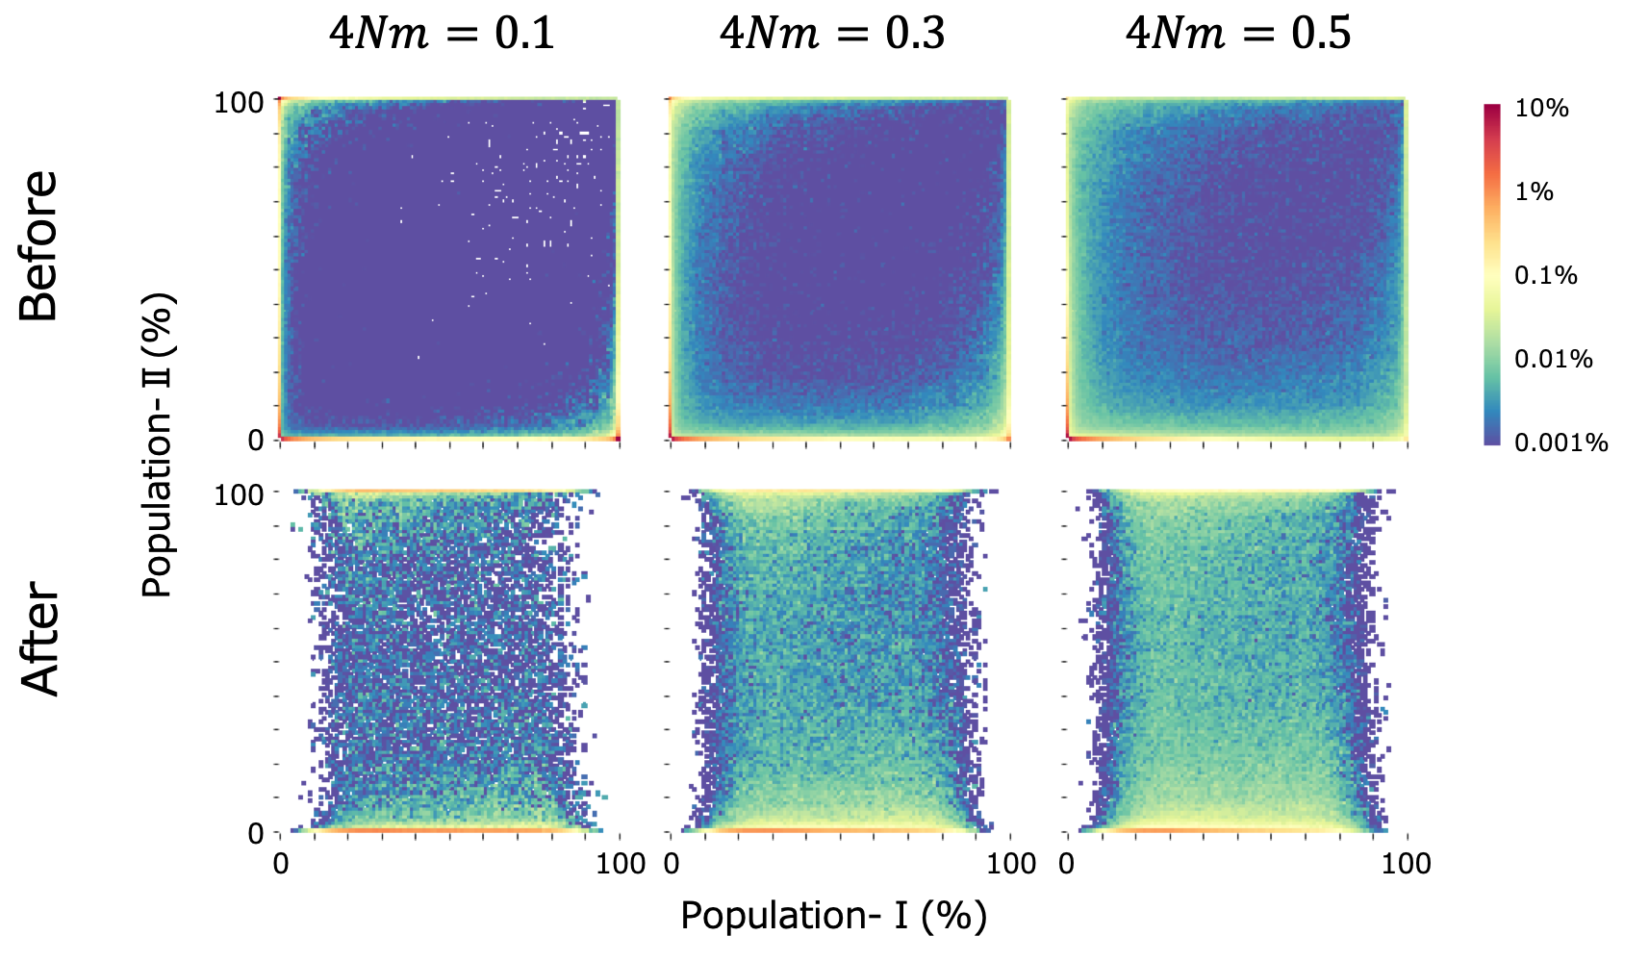

Figure S2
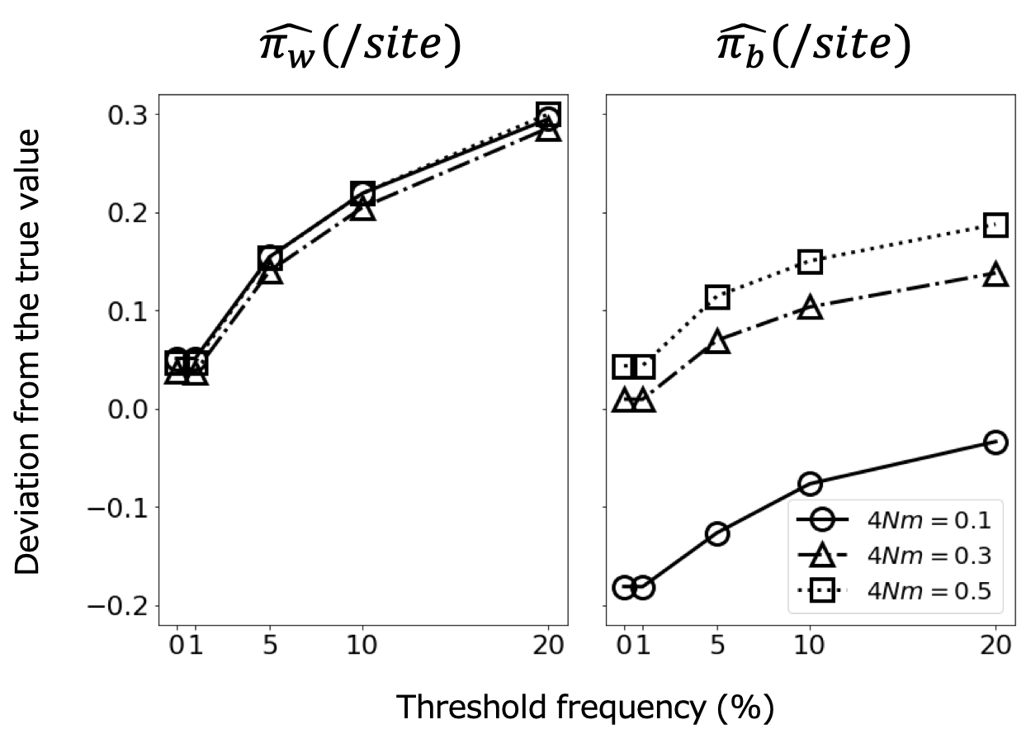

Figure S3
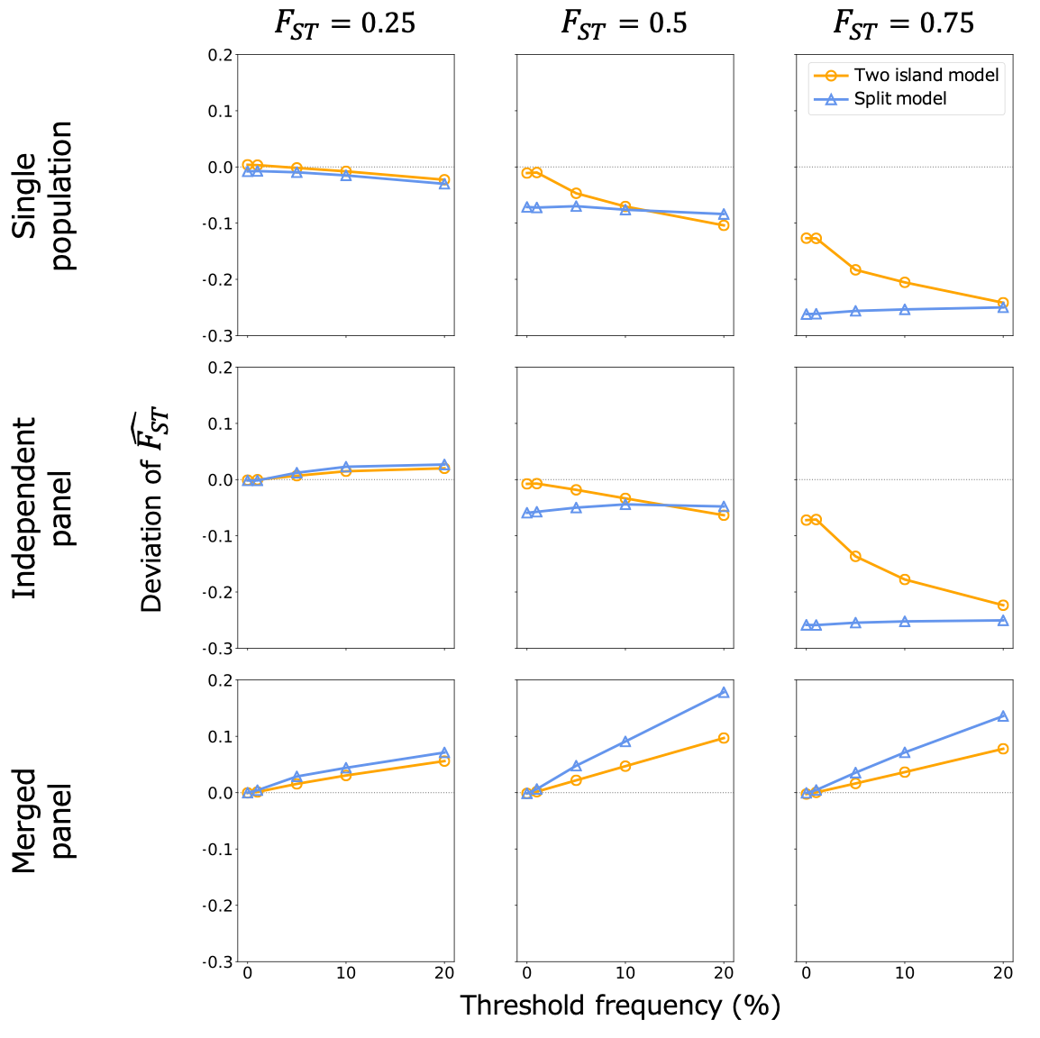

Figure S4
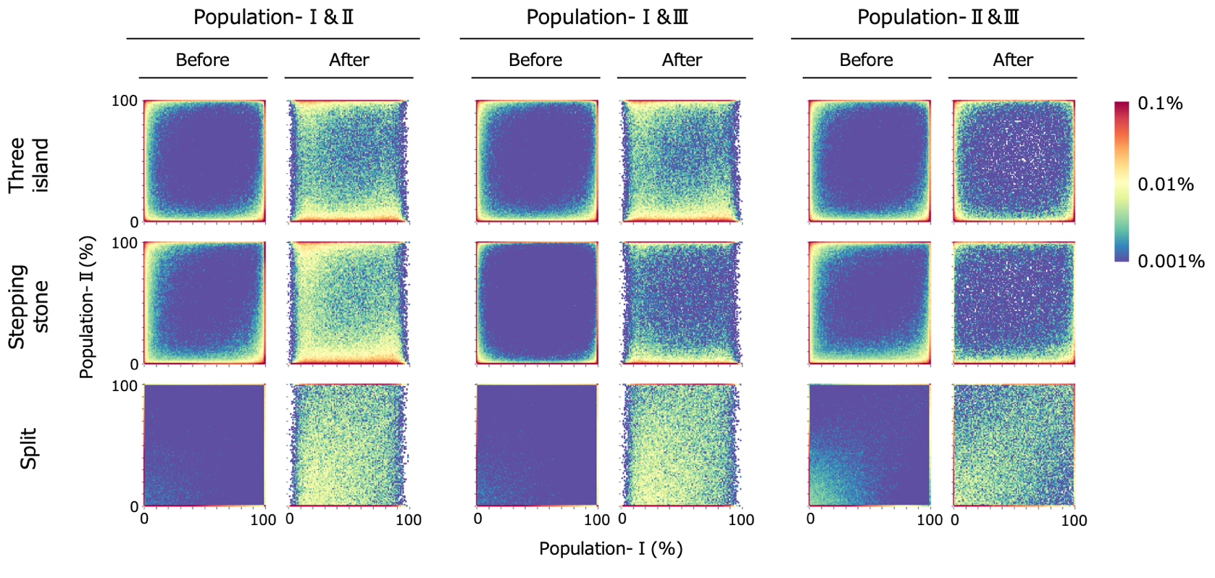

Figure S5
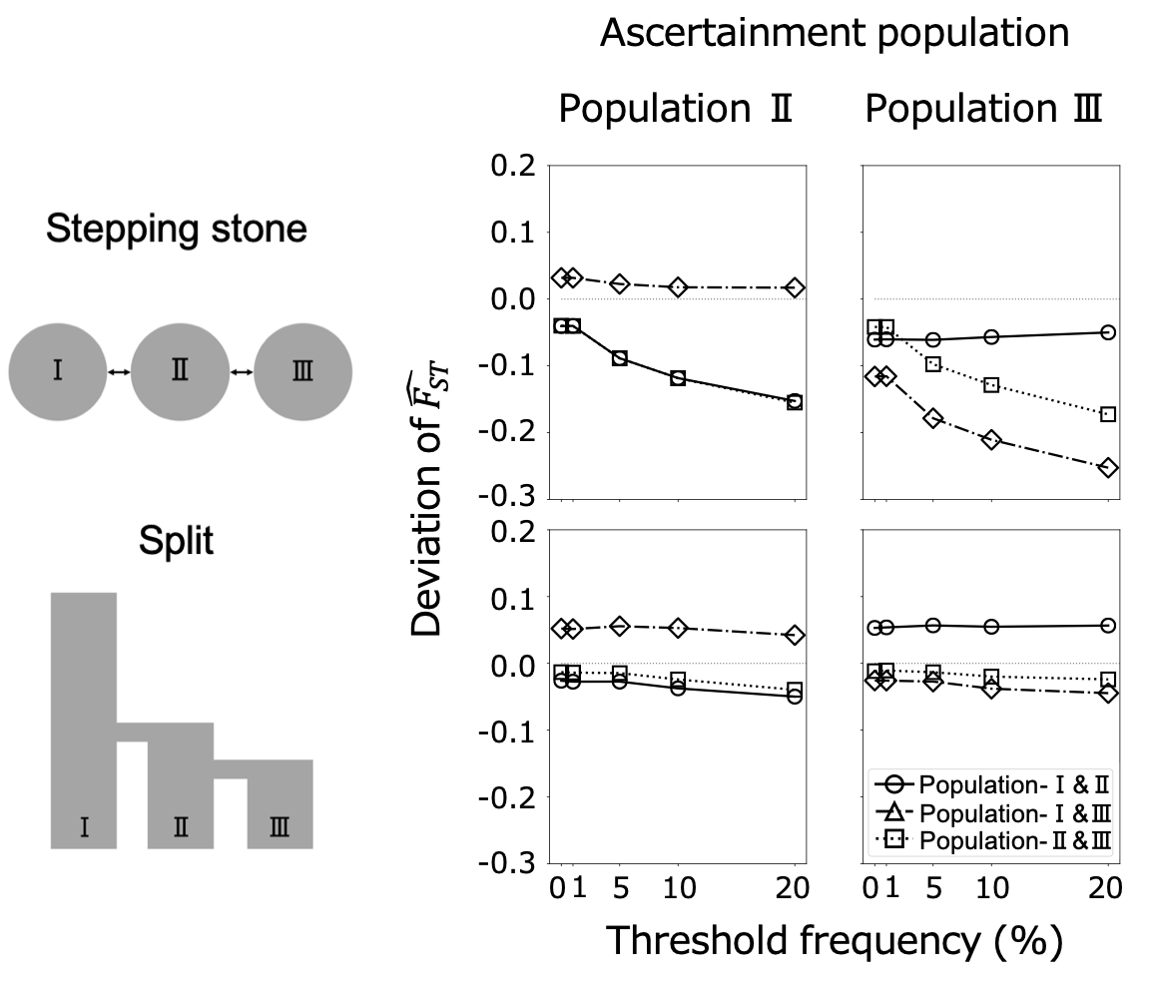

Figure S6
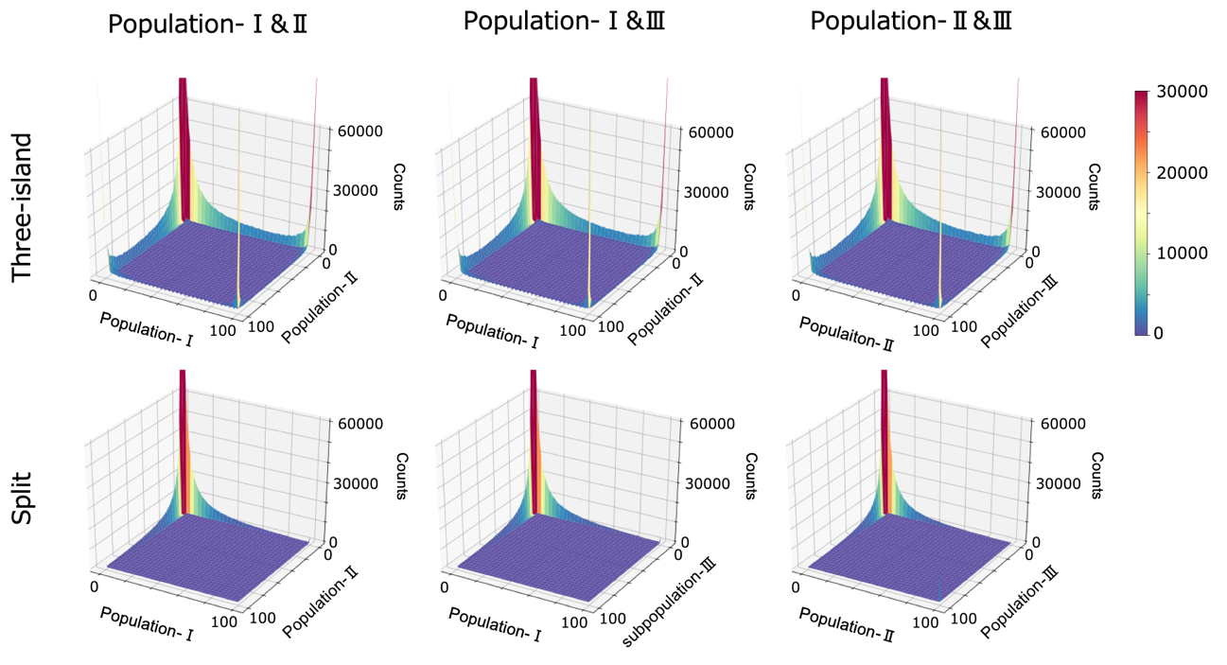

Figure S7
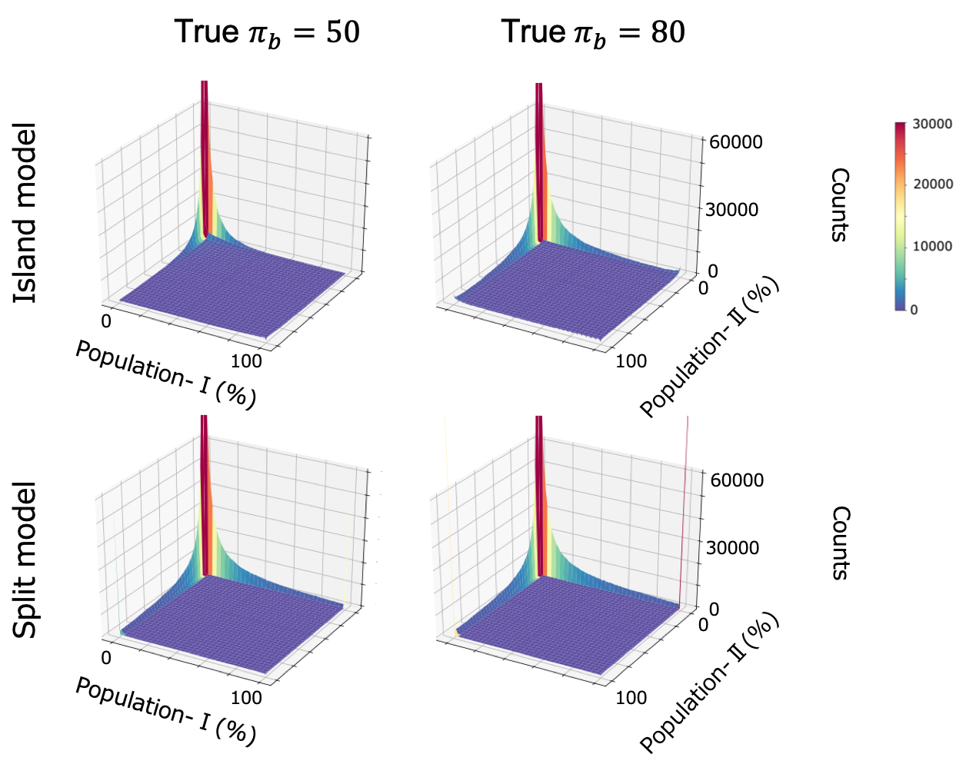

Figure S8
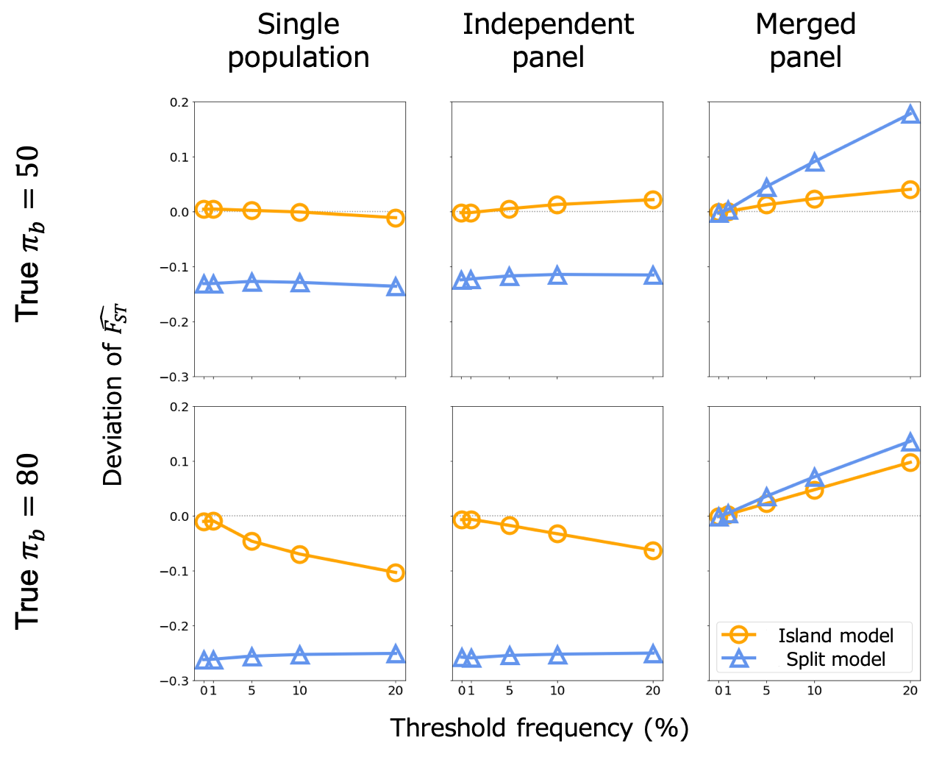

Figure S9
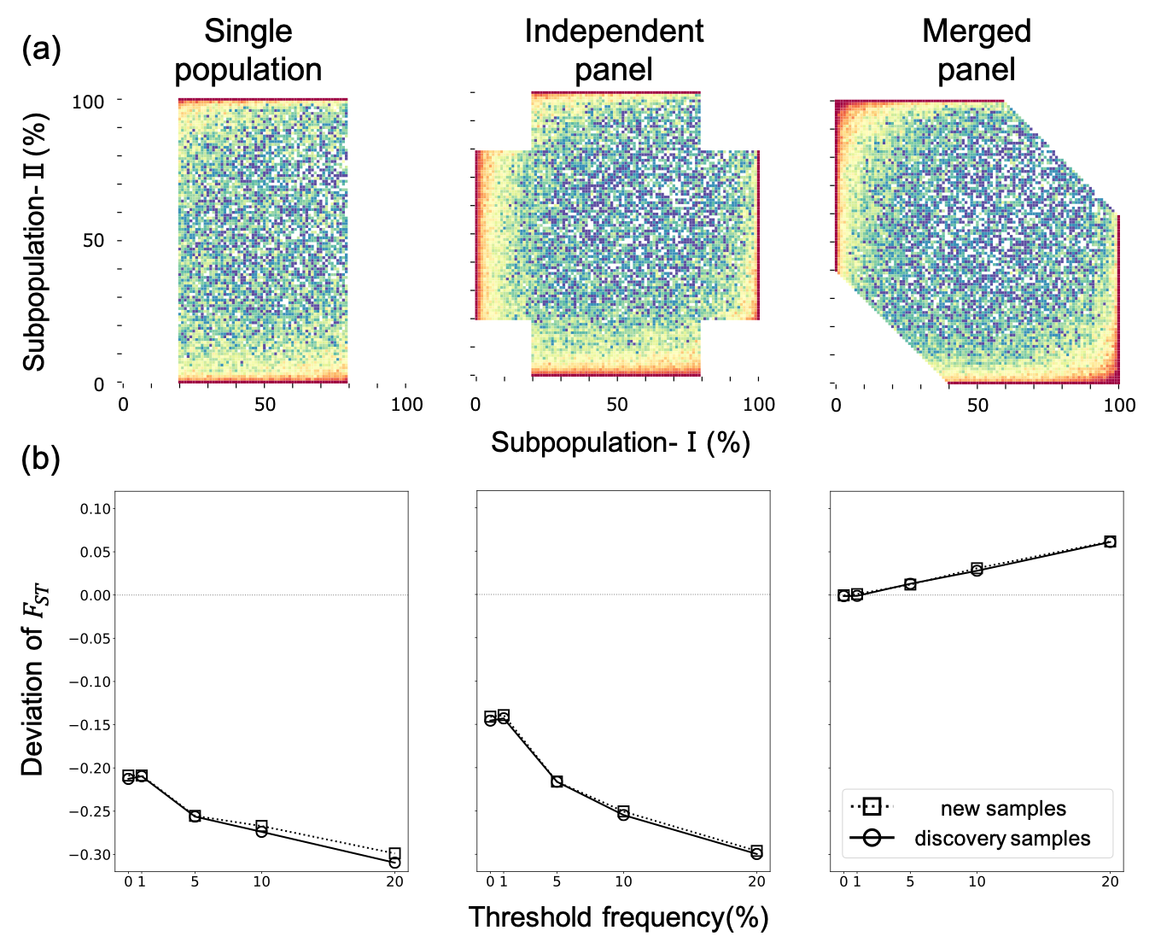

Table S1
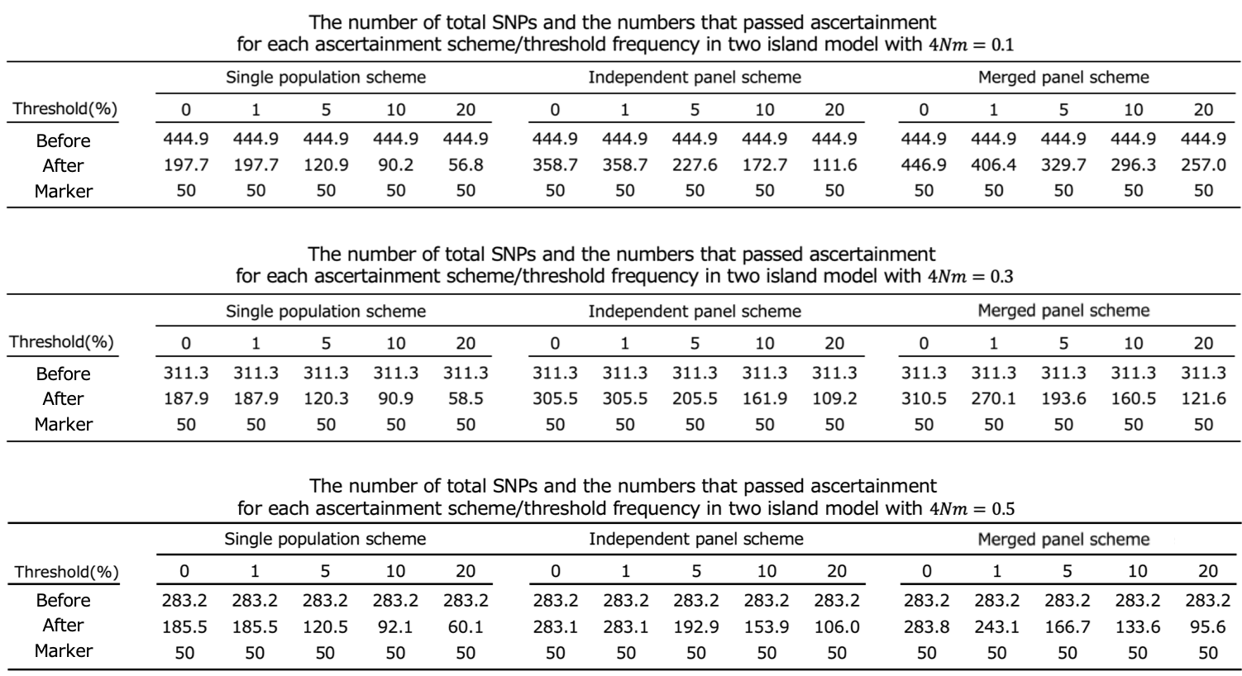

Table S2
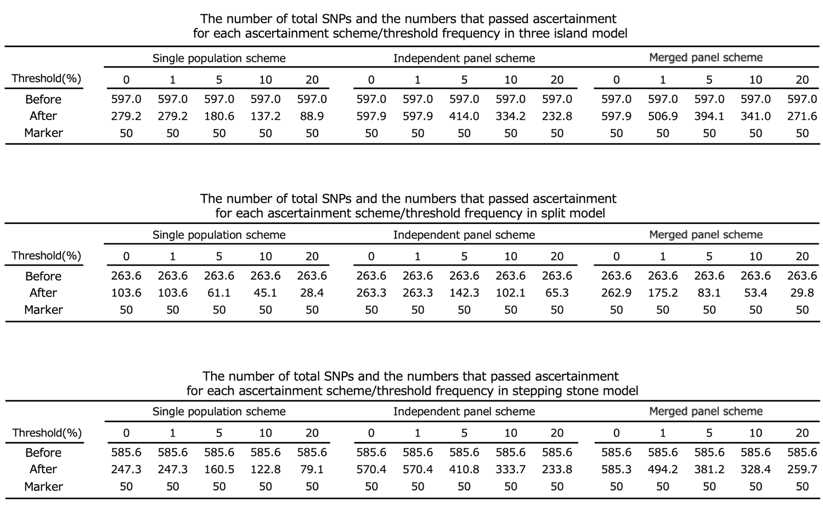

Table S3
