Figure S1 The manhattan represented the Δ (SNP-index) value in QTL-seq on all the 19 chromosomes except Chr. A10.
The red lines represented the distribution of average SNP index which were estimated using a sliding window approach with a 1 Mb window size and 10 kb step size. The green was the threshold value 95% for the confidence level.

Figure S2 The genotype based on a bin map of 200 individuals in the F₂ population in Yangluo in 2018
“aa” and “bb” represented sdw-e and ZS11-HP genotype, respectively. “ab” represented heterozygous genotype. “--” means the missing genotype. Chromosomes were separated by white vertical lines.

Figure S3 2D heat map showed a matrix of pairwise recombination value for the F₂ linkage map using Checkmatrix.
Each row and each column are the markers arranged in the order of the linkage group. Each small square represents the recombination rate between markers. The change of color from yellow to red to purple indicates the change of recombination rate from small to large. The closer the distance, the smaller the recombination rate is, and the color is closer to yellow; the farther the distance, the greater the recombination rate is, and the closer the color is to purple.

Linkage group A01:
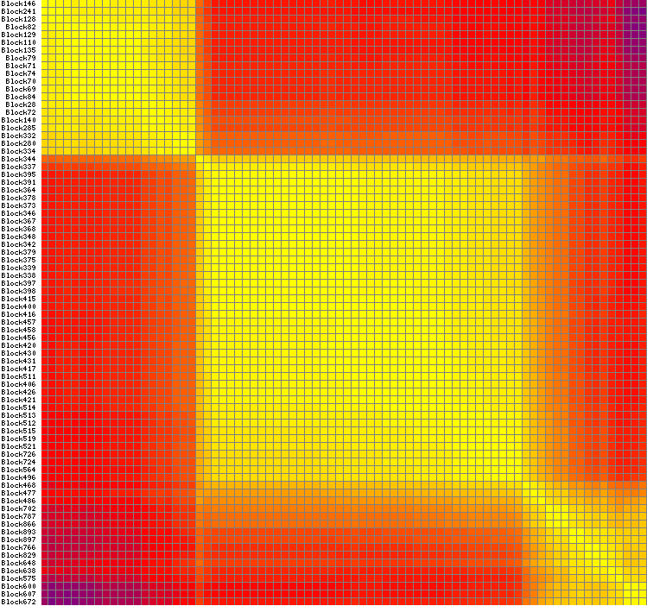

Linkage group A02:
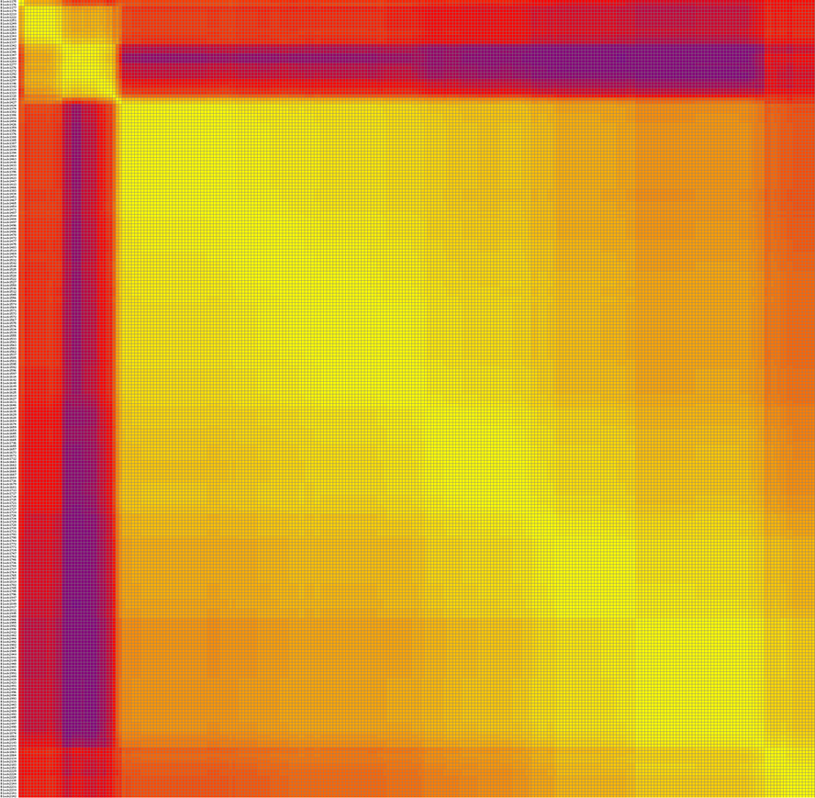

Linkage group A03:
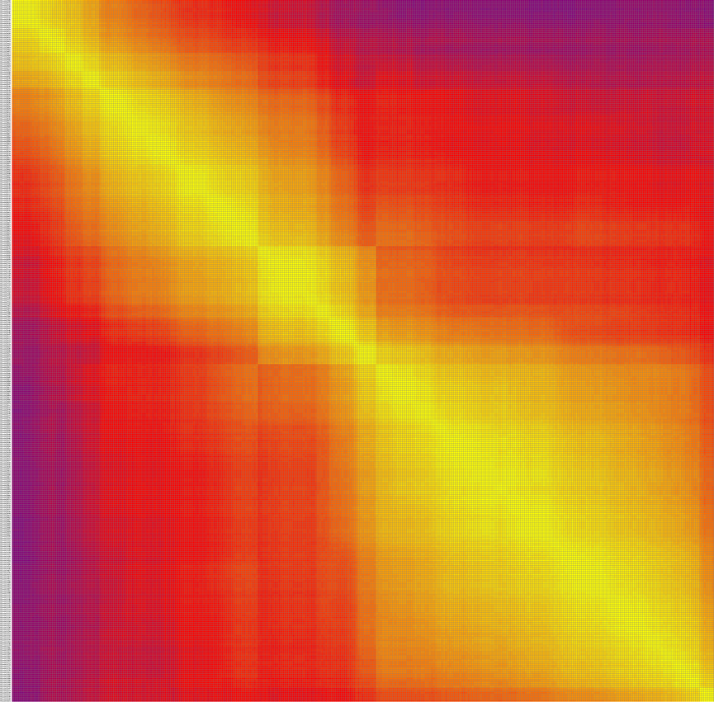

Linkage group A04:
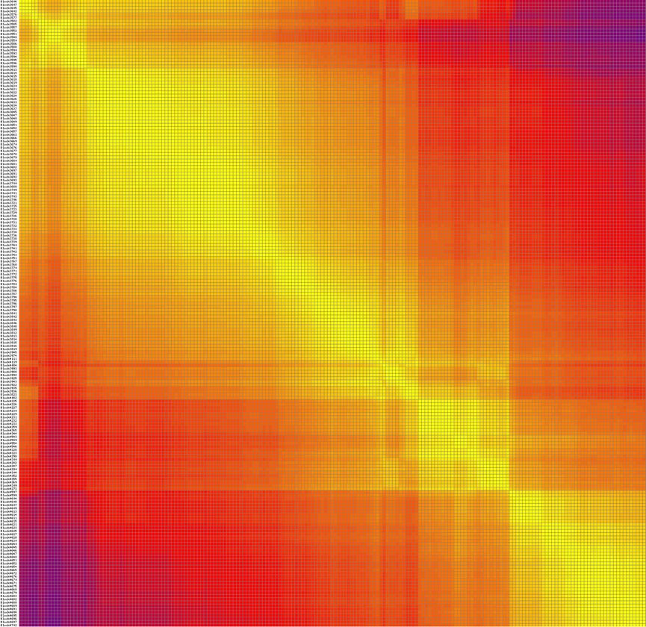

Linkage group A05:
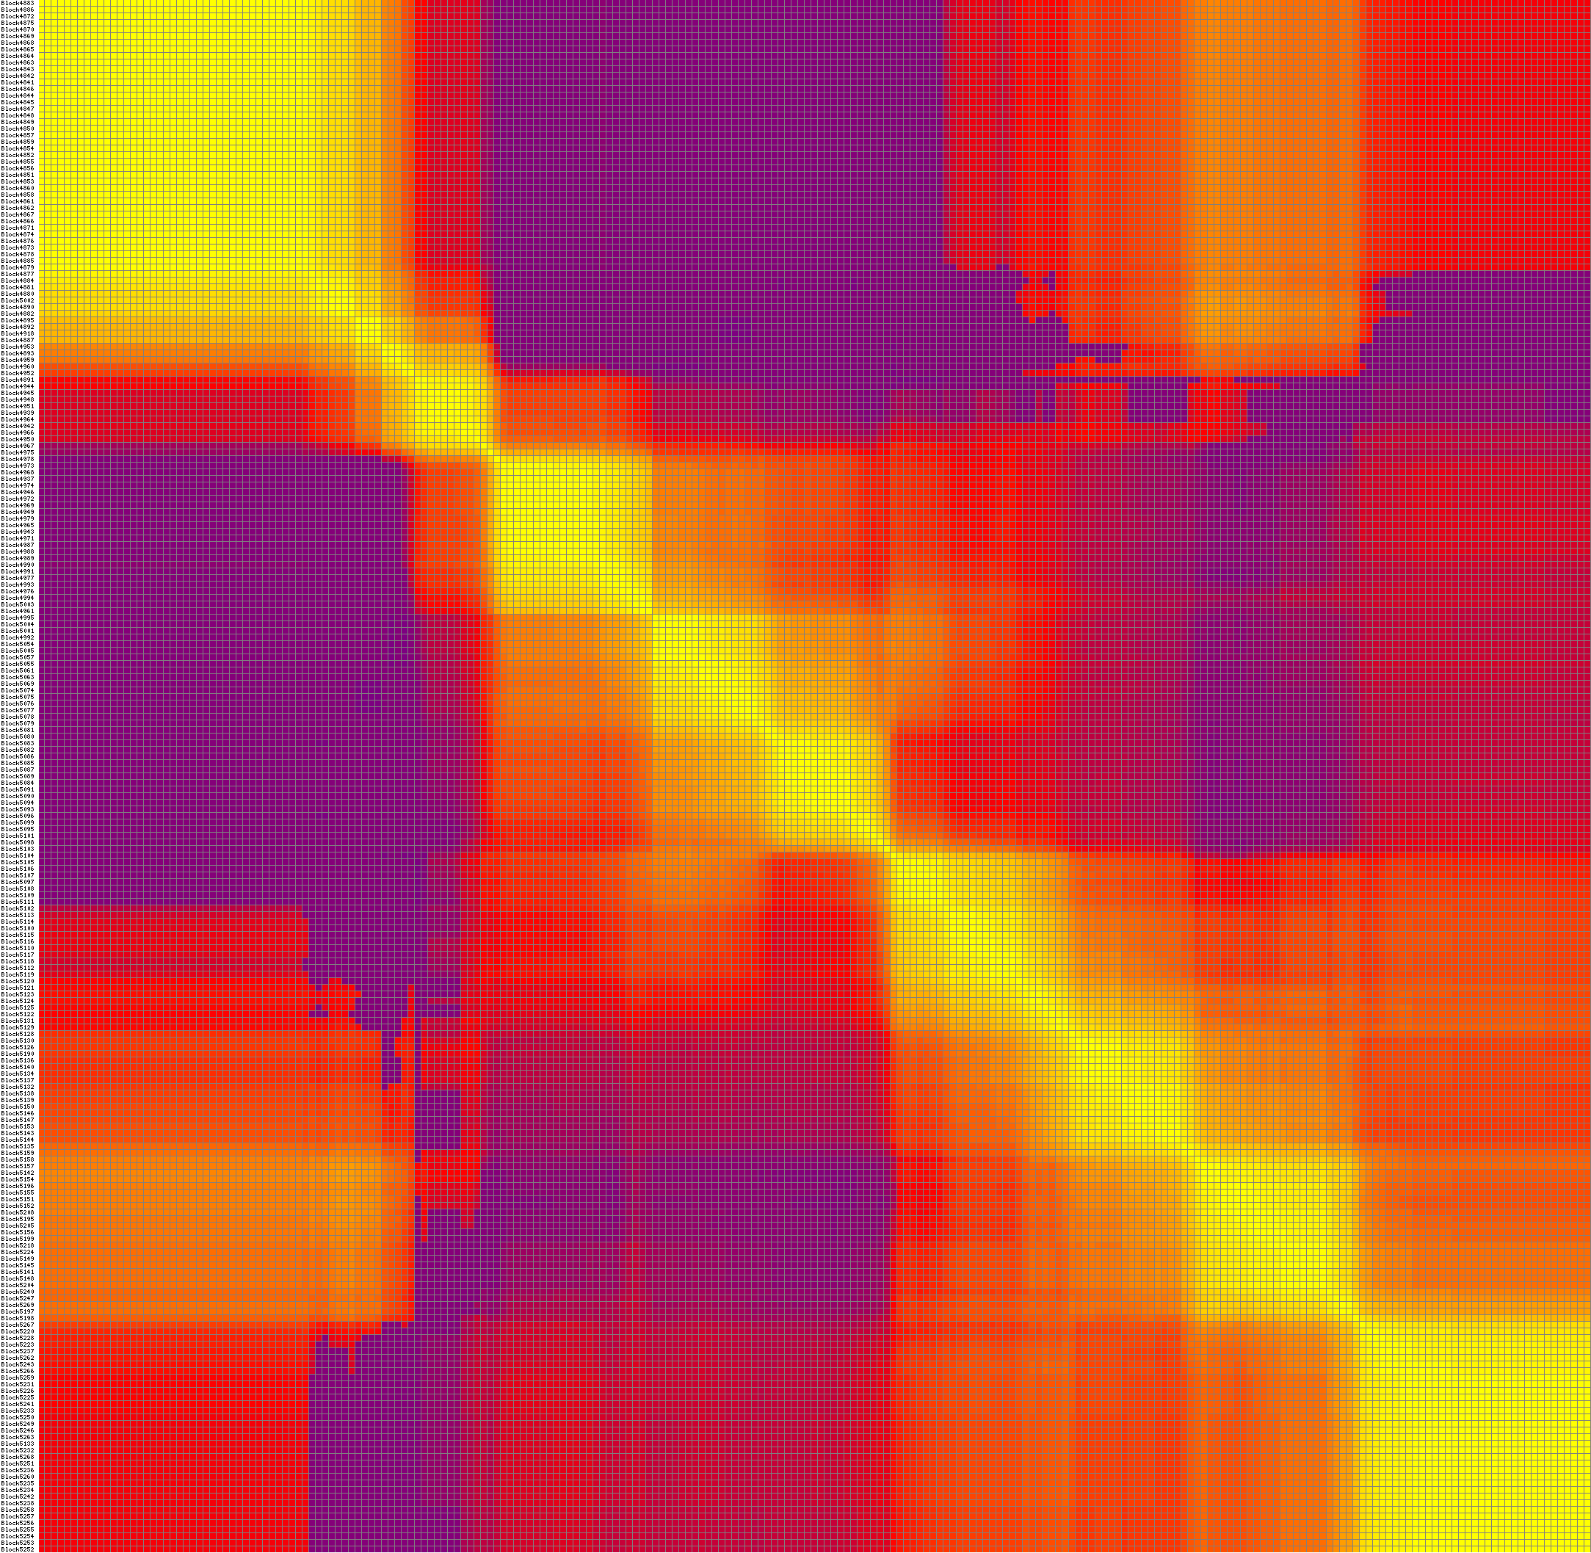

Linkage group A06:
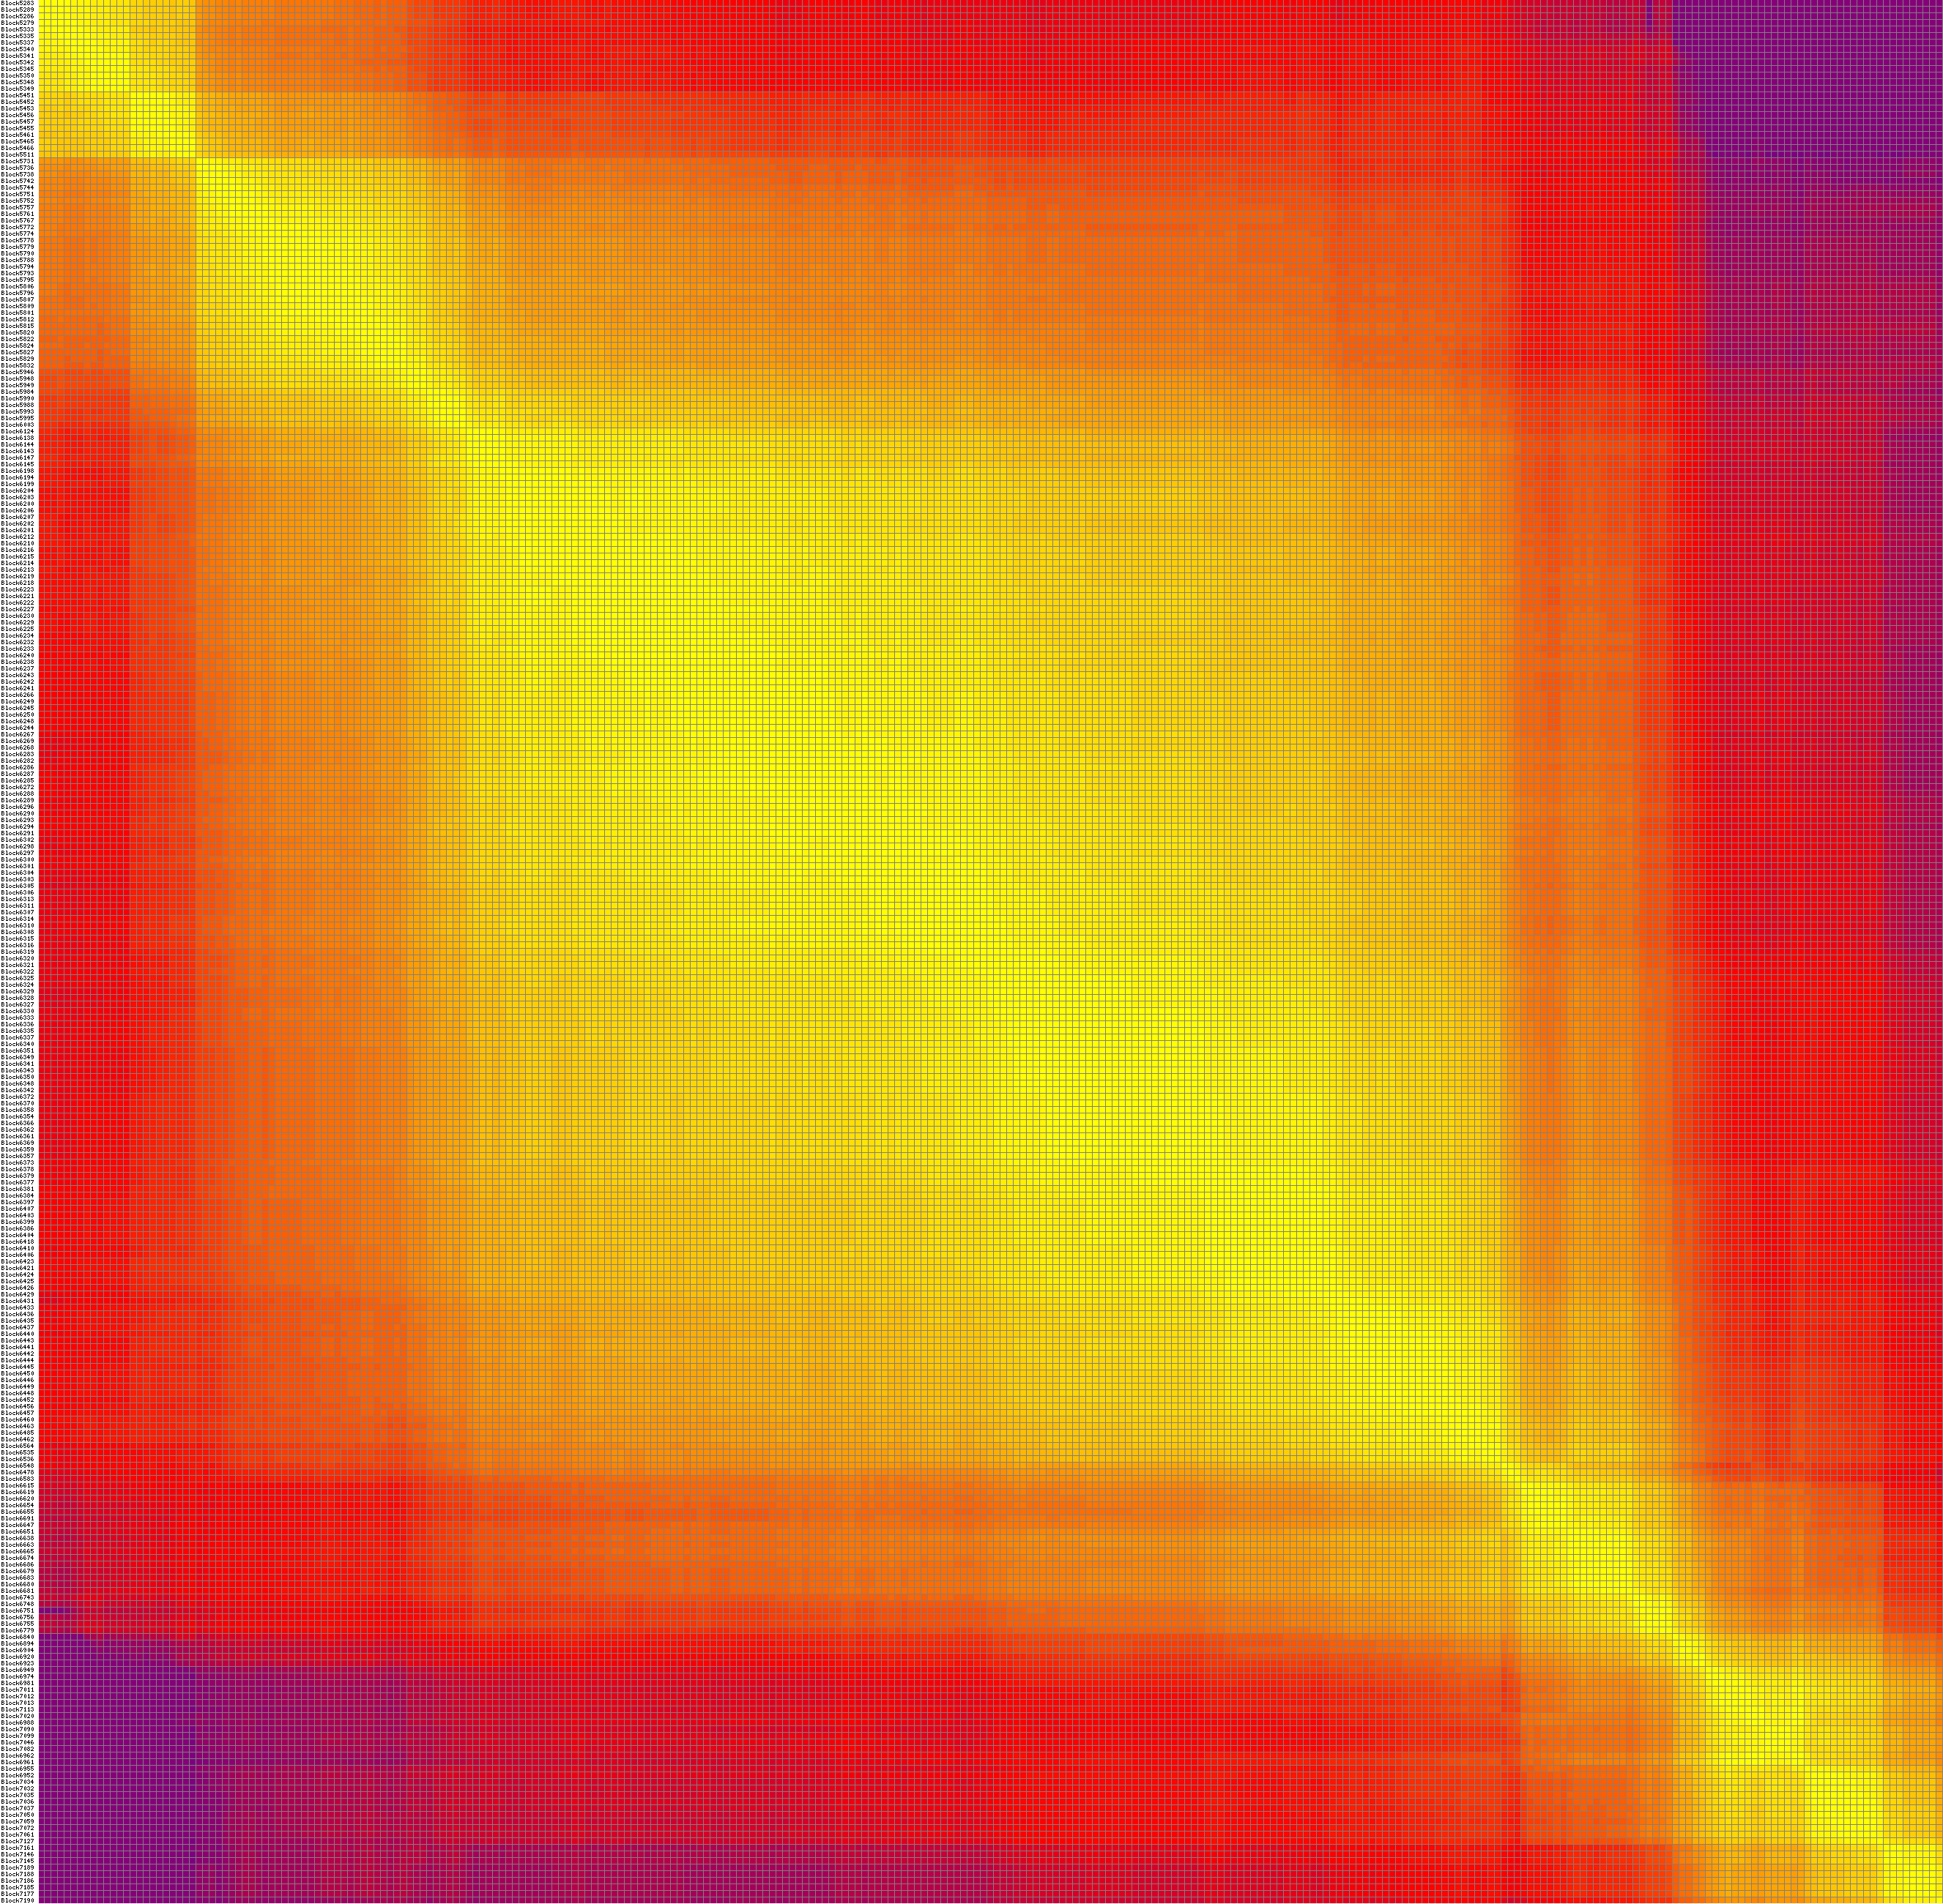

Linkage group A07:
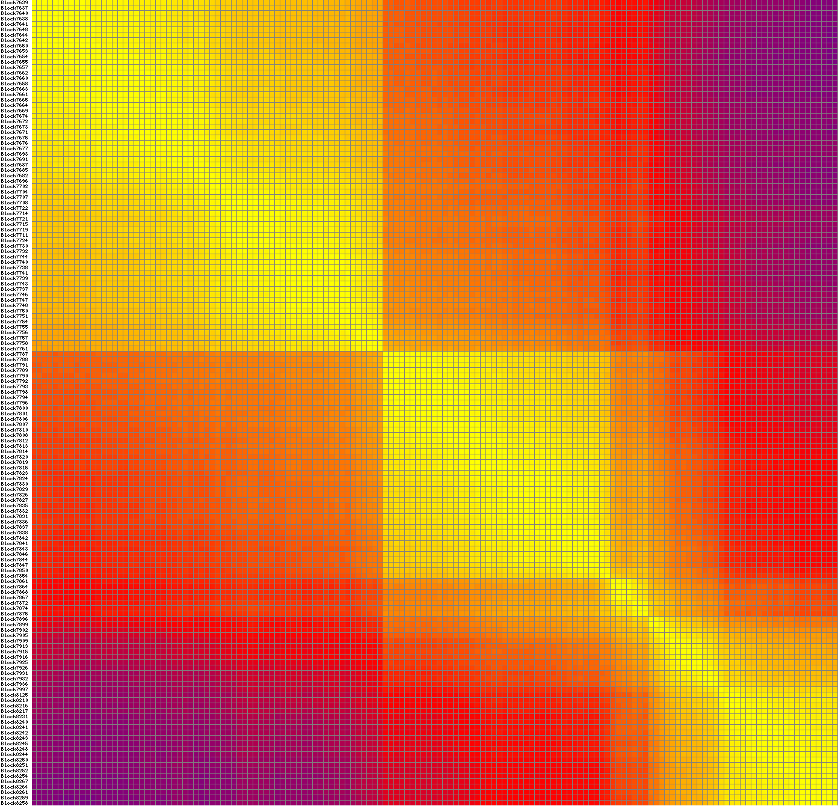

Linkage group A08:
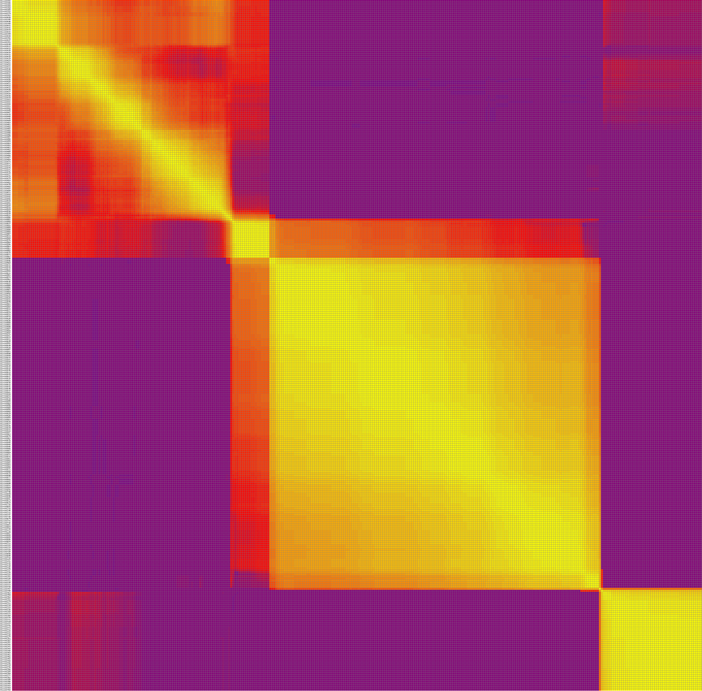

Linkage group A09:
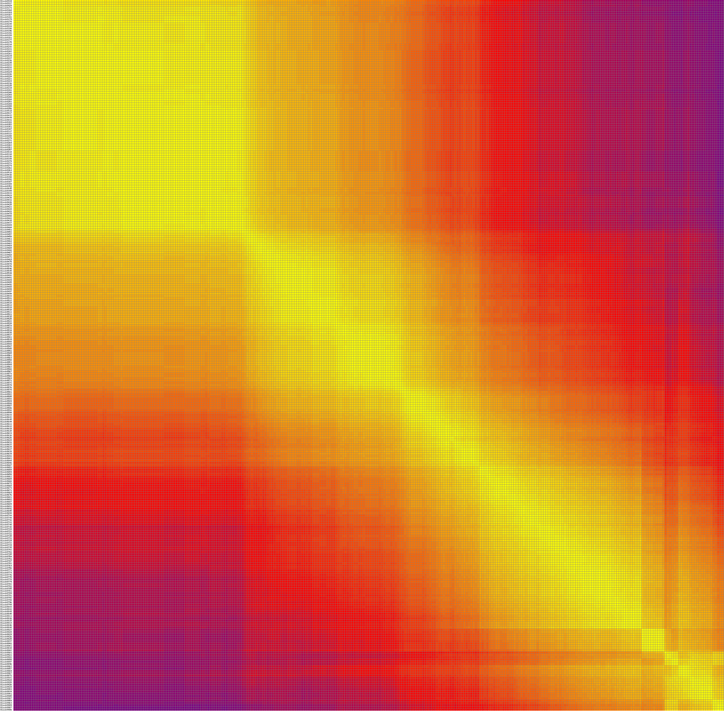

Linkage group A10:
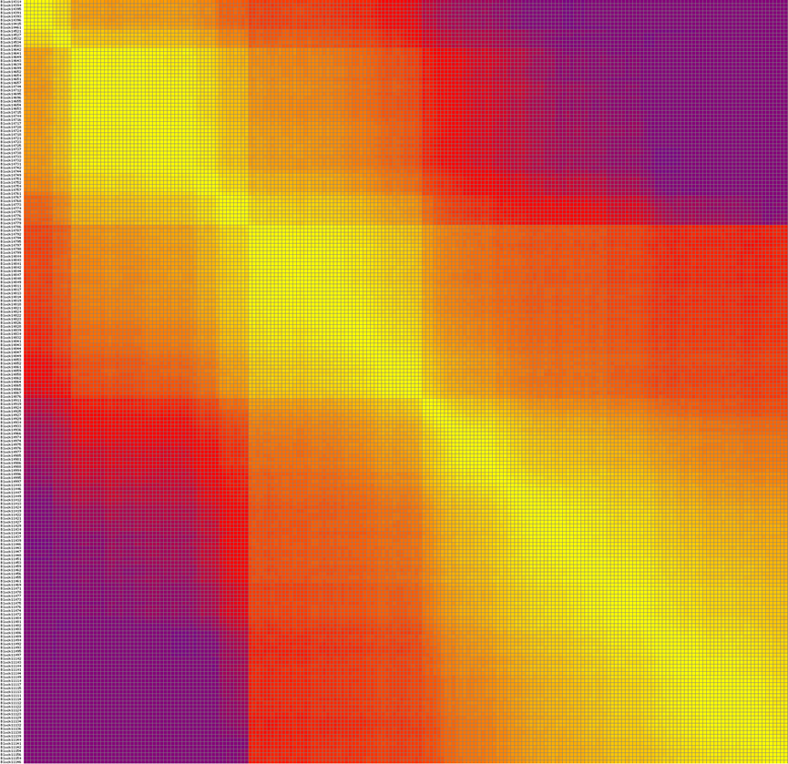

Linkage group C01:
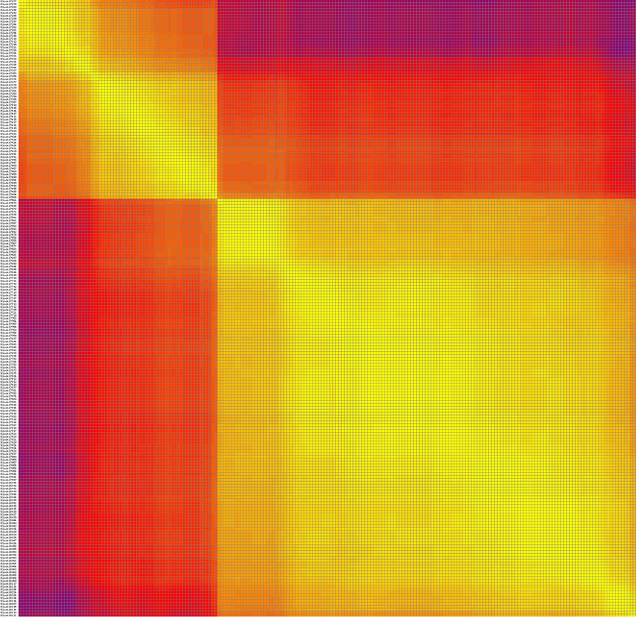

Linkage group C02:
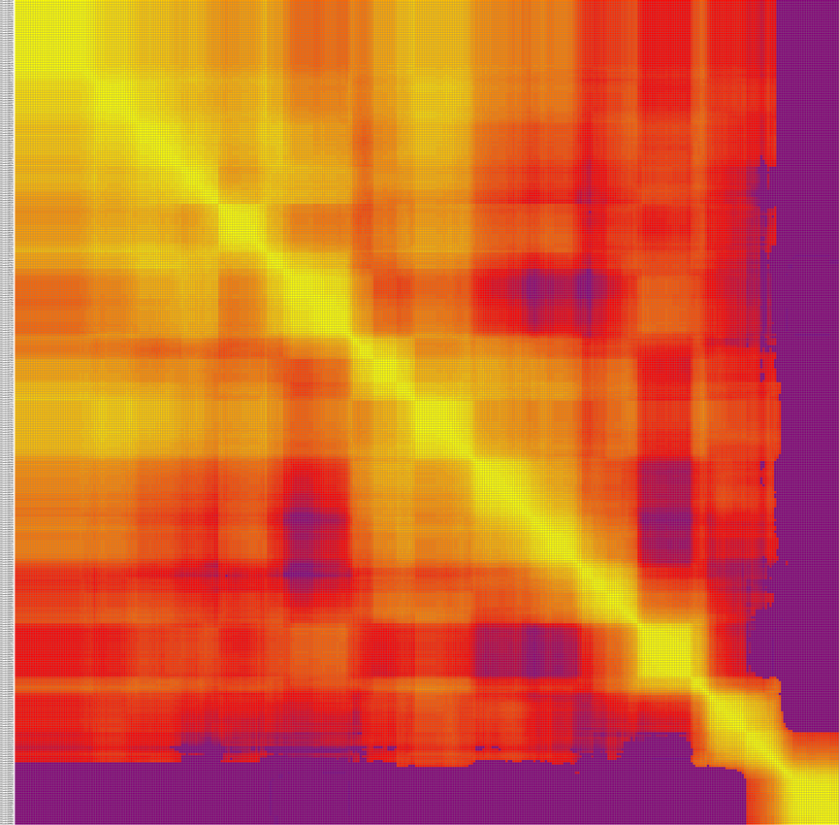

Linkage group C03:
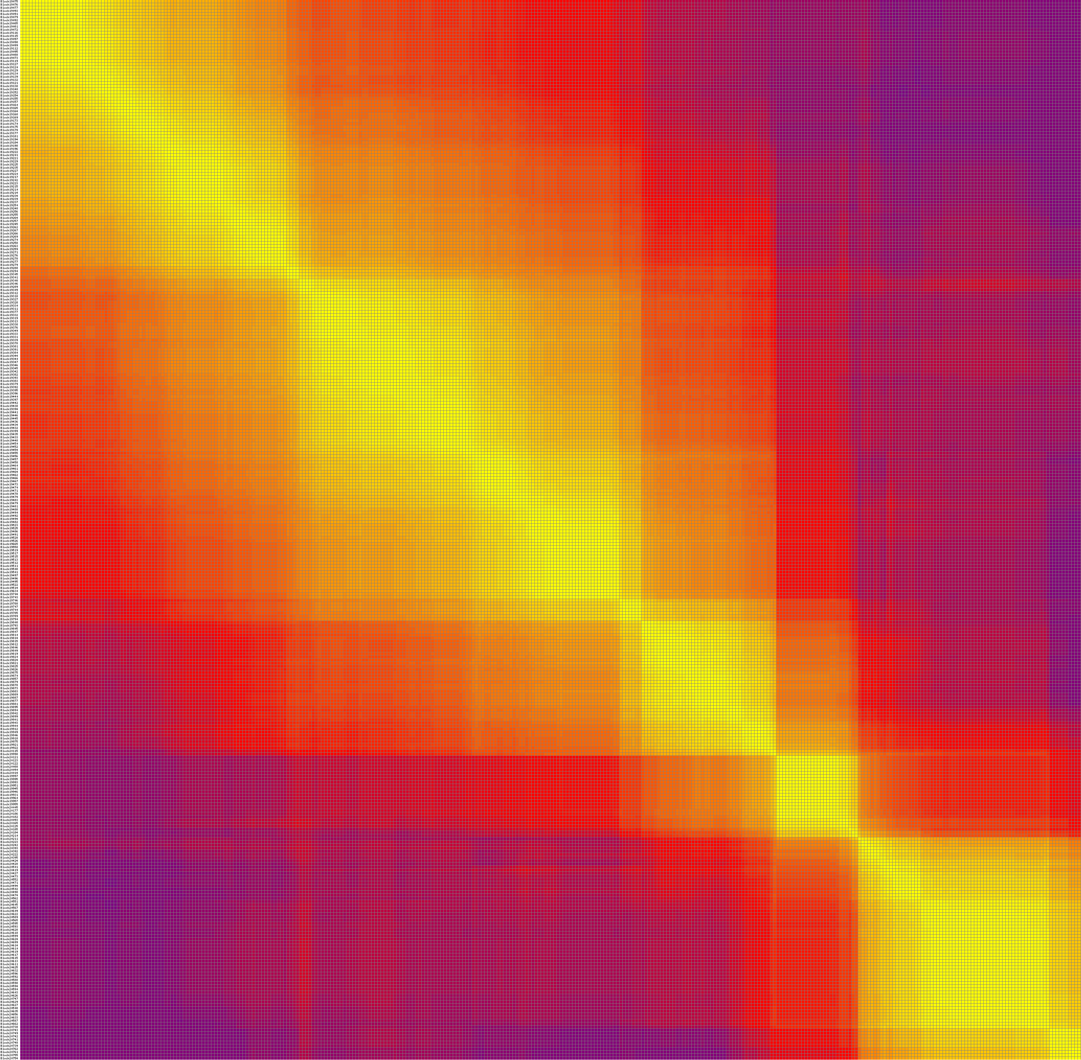

Linkage group C04:
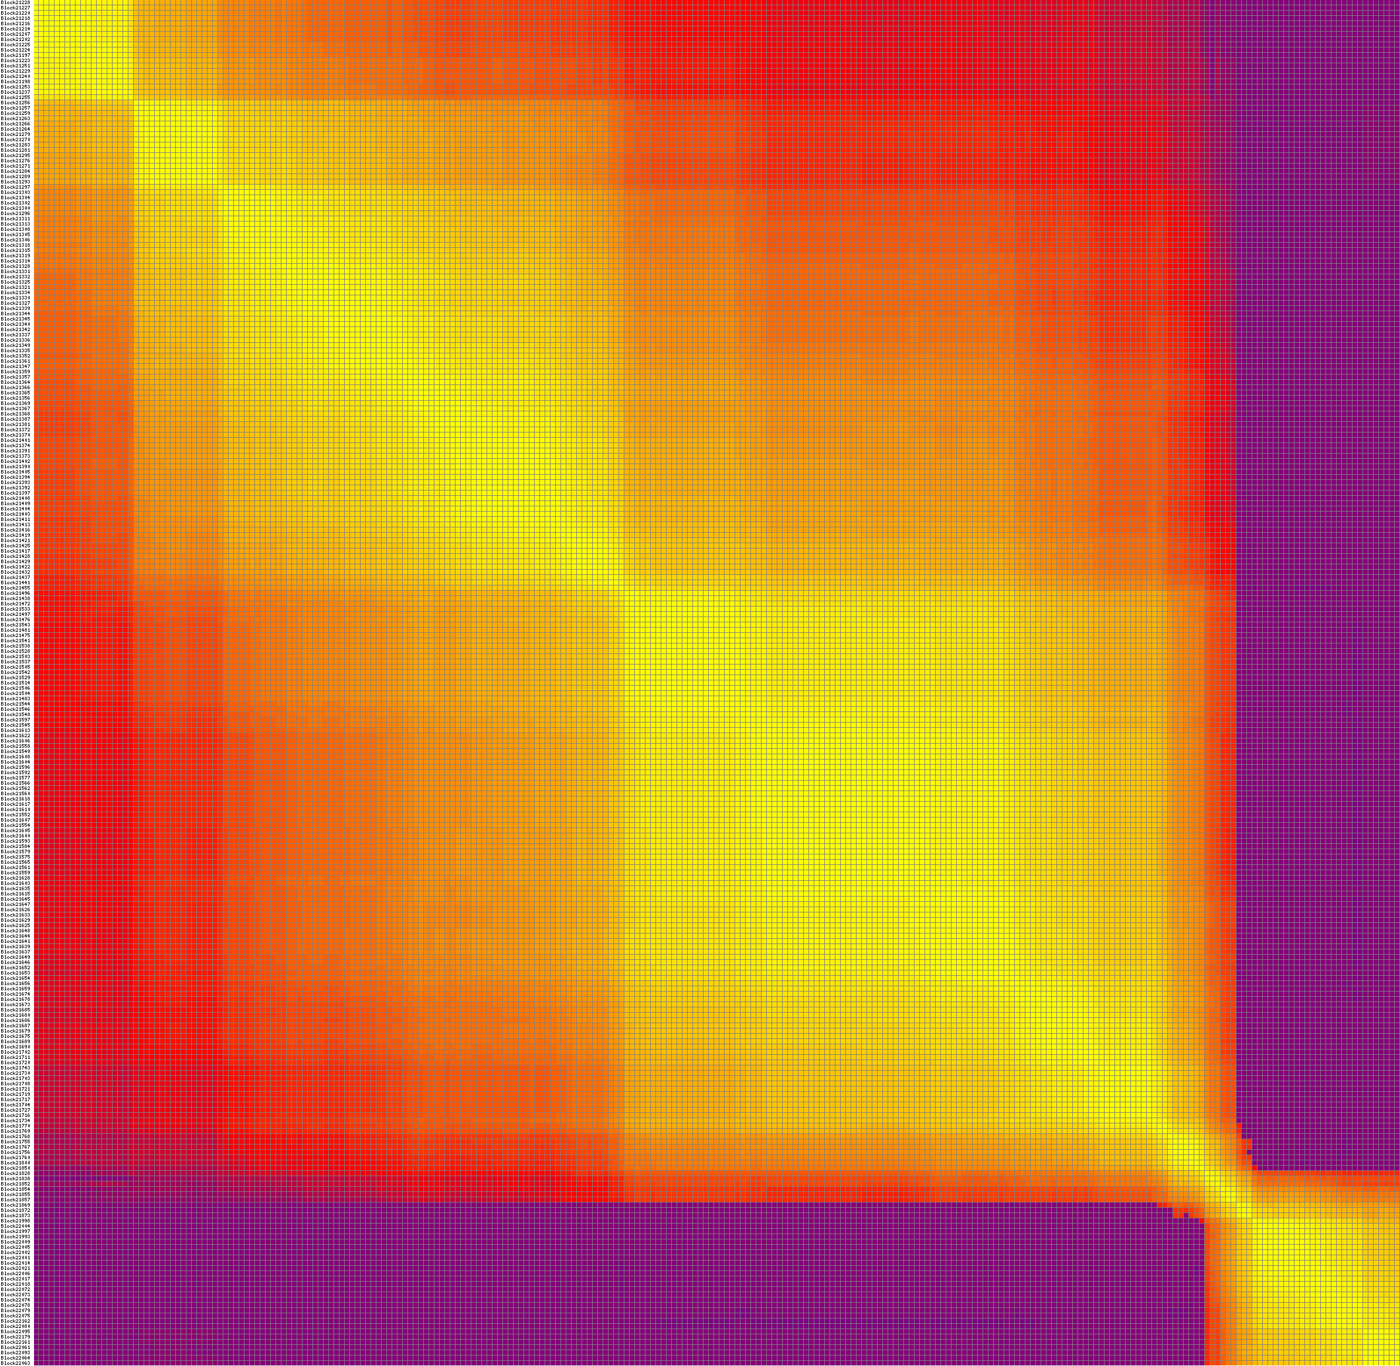

Linkage group C05:
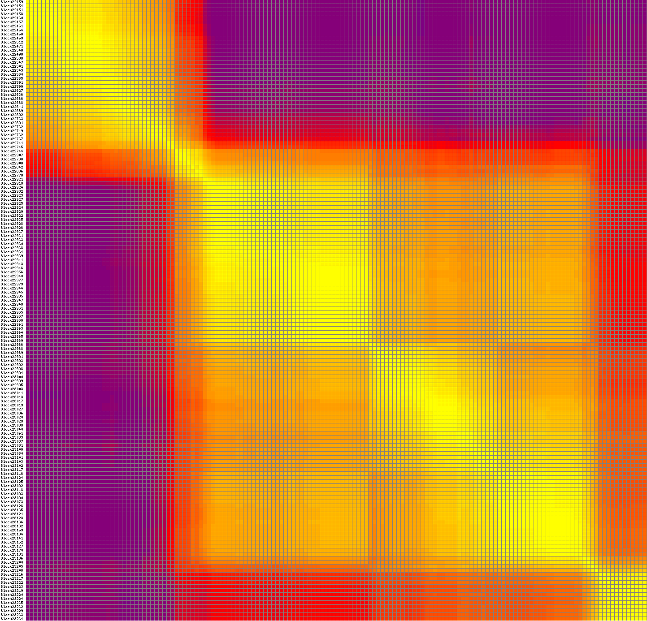

Linkage group C06:
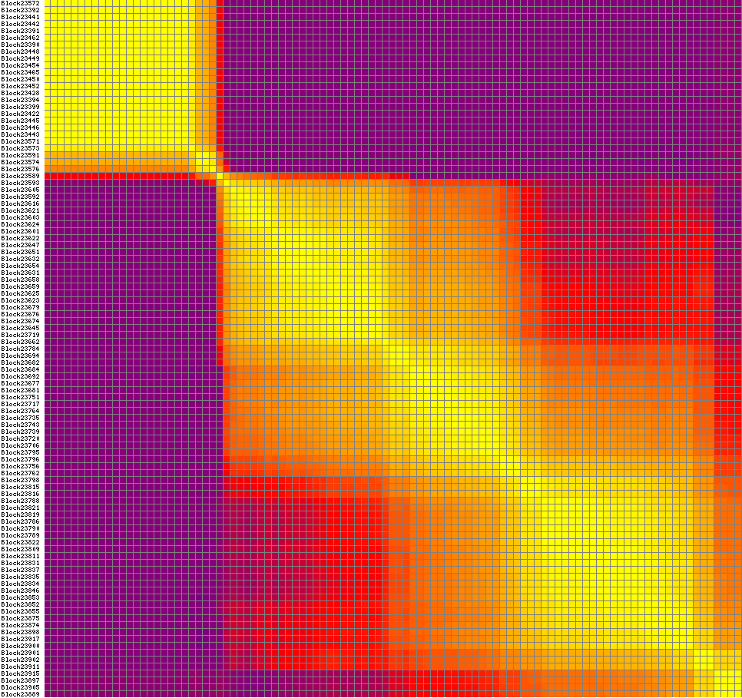

Linkage group C07:
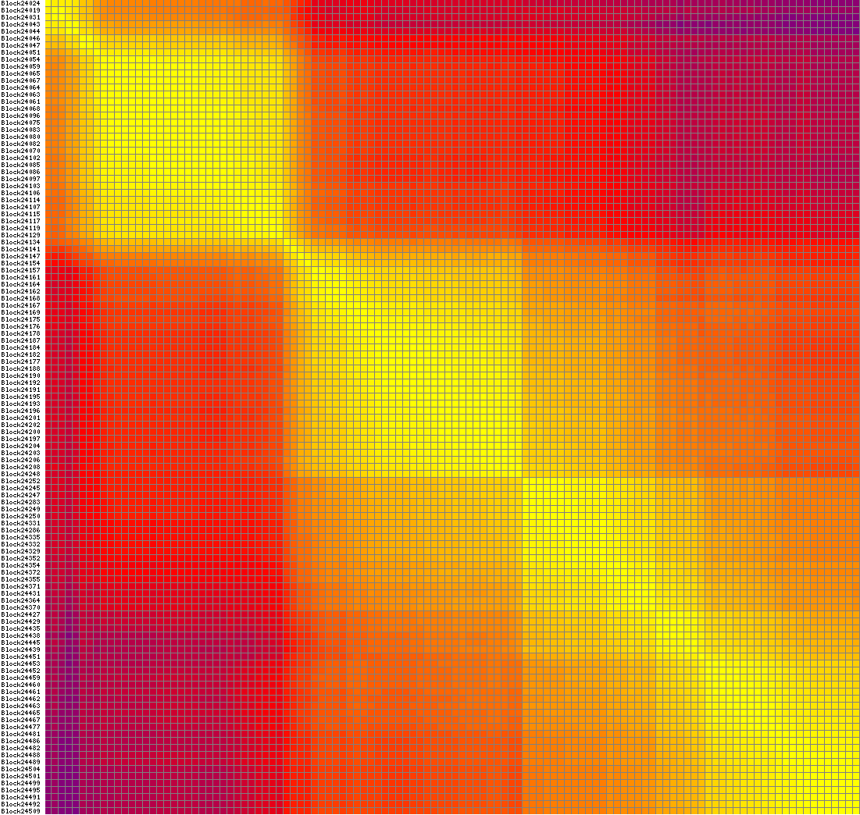

Linkage group C08:
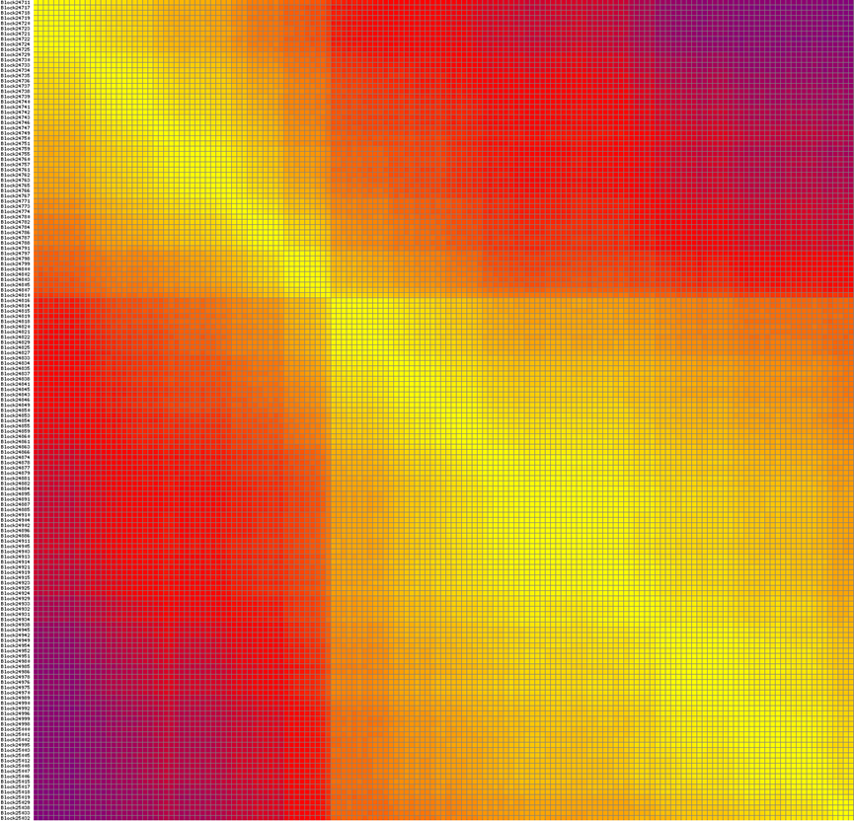

Linkage group C09:
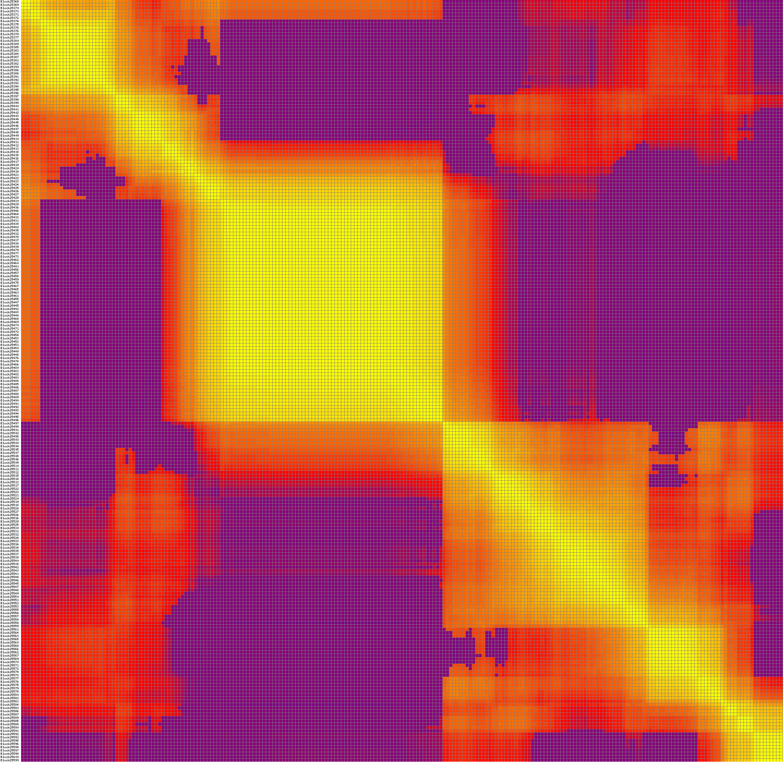

Figure S4 The QTL scanning for plant height in linkage group A10
A: QTL scanning by IM method, B: QTL scanning by CIM method. LOD, the logarithm of the odds; a, additive effect; d, dominant effect.

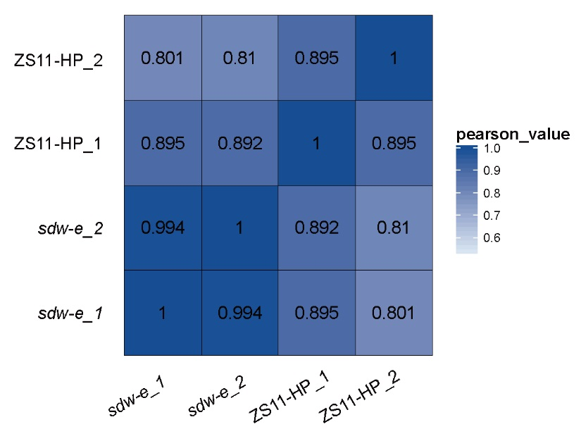
Figure S5 Spearman’s correlation plot of the four samples based on the RNA-seq data in the study.

