Supplementary Information

Prediction of biological age and evaluation of genome-wide dynamic methylomic changes throughout human aging
Mahmoud Amiri Roudbar, Seyedeh Fatemeh Mousavi, Siavash Salek Ardestani, Fernando Brito Lopes, Mehdi Momen, Daniel Gianola, Hasan Khatib.

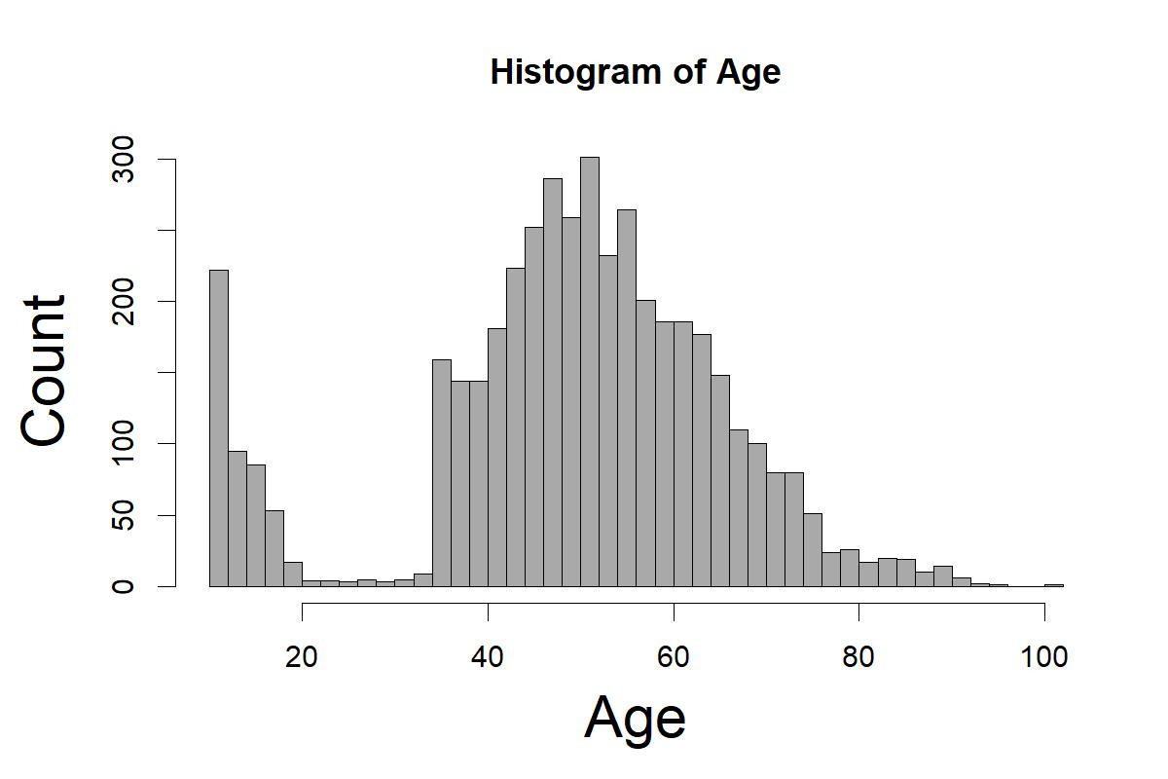
Figure S1. A histogram of the age distribution for all individuals.

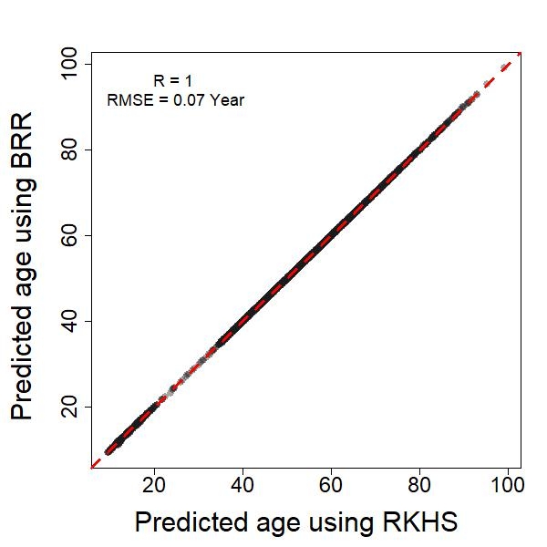
Figure S2. Scatter plot of methylomic predicted age for all individuals based on the Bayes Ridge Regression (BRR) and reproducing kernel Hilbert space (RKHS) approaches using a subset of the age-associated methylation sites. Correlation between predicted age using BRR and RKHS is close to one with a very small root mean square error (RMSE).

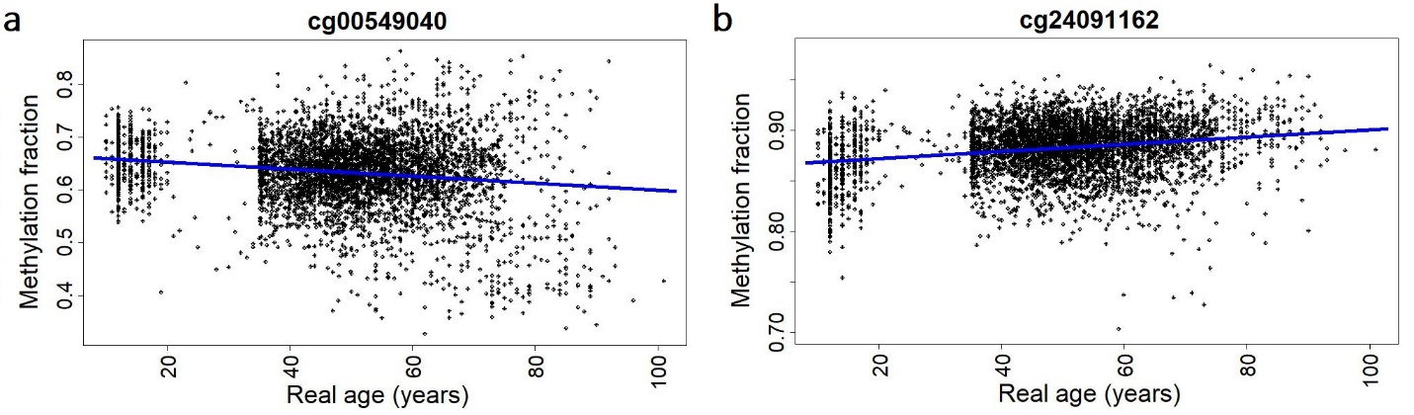

Figure S3. Plots of methylation beta values for markers with (a) and without (b) heteroscedasticity. Plots show changes in methylation residuals with age, defined as the difference between an individual’s methylation beta value and expected methylation beta value (blue line).
Table S1. Details of each dataset.
Availability | DNA origin | Sample size (Prob. Female) | Median age (range) | Mean age (SD) | Citation
GSE55763 | Peripheral blood | 2675 (0.32) | 50.1 (23.7, 75.0) | 51 (10.09) | Lehne et al. 2015
GSE40279 | Whole blood | 656 (0.52) | 65 (19, 101) | 64 (14.74) | Hannum et al. 2013
GSE56105 | Whole blood | 614 (0.49) | 14 (10, 75) | 21.3 (14.11) | McRae et al. 2014
GSE50660 | Peripheral blood | 464 (0.3) | 56 (38, 67) | 55.4 (6.66) | Tsaprouni et al. 2014

Table S2. The estimated parameters from the linear model for age with sex and dataset as fixed effects and B cell type as a covariate.
 | Estimate | Std. Error | t value | Pr(>|t|)
Intercept | 64.352 | 0.574 | 112.026 | 0.00E+00
Male | -0.89 | 0.356 | -2.5 | 1.24E-02
Dataset 'GSE50660' | -8.459 | 0.687 | -12.322 | 2.52E-34
Dataset 'GSE55763' | -12.882 | 0.495 | -26.046 | 3.21E-139
Dataset 'GSE56105' | -42.698 | 0.632 | -67.587 | 0.00E+00
B cell | 1.722 | 5.02 | 0.343 | 7.32E-01

Table S3. The estimated parameters from the linear model for age with sex and dataset as fixed effects and CD4T cell type as a covariate.
 | Estimate | Std. Error | t value | Pr(>|t|)
Intercept | 64.443 | 0.62 | 103.983 | 0.00E+00
Male | -0.886 | 0.356 | -2.49 | 1.28E-02
Dataset 'GSE50660' | -8.454 | 0.686 | -12.317 | 2.67E-34
Dataset 'GSE55763' | -12.881 | 0.495 | -26.043 | 3.47E-139
Dataset 'GSE56105' | -42.711 | 0.636 | -67.174 | 0.00E+00
CD4T cell | 0.154 | 2.913 | 0.053 | 9.58E-01

Table S4. The estimated parameters from the linear model for age with sex and dataset as fixed effects and CD8T cell type as a covariate.
 | Estimate | Std. Error | t value | Pr(>|t|)
Intercept | 64.342 | 0.551 | 116.871 | 0.00E+00
Male | -0.89 | 0.356 | -2.499 | 1.25E-02
Dataset 'GSE50660' | -8.46 | 0.686 | -12.323 | 2.49E-34
Dataset 'GSE55763' | -12.872 | 0.495 | -26.005 | 8.09E-139
Dataset 'GSE56105' | -42.677 | 0.635 | -67.195 | 0.00E+00
CD8T cell | 1.639 | 3.803 | 0.431 | 6.67E-01

Table S5. The estimated parameters from the linear model for age with sex and dataset as fixed effects and granulocyte cell type as a covariate.
 | Estimate | Std. Error | t value | Pr(>|t|)
Intercept | 64.353 | 1.157 | 55.612 | 0.00E+00
Male | -0.884 | 0.356 | -2.481 | 1.31E-02
Dataset 'GSE50660' | -8.454 | 0.686 | -12.316 | 2.71E-34
Dataset 'GSE55763' | -12.883 | 0.495 | -26.012 | 7E-139
Dataset 'GSE56105' | -42.71 | 0.632 | -67.554 | 0.00E+00
Granulocyte | 0.196 | 1.853 | 0.106 | 9.16E-01

Table S6. The estimated parameters from the linear model for age with sex and dataset as fixed effects and monocyte cell type as a covariate.
 | Estimate | Std. Error | t value | Pr(>|t|)
Intercept | 65.106 | 0.642 | 101.369 | 0.00E+00
Male | -0.884 | 0.356 | -2.486 | 1.30E-02
Dataset 'GSE50660' | -8.444 | 0.686 | -12.305 | 3.10E-34
Dataset 'GSE55763' | -12.864 | 0.495 | -26.01 | 7.34E-139
Dataset 'GSE56105' | -42.672 | 0.632 | -67.564 | 0.00E+00
Monocyte | -10.093 | 6.864 | -1.47 | 1.42E-01

Table S7. The estimated parameters from the linear model for age with sex and dataset as fixed effects and NK cell type as a covariate.
 | Estimate | Std. Error | t value | Pr(>|t|)
Intercept | 64.499 | 0.553 | 116.697 | 0.00E+00
Male | -0.884 | 0.356 | -2.484 | 1.30E-02
Dataset 'GSE50660' | -8.456 | 0.687 | -12.317 | 2.68E-34
Dataset 'GSE55763' | -12.886 | 0.497 | -25.948 | 2.95E-138
Dataset 'GSE56105' | -42.718 | 0.638 | -66.944 | 0.00E+00
NK cell | -0.395 | 3.325 | -0.119 | 9.06E-01

Table S8. The estimated parameters from the linear model for age with sex and dataset as fixed effects and B cell type as a covariate.
Method | No. of the CpG sites in the original model | No. of the missed CpG sites | Name of the missed CpG sites
Horvath multi-tissue | 353 | 2 | cg05755779; cg25683012
Horvath skin | 391 | 9 | cg18769120; cg23091758; cg26311454; cg13027206; cg25005357; cg11620135; cg21944491; cg21911021; cg01892695
Levine | 513 | 4 | cg18392482; cg01128603; cg20674577; cg08212685

Table S9. Results of the Breusch-Pagan test for heteroscedasticity of aDMPs from un-adjusted beta values.
 | Number of markers with heteroscedasticity (% of increased with aging) | Number of markers without heteroscedasticity
All markers | 121023 (97.29) | 2907
CpG Island | 35122 (97.91) | 753
CpG Shore | 31132 (96.83) | 671
CpG Shelf | 11136 (97.41) | 297
CpG Open Sea | 43633 (97.1) | 1186
Enhancer | 35279 (97.65) | 832
DHS | 21347 (97.41) | 491
CDMR; DMR; RDMR¹ | 2840 (98.8); 9835 (99.08); 5204 (97.67) | 48; 186; 91
Regulatory associated | 37292 (95.4) | 1110
¹DMR, Differentially Methylated Region; CDMR, Cancer-specific Differentially Methylated Region; RDMR, Reprogramming-specific Differentially Methylated Region.
Table S10. Age-associated methylation sites properties from the adjusted and un-adjusted beta values.
 | Total number of markers | Number of associated markers in adjusted (% of positively associated) | Number of associated markers in un-adjusted (% of positively associated)
All associated markers | 423394 | 107806 (47.25) | 123930 (41.11)
CpG Island | 150254 | 35510 (82.86) | 35875 (82.76)
CpG Shore | 112067 | 27438 (45.6) | 31803 (38.84)
CpG Shelf | 47144 | 8873 (16.7) | 11433 (14.2)
CpG Open Sea | 176047 | 35985 (20.9) | 44819 (16.24)
Enhancer | 102559 | 30174 (41.19) | 36111 (34.12)
DHS | 59916 | 19919 (69.6) | 21838 (62.89)
CDMR; DMR; RDMR¹ | 6659; 18447; 12231 | 2507 (66.57); 9767 (94.23); 4770 (60.86) | 2888 (62.53); 10021 (93.85); 5295 (55.6)
Regulatory associated | 170092 | 35542 (54.66) | 38402 (51.41)
5' UTR | 65535 | 14202 (56.63) | 15640 (51.53)
1st exon | 39372 | 8732 (69.42) | 8979 (67.6)
¹DMR, Differentially Methylated Region; CDMR, Cancer-specific Differentially Methylated Region; RDMR, Reprogramming-specific Differentially Methylated Region.

Table S11. The estimated parameters of the linear model for the average of un-adjusted methylation from the associated markers located at the CpG islands with sex, dataset, and age as fixed effects.
 | Estimate | Std. Error | t value | Pr(>|t|)
Intercept | 1.77E-01 | 9.37E-04 | 188.89 | 0.00E+00
Age | 3.46E-04 | 1.31E-05 | 26.48 | 1.59E-143
Dataset 'GSE50660' | 6.25E-03 | 6.06E-04 | 10.32 | 1.10E-24
Dataset 'GSE55763' | 9.91E-03 | 4.61E-04 | 21.5 | 1.48E-97
Dataset 'GSE56105' | 6.96E-03 | 7.82E-04 | 8.91 | 7.58E-19
Male | 9.50E-04 | 3.09E-04 | 3.07 | 2.12E-03

Table S12. The estimated parameters of the linear model for the average of un-adjusted methylation from the associated markers located at the CpG shores with sex, dataset, and age as fixed effects.
 | Estimate | Std. Error | t value | Pr(>|t|)
Intercept | 4.29E-01 | 6.35E-04 | 674.99 | 0.00E+00
Age | -1.23E-04 | 8.87E-06 | -13.92 | 4.02E-43
Dataset 'GSE50660' | 3.69E-03 | 4.11E-04 | 8.98 | 3.83E-19
Dataset 'GSE55763' | 4.04E-03 | 3.13E-04 | 12.93 | 1.42E-37
Dataset 'GSE56105' | 2.48E-03 | 5.30E-04 | 4.69 | 2.88E-06
Male | -6.21E-04 | 2.09E-04 | -2.97 | 3.03E-03

Table S13. The estimated parameters of the linear model for the average of un-adjusted methylation from the associated markers located at the CpG shelves with sex, dataset, and age as fixed effects.
 | Estimate | Std. Error | t value | Pr(>|t|)
Intercept | 6.75E-01 | 7.27E-04 | 928.93 | 0.00E+00
Age | -3.00E-04 | 1.01E-05 | -29.61 | 7.41E-176
Dataset 'GSE50660' | -7.71E-03 | 4.70E-04 | -16.41 | 8.40E-59
Dataset 'GSE55763' | -7.21E-03 | 3.58E-04 | -20.15 | 1.99E-86
Dataset 'GSE56105' | -1.74E-03 | 6.07E-04 | -2.86 | 4.27E-03
Male | -9.76E-04 | 2.40E-04 | -4.07 | 4.78E-05

Table S14. The estimated parameters of the linear model for the average of un-adjusted methylation from the associated markers located at the CpG open seas with sex, dataset, and age as fixed effects.
 | Estimate | Std. Error | t value | Pr(>|t|)
Intercept | 6.57E-01 | 7.40E-04 | 887.07 | 0.00E+00
Age | -2.93E-04 | 1.03E-05 | -28.4 | 4.65E-163
Dataset 'GSE50660' | -6.22E-03 | 4.78E-04 | -13 | 6.24E-38
Dataset 'GSE55763' | -9.15E-03 | 3.64E-04 | -25.14 | 1.99E-130
Dataset 'GSE56105' | -1.58E-03 | 6.18E-04 | -2.56 | 1.04E-02
Male | -5.84E-04 | 2.44E-04 | -2.39 | 1.68E-02

Table S15. Diseases associated with the set of genes that were determined to have age-associated methylation alterations using genetic association database (GAD).
GAD term | Count | % | FDR
Tobacco Use Disorder | 2177 | 20.62 | 8.39E-138
Hip | 241 | 2.28 | 2.10E-05
Body Mass Index | 308 | 2.92 | 6.36E-05
Erythrocyte Count | 136 | 1.29 | 2.86E-04
Cholesterol | 275 | 2.60 | 3.01E-04
Body Height | 356 | 3.37 | 6.39E-04
Waist Circumference | 170 | 1.61 | 9.06E-04
Heart Rate | 178 | 1.69 | 1.12E-03
Heart Failure | 248 | 2.35 | 1.26E-03
Type 2 Diabetes | 1244 | 11.78 | 2.26E-03
Hemoglobins | 173 | 1.64 | 4.08E-03
Triglycerides | 275 | 2.60 | 5.41E-03
Arteries | 112 | 1.06 | 6.31E-03
Celiac Disease | 191 | 1.81 | 8.97E-03
Coronary Artery Disease | 315 | 2.98 | 1.05E-02
Body Weight | 258 | 2.44 | 1.13E-02
Cell Adhesion Molecules | 53 | 0.50 | 1.19E-02
Stroke | 332 | 3.14 | 1.62E-02
Alcoholism | 312 | 2.96 | 2.88E-02
Blood Pressure | 285 | 2.70 | 3.51E-02
Iron | 169 | 1.60 | 4.27E-02
Parkinson Disease | 142 | 1.34 | 4.55E-02

Table S16. KEGG Pathway associated with our set of genes that were determined to have age-associated methylation alterations.
KEGG pathway term | Count | % | FDR
hsa04510:Focal adhesion | 147 | 1.39 | 3.35E-08
hsa04810:Regulation of actin cytoskeleton | 142 | 1.34 | 2.53E-05
hsa04724:Glutamatergic synapse | 83 | 0.79 | 2.99E-04
hsa04152:AMPK signaling pathway | 88 | 0.83 | 4.38E-04
hsa04728:Dopaminergic synapse | 90 | 0.85 | 1.09 E-03
hsa04014:Ras signaling pathway | 146 | 1.38 | 1.14 E-03
hsa04071:Sphingolipid signaling pathway | 85 | 0.80 | 1.42 E-03
hsa04151:PI3K-Akt signaling pathway | 211 | 2.00 | 1.54 E-03
hsa04520:Adherens junction | 55 | 0.52 | 2.09E-03
hsa05100:Bacterial invasion of epithelial cells | 59 | 0.56 | 3.10E-03
hsa04022:cGMP-PKG signaling pathway | 106 | 1.00 | 3.54E-03
hsa05200:Pathways in cancer | 235 | 2.23 | 4.10E-03
hsa04012:ErbB signaling pathway | 64 | 0.61 | 5.25E-03
hsa05231:Choline metabolism in cancer | 72 | 0.68 | 7.59E-03
hsa04010:MAPK signaling pathway | 158 | 1.50 | 7.60E-03
hsa04919:Thyroid hormone signaling pathway | 80 | 0.76 | 9.36E-03
hsa04261:Adrenergic signaling in cardiomyocytes | 93 | 0.88 | 1.20E-02
hsa04015:Rap1 signaling pathway | 133 | 1.26 | 1.68E-02
hsa04911:Insulin secretion | 61 | 0.58 | 3.28E-02
hsa04512:ECM-receptor interaction | 62 | 0.59 | 3.91E-02

Table S17. Estimates of regression coefficient and their standard error (in parentheses) and AIC from models without or with sex effect (Model 1 and 2, respectively) and model with interaction between age and sex (Model 3) for AMAR in reproducing kernel Hilbert space (RKHS) and Bayesian Ridge Regression (BRR) approaches; best model is displayed in bold according to AIC estimates.
Approach | Model | Intercept (SE) | Reg. Coef. of Age (SE) | Reg. Coef. of Male (SE) | Reg. Coef. of Male:age (SE) | AIC
RKHS | Model 1 | 1.01e+00 (6.44e-04) | -1.14e-04 (1.24e-05) | - | - | -25369.55
 | Model 2 | 1.01e+00 (6.96e-04) | -1.14e-04 (1.24e-05) | -4.19e-04 (4.24e-04) | - | -25368.53
 | Model 3 | 1.01e+00 (9.77e-04) | -1.60e-04 (1.87e-05) | -4.46e-03 (1.30e-03) | 8.21e-05 (2.50e-05) | -25377.35
BRR | Model 1 | 1.01e+00 (6.46e-04) | -9.56e-05 (1.24e-05) | - | - | -25342.9
 | Model 2 | 1.01e+00 (6.98e-04) | -9.55e-05 (1.24e-05) | -5.02e-04 (4.26e-04) | - | -25342.29
 | Model 3 | 1.01e+00 (9.79e-04) | -1.44e-04 (1.87e-05) | -4.73e-03 (1.30e-03) | 8.60e-05 (2.50e-05) | -25352.09

