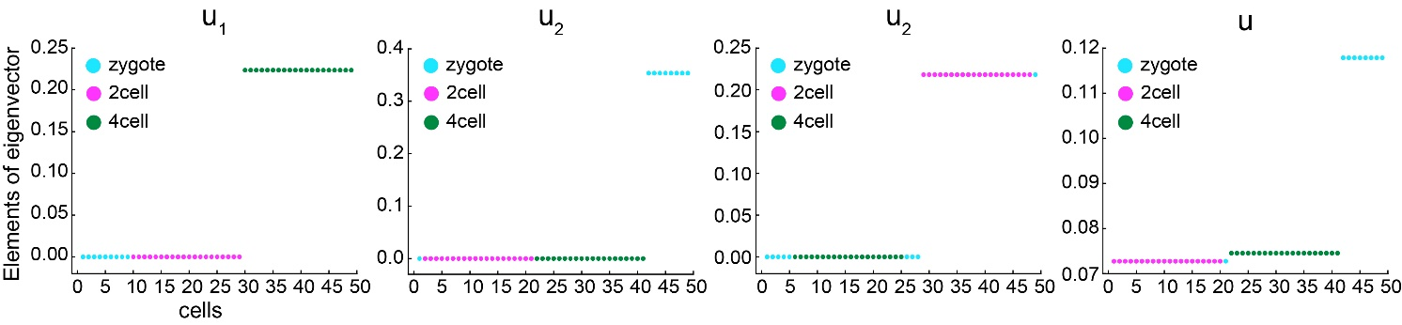
Figure S1. The center of eigenvectors corresponding to the eigenvalue 0 of L improves the clustering accuracy. $u_{1}$, $u_{2}$, and $u_{3}$ are the eigenvectors corresponding to the top three smallest eigenvalues of Laplace matrix of $L$ generated from Biase’s dataset, $u$ is the center of $u_{1}$, $u_{2}$, and $u_{3}$.

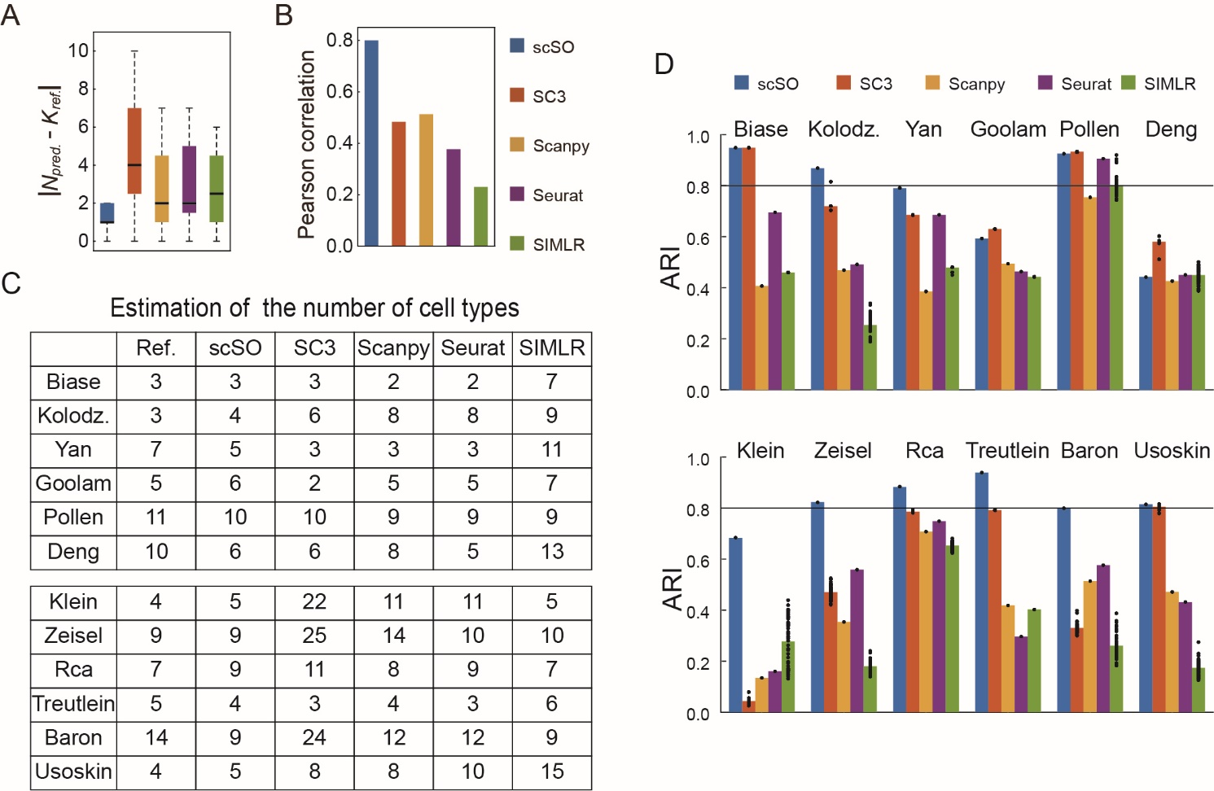
Figure S2. Results of different methods using their own filtering and normalization processes, as in Fig. 2. (A) Difference ($∆_{m}$) between the reference and predicted cell type numbers. Center line, median; box limits, upper and lower quartiles; whiskers, 1.5x interquartile range. (B) Pearson correlation coefficient between the reference and predicted cell type numbers. (C) A table listing the reference cell type numbers reported by the data source papers, and the predicted cell type numbers generated by different methods. (D) ARI values between the reference cell types and predicted cell clusters. Bar: average ARI; Dots: ARI values for multiple runs. SC3 and SIMLR were performed 50 times for each dataset.
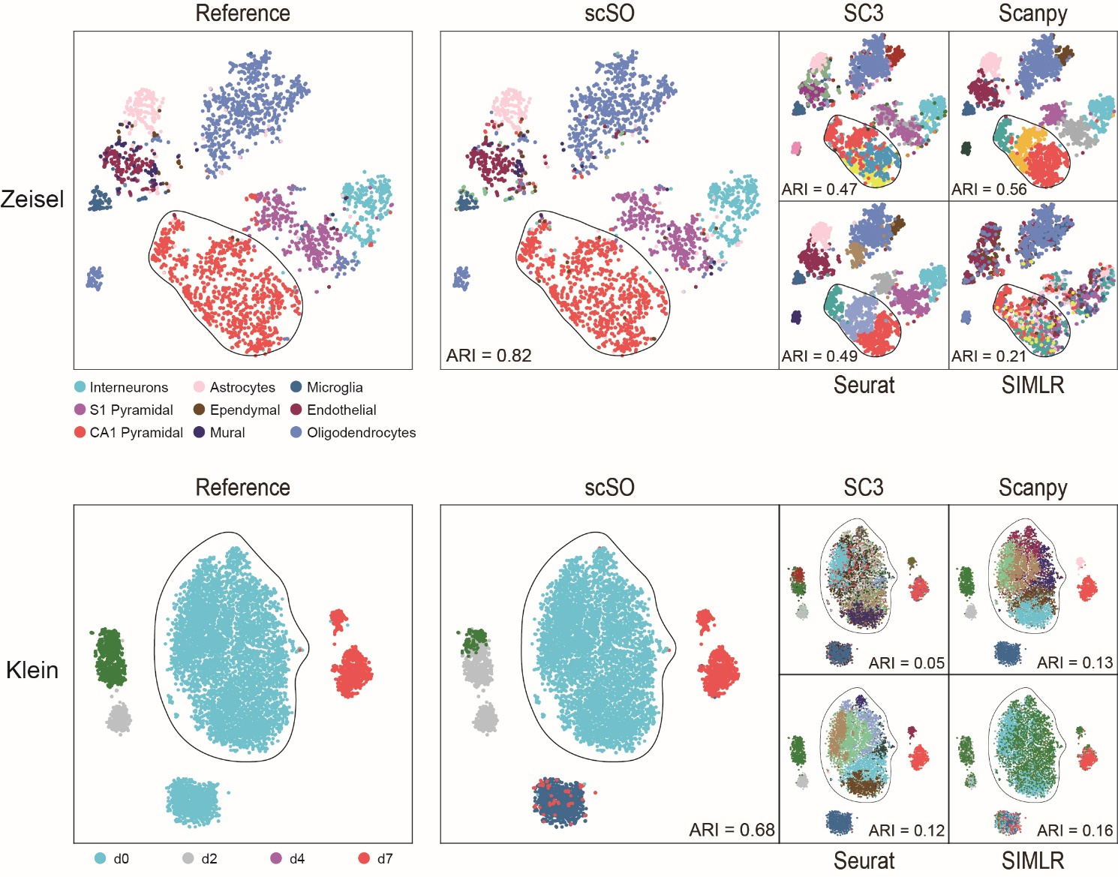
Figure S3. Clustering results of different methods on single-cell datasets (Upper: Zeisel’s dataset; Bottom: Klein’s dataset). 2D-TSNE embedding of the cells in those datasets, colored by the reference cell types (left panel), and the cell clusters predicted by different methods (right panels).

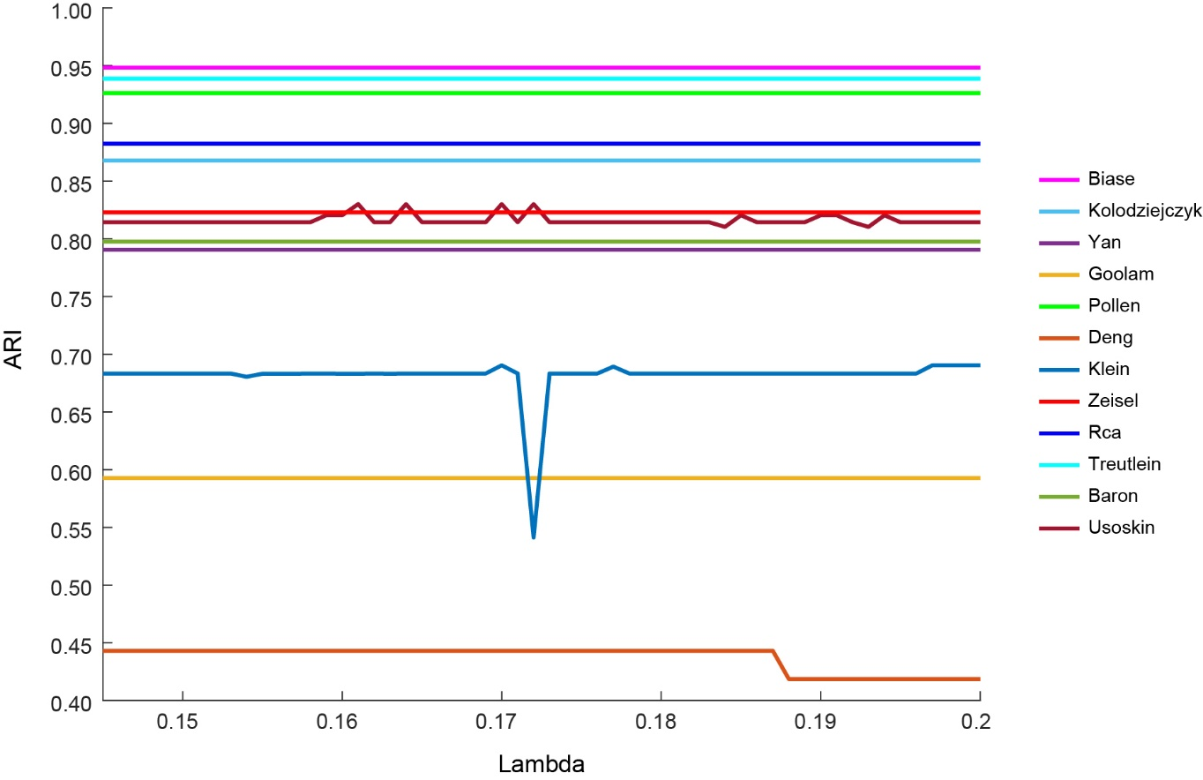
Figure S4. Clustering results of scSO corresponding to different balance parameters $λ$. The horizontal axis and the vertical axis represent $λ$ and ARI values, respectively. The color of the solid line indicates different datasets.

