ONLINE SUPPLEMENT

Heritability of Fat Distributions in the Founder Strains of Diversity Outbred Mice

Brendan T. Keenan*, Jeanette C. Webster*, Andrew S. Wiemken*, Nir Lavi-Romer*,
Teresa Nguyen*, Karen L. Svenson†, Raymond J. Galante*, Gary A. Churchill†, Stephen Pickup‡, Allan I. Pack*, Richard J. Schwab*

*Division of Sleep Medicine, Department of Medicine, University of Pennsylvania, Philadelphia, PA
†The Jackson Laboratory, Bar Harbor, ME
‡Department of Radiology, University of Pennsylvania, Philadelphia, PA

Supplemental Methods 1-3
Figure S1: Comparison of Body Weight among Founder Strains 4
Figure S2: Comparison of Abdominal Fat Measurements among Founder Strains 5
Figure S3: Comparison of Thoracic Fat Measurements among Founder Strains 6
Figure S4: Comparison of Neck Fat Measurements among Founder Strains 7
Figure S5: Heritability Estimates with and without the NZO/HILtJ Strain 8
Supplemental References 9

SUPPLEMENTAL METHODS

Magnetic Resonance Imaging Methods
Images were obtained on the euthanized mice for approximately 30 minutes on a 9.4 Tesla 31 cm horizontal bore MR system equipped with a 12 cm ID, 40 gauss/cm gradient tube and interfaced to an Avance III console (Bruker, Billerica, MA). Following euthanasia, animals were mounted in a 35 x 40 (ID x Length) mm quadrature birdcage coil (M2M, Cleveland, OH) such that the abdomen was centered in the coil and the coil was positioned in the magnet. The scanner was calibrated, a series of scout images acquired, and a contiguous axial series spanning from the rostral end of the xiphoid process to the first sacral vertebra was acquired using a three point Dixon (Glover and Schneider 1991) spin-echo method (TE = 6 msec, TR = 2 sec, matrix = 128 x 128, FOV = 40 x 40 mm, slice thickness = 0.4, slices = 120, averages = 1, receiver band width = 50 kHz, total acquisition time ~ 13 min). The protocol employed echo shifts of $∆t=-π/{6ω_{f}}+{2nπ}/{3ω_{f}}$ where $ω_{f}$ was the offset of the main lipid resonance and n = 0, 1 and 2 (Pineda et al. 2005). At the conclusion of the scan, the coil was removed from the magnet and the animal was repositioned such that the thorax was centered in the coil and the above protocol was repeated for an axial series including all anatomy rostral to the caudal tip of the xiphoid process. The animal was then removed from the magnet and mounted in a 20 x 20 mm quadrature mouse brain coil (M2M, Cleveland, OH) and the Dixon protocol was repeated for an axial series including all anatomy rostral to the third cervical vertebra (TE = 6 msec, TR = 2 sec, matrix = 128 x 128, FOV = 20 x 20 mm, slice thickness = 0.4, slices = 40, averages = 1, receiver bandwidth = 50 kHz, total acquisition time ~ 13 min). The acquired spin echo data were Fourier transformed and saved as magnitude images automatically. The acquired data were also transformed to complex valued images and then to fat, water and field offset (ΔBo) images using a variable projection guided volume growing method developed in the Interactive Data Language (Harris Geospatial Solutions, Broomfield, CO) programming environment (Hernando et al. 2008).
Statistical Analysis
Continuous variables are summarized using means and standard deviations or medians and ranges, as noted. For each phenotype of interest, we compared the phenotype values among founder mouse strains and calculated the proportion of phenotypic variability explained by differences in strain (e.g., heritability). Additional details are presented below.
For each phenotype, we examined whether values differed among founder mouse strains using an analysis of variance (ANOVA), testing the global null hypothesis of no differences in phenotype values among the 8 founder strains. Given 12 different fat distribution measures (body weight, total, internal and subcutaneous abdominal, thorax and neck fat, tongue fat and pericardial fat), statistical significance in ANOVA comparisons was based on a Bonferroni-corrected p<0.0042. Complementary assessments of between strain differences were performed to assist in interpreting significant overall differences, with statistical significance based on a Bonferroni-corrected threshold of p<0.0018, based on 28 pairwise comparisons among 8 founder strains; a p<0.05 was considered nominal evidence. In addition to evaluating fat distributions on the observed scale, we created normalized phenotypes using a rank-based inverse normal transformation. Briefly, for each phenotype, the transformed value for animal i was set equal to $Z_{i}=Φ^{-1}\left(\frac{r_{i}}{N+1}\right)$, where Φ⁻¹ denotes the inverse of the cumulative distribution function of the standard normal distribution, r_{i} represents the rank of the phenotype from lowest to highest within the given population, and N the total number of non-missing phenotypes.
To determine whether underlying genetic architecture influences measured phenotypes, we estimated the heritability (and associated 95% confidence interval) of each phenotype within the founder strains. Briefly, because mice are exposed to the same environmental conditions, the proportion of phenotypic variability explained by differences among strains provides an estimate of the heritability of that phenotype. Specifically, we used a random mixed-effects model with strain as a random effect to estimate this variance attributable to differences in strains (e.g., genetic variance). Based on these estimates, heritability (h²) was calculated as the genetic variability divided by the total phenotypic variability. Non-parametric 95% confidence intervals around this estimate were calculated as the 2.5th to 97.5th percentiles from 1,000 bootstrapped samples. We considered heritability estimates statistically significant if the associated 95% confidence interval did not overlap zero, which suggests that underlying genetic architecture explains a significant proportion of variability for the given phenotype. To understand whether individual phenotypes were heritable independent of the effect of differences in general obesity, we also calculated heritability in an identical way, but including body weight as a fixed covariate in the random mixed-effects model. Similarly, to evaluate whether estimated heritability was driven only by the more obese NZO/HILtJ strain, we repeated analyses in the same manner, but excluding these mice. Statistical significance for pairwise comparisons excluding the NZO/HILtJ was based on a Bonferroni-corrected threshold of p<0.0024, based on 21 pairwise comparisons among 7 founder strains. Other significance thresholds are similar to those described for primary analyses.

Figure S1: Comparison of Body Weight among Founder Strains. The figure illustrates the body weight distribution across the eight founder strains of the Diversity Outbred mice. Vertical error bars represent the observed mean ± standard deviation. Body weight was significantly different across strains (p<0.0001), with the NZO/HILtJ strain having significantly higher body weight compared to all others strains, and the inbred strains generally demonstrating higher body weight than the wild-derived strains. A very high heritability of 0.918 (95% CI: 0.888, 0.948) was observed.
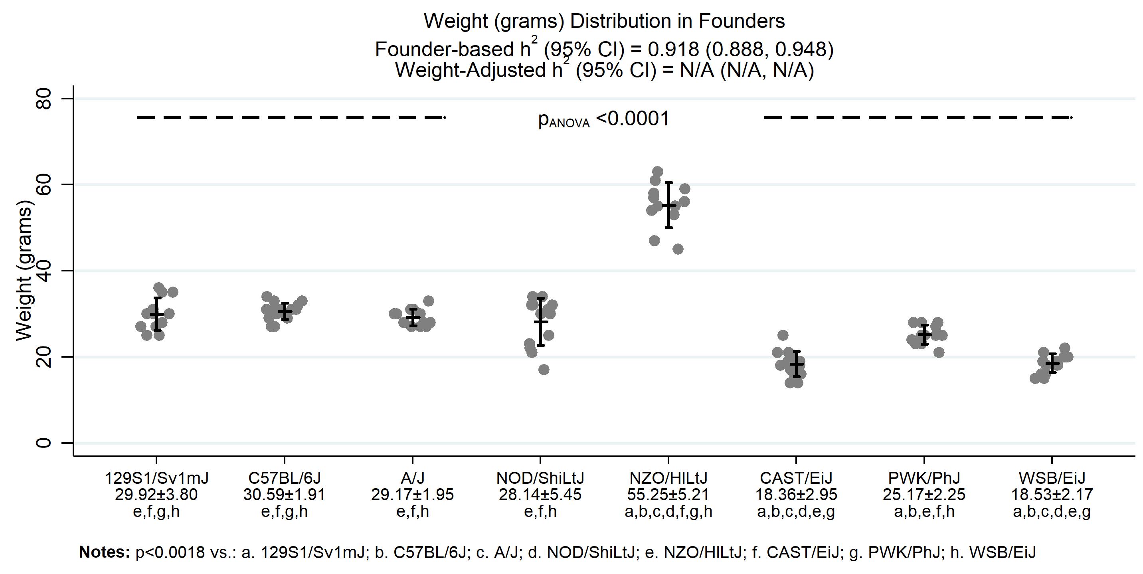

Figure S2: Comparison of Abdominal Fat Measurements among Founder Strains. The distributions of (A) total, (B) subcutaneous and (C) visceral abdominal fat are shown. Vertical error bars represent the observed mean ± standard deviation. All measures showed significant differences among the founder strains, with significantly more fat in the NZO/HILtJ than all other strains, as well as generally lower fat in the CAST/EiJ and WSB/EiJ strains. Measures of total (h² [95% CI] = 0.898 [0.850, 0.946]), subcutaneous (0.859 [0.802, 0.917]) and visceral (0.911 [0.868, 0.954]) abdominal fat were all highly heritable. Heritability of total (0.713 [0.600, 0.826]), subcutaneous (0.678 [0.577, 0.778]) and visceral (0.729 [0.608, 0.851]) fat were slightly reduced, but remained high, controlling for body weight.
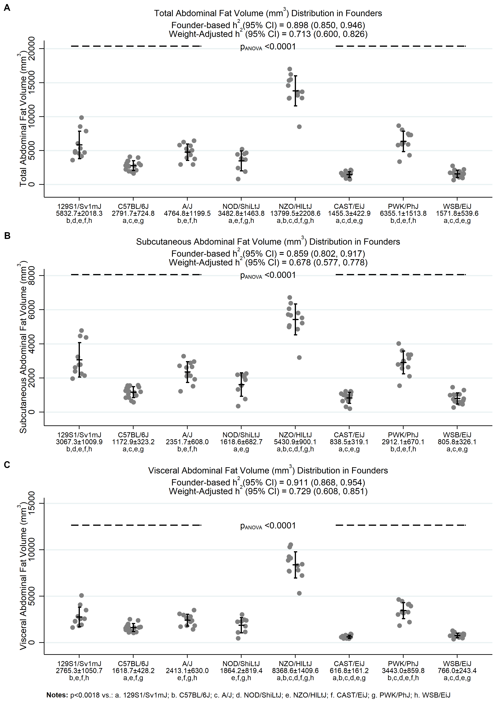
Figure S3: Comparison of Thoracic Fat Measurements among Founder Strains. The distributions of (A) total and (B) subcutaneous thoracic fat and (C) intrathoracic fat are shown. Vertical error bars represent the observed mean ± standard deviation. All measures showed significant differences among the founder strains, with significantly more fat in the NZO/HILtJ and some evidence of less fat in the CAST/EiJ and WSB/EiJ strains. Measures of total (0.736 [0.602, 0.871]) and subcutaneous (0.746 [0.631, 0.861]) thoracic fat and intrathoracic fat (0.686 [0.504, 0.868]) were all heritable. However, only subcutaneous thoracic fat remained significantly heritable (0.453 [0.223, 0.684]) when adjusting for body weight.
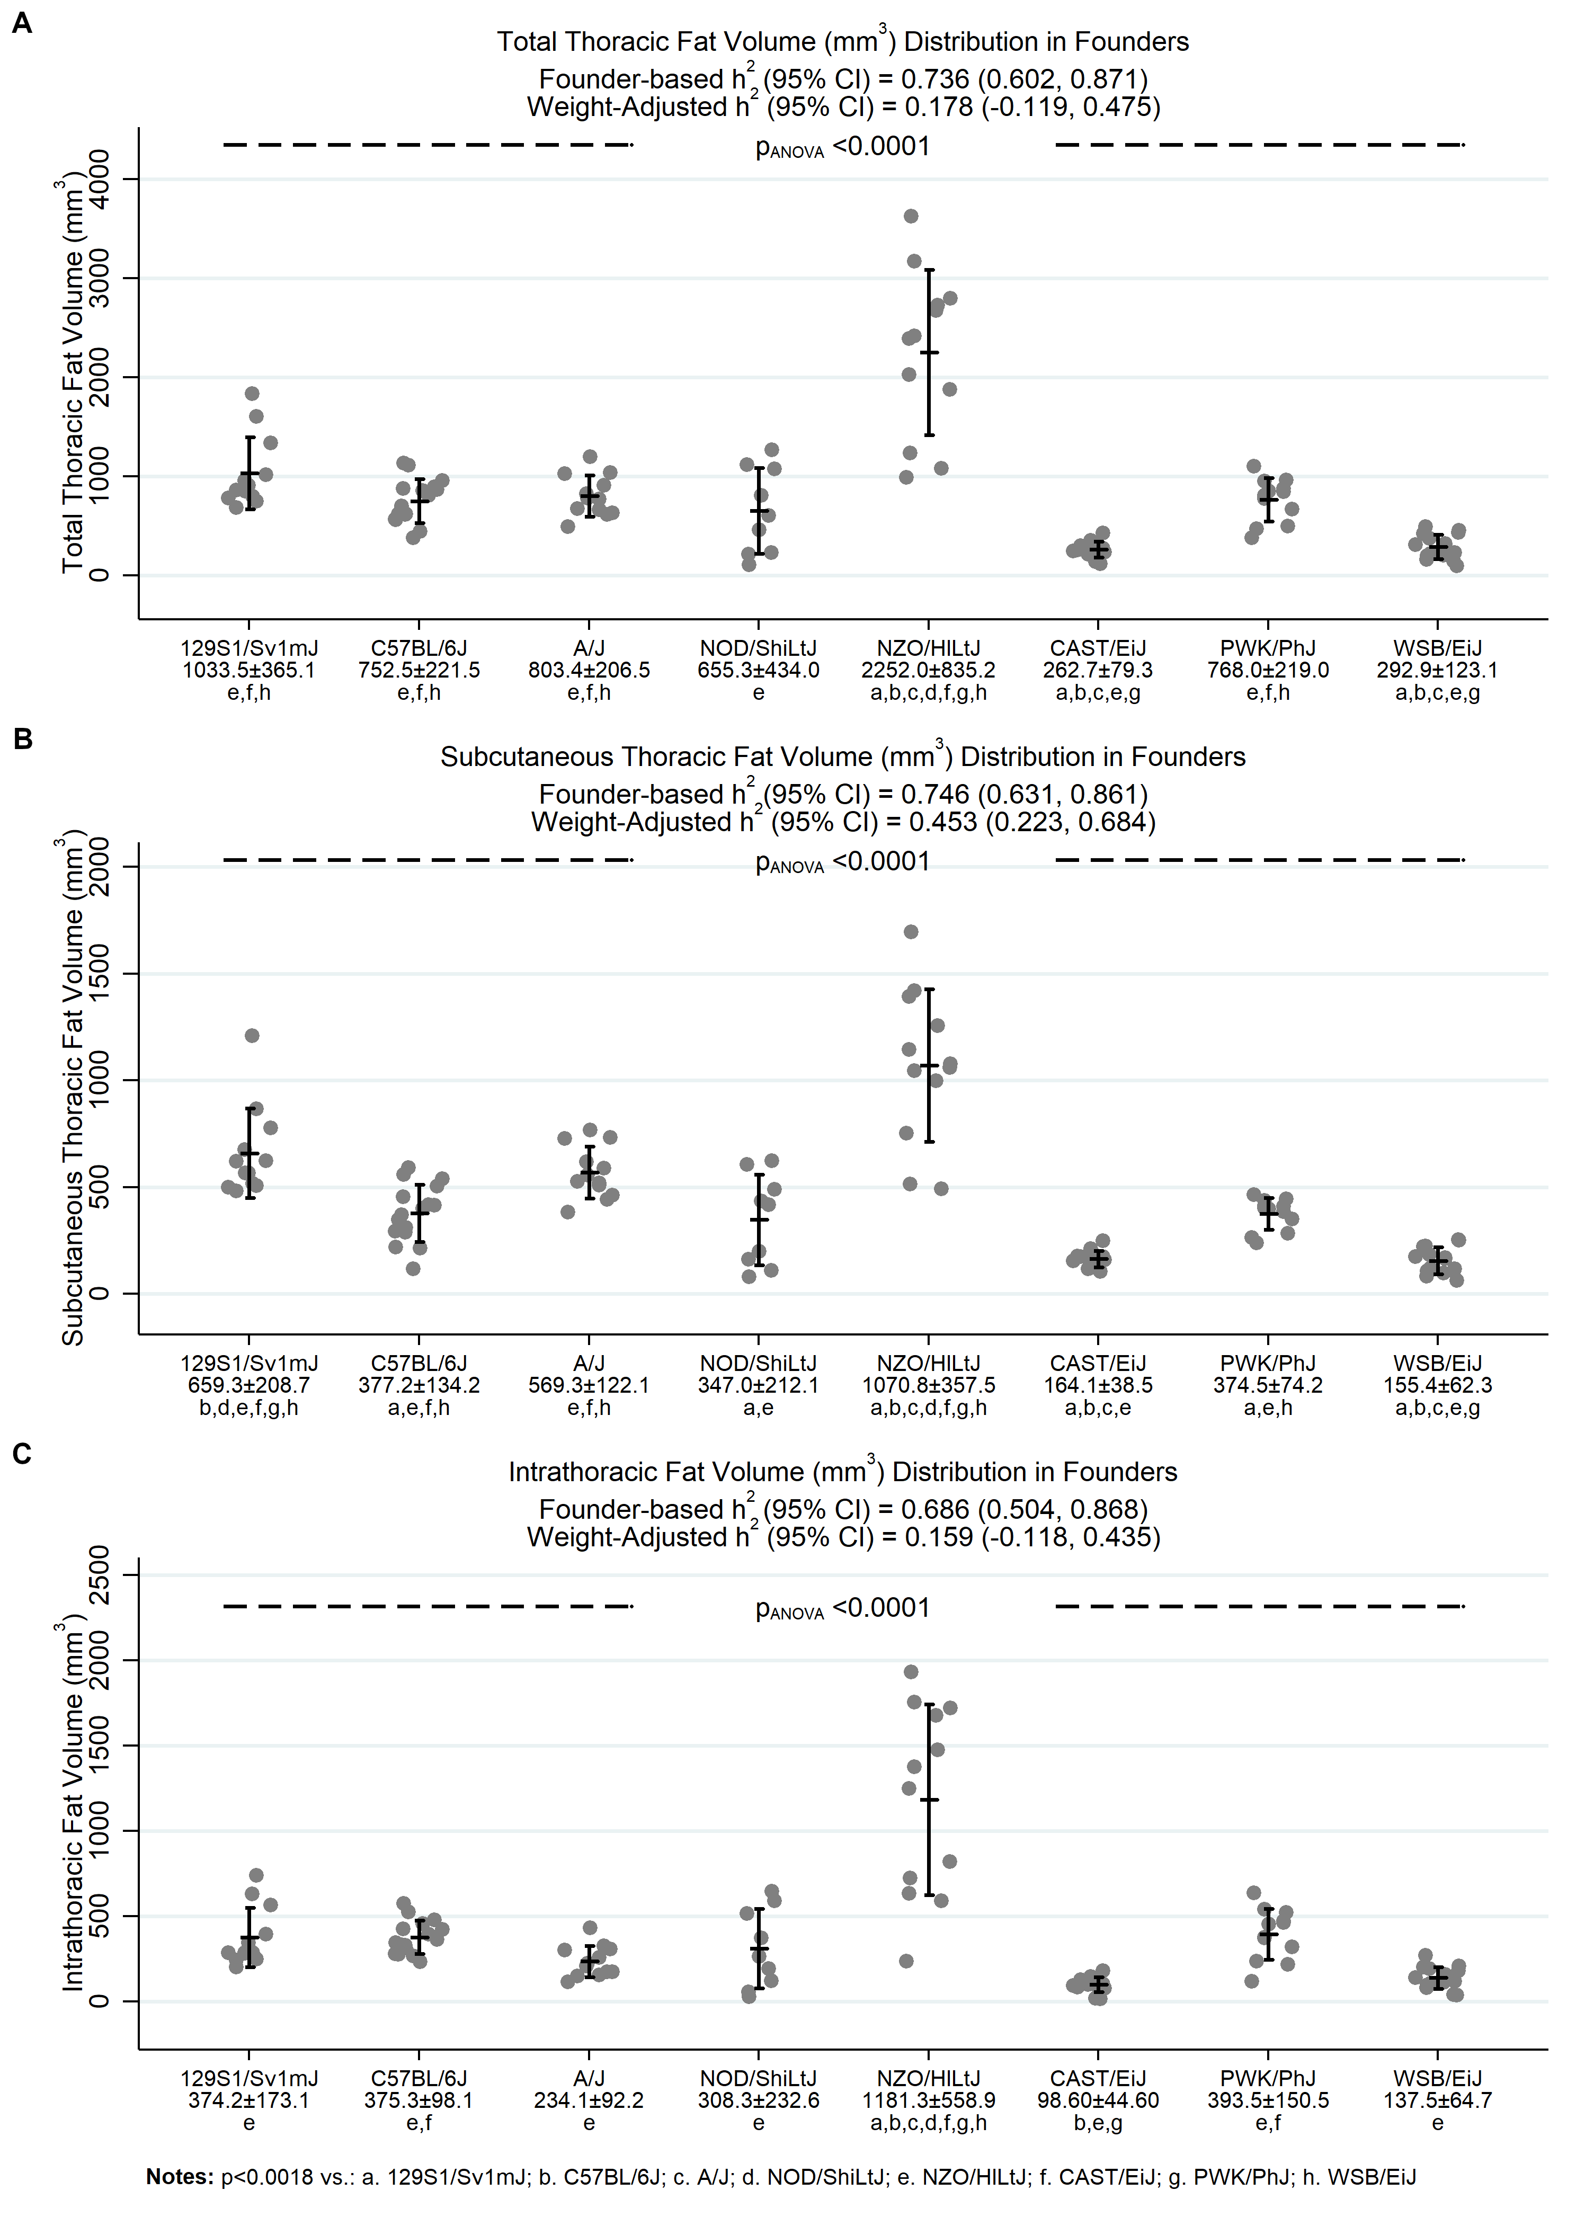

Figure S4: Comparison of Neck Fat Measurements among Founder Strains. The distributions of (A) total and (B) subcutaneous neck fat and (C) internal (intra-neck) fat are shown. As with other fat measures, the NZO/HILtJ strain had significantly greater volume of neck fat compared to all other strains. We observed significant heritability for total (0.666 [0.487, 0.845]) and subcutaneous (0.710 [0.556, 0.865]) neck fat and intra-neck fat (0.440 [0.254, 0.627]), with only subcutaneous neck fat remaining significant when adjusting for body weight (0.354 [0.106, 0.601]).
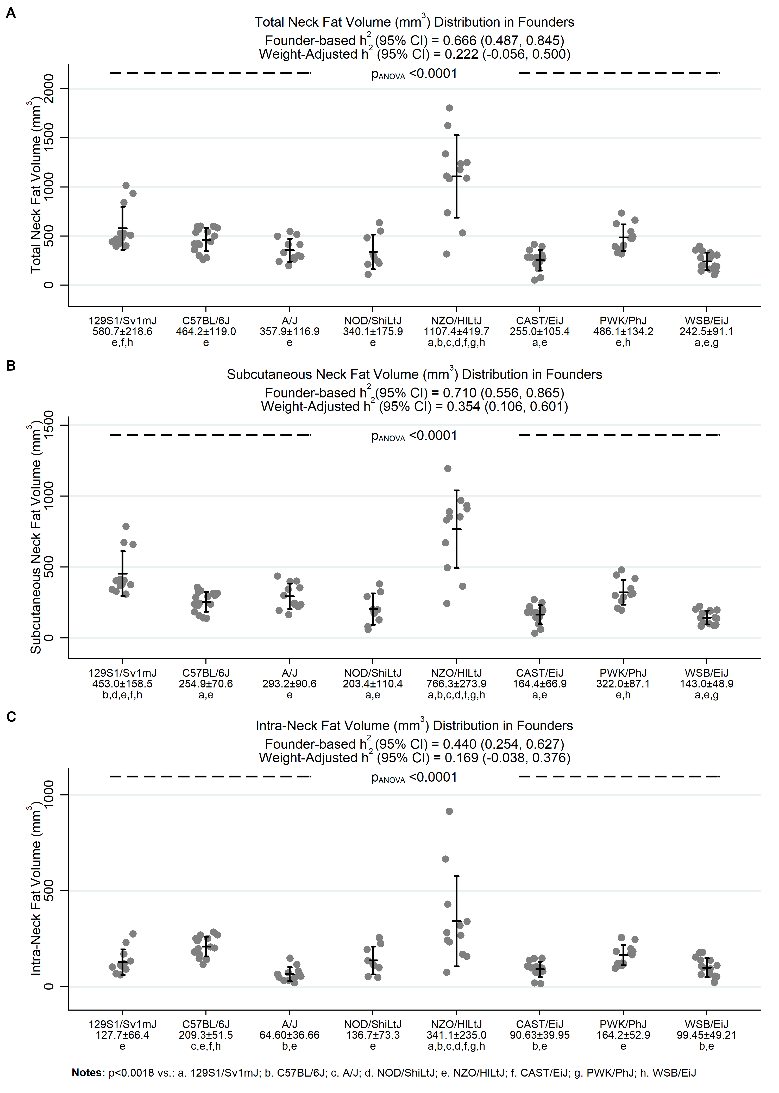

Figure S5. Heritability Estimates with and without the NZO/HILtJ Strain. Unadjusted and weight-adjusted heritability estimates derived with and without inclusion of the more obese NZO/HILtJ strains are compared using correlation plots (A, C) and general methods for assessing agreement described by Bland and Altman (B, D). Heritability estimates are positively correlated (rho = 0.71, p=0.004). Results show a 14% decrease in h² estimates when excluding NZO/HILtJ mice (p=0.0001), although all h² estimates remained >40% and 95% confidence intervals did not include 0% (see also Supplemental File 3). For weight-adjusted h² estimates, there was a high correlation between estimates derived with and without the NZO/HILtJ strain (rho = 0.95, p<0.001), with evidence of a 7% larger weight-adjusted h² on average after excluding the NZO/HILtJ mice (p=0.005). This increase was larger for weight-adjusted h² that were lower, on average, in the analyses including the NZO/HILtJ strain.
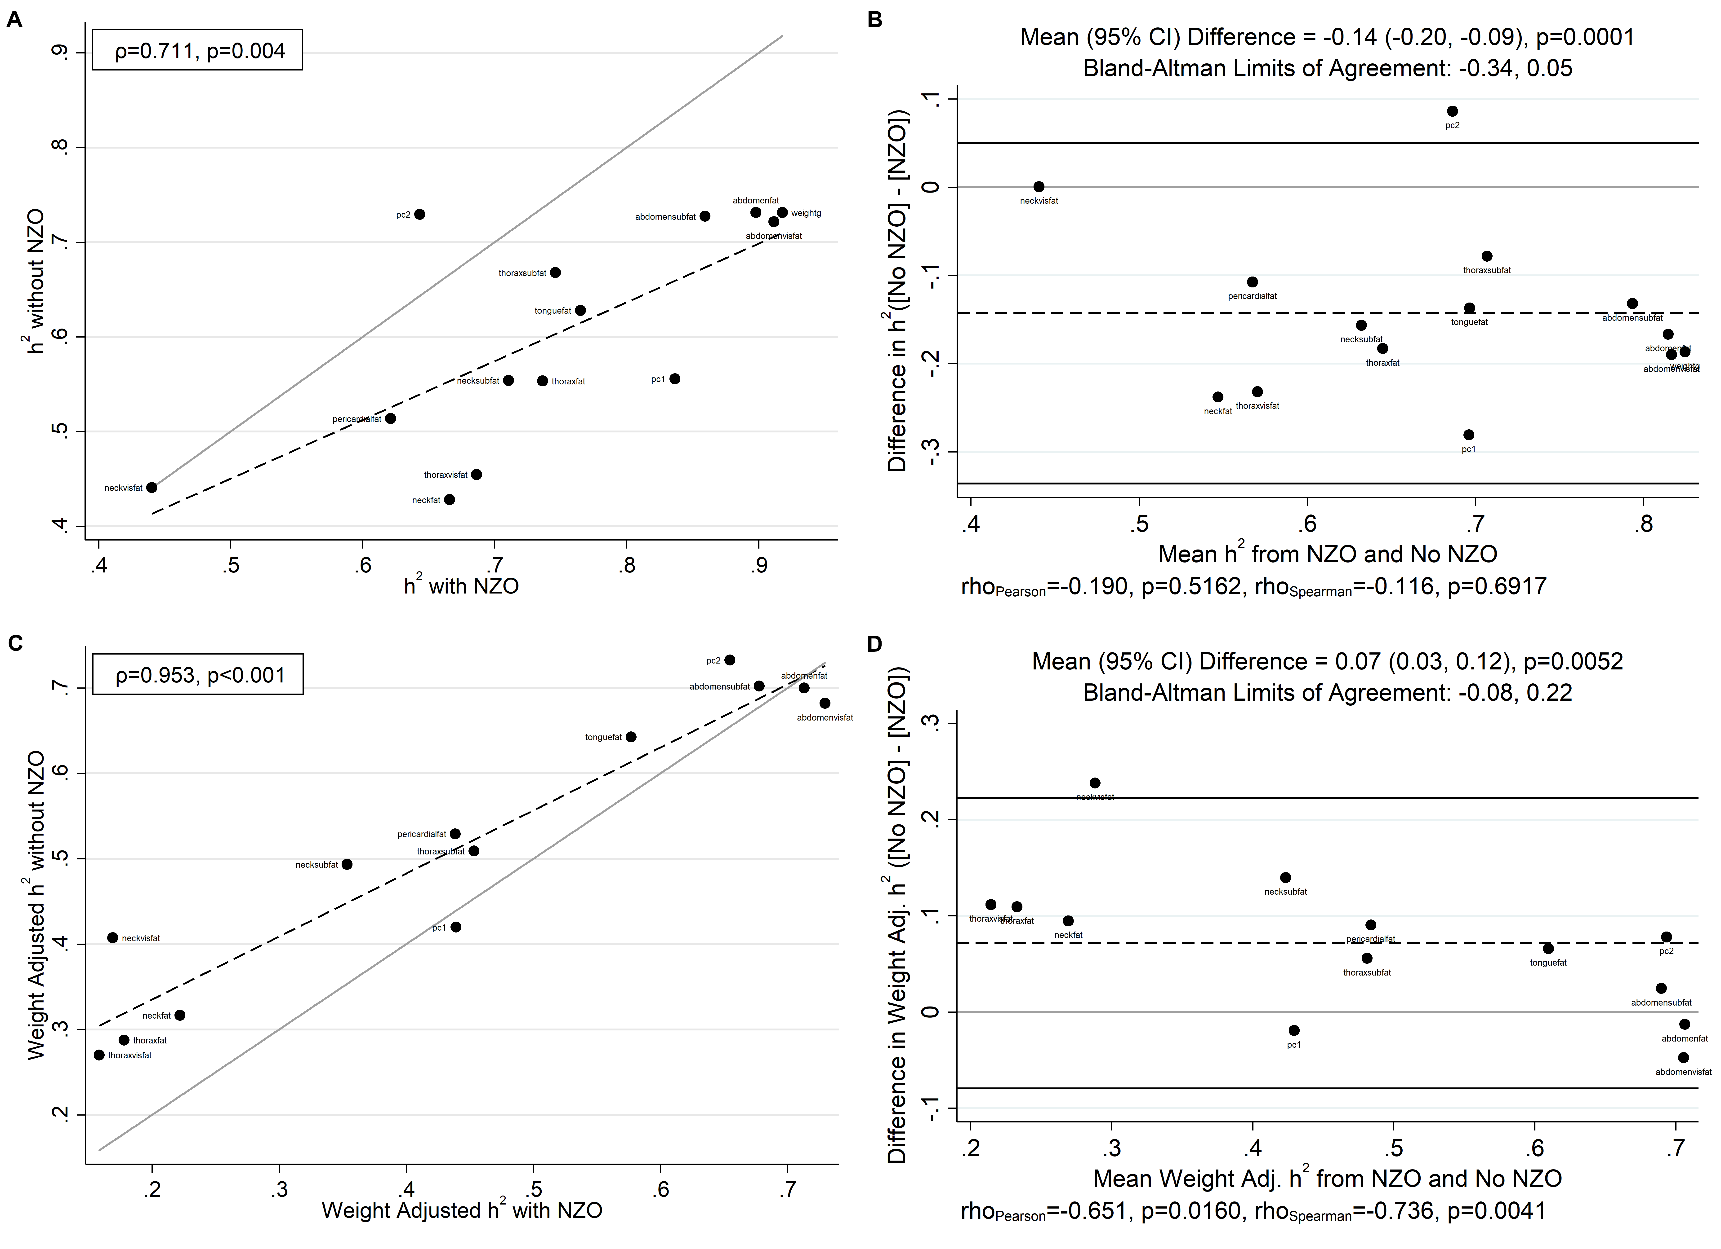

SUPPLEMENTAL REFERENCES

Glover, G.H., and E. Schneider, 1991 Three-point Dixon technique for true water/fat decomposition with B0 inhomogeneity correction. Magnetic Resonance in Medicine 18 (2):371-383.
Hernando, D., J.P. Haldar, B.P. Sutton, J. Ma, P. Kellman et al., 2008 Joint estimation of water/fat images and field inhomogeneity map. Magnetic Resonance in Medicine 59 (3):571-580.
Pineda, A.R., S.B. Reeder, Z. Wen, and N.J. Pelc, 2005 Cramer-Rao bounds for three-point decomposition of water and fat. Magnetic Resonance in Medicine 54 (3):625-635.

