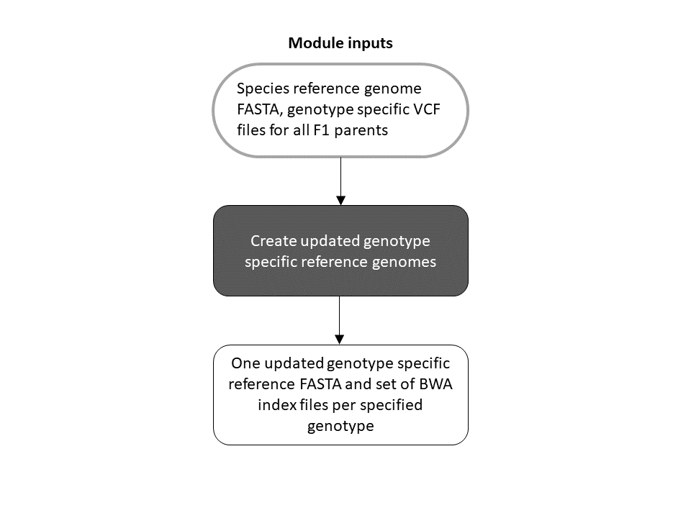

Figure S1: Workflow of the Genotype Specific Reference Module.

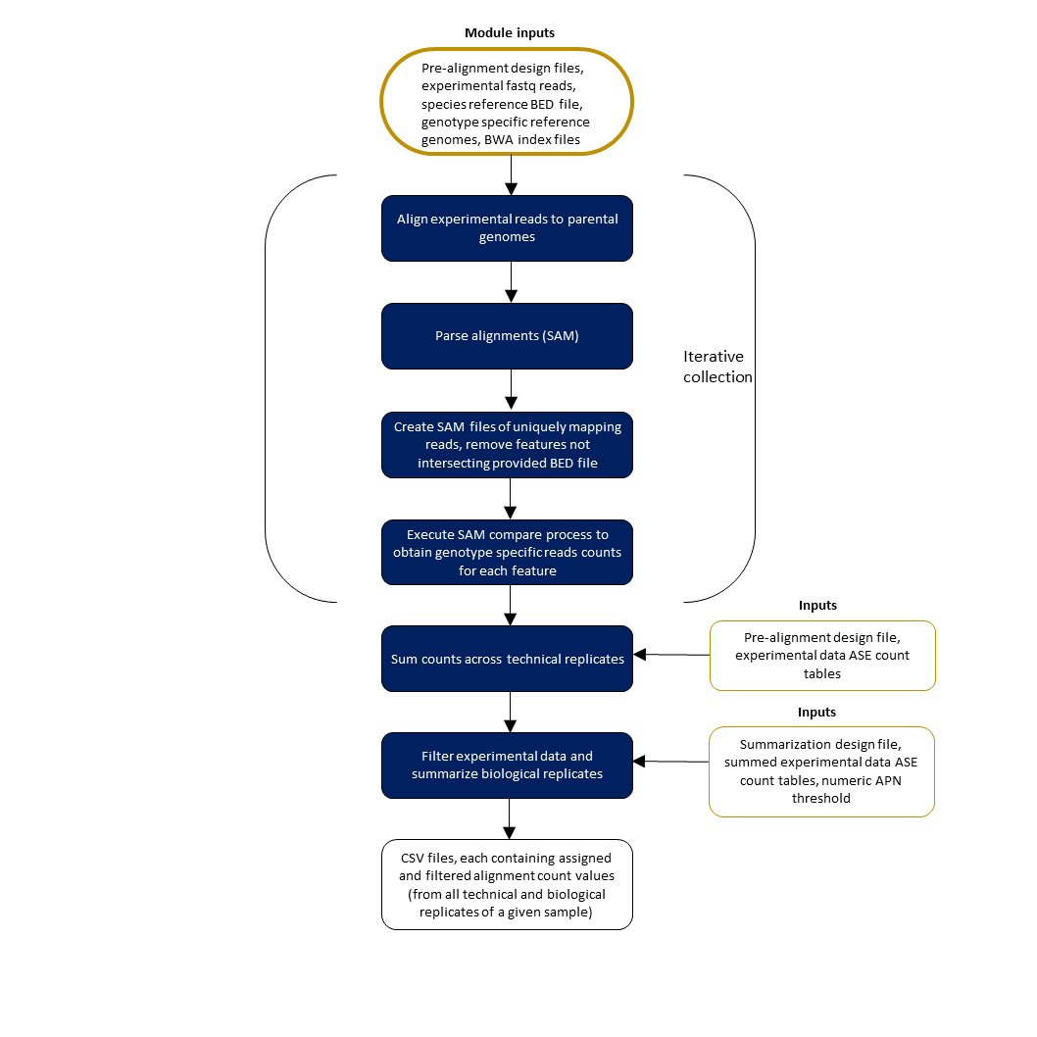
Figure S2: Alignment and SAM compare Module.
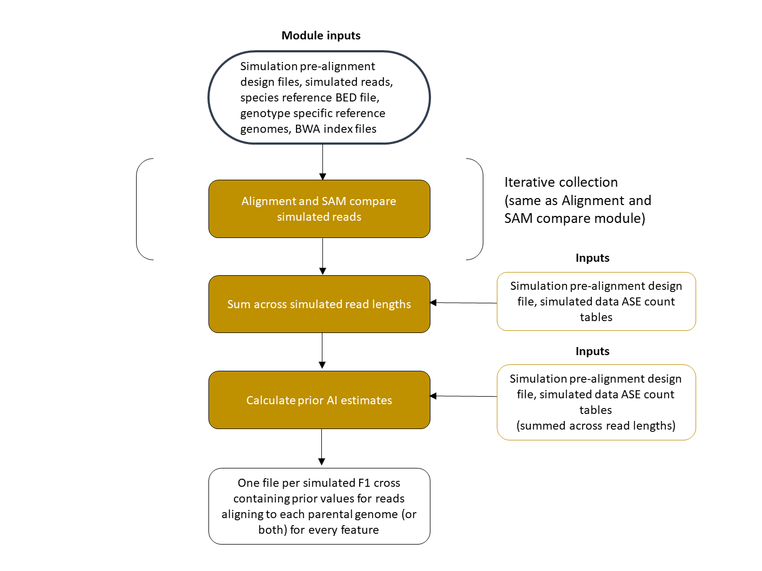
Figure S3: Prior calculation module.

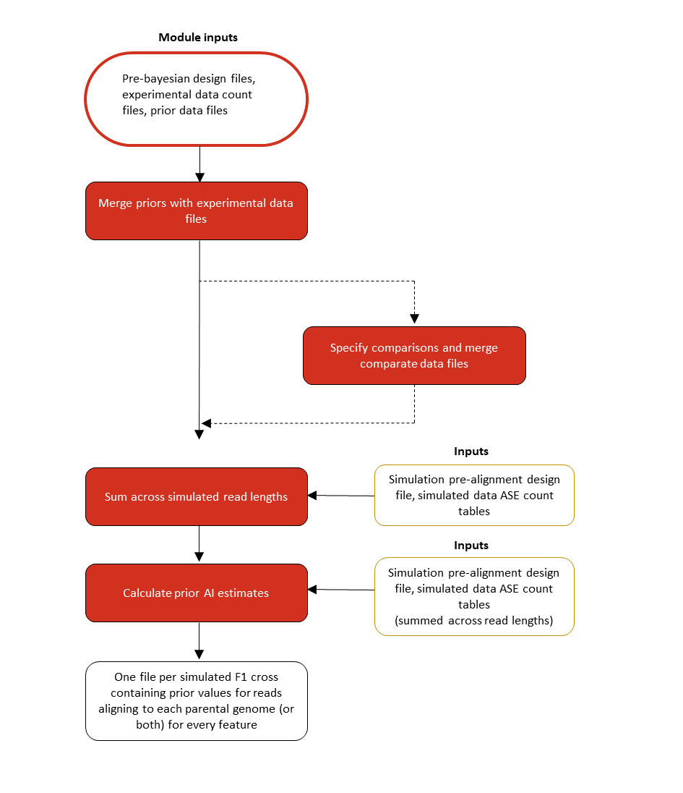
Figure S4: Bayesian Model module.

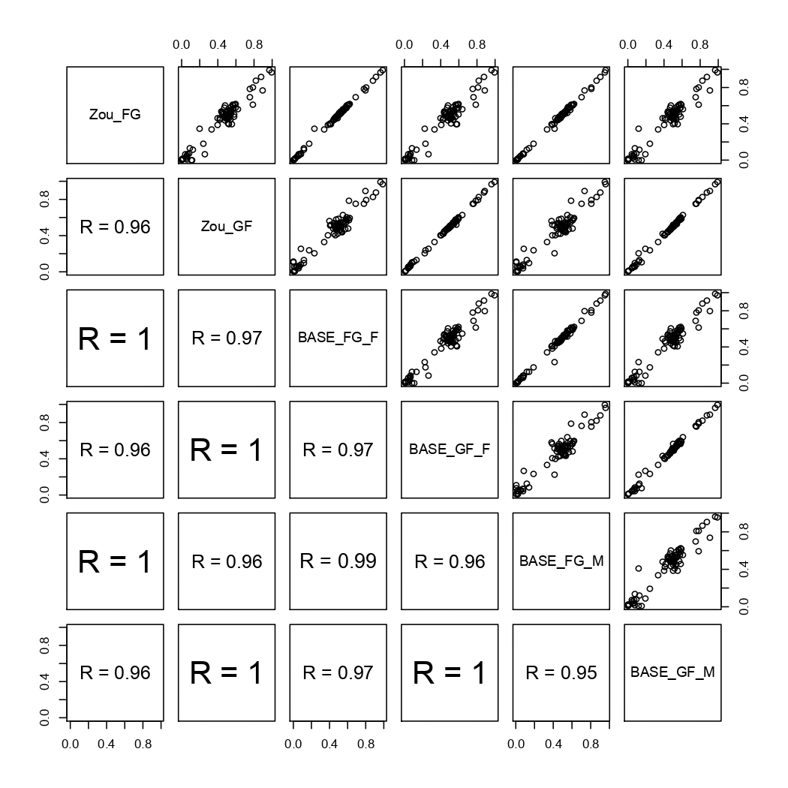
Figure S5: The correlation in estimates for 95 imprinted genes between the original data analysis (Zou) and the Bayesian model implemented in the present work (BASE). In the upper triangle are the correlation plots with the BASE estimates on the X axis and the estimates from the original data analysis (Zou et. al. 2014) on the Y axis. In the lower triangle are Spearman’s correlation coefficients. FG = CAST X PWK, GF = PWK X CAST, F = Females, M = Males

