Supporting Information

Dri1 mediates heterochromatin assembly via RNAi and histone deacetylation
Hyoju Ban, Wenqi Sun, Yuhang Chen, Yong Chen, Fei Li

Supplementary figures

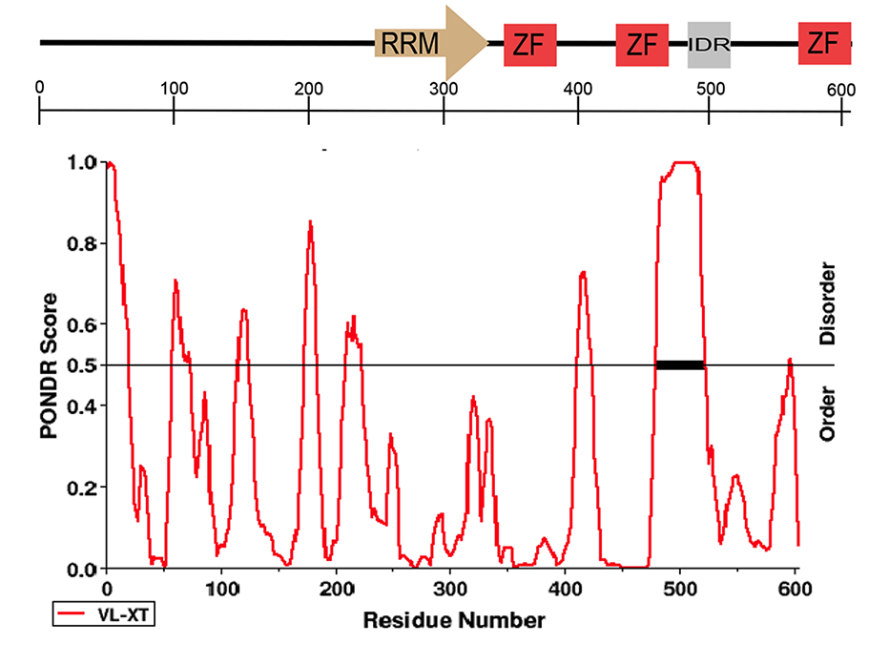
Fig. S1. Predication of intrinsically disordered region (IDR) in Dri1 by PONDR. The top panel presents the domains structure of Dri1. Dark rectangle in the bottom panel indicts the position of the predicted IDS domain. Prediction was performed using PONDR-VLXT. A score above 0.5 indicates disorder.

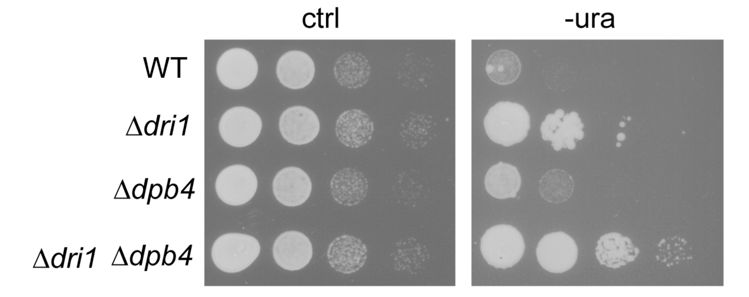
Fig. S2. Serial dilutions of indicated strains with ura4⁺ in pericentromeric otr3 repeat were spotted on the minimal medium without uracil (–ura) and incubated for 4 days

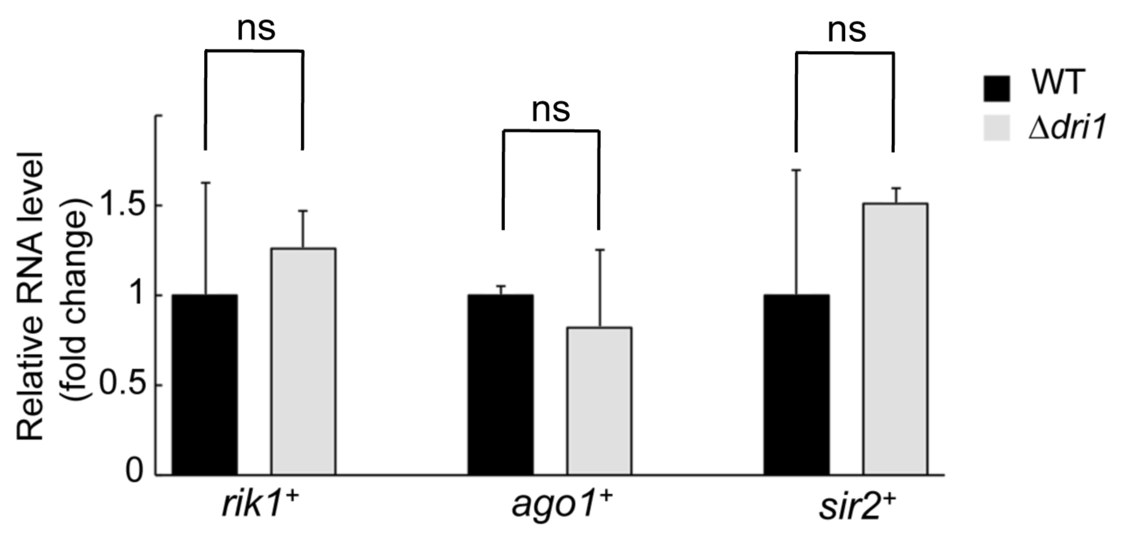
Fig. S3. The mRNA levels of rik1⁺, ago1⁺, and sir2⁺ in the Δdri1 mutant were analyzed by RT-PCR. Actin was used as a control. Experiments were performed in triplicate. Error bars indicate SD. ns, no significant differences.

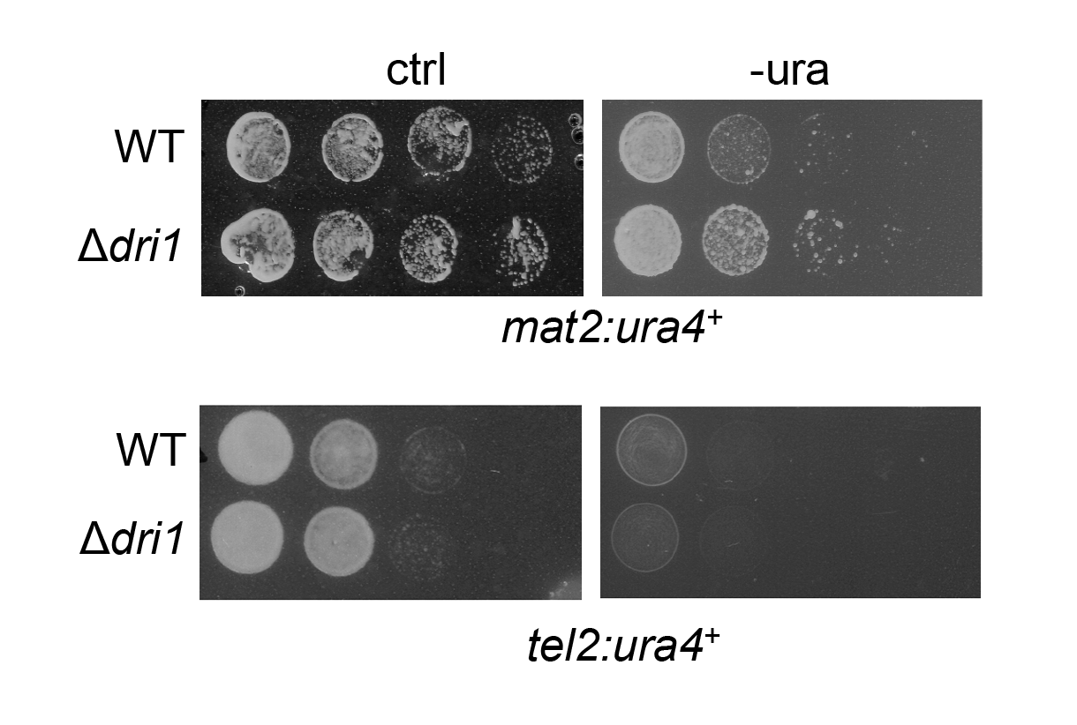
Fig. S4. The effect of Dri1 on heterochromatin silencing in mating-type locus and telomeres. Serial dilutions of the Δdri1 mutant cells with ura4⁺ either in the mating-type region (top panel) or in a telomeric region (bottom panel) were spotted on the minimal medium without uracil (–ura) and incubated at 30⁰C for 4 days.

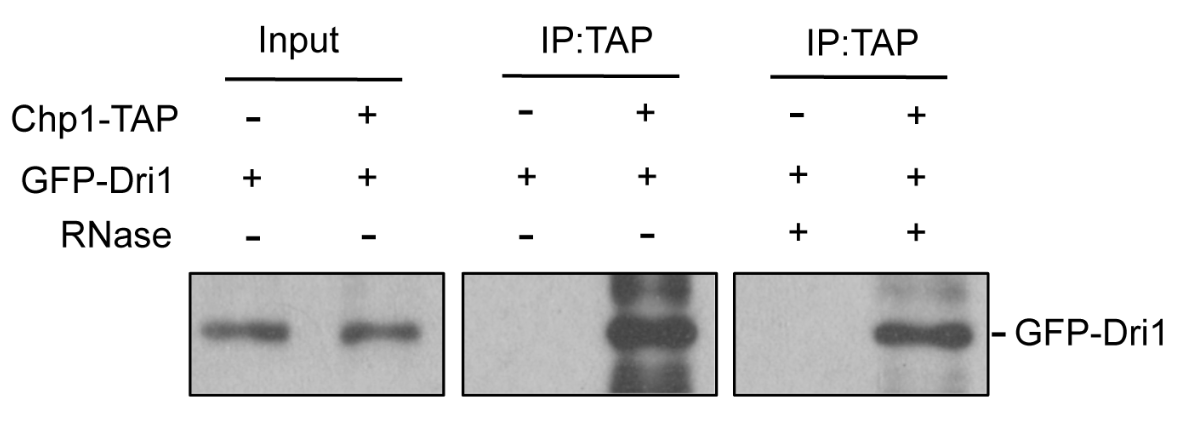
Fig. S5. Co-IP experiments show that the Dri1 still interacts with Chp1 after RNase treatment. Cell lysates from cells expressing GFP-Dri1 and Chp1-TAP were immunoprecipitated with lgG sepharose, and analyzed by immunoblotting using a GFP antibody. Cells expressing GFP-Dri1 only were used as a control.

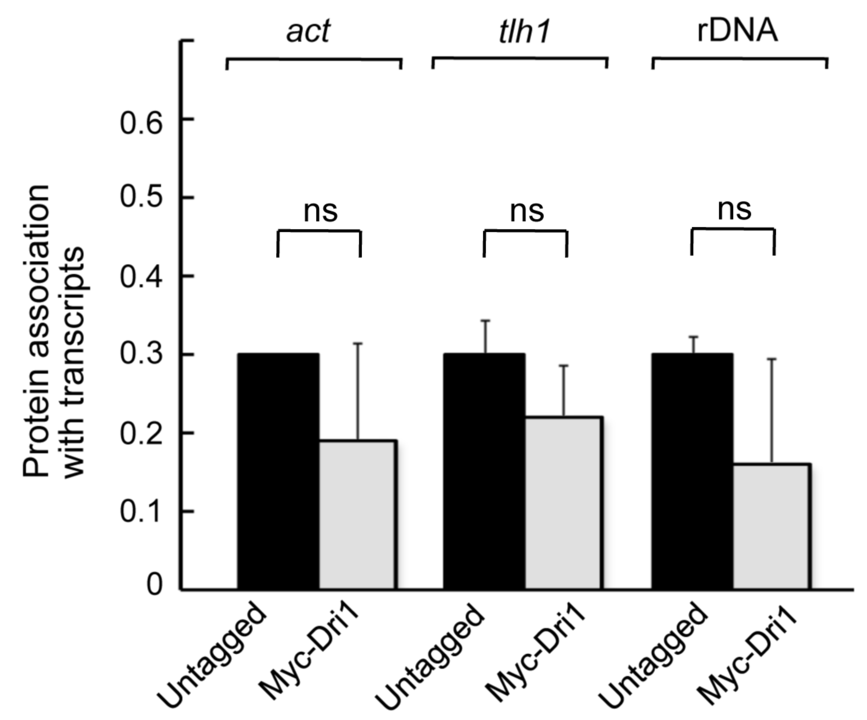
Fig. S6. RIP was performed from extracts of cells expressing Myc-Dri1 using an anti-Myc antibody. Untagged cells were used a negative control. Immunoprecipitated RNAs were quantified by RT-qPCR using primers specific for act1⁺, tlh1⁺, and rDNA region. Experiments were performed in triplicate. Error bars indicate SD. ns, no significant differences.

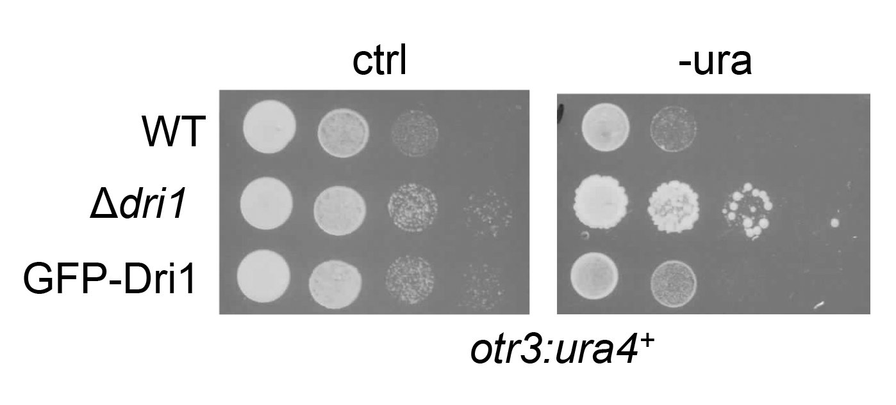
Fig. S7. Replacing endogenous Dri1 with GFP-Dri1 results in no obvious silencing defect, indicating that GFP-Dri1 is functional. Serial dilutions of indicated strains carrying ura4⁺ in pericentromeric otr3 repeat were plated on the minimal medium without uracil.

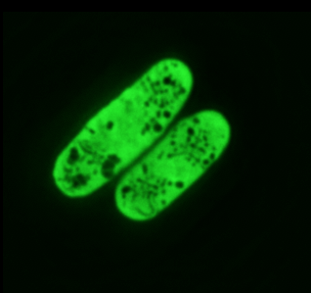
Fig. S8. The distribution pattern of mildly overexpressed GFP alone by the nmt1 promoter.

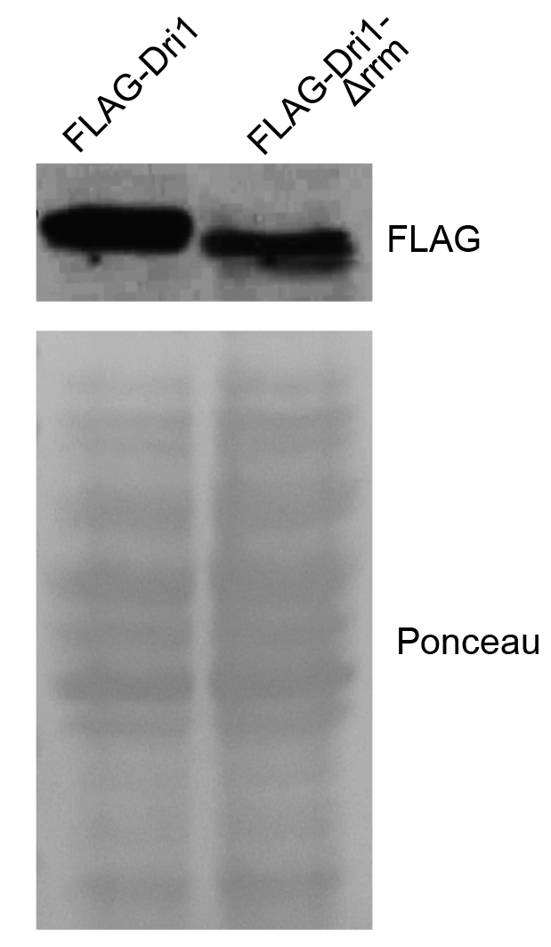

Fig. S9. Western blot analysis of cells expressing indicated proteins using an anti-FLAG antibody. Ponceau staining was used as a loading control.

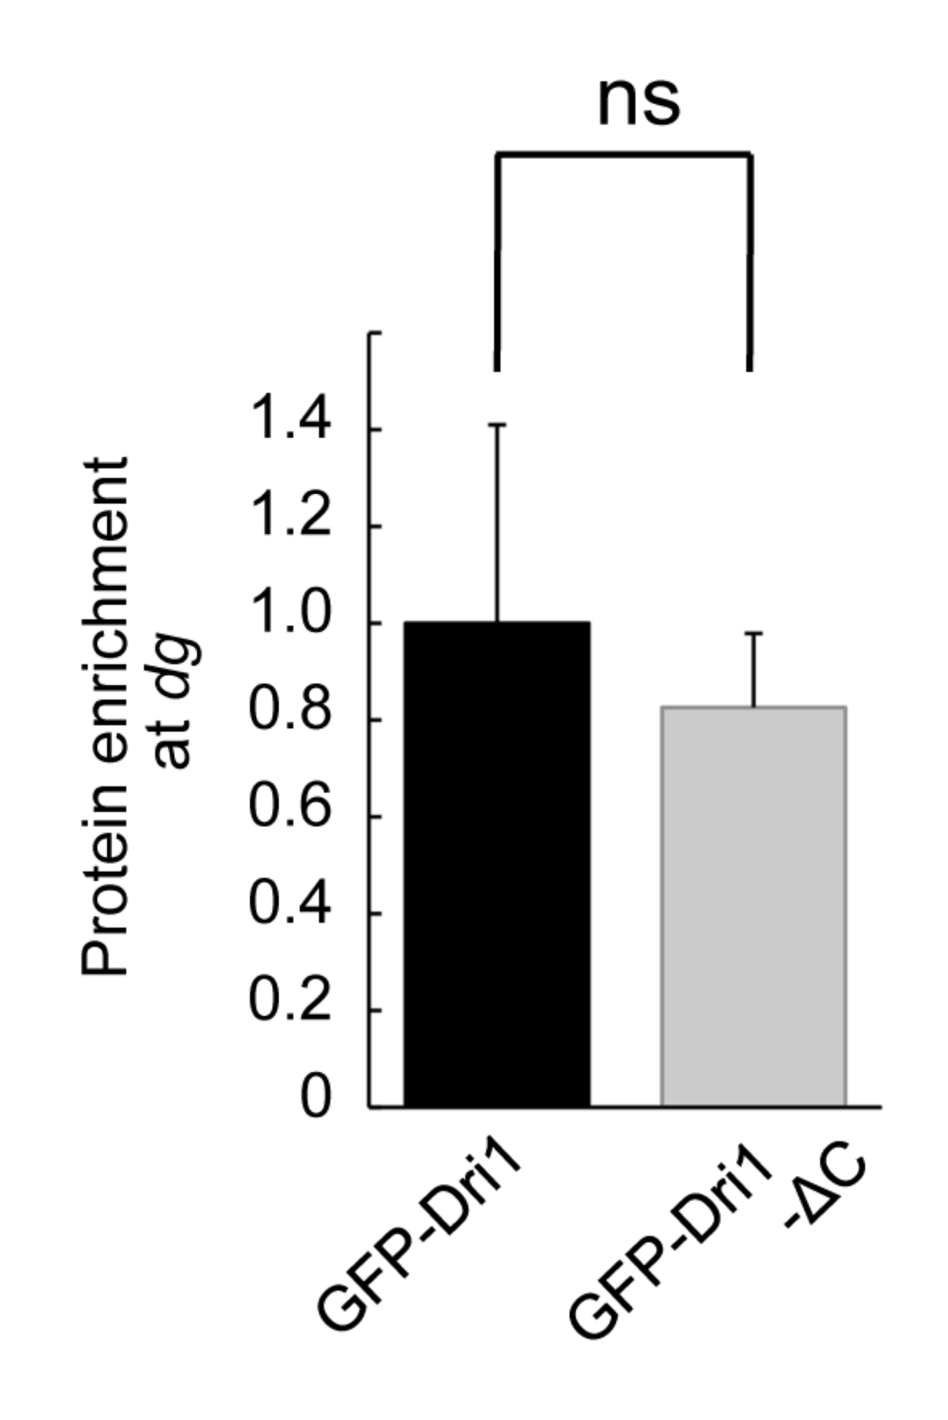
Fig. S10. The effect of the C-terminus of Dri1 on its association with heterochromatin. ChIP analysis of GFP-Dri1-∆C and GFP-Dri1 as a control in the otr region with an antibody specific for GFP. Experiments were performed in triplicate. Error bars indicate SD. ns, no significant differences.

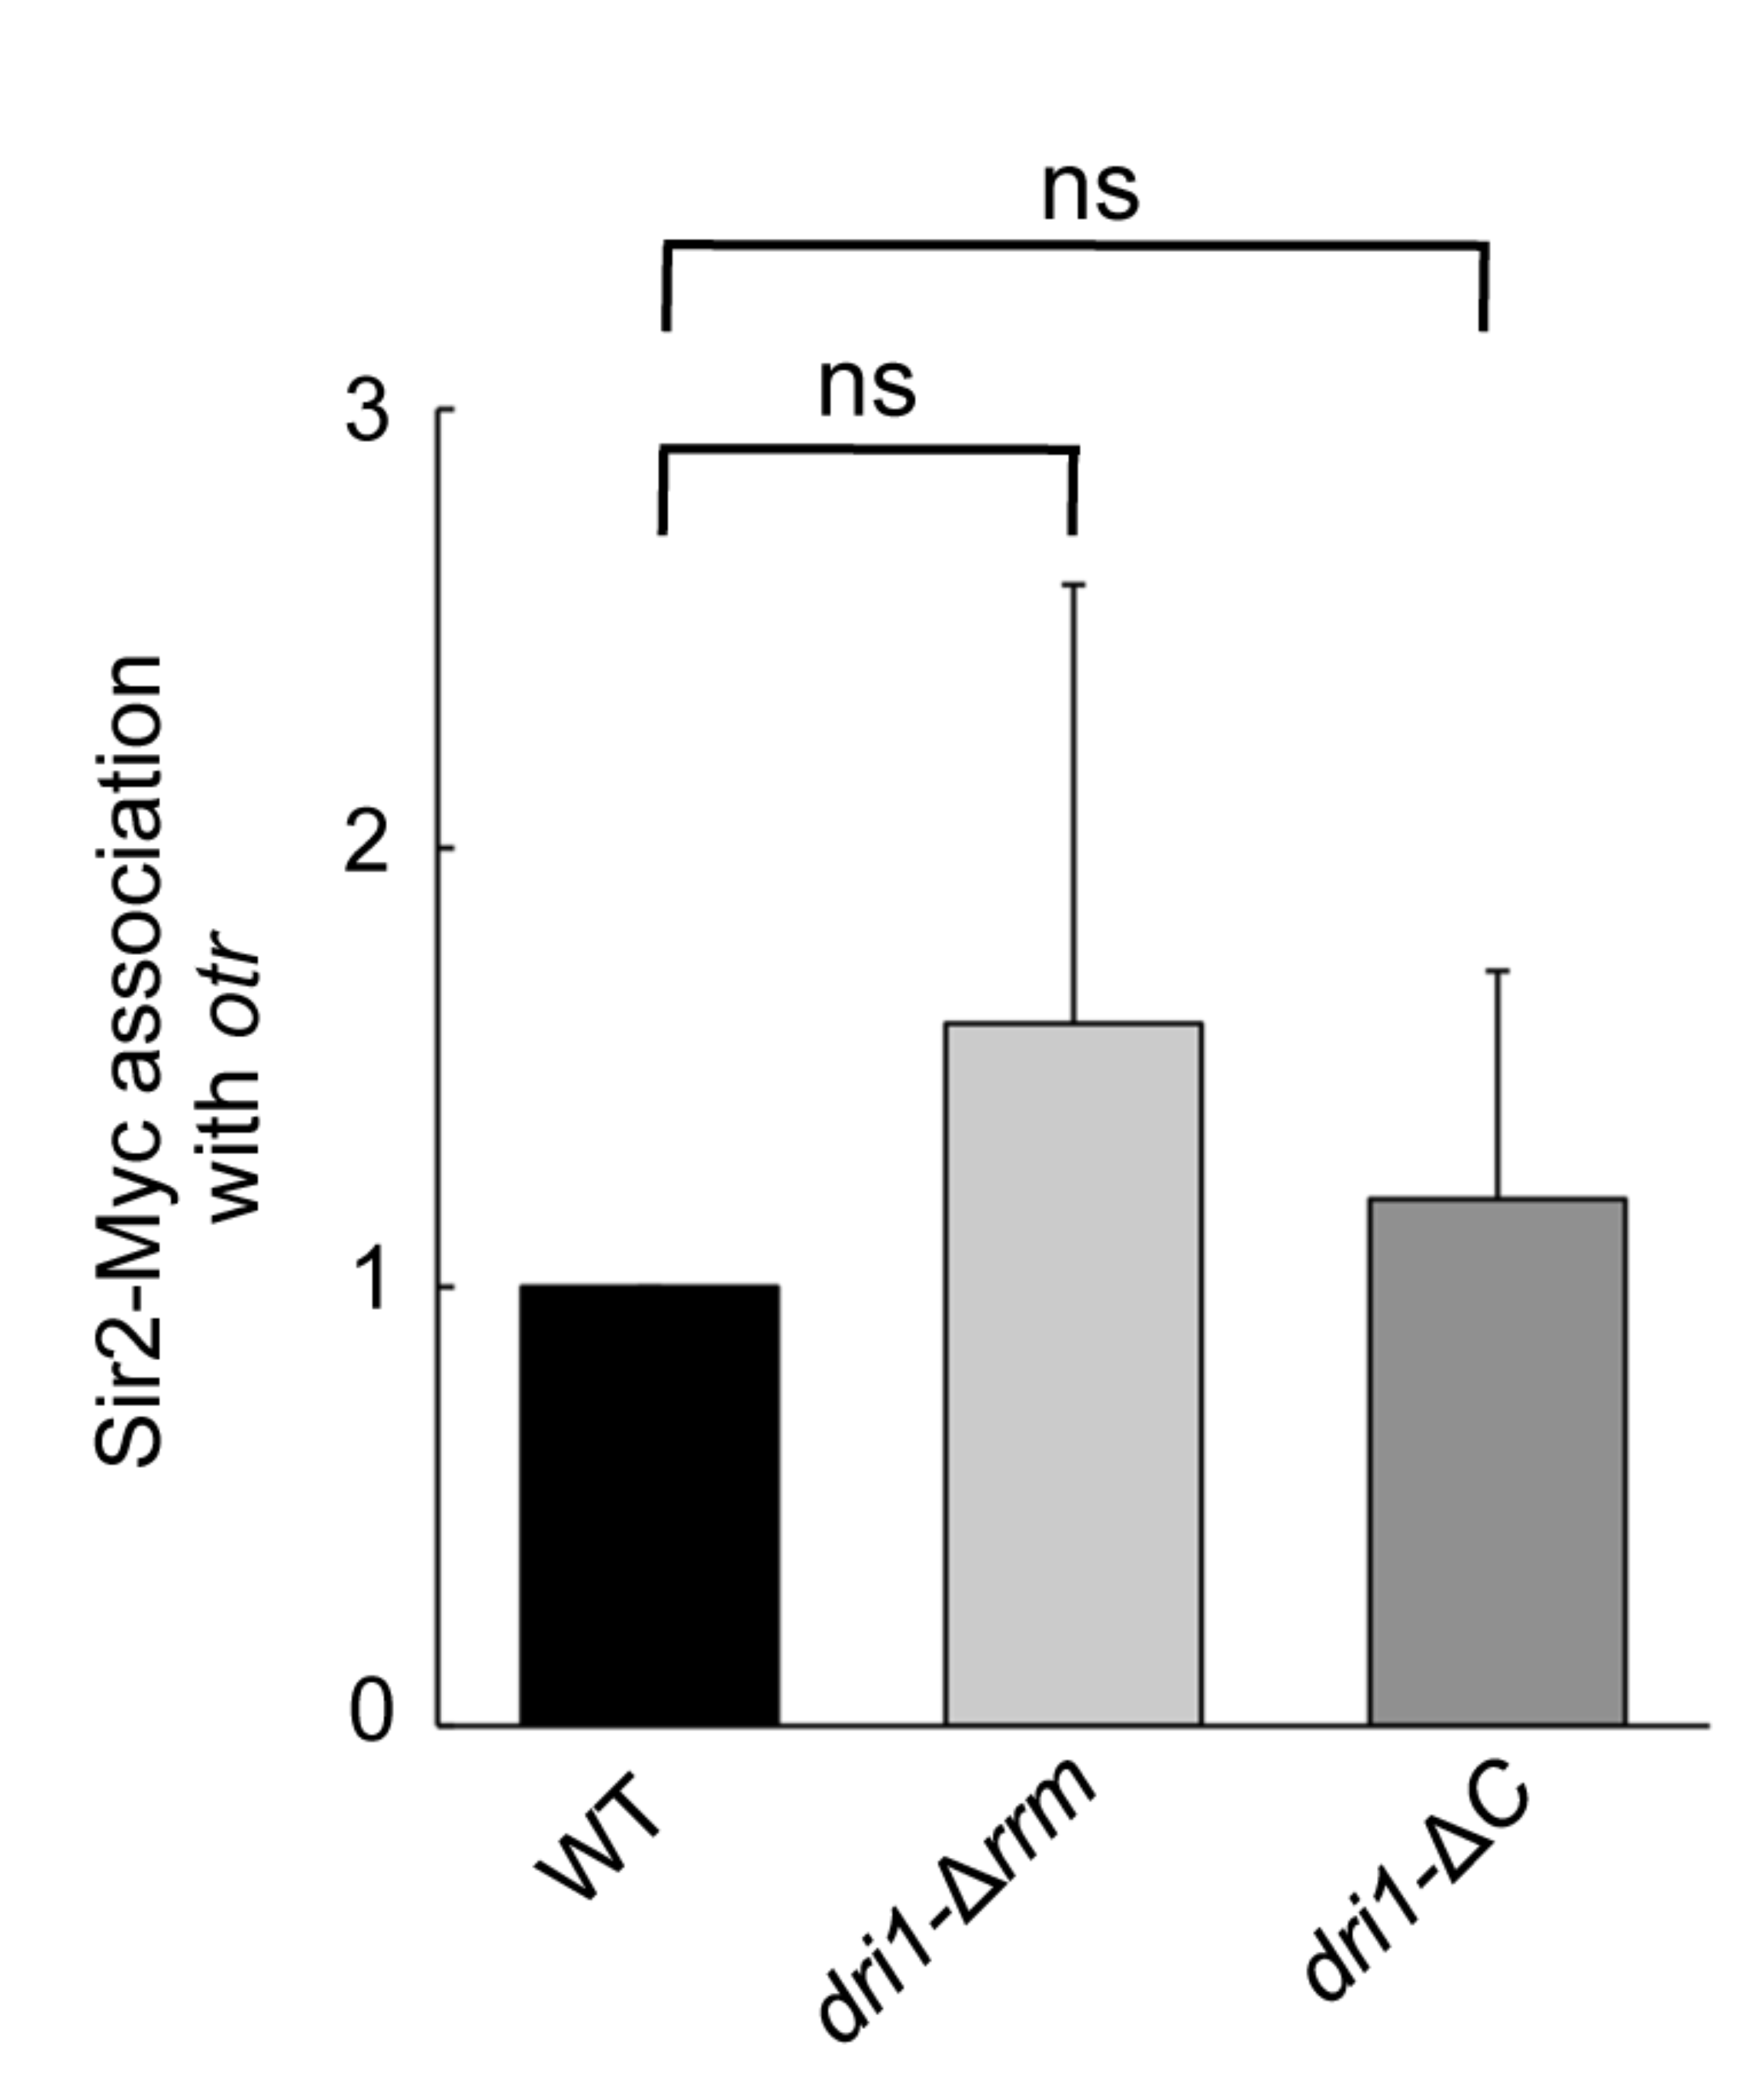
Fig. S11. ChIP analysis of Sir2-Myc in the indicated strains in the pericentromeric otr region. Experiments were performed in triplicate. Error bars indicate SD. ns, no significant differences.

Table S1. Strains used in this study.

Strain | Genotype | Figures
FL 751 | h⁻ ura4-D18 leu 1-32 ade6-216 otr3::ura4 at repeat 2 (R2) | Fig. 1C, 1D, 1E, 5A, S2, S3
FL752 | h⁻ ura4-D18 leu 1-32 otr3::ura4(R2) Δdri1::kan | Fig. 1C, 1D, 5A, S2, S3
FY597 | h⁹⁰ mat3-M::ura4 ade6-210 leu1-32 ura4-DS/E | Fig. S4
FL754 | h? mat3-M::ura4 ura4-DS/E Δdri1::kan ade6-210 leu1-32 | Fig. S4
FL755 | h? TEL2L::ura4 ura4DS/E Δdri1::kan | Fig. S4
FL78 | h⁹⁰ TEL2L-ura4 ade6-210 his3D1 leu1-32 ura4DS/E | Fig. S4
FL756 | h⁻ ura4-D18 leu 1-32 otr3::ura4 (R2) dri1-Δrrm-kan | Fig. 6B
FY14523 | h⁹⁰ chp1-GFP-HA-Kan, ade6-216 leu1-32 lys1-131 ura4-D18 | Fig. 2B
FL758 | h? chp1-GFP-HA-Kan, Δdri1::ura4 ura4-D18, his3?, leu1-32, ade6-216 | Fig. 2B
FL759 | h? dri1-ΔC-kan, otr3::ura4 (R2) ura4-D18, his3?, leu1-32, ade6? lys1? | Fig. 6D
FL760 | h⁻ ade6-216 leu1-32 ura4-D18 myc-dri1 his3D | Fig. 2D, S6
FL761 | h⁺ GFP-dri1-kan leu1-32 ura4-D18 ade6-216 | Fig. 3C, S10
FL762 | h? dri1-Δzf3-kan otr3::ura4 (R2) ura4-D18 ade6-216, leu1-32 his3D | Fig. 6C
FL763 | h? dri1-Δidr-kan otr3::ura4 (R2) ura4-D18 ade6-216, leu1-32 his3D | Fig. 6C
FL764 | h? dri1-zf1*-kan otr3::ura4 (R2) ura4-D18 ade6-216, leu1-32 his3D | Fig. 6C
FL765 | h? dri1-zf2*-kan otr3::ura4 (R2) ura4-D18 ade6-216, leu1-32 his3D | Fig. 6C
JB159 | h? dpb4-TAP-kan, GFP-dri1-ΔC-kan ura4-D18 ade6-216, leu1-32 his3D | Fig. 6E, S10
FL766 | h? dpb4-TAP-kan, GFP-dri1-kan ade6-216, leu1-32 his3D | Fig. 1B
FL767 | h? chp1-GFP-HA-kan, GFP-dri1-kan ade6-216, leu1-32 his3D | Fig. 2C, S5
JB17 | h? ade6-M210 ura4-D18 leu1-32 Δdri1::kan Δdcr1::kan | Fig. 2A
JB72 | h? ade6-M210 ura4-D18 leu1-32 otr3::ura4(R2) Δdpb4::kan | Fig. S2
JB171 | h? pREP1-GFP-dri1⁺ PSV40::swi6-mcherry-ura4 his5Δ ura4Δ leuΔ | Fig. 3A, 3B, 3D
JB189 | h⁺ GFP-dri1-kan leu1-32 ura4-D18 ade6-216 Δdpb4::kan | Fig. 3C
JB190 | h⁺ GFP-dri1-kan leu1-32 ura4-D18 ade6-216 Δclr4::kan | Fig. 3C
FL55 | h? Δdcr1::kanMX6 ura4D18 leu1-32 ade6-210 | Fig. 1E, 2A
FY10356 | h- GBD-clr4-ΔCD::nat 3xgbs-ade6⁺ ura4-D18 ade6-216, leu1-32 his3D | Fig. 4B, 4C
JB191 | h? GBD-clr4-ΔCD::nat 3xgbs-ade6⁺ Δsir2::kan ura4-D18 ade6-216, leu1-32 his3D | Fig. 4B, 4C, 5A
JB192 | h? GBD-clr4-ΔCD::nat 3xgbs-ade6⁺ Δdcr1::kan ura4-D18 ade6-216, leu1-32 his3D | Fig. 4B, 4C
JB193 | h⁻ ura4-D18 leu 1-32 otr3::ura4 (R2) dri1-Δrrm-kan chp1-GFP-HA-Kan | Fig.6F
JB194 | h? ura4-D18 leu 1-32 otr3::ura4 (R2) dri1-ΔC-kan chp1-GFP-HA-Kan | Fig.6F
JB195 | h? ade6-M210 ura4-D18 leu1-32 otr3::ura4(R2) Δdpb4::kan Δdcr1::kan | Fig. S2
JB196 | h? pREP1-GFP his5Δ ura4Δ leuΔ | Fig. S8
FL772 | h? GBD-clr4-ΔCD::nat 3xgbs-ade6⁺ Δdri1::kan ura4-D18 ade6-216, leu1-32 his3D | Fig. 4B, 4C
FL773 | h- sir2-myc::kan ade6-216, leu1-32 his3D | Fig. 5B, 5C, 5D, S11
FL774 | h? sir2-myc::kan Δdri1::ura4 ade6-216, leu1-32 his3D | Fig. 5B, 5C, 5D
FL775 | h? Δclr4::leu1 otr3::ura4 (R2) ura4-D18 ade6? leu1-32 his3D arg-D4 | Fig. 1C, 1D
FL776 | h+ otr1R(SphI)::ura4+ ura4D-18, leu1-32, ade6-M210, 3XFLAG-Ago1::Nat | Fig. 2D
FL255 | h⁻ ade6-216 leu1-32 ura4-D18 his3D | Fig. 2D, S6
JB78 | h⁻ ura4-D18 leu1-32 ade6-216 FLAG-dri1::kan | Fig. S9
JB94 | h? ura4-D18 leu1-32 ade6-216 FLAG-dri1-Δrrm::kan | Fig. S9
JB134 | h⁺ GFP-dri1-kan leu1-32 ura4-D18 ade6-216 otr3::ura4(R2) | Fig. S7
JB197 | h⁻ ura4-D18 leu1-32 dri1-Δrrm-kan sir2-myc::kan | Fig. S11
JB198 | h? ura4-D18 leu1-32 dri1-ΔC-kan sir2-myc::kan | Fig. S11

Table S2. Primers used in this study.

Primer name | Sequence
dh_F | GAAAACACATCGTTGTCTTCAGAG
dh_R | CGTCTTGTAGCTGCATGTGAA
dgF | CTGCGGTTCACCCTTAAC
dgR | CGGATCTAGCTTCGCCATC
Actin Forward | ATG GAA GAA GAA ATC GCA GCG
Actin Reverse | GAT GCC AAA TCT TTT CCA TAT C
otr dg forward | CCATCACCACTTTCATCTCC
otr dg reverse | CAGGATACCTAGACGCACAA

