**Supplemental Data**

**Figure S1. Impact of ChIP normalization on centromere size measurements.** (A) The 5 Mb centromere core region for centromere 5 in the inbred IL14H. The regions around this 5 Mb domain were defined as background. (B) CENH3-ChIP profiles of four IL14H biological replicates of centromere 5 before scaling. (C) The same four biological replicates after normalizing for ChIP efficiency. The window size is 10 Mb.

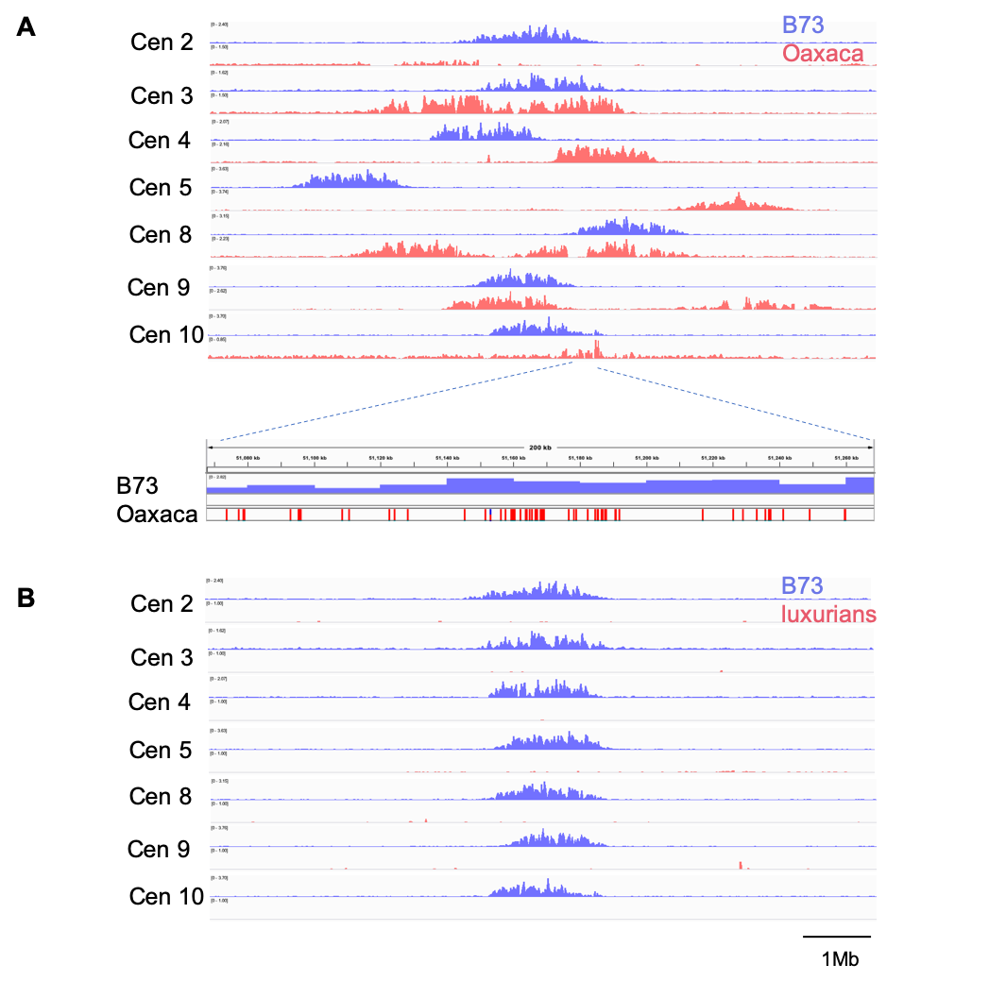

**Figure S2. Comparison of B73 centromeres to those in Oaxaca and *Zea luxurians*.** (A) CENH3 ChIP-seq profiles for seven B73 and Oaxaca centromeres mapped to the B73 reference. The data are from a single heterozygous plant. (B) CENH3 ChIP-seq profiles for seven B73 and *Zea luxurians* centromeres mapped to the B73 reference. The data are from a single heterozygous plant. There appears to be no centromeres in *Zea luxurians* because the centromeres are embedded in long CentC arrays that lack homology to the B73 reference. The window size is 10Mb.

**Table S1. ChIP datasets generated in this study.**



1 Genome sizes are from [(Chia *et al.* 2012)](https://paperpile.com/c/78bVPo/alpx).

**Table S2. Genome sizes measured in this study.** Measured genome sizes were divided by the average size of the six B73 samples.

b

**Table S3. Primers used in this study.**



**Table S4**. **Genome and centromere sizes in Oaxaca X B73 hybrids.** Genome sizes were not measured for the plants subjected to ChIP. The genome sizes shown are averages of multiple sibling individuals measured from the same ears (Supplemental Table 2). For centromere sizes, the unit of measure is bp.



**Table S5. Genome and centromere sizes in B73 X *Zea luxurians* hybrids.** Genome sizes were not measured for the plants subjected to ChIP. The genome sizes shown are averages of multiple sibling individuals measured from the same ears (Supplemental Table 2). For centromere sizes, the unit of measure is bp.



**Table S6. Sequence Read Archive run IDs for all ChIP data used in this study.**

|  |  |  |  |  |  |  |  |  |
| --- | --- | --- | --- | --- | --- | --- | --- | --- |
| Sample_name | Species/  subspecies | Cultivar | Accession | ChIP SRA run | input SRA run | Library  layout | Tissue | Reference |
| CML103_1 | Zea mays | CML103 | PRJNA639705 | SRR12023802 | NA | paired | seedling | this study |
| CML103_2 | Zea mays | CML103 | PRJNA639705 | SRR12023791 | NA | paired | seedling | this study |
| CML277_1 | Zea mays | CML277 | PRJNA639705 | SRR12023780 | NA | paired | seedling | this study |
| CML277_2 | Zea mays | CML277 | PRJNA639705 | SRR12023769 | NA | paired | seedling | this study |
| CML333_1 | Zea mays | CML333 | PRJNA639705 | SRR12023758 | NA | single | seedling | this study |
| CML333_2 | Zea mays | CML333 | PRJNA639705 | SRR12023747 | NA | single | seedling | this study |
| CML333_3 | Zea mays | CML333 | PRJNA639705 | SRR12023736 | NA | single | seedling | this study |
| HP301_1 | Zea mays | HP301 | PRJNA639705 | SRR12023730 | NA | paired | seedling | this study |
| HP301_2 | Zea mays | HP301 | PRJNA639705 | SRR12023729 | NA | paired | seedling | this study |
| IL14H_1 | Zea mays | IL14H | PRJNA639705 | SRR12023801 | NA | paired | seedling | this study |
| IL14H_2 | Zea mays | IL14H | PRJNA639705 | SRR12023800 | NA | paired | seedling | this study |
| IL14H_3 | Zea mays | IL14H | PRJNA639705 | SRR12023799 | NA | paired | seedling | this study |
| Ki11_1 | Zea mays | Ki11 | PRJNA639705 | SRR12023798 | NA | single | seedling | this study |
| Ki11_2 | Zea mays | Ki11 | PRJNA639705 | SRR12023797 | NA | single | seedling | this study |
| Ki11_3 | Zea mays | Ki11 | PRJNA639705 | SRR12023796 | NA | single | seedling | this study |
| Ki3_1 | Zea mays | Ki3 | PRJNA639705 | SRR12023795 | NA | paired | seedling | this study |
| Ki3_2 | Zea mays | Ki3 | PRJNA639705 | SRR12023794 | NA | paired | seedling | this study |
| NC350_1 | Zea mays | NC350 | PRJNA639705 | SRR12023793 | NA | paired | seedling | this study |
| NC350_2 | Zea mays | NC350 | PRJNA639705 | SRR12023792 | NA | paired | seedling | this study |
| Oh7b_1 | Zea mays | Oh7b | PRJNA639705 | SRR12023790 | NA | paired | seedling | this study |
| Oh7b_2 | Zea mays | Oh7b | PRJNA639705 | SRR12023789 | NA | paired | seedling | this study |
| P39_1 | Zea mays | P39 | PRJNA639705 | SRR12023788 | NA | single | seedling | this study |
| P39_2 | Zea mays | P39 | PRJNA639705 | SRR12023787 | NA | single | seedling | this study |
| P39_3 | Zea mays | P39 | PRJNA639705 | SRR12023786 | NA | single | seedling | this study |
| Tzi8_1 | Zea mays | Tzi8 | PRJNA639705 | SRR12023785 | NA | paired | seedling | this study |
| Tzi8_2 | Zea mays | Tzi8 | PRJNA639705 | SRR12023784 | NA | paired | seedling | this study |
| B73_4 | Zea mays | B73 | PRJNA639705 | SRR12023803 | NA | single | seedling | this study |
| OaxB73_F2_1 | Zea mays | OaxB73_F2 | PRJNA639705 | SRR12023783 | NA | single | seedling | this study |
| OaxB73_F2_2 | Zea mays | OaxB73_F2 | PRJNA639705 | SRR12023782 | NA | single | seedling | this study |
| OaxB73_F2_3 | Zea mays | OaxB73_F2 | PRJNA639705 | SRR12023781 | NA | single | seedling | this study |
| OaxB73_F2_4 | Zea mays | OaxB73_F2 | PRJNA639705 | SRR12023779 | NA | single | seedling | this study |
| OaxB73_F2_5 | Zea mays | OaxB73_F2 | PRJNA639705 | SRR12023778 | NA | single | seedling | this study |
| OaxB73_F2_6 | Zea mays | OaxB73_F2 | PRJNA639705 | SRR12023777 | NA | single | seedling | this study |
| OaxB73_F2_7 | Zea mays | OaxB73_F2 | PRJNA639705 | SRR12023776 | NA | single | seedling | this study |
| OaxB73_F2_8 | Zea mays | OaxB73_F2 | PRJNA639705 | SRR12023775 | NA | single | seedling | this study |
| OaxB73_F2_9 | Zea mays | OaxB73_F2 | PRJNA639705 | SRR12023774 | NA | single | seedling | this study |
| OaxB73_BC1F2_1 | Zea mays | OaxB73_BC1F2 | PRJNA639705 | SRR12023773 | NA | single | seedling | this study |
| OaxB73_BC1F2_2 | Zea mays | OaxB73_BC1F2 | PRJNA639705 | SRR12023772 | NA | single | seedling | this study |
| OaxB73_BC1F2_4 | Zea mays | OaxB73_BC1F2 | PRJNA639705 | SRR12023771 | NA | single | seedling | this study |
| OaxB73_BC1F2_6 | Zea mays | OaxB73_BC1F2 | PRJNA639705 | SRR12023770 | NA | single | seedling | this study |
| OaxB73_BC1F2_8 | Zea mays | OaxB73_BC1F2 | PRJNA639705 | SRR12023768 | NA | single | seedling | this study |
| OaxB73_BC1F2_9 | Zea mays | OaxB73_BC1F2 | PRJNA639705 | SRR12023767 | NA | single | seedling | this study |
| OaxB73_BC1F2_10 | Zea mays | OaxB73_BC1F2 | PRJNA639705 | SRR12023766 | NA | single | seedling | this study |
| OaxB73_BC1F2_11 | Zea mays | OaxB73_BC1F2 | PRJNA639705 | SRR12023765 | NA | single | seedling | this study |
| OaxB73_BC1F2_12 | Zea mays | OaxB73_BC1F2 | PRJNA639705 | SRR12023764 | NA | single | seedling | this study |
| OaxB73_BC1F2_13 | Zea mays | OaxB73_BC1F2 | PRJNA639705 | SRR12023763 | NA | single | seedling | this study |
| OaxB73_BC1F2_15 | Zea mays | OaxB73_BC1F2 | PRJNA639705 | SRR12023762 | NA | single | seedling | this study |
| OaxB73_BC1F2_16 | Zea mays | OaxB73_BC1F2 | PRJNA639705 | SRR12023761 | NA | single | seedling | this study |
| OaxB73_BC1F2_17 | Zea mays | OaxB73_BC1F2 | PRJNA639705 | SRR12023760 | NA | single | seedling | this study |
| OaxB73_BC1F2_18 | Zea mays | OaxB73_BC1F2 | PRJNA639705 | SRR12023759 | NA | single | seedling | this study |
| OaxB73_BC1F2_19 | Zea mays | OaxB73_BC1F2 | PRJNA639705 | SRR12023757 | NA | single | seedling | this study |
| B73lux_F1_1 | Zea mays subsp. mays x Zea luxurians | B73lux_F1 | PRJNA639705 | SRR12023756 | NA | single | seedling | this study |
| B73lux_F1_2 | Zea mays subsp. mays x Zea luxurians | B73lux_F1 | PRJNA639705 | SRR12023755 | NA | single | seedling | this study |
| B73lux_F1_3 | Zea mays subsp. mays x Zea luxurians | B73lux_F1 | PRJNA639705 | SRR12023754 | NA | single | seedling | this study |
| B73lux_F2_1 | Zea mays subsp. mays x Zea luxurians | B73lux_F2 | PRJNA639705 | SRR12023753 | NA | single | seedling | this study |
| B73lux_F2_2 | Zea mays subsp. mays x Zea luxurians | B73lux_F2 | PRJNA639705 | SRR12023752 | NA | single | seedling | this study |
| B73lux_F2_3 | Zea mays subsp. mays x Zea luxurians | B73lux_F2 | PRJNA639705 | SRR12023751 | NA | single | seedling | this study |
| B73lux_F2_4 | Zea mays subsp. mays x Zea luxurians | B73lux_F2 | PRJNA639705 | SRR12023750 | NA | single | seedling | this study |
| B73lux_F2_5 | Zea mays subsp. mays x Zea luxurians | B73lux_F2 | PRJNA639705 | SRR12023749 | NA | single | seedling | this study |
| B73lux_F2_6 | Zea mays subsp. mays x Zea luxurians | B73lux_F2 | PRJNA639705 | SRR12023748 | NA | single | seedling | this study |
| B73lux_BC1F2_1 | Zea mays subsp. mays x Zea luxurians | B73lux_BC1F2 | PRJNA639705 | SRR12023746 | NA | single | seedling | this study |
| B73lux_BC1F2_2 | Zea mays subsp. mays x Zea luxurians | B73lux_BC1F2 | PRJNA639705 | SRR12023745 | NA | single | seedling | this study |
| B73lux_BC1F2_6 | Zea mays subsp. mays x Zea luxurians | B73lux_BC1F2 | PRJNA639705 | SRR12023744 | NA | single | seedling | this study |
| B73lux_BC1F2_11 | Zea mays subsp. mays x Zea luxurians | B73lux_BC1F2 | PRJNA639705 | SRR12023743 | NA | single | seedling | this study |
| B73lux_BC1F2_13 | Zea mays subsp. mays x Zea luxurians | B73lux_BC1F2 | PRJNA639705 | SRR12023742 | NA | single | seedling | this study |
| B73lux_BC1F2_15 | Zea mays subsp. mays x Zea luxurians | B73lux_BC1F2 | PRJNA639705 | SRR12023741 | NA | single | seedling | this study |
| B73lux_BC1F2_16 | Zea mays subsp. mays x Zea luxurians | B73lux_BC1F2 | PRJNA639705 | SRR12023740 | NA | single | seedling | this study |
| B73lux_BC1F2_17 | Zea mays subsp. mays x Zea luxurians | B73lux_BC1F2 | PRJNA639705 | SRR12023739 | NA | single | seedling | this study |
| B73lux_BC1F2_19 | Zea mays subsp. mays x Zea luxurians | B73lux_BC1F2 | PRJNA639705 | SRR12023738 | NA | single | seedling | this study |
| trangenic_WT_1 | Zea mays | mixed | PRJNA639705 | SRR12023737 | NA | single | seedling | this study |
| trangenic_WT_2 | Zea mays | mixed | PRJNA639705 | SRR12023735 | NA | single | seedling | this study |
| trangenic_WT_3 | Zea mays | mixed | PRJNA639705 | SRR12023734 | NA | single | seedling | this study |
| trangenic_Ox_1 | Zea mays | mixed | PRJNA639705 | SRR12023733 | NA | single | seedling | this study |
| trangenic_Ox_2 | Zea mays | mixed | PRJNA639705 | SRR12023732 | NA | single | seedling | this study |
| trangenic_Ox_3 | Zea mays | mixed | PRJNA639705 | SRR12023731 | NA | single | seedling | this study |
| MS71 | Zea mays | MS71 | PRJNA305893 | [SRR2994641](https://trace.ncbi.nlm.nih.gov/Traces/sra?run=SRR2994641) | NA | paired | leaves |  |
| Mo18W | Zea mays | Mo18W | PRJNA305893 | [SRR3018349](https://trace.ncbi.nlm.nih.gov/Traces/sra?run=SRR3018349) | NA | paired | leaves |  |
| B97 | Zea mays | B97 | PRJNA305893 | [SRR3018373](https://trace.ncbi.nlm.nih.gov/Traces/sra?run=SRR3018373) | NA | paired | leaves |  |
| CML333 | Zea mays | CML333 | PRJNA305893 | [SRR3018392](https://trace.ncbi.nlm.nih.gov/Traces/sra?run=SRR3018392) | NA | paired | leaves |  |
| P39 | Zea mays | P39 | PRJNA305893 | [SRR3018404](https://trace.ncbi.nlm.nih.gov/Traces/sra?run=SRR3018404) | NA | paired | leaves |  |
| Il14H | Zea mays | Il14H | PRJNA305893 | [SRR3018410](https://trace.ncbi.nlm.nih.gov/Traces/sra?run=SRR3018410) | NA | paired | leaves |  |
| KI11 | Zea mays | KI11 | PRJNA305893 | [SRR3018575](https://trace.ncbi.nlm.nih.gov/Traces/sra?run=SRR3018575) | NA | paired | leaves |  |
| Ky21 | Zea mays | Ky21 | PRJNA305893 | [SRR3018597](https://trace.ncbi.nlm.nih.gov/Traces/sra?run=SRR3018597) | NA | paired | leaves |  |
| Tx303 | Zea mays | Tx303 | PRJNA305893 | [SRR3018625](https://trace.ncbi.nlm.nih.gov/Traces/sra?run=SRR3018625) | NA | paired | leaves |  |
| NC358 | Zea mays | NC358 | PRJNA305893 | [SRR3018741](https://trace.ncbi.nlm.nih.gov/Traces/sra?run=SRR3018741) | NA | paired | leaves |  |
| KI3 | Zea mays | KI3 | PRJNA305893 | [SRR3018808](https://trace.ncbi.nlm.nih.gov/Traces/sra?run=SRR3018808) | NA | paired | leaves |  |
| Hp301 | Zea mays | Hp301 | PRJNA305893 | [SRR3018811](https://trace.ncbi.nlm.nih.gov/Traces/sra?run=SRR3018811) | NA | paired | leaves |  |
| CML69 | Zea mays | CML69 | PRJNA305893 | [SRR3018813](https://trace.ncbi.nlm.nih.gov/Traces/sra?run=SRR3018813) | NA | paired | leaves |  |
| CML247 | Zea mays | CML247 | PRJNA305893 | [SRR3018814](https://trace.ncbi.nlm.nih.gov/Traces/sra?run=SRR3018814) | NA | paired | leaves |  |
| TZI8 | Zea mays | TZI8 | PRJNA305893 | [SRR3018816](https://trace.ncbi.nlm.nih.gov/Traces/sra?run=SRR3018816) | NA | paired | leaves |  |
| M162W | Zea mays | M162W | PRJNA305893 | [SRR3018819](https://trace.ncbi.nlm.nih.gov/Traces/sra?run=SRR3018819) | NA | paired | leaves |  |
| CML103 | Zea mays | CML103 | PRJNA305893 | [SRR3018820](https://trace.ncbi.nlm.nih.gov/Traces/sra?run=SRR3018820) | NA | paired | leaves |  |
| OH7B | Zea mays | OH7B | PRJNA305893 | [SRR3018821](https://trace.ncbi.nlm.nih.gov/Traces/sra?run=SRR3018821) | NA | paired | leaves |  |
| OH43 | Zea mays | OH43 | PRJNA305893 | [SRR3018822](https://trace.ncbi.nlm.nih.gov/Traces/sra?run=SRR3018822) | NA | paired | leaves |  |
| CML322 | Zea mays | CML322 | PRJNA305893 | [SRR3018825](https://trace.ncbi.nlm.nih.gov/Traces/sra?run=SRR3018825) | NA | paired | leaves |  |
| CML52 | Zea mays | CML52 | PRJNA305893 | [SRR3018826](https://trace.ncbi.nlm.nih.gov/Traces/sra?run=SRR3018826) | NA | paired | leaves |  |
| CML228 | Zea mays | CML228 | PRJNA305893 | [SRR3018827](https://trace.ncbi.nlm.nih.gov/Traces/sra?run=SRR3018827) | NA | paired | leaves |  |
| M37W | Zea mays | M37W | PRJNA305893 | [SRR3018833](https://trace.ncbi.nlm.nih.gov/Traces/sra?run=SRR3018833) | NA | paired | leaves |  |
| B73_1 | Zea mays | B73 | SRP105290 | SRR5466739 | NA | single | seedling | Gent et al., 2017 |
| B73_2 | Zea mays | B73 | SRP105290 | SRR5466555 | NA | single | seedling | Gent et al., 2017 |
| B73_3 | Zea mays | B73 | SRP105290 | SRR5466556 | NA | single | seedling | Gent et al., 2017 |
| B73_5 | Zea mays | B73 | SRP105290 | SRR5466737 | NA | single | seedling | Gent et al., 2017 |
| B73_6 | Zea mays | B73 | SRP105290 | SRR5466390 | NA | single | seedling | Gent et al., 2017 |
| J178-3 | Zea luxurians | PI 422162 | SRP105290 | SRR5466387 | SRR5466389 | single | seedling | Gent et al., 2017 |
| Oax-2 | Zea mays mays | PI 628470 | SRP105290 | SRR5466588 | SRR5466710 | single | seedling | Gent et al., 2017 |