NAM Phenotypes.
To both validate the CP-NAM and identify loci underlying pericarp (outer seed coat) and testa (tissue layer between the pericarp and the endosperm) pigmentation, we characterized the association between these phenotypes and our set of SNPs generated using both QTL mapping and GWAS. Preliminary quality control of the grain phenotypes indicated that the distributions for pericarp color are not strongly suited for identifying the associated genes – with only two of the 11 RIL populations containing more than 10 individuals with a yellow phenotype (Figure S1). The pericarps are also occasionally spotted or tinted red, which further complicated phenotyping of these populations. Approximately 70% of all individuals had a pigmented testa layer, and each RIL population had 45-75% testa pigmentation with the exceptions of PI297155 and PI563295 which were almost entirely pigmented.

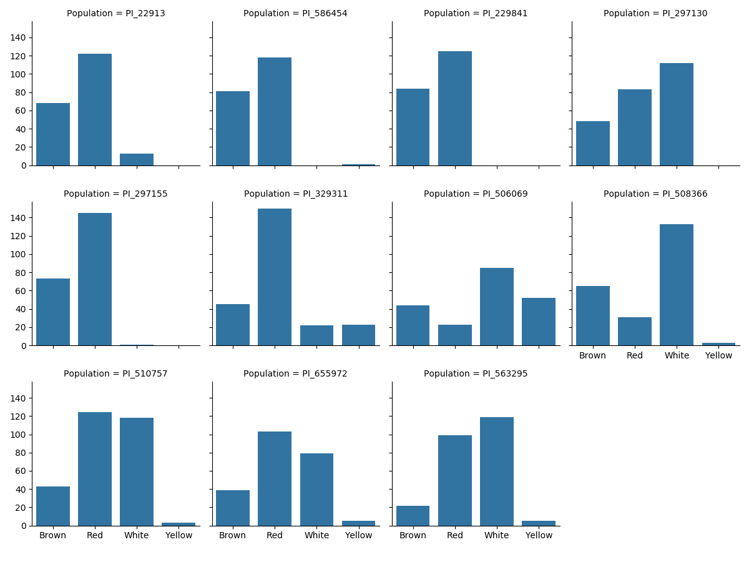

Supplementary Figure Distribution of pericarp phenotypes for individual NAM populations.

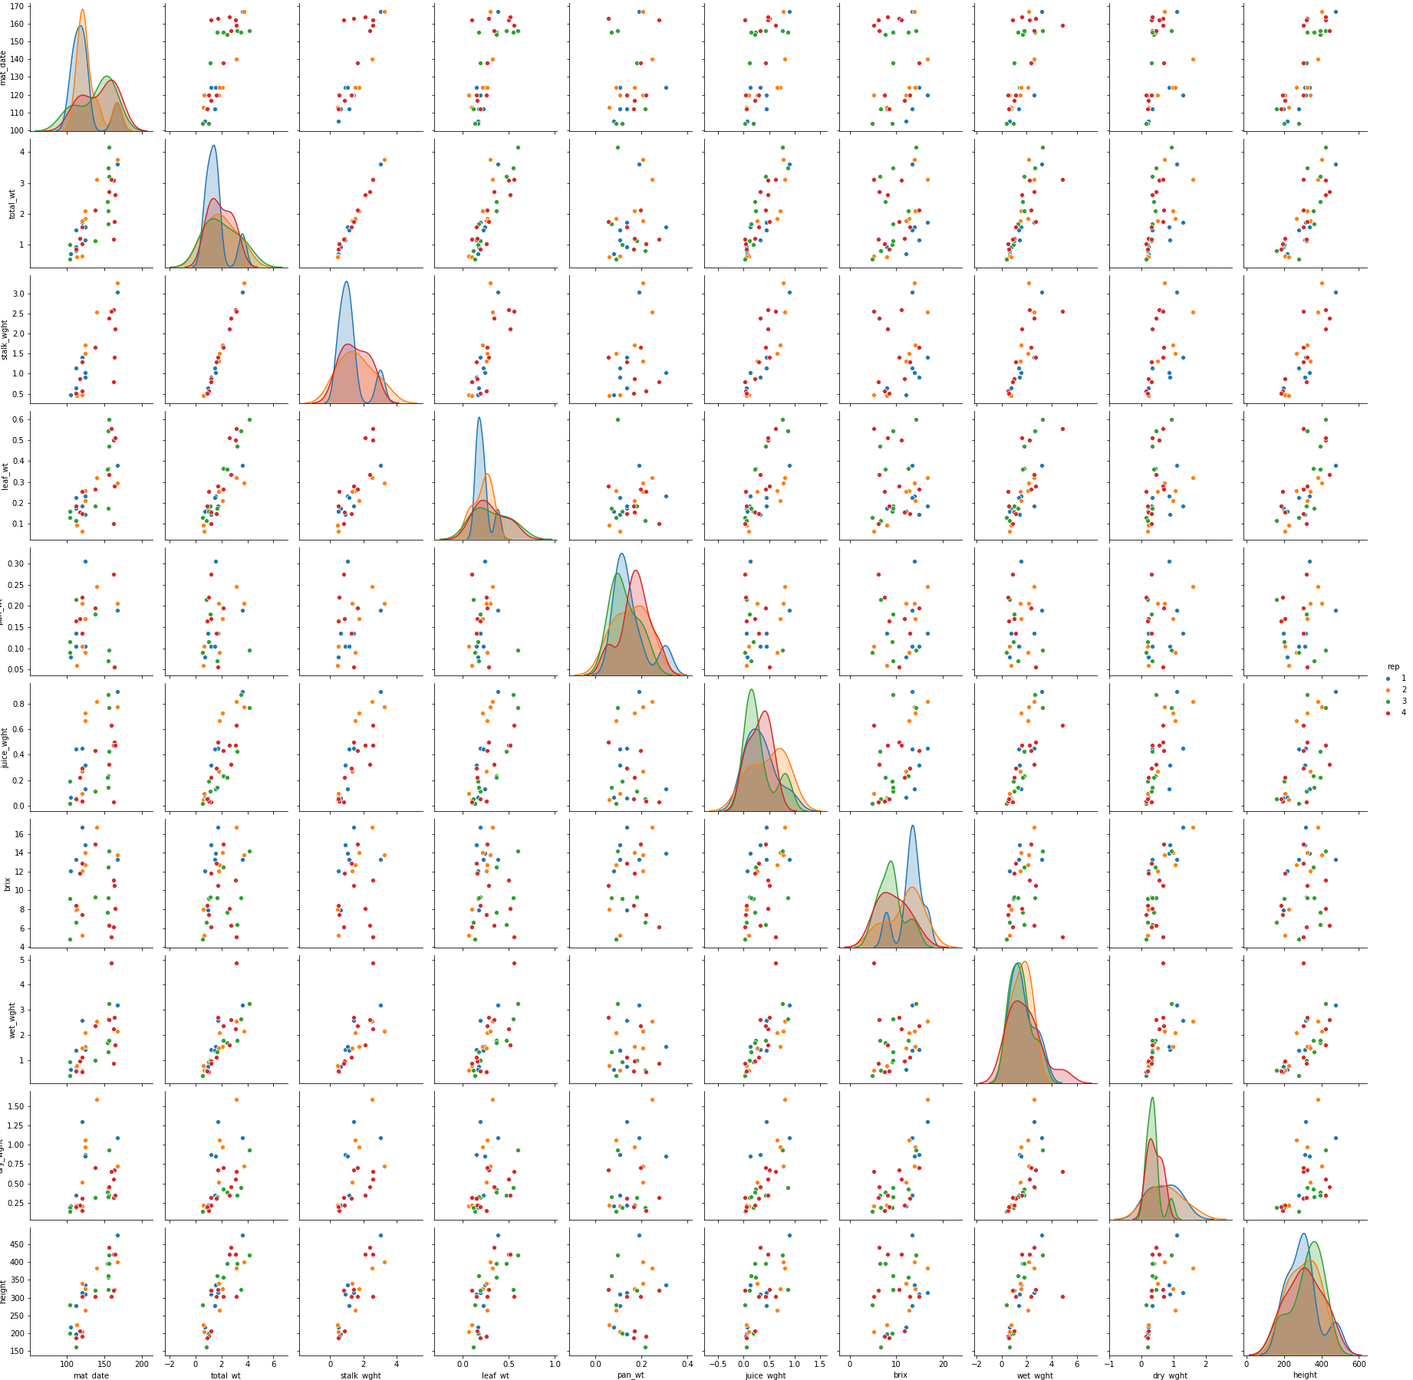

Supplementary Figure Distribution of agronomic phenotypes for CP-NAM parents colored by replicate. Phenotypes from left to right are maturity date, total weight, stalk weight, leaf weight, panicle weight, juice weight, brix, wet weight, dry weight, and plant height.

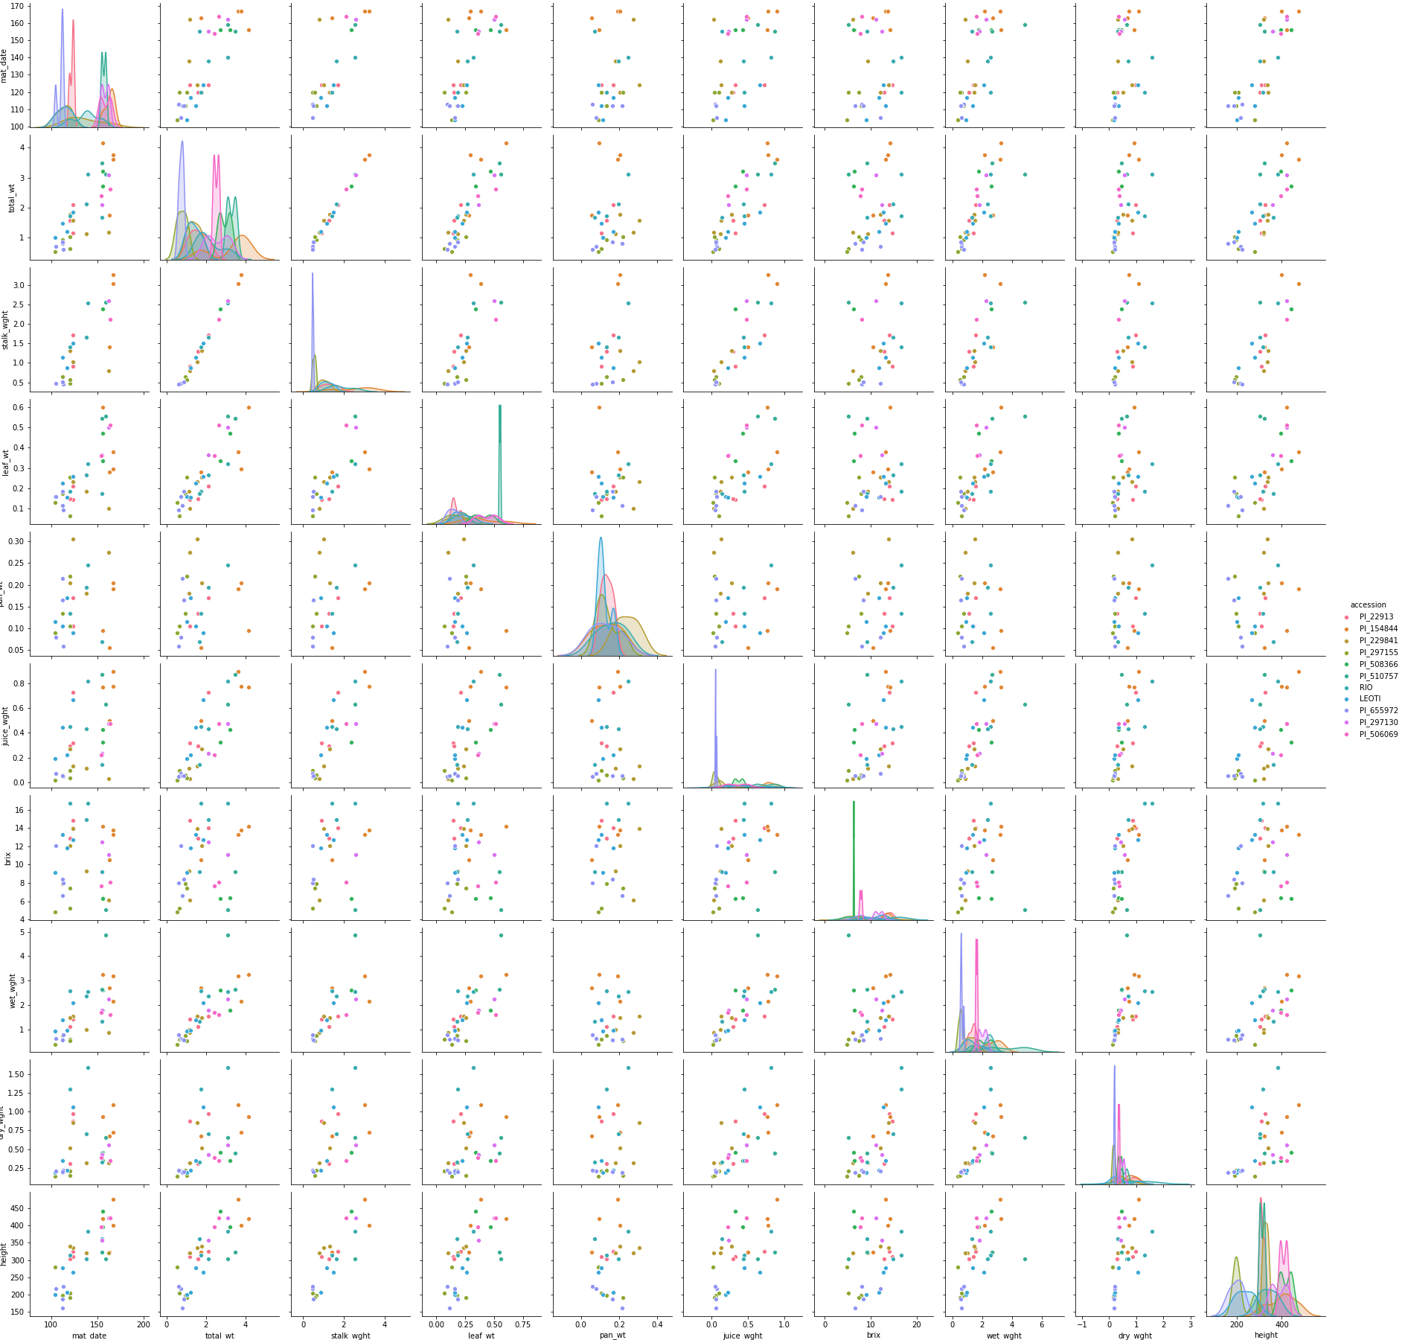

Supplementary Figure Distribution of agronomic phenotypes for CP-NAM parents colored by parent. Phenotypes from left to right are maturity date, total weight, stalk weight, leaf weight, panicle weight, juice weight, brix, wet weight, dry weight, and plant height.
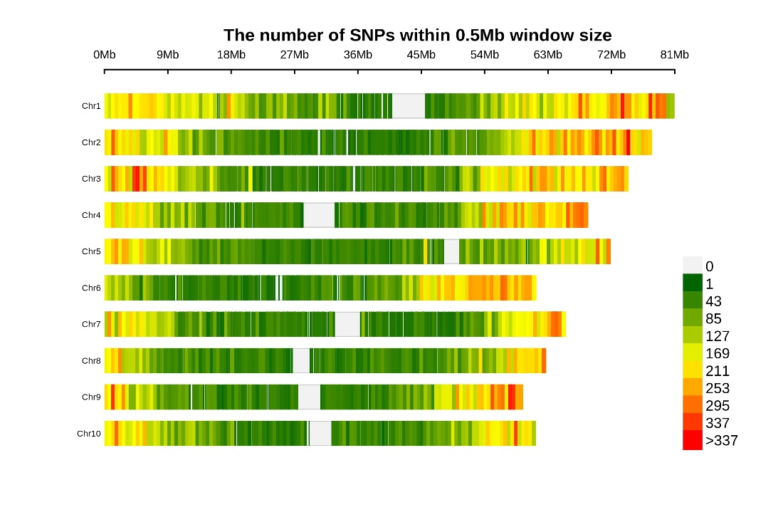

Supplementary Figure SNP density prior to minor allele frequency filtering.

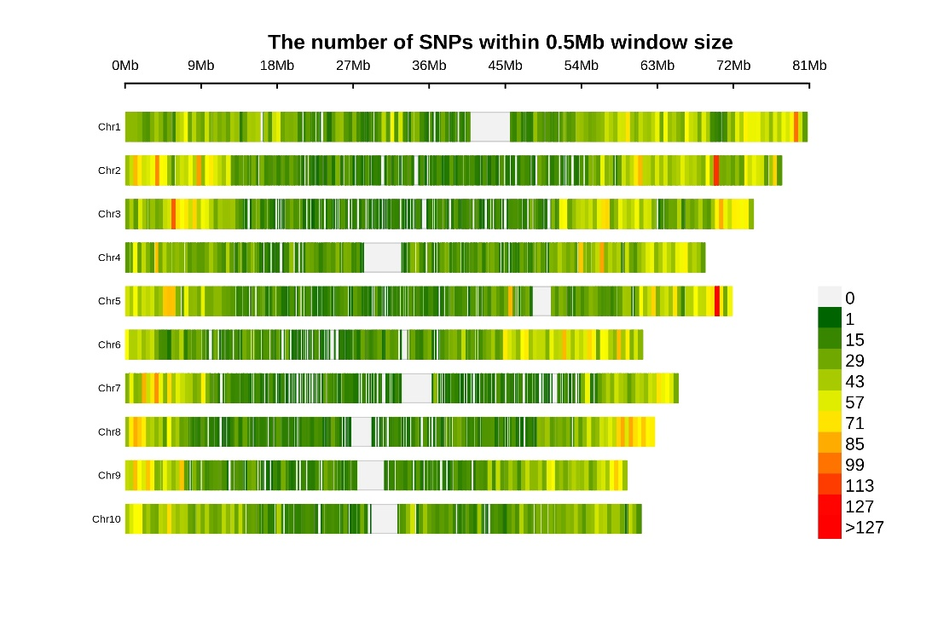

Supplementary Figure SNP density after filtering minor allele frequency at 0.05.
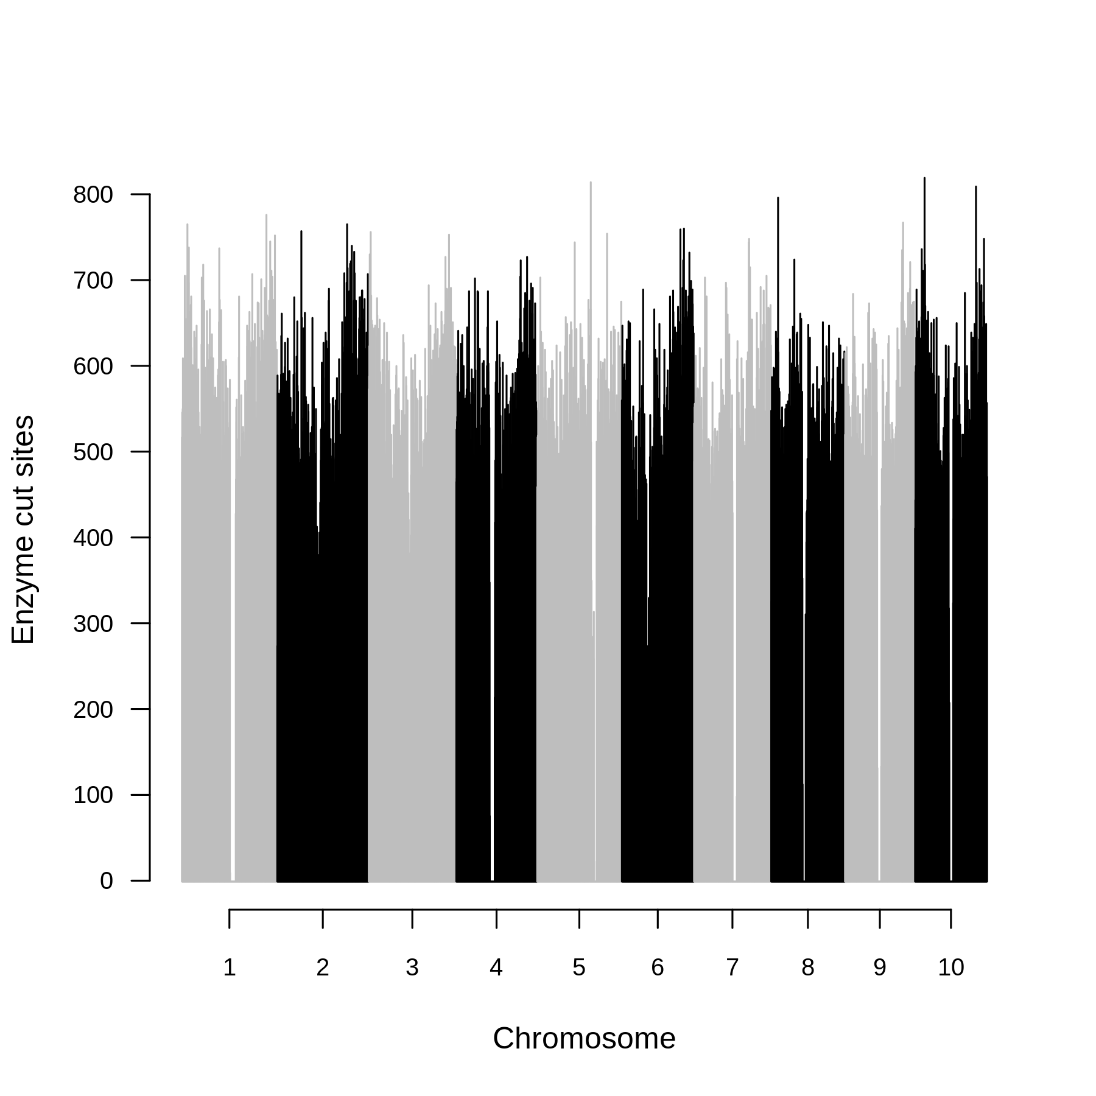

Supplementary Figure Distribution of MspI and PstI restriction sites across the genome in 200‐kb sliding windows
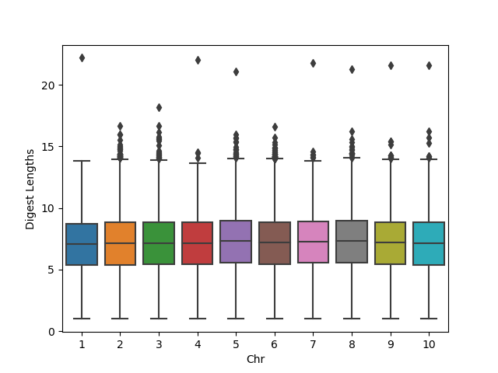

Supplementary Figure Distribution of MspI and PstI restriction digest log2 lengths across the genome in 200‐kb sliding windows

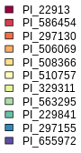
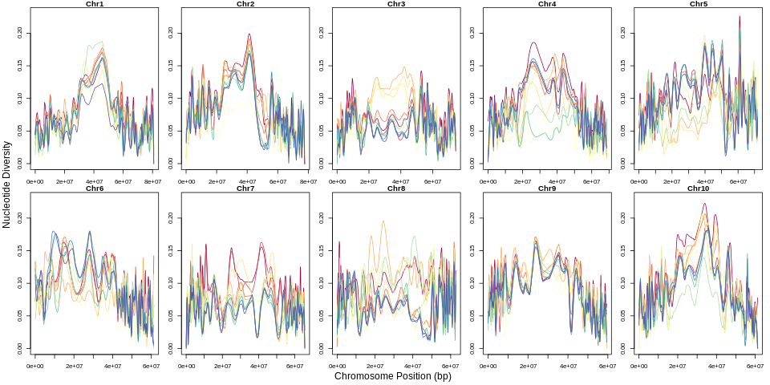

Supplementary Figure Nucleotide diversity for the CP-NAM chromosomes 1-10.

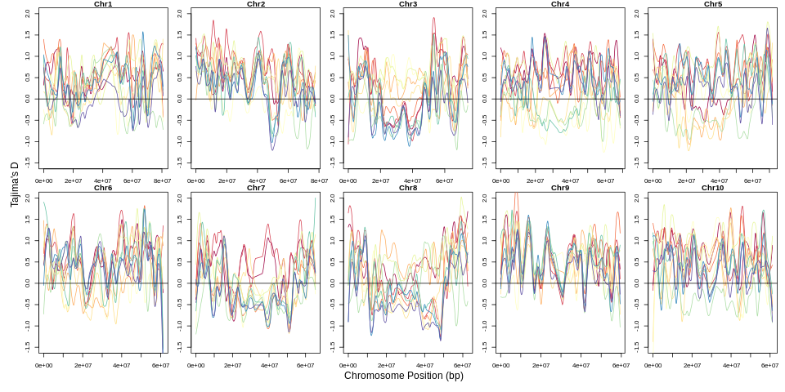

Supplementary Figure Tajima’s D for the CP-NAM chromosomes 1-10.

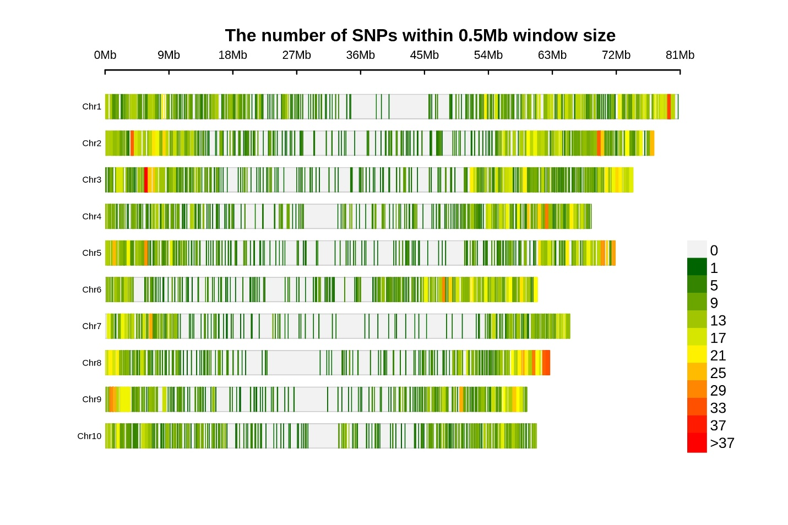

Supplementary Figure SNP density for SNPs common to the Tx430 and CP-NAM.

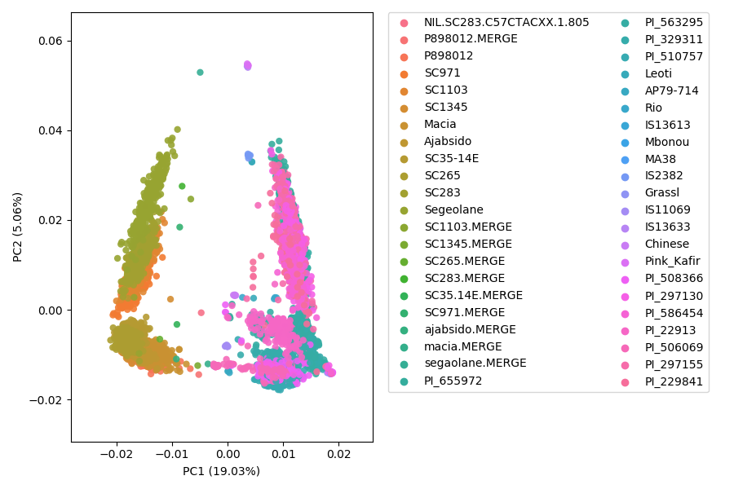

Supplementary Figure Principal component analysis of the common SNPs between Tx430 NAM and CP-NAM. Parents are labelled with common name. Each RIL population is represented by the male parent PI.

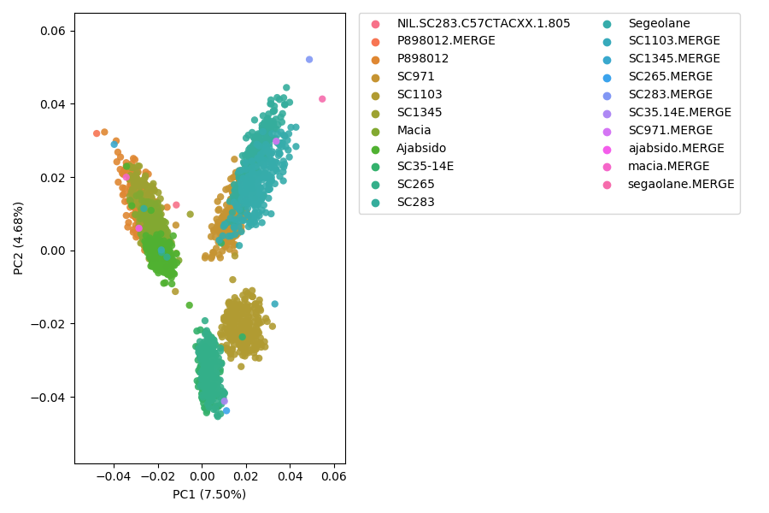

Supplementary Figure Principal component analysis of every Tx430 NAM RIL population with parents. Parents are labelled with common name. Each RIL population is represented by the male parent PI.

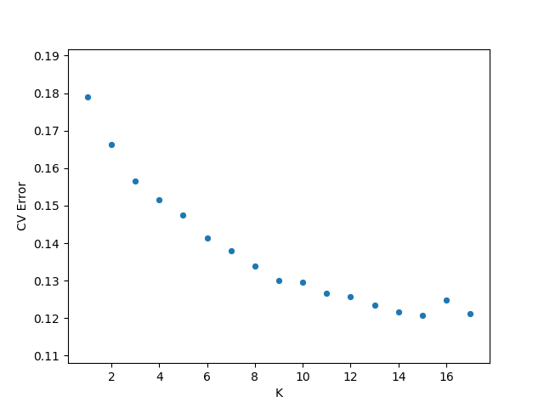

Supplementary Figure Selected number of ancestral populations (x-axis) by cross-validation error (y-axis).

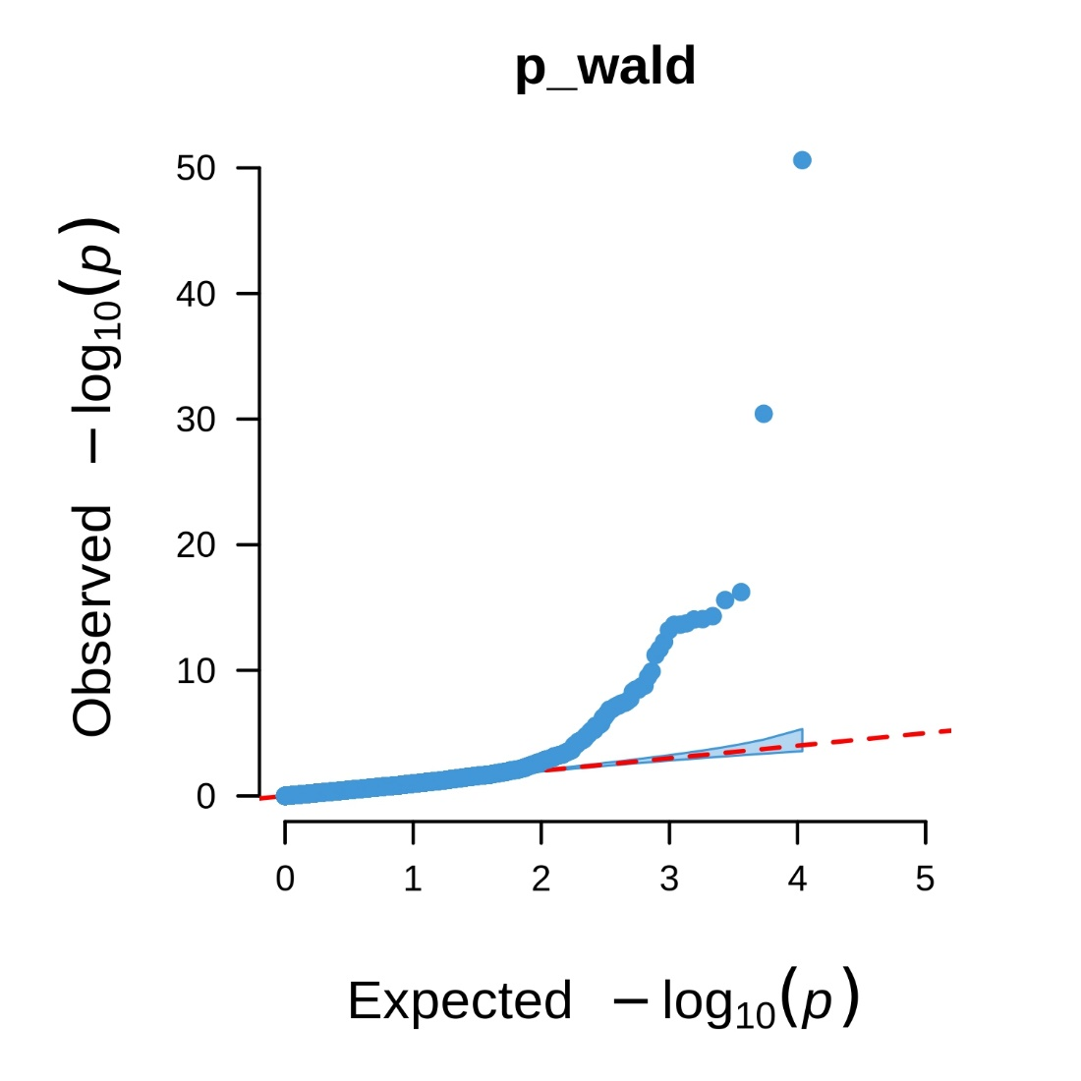

Supplementary Figure Q-Q plot for univariate GWAS for pericarp pigmentation.
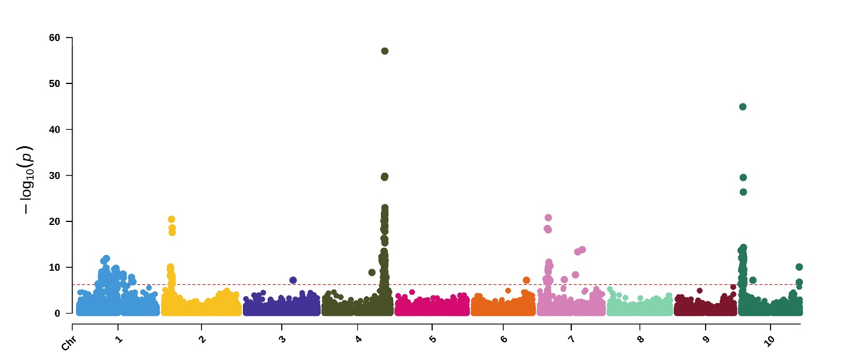

Supplementary Figure Manhattan plot for NAM pericarp pigmentation where red and brown are combined (numbered as 3), yellow (2) and white (1).

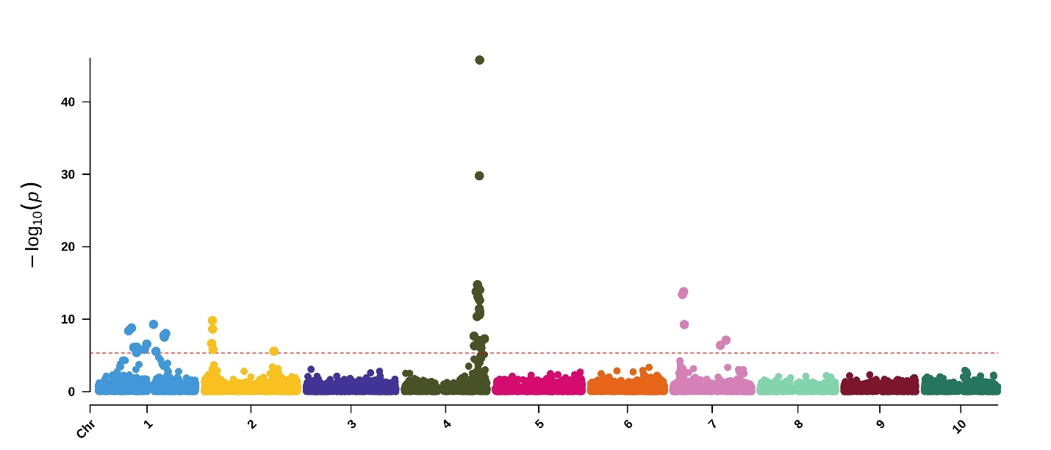

Supplementary Figure Univariate GWAS for pericarp pigmentation with testa covariate. The red dashed line represents the Bonferroni-corrected threshold.

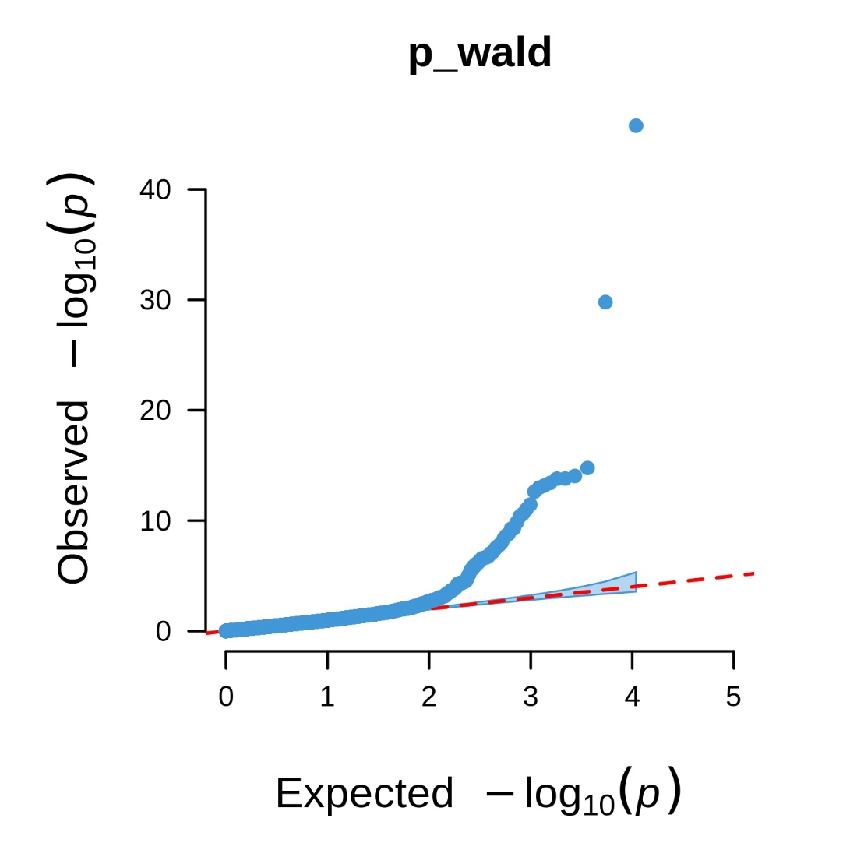

Supplementary Figure Q-Q plot for univariate GWAS for pericarp pigmentation with testa covariate.
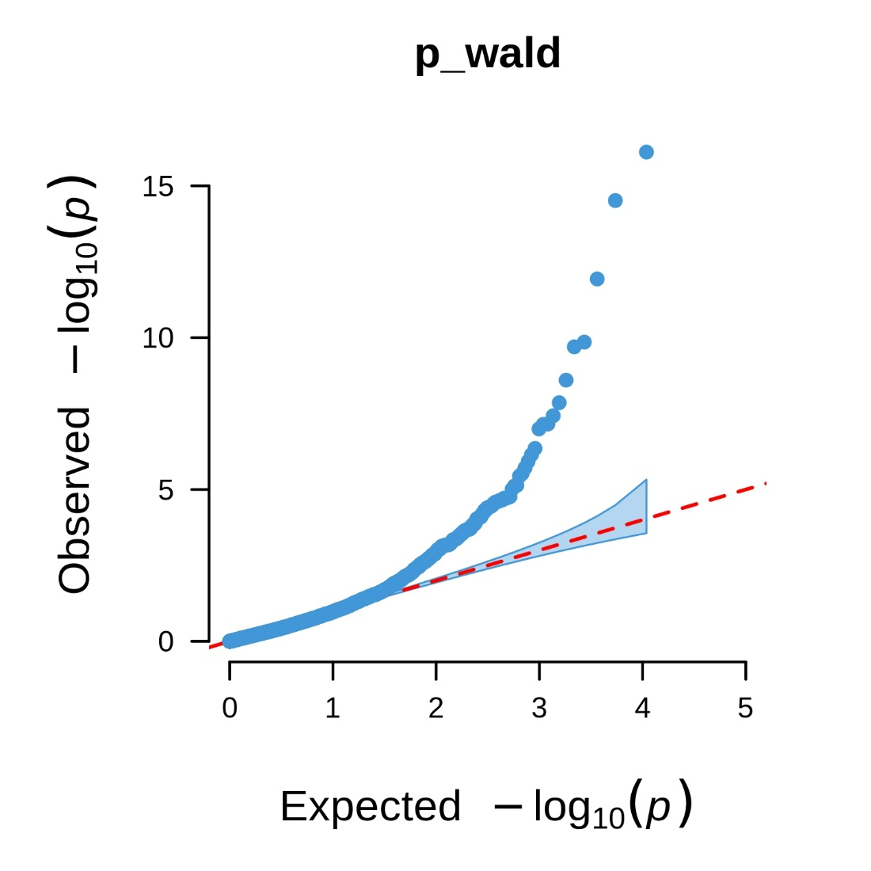

Supplementary Figure Q-Q plot for univariate GWAS for binary yellow pericarp pigmentation.
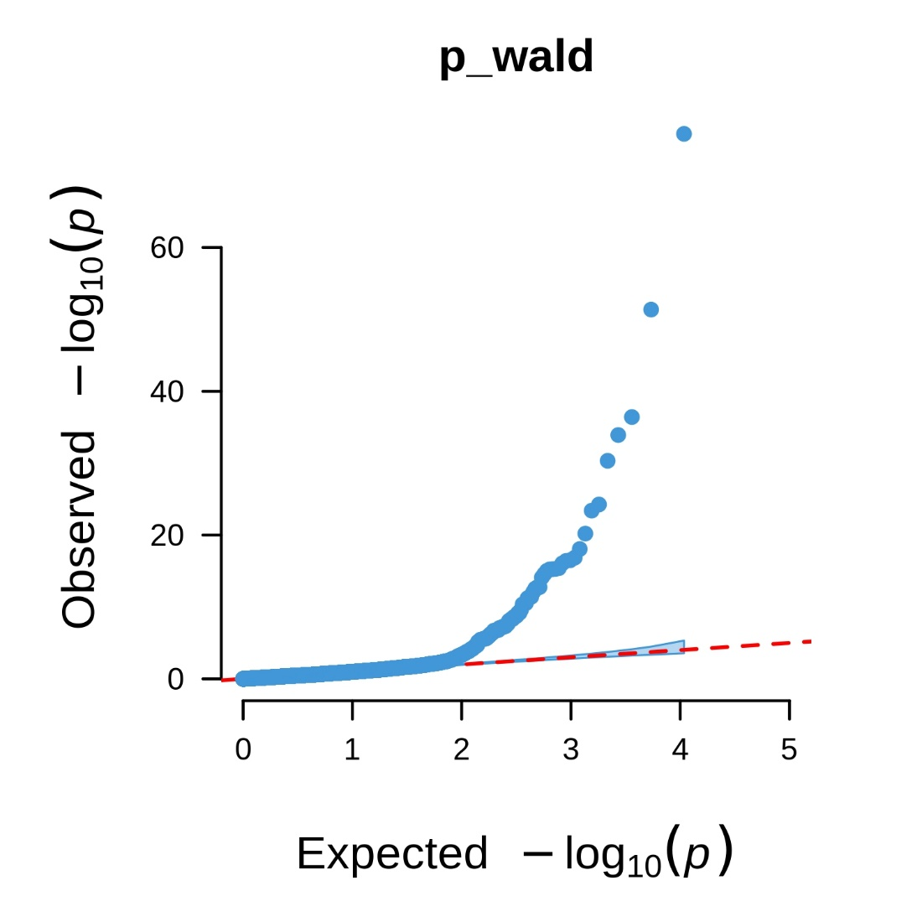

Supplementary Figure Q-Q plot for the multivariate GWAS for pericarp color and testa pigmentation.
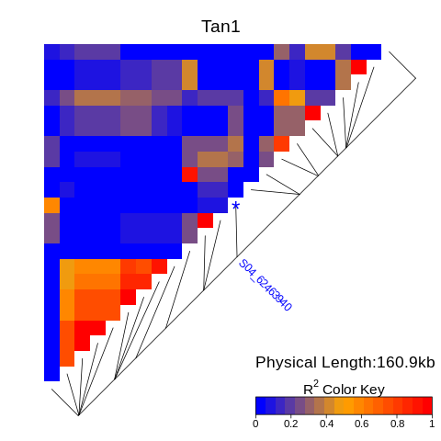

Supplementary Figure Heatmap of the linkage disequilibrium (R²) 100 kb upstream and downstream of the most significant Tan1 SNP using the unfiltered SNP set.
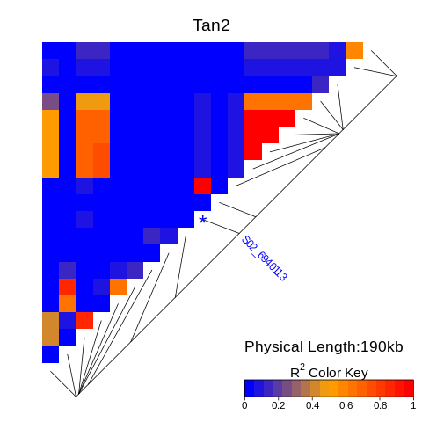

Supplementary Figure Heatmap of the linkage disequilibrium (R²) 100 kb upstream and downstream of the most significant Tan2 SNP using the unfiltered SNP set.
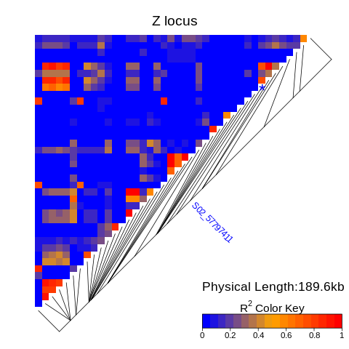

Supplementary Figure Heatmap of the linkage disequilibrium (R²) 100 kb upstream and downstream of the most significant SNP around the classical Z locus mediating mesocarp thickness using the unfiltered SNP set.
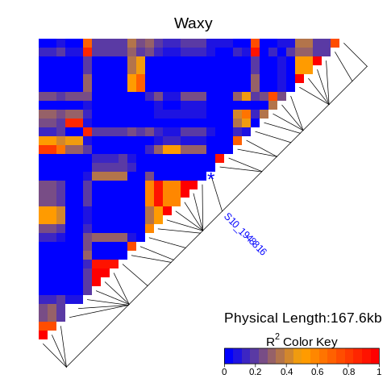

Supplementary Figure Heatmap of the linkage disequilibrium (R²) 100 kb upstream and downstream of the most significant Waxy SNP using the unfiltered SNP set.
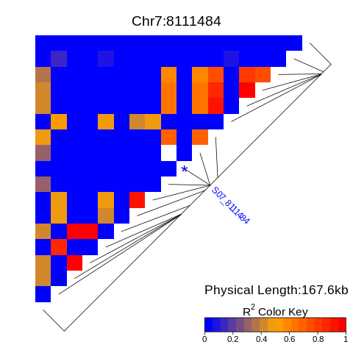

Supplementary Figure Heatmap of the linkage disequilibrium (R²) 100 kb upstream and downstream of the most significant SNP on chromosome 7 using the unfiltered SNP set.
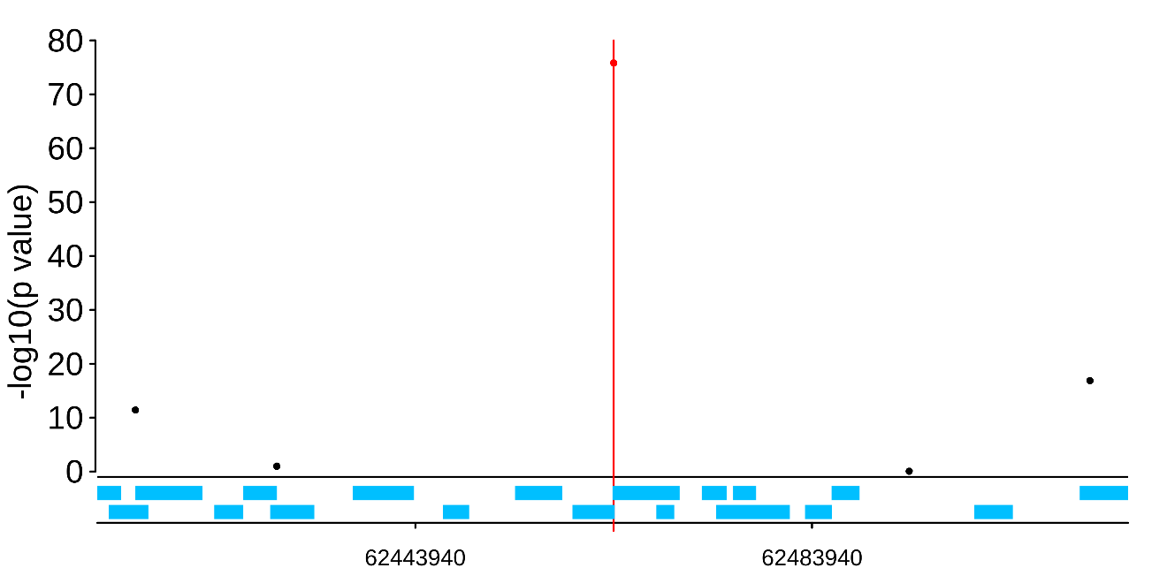

Supplementary Figure SNPs and gene distribution 100 kb upstream and downstream of the most significant Tan1 SNP using the pruned SNP set utilized by the multivariate GWAS.
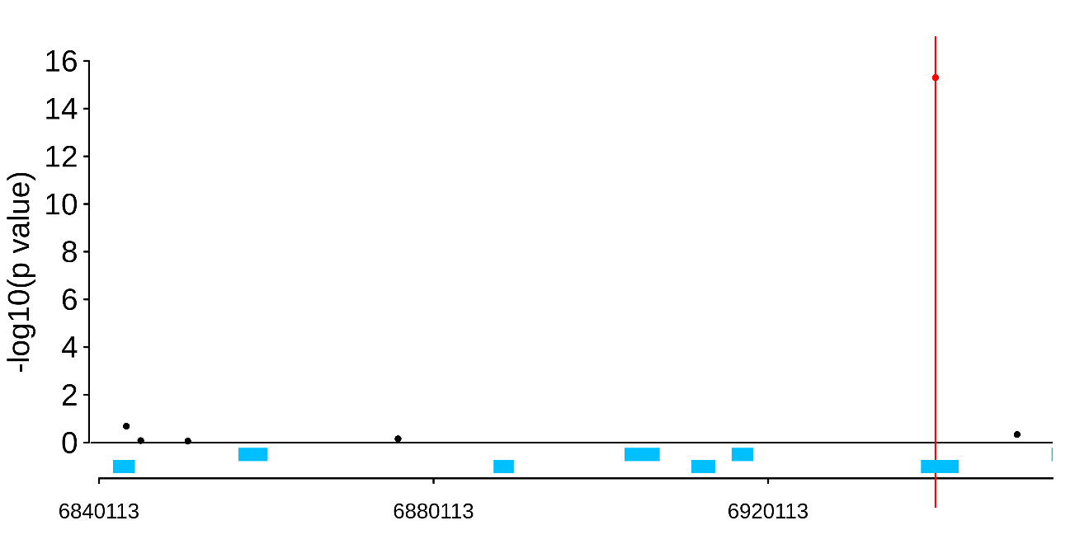

Supplementary Figure SNPs and gene distribution 100 kb upstream and downstream of the most significant Tan2 SNP using the pruned SNP set utilized by the multivariate GWAS.
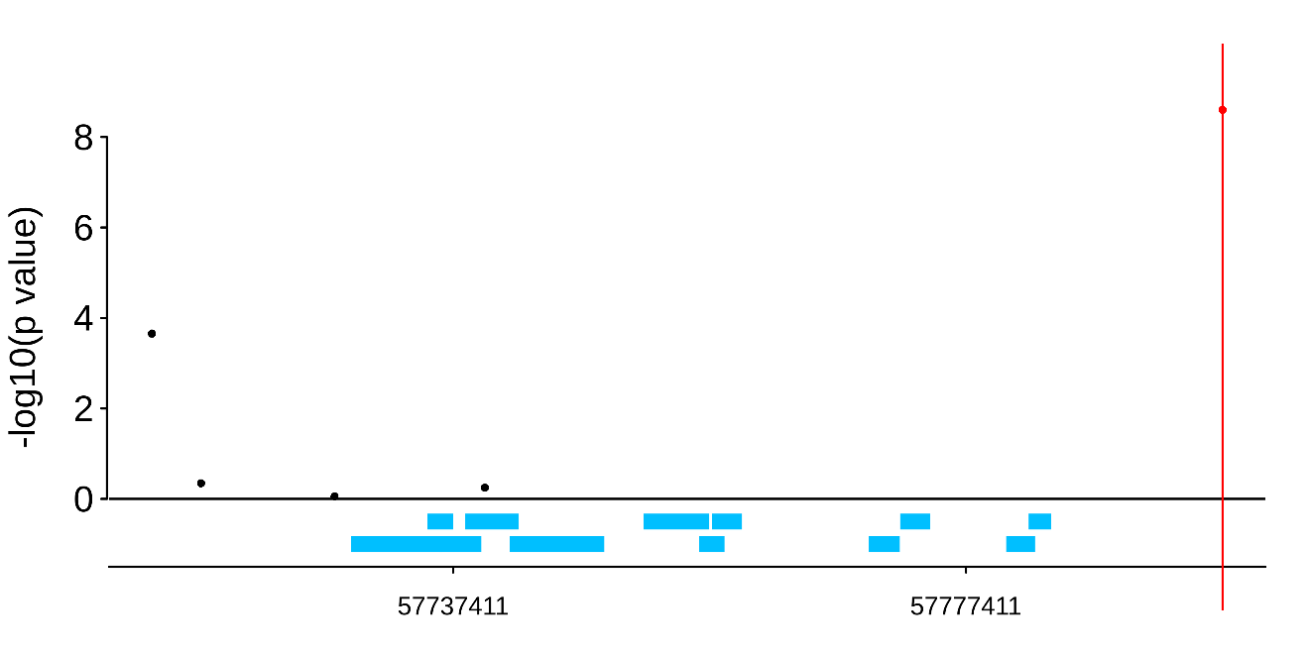

Supplementary Figure SNPs and gene distribution 100 kb upstream and downstream of the most significant Z-locus SNP using the pruned SNP set utilized by the univariate GWAS for yellow pericarp.
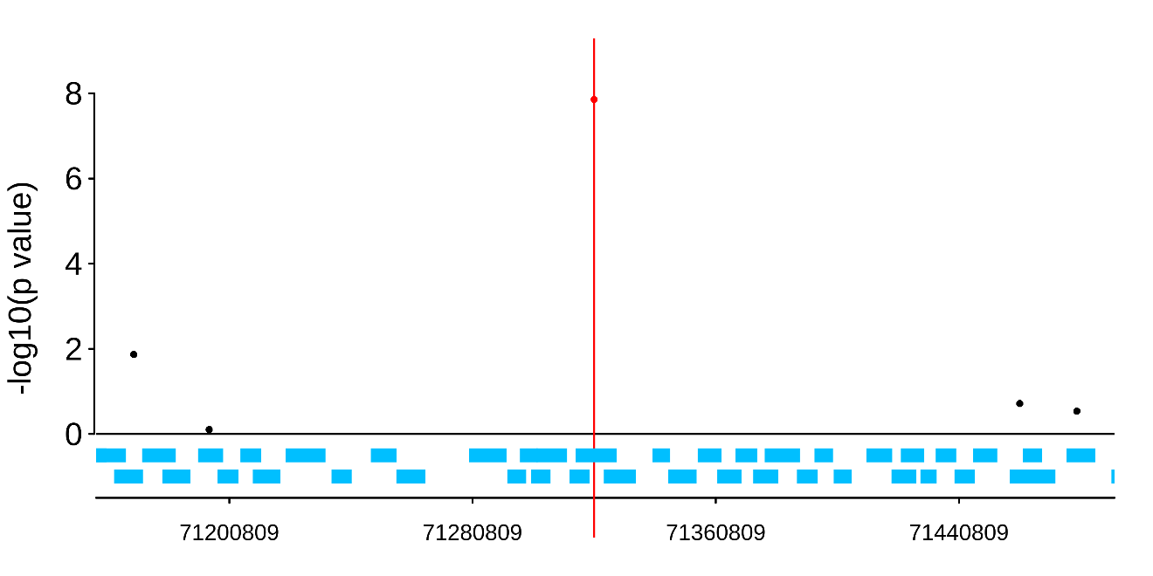

Supplementary Figure SNPs and gene distribution 200 kb upstream and downstream of the most significant Y1 SNP using the pruned SNP set utilized by the univariate GWAS for yellow pericarp.

INDIVIDUAL RIL POPULATIONS
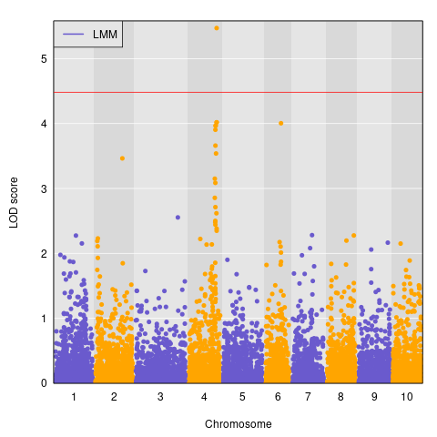

Supplementary Figure PI_22913 RIL population QTL mapping results. The threshold represents a 5% significance threshold after 5,000 permutations (4.48).
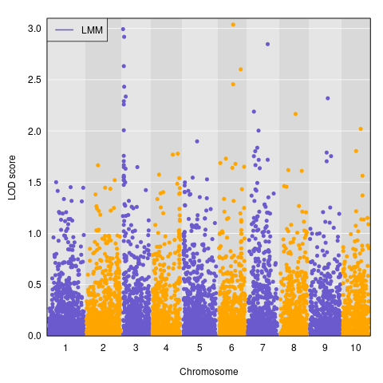

Supplementary Figure PI_229841 RIL population QTL mapping results. The threshold represents a 5% significance threshold after 5,000 permutations (4.17).

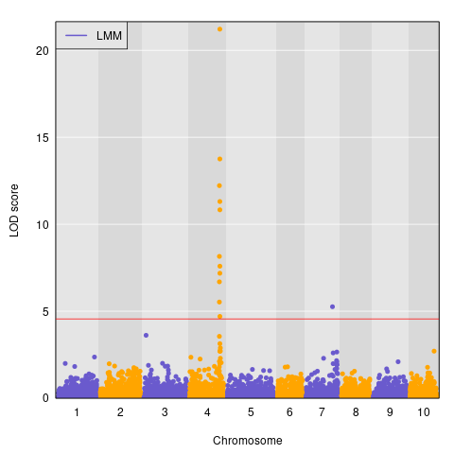

Supplementary Figure PI_297130 RIL population QTL mapping results. The threshold represents a 5% significance threshold after 5,000 permutations (4.56).

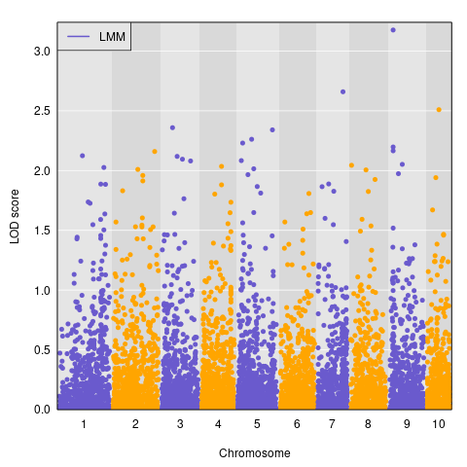

Supplementary Figure PI_297155 RIL population QTL mapping results. The threshold represents a 5% significance threshold after 5,000 permutations (4.43).

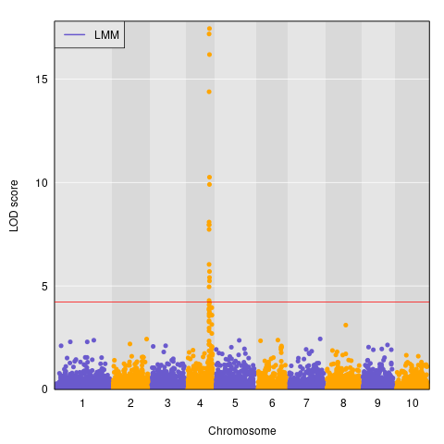

Supplementary Figure PI_329311 RIL population QTL mapping results. The threshold represents a 5% significance threshold after 5,000 permutations (4.22).

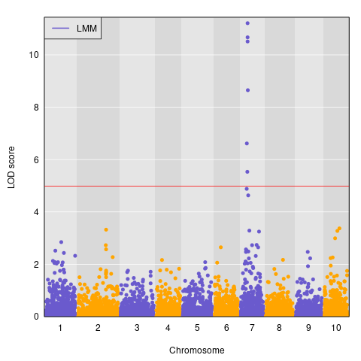

Supplementary Figure PI_506069 RIL population QTL mapping results. The threshold represents a 5% significance threshold after 5,000 permutations (4.98).

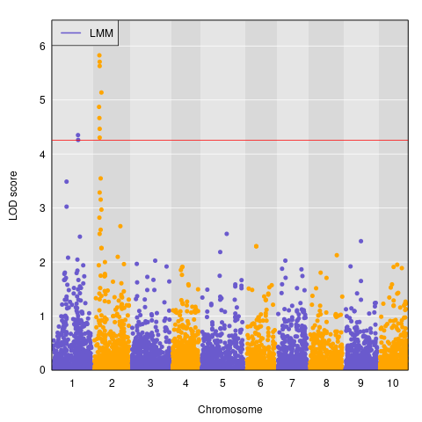

Supplementary Figure PI_508366 RIL population QTL mapping results. The threshold represents a 5% significance threshold after 5,000 permutations (4.26).

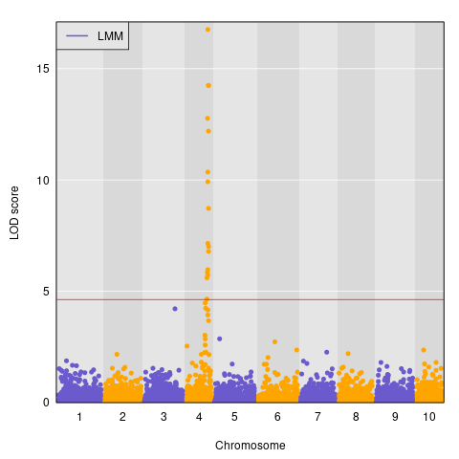

Supplementary Figure PI_510757 RIL population QTL mapping results. The threshold represents a 5% significance threshold after 5,000 permutations (4.63).

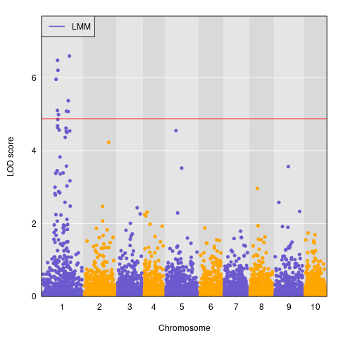

Supplementary Figure PI_563295 RIL population QTL mapping results. The threshold represents a 5% significance threshold after 5,000 permutations (4.87).

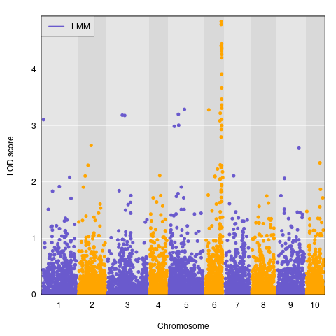

Supplementary Figure PI_586454 RIL population QTL mapping results. The threshold represents a 5% significance threshold after 5,000 permutations (6.00).

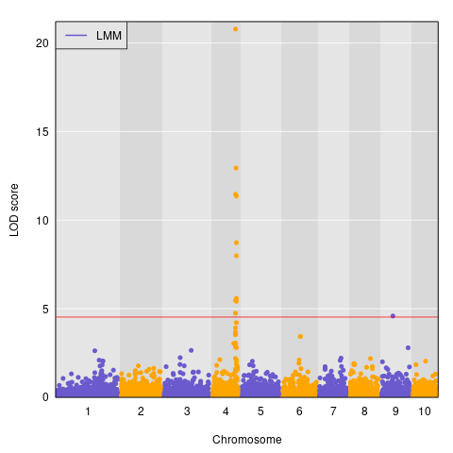

Supplementary Figure PI_655972 RIL population QTL mapping results. The threshold represents a 5% significance threshold after 5,000 permutations (4.53).

