Supplemental Material
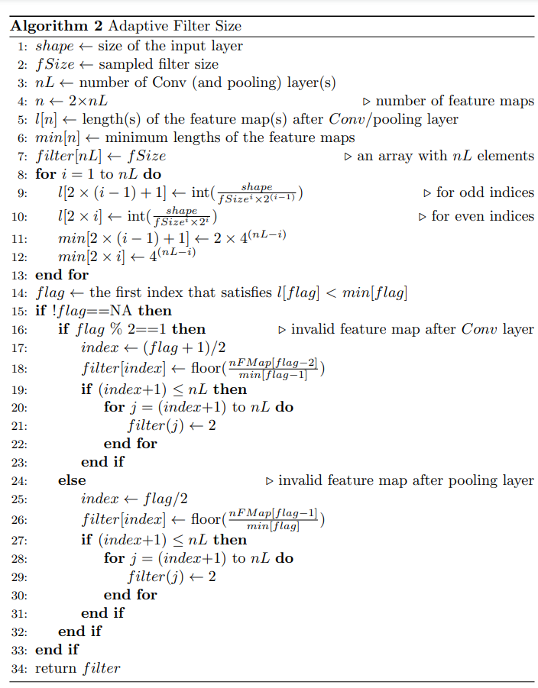
Figure S1 Pseudocode for adaptive filter size. Conv, convolutional layer; int(x), convert x into the nearest integer; floor(x), get the largest integer that is smaller or equal to x.
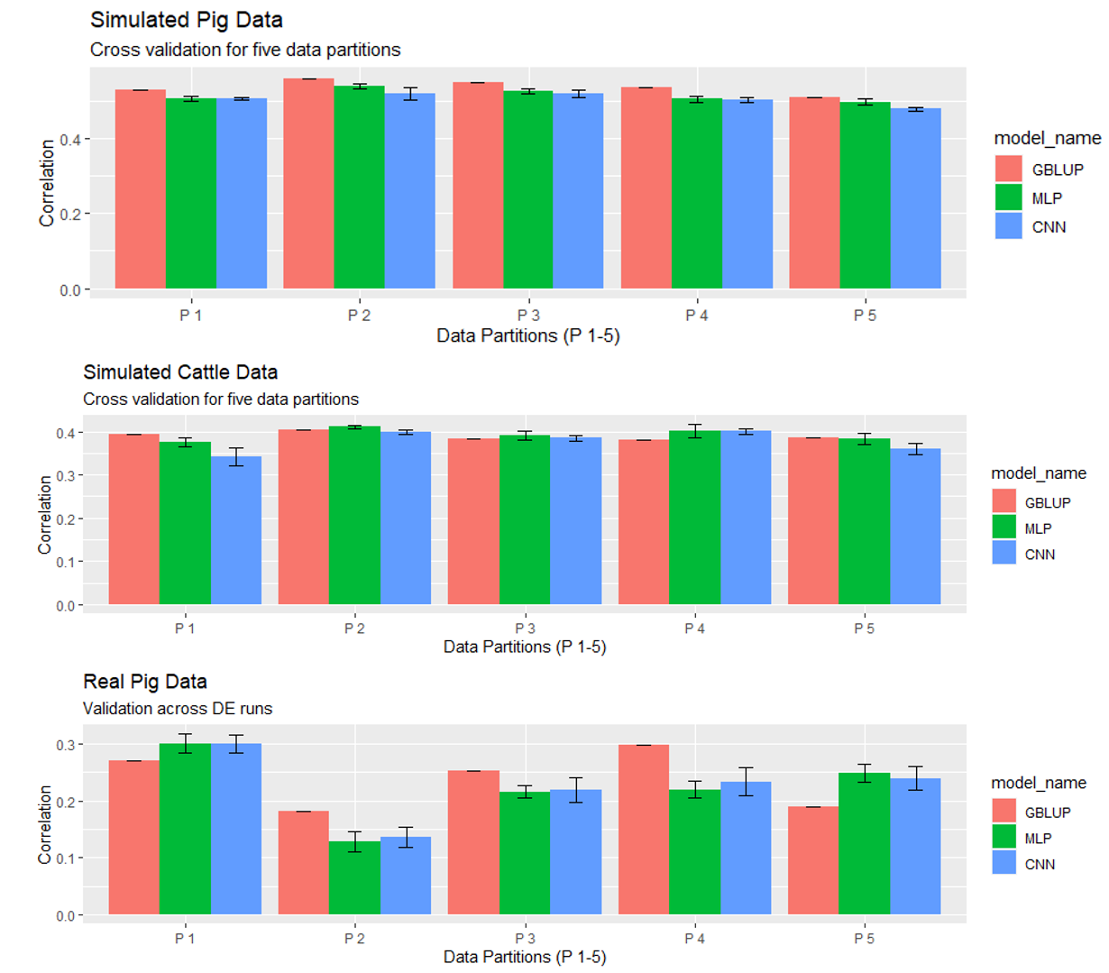
Figure S2 Mean predictive performance and error bars across datasets and data partitions. The error bar represents the mean ± standard deviation of cross validation by fitting the same model 30 times. Pink, green, and blue bars correspond to GBLUP, MLP, and CNN models, respectively. MLP, multilayer perceptron; CNN, convolutional neural network; GBLUP, genomic best linear unbiased prediction.

Table S1 Adaptive hyperparameter space for the number of neurons
Layer | One HL | Two HLs | Three HLs | Four HLs | Five HLs
1 | [4-512] | [259-512] | [344-512] | [386-512] | [412-512]
2 |  | [4-258] | [175-343] | [259-385] | [311-411]
3 |  |  | [4-174] | [132-258] | [210-310]
4 |  |  |  | [4-131] | [109-209]
5 |  |  |  |  | [4-108]
Number of neurons (nodes) given the depth of network (number of hidden layers, HL) in multilayer perceptron models.

Table S2 Adaptive hyperparameter space for number of filters
Layer | One layer | Two layers | Three layers | Four layers | Five layers
1 | [4-128] | [4-65] | [4-44] | [4-34] | [4-28]
2 | -- | [66-128] | [45-85] | [35-65] | [29-53]
3 | -- | -- | [86-128] | [66-96] | [54-78]
4 | -- | -- | -- | [97-128] | [79-103]
5 | -- | -- | -- | -- | [104-128]
Number of filters (kernels) given the depth (number of convolutional layers) of convolutional neural network.

Table S3 Minimum length of feature maps applied to each layer of convolutional neural network.
Layer | One layer | Two layers | Three layers | Four layers | Five layers
Conv 1 | 4 | 16 | 64 | 256 | 1024
Pooling 1 | 2 | 8 | 32 | 128 | 512
Conv 2 | -- | 4 | 16 | 64 | 256
Pooling 2 | -- | 2 | 8 | 32 | 128
Conv 3 | -- | -- | 4 | 16 | 64
Pooling 3 | -- | -- | 2 | 8 | 32
Conv 4 | -- | -- | -- | 4 | 16
Pooling 4 | -- | -- | -- | 2 | 8
Conv 5 | -- | -- | -- | -- | 4
Pooling 5 | -- | -- | -- | -- | 2
Conv: Convolutional layer.

Table S4 Distributions of optimized hyperparameters related to multilayer perceptron architectures for simulated pig data
 | Activation function |  |  |  |  |  | Number of layers
 | elu | linear | selu | relu | softplus |  | One | Two | Three | Other
Pop1 | 6 | 38 | 4 | 0 | 2 |  | 3 | 18 | 29 | 0
Pop2 | 7 | 11 | 10 | 9 | 13 |  | 3 | 37 | 6 | 4
Pop3 | 11 | 20 | 10 | 6 | 3 |  | 8 | 33 | 7 | 2
Pop4 | 13 | 20 | 8 | 5 | 4 |  | 8 | 15 | 23 | 4
Pop5 | 11 | 1 | 13 | 15 | 10 |  | 8 | 30 | 7 | 5

Pop 1-5: MLP solutions to five data partitions (five differential evolution runs).

Table S5 Distributions of optimized hyperparameters related to CNN architectures for simulated pig data
 | Activation function |  |  |  |  | Number of layers |  |  |  |  | Filter size |  |  |  | Size of fully connected layer
 | elu | linear | selu | tanh |  | One | Two | Three | Other |  | Q0.05 | Median | Q0.95 |  | Q0.05 | Median | Q0.95
Pop1 | 13 | 18 | 14 | 5 |  | 19 | 26 | 5 | 0 |  | 10 | 16 | 19 |  | 19 | 73 | 380
Pop2 | 20 | 14 | 16 | 0 |  | 31 | 19 | 0 | 0 |  | 5 | 10 | 20 |  | 22 | 149 | 477
Pop3 | 13 | 19 | 18 | 0 |  | 8 | 37 | 4 | 1 |  | 2 | 8 | 20 |  | 12 | 53 | 452
Pop4 | 16 | 27 | 7 | 0 |  | 35 | 15 | 0 | 0 |  | 6 | 11 | 20 |  | 9 | 36 | 308
Pop5 | 8 | 26 | 15 | 1 |  | 32 | 10 | 8 | 0 |  | 8 | 13 | 20 |  | 20 | 39 | 481
Pop 1-5: CNN solution populations of five differential evolutions runs. Size of fully connected layer: the number of neurons applied in the fully connected layer (after flatten layer). Q0.05, 5% quantile; Q0.95, 95% quantile.

Table S6 Distributions of optimized hyperparameters related to multilayer perceptron architectures for the simulated cattle data
 | Activation function |  |  |  |  |  | Number of layers
 | linear | relu | elu | selu | softplus |  | One | Two | Three | Four
Pop1 | 43 | 0 | 4 | 2 | 1 |  | 17 | 17 | 13 | 3
Pop2 | 30 | 9 | 1 | 4 | 6 |  | 25 | 10 | 12 | 3
Pop3 | 41 | 1 | 6 | 2 | 0 |  | 6 | 28 | 14 | 2
Pop4 | 44 | 2 | 1 | 1 | 2 |  | 7 | 33 | 10 | 0
Pop5 | 49 | 1 | 0 | 0 | 0 |  | 19 | 20 | 10 | 1
Pop 1-5: MLP solutions to five data partitions (five differential evolution runs).

Table S7 Distributions of optimized hyperparameters related to CNN architectures for simulated cattle data
 | Activation function |  |  |  |  |  | Number of layers |  |  |  |  | Filter size |  |  |  | Size of fully connected layer
 | elu | linear | selu | tanh | other |  | One | Two | Three | Other |  | Q0.05 | Median | Q0.95 |  | Q0.05 | Median | Q0.95
Pop1 | 3 | 45 | 0 | 2 | 0 |  | 34 | 10 | 6 | 0 |  | 8 | 18 | 20 |  | 16 | 46 | 354
Pop2 | 11 | 27 | 5 | 7 | 0 |  | 8 | 9 | 33 | 0 |  | 10 | 17 | 20 |  | 12 | 195 | 386
Pop3 | 0 | 49 | 1 | 0 | 0 |  | 40 | 8 | 2 | 0 |  | 6 | 15 | 20 |  | 24 | 26 | 396
Pop4 | 13 | 17 | 19 | 0 | 1 |  | 9 | 9 | 32 | 0 |  | 10 | 18 | 18 |  | 27 | 221 | 485
Pop5 | 7 | 37 | 2 | 4 | 0 |  | 12 | 16 | 21 | 1 |  | 10 | 18 | 20 |  | 26 | 148 | 416
Pop 1-5: CNN populations of five differential evolutions runs. Size of fully connected layer: the number of neurons applied in the fully connected layer (after flatten layer). Q0.05, 5% quantile; Q0.95, 95% quantile.

Table S8 Distributions of optimized hyperparameters related to multilayer perceptron architectures for the real pig data
 | Activation function |  |  | Number of layers
 | sigmoid | Other |  | Two | Three | Four
Pop1 | 47 | 3 |  | 6 | 44 | 0
Pop2 | 50 | 0 |  | 0 | 46 | 4
Pop3 | 50 | 0 |  | 0 | 44 | 6
Pop4 | 50 | 0 |  | 2 | 38 | 10
Pop5 | 50 | 0 |  | 1 | 46 | 3
Pop 1-5: MLP solutions to five data partitions (five differential evolution runs).

Table S9 Distributions of optimized hyperparameters related to CNN architectures for real pig data
 | Activation function |  |  |  |  | Number of layers |  |  |  |  | Filter size |  |  |  |  |  | Size of fully connected layer
 | elu | linear | tanh | other |  | Two | Three | Four | Other |  | Q0.05 | Median | Q0.95 |  |  | Q0.05 |  | Median | Q0.95
Pop1 | 19 | 6 | 25 | 0 |  | 16 | 24 | 10 | 0 |  | 12 | 13 | 18 |  |  | 22 |  | 367 | 506
Pop2 | 38 | 1 | 5 | 6 |  | 7 | 30 | 12 | 1 |  | 12 | 16 | 17 |  |  | 50 |  | 197 | 463
Pop3 | 3 | 4 | 40 | 3 |  | 16 | 26 | 8 | 0 |  | 8 | 13 | 18 |  |  | 60 |  | 150 | 463
Pop4 | 33 | 4 | 1 | 12 |  | 26 | 11 | 10 | 3 |  | 9 | 15 | 17 |  |  | 50 |  | 158 | 426
Pop5 | 20 | 14 | 16 | 0 |  | 2 | 25 | 22 | 1 |  | 5 | 11 | 18 |  |  | 12 |  | 195 | 416
Pop 1-5: CNN populations of five differential evolutions runs. Size of fully connected layer: the number of neurons applied in the fully connected layer (after flatten layer). Q0.05, 5% quantile; Q0.95, 95% quantile.

 | Optimizer |  |  |  | Epochs |  |  |  | Batch size |  |  |  | Dropout rate |  |  |  | L2
 | adam | adamax | other |  | Q0.05 | median | Q0.95 |  | Q0.05 | median | Q0.95 |  | Q0.05 | median | Q0.95 |  | Q0.05 | median | Q0.95
Pop1 | 48 | 0 | 2 |  | 27 | 35 | 47 |  | 14 | 30 | 53 |  | 0.03 | 0.16 | 0.45 |  | 0.03 | 0.18 | 0.67
Pop2 | 43 | 6 | 1 |  | 23 | 43 | 49 |  | 12 | 36 | 56 |  | 0.01 | 0.05 | 0.41 |  | 0.01 | 0.16 | 0.75
Pop3 | 43 | 6 | 1 |  | 23 | 32 | 48 |  | 6 | 28 | 52 |  | 0.01 | 0.05 | 0.57 |  | 0.01 | 0.17 | 0.69
Pop4 | 41 | 8 | 1 |  | 23 | 36 | 48 |  | 15 | 40 | 58 |  | 0.01 | 0.12 | 0.50 |  | 0.02 | 0.23 | 0.76
Pop5 | 35 | 15 | 0 |  | 22 | 35 | 50 |  | 19 | 38 | 57 |  | 0 | 0.04 | 0.14 |  | 0.01 | 0.14 | 0.87
Table S10 Distributions of optimized hyperparameters related to MLP model compilation and fitting for simulated pig data
Pop 1-5: MLP solution populations of five differential evolution runs. Q0.05, 5% quantile; Q0.95, 95% quantile.

Table S11 Distributions of optimized hyperparameters related to CNN model compilation and fitting for simulated pig data
 | Optimizer |  |  |  |  |  | Epochs |  |  |  | Dropout rate |  |  |  | L2 |  |  | Pooling
 | adam | adamax | adadelta | nadam | rmsprop |  | Q0.05 | median | Q0.95 |  | Q0.05 | median | Q0.95 |  | Q0.05 | median | Q0.95 | Max | Average
Pop1 | 4 | 11 | 8 | 8 | 19 |  | 24 | 31 | 48 |  | 0.02 | 0.36 | 0.79 |  | 0.01 | 0.10 | 0.49 | 27 | 23
Pop2 | 10 | 10 | 20 | 0 | 10 |  | 21 | 34 | 49 |  | 0.04 | 0.42 | 0.79 |  | <0.01 | 0.04 | 0.25 | 22 | 28
Pop3 | 13 | 13 | 11 | 7 | 6 |  | 22 | 28 | 44 |  | 0.11 | 0.56 | 0.77 |  | 0.01 | 0.11 | 0.49 | 42 | 8
Pop4 | 10 | 29 | 5 | 3 | 3 |  | 23 | 31 | 46 |  | 0.05 | 0.39 | 0.78 |  | 0.01 | 0.12 | 0.64 | 22 | 28
Pop5 | 22 | 1 | 4 | 10 | 13 |  | 22 | 31 | 49 |  | 0.02 | 0.39 | 0.79 |  | 0.01 | 0.07 | 0.44 | 29 | 21
Pop 1-5: CNN solution populations of five differential evolution runs. Q0.05, 5% quantile; Q0.95, 95% quantile.

Table S12 Distributions of optimized hyperparameters related to MLP model compilation and fitting for simulated cattle data
 | Optimizer |  |  |  | Epochs |  |  |  | Batch size |  |  |  | Dropout rate |  |  |  | L2
 | adam | adamax | nadam |  | Q0.05 | median | Q0.95 |  | Q0.05 | median | Q0.95 |  | Q0.05 | median | Q0.95 |  | Q0.05 | median | Q0.95
Pop1 | 47 | 1 | 2 |  | 23 | 41 | 47 |  | 11 | 31 | 57 |  | 0.01 | 0.15 | 0.52 |  | 0.04 | 0.27 | 0.81
Pop2 | 39 | 10 | 1 |  | 26 | 38 | 48 |  | 18 | 40 | 57 |  | <0.01 | 0.09 | 0.45 |  | 0.06 | 0.26 | 0.85
Pop3 | 44 | 4 | 2 |  | 26 | 33 | 44 |  | 12 | 26 | 52 |  | 0.01 | 0.18 | 0.53 |  | 0.03 | 0.22 | 0.87
Pop4 | 40 | 0 | 10 |  | 21 | 39 | 50 |  | 10 | 23 | 47 |  | 0.03 | 0.21 | 0.54 |  | 0.03 | 0.39 | 0.86
Pop5 | 41 | 2 | 7 |  | 22 | 29 | 48 |  | 9 | 24 | 52 |  | 0.02 | 0.26 | 0.72 |  | 0.06 | 0.27 | 0.91
Pop 1-5: MLP solution populations of five differential evolution runs. Q0.05, 5% quantile; Q0.95, 95% quantile.

Table S13 Distributions of optimized hyperparameters related to CNN model compilation and fitting for simulated cattle data
 | Optimizer |  |  |  |  |  | Epochs |  |  |  | Dropout rate |  |  |  | L2 |  |  | Pooling
 | adadelta | adam | adamax | nadam | rmsprop |  | Q0.05 | median | Q0.95 |  | Q0.05 | median | Q0.95 |  | Q0.05 | median | Q0.95 | Max | Average
Pop1 | 3 | 28 | 11 | 1 | 7 |  | 23 | 35 | 50 |  | 0.01 | 0.30 | 0.65 |  | 0.03 | 0.24 | 0.72 | 20 | 30
Pop2 | 17 | 16 | 7 | 2 | 8 |  | 22 | 33 | 50 |  | 0.06 | 0.28 | 0.68 |  | 0.02 | 0.29 | 0.59 | 10 | 40
Pop3 | 3 | 21 | 22 | 0 | 4 |  | 22 | 40 | 44 |  | 0.04 | 0.29 | 0.78 |  | 0.02 | 0.16 | 0.50 | 12 | 38
Pop4 | 11 | 3 | 29 | 2 | 5 |  | 23 | 29 | 46 |  | 0.05 | 0.35 | 0.67 |  | 0.01 | 0.23 | 0.75 | 17 | 33
Pop5 | 4 | 19 | 5 | 1 | 21 |  | 21 | 34 | 46 |  | 0.02 | 0.24 | 0.60 |  | <0.01 | 0.11 | 0.52 | 27 | 23
Pop 1-5: CNN solution populations of five differential evolution runs. Q0.05, 5% quantile; Q0.95, 95% quantile.

Table S14 Distributions of optimized hyperparameters related to MLP model compilation and fitting for real pig data
 | Optimizer |  |  |  | Epochs |  |  |  | Batch size |  |  |  | Dropout rate |  |  |  | L2
 | adam | adamax | sgd |  | Q0.05 | median | Q0.95 |  | Q0.05 | median | Q0.95 |  | Q0.05 | median | Q0.95 |  | Q0.05 | median | Q0.95
Pop1 | 1 | 9 | 40 |  | 25 | 40 | 45 |  | 7 | 18 | 64 |  | 0.03 | 0.38 | 0.85 |  | 0.12 | 0.66 | 0.95
Pop2 | 19 | 30 | 1 |  | 22 | 37 | 45 |  | 28 | 55 | 64 |  | 0.04 | 0.41 | 0.82 |  | 0.09 | 0.60 | 0.92
Pop3 | 0 | 47 | 3 |  | 30 | 44 | 49 |  | 21 | 44 | 68 |  | 0.05 | 0.33 | 0.79 |  | 0.05 | 0.55 | 0.94
Pop4 | 2 | 47 | 1 |  | 31 | 33 | 47 |  | 30 | 31 | 32 |  | 0.15 | 0.56 | 0.86 |  | 0.04 | 0.37 | 0.86
Pop5 | 1 | 40 | 9 |  | 21 | 24 | 41 |  | 8 | 47 | 63 |  | 0.05 | 0.38 | 0.84 |  | 0.05 | 0.48 | 0.90
Pop 1-5: MLP solution populations of five differential evolution runs. Q0.05, 5% quantile; Q0.95, 95% quantile.

Table S15 Distributions of optimized hyperparameters related to CNN model compilation and fitting for real pig data
 | Optimizer |  |  |  | Epochs |  |  |  | Dropout rate |  |  |  | L2 |  |  |  | Pooling
 | adam | adamax | other |  | Q0.05 | median | Q0.95 |  | Q0.05 | median | Q0.95 |  | Q0.05 | median | Q0.95 |  | Max | Average
Pop1 | 36 | 9 | 5 |  | 22 | 31 | 41 |  | 0.02 | 0.32 | 0.71 |  | 0.03 | 0.54 | 0.96 |  | 1 | 49
Pop2 | 34 | 13 | 3 |  | 25 | 36 | 50 |  | 0.08 | 0.41 | 0.78 |  | 0.04 | 0.51 | 0.97 |  | 2 | 48
Pop3 | 45 | 4 | 1 |  | 22 | 34 | 45 |  | 0.02 | 0.41 | 0.88 |  | 0.16 | 0.49 | 0.93 |  | 13 | 37
Pop4 | 40 | 7 | 3 |  | 29 | 31 | 49 |  | 0.03 | 0.33 | 0.75 |  | 0.05 | 0.60 | 0.98 |  | 8 | 42
Pop5 | 44 | 5 | 1 |  | 24 | 44 | 46 |  | 0.03 | 0.38 | 0.77 |  | 0.05 | 0.55 | 0.95 |  | 0 | 50
Pop 1-5: CNN solution populations of five differential evolution runs. Q0.05, 5% quantile; Q0.95, 95% quantile.

Table S16 Selected MLP and CNN architecture derived from other studies
Study | Model | Activation | No. layers | No. neurons (filters) | Dropout | Filter size
Bellot et al. (2018) | MLP | elu | 1 | 32 | 0.0100 | NA
Pérez-Enciso and Zingaretti (2019) | MLP | relu | 4 | [64,64,64,64] | 0.0005 | NA
Bellot et al. (2018) | CNN | linear | 1+1 | [16,32] | 0.0100 | 3
Pérez-Enciso and Zingaretti (2019) | CNN | relu | 4 | [64,64,64,64] | 0.0005 | 3
No. layers, the number of fully connected layers or convolutional layers; No. neurons (filters), the number of neurons or filters adaptive based on the number of layers. In the No. layers column, 1+1 means one convolutional layer plus one fully connected layer.

