Discovery of three loci increasing resistance to charcoal rot caused by Macrophomina phaseolina in octoploid strawberry

Supplementary Figures

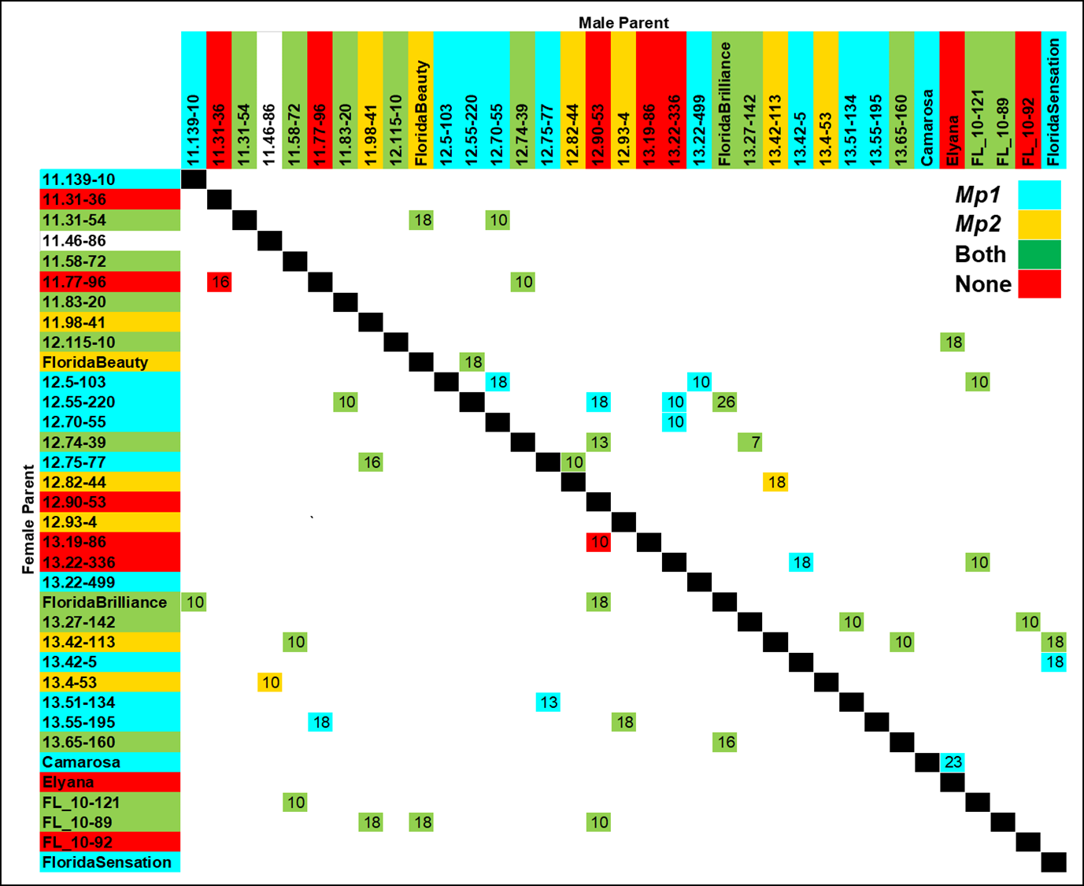
Supplementary Figure 1. Cross combinations comprising the 2016-17 discovery population. Numbers indicate the number of seedlings evaluated for that full-sib family. Colors indicate the presence (parents) or segregation (full-sib families) of one or more resistant QTL alleles at the Mp1 and/or Mp2 loci. The QTL alleles of individual 11.46-86 (color white) could not be inferred because of missing data.

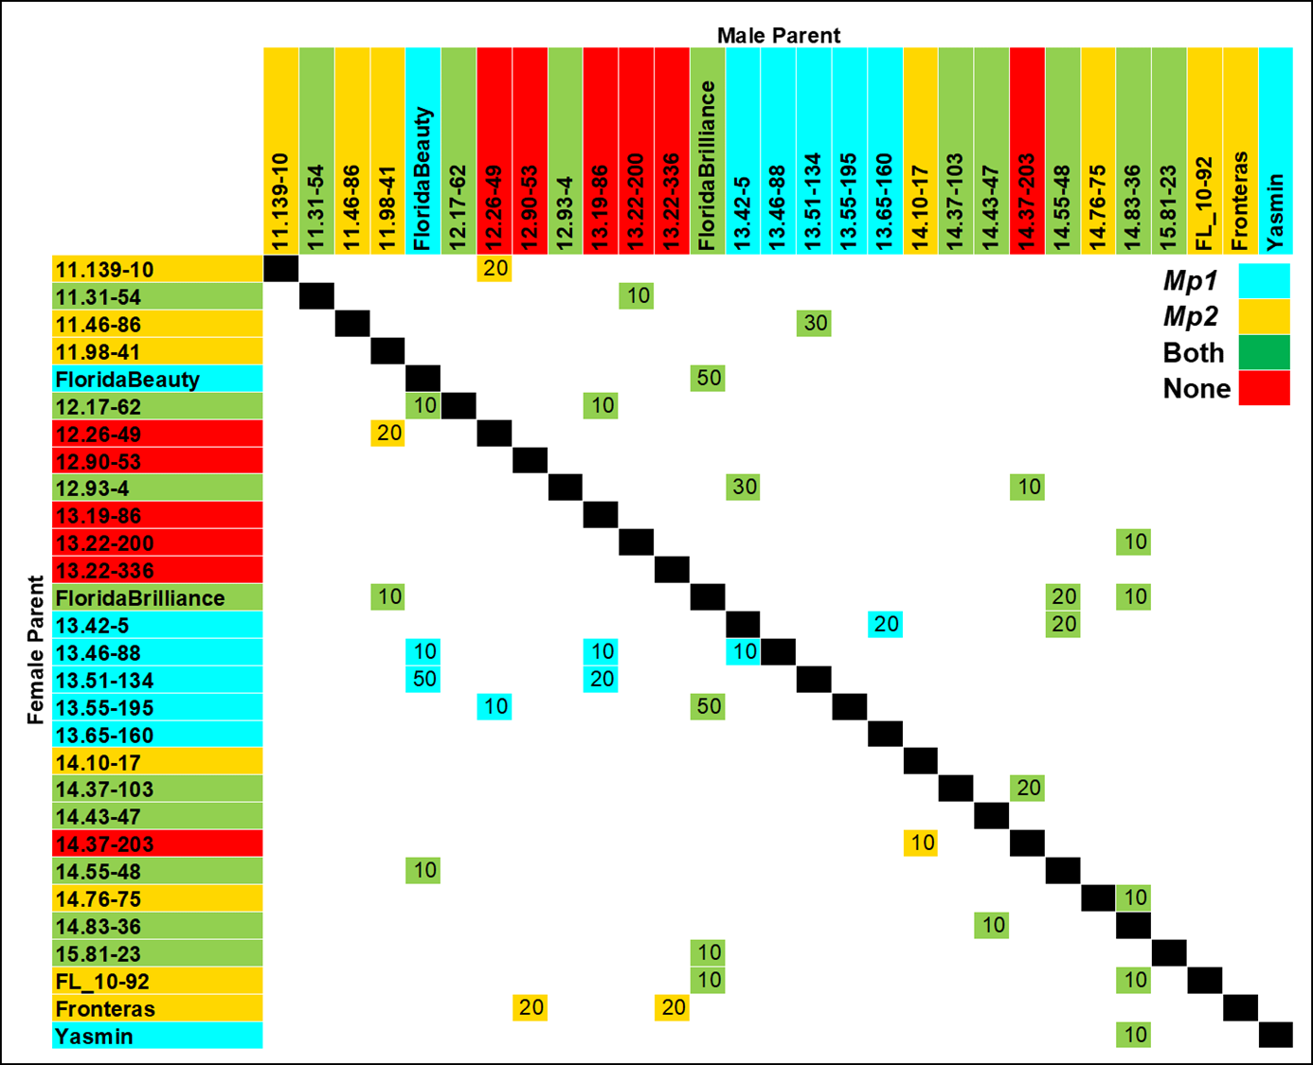

Supplementary Figure 2. Cross combinations comprising the 2017-18 discovery population. Numbers indicate the number of seedlings evaluated for that full-sib family. Colors indicate the presence (parents) or segregation (full-sib families) of one or more resistant QTL alleles at the Mp1 and/or Mp2 loci.

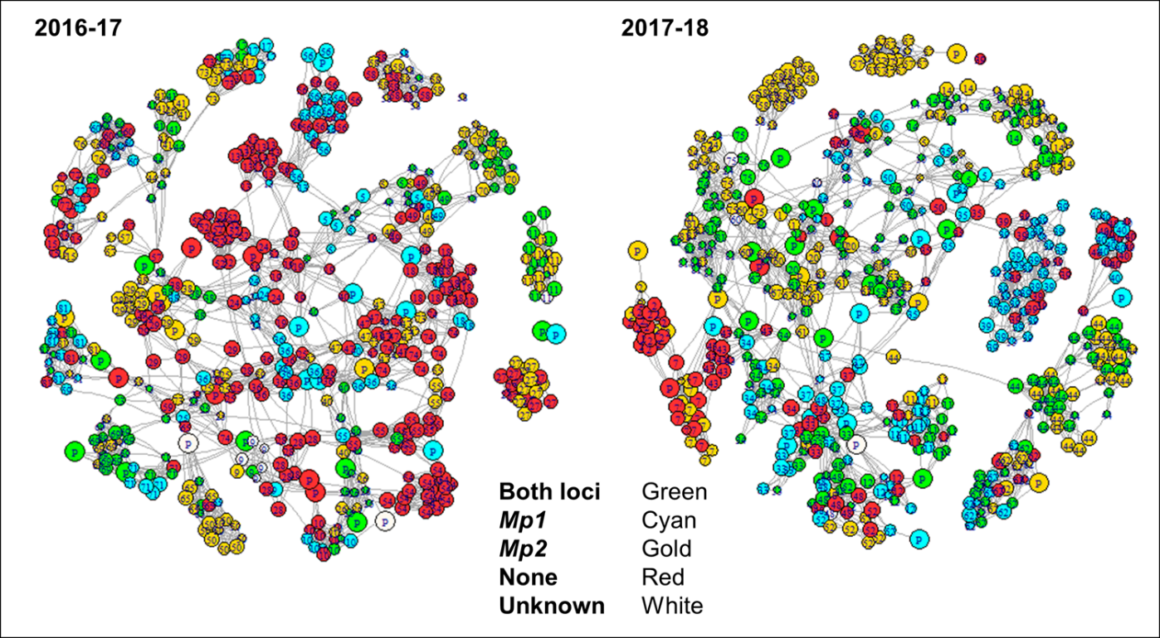
Supplementary Figure 3. Network of relationships among two QTL discovery populations (2016-17 and 2017-18). Colors indicate the presence/absence of one or more resistant QTL alleles at the Mp1 and/or Mp2 loci. The size of each node reflects scaled AUDPC values, except for parents (“P”), and numbers within nodes represents family numbers. The length of the lines between nodes represent genetic distances based on SNP markers used for the QTL analyses.

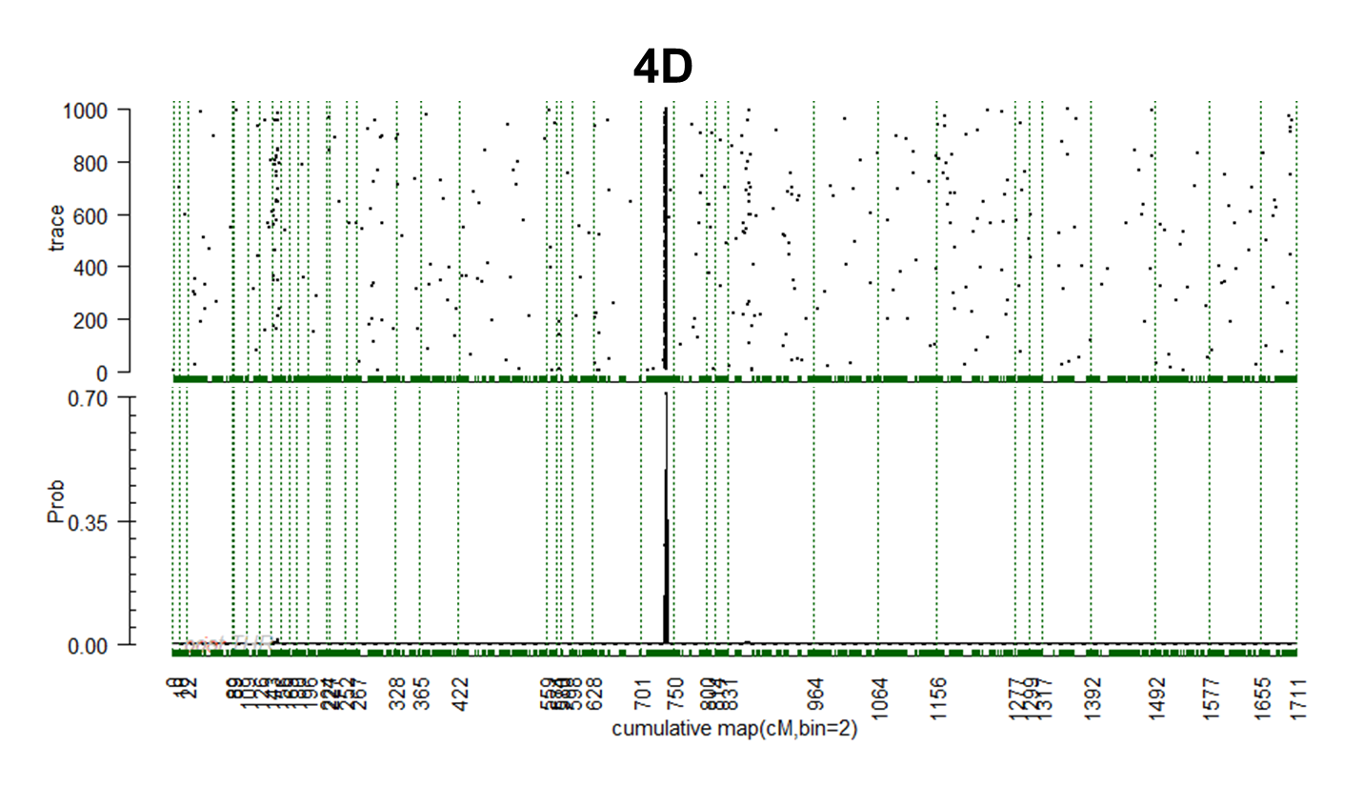

Supplementary Figure 4. Genome wide trace plot (top panel) and posterior probability plot (bottom panel) from VisualFlexQTL™ outputs showing the position of a QTL on LG 4D conferring resistance to charcoal rot caused by Macrophomina phaseolina from the FVC 11-58 source. The region between two green dotted vertical lines represents a unique LG.
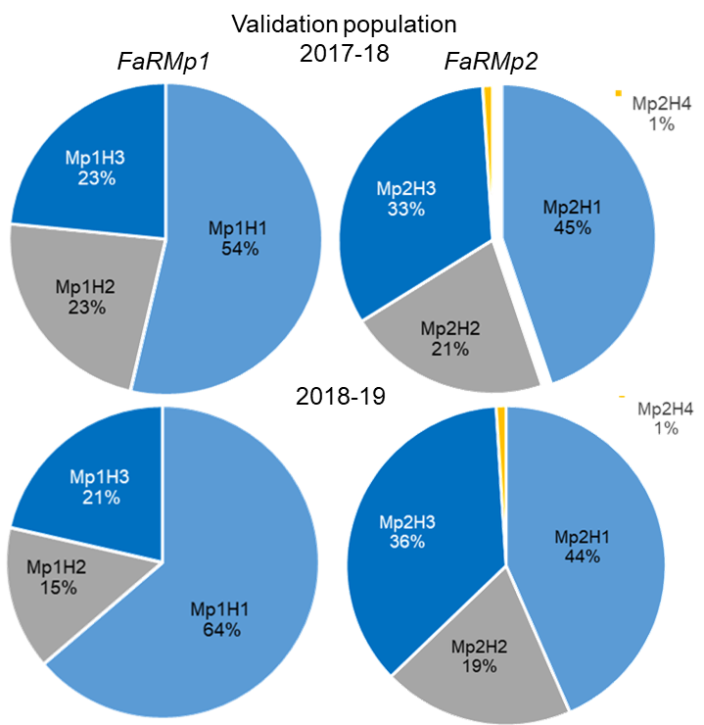

Supplementary Figure 5. Frequencies of SNP haplotypes at the FaRMp1 and FaRMp2 loci for the 2017-18 and 2018-19 QTL validation populations.
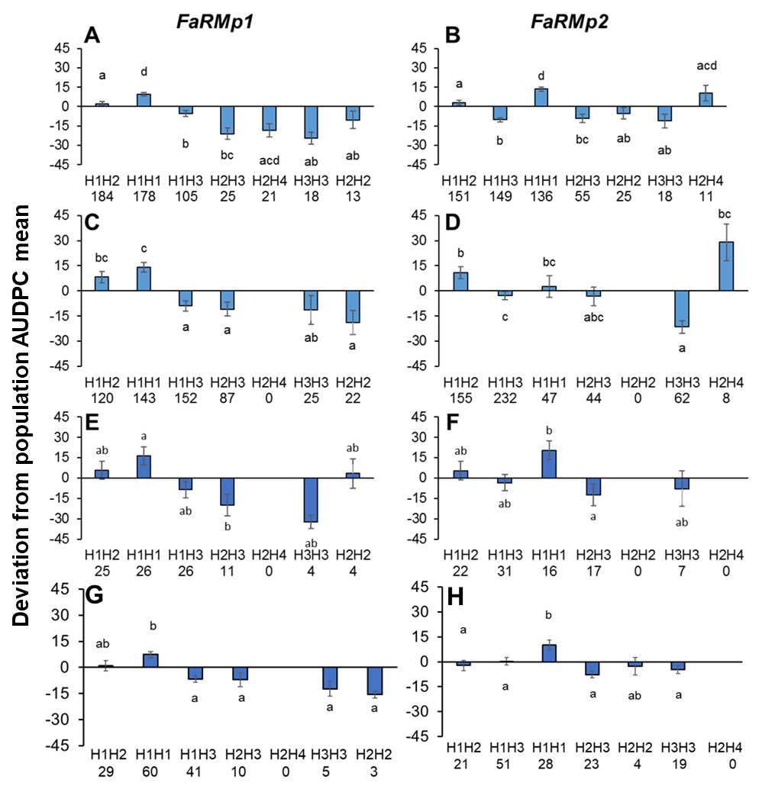

Supplementary Figure 6. Diplotype (QTL genotype) effects as deviations from seasonal AUDPC means at the FaRMp1 and FaRMp2 loci for two QTL discovery populations (A-B for 2016-17, C-D for 2017-18) and two validation populations (E-F for 2017-18 and G-H for 2018-19). Different letters above or below each bar represent statistically significant differences (P < 0.05), as determined by Tukey’s multiple comparison test. Diplotype sample sizes are shown below the diplotype designations. Bars represent standard errors.

