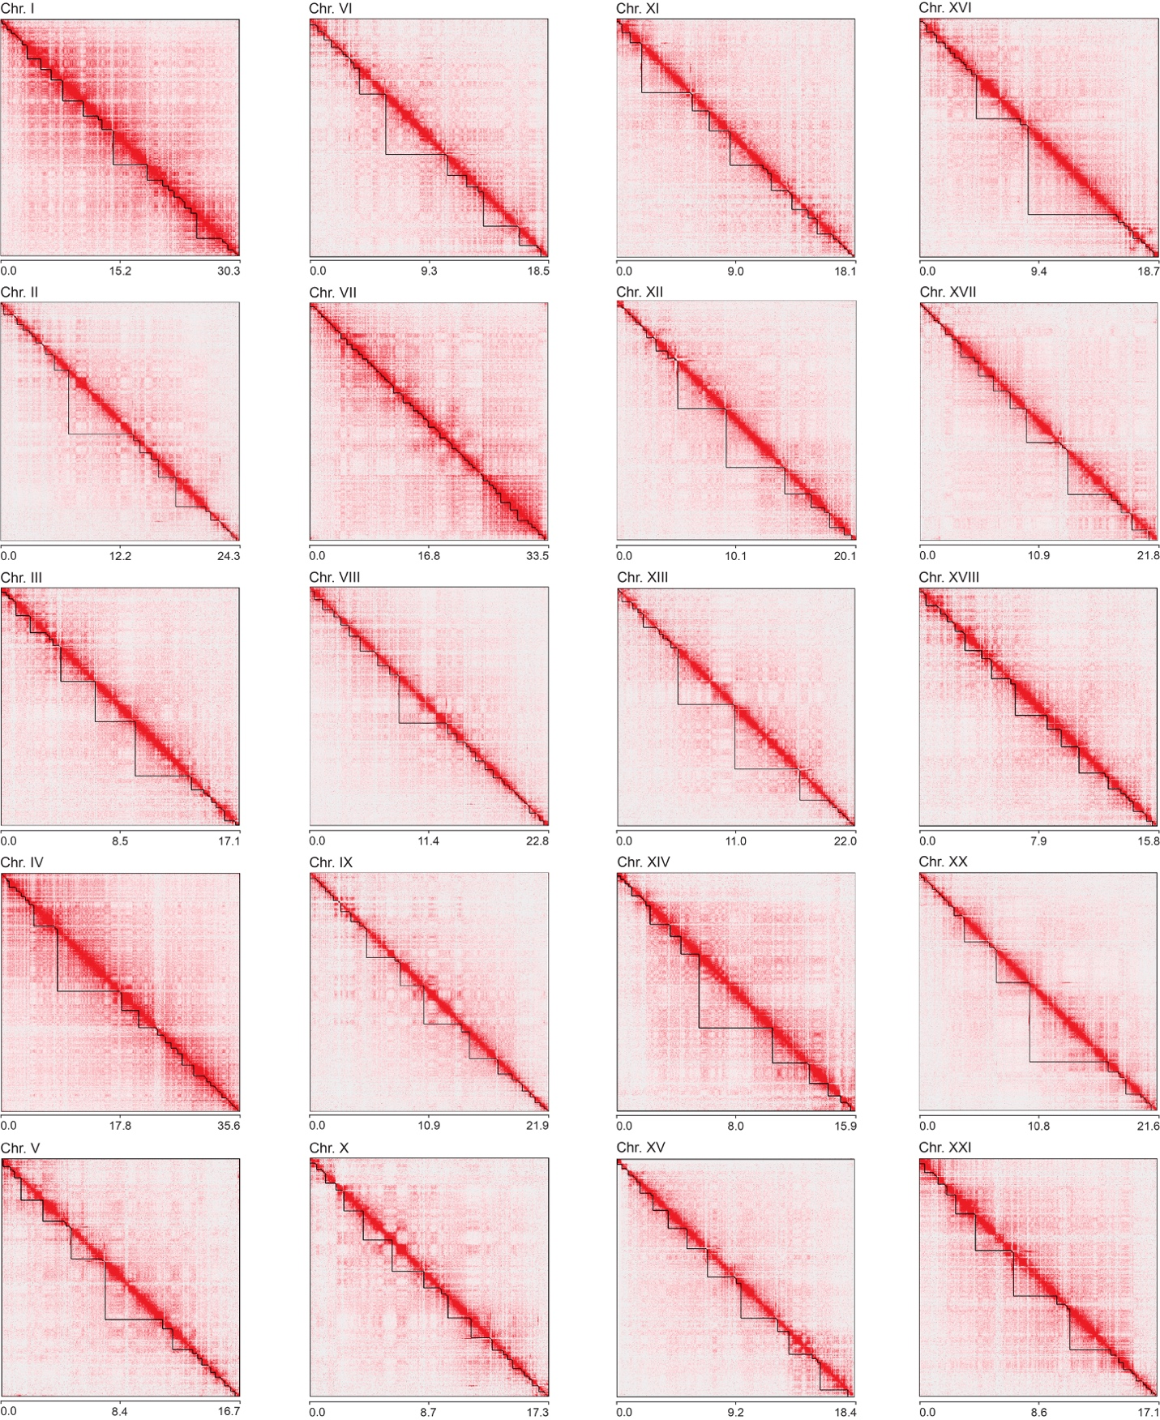
Figure S10. Hi-C chromosome conformation capture sequencing and proximity-guided scaffolding generated 20 main autosomal scaffolds. Contact maps for each autosome are shown. There is an enrichment of interactions between contigs that are in close proximity, visualized along the diagonal.

