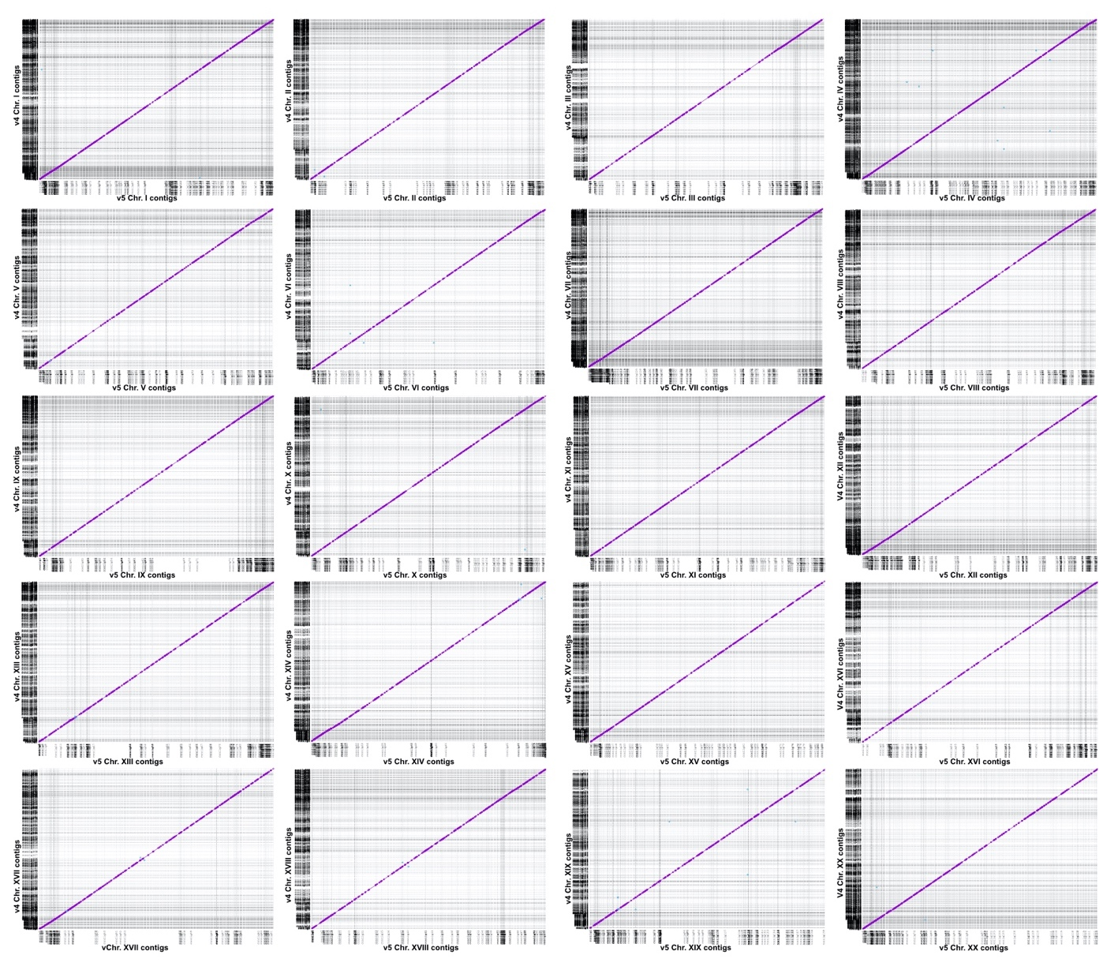

Figure S5. The v. 4 reference assembly and the v. 5 reference assembly are collinear. There are fewer contigs in the v. 5 assembly, revealing a more contiguous assembly across all chromosomes. Chromosomes in the v. 4 assembly were broken at N’s into individual contigs and aligned to the contigs in the v. 5 reference assembly using nucmer.

