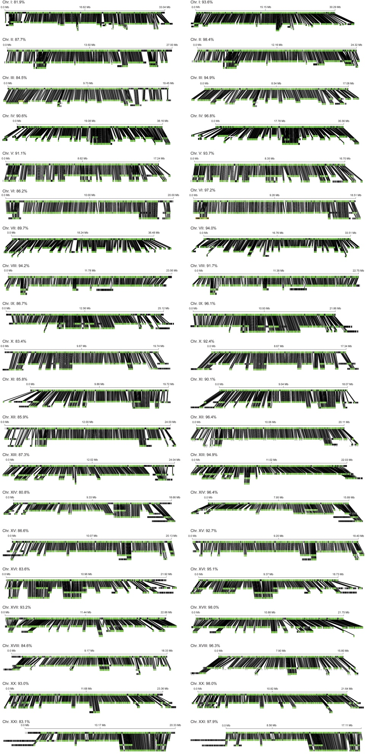
Figure S3. BioNano optical maps align with high coverage to the Paxton Lake de novo genome assembly. Optical contigs were aligned to the initial assembly (left). Contigs were removed from the initial assembly if less than 50% of its length did not overlap with an optical contig, creating the refined assembly (right). For each chromosome, the reference sequence is shown on the top and the optical contigs are shown on the bottom. Percent coverage of each chromosome by optical contigs is shown.

