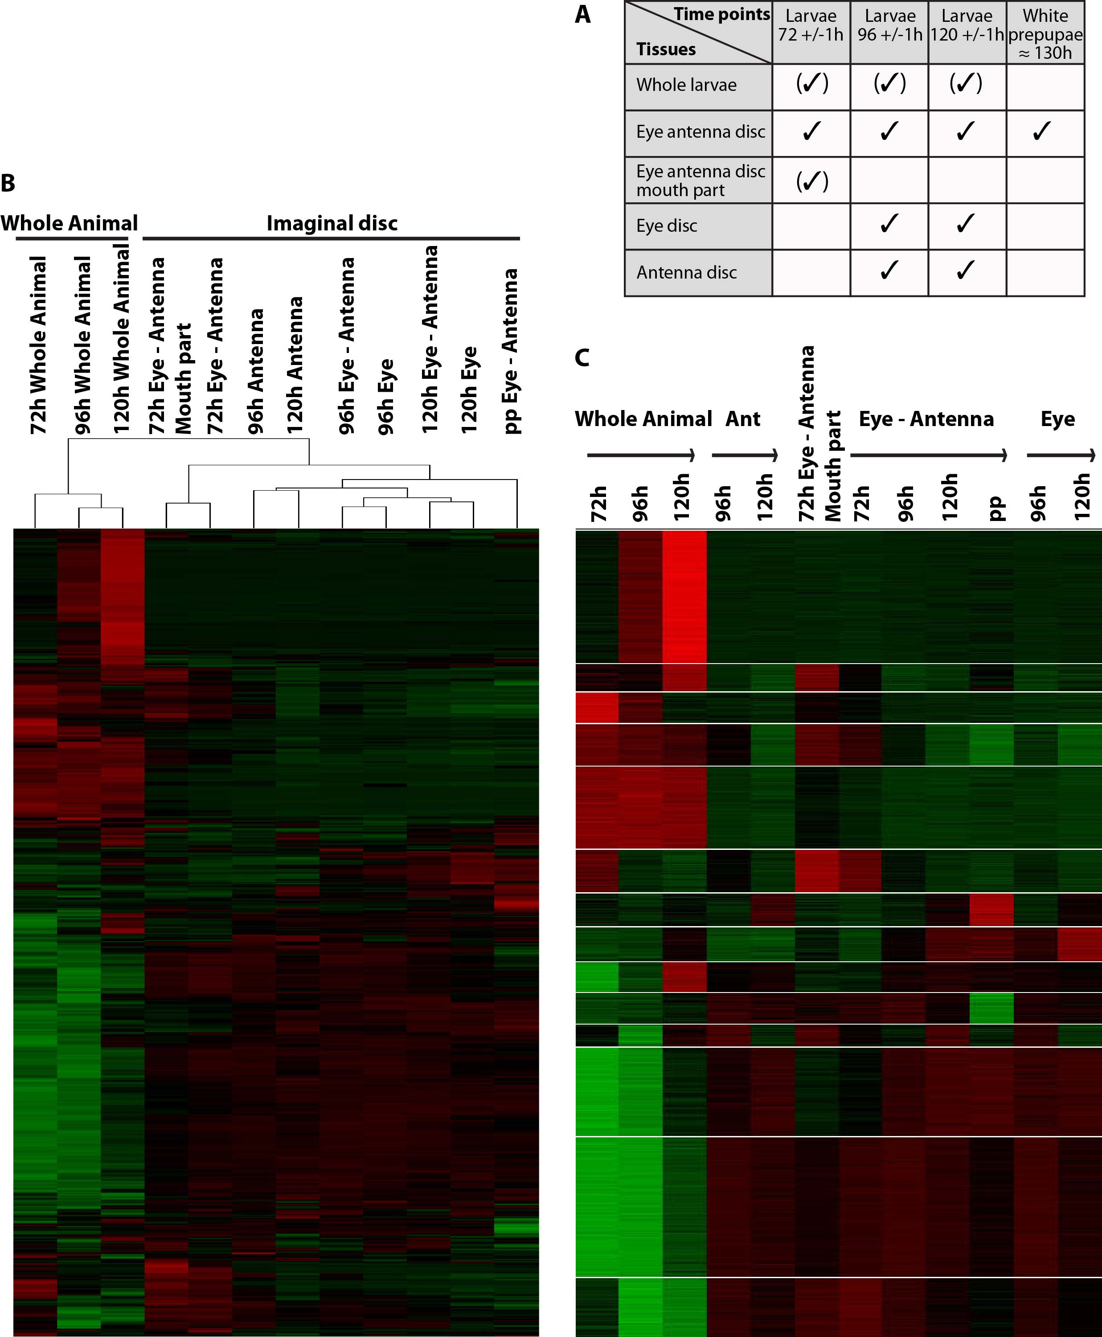

Supplemental figure 1 RNA profiles of eye and/or antenna discs and whole larvae
A) The 12 RNA samples used in the transcriptomic analysis. RNA was extracted from the eye-antennal primordium at four time points: the larval stage 72, 96, 120h after egg laying (AEL) and at the white prepupal stages. At 96 and 120h AEL it was also possible to analyze the eye and antenna discs independently. RNAs were also extracted from staged whole larvae 72, 96 and 120h AEL. RNA samples in brackets were not used in the final clustering presented in Figure 1D. (B-C) BIC-SK means adaptative clustering of 13160 genes expressed with a FPKM (Fragments Per Kilobase of transcript per Million mapped reads) ≥ 0.5 in one of the 12 RNA samples. The expression level of each gene is normalized and indicated by color, red representing high expression and green low expression. (B) Unsupervised clustering grouped RNA samples by similarity. The whole animal samples were closely related. Developmental stage differentiated imaginal disc samples more than the différence between eye and antenna. (C) Clustering supervised according to tissue of origin. The gene expression profiles are split between those at high levels in whole larvae (upper half), and those at low levels (lower half), obscuring trends in imaginal disc transcription.

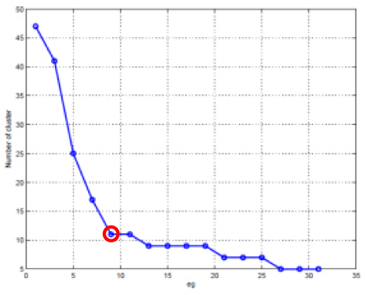
Supplemental Figure 2 Optimizing the cluster number. The inflexion point indiçâtes the optimum cluster number for gene expression in the 8 samples ( Figure 1D) should be 11.

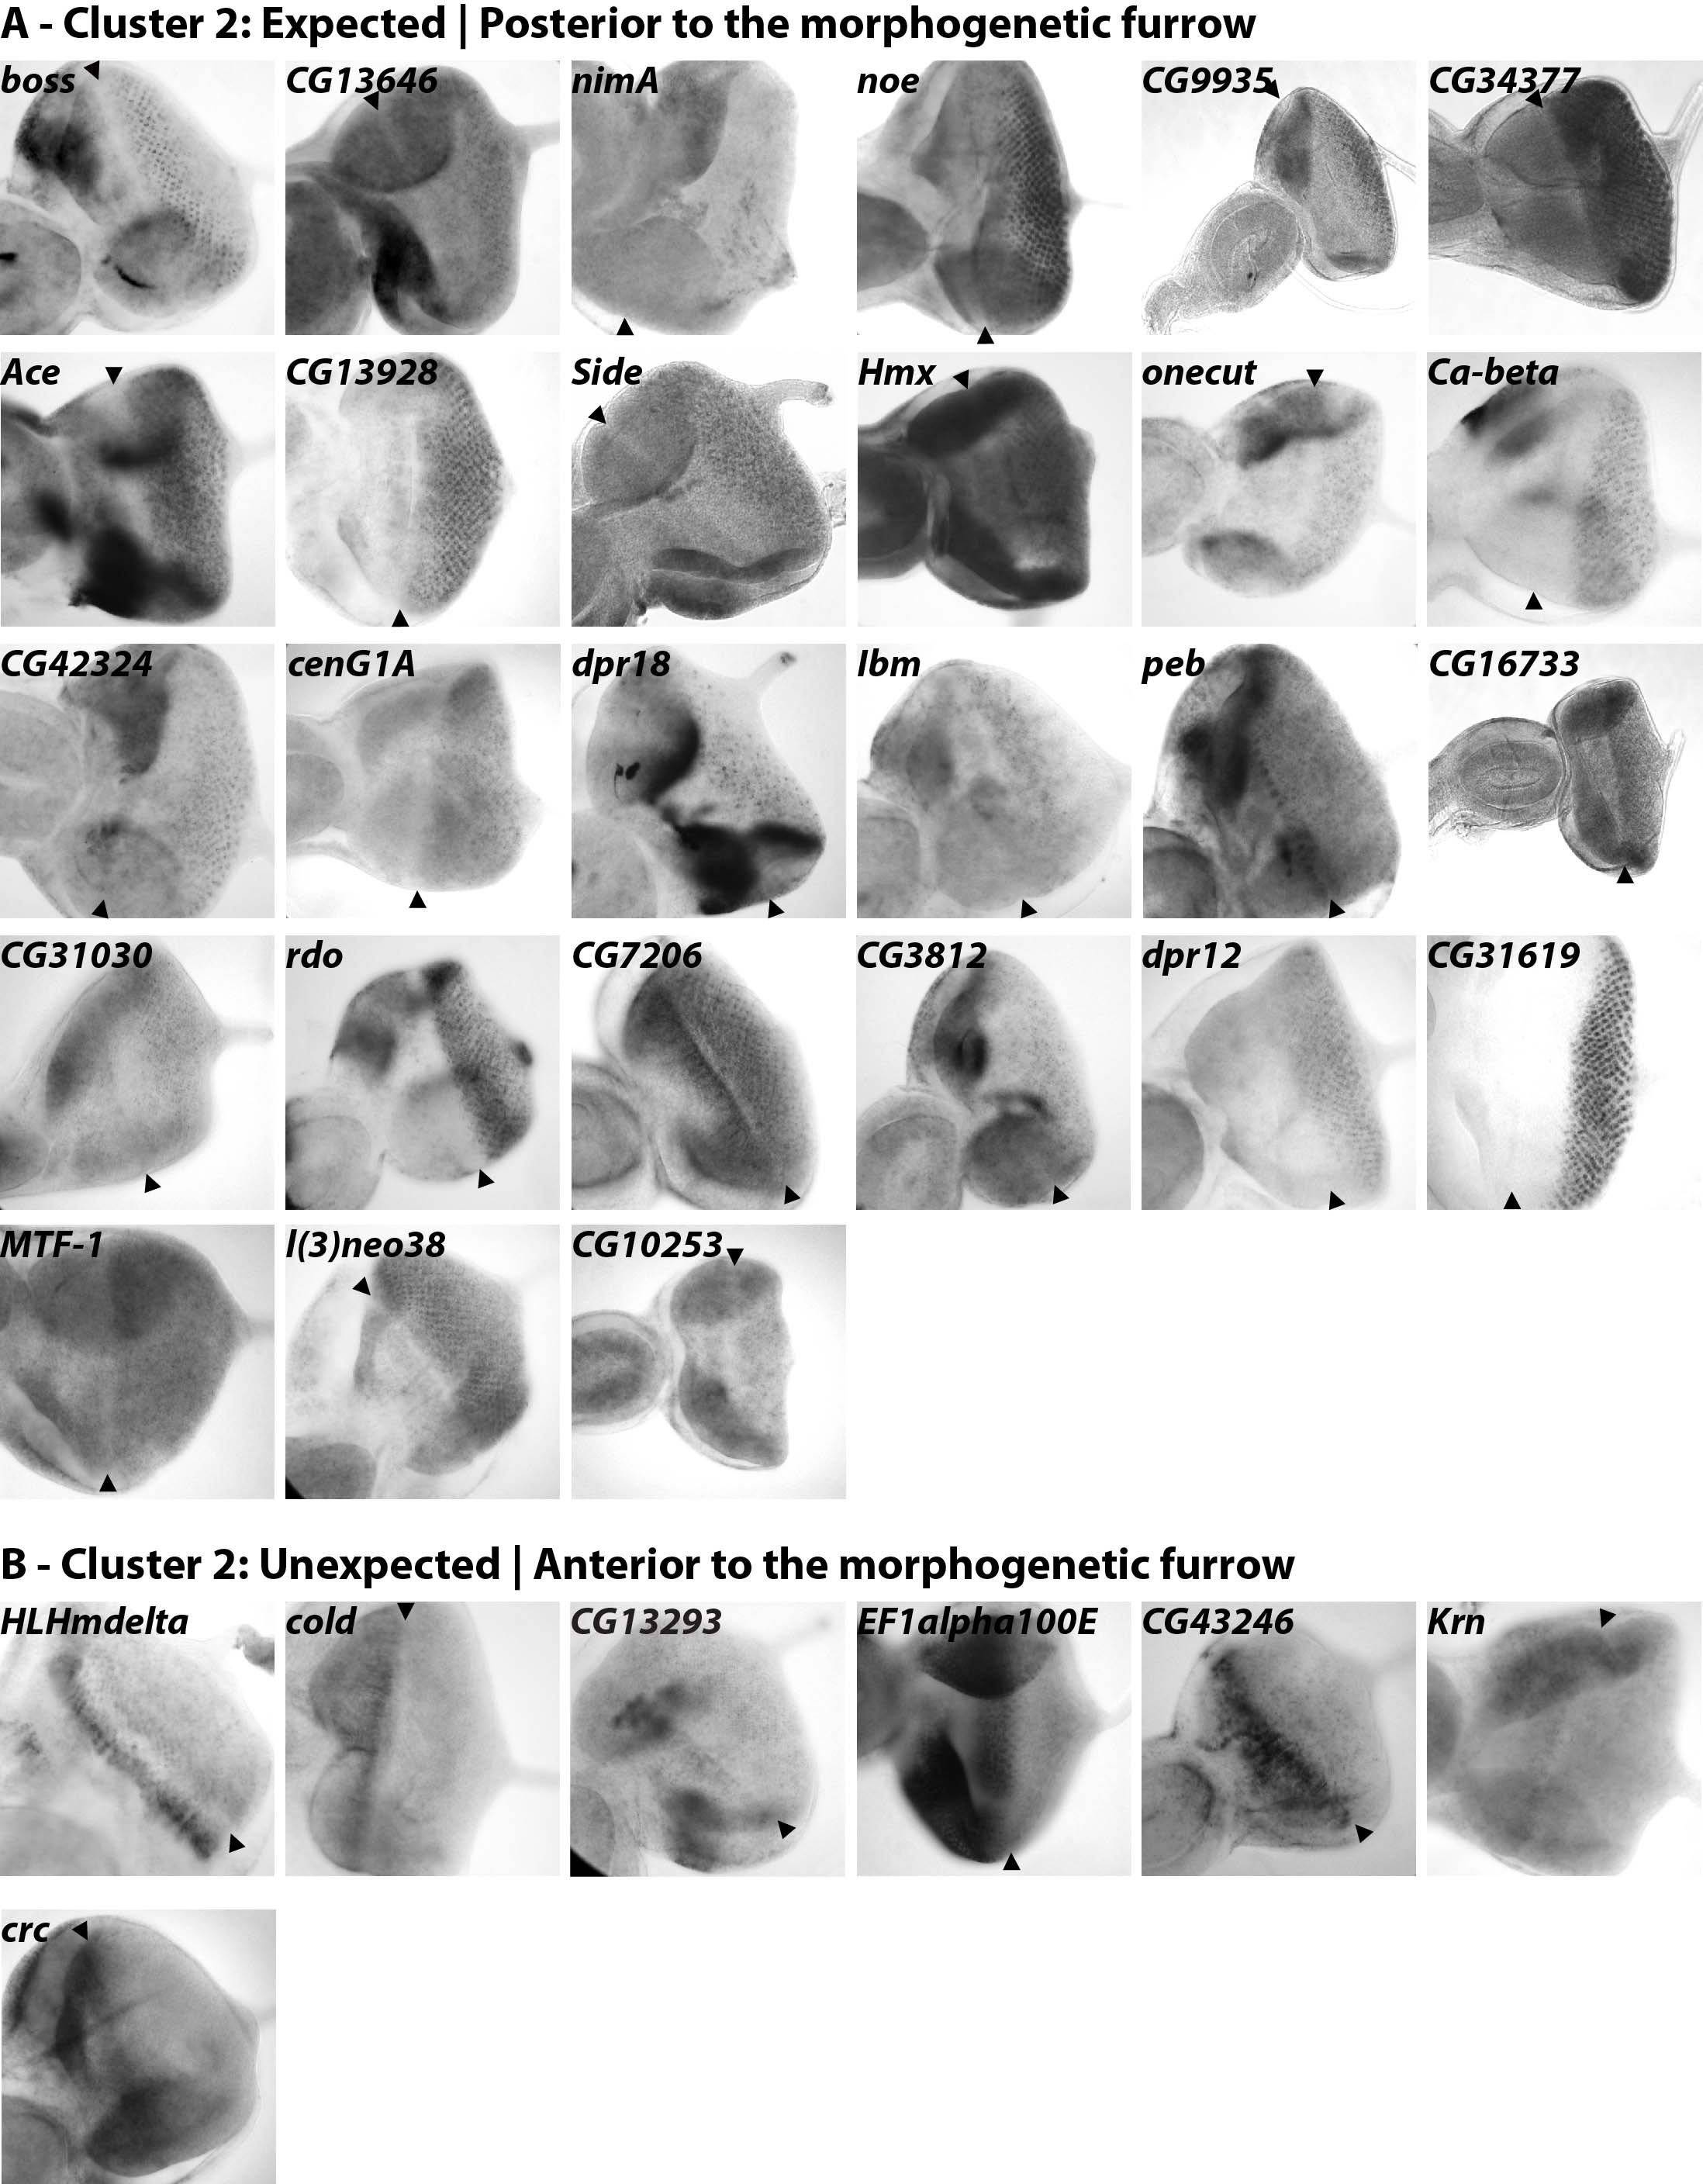
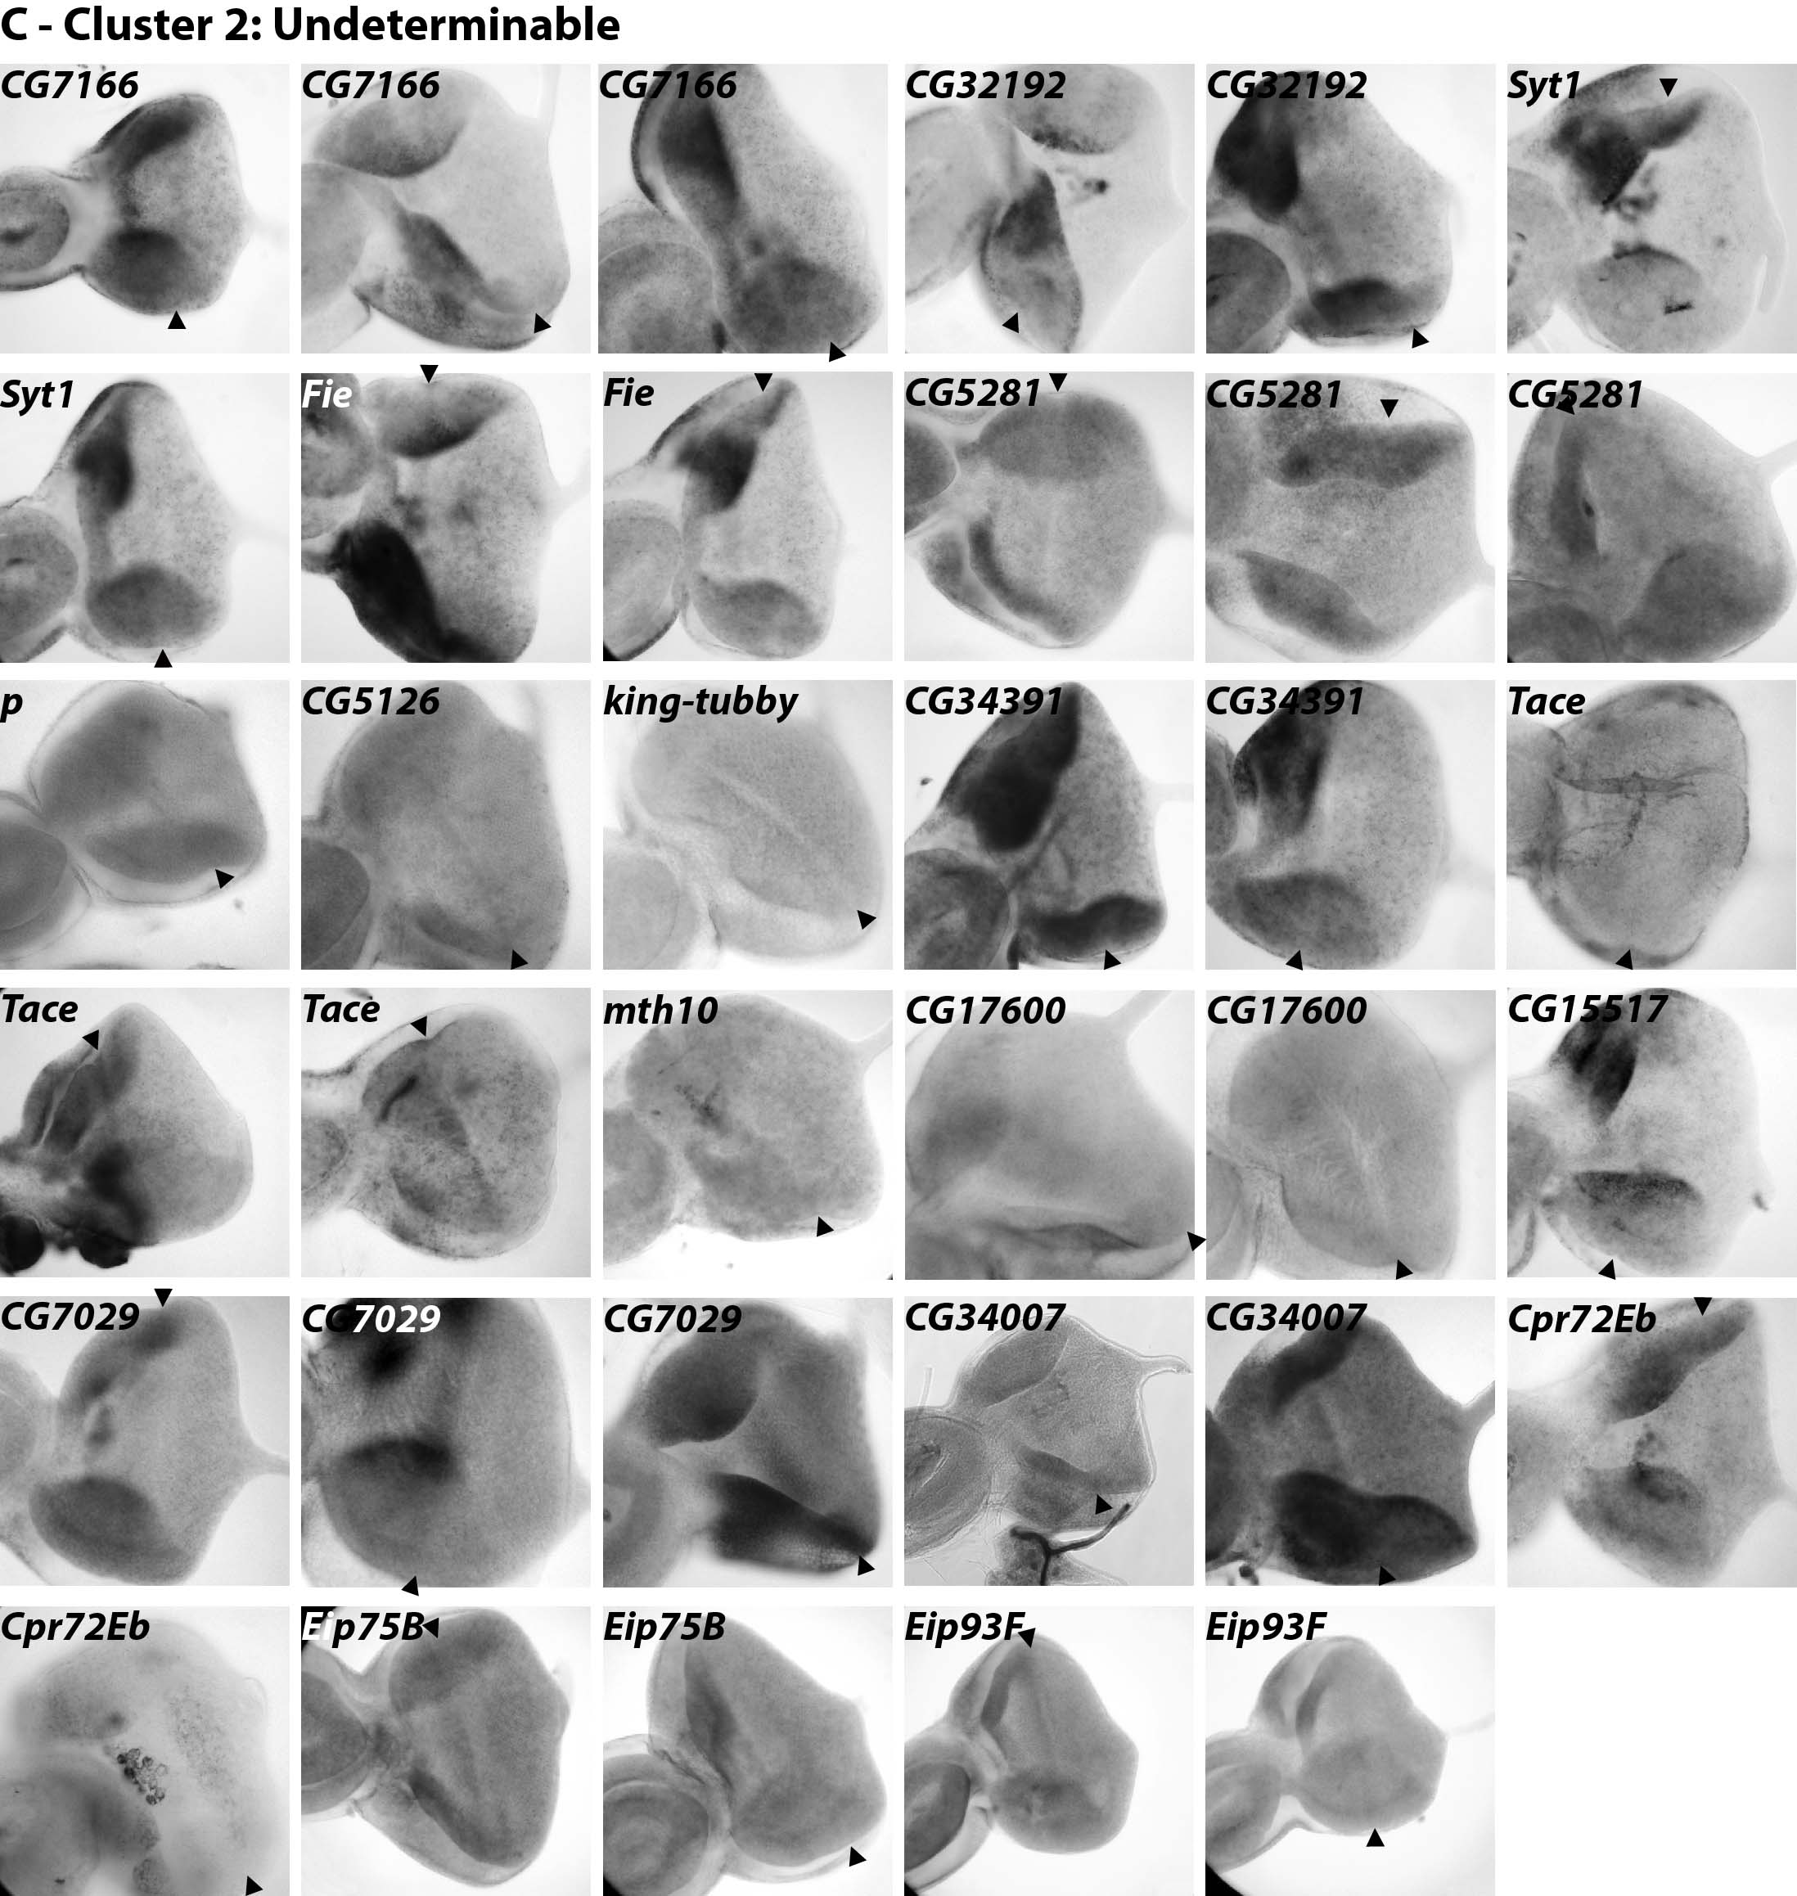
Supplemental Figure 3 ISH of 52 genes from the eye differentiation cluster 2
52 genes included in cluster 2 were randomly tested by In situ hybridization (ISH) performed on eye-antennal imaginal discs from third-instar larvae. Anterior side is shown to the left. (A, 1st to 5th rows) 27 genes were found expressed posterior to the morphogenetic furrow (MF) (boss, CG13646, nimA, noe, CG9935, CG34377, Ace, CG13928, dpr12, CG31619, Side, Hmx, MTF-1, l(3)neo38, onecut, Ca-beta, CG42324, cnG1A, dpr18, Ibm, peb, CG16733, CG31030, rdo, CG10253, CG7206, CG3812) and (A, 6th to 7th rows) 7 genes anterior to the MF (HLHmdelta, cold, CG13293, EF1alpha100E, Krn, CG43246, crc). (B) 18 genes had undetermined expression pattern after ISH (CG7166, CG32192, Syt1, Fie, CG5281, p, CG5126, king-tubby, Eip75B, Eip93F, CG34391, Tace, mth10, CG17600, CG15517, CG7029, CG34007, Cpr72Eb).

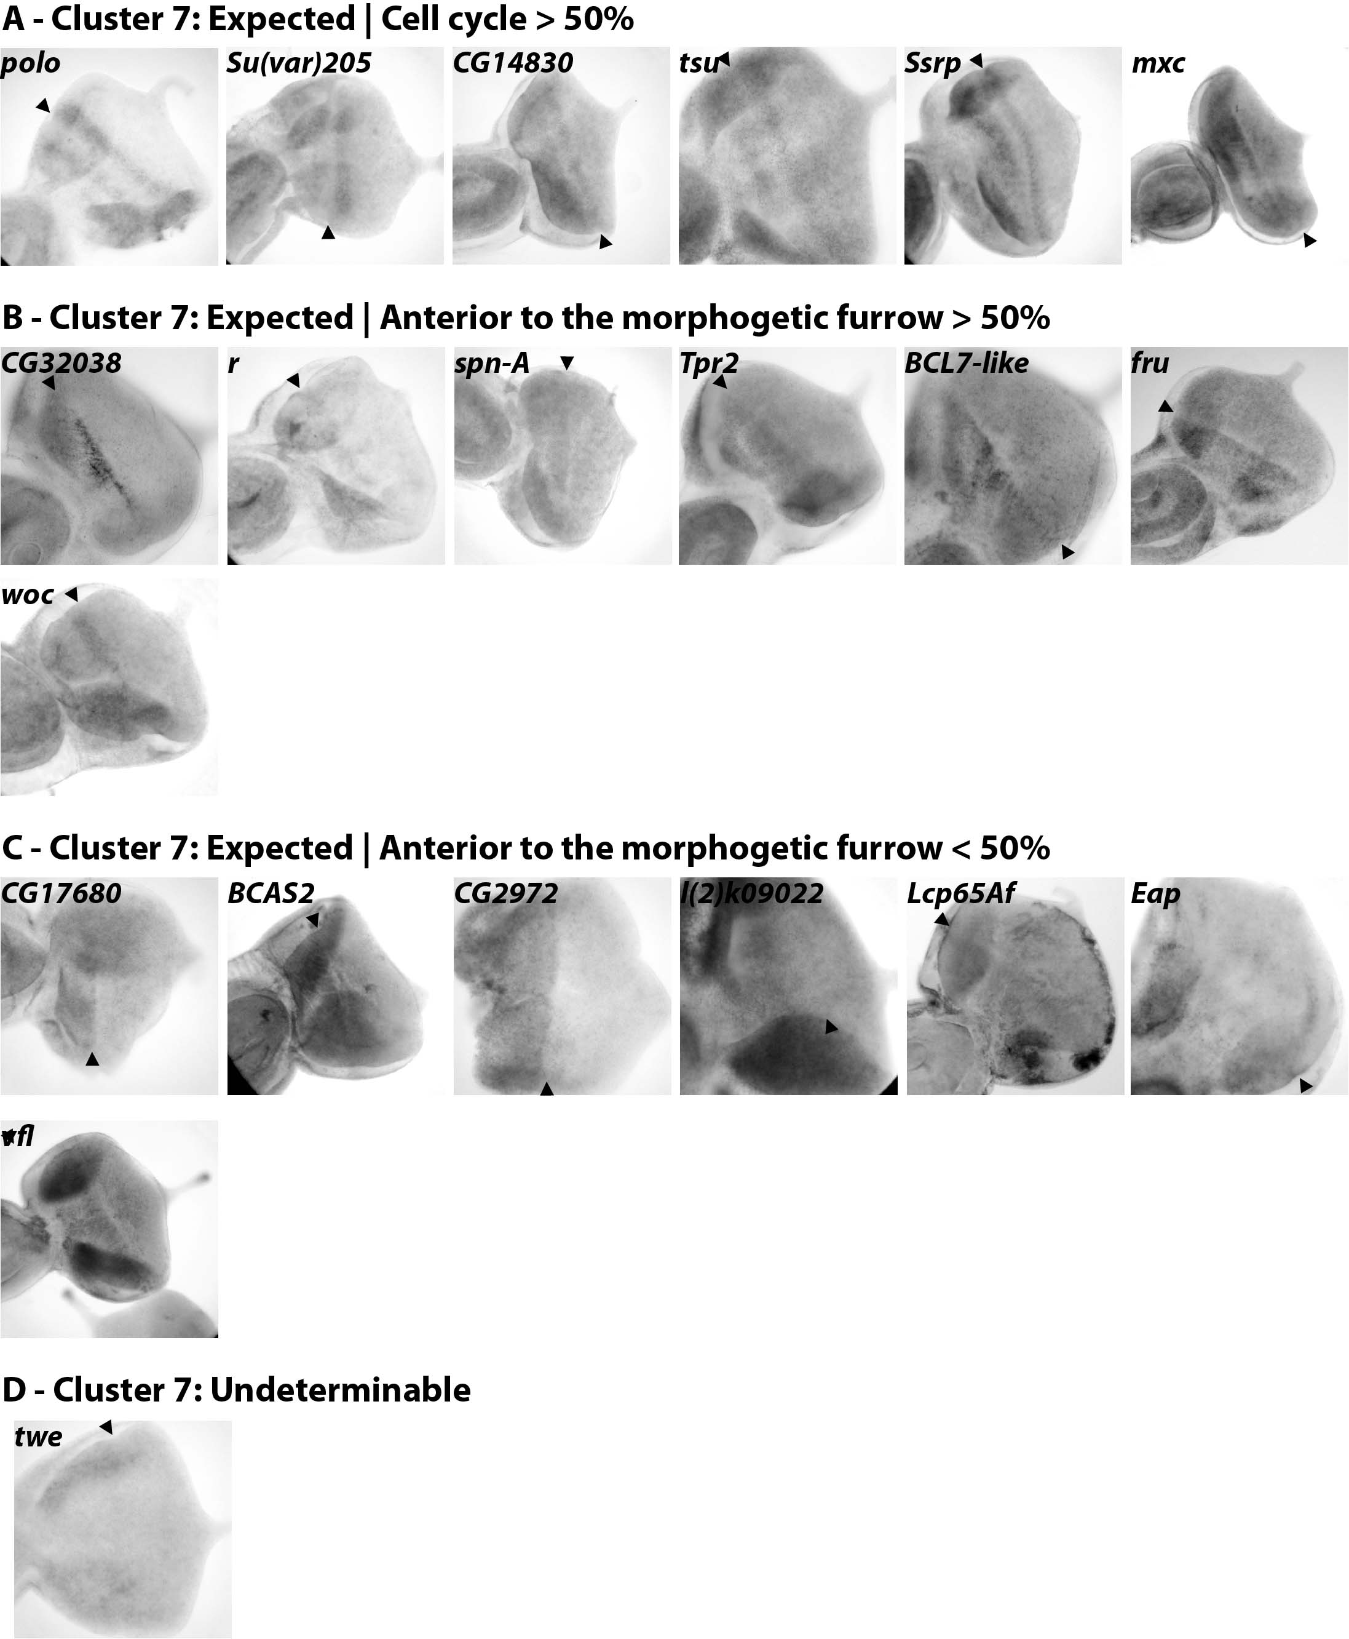

Supplemental Figure 4 ISH of 21 genes from the proliferation cluster 7
6 genes were found expressed in a ‘cell cycle pattern’ that resembles stg (polo, Su(var)205, CG14830, Ssrp, mxc, tsu) and 7 genes expressed anterior to the MF pattern (CG32038, fru, r, spn-A, Tpr2, woc, BCL7-like). 7 genes more genes presented signal anterior to the furrow in only a subset of the eye discs (CG17680, vfl, BCAS2, CG2972, l(2)k09022, Lcp65Af, Eap). No signal was ever detected for twe.

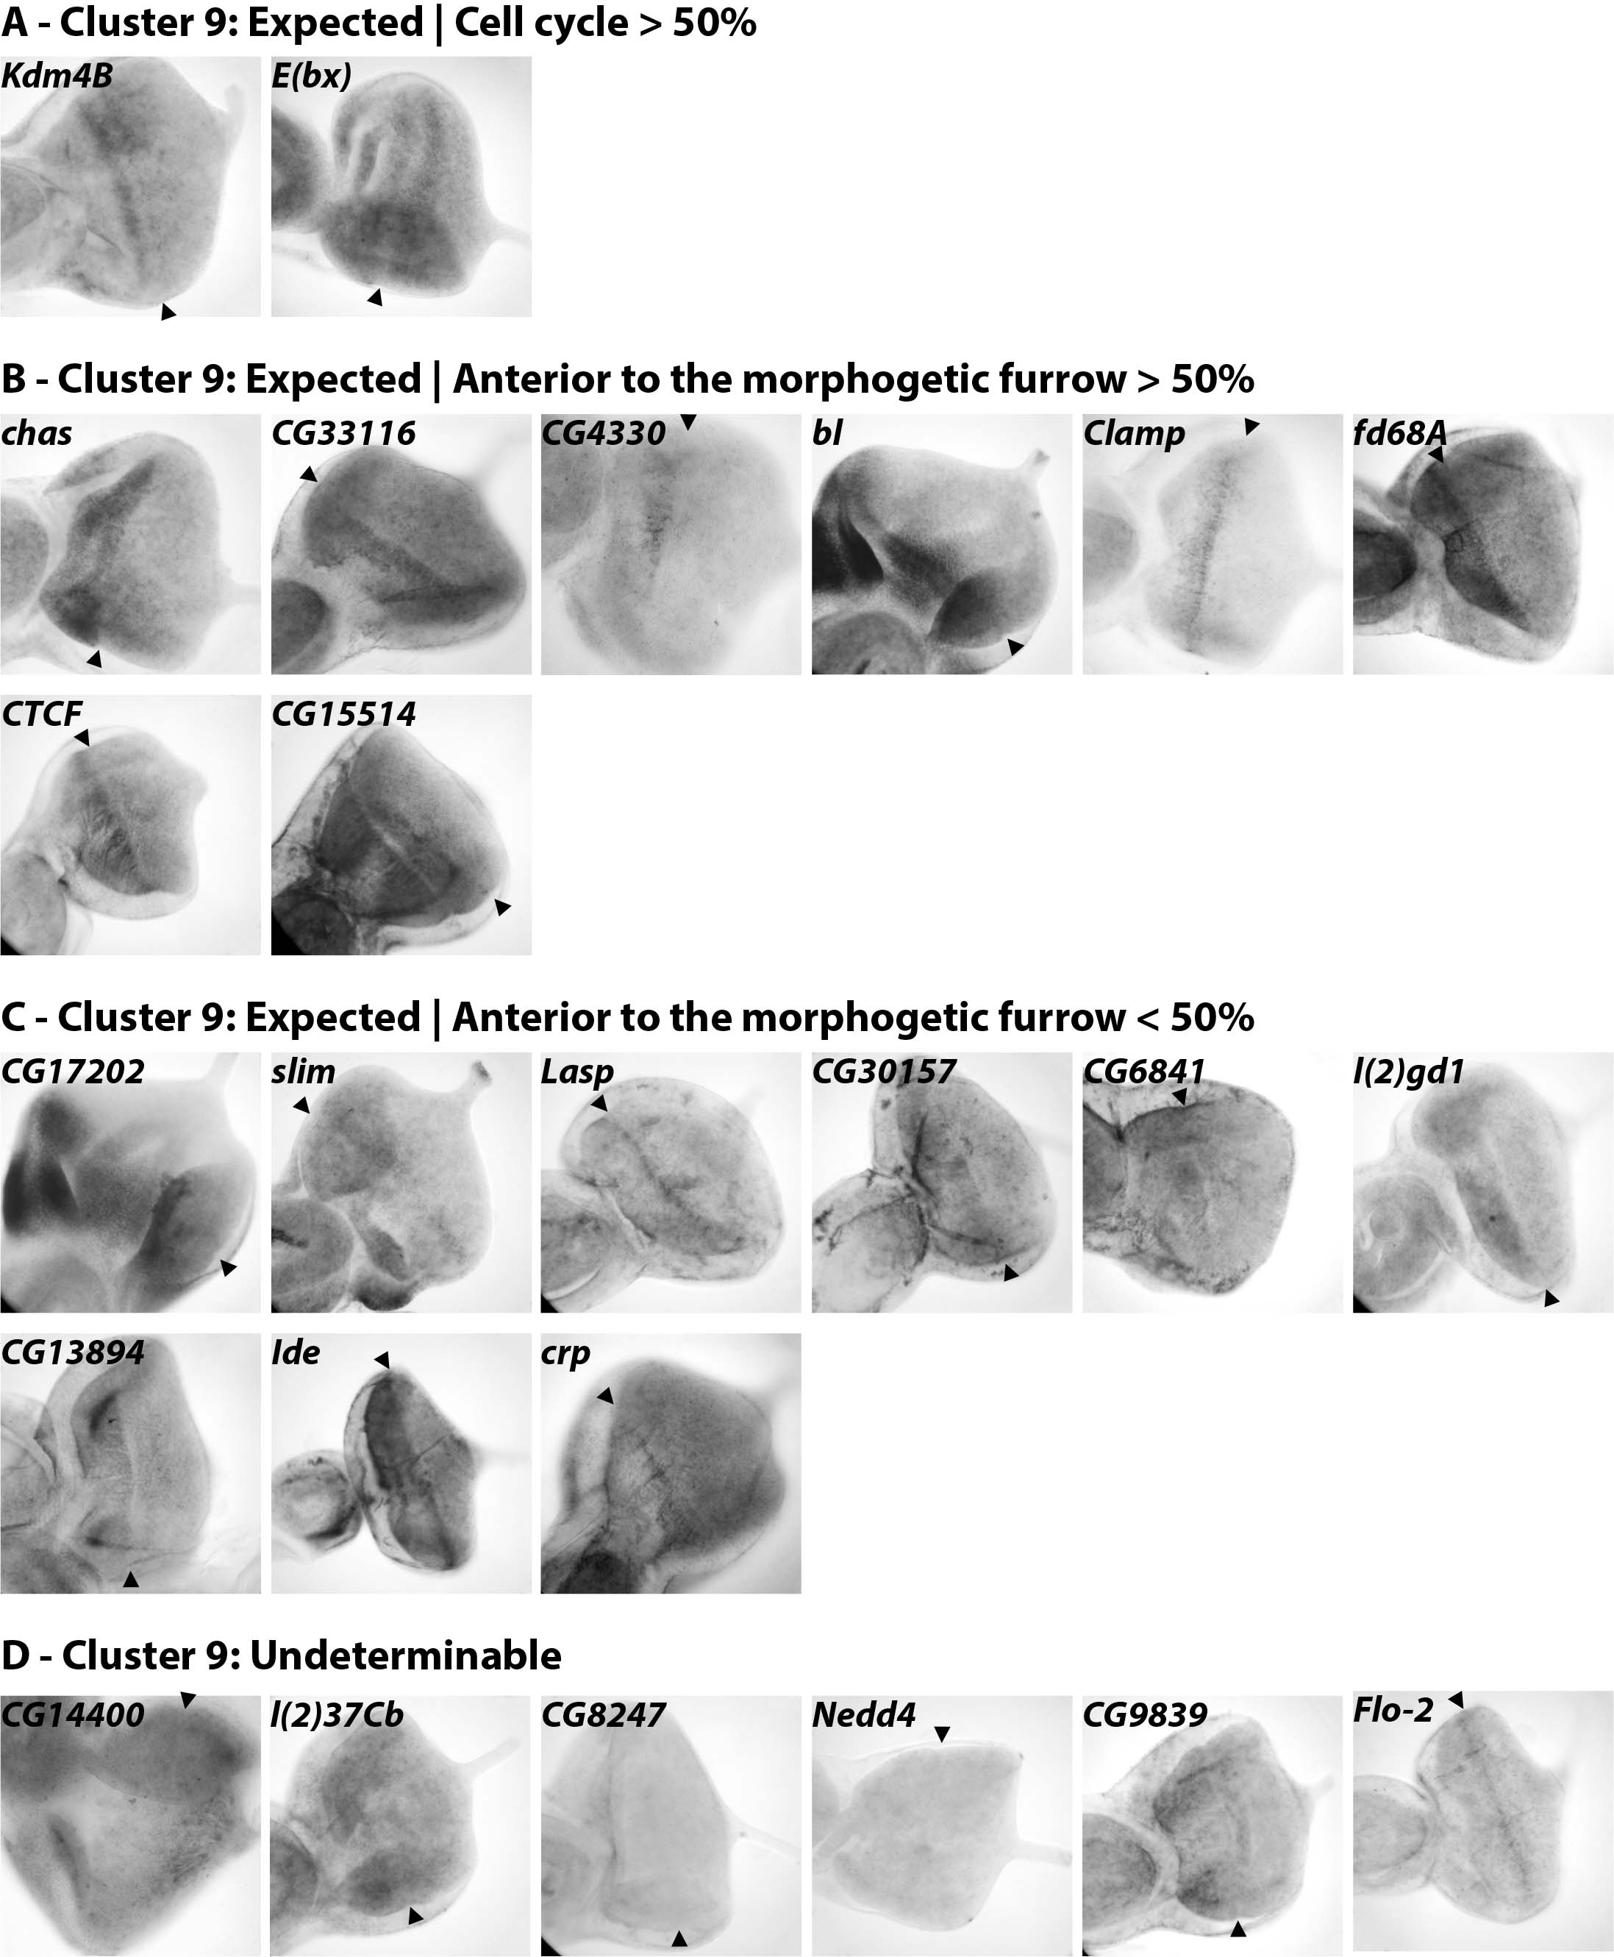
Supplemental Figure 5 ISH of 25 genes from the MF cluster 9
2 genes were expressed in a ‘cell cycle pattern’ resembling stg (Kdm4B, E(bx)). 8 genes were expressed anterior to the MF (CTCF, Clamp, chas, CG33116, fd68A, CG4330, CG15514, bl). 9 more genes presented signal anterior to the furrow in only a subset of the eye discs (CG17202, slim, Lasp, CG30157, crp, CG6841, l(2)gd1, CG13894, Ide). No ISH signal was detected for 6 genes (CG14400, l(2)37Cb, CG8247, Nedd4, CG9839, Flo-2).

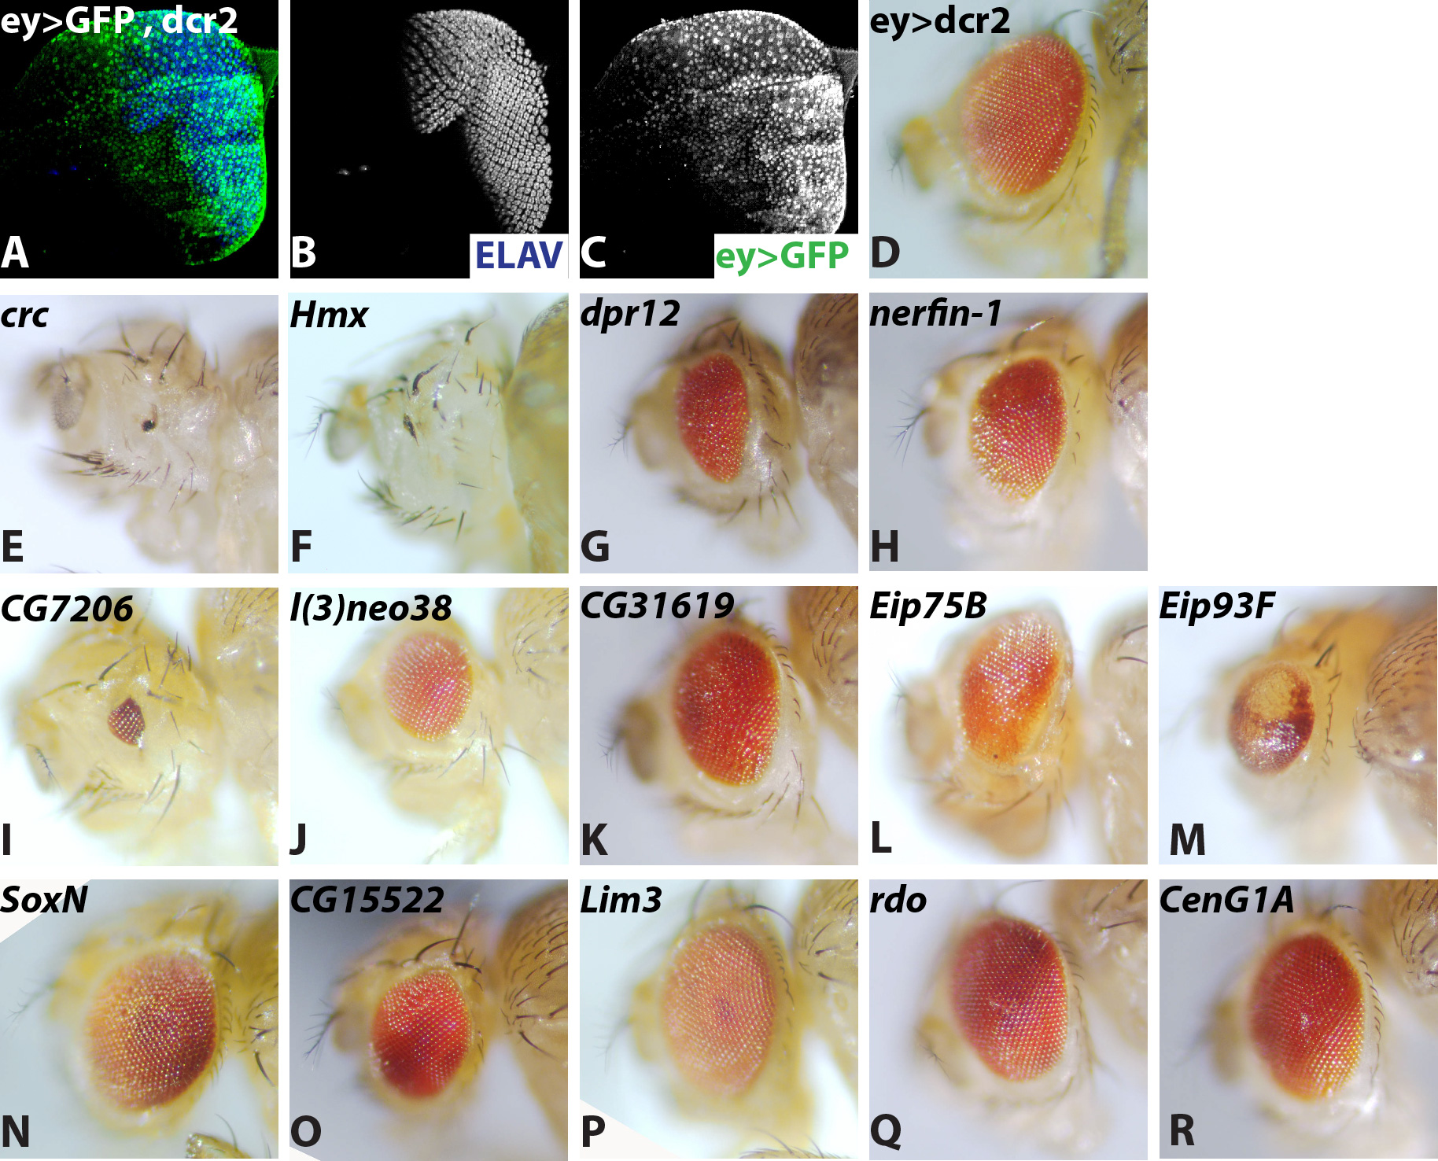

Supplemental Figure 6 Adult eye phenotypes after RNAi
(A, C) eyeless-Gal4 drives dcr2 and GFP throughout the eye disc (ey>GFP, dcr2). (B) ELAV immunostaining, labelling differentiated photoreceptors posterior to the MF. (D) Control adult eye expressing dcr2 only (ey>dcr2) at 29°C. (E-R) Adult eye phenotype observed after expression of RNAi and dcr2 (ey>RNAi, dcr2) at 29°C. (E-H) Strong RNAi phenotypes observed with more than one RNAi for (E) crc, (F) Hmx, (G) dpr12, (H) nerfin-1. (I-M) Strong RNAi phenotypes obtained with one RNAi onlu for (I) CG7206, (J) l(3)neo38, (K) CG31619, (L) Eip75B, (M) Eip93F. (N-R) Weak RNAi phenotypes obtained with one RNAi only for (N) SoxN, (O) CG15522, (P) Lim3, (Q) rdo, (R) CenG1A. Anterior side is shown to the left.

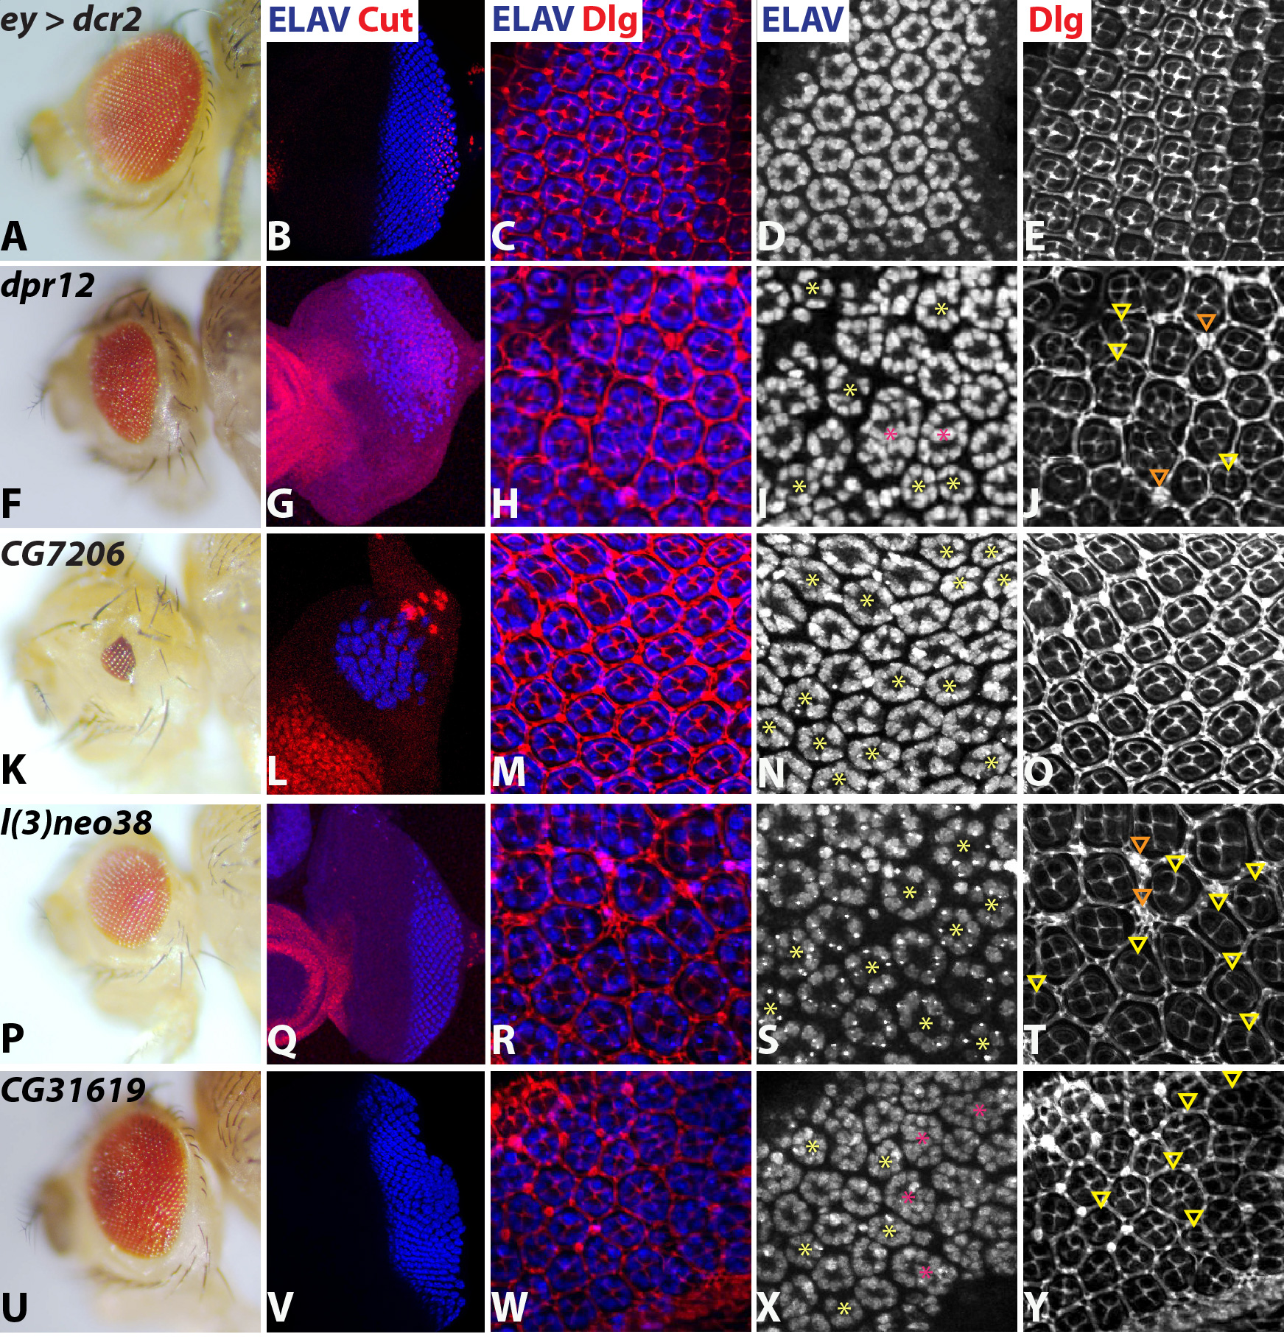 Supplemental Figure 7 Cellular defects after RNAi of putative différentiation genes
Adult eyes (A, F, K, P, U) , eye discs (B, G, L, Q, V) and retinae 38-40h after puparium formation (APF) (C-E, H-J, M-O, R-T, W-Y). (A-E) controls (ey>dcr2). (F-J) RNAi of dpr12. (K-O) RNAi of CG7206. (P-T) RNAi of l(3)neo38. (U-Y) RNAi of CG31619. ELAV (blue) and cut (red) labelling of neural photoreceptor cells and non-neural cone cells respectively (panels A-B, F-G, K-L, P-Q, U-V). Dlg (in red - C, H, M, R, W) outlined all cells. The focal planes used here clearly distinguished inter-ommatidial cells, the border of each ommatidial unit as well as their four cone cells in control animal (E). Yellow asterisks: ommatidia with a number of photoreceptors different form 8. Pink asterisk: ommatidia fused. Yellow arrowheads: ommatidia with a number of cone cells different from 4. Orange arrowheads: extra-inter ommatidial cells. dpr12 (G-I), CG7206 (L-N), l(3)neo38 (Q-S) and CG31619 (V-X) downregulation disturbed differentiated photoreceptors pattern in eye disc and pupal retina. dpr12 (J), CG7206 (L), l(3)neo38 (T) and CG31619 (Y) RNAi retina displayed erratic number of cone cells and dpr12 and CG31619 extra inter ommatidial cells.

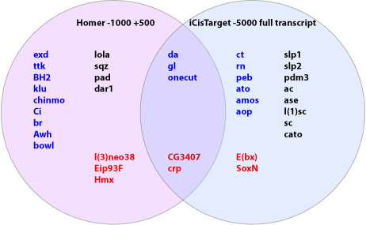
Supplemental Figure 8 Comparison between iCis target and Homer for Response Element prediction.
Predictions of putative response elements enriched in Differentiation Cluster 2 showed limited overlap. All of the transcription factor candidates predicted to bind these response elements are either already known to be involved in eye differentiation (blue), in neurogenesis (black), or directly shown in this paper to be expressed posterior to the MF or to have a phenotype on gene knockdown (red).

LIST OF SUPPLEMENTAL TABLES

Supplemental Table 1 mRNA sequencing results
mRNA abundance (FPKM) across the 12 RNA samples. One replicate was analyzed for each timepoint.

Supplemental Table 2 Contents of the 11 clusters
Gene lists for each of the 11 clusters of the BIC-SK means, supervised adaptative clustering based on 8 RNA samples that is shown in Figure 1D.

Supplemental Table 3 List of reference genes
The reference genes used to exemplify differentiation, proliferation and expression anterior and posterior to the MF.
Supplemental Table 4 GO enrichment
Enriched biological process GO terms of the 11 clusters shown in Figure 1D. GO terms with a FDR<0.01 after Benjamini Hochberg adjustment are highlighted in grey.

Supplemental Table 5 KEGG enrichment
Enriched KEGG pathways of the 11 clusters shown in Figure 1D. KEGG pathway terms with a FDR<0.05 after Benjamini Hochberg adjustment are highlighted in grey and those with enrichment<0.01 are highlighted in blue.

Supplemental Table 6 Summary of ISH expression patterns
Classification of expression patterns determined by ISH of 98 genes from Clusters 2,7,9, using both sensé and anti-sense probes, as well as the individual probe parameters. Also tabulated is whether RNAi for the genes was performed, whether there was a morphological phénotype after RNAi, and whether genes were selected for ISH on the basis of an RNAi phénotype or independently. Statistical analysis indiçâtes that the expression patterns detected differ among clusters, and that thèse différences are maintained when only genes selected for ISH independently of RNAi phénotype are analyzed.

Supplemental Table 7 Contents of the subclusters
Gene lists for Cluster 2A, Cluster 2B, Cluster 2 core, Cluster 7 core, and Cluster 9 core.

Supplemental Table 8 GO enrichment of subclusters
Enriched biological process GO terms of Clusters 2A, 2B, and the Cluster 2, 7 & 9 cores. GO terms with a FDR<0.01 after Benjamini Hochberg adjustment are highlighted in grey.

Supplemental Table 9 KEGG enrichment of subclusters
Enriched KEGG pathways of Clusters 2A, 2B, and the Cluster 2, 7 & 9 cores. KEGG pathway terms with a FDR<0.05 after Benjamini Hochberg adjustment are highlighted in grey and those with enrichment<0.01 are highlighted in blue.

Supplemental Table 10 Summary of iCis Target motif identification
The response elements enriched within clusters 2, 2A, 2 core, 7, 7 core, 9 & 9 core as determined by iCisTarget with NES<3.

Supplemental Table 11 Response element identification with Homer
Table showing the enriched response elements identified with the Homer program in the regulatory sequences of the genes included in the clusters 2, 7, 9, subclusters 2A and 2B, core clusters 2, 7, 9.

Supplemental Table 12 Putative transcription factors in clusters 2, 7 and 9
Proteins with predicted DNA-binding domains from clusters 2,7,9 and their subclusters. 27 of 75 putative DBP in the eye-specific differentiation cluster 2 had previously-known functions in eye development. 38 remaining genes whose expression reached FPKM>3 in at least one eye or eye-antennal RNA dataset were subjected to RNAi knockdown.
Supplemental Table 13 List of RNAi strains
186 RNAi strains corresponding to 87 used were expressed during eye development.
Supplemental Table 14 Summary of RNAi phenotypes
Adult eye phenotypes observed upon downregulation by RNAi of 14 genes from cluster 2 following downregulation in the entire eye disc (ey>RNAi, dcr2) or posterior to the MF (GMR>RNAi, dcr2) and 10 genes from other clusters following downregulation in the entire eye disc (ey>RNAi, dcr2). Column F shows minimum s19 specificity score of the VDRC strains when a phenotype was recorded.
Supplemental Table 15 RNAseq quality control
Read mapping statistics for RNAseq datasets.

