Supplementary image file: Figure_S3.pdf
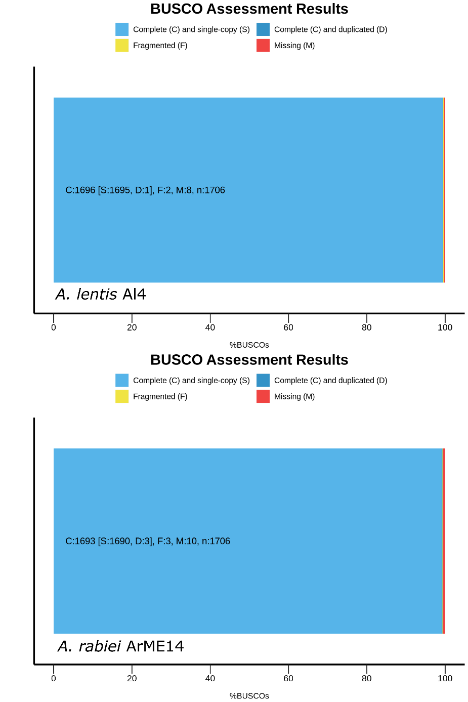
Assessment of genome assembly and annotation completeness for the A. lentis Al4 reference genome assembly (top) and comparison with the published A. rabiei assembly for isolate ArME14 (bottom), using BUSCO v4.1.4. BUSCO was run using annotated protein files with graphical output within BUSCO by implementation of ggplot in R. For benchmarking of Al4 annotated assemblies against the BUSCO ascomycota_odb10 single-copy orthologs file for 1,706 proteins, 1,695 proteins were matched and single-copy, one was complete and duplicated, two annotations were fragmented and eight proteins were missing. By comparison, the reference A. rabiei ArME14 genome assembly had slightly lower annotation completeness.

