Supplemental Figures

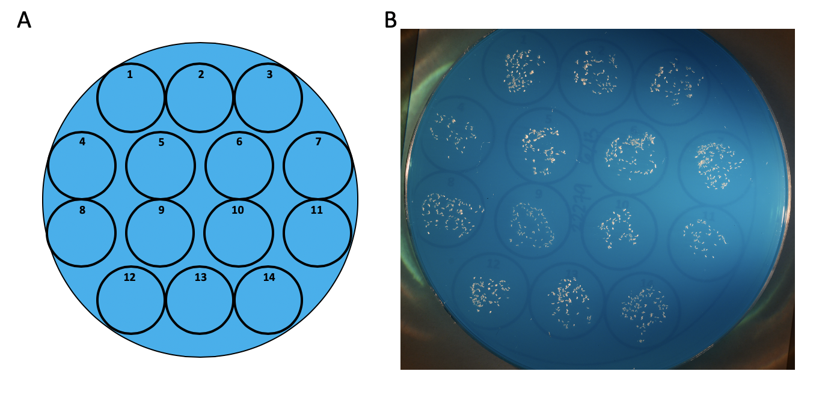
Figure S1. Embryo counting process. Embryos from each strain were arrayed on a 100mm petri dish containing 2% agar with dye for contrast. A. Template used for arraying embryos. B. An example of embryos arranged in each cell of the template. After taking a picture of each dish, embryos were transferred to vials containing water or 2mM CuSO₄. All embryos from each cell on the template were transferred to one vial, resulting in up to 7 control vials and 7 copper vials per strain.

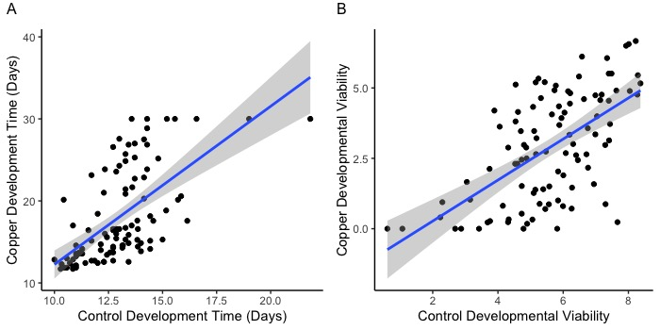
Figure S2. Developmental responses were correlated on control and copper media. A. Development time on control food was correlated development time on copper food (F_{(1,98)} = 61.0, P < 0.0001, R² = 38%). Vials in which no individuals emerged were given a value of 30 days. B Square root transformed developmental viability on control and 2mM CuSO₄ was also correlated (F_{(1,98)} = 57.1, P < 0.0001, R² = 36%). Each point represents the strain mean response. Grey shading indicates the 95% CI of the regression.

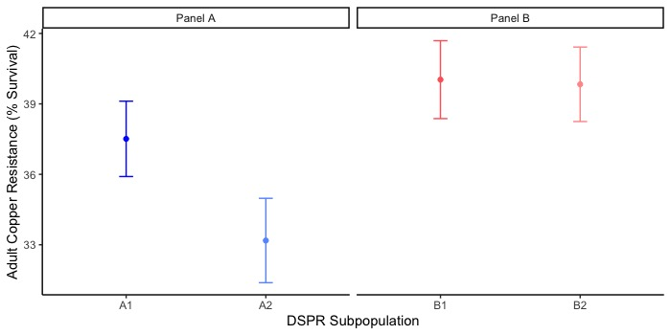
Figure S3. The effect of subpanel on adult copper resistance was panel-dependent. Mean (± 95% CI) female copper resistance per subpanel. Subpanel influenced percent survival in the A (F_{1,2289} = 12.64; p < 0.001) but not B panel (F_{1,2495} = 0.03; p = 0.86).

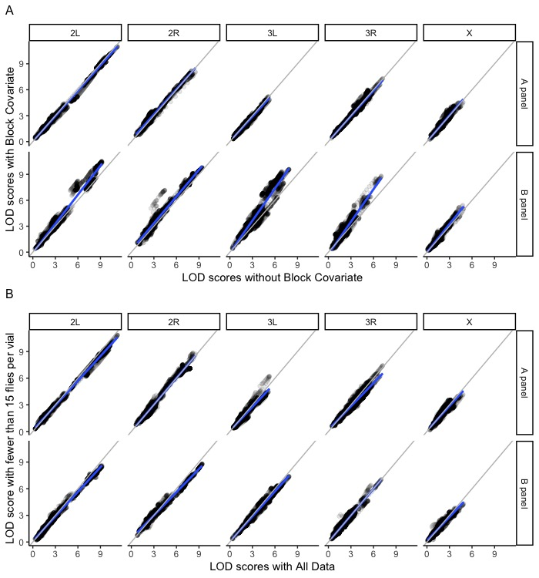
Figure S4. LOD scores were highly correlated between models. Comparison of LOD scores between a model with batch included as a covariate (A) and when vials with fewer than 15 flies were removed from the calculation of mean survival prior to mapping (B). Best fit lines are shown in blue in each plot; grey lines indicate the 1:1 line for comparison.
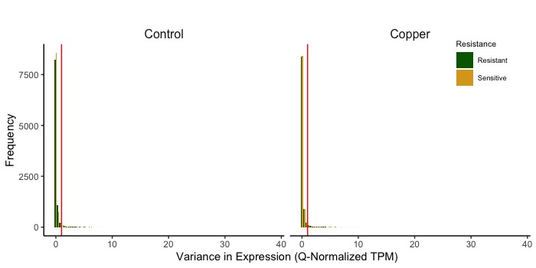
Figure S5. Variance in quantile-normalized TPM by within each sample group (resistant vs. sensitive) and treatment group (copper vs. control). The red vertical line indicates the cutoff of 1. All genes with a variance equal to or greater than 1 were excluded from all downstream analyses of DE gene from the three DE models.

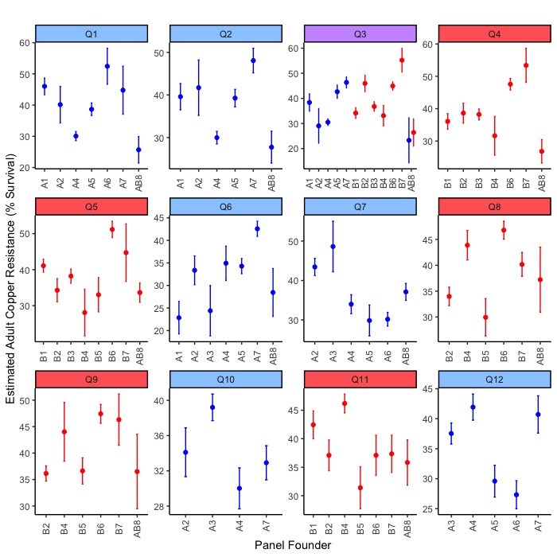
Figure S6. Estimated founder haplotype effects at each QTL associated with adult copper resistance. Data are presented as estimated founder means (±SE) when the founder haplotype was present in more than 7 DSPR strains. Plots are colored by panel; panel A is plotted in blue, panel B is plotted in red. Purple indicates the shared QTL (Q3) between the A and B panels.

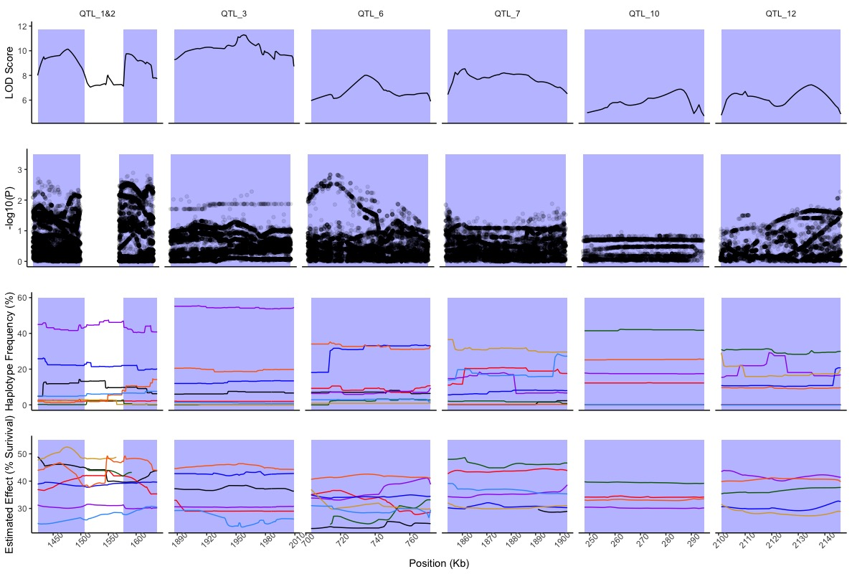
Figure S7. For QTL identified in the A panel, we report fine mapping, haplotype frequency, and estimated effects of founder haplotypes on adult copper survival for each marker position through the QTL interval. Haplotype-specific data is shown as colored lines (black = A1, red = A2, green = A3, purple = A4, dark blue = A5, gold = A6, orange = A7, light blue = AB8), and shaded boxes in each plot pane show the boundaries of each QTL. Incomplete lines reporting estimated effects reflect too few strains present with a particular founder haplotype to calculate the estimated effect. Fine mapping did not reveal any promising candidate genes. Haplotype frequency did not suggest that close proximity QTL (Q1 and Q2) were inappropriately separated due to a sudden shift in haplotype frequency.

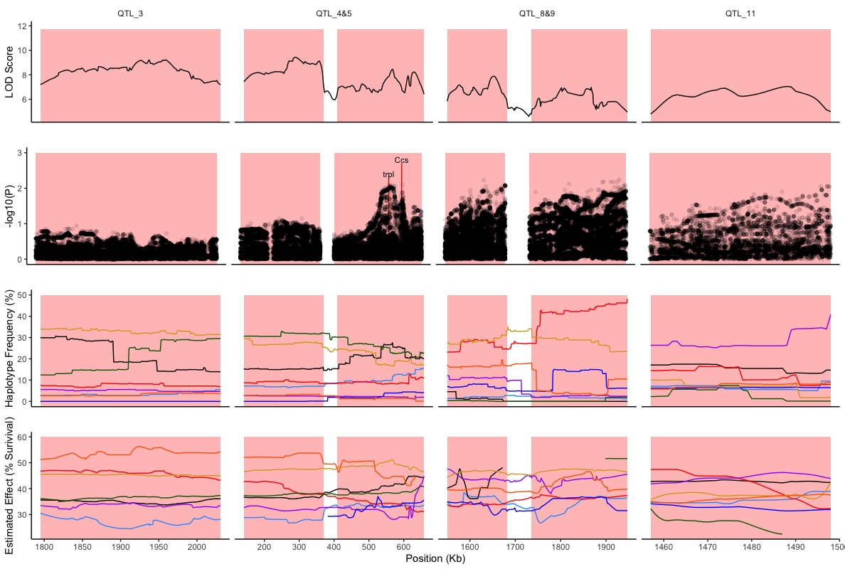
Figure S8. For QTL identified in the B panel, we report fine mapping, haplotype frequency, and estimated effects of founder haplotypes on adult copper survival for each marker position through the QTL interval. Haplotype-specific data is shown as colored lines (black = B1, red = B2, green = B3, purple = B4, dark blue = B5, gold = B6, orange = B7, light blue = AB8), and shaded boxes in each plot pane show the boundaries of each QTL. Incomplete lines reporting estimated effects reflect too few strains present with a particular founder haplotype to calculate the estimated effect. Fine mapping supported Ccs and trpl as promising candidate genes. Haplotype frequency did not suggest that close proximity QTL (Q4/Q5 and Q8/Q9) were inappropriately separated due to a sudden shift in haplotype frequency.

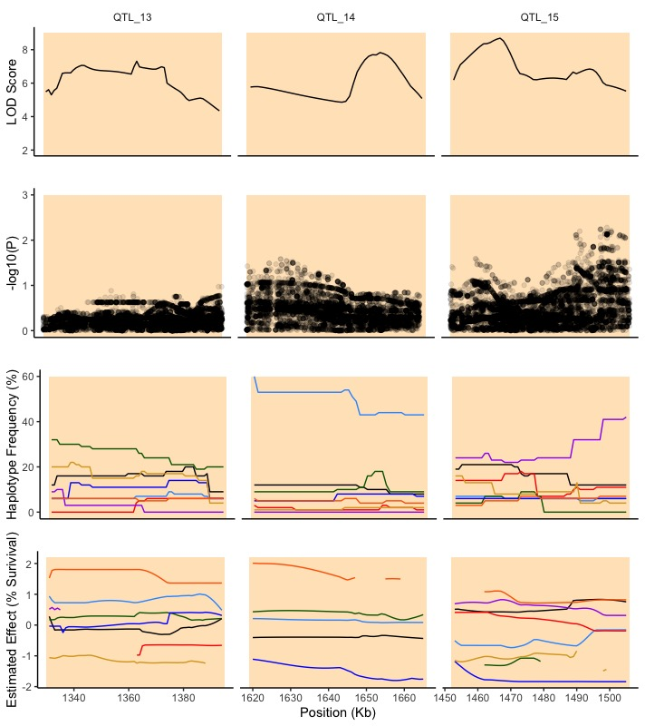
Figure S9. For QTL identified in the B panel associated with copper treatment-specific developmental viability, we report fine mapping, haplotype frequency, and estimated effects of founder haplotypes on adult copper survival for each marker position through the QTL interval. Haplotype-specific data is shown as colored lines (black = B1, red = B2, green = B3, purple = B4, dark blue = B5, gold = B6, orange = B7, light blue = AB8), and shaded boxes in each plot pane show the boundaries of each QTL. Incomplete lines reporting estimated effects reflect too few strains present with a particular founder haplotype to calculate the estimated effect. Fine mapping did not reveal any promising candidate genes.

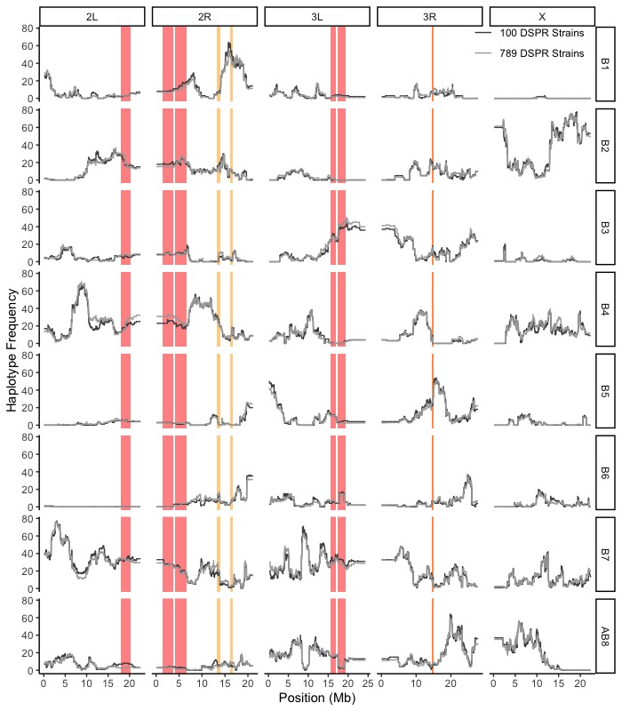
Figure S10. Founder haplotype representation was similar between the sample of strains used to measure adult and developmental traits in the B panel. Founder haplotype frequencies are shown at each marker position (every 10,000 bp) through the genome for the 789 DSPR strains sampled for the adult copper resistance phenotype (light grey) and the 100 DSPR strains sampled for the copper treatment-specific developmental viability phenotype (dark grey). Representation of founder haplotypes in the DSPR strains sampled for the developmental phenotype is similar to founder haplotype representation in the 789 strains sampled for the adult phenotype. In each panel, QTL intervals for adult copper resistance and treatment-specific developmental viability are shown as red and yellow bars, respectively. A panel QTL are not shown.
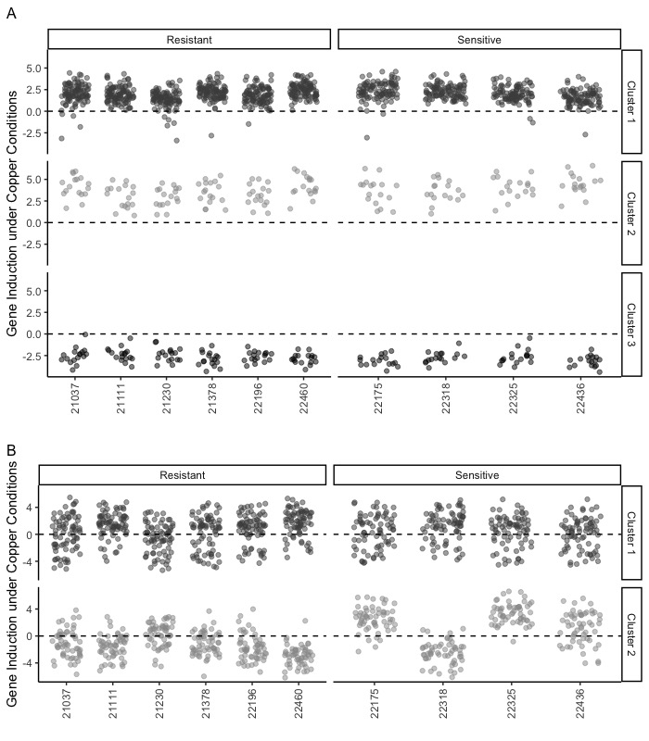
Figure S11. Clust analysis of genes influenced by treatment or resistance class. A. Clust identified 3 clusters from genes with DE due to treatment. 17 genes from cluster 1 were also implicated by adult copper resistance QTL; one gene was also implicated by copper treatment-specific developmental viability QTL Q15. From treatment clusters 2 and 3, 2 and 4 genes, respectively, were also implicated by adult copper resistance QTL. B. Clust identified 2 clusters from genes with DE due to resistance class. In cluster1, 11 genes were also implicated by adult copper resistance QTL; 4 genes from cluster 2 were also implicated by adult copper resistance QTL. One gene from cluster 2 was implicated by treatment-specific developmental viability QTL Q15 as well. Points are shaded to help distinguish clusters.

Supplemental Tables
Table S1. Correlations between standards across each of plate and block were high and consistent.
 | block1_P1 | block1_P2 | block1_P3 | block2_P1 | block2_P2 | block2_P3 | block3_P1 | block3_P2 | block3_P3
block1_P1 | -- | 99.99 | 99.99 | 99.97 | 99.97 | 99.91 | 99.96 | 99.94 | 99.94
block1_P2 |  | -- | 99.99 | 99.98 | 99.98 | 99.90 | 99.97 | 99.96 | 99.96
block1_P3 |  |  | -- | 99.98 | 99.98 | 99.92 | 99.97 | 99.95 | 99.96
block2_P1 |  |  |  | -- | 99.99 | 99.86 | 99.99 | 99.98 | 99.97
block2_P2 |  |  |  |  | -- | 99.87 | 99.98 | 99.97 | 99.97
block2_P3 |  |  |  |  |  | -- | 99.84 | 99.86 | 99.88
block3_P1 |  |  |  |  |  |  | -- | 99.98 | 99.97
block3_P2 |  |  |  |  |  |  |  | -- | 99.99
block3_P3 |  |  |  |  |  |  |  |  | --

Table S2. Summary of analysis of variance and regressions.
A. Effect of DSPR strain on development time, control food
Source | df | SS | MS | F value | P value
DSPR Strain | 99 | 1573 | 15.89 | 31.61 | < 0.00001
Residuals | 579 | 291.1 | 0.50
B. Effect of DSPR strain on developmental viability, control food
Source | df | SS | MS | F value | P value
DSPR Strain | 99 | 2046 | 20.66 | 11.77 | < 0.00001
Residuals | 579 | 1016 | 1.75
C. Correlation between copper and control development time
Source | df | SS | MS | F value | P value
Treatment | 1 | 1214 | 1214 | 61.0 | < 0.00001
Residuals | 98 | 1950 | 19.9
D. Correlation between copper and control developmental viability
Source | df | SS | MS | F value | P value
Treatment | 1 | 128.4 | 128.4 | 54.1 | < 0.00001
Residuals | 98 | 232.8 | 2.38
E. Variation in adult copper resistance among DSPR Mapping Panel A
Source | df | SS | MS | F value | P value
Subpanel | 1 | 10621 | 10620.7 | 12.64 | < 0.001
Batch | 5 | 38679 | 7735.8 | 9.20 | < 0.001
Subpanel x Batch | 2 | 919 | 459.5 | 0.55 | 0.58
Residuals | 2289 | 1923750 | 840.4
F. Variation in adult copper resistance among DSPR Mapping Panel B
Source | df | SS | MS | F value | P value
Subpanel | 1 | 25 | 24.5 | 0.03 | 0.86
Batch | 5 | 30334 | 6066.7 | 7.18 | < 0.001
Subpanel x Batch | 3 | 2774 | 924.6 | 1.09 | 0.35
Residuals | 2495 | 2107619 | 844.7
G. Effect of copper on consumption in 95 DSPR strains
Source | df | SS | MS | F value | P value
DSPR Strain | 94 | 4.46e-5 | 4.70e-7 | 3.08 | < 0.00001
Treatment | 1 | 3.55e-4 | 3.55e-4 | 2306 | < 0.00001
DSPR Strain x Treatment | 94 | 4.01e-5 | 4.30e-7 | 2.77 | < 0.00001
Residuals | 348 | 5.36e-5 | 1.5e-7
H. Effect of adult copper resistance on copper consumption
Source | Estimate | SE |  | t value | P value
Intercept | 1.80e-03 | 9.56e-05 |  | 18.83 | < 0.00001
Adult Copper Survival | 1.76e-06 | 1.78e-06 |  | 0.992 | 0.32
I. Effect of adult copper resistance on control consumption
Source | Estimate | SE |  | t value | P value
Intercept | 56.78 | 4.56 |  | 12.46 | < 0.00001
Adult Copper Survival | -48436.9 | 13602.5 |  | -3.56 | 0.001
J. Correlation between adult copper resistance and feeding plasticity
Source | df | SS | MS | F value | P value
Adult Copper resistance | 1 | 1.57e-6 | 1.57e-6 | 5.33 | 0.023
Residuals | 93 | 2.74e-5 | 2.74e-5
K. Effect of copper on development time
Source | df | SS | MS | F value | P value
DSPR Strain | 99 | 15505 | 156.6 | 24.21 | < 0.00001
Treatment | 1 | 8366 | 8366 | 1293 | < 0.00001
DSPR Strain x Treatment | 99 | 7525 | 76.0 | 11.75 | < 0.00001
Residuals | 1157 | 7485 | 6.5
L. Effect of copper on developmental viability
Source | df | SS | MS | F value | P value
DSPR Strain | 99 | 3169 | 32.01 | 49.17 | < 0.00001
Treatment | 1 | 2543 | 2543 | 3905 | < 0.00001
DSPR Strain x Treatment | 99 | 846.0 | 8.55 | 13.13 | < 0.00001
Residuals | 1157 | 753.3 | 0.65
M. Correlation between treatment-specific development time and treatment-specific developmental viability
Source | df | SS | MS | F value | P value
Treatment-specific Development Time | 1 | 102.0 | 102.0 | 76.4 | < 0.00001
Residuals | 98 | 130.8 | 1.34
N. Correlation between adult copper resistance and treatment-specific development time
Source | Estimate | SE |  | t value | P value
Intercept | 0.32 | 0.91 |  | 0.35 | 0.72
Adult Copper Resistance | -0.0006 | 0.02 |  | -0.40 | 0.69
O. Correlation between adult copper resistance and treatment-specific developmental viability
Source | Estimate | SE |  | t value | P value
Intercept | -0.45 | 0.31 |  | -1.44 | 0.15
Adult Copper Resistance | 0.009 | 0.006 |  | 1.65 | 0.10
P. Correlation between estimated haplotype effects
Source | df | SS | MS | F value | P value
Estimated Haplotype Effect | 1 | 3.41 | 3.41 | 7.11 | 0.04
Residuals | 5 | 2.40 | 0.48

Table S3. RNAi stocks for candidate genes.
Gene | Stock ID | Association in This Study | Proposed Metal Association |  | Driver | N
trpl | BDSC_26722 (VAL10) | Q5B, RNAseq | Mn (Gaudet et al. 2011) |  | Ubiquitous | 17
 |  |  |  |  | Midgut | 18
CG5235 | BDSC_27694 (VAL10) | Q8B, RNAseq | Cu (Gaudet et al. 2011) |  | Ubiquitous | 18
 |  |  |  |  | Midgut | 18
 | BDSC_66964 (VAL20) |  |  |  | Ubiquitous | 11
 |  |  |  |  | Midgut | 18
ZnT41F | BDSC_65382 (VAL20) | Q4B | Zn (Lye et al. 2013) |  | Ubiquitous | 11
 |  |  |  |  | Midgut | 16
 | BDSC_28638 (VAL10) |  |  |  | Ubiquitous | 17
 |  |  |  |  | Midgut | 18
MtnC | BDSC_53292 (VAL20) | RNAseq |  |  | Ubiquitous | NA
 |  |  | Cu, Zn, Cd (Egli et al. 2006a; Calap-Quintana et al. 2017) |  | Midgut | 17
 | BDSC_63008 (VAL20) |  |  |  | Ubiquitous | 12
 |  |  |  |  | Midgut | 18
Catsup | BDSC_55396 (VAL20) | Q3A | Zn (Lye et al. 2013) |  | Ubiquitous | 4
 |  |  |  |  | Midgut | 18
CG11825 | BDSC_58199 (VAL20) | Q5B | Cu (Norgate et al. 2007) |  | Ubiquitous | 8
 |  |  |  |  | Midgut | 17
Ccs | BDSC_62919 (VAL20) | Q5B | Cu, Zn (Kirby et al. 2008; Gaudet et al. 2011) |  | Ubiquitous | 12
 |  |  |  |  | Midgut | 18
Sod1 | BDSC_34616 (VAL20) | NA | Cu, Zn (Gaudet et al. 2011) |  | Ubiquitous | 17
 |  |  |  |  | Midgut | 18
Sod2 | BDSC_32496 (VAL20) |  |  |  | Ubiquitous | 17
 |  |  |  |  | Midgut | 18
whd | BDSC_33635 (VAL20) | Q5B, RNAseq | Fe, Cd (Strub et al. 2008) |  | Ubiquitous | 18
 |  |  |  |  | Midgut | 18
DCP2 | BDSC_34806 (VAL20) | Q8B | Mn (Thurmond et al. 2019) |  | Ubiquitous | 17
 |  |  |  |  | Midgut | 18
CG10505 | BDSC_38317 (VAL20) | RNAseq | Cu, Zn, Cd (Yepiskoposyan et al. 2006; Thurmond et al. 2019) |  | Ubiquitous | 16
 |  |  |  |  | Midgut | 18
babo | BDSC_40866 (VAL20) | Q5B | (Thurmond et al. 2019) |  | Ubiquitous | 15
 |  |  |  |  | Midgut | 18
swm | BDSC_52935 (VAL20) | Q3B | (Thurmond et al. 2019) |  | Ubiquitous | NA
 |  |  |  |  | Midgut | 13
Mvl | BDSC_55316 (VAL20) | RNAseq | Fe, Cu, Mn, Cd (Southon et al. 2008; Bettedi et al. 2011) |  | Ubiquitous | 14
 |  |  |  |  | Midgut | 18
stl | BDSC_57811 (VAL20) | Q7A, RNAseq | Zn (Ozdowski et al. 2009) |  | Ubiquitous | 18
 |  |  |  |  | Midgut | 18

Table S4. Genes mapped to regions associated with each QTL. Data from FlyBase release FB2020_01. Grey text indicates non-protein coding genes. Red text indicates genes that overlap between QTL intervals.
See additional file Supplemental Table 4

Table S5. DE genes identified with the resistance class model (~ TRT + RES vs. reduced model: ~ TRT), treatment model (~ TRT + RES vs. reduced model: ~ RES), and the full model (~ TRT + RES vs reduced model: ~ 1). Gene position data is from FlyBase release FB2020_01.
See additional file Supplemental Table 5

Table S6. GO terms and associated gene IDs identified for the DE genes from the full model (~ TRT + RES vs reduced model: ~ 1), treatment model (~ TRT + RES vs. reduced model: ~ RES), resistance model (~ TRT + RES vs. reduced model: ~ TRT), and the clusters formed for the treatment and resistance sets of DE genes. GO analysis was performed using FlyMine.
See additional file Supplemental Table 6

Supplemental Files
File S1. README file for datafiles accompanying this study.

