Supplementary data
for
Inference of population genetic parameters from the semi-randomly serial-sampled sequences of human seasonal influenza A/H3N2
by
Myriam Croze and Yuseob Kim

Table S1. Bootstrap tests for the significance of difference in mutation rates, pairwise sequence diversity, and effective population size between segments, for 27-, 10-, and 37-year data sets. Each number is the percentage of resampled data that yield the difference of a given statistic twice larger than the difference in the observed data.

 |  | 27-year (1980-2006) |  |  | 10-year (2007-2017) |  |  | 37 year (1980-2017)
 |  | $$\hat{μ}$$ | $$\check{π}$$ | $$\hat{N_{e}}$$ | $$\hat{μ}$$ | $$\check{π}$$ | $$\hat{N_{e}}$$ | $$\hat{μ}$$ | $$\check{π}$$ | $$\hat{N_{e}}$$
HA vs | PB1 | 0.026 | 0.005 | 0.007 | 0.326 | 0.040 | 0.138 | 0.099 | 0 | 0.002
 | PB2 | 0.012 | 0 | 0.007 | 0.379 | 0.037 | 0.165 | 0.019 | 0 | 0.002
 | PA | 0.004 | 0.012 | 0.014 | 0.425 | 0.359 | 0.359 | 0.006 | 0.001 | 0.001
 | NP | 0 | 0.002 | 0.018 | 0.100 | 0.359 | 0.134 | 0.007 | 0 | 0.020
 | NA | 0.008 | 0.025 | 0.011 | 0.294 | 0.153 | 0.478 | 0.007 | 0.020 | 0.080
PB1 vs | PB2 | 0.175 | 0.347 | 0.204 | 0.438 | 0.482 | 0.430 | 0.149 | 0.390 | 0.133
 | PA | 0.152 | 0.484 | 0.280 | 0.391 | 0.084 | 0.208 | 0.090 | 0.457 | 0.153
 | NP | 0.017 | 0.225 | 0.068 | 0.178 | 0.106 | 0.356 | 0.059 | 0.406 | 0.140
 | NA | 0.168 | 0.488 | 0.281 | 0.476 | 0.004 | 0.154 | 0.057 | 0.115 | 0.362
PB2 vs | PA | 0.467 | 0.345 | 0.415 | 0.445 | 0.057 | 0.239 | 0.382 | 0.378 | 0.473
 | NP | 0.114 | 0.329 | 0.155 | 0.138 | 0.092 | 0.314 | 0.294 | 0.324 | 0.442
 | NA | 0.481 | 0.353 | 0.408 | 0.411 | 0.001 | 0.184 | 0.316 | 0.077 | 0.292
PA vs | NP | 0.133 | 0.190 | 0.128 | 0.119 | 0.482 | 0.169 | 0.390 | 0.433 | 0.446
 | NA | 0.479 | 0.510 | 0.488 | 0.358 | 0.093 | 0.398 | 0.425 | 0.134 | 0.286
NP vs | NA | 0.167 | 0.241 | 0.132 | 0.241 | 0.086 | 0.154 | 0.469 | 0.158 | 0.247

Table S2. Sampling-time-corrected sequence diversity and F_{ST} in the simulation of metapopulation dynamics under neutrality (s = 0) and with τ_{max} = 300 days. The values in bold are the closest to the observation..
K_{max} |  | m
 |  | 0 | 0.00001 | 0.0001 | 0.001 | 0.01
100 | $$\check{π}$$ | NA | 0.237 | 0.141 | 0.025 | 0.064
 | F_{ST} | NA | 0.952 | 0.916 | 0.459 | 0.0291
250 | $$\check{π}$$ | 0.255 | 0.243 | 0.128 | 0.043 | 0.064
 | F_{ST} | 0.895 | 0.938 | 0.828 | 0.320 | 0.029
500 | $$\check{π}$$ | 0.259 | 0.248 | 0.100 | 0.064 | 0.112
 | F_{ST} | 0.803 | 0.924 | 0.675 | 0.225 | 0.014
1,000 | $$\check{π}$$ | 0.268 | 0.255 | 0.107 | 0.104 | 0.179
 | F_{ST} | 0.647 | 0.887 | 0.542 | 0.132 | 0.005
2,000 | $$\check{π}$$ | 0.284 | 0.254 | 0.139 | 0.154 | 0.267
 | F_{ST} | 0.387 | 0.818 | 0.423 | 0.074 | 0.005
5,000 | $$\check{π}$$ | 0.320 | 0.262 | 0.222 | 0.262 | 0.368
 | F_{ST} | -0.105 | 0.643 | 0.272 | 0.033 | 0.003
10,000 | $$\check{π}$$ | 0.362 | 0.282 | 0.292 | 0.338 | 0.425
 | F_{ST} | -0.544 | 0.502 | 0.176 | 0.015 | 0.000

Table S3. Sampling-time-corrected sequence diversity and F_{ST} in the simulation of metapopulation dynamics with positive selection (s) and for various values of migration (m ), maximum carrying capacity (K_{max}) and epitope (ε) (τ_{max} = 300 days).
 |  |  | s = 0.05 |  |  |  |  | s = 0.1 |  |  |  |  | s = 0.15
 |  |  | m |  |  |  |  | m |  |  |  |  | m
K_{max} | ε |  | 0 | 0.00001 | 0.0001 | 0.001 | 0.01 | 0 | 0.00001 | 0.0001 | 0.001 | 0.01 | 0 | 0.00001 | 0.0001 | 0.001 | 0.01
250 | 10 | $$\check{π}$$ | NA | 0.183 | 0.074 | 0.031 | 0.029 | NA | NA | 0.053 | 0.023 | 0.019 | NA | NA | 0.038 | 0.019 | 0.016
 |  | F_{ST} | NA | 0.903 | 0.789 | 0.312 | 0.027 | NA | NA | 0.760 | 0.297 | 0.022 | NA | NA | 0.738 | 0.280 | 0.007
 | 20 | $$\check{π}$$ | NA | NA | 0.065 | 0.028 | 0.025 | NA | NA | 0.041 | 0.021 | 0.016 | NA | NA | 0.042 | 0.021 | 0.013
 |  | F_{ST} | NA | NA | 0.784 | 0.310 | 0.026 | NA | NA | 0.639 | 0.285 | 0.022 | NA | NA | 0.757 | 0.289 | 0026
 | 30 | $$\check{π}$$ | NA | NA | 0.059 | 0.027 | 0.023 | NA | NA | 0.037 | 0.019 | 0.015 | NA | NA | 0.028 | 0.016 | 0.012
 |  | F_{ST} | NA | NA | 0.779 | 0.311 | 0.026 | NA | NA | 0.736 | 0.286 | 0.022 | NA | NA | 0.719 | 0.266 | 0.026
 | 40 | $$\check{π}$$ | NA | NA | 0.057 | 0.026 | 0.021 | NA | NA | 0.035 | 0.018 | 0.015 | NA | NA | 0.025 | 0.015 | 0.012
 |  | F_{ST} | NA | NA | 0.776 | 0.314 | 0.023 | NA | NA | 0.729 | 0.278 | 0.025 | NA | NA | 0.614 | 0.262 | 0.025
500 | 10 | $$\check{π}$$ | NA | 0.172 | 0.052 | 0.034 | 0.030 | NA | NA | 0.037 | 0.023 | 0.019 | NA | NA | 0.024 | 0.018 | 0.015
 |  | F_{ST} | NA | 0.883 | 0.620 | 0.211 | 0.010 | NA | NA | 0.595 | 0.200 | 0.011 | NA | NA | 0.448 | 0.191 | 0.013
 | 20 | $$\check{π}$$ | NA | NA | 0.048 | 0.030 | 0.027 | NA | NA | 0.032 | 0.021 | 0.017 | NA | NA | 0.025 | 0.021 | 0.014
 |  | F_{ST} | NA | NA | 0.623 | 0.213 | 0.008 | NA | NA | 0.595 | 0.207 | 0.010 | NA | NA | 0.564 | 0.200 | 0.011
 | 30 | $$\check{π}$$ | NA | NA | 0.045 | 0.028 | 0.025 | NA | NA | 0.030 | 0.020 | 0.016 | NA | NA | 0.024 | 0.016 | 0.013
 |  | F_{ST} | NA | NA | 0.626 | 0.213 | 0.010 | NA | NA | 0.589 | 0.202 | 0.013 | NA | NA | 0.572 | 0.198 | 0.014
 | 40 | $$\check{π}$$ | NA | NA | 0.042 | 0.027 | 0.024 | NA | NA | 0.029 | 0.020 | 0.016 | NA | NA | 0.022 | 0.016 | 0.013
 |  | F_{ST} | NA | NA | 0.616 | 0.211 | 0.010 | NA | NA | 0.584 | 0.198 | 0.012 | NA | NA | 0.562 | 0.198 | 0.014
1,000 | 10 | $$\check{π}$$ | 0.255 | 0.141 | 0.048 | 0.035 | 0.034 | NA | 0.088 | 0.034 | 0.024 | 0.020 | NA | NA | 0.025 | 0.019 | 0.016
 |  | F_{ST} | 0.740 | 0.849 | 0.499 | 0.129 | 0.003 | NA | 0.821 | 0.477 | 0.185 | 0.000 | NA | NA | 0.456 | 0.133 | 0.007
 | 20 | $$\check{π}$$ | NA | 0.126 | 0.044 | 0.031 | 0.029 | NA | 0.062 | 0.031 | 0.021 | 0.018 | NA | 0.035 | 0.024 | 0.021 | 0.014
 |  | F_{ST} | NA | 0.838 | 0.496 | 0.139 | 0.002 | NA | 0.773 | 0.482 | 0.136 | 0.003 | NA | 0.683 | 0.455 | 0.140 | 0.008
 | 30 | $$\check{π}$$ | NA | NA | 0.043 | 0.030 | 0.027 | NA | 0.054 | 0.029 | 0.021 | 0.018 | NA | 0.029 | 0.023 | 0.016 | 0.014
 |  | F_{ST} | NA | NA | 0.494 | 0.138 | 0.000 | NA | 0.758 | 0.476 | 0.146 | 0.005 | NA | 0.659 | 0.457 | 0.149 | 0.010
 | 40 | $$\check{π}$$ | NA | 0.103 | 0.041 | 0.029 | 0.026 | NA | 0.046 | 0.029 | 0.020 | 0.017 | NA | NA | 0.023 | 0.016 | 0.013
 |  | F_{ST} | NA | 0.836 | 0.498 | 0.143 | 0.000 | NA | 0.763 | 0.477 | 0.143 | 0.006 | NA | NA | 0.460 | 0.149 | 0.009

Table S3 (next). Sampling-time-corrected sequence diversity and F_{ST} in the simulation of metapopulation dynamics with positive selection (s) and for various values of migration (m ), maximum carrying capacity (K_{max}) and epitope (ε) (τ_{max} = 300 days).
 |  |  | s = 0.05 |  |  |  |  | s = 0.1 |  |  |  |  | s = 0.15
 |  |  | m |  |  |  |  | m |  |  |  |  | m
K_{max} | ε |  | 0 | 0.00001 | 0.0001 | 0.001 | 0.01 | 0 | 0.00001 | 0.0001 | 0.001 | 0.01 | 0 | 0.00001 | 0.0001 | 0.001 | 0.01
2,000 | 10 | $$\check{π}$$ | 0.260 | 0.108 | 0.049 | 0.036 | 0.036 | NA | 0.070 | 0.033 | 0.025 | 0.022 | NA | 0.044 | 0.026 | 0.019 | 0.017
 |  | F_{ST} | 0.699 | 0.794 | 0.402 | 0.075 | -0.003 | NA | 0.768 | 0.393 | 0.124 | -0.002 | NA | 0.732 | 0.382 | 0.099 | 0.003
 | 20 | $$\check{π}$$ | NA | 0.094 | 0.045 | 0.046 | 0.031 | NA | 0.056 | 0.031 | 0.022 | 0.020 | NA | 0.036 | 0.025 | 0.022 | 0.015
 |  | F_{ST} | NA | 0.792 | 0.407 | 0.030 | -0.002 | NA | 0.763 | 0.399 | 0.097 | 0.000 | NA | 0.732 | 0.378 | 0.101 | 0.003
 | 30 | $$\check{π}$$ | NA | 0.089 | 0.044 | 0.031 | 0.029 | NA | 0.052 | 0.029 | 0.021 | 0.018 | NA | 0.033 | 0.024 | 0.017 | 0.014
 |  | F_{ST} | NA | 0.787 | 0.421 | 0.083 | -0.002 | NA | 0.767 | 0.398 | 0.098 | 0.001 | NA | 0.750 | 0.391 | 0.115 | 0.003
 | 40 | $$\check{π}$$ | NA | 0.086 | 0.041 | 0.030 | 0.027 | NA | 0.049 | 0.029 | 0.020 | 0.018 | NA | 0.031 | 0.023 | 0.017 | 0.014
 |  | F_{ST} | NA | 0.788 | 0.411 | 0.087 | -0.003 | NA | 0.761 | 0.403 | 0.107 | 0.001 | NA | 0.720 | 0.393 | 0.115 | 0.009
5,000 | 10 | $$\check{π}$$ | 0.264 | 0.083 | 0.049 | 0.039 | 0.037 | NA | 0.054 | 0.033 | 0.025 | 0.023 | NA | 0.041 | 0.026 | 0.020 | 0.018
 |  | F_{ST} | 0.674 | 0.653 | 0.290 | 0.036 | -0.006 | NA | 0.637 | 0.294 | 0.079 | -0.003 | NA | 0.624 | 0.382 | 0.071 | 0.000
 | 20 | $$\check{π}$$ | NA | 0.077 | 0.046 | 0.035 | 0.033 | 0.049 | 0.049 | 0.031 | 0.023 | 0.021 | NA | 0.038 | 0.025 | 0.023 | 0.016
 |  | F_{ST} | NA | 0.645 | 0.303 | 0.042 | -0.004 | 0.638 | 0.640 | 0.302 | 0.061 | -0.005 | NA | 0.619 | 0.304 | 0.065 | 0.002
 | 30 | $$\check{π}$$ | NA | 0.071 | 0.044 | 0.033 | 0.031 | NA | 0.045 | 0.031 | 0.022 | 0.020 | NA | 0.035 | 0.024 | 0.018 | 0.015
 |  | F_{ST} | NA | 0.584 | 0.303 | 0.042 | -0.006 | NA | 0.625 | 0.30 | 0.069 | 0.001 | NA | 0.613 | 0.305 | 0.087 | 0.004
 | 40 | $$\check{π}$$ | NA | 0.072 | 0.043 | 0.031 | 0.030 | NA | 0.045 | 0.029 | 0.021 | 0.019 | NA | 0.034 | 0.023 | 0.017 | 0.015
 |  | F_{ST} | NA | 0.658 | 0.308 | 0.046 | -0.002 | NA | 0.630 | 0.306 | 0.071 | 0.005 | NA | 0.630 | 0.311 | 0.089 | 0.006
10,000 | 10 | $$\check{π}$$ | 0.266 | 0.079 | 0.052 | 0.040 | 0.040 | NA | 0.054 | 0.034 | 0.026 | 0.024 | NA | 0.041 | 0.026 | 0.020 | 0.018
 |  | F_{ST} | 0.665 | 0.549 | 0.213 | 0.026 | -0.004 | NA | 0.545 | 0.233 | 0.039 | -0.003 | NA | 0.529 | 0.291 | 0.052 | 0.002
 | 20 | $$\check{π}$$ | 0.261 | 0.073 | 0.045 | 0.035 | 0.035 | 0.048 | 0.048 | 0.031 | 0.023 | 0.021 | NA | 0.035 | 0.025 | 0.023 | 0.07
 |  | F_{ST} | 0.692 | 0.563 | 0.217 | 0.026 | -0.004 | 0.531 | 0.528 | 0.247 | 0.049 | -0.006 | NA | 0.522 | 0.257 | 0.041 | 0.003
 | 30 | $$\check{π}$$ | NA | 0.067 | 0.045 | 0.034 | 0.033 | NA | 0.044 | 0.030 | 0.022 | 0.021 | NA | 0.035 | 0.024 | 0.018 | 0.016
 |  | F_{ST} | NA | 0.539 | 0.233 | 0.026 | -0.005 | NA | 0.530 | 0.253 | 0.048 | -0.002 | NA | 0.524 | 0.265 | 0.066 | 0.001
 | 40 | $$\check{π}$$ | NA | 0.067 | 0.043 | 0.032 | 0.031 | NA | 0.043 | 0.030 | 0.021 | 0.020 | NA | 0.032 | 0.023 | 0.018 | 0.016
 |  | F_{ST} | NA | 0.553 | 0.242 | 0.029 | -0.008 | NA | 0.534 | 0.259 | 0.052 | -0.001 | NA | 0.525 | 0.260 | 0.073 | 0.001

Figure S1. Sampling-time-corrected sequence diversity $\check{π}$ (A) and F_{ST} (B) of segment HA in the 10-year H3N2 data set, with the increasing upper bound of sampling time difference (τ_{max}, in days) between two sequences that are compared. The gray dot indicates the result when each pair of sequences were sampled within the same 6-month flu season.

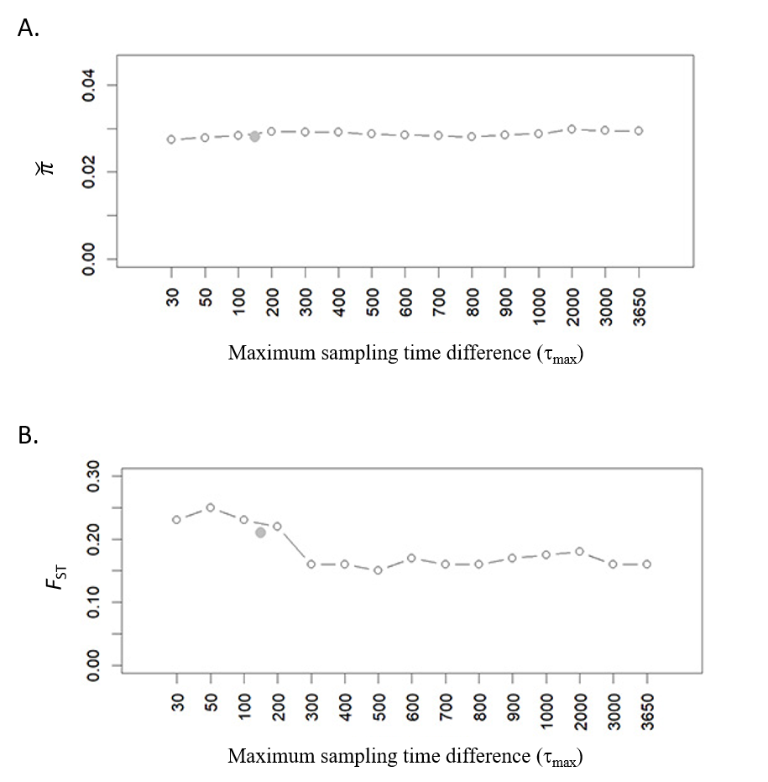

Figure S2. F_{ST} and $\check{π}$ from 300 simulated replicates under positive selection (s = 0.1) for various τ_{max}, with ε = 20 and m = 0.001 (A and B) or 0.0001 (C) and K_{max} = 1000 (B and C) or 10000 (A). The red plot indicates the result when each pair of sequences were sampled within the same 6-month flu season. The blue dots indicate the values observed in H3N2 data.
A.
B.
C.

Maximum sampling time difference (τ_{max})
Maximum sampling time difference (τ_{max})
Maximum sampling time difference (τ_{max})
Maximum sampling time difference (τ_{max})
Maximum sampling time difference (τ_{max})
Maximum sampling time difference (τ_{max})

Figure S3: TCMD for simulated data under positive selection with s = 0.05 and ε = 10, 20, 30, and 40. For each set of s and ε, the best values of K_{max} and m were found as shown in Table 2. The grey curves represent 300 simulated replicates for the same parameters. The black curve represents the average of those replicates and the red one represents the observed data.

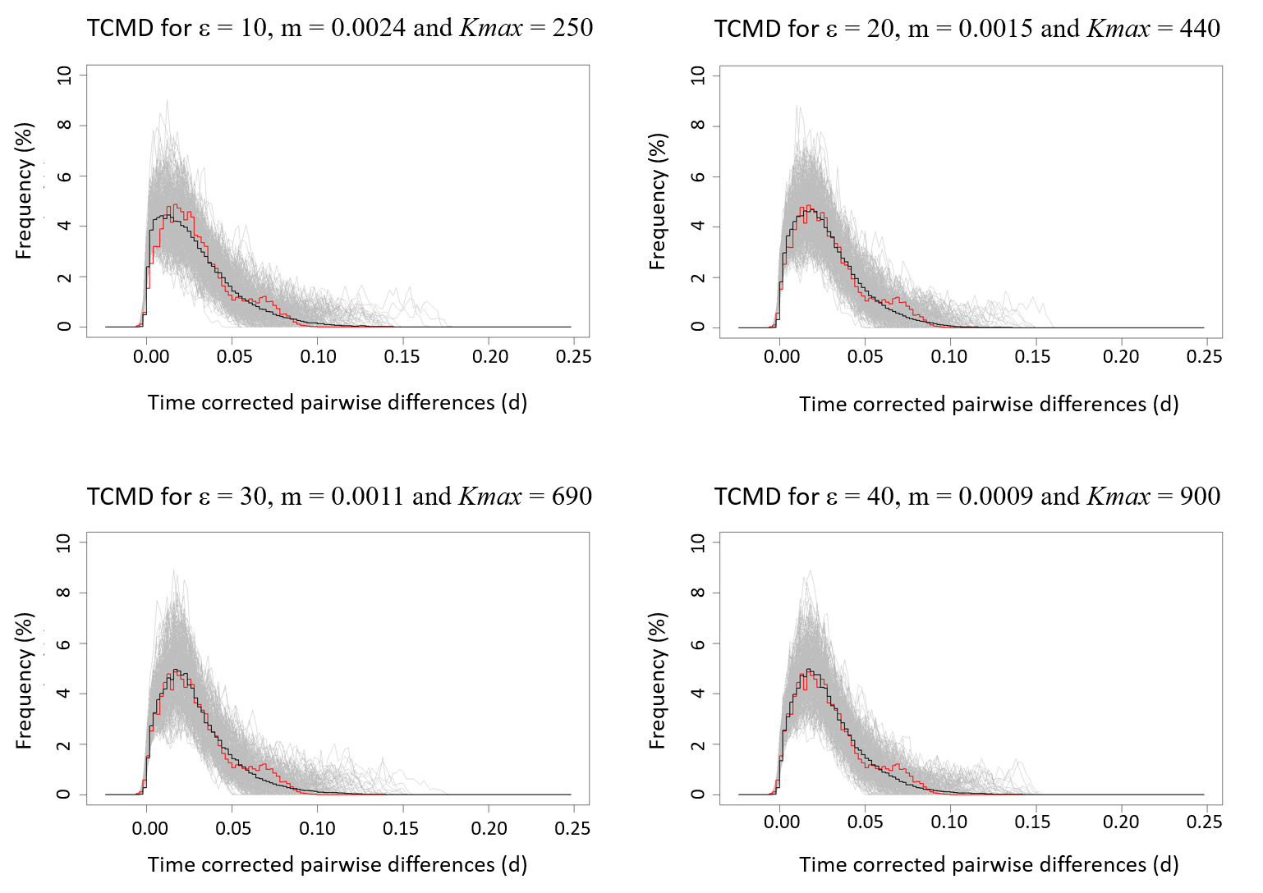
Figure S4. TCMD for simulated data under positive selection with s = 0.1 and ε = 10, 20, 30, and 40. For each set of s and ε, the best values of K_{max} and m were found as shown in Table 2. The grey curves represent 300 simulated replicates for the same parameters. The black curve represents the average of those replicates and the red one represents the observed data.

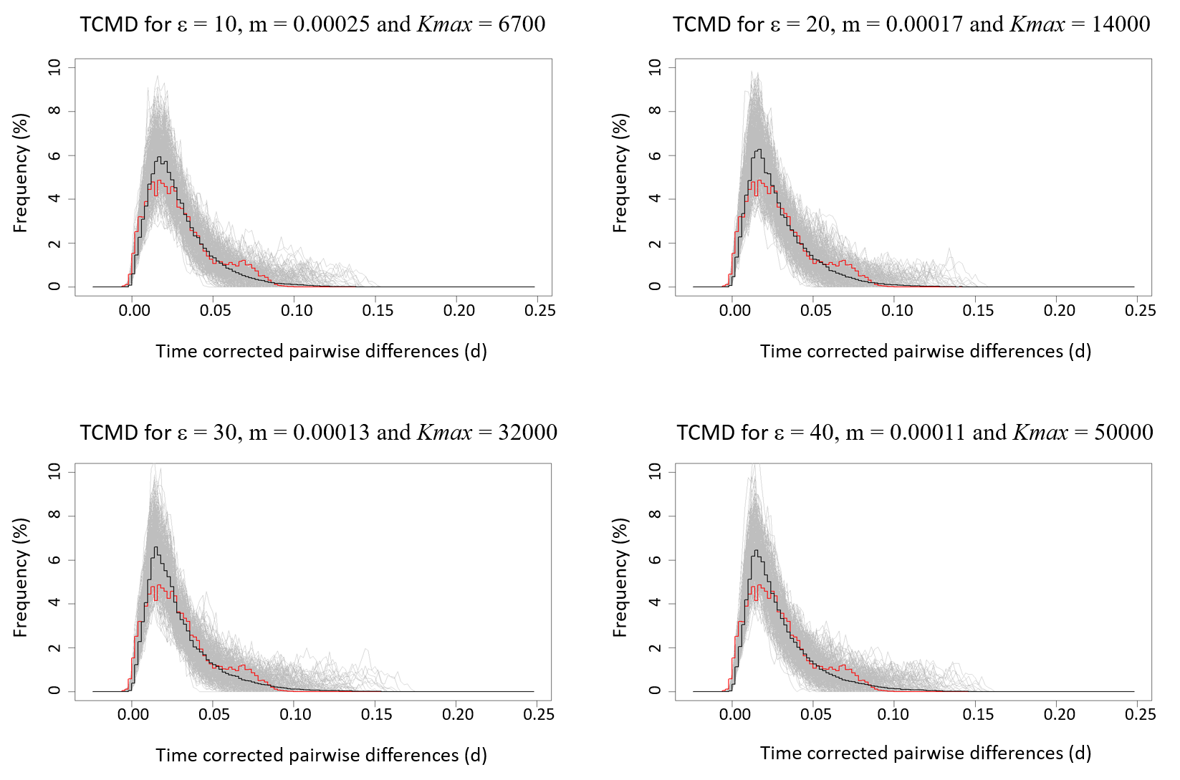

Figure S5. TCMD of simulated 10-year HA sequences for different values of m (A; with K_{max} = 1000) and of K_{max} (B; with m = 0.0001). Other parameters: s = 0.1 and ε = 10. Each curve is an average over 300 simulated replicates.
A.
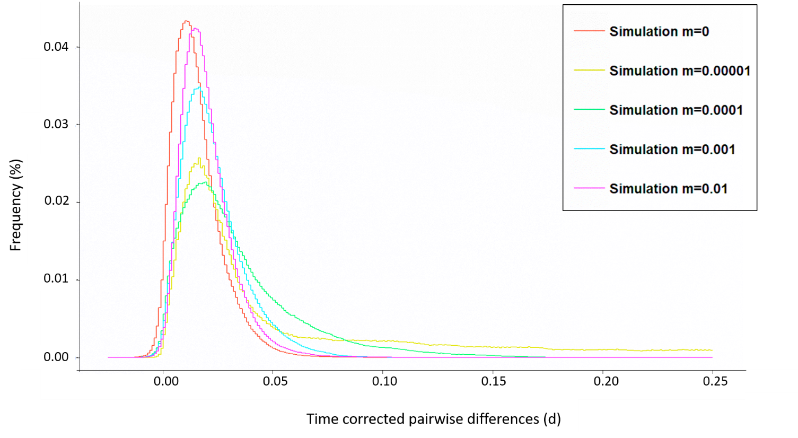

B.
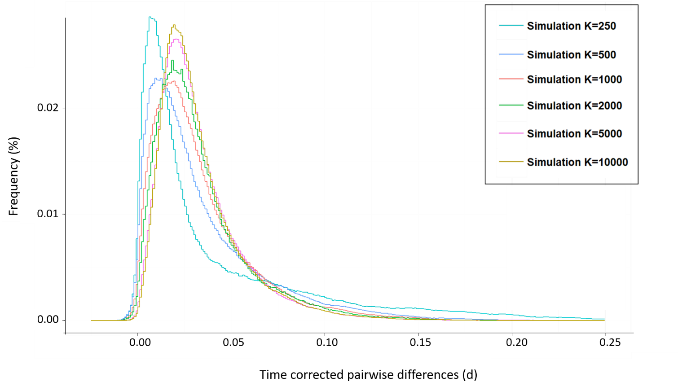

Figure S6. TCMD for simulated data with increasing frequency of beneficial mutations (ɛ) and other parameters that yield π and F_{ST} matching the observed data. Under neutrality (ɛ = 0), m = 0.004 and K_{max} = 110. Under positive selection with s = 0.05 (A), we use (ɛ, m, K_{max}) = (2, 0.0036, 130), (5, 0.003, 170), (10, 0.0024, 250), and (20, 0.0015, 440). With s = 0.1 (B), we use (ɛ, m, K_{max}) = (2, 0.003, 180), (5, 0.0004, 2500), (10, 0.00025, 6700), and (20, 0.00017, 1400).
A.
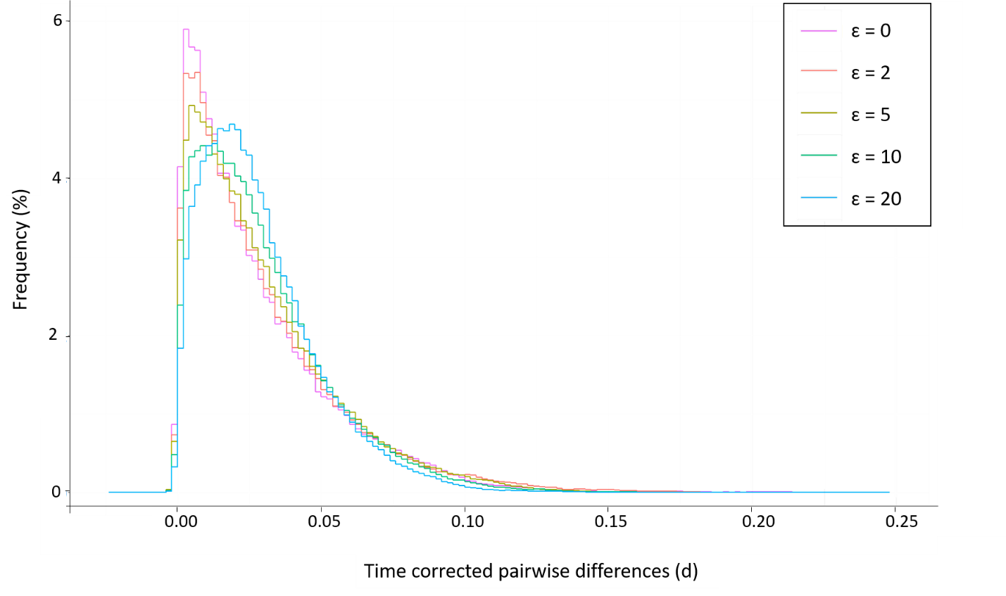
B.
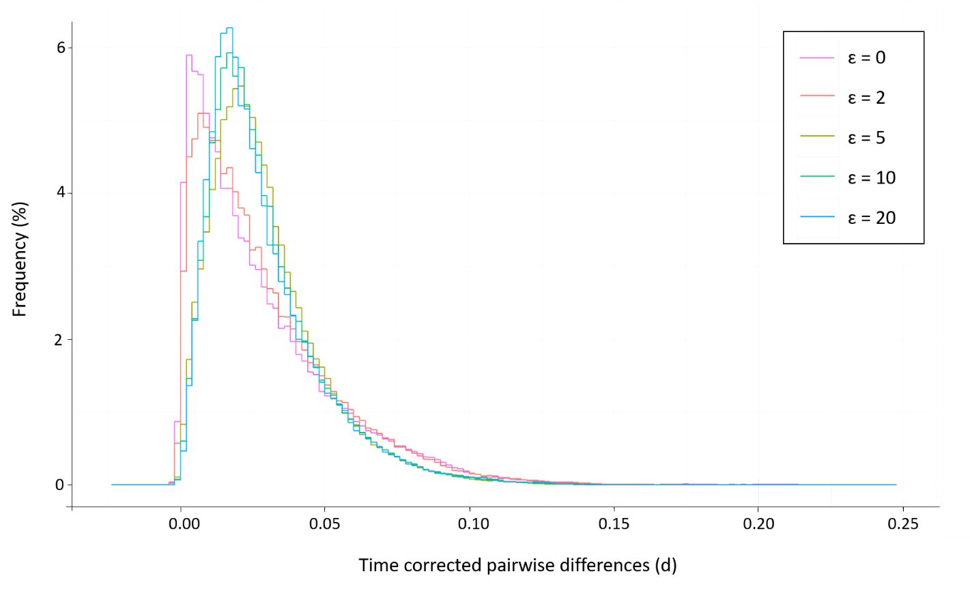

Figure S7. Plot of the GC content (in %) of the HA segment of H3N2 viruses against the time of sampling.

