Supplemental file 1
Microinjection
Initially, we followed the microinjection methods used for the transformation of C. elegans (Evans 2006). We prepared dried 2 % w/v agarose pads and used the Halocarbon Oil 700 for the immobilisation of the nematodes. H. schachtii was not immobilised using this method. To overcome this problem we used dried 5 % w/v agarose pads that improved the immobilisation, but still to a much lesser extent than is achieved with C. elegans on dried 2 % w/v agarose pads. Our initial attempts using the pre-pulled Eppendorf needles failed mostly due to needle tips breaking when pressed against the hard cuticle of H. schachtii or because the needle became blocked by the contents of the nematode flowing into the needle. Using self-pulled needles we were able to insert the intact needle through the cuticle more reliably. However, often this led to bursting of the animal through the injection site. This suggests that H. schachtii likely has much higher internal pressure than does C. elegans, which leads to bursting upon entry of a needle. In addition, and perhaps related to either high internal pressure and/or stiff body wall, we had to use the highest pressure setting on the Eppendorf Femtojet pump to be able to deliver any material. Even at these maximum pressure settings we often failed to see any delivery from the needle (as judged by visible expansion inside the animal). On a few occasions, inserting the needle into the large vacuous structures (Figure S1) caused them to “burst”, leak their contents, and led to the expansion of the germline. A secondary injection in the gonad was subsequently easier. Nevertheless, upon withdrawal of the needle animals usually leaked through the puncture hole/s. The vacuous structures might contribute to the high internal pressures.

Meloidogyne hapla worms, on the other hand, were easier to immobilise using both dried 2 and 5 % w/v agarose pads. Their large size (approximately twice that of H. schachtii males) makes identification of the gonad easier under the injection microscope. Using self-pulled needles we were successful in inserting the needle into the gonad and observing the delivery of material through the needle. Meloidogyne hapla animals withstood the injection better than H. schachtii, and we observed much less bursting despite using the maximum pressure settings. Many animals were mobile in the buffer 2-3 days post injection.

We also attempted to adapt a microinjection technique previously applied to C. elegans (C. C. Mello et al. 1991; C. Mello and Fire 1995) to female Heterodera schachtii infecting Arabidopsis thaliana in tissue culture (Sijmons et al. 1991), and recover eggs. A 90 mm petri dish containing actively developing J4-adult H. schachtii on Arabidopsis roots were placed on an Zeiss Axiovert 100 inverted microscope and females were located and moved into proper alignment for microinjection from above. Adaptations to the standard injection process were made, most notably microinjection needles required beveling and a piezo-stepper was used to penetrate the tough outer cuticle of the developing female.

Initially, GFP-tagged C. elegans constructs were used (col-19, col-10, mec-2) (Design, Mistakes, and Photos, n.d.), but later GFP-tagged, cyst nematode specific, cellulase (mix of eng-1 and 2), and dsRNA cellulase were tried. Late-stage J4 females were chosen to be injected, so that developing oocytes were present during the injection process.

In general, eggs were collected from sets of injected females and hatched in pools of like constructs to observe or test resulting second-stage juveniles. For GFP-tagged constructs, over 800 juveniles were observed under fluorescence, without a single abnormal fluorescent pattern (i.e. above autofluorescence) being observed. To analyze the dsRNA cellulase injection, 110 J2 were hatched and pooled for fixation and immuno-labeling to assay for presence of cellulase protein. The J2 were immunolabeled with antisera against both H.s. eng-1 and H.s. eng-2. We were unable to detect a difference in the levels of cellulase in J2 from the microinjected females versus J2 from un-injected females. Additionally, we assayed for the presence of the GFP construct in the J2 progeny via PCR. PCR-based assays proved inconclusive as well. These observations, taken together, indicate a lack of transmission of injected constructs to the resultant progeny of the injected females. The inability to see the desired target of microinjection within the cyst nematode female, unlike in C. elegans where the flooding of the gonad arms can be visualized, has proven difficult to overcome.

Bombardment
We constructed several promoter:reporter constructs to test the efficacy of bombardment for the delivery of macromolecules to various species and life stages of plant-parasitic root knot and cyst nematodes. Promoter-Reporter constructs were designed using G. pallida promoter regions (Cotton et al. 2014). All constructs were prepared in the backbone of the C. elegans reporter vector pPD95.75 (Design, Mistakes, and Photos, n.d.). The promoter of GPLIN_001416800, encoding the fatty acid-retinol binding protein FAR-1, was selected as this gene is the most highly expressed in the J2 stage of G. pallida and the 4th most highly expressed gene in eggs. A 767 bp promoter region immediately upstream of the ATG start codon was amplified from genomic DNA using the primers FAR-PF (ACAAAGCTTATATTGTATTATTATCAAACG) and FAR-PR (ACAGGATCCGTGAACTGGAGGAACAAAG) to generate a transcriptional fusion. A 2nd FAR-1 construct was designed as a translational fusion within the 2nd exon of GPLIN_001416800. Amplification of this promoter fragment utilised FAR-PF and FAR-PEx2R (ACAGGATCCTTCATGGCGTTCCGCCACTTC). A 2nd highly expressed gene, GPLIN_000313600 that encodes a b-1,4-endoglucanase, was selected to provide gland-cell specific expression. The promoter region of this gene was also amplified for cloning as a translational fusion within the 2nd exon using primers ENG-PF (ACAAAGCTTTTGAATTTGGCACCAATTTATC) and ENG-PR (ACAGGATCCTCCGTTGGAACCATAAAG). The GFP-containing vector pPD95.75 was modified by replacing the GFP coding sequence with that of mCherry from plasmid pBCN22-R4R3 (Semple, Garcia-Verdugo, and Lehner 2010) as preliminary experiments had determined that analysis of a red fluorescent protein would pose fewer problems with autofluorescence in plant parasitic nematodes. In later constructs, mCherry was replaced by the wrmScarlet-1 variant from pSEM90 as this is reported to have 8x greater fluorescence than mRFP in C. elegans (El Mouridi et al. 2017). The wrmScarlet coding region was amplified using primers wrmSc-F (ACAGGTACCATGGTCAGCAAGGGAGAG) and wrmSc-R (ACAGAATTCTTACTTGTAGAGCTCGTC) for cloning into pPD95.75.
Three reporter constructs were used for the experiments described here: FARp:mCh (GpaFAR-1 transcriptional fusion with mCherry); FARpx:wrmSc (GpaFAR-1 translational fusion with wrmScarlet; ENGpx:wrmSc (GpaENG translational fusion with wrmScarlet). Plasmid DNA (18 μl; minimum concentration 400 ng/μl) was linearised by restriction enzyme digestion (ApaI or SpeI) and loaded onto 70 μl of gold beads (0.6 mm, Sigma) using standard protocols for C. elegans (Schweinsberg 2013).
Young adult C. elegans were collected and distributed between seven target regions (aligned with a Hepta-adapter template) on a 9 cm NGM-lite plate seeded with E. coli (HB101). Bombardment was carried out according to established protocols (Schweinsberg 2013). In brief: linearised-DNA was distributed evenly between seven isopropanol-sterilised macrocarrier discs (Bio-Rad) and allowed to air dry. The macrocarrier discs were loaded into the bombardment compartment with a stopping screen and rupture disc (1350 psi, Bio-Rad). The hepta-adaptor (PDS100/ HE system, Bio-Rad) was secured inside the chamber, and all components were aligned so that the gas acceleration tube was directly above a macrocarrier disc and worm target. The Biolistics system used was PDS-1000-HE Biolistic® Particle Delivery System. A vacuum inside the chamber was established (27 in/Hg) and a shot was fired. 1 ml M9 buffer was applied to each bombarded plate after the shot, and the nematodes left to recover for 1-2 hours. Subsequently, 4 ml of M9 buffer was used to wash worms from the bombarded plate and distribute them evenly across 8 seeded 9 cm NGM-Lite plates. For bombardment of plant parasitic nematodes (PPN) 5,000-10,000 hatched J2s of G. pallida or M. incognita, or 10,000 M. incognita eggs, were distributed between the seven target regions on each unseeded NGM-lite plate and the procedure for bombardment carried out as for C. elegans, above. Transformation success was initially monitored using a stereo binocular fluorescence microscope (Olympus SZX12 with RFP filter set (Semrock), QImaging-QIcam digital camera and Q-Capture Pro 6.0 software (Media Cybernetics, USA)) at intervals over 1-10 days post-bombardment.
We were able to confirm the functionality of the reporter constructs containing the GpaFAR-1 promoter in C. elegans (Figure S3A, B). GpaFAR-1 is expressed in the hypodermis of J2 nematodes (Prior et al. 2001) and a similar pattern of spatial expression was reproduced in C. elegans bombarded with the transcriptional fusion construct. In contrast, fluorescent protein produced from the translational fusion construct accumulated within coelomocytes, as the native signal peptide of the FAR-1 protein directed the fusion protein to the pseudocoelom. The fluorescence of both mCherry and wrmScarlet was sufficiently bright for transgenic individuals to be selected by eye under a stereobinocular microscope. As expected, since comparable tissues are not present in C. elegans, we did not recover any transgenic worms expressing fluorescent protein from the G. pallida endoglucanase promoter. When the standard conditions for C. elegans bombardment were used with J2s of G. pallida and both J2s and eggs of M. incognita, no fluorescence was detected in any individual despite extensive observations (Figure S3C, D).
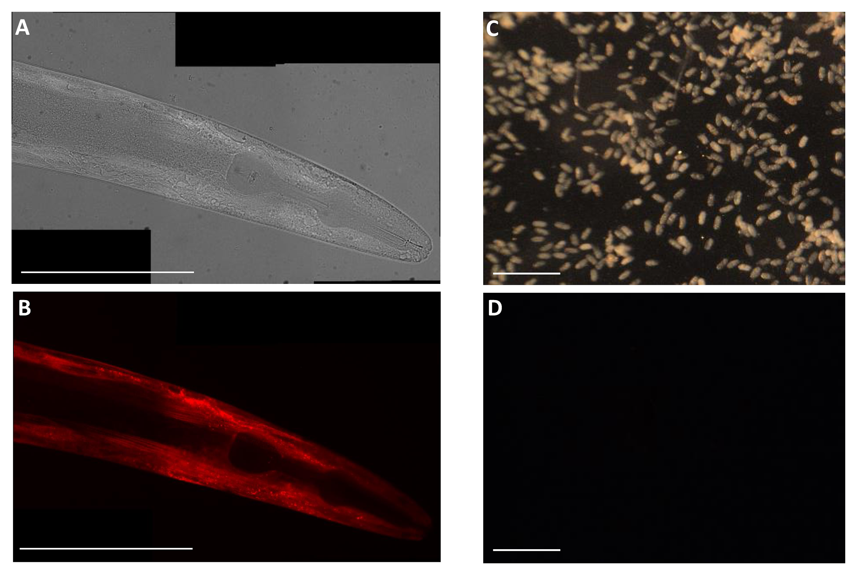
Figure S3: Fluorescent reporter expression following bombardment with FARp:mCherry. A) Brightfield and B) fluorescent images of C. elegans expressing mCherry in the hypodermis under the control of the G. pallida FAR-1 promoter (Scale bar = 100 µm). C) Brightfield and D) fluorescent images demonstrate a lack of mCherry expression when eggs of M. incognita are bombarded with the same construct (Scale bar = 500 µm).

We also observed that many nematodes appeared not to survive the bombardment process using standard conditions for C. elegans. Therefore bombardment parameters reported for successful transformation of other nematode species (Higazi et al. 2002; Davis et al. 1999) were used to inform a series of experiments to determine more appropriate conditions: rupture discs of 650, 1000 or 1350 psi and vacuums of 12, 15, 18, 22 or 27 in/Hg. To determine the mortality rate resulting from varying the bombardment parameters (each replicated four times), M. incognita eggs were incubated in 0.1% Meldolas Blue solution for 24 hours, the % non-viable eggs (stained blue) in replicate batches of 50-100 were counted under the microscope (Figure S4). This confirmed that the standard C. elegans conditions (red arrow) killed >80% of the eggs, whereas the conditions for Ascaris (blue arrow) and Brugia malayi (green arrow) resulted in much lower mortality. Application of the vacuum alone did not significantly affect egg viability, but a combination of increasing pressure and vacuum strength killed increasingly large numbers.

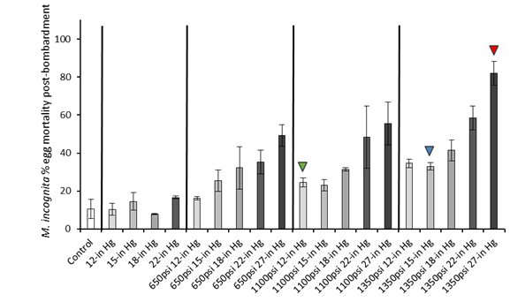
Figure S4: Mortality imposed on eggs of M. incognita by differing bombardment conditions. Eggs of M. incognita were exposed to either vacuum alone, or were bombarded with gold particles at the pressure and vacuum combinations indicated. Control eggs were subjected to neither vacuum nor bombardment. The mean % dead eggs was calculated after staining with Meldola’s Blue and analysing 50-100 eggs from each of four bombardments per condition. Error bars = standard error of the mean. Arrowheads indicate reported successful bombardment conditions for B. malayi (green), Ascaris (blue) and C. elegans (red).

As a result of these tests, future bombardments of PPNs (both eggs and J2s) were carried out using the conditions (1350 psi/ 15 inches Hg) previously described for Ascaris (Davis et al. 1999) to provide a balance between biolistic power and post-bombardment viability. Repeated bombardment attempts of both eggs and J2s with the FAR-1 promoter constructs did not yield any visual evidence of fluorescent protein expression. As only single cells would likely be transformed, any successful events in J2s would obviously be very difficult to identify. To improve the chances of detection, a construct was developed using a promoter for a G. pallida endoglucanase gene with expected expression in the large sub-ventral glands that are prominent in the pre-parasitic J2 stage. However no bombardments using this construct yielded any nematodes with detectable fluorescence in the gland cells. Successful transformation of C. elegans relies on selection of the progeny of bombarded worms, when the transgenic DNA has been incorporated into the germline. Therefore in one experiment using the FARpx:wrmSc construct, bombarded eggs and J2s of M. incognita were inoculated onto host tomato roots and the second generation J2s were collected for visual inspection. No fluorescent individuals were identified.
Given the difficulties of visually screening sufficient individual J2s at the magnification required to detect rare, single cell transformation events we used a pool of bombarded individuals to extract RNA for diagnostic RT-PCR. This experiment used J2s of G. pallida and the FARpx:wrmSc plasmid. The forward primer used for amplification was designed to span an intron in the construct, such that it should only amplify from cDNA (F = AAGGACCCAAAGGAGGAC, R = CTCGATCTCGAACTCGTG). An amplification product of the expected size (126 bp) was generated from cDNA prepared from J2s that had been bombarded with the FARpx:wrmSc construct, but was absent from control samples lacking that plasmid and also from a sample prepared from J2s incubated in the plasmid DNA without bombardment (Figure S5). We conclude that transformation by bombardment and expression of transgene mRNA, presumably in hypodermal cells in G. pallida J2s is possible. However, in the absence of a suitable selectable marker, identification of progeny from rare germ-line transformed individuals is technically intractable.
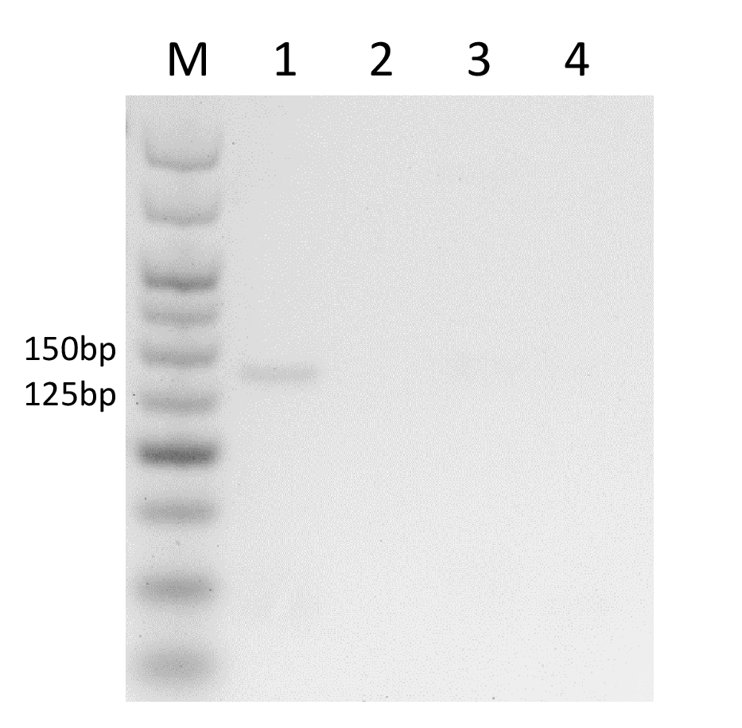
Figure S5: RT-PCR confirmation of reporter construct entry and expression in bombarded J2s of G. pallida. Lane 1 – J2s bombarded with FARpx:wrmSc; Lane 2 – J2s bombarded with an unrelated non-reporter construct; Lane 3 – J2s incubated overnight in FARpx:wrmSc plasmid; Lane 4 – control, untreated J2s. Expected product size is 126 bp. Marker is Hyperladder V (Bioline).
Electroporation
Introduction of reporter plasmid (FARp:mCh) to G. pallida J2s was also attempted via square-wave electroporation using a BioRad Gene Pulser Xcell with CE module. One hundred hatched G. pallida J2s were added to 4 mm cuvettes containing 100 µl FITC (1 mg/ml) or FARp:mCh plasmid (50 ng/µl). Cuvettes were incubated at RT for 24 hours before electroporating. A variety of voltages and pulse lengths were tested based on parameters described for successful electroporation of other helminths (Ittiprasert et al. 2019; Arunsan et al. 2019). The parameters were every combination of 125, 150, 200, 300, 400 and 500 V for either 20, 25 or 30 ms. Post-electroporation the nematodes were washed twice, incubated for 2 hours and then observed under a microscope. A further examination was made after 24 hours. Uptake of FITC by electroporated nematodes was no greater than that observed for control, un-electroporated nematodes in any condition. There was no visible red fluorescence resulting from expression of FARp:mCh in any condition. Furthermore, the various parameters resulted in an average J2 mortality of 61.1% ± 2.8% SEM, with those dead individuals cleaved in half by the treatments. The surviving nematodes tended to show a visibly ‘twitching’ phenotype.

Challenges associated with lipofection-based delivery of CRISPR-Cas components to second stage juvenile H. schachtii.
We also explored the possibility of using CRISPR-Cas9 to initiate homology directed repair (HDR) and/or non-homologous end joining (NHEJ) in somatic cells of H. schachtii juveniles using lipofection. The intention was to determine whether lipofection of proteins directly to somatic cells would be a rapid way to test many of the unknowns in the first CRISPR experiment in plant-parasitic nematodes, avoiding the additional complications of the germline until an “editable” locus is known. Initially we encapsulated CRISPR-Cas9 protein, guide RNAs, and a single stranded donor DNA fragment designed to introduce an amino acid mutation into the coding sequence of a FAR-1-like gene of H. schachtii into CRISPRMAX liposomes. These components were delivered to H. schachtii J2s by in vitro soaking (Figure S6A). Two negative controls were used: one omitting the guide RNAs but keeping the donor fragment, and one omitting all CRISPR components. We extracted DNA from approximately 20,000 treated nematodes, digested single stranded DNA, and amplified a 429 bp region of interest by PCR using oligonucleotide primers F1:R1, and sequenced the purified amplicons using Illumina technology. In nematodes transfected with donor DNA fragments the expected edit was present in the amplicon, even in the absence of the guide RNAs (Figure S6B). The most parsimonious explanation for this is template switching of the polymerase during amplification from the genome, to the donor DNA fragment, and back. We confirmed this activity in vitro by using a second round of PCR, on the purified product of F1:R1, with an oligonucleotide primer F2, that is specific to the desired edit (Figure S6C). Given the promiscuity of template switching, future experiments did not use donor fragments, and focused on detection of NHEJ.
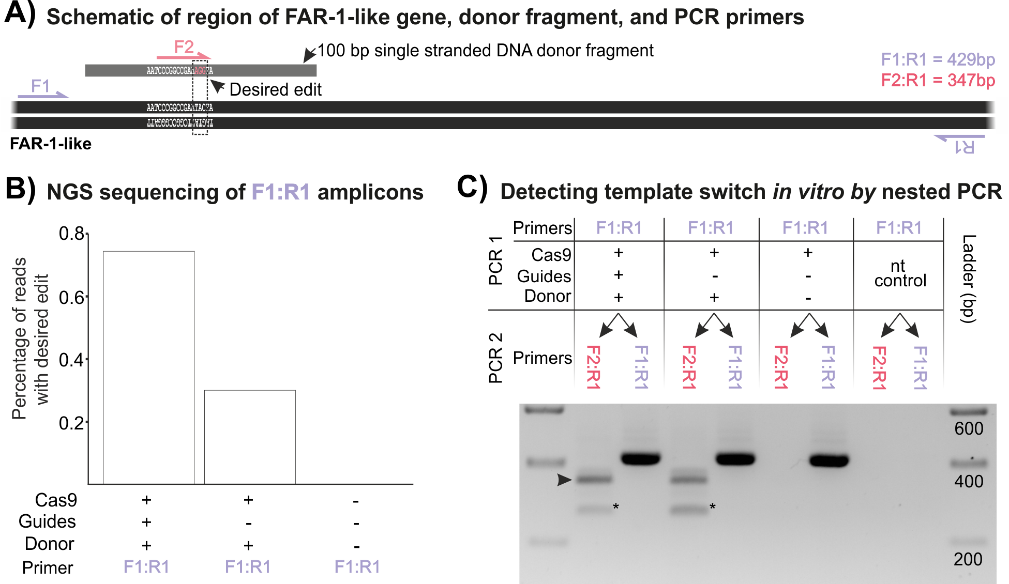
Figure S6: PCR-derived template switching shrouds detection of HDR. A) Schematic representation of a region of FAR-1-like gene of H. schachtii indicating primer binding sites and single stranded donor template carrying desired edit (pink bases, AGG from TAC). B) Next Generation Sequencing (NGS) of the F1:R1 amplicon from transfected J2s reveals apparent HDR events, even in the absence of guide RNAs. C) Template switching can be detected in vitro (arrow) using a second primer (F2), on the purified product of F1:R1, that is specific to the desired edit. Star indicates a non-specific amplicon.
Subsequently, twenty eight guide RNAs were designed to target ten genes (at least one, and up to four, guide RNAs per gene (Table S1)). For half of the genes we used guide RNAs modified for increased editing efficiency (2’-O-Methyl at first 3 and last bases, 3’phosphorothiate bonds between first 3 and last 2 bases, Synthego) and five genes used standard guide RNAs (Synthego). Primers were designed to amplify a 300-500 bp fragment that contained the regions targeted by the guide RNAs for each gene (Table S1). For each gene (DRYAD accession doi:10.5061/dryad.r4xgxd296), ribonucleoprotein complexes were assembled and encapsulated in both RNAIMAX and CRISPRMAX liposomes, and independently delivered to juveniles as described for mRNA. DNA was extracted from transfected nematodes, the region of interest amplified, and the amplicon sequenced using 250 bp paired end Illumina reads. All reads were compared to a reference sequence to identify the presence of indels (Figure S7) and substitutions (Figure S8) within the region targeted by each guide RNA (i.e. 1 to 6 bp upstream of the protospacer adjacent motif). Across the data set, there are generally low numbers of reads containing indels and/or substitutions within the guide region/s, and are only two consistent differences between treated and negative control nematodes (albeit with very low number of absolute read support, Gene 1 guide 1 and Gene 8 guide 1). This suggests that either the CRISPR-Cas9 is inducing NHEJ below the detection limit of this experiment and is shrouded by noise (of PCR and/or sequencing) or the CRISPR-Cas9 reagents are not delivered in sufficient quantity/at all to induce NHEJ.

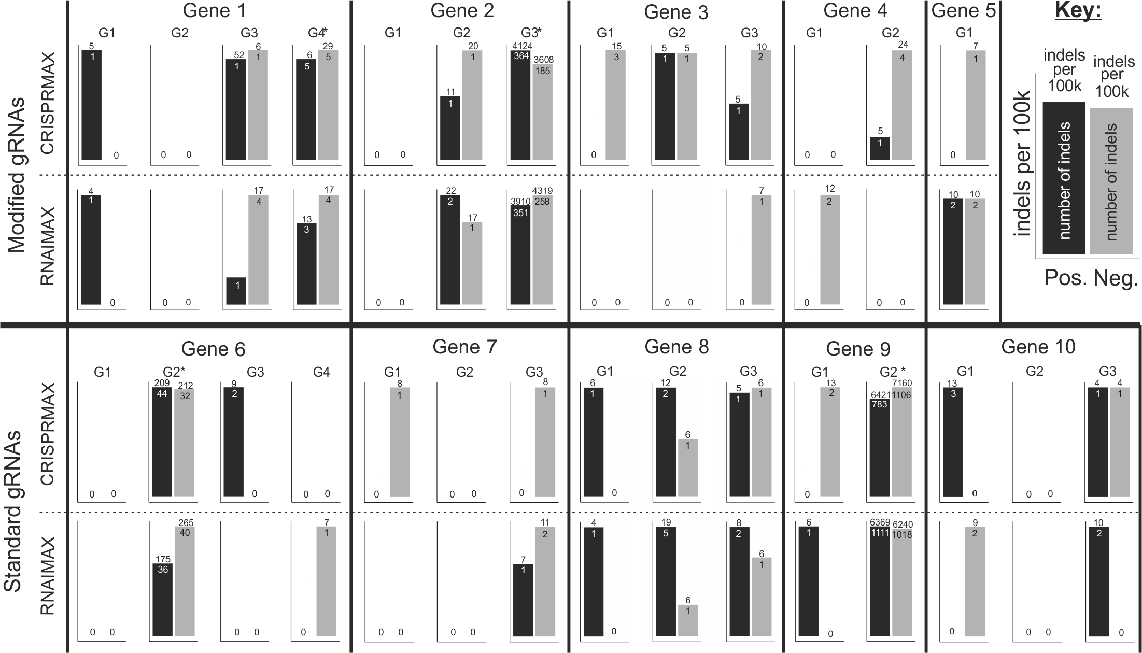
Figure S7: Next generation sequence indel analysis of lipofection-based CRISPR-Cas9 trial. Two lipofection reagents, CRISPRMAX and RNAIMAX were used to deliver CRISPR-cas9 components to H. schachtii, guided by either modified (top) or standard (bottom) gRNAs (G1-4). For each of 10 genes, bar graphs show the number of indels per 100,000 reads (number above the bar). Absolute number of reads containing indels is shown within each bar for positive (black bars) or negative (grey bars, omission of guides). Guide regions with several polynucleotides, and therefore high sequencing inaccuracy, are indicated with a *.

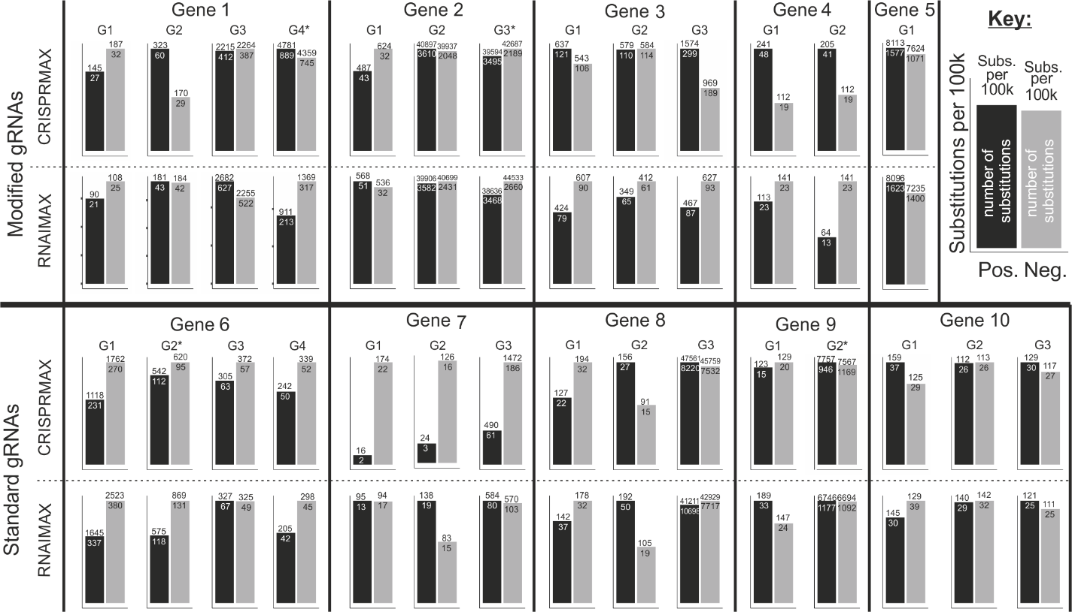

Figure S8: Next generation sequence substitution analysis of lipofection-based CRISPR-Cas9 trial. Two lipofection reagents, CRISPRMAX and RNAIMAX were used to deliver CRISPR-cas9 components to H. schachtii, guided by either modified (top) or standard (bottom) gRNAs (G1-4). For each of 10 genes, bar graphs show the number of substitutions per 100,000 reads (number above the bar). Absolute number of reads containing substitutions is shown within each bar for positive (black bars) or negative (grey bars, omission of guides). Guide regions with several polynucleotides, and therefore high sequencing inaccuracy, are indicated with a *.

Methods associated with the delivery of CRISPR reagents to plant-parasitic nematodes by lipofection and analysis of target loci
Two-component guide RNAs (designed using CRISPOR (Haeussler et al. 2016) (Table S1)) were annealed by combining 3 µL Alt-R® CRISPR-Cas9 tracrRNA, ATTO™ 550 with 4 µL Nuclease-free Duplex Buffer and finally 1.5 µL of Alt-R® CRISPR-Cas9 crRNAs (Integrated DNA Technologies) and incubated at 95°C for 5 minutes and allowed to cool slowly to room temperature. The ribonucleoprotein complex was assembled in vitro by combining 3 µM gRNA either single guides (Synthego) with 25 µg of Streptococcus pyogenes 2xNLS-Cas9 protein (Synthego) or annealed crRNA:tracrRNA pair (IDT) with 25 µg of Alt-R® S. pyogenes V3 Cas9 protein (IDT). After 5 minutes, the CRISPR-Cas9 ribonucleoprotein complexes were encapsulated in liposomes for 20 minutes at room temperature (3% v/v RNAIMAX (Invitrogen) or CRISPRMAX (Invitrogen) lipofectamine) and delivered to juveniles following essentially the same protocol as for mRNAs. In this case, octopamine (Sigma-Aldrich) was added to a final concentration of 50 mM, and the mixture was combined with 2,000 H. schachtii J2s and incubated at room temperature for 8 hours. The mixture was removed and the nematodes were washed 3 times in 200 µl of 0.01% v/v Tween 20 in sterile water. The DNA was extracted from transfected nematodes using the ChargeSwitch™ gDNA Mini Tissue Kit (Invitrogen) following the manufacturer’s instructions. Fragments containing the target site were amplified by PCR.

To assess template switching, a single stranded donor fragment (PAGE purified DNA oligo (IDT)) encoding a desired edit to the FAR-1-like gene of H. schachtii was co-encapsulated in liposomes with the ribonucleoprotein complex and relevant guide RNAs prior to delivery. Following DNA extraction, remaining ssDNA oligonucleotides were digested by the addition of 3 µL exonuclease 1 (NEB) to 20 µL extracted DNA, 3 µL exonuclease buffer (NEB) and 4 µL nuclease-free water (Ambion) and incubated at 37 °C for 15 minutes in an Eppendorf ThermoMixer® (Eppendorf) followed by an incubation of 80 °C for 15 minutes to inactivate the exonuclease. The remaining DNA was used to amplify fragments of the target site by PCR and amplicons were purified using the Monarch® PCR & DNA Cleanup Kit (NEB) following the manufacturer’s instructions and either sent for 250 bp paired end Illumina amplicon sequencing (Genewiz), or used as template in a second round of PCR with edit-specific primers and analysed by agarose gel electrophoresis. All template switching experiments were soaked for eight hours in the following three conditions: i) containing all components of the CRISPR-Cas reaction (termed positive), ii) all components of the CRISPR-Cas reaction with the exclusion of the relevant gRNAs (termed no-guide control), and iii) H. schachtii J2s without additional reagents (termed negative control).

To assess non-homologous end joining, ten H. schachtii genes were selected based on their expression at J2 (Pers. comm. Eves-van den Akker) and/or putative function assigned by sequence homology to C. elegans. Sequences of genes of interest are available in DRYAD repository doi:10.5061/dryad.r4xgxd296. A total of 28 gRNAs over the ten genes were designed using CRISPOR (Haeussler et al. 2016) (Table S1). Transfection experiments were performed, largely as above, for 24 hours with the following two conditions: i) containing all components of the CRISPR-Cas reaction (termed positive), and ii) all components of the CRISPR-Cas reaction with the exclusion of the relevant gRNAs (termed negative). DNA was extracted from transfected nematodes and the region of interest amplified proof reading PCR (primers in Table S1). Amplicons were purified using the Monarch® PCR & DNA Cleanup Kit (NEB) following the manufacturer’s instructions and sent for 250 bp paired end Illumina amplicon sequencing (Genewiz). Reads were trimmed (Phred-64) and overlapping pairs were re-capitulated into the amplified fragment using scripts designed for similar metagenetic analyses (Eves‐van den Akker et al. 2015) (https://github.com/sebastianevda/SEvdA_metagen). Recapitulated fragments were further analysed for edits within the guide region using a set if custom shell and python scripts (https://github.com/OlafKranse/Selective-analyses-of-areas-of-interest-for-next-generation-sequencing). In brief: the most common amplicon was set as reference; the regions targeted by the guide RNAs in this reference were located; unique reads are aligned individually to the new reference; the sequences within the guide location (6 bp upstream of PAM) are compared; if there is a difference in sequence, a record is made containing which type of difference (e.g. SNP or INDEL) and the number of occurrences of that specific mutation.
Supplemental references
Arunsan, Patpicha, Wannaporn Ittiprasert, Michael J. Smout, Christina J. Cochran, Victoria H. Mann, Sujittra Chaiyadet, Shannon E. Karinshak, et al. 2019. “Programmed Knockout Mutation of Liver Fluke Granulin Attenuates Virulence of Infection-Induced Hepatobiliary Morbidity.” ELife 8 (January). https://doi.org/10.7554/eLife.41463.
Cotton, James A., Catherine J. Lilley, Laura M. Jones, Taisei Kikuchi, Adam J. Reid, Peter Thorpe, Isheng J. Tsai, Helen Beasley, Vivian Blok, and Peter J. A. Cock. 2014. “The Genome and Life-Stage Specific Transcriptomes of Globodera Pallida Elucidate Key Aspects of Plant Parasitism by a Cyst Nematode.” Genome Biology 15 (3): R43.
Davis, R. E., A. Parra, P. T. LoVerde, E. Ribeiro, G. Glorioso, and S. Hodgson. 1999. “Transient Expression of DNA and RNA in Parasitic Helminths by Using Particle Bombardment.” Proceedings of the National Academy of Sciences of the United States of America 96 (15): 8687–92.
Design, Vector, Strategic Mistakes, and Late Night Gel Photos. n.d. “Fire Lab Vector Kit-June 1995 (Updated to August 1996).” ftp://ftp.wormbase.org/pub/wormbase/datasets-wormbase/reagents/firelab_vectors/FireLabVectors/1995%20Vector%20Kit/Vec95_Docs/Vec95Doc.rtf.
El Mouridi, Sonia, Claire Lecroisey, Philippe Tardy, Marine Mercier, Alice Leclercq-Blondel, Nora Zariohi, and Thomas Boulin. 2017. “Reliable CRISPR/Cas9 Genome Engineering in Caenorhabditis Elegans Using a Single Efficient SgRNA and an Easily Recognizable Phenotype.” G3 7 (5): 1429–37.
Evans, Thomas C. 2006. “Transformation and Microinjection.” WormBook: The Online Review of C. Elegans Biology 10.
Eves‐van den Akker, Sebastian, Catherine J. Lilley, Alex Reid, Jon Pickup, Eric Anderson, Peter J. A. Cock, Mark Blaxter, Peter E. Urwin, John T. Jones, and Vivian C. Blok. 2015. “A Metagenetic Approach to Determine the Diversity and Distribution of Cyst Nematodes at the Level of the Country, the Field and the Individual.” Molecular Ecology 24 (23): 5842–51.
Haeussler, Maximilian, Kai Schönig, Hélène Eckert, Alexis Eschstruth, Joffrey Mianné, Jean-Baptiste Renaud, Sylvie Schneider-Maunoury, et al. 2016. “Evaluation of Off-Target and on-Target Scoring Algorithms and Integration into the Guide RNA Selection Tool CRISPOR.” Genome Biology 17 (1): 148.
Higazi, Tarig B., Anthony Merriweather, Limin Shu, Richard Davis, and Thomas R. Unnasch. 2002. “Brugia Malayi: Transient Transfection by Microinjection and Particle Bombardment.” Experimental Parasitology 100 (2): 95–102.
Ittiprasert, Wannaporn, Victoria H. Mann, Shannon E. Karinshak, Avril Coghlan, Gabriel Rinaldi, Geetha Sankaranarayanan, Apisit Chaidee, et al. 2019. “Programmed Genome Editing of the Omega-1 Ribonuclease of the Blood Fluke, Schistosoma Mansoni.” ELife 8 (January). https://doi.org/10.7554/eLife.41337.
Mello, C. C., J. M. Kramer, D. Stinchcomb, and V. Ambros. 1991. “Efficient Gene Transfer in C.Elegans: Extrachromosomal Maintenance and Integration of Transforming Sequences.” The EMBO Journal. https://doi.org/10.1002/j.1460-2075.1991.tb04966.x.
Mello, C., and A. Fire. 1995. “DNA Transformation.” Methods in Cell Biology 48: 451–82.
Prior, Alison, John T. Jones, Vivian C. Blok, Jeremy Beauchamp, Lindsay McDERMOTT, Alan Cooper, and Malcolm W. Kennedy. 2001. “A Surface-Associated Retinol-and Fatty Acid-Binding Protein (Gp-FAR-1) from the Potato Cyst Nematode Globodera Pallida: Lipid Binding Activities, Structural Analysis and Expression Pattern.” Biochemical Journal 356 (2): 387–94.
Schweinsberg, Peter J. 2013. “C. Elegans Gene Transformation by Microparticle Bombardment.” WormBook. https://doi.org/10.1895/wormbook.1.166.1.
Semple, Jennifer I., Rosa Garcia-Verdugo, and Ben Lehner. 2010. “Rapid Selection of Transgenic C. Elegans Using Antibiotic Resistance.” Nature Methods 7 (9): 725–27.
Sijmons, Peter C., Florian M. W. Grundler, Nicola von Mende, Paul R. Burrows, and Urs Wyss. 1991. “Arabidopsis Thaliana as a New Model Host for Plant-Parasitic Nematodes.” The Plant Journal: For Cell and Molecular Biology 1 (2): 245–54.

