SUPPLEMENTAL MATERIALS
Table S1. Oligonucleotides used in this study.
Name | Sequence (5´-3´) | Purpose
MB525 | AAAACAGAACCGTTATACATATTGAGATGGTTAAGGTCGTAGAAAAGAAATGTTCATTTGAGAAGGAAAACGGATCCCCGGGTTAATTAA | Deleting HRQ1 with NatMX
MB526 | TCCACCAAGTGAATCTACAAGTAGTAGAATAGAGTATTTATATTCGGTTTACAAACTACAAATAGCGTGCGAATTCGAGCTCGTTTAAAC | Deleting HRQ1 with NatMX
MB527 | GTGAATTGCTCAGAAGAGAAAGGCATACCGTC | PCR-amplifying hrq1-K318A(NatMX) and analyzing the HRQ1 locus
MB528 | CTGTGCATCAACAAGGTGACAGAATGTTGATG | PCR-amplifying hrq1-K318A(NatMX) and analyzing the HRQ1 locus
MB932 | CCGGAAGTATATCAGGGTATGGAACACG | Sequencing hrq1-K318A
MB1028 | TAAGATTATTGACGTTAGAAGAGCTACGAAAGACGATACTCATACAAATGAAATCATTAAAAAAGAGATAGGGGGAGGCGGGGGTGGA | Tagging Hrq1 with 3xFLAG
MB1029 | TCCACCAAGTGAATCTACAAGTAGTAGAATAGAGTATTTATATTCGGTTTACAAACTACAAATAGCGTGCGAATTCGAGCTCGTTTAAAC | Tagging Hrq1 with 3xFLAG

Table S2. Synthetic genetic interactions between the single-gene deletion collection and hrq1Δ (see file S2).
Table S3. Synthetic genetic interactions between the temperature-sensitive allele collection and hrq1Δ (see file S2).
Table S4. Synthetic genetic interactions between the single-gene deletion collection and hrq1-K318A (see file S2).
Table S5. Synthetic genetic interactions between the temperature-sensitive allele collection and hrq1-K318A (see file S2).
Table S6. Hrq1-interacting proteins (see file S3).
Table S7. Gene expression levels in hrq1Δ and hrq1-K318A cells compared to wild-type (see file S4).

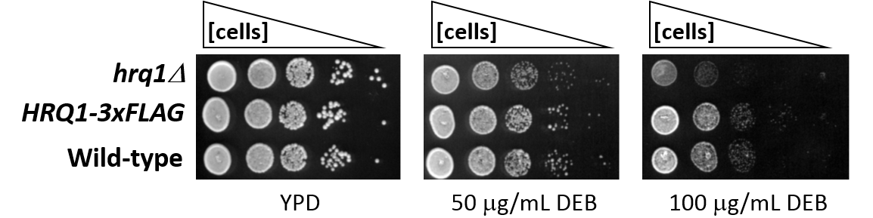
Figure S1. The C-terminal 3xFLAG tag does not interfere with the role of Hrq1 in DNA inter-strand crosslink repair. The indicated strains were grown overnight in YPD medium at 30°C with aeration, diluted to OD₆₀₀ = 1 in sterile H₂O, and then serially diluted 10-fold to 10⁻⁴. Five microliters of these dilutions were then spotted onto YPD agar plates and YPD agar plates supplemented with 50 or 100 μg/mL diepoxybutane (DEB). The plates were incubated at 30°C for 2 days before capturing images with a flatbed scanner and scoring growth.

