Supplemental Material

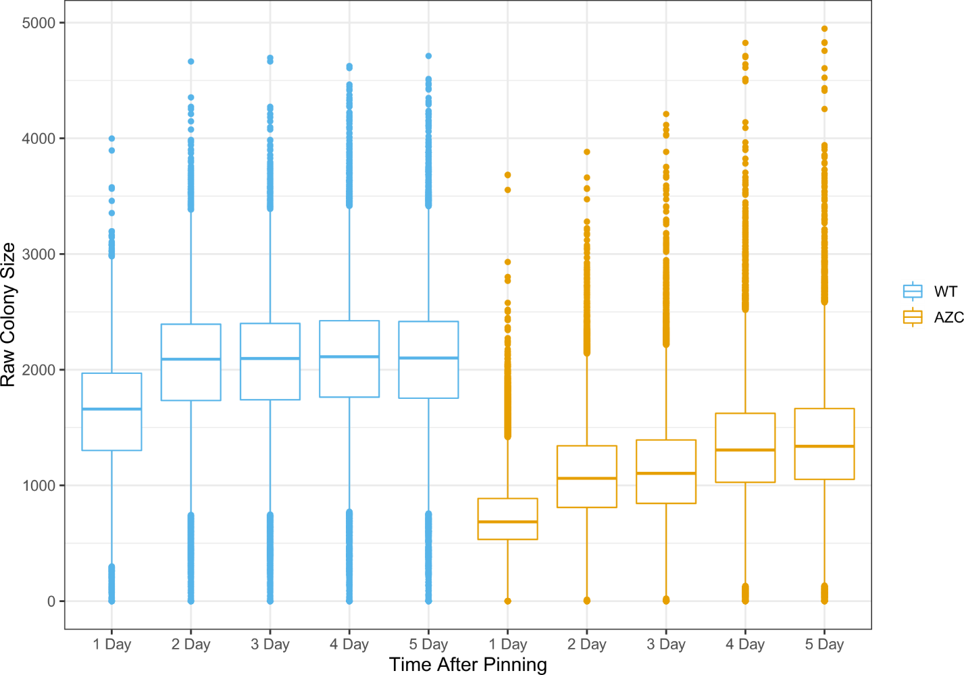

Figure S1. Raw colony size for all strains screened. Cells were pinned onto either SD media (WT) or SD media containing 300 µM AZC and grown at 30° for 5 days. Plates were imaged every 24 hrs and colony size was measured using SGATools (Wagih et al. 2013).

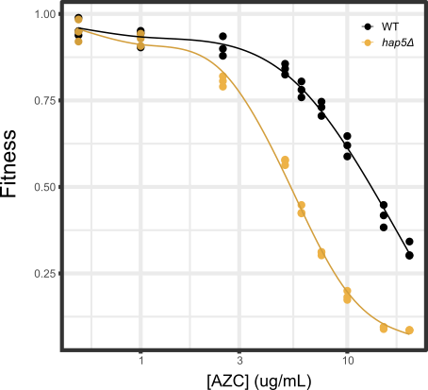

Figure S2. Dose-response curve of wild-type (his3Δ) and AZC sensitive (hap5Δ) yeast strains to various concentrations of AZC. Strains were grown in triplicate to saturation in YPD medium, diluted to an OD₆₀₀ of 0.1 in SD medium containing AZC and grown for 24 hrs at 30°. Fitness was defined as the area under the growth curve at the indicated AZC concentration, normalizing to the growth of the wild-type strain in medium lacking AZC. Each point represents a biological replicate (n = 3).

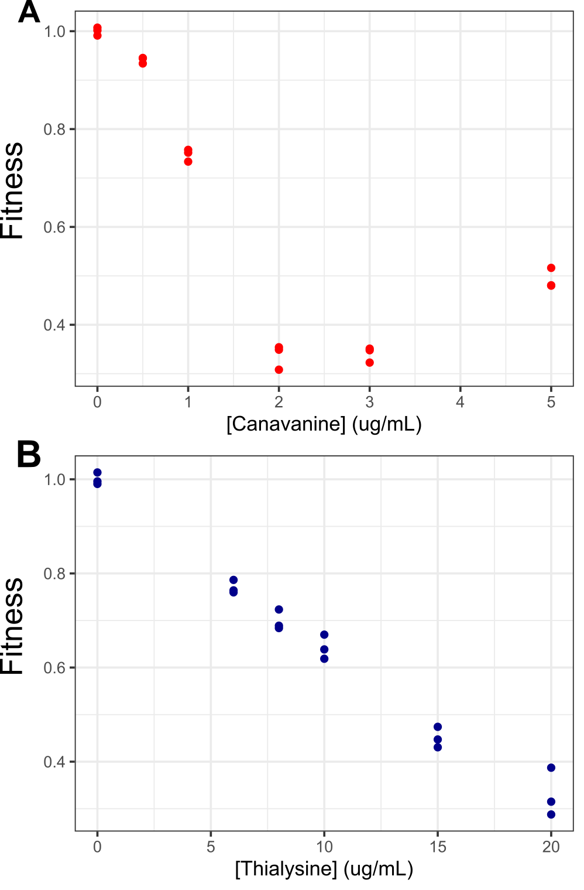

Figure S3. Dose-response curve of wild-type (his3Δ) yeast strains to various concentrations of (A) canavanine and (B) thialysine. Strains were grown in triplicate to saturation in YPD medium, diluted to an OD₆₀₀ of 0.1 in SD medium containing the indicated amino acid analog and grown for 24 hrs at 30°. Fitness was defined as the area under the growth curve at the indicated concentration, normalizing to the growth of the wild-type strain in medium lacking the amino acid analog. Each point represents a biological replicate (n = 3).

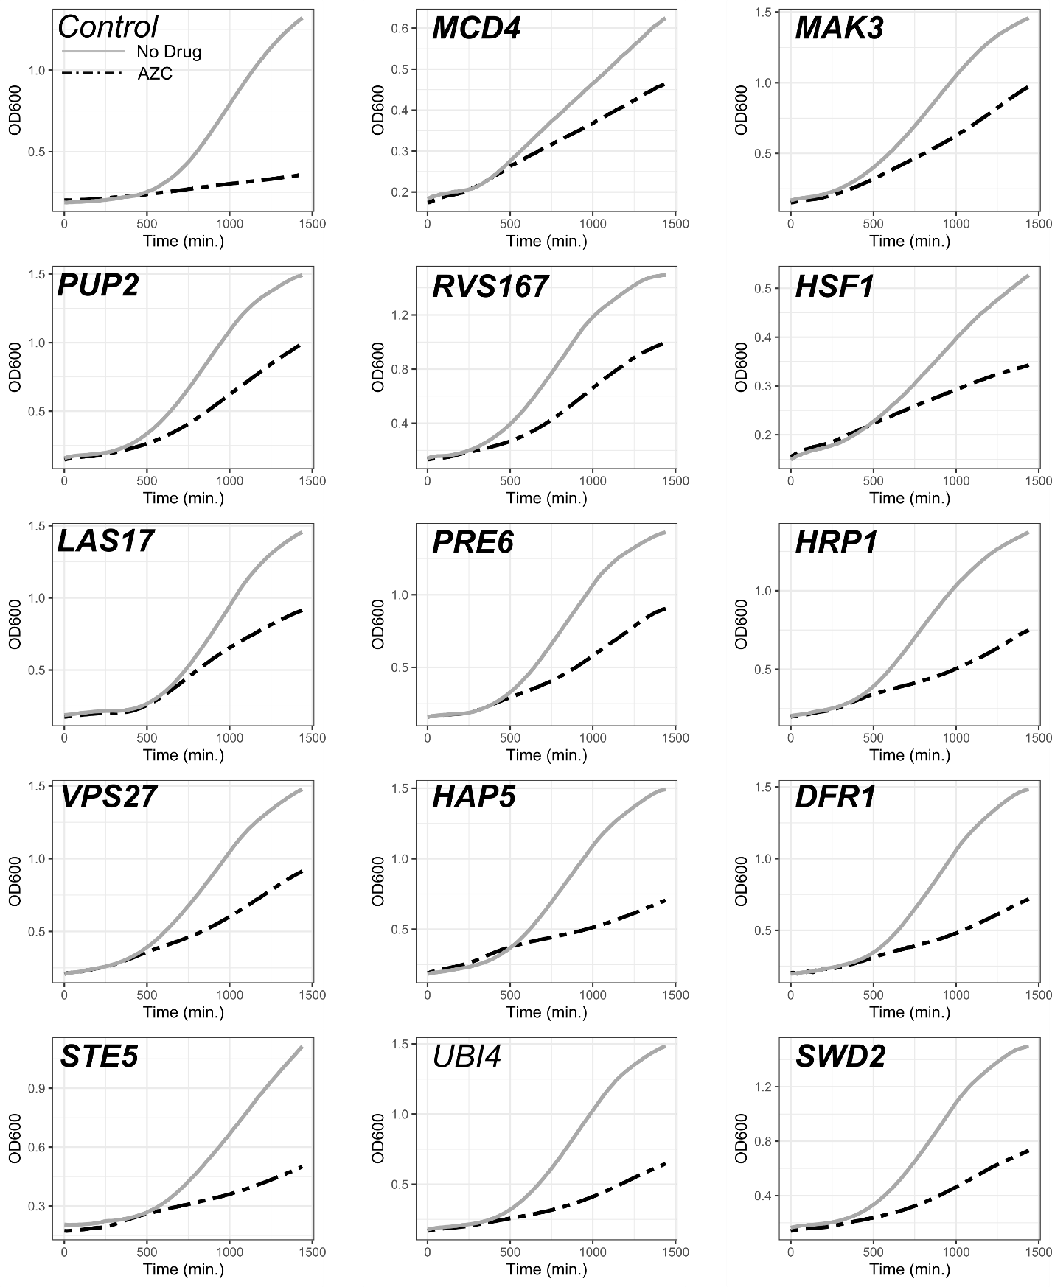

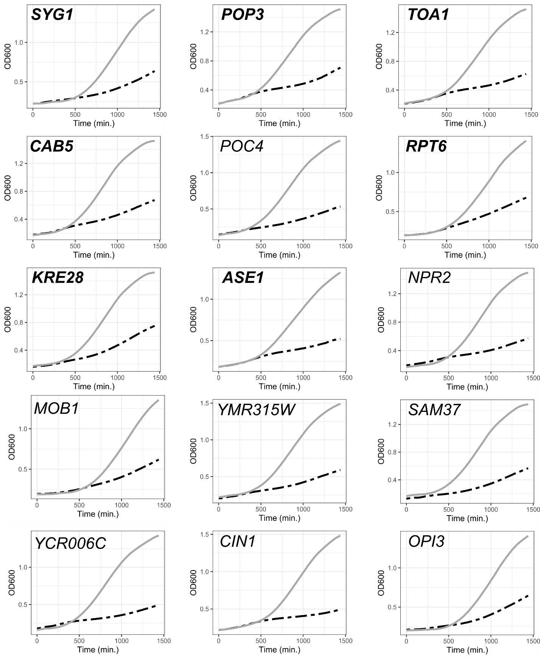
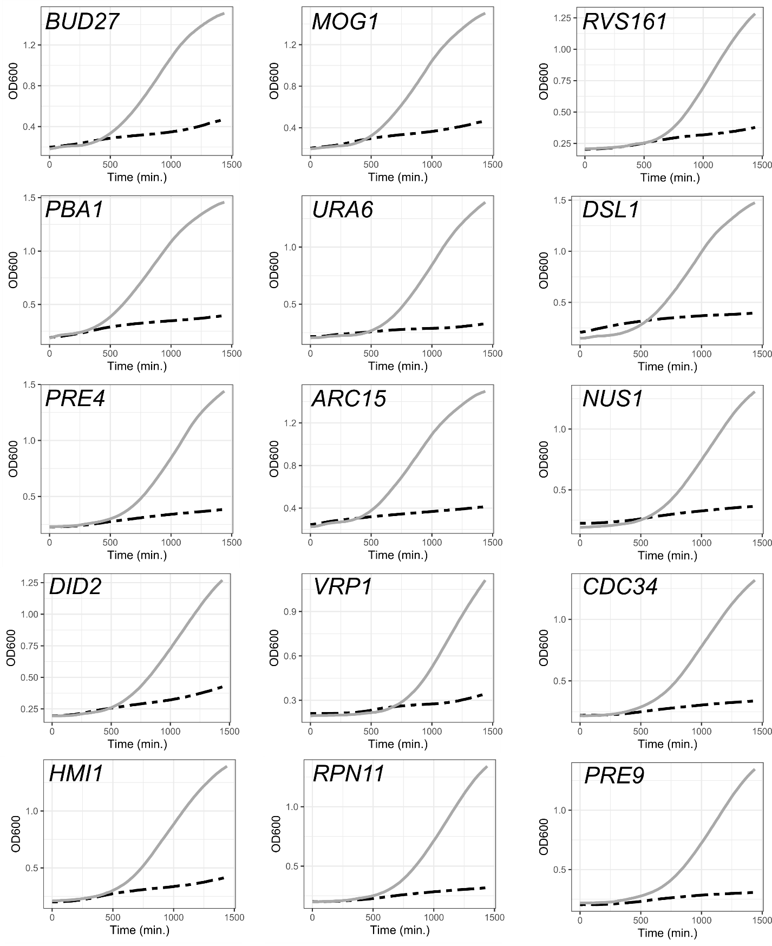

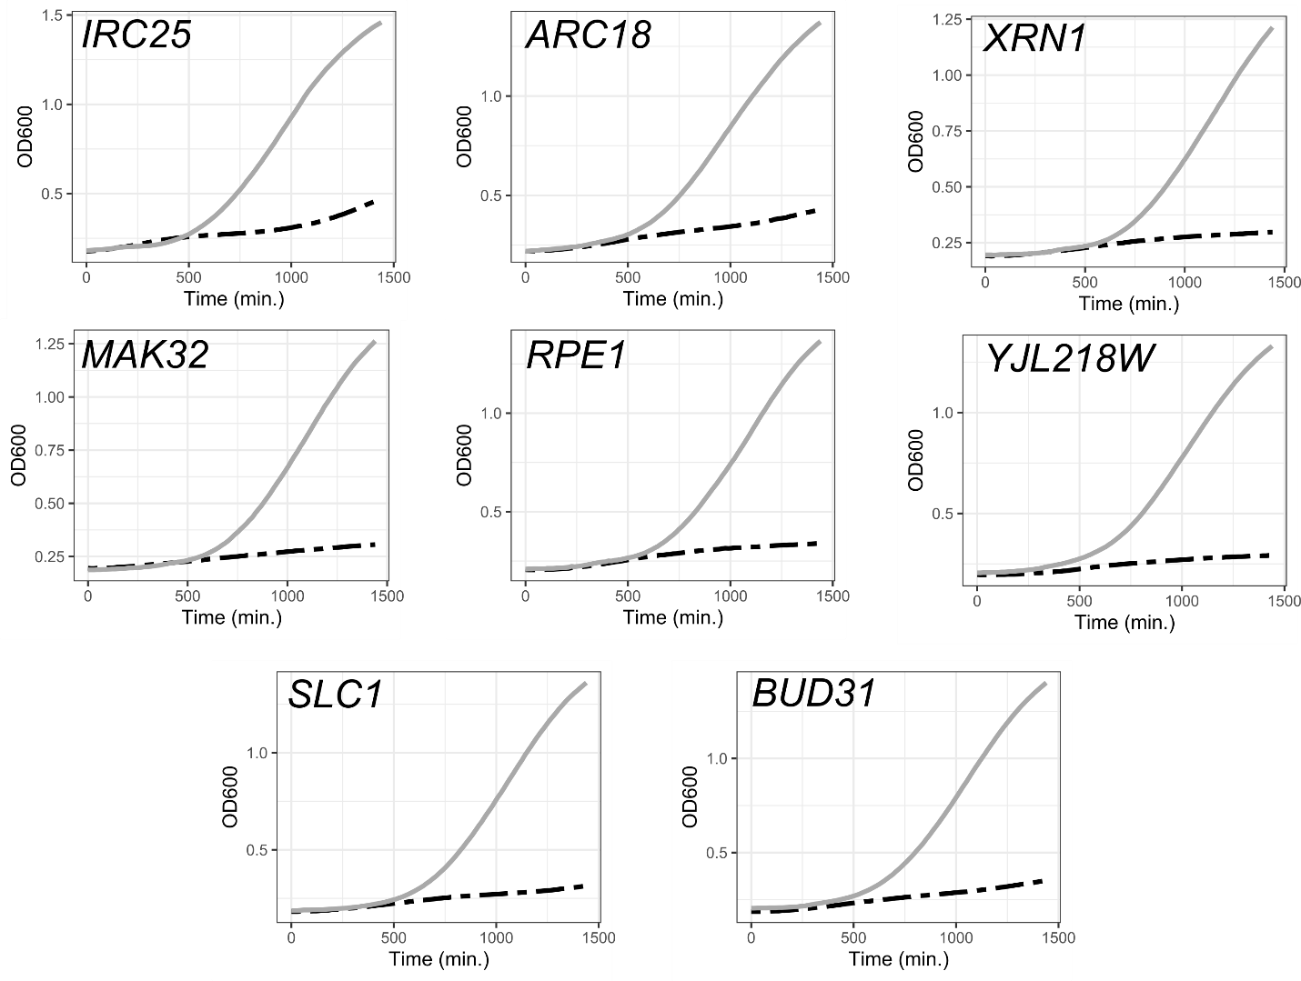
Figure S4. Representative growth curves for each overexpression strain. Strains from the FLEX collection (Hu et al. 2007; Douglas et al. 2012) were grown overnight in medium lacking uracil and containing raffinose. Strains were diluted to an OD₆₀₀ of 0.1 in media lacking uracil and containing galactose either with 10 µg/mL AZC or without and grown for 24 hr at 30° with agitation in a plate reader. OD₆₀₀ was measured every 15 minutes. Gene names that are in bold are considered to suppress AZC toxicity and result in a ratio of the AUC plus/minus AZC two-fold or greater than that of the control strain with a correct p-value ≤ 0.05 (n = 3).

