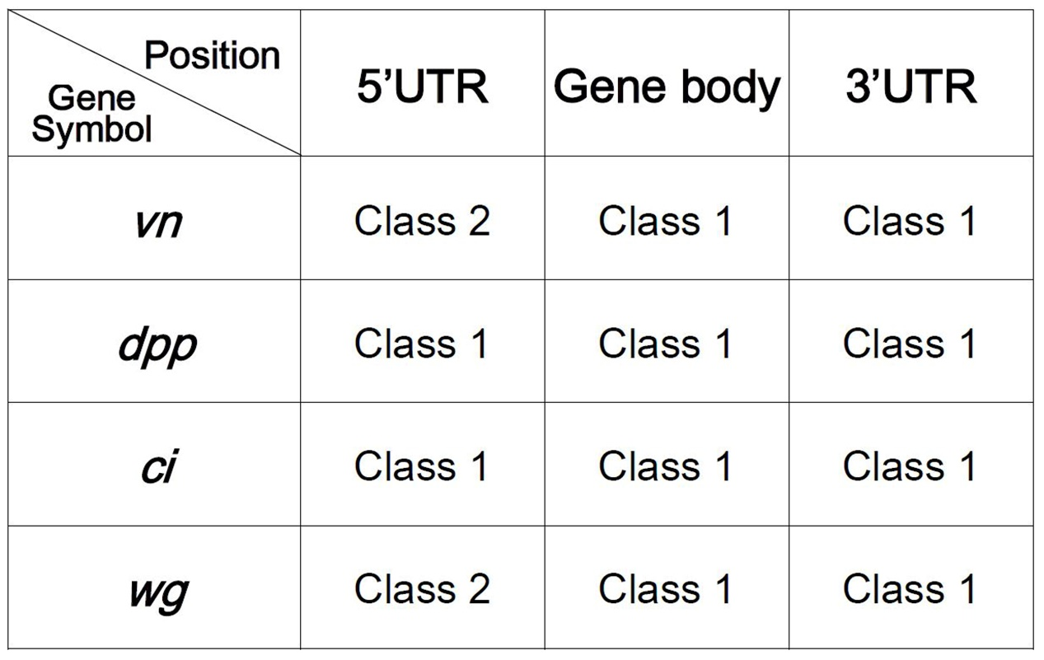

Figure S1. Statistical results of sgRNAs targeting the downstream of the transcriptional start site. sgRNAs were designed to target 5’UTR, gene body and 3’UTR regions of vn, dpp, ci and wg respectively, the activation phenotypes were analyzed according to the classification criteria in Fig. 1a.

