Supplemental figure legends:

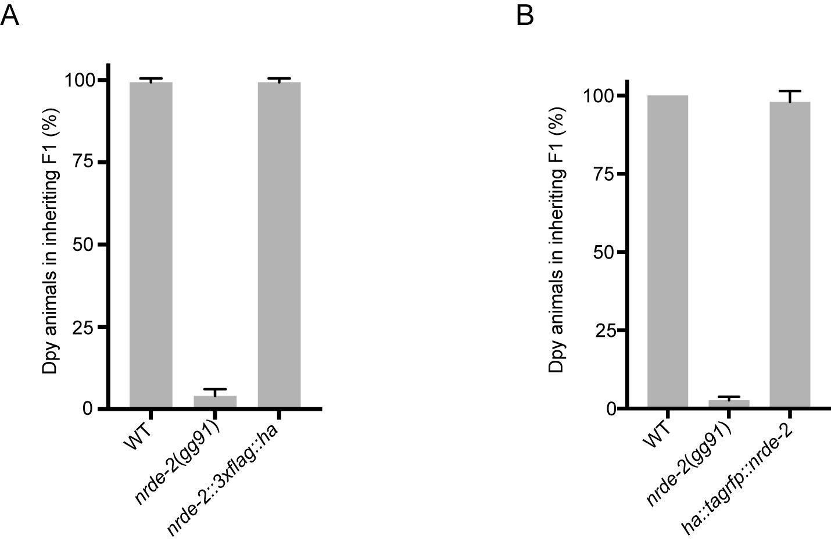
Supplemental figure 1. CRISPR/Cas9 tagged nrde-2 produces functional proteins. (A-B) Animals of the indicated genotypes were subjected to dpy-11 RNAi. The % of progeny exhibiting a Dpy phenotype is indicted. Note, epitope tagged alleles of mtr-4 described in this study also generated functional MTR-4 proteins as indicated by the fact that these animals appeared normal, while animals with the function of MTR-4 disrupted are lethal (see Figure 3 and S4).

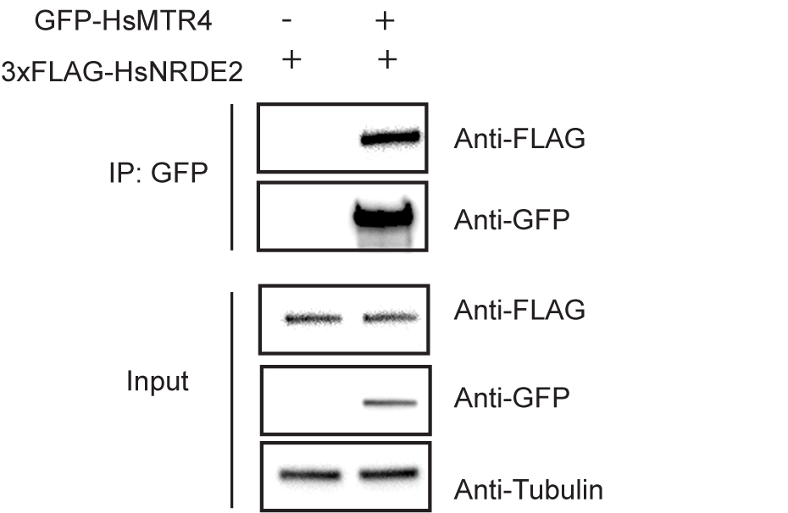
Supplemental figure 2. Human NRDE2 and MTR4 interact. Co-IP analysis of GFP-HsMTR4 and 3xFLAG-HsNRDE2 from human HEK293T cells were IP’ed with anti-GFP antibodies and detected by Western blot with indicated antibodies.

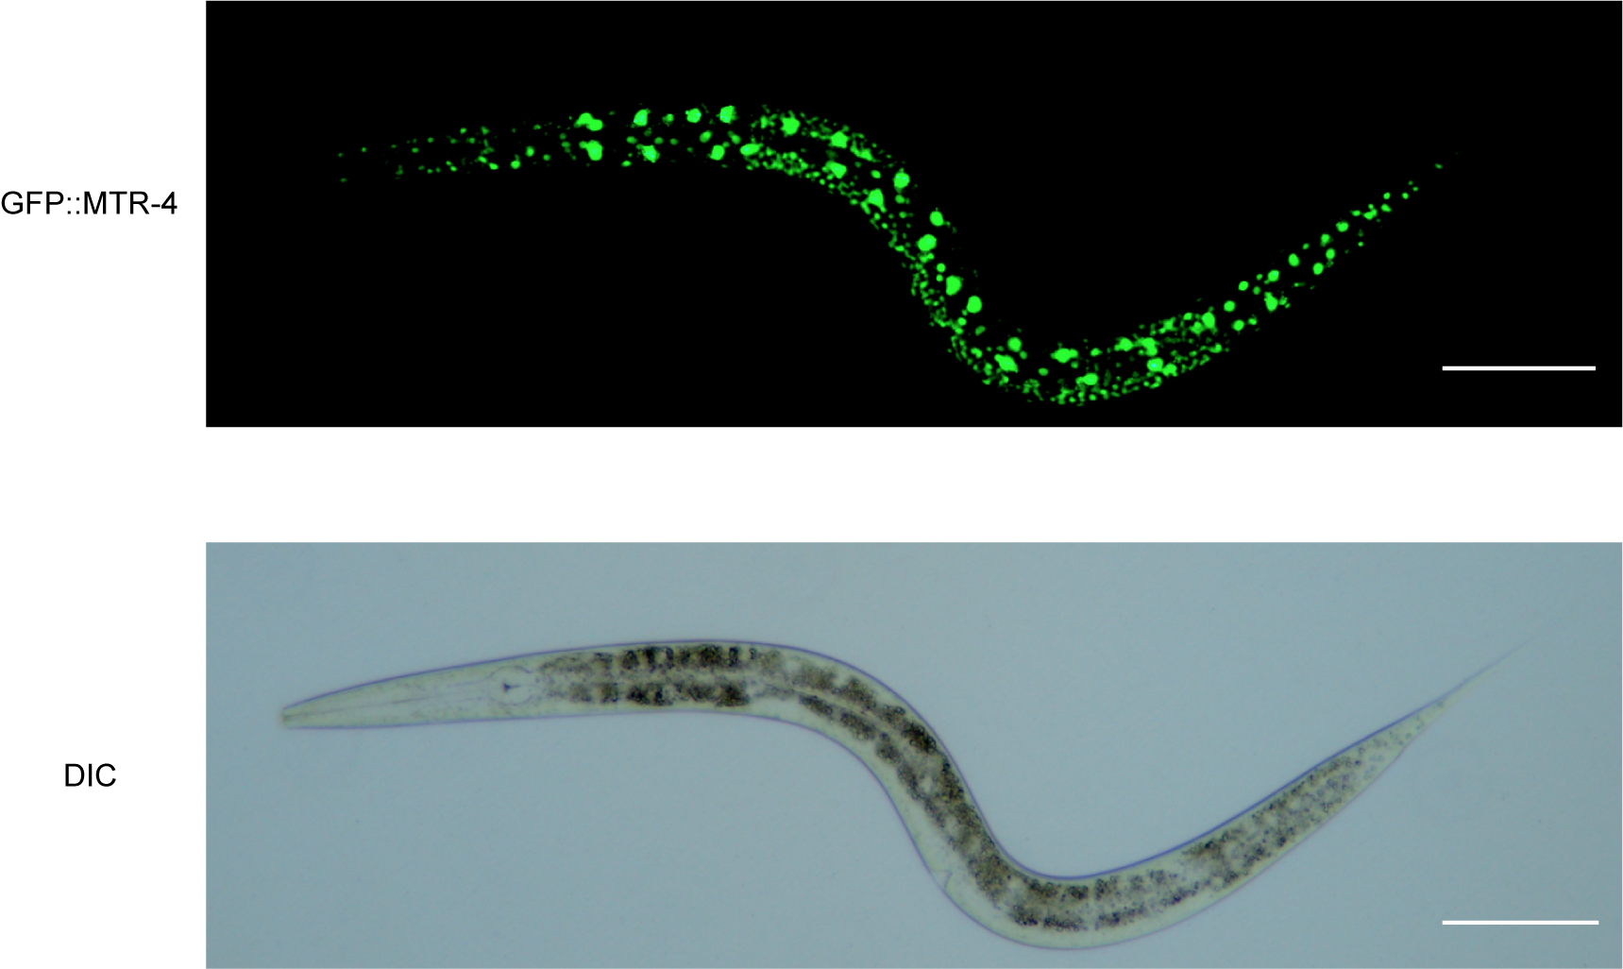

Supplemental figure 3. Fluorescent and light micrographs of a larva animal expressing GFP::MTR-4. DIC, differential interference contrast. Scale bar: 20μm.
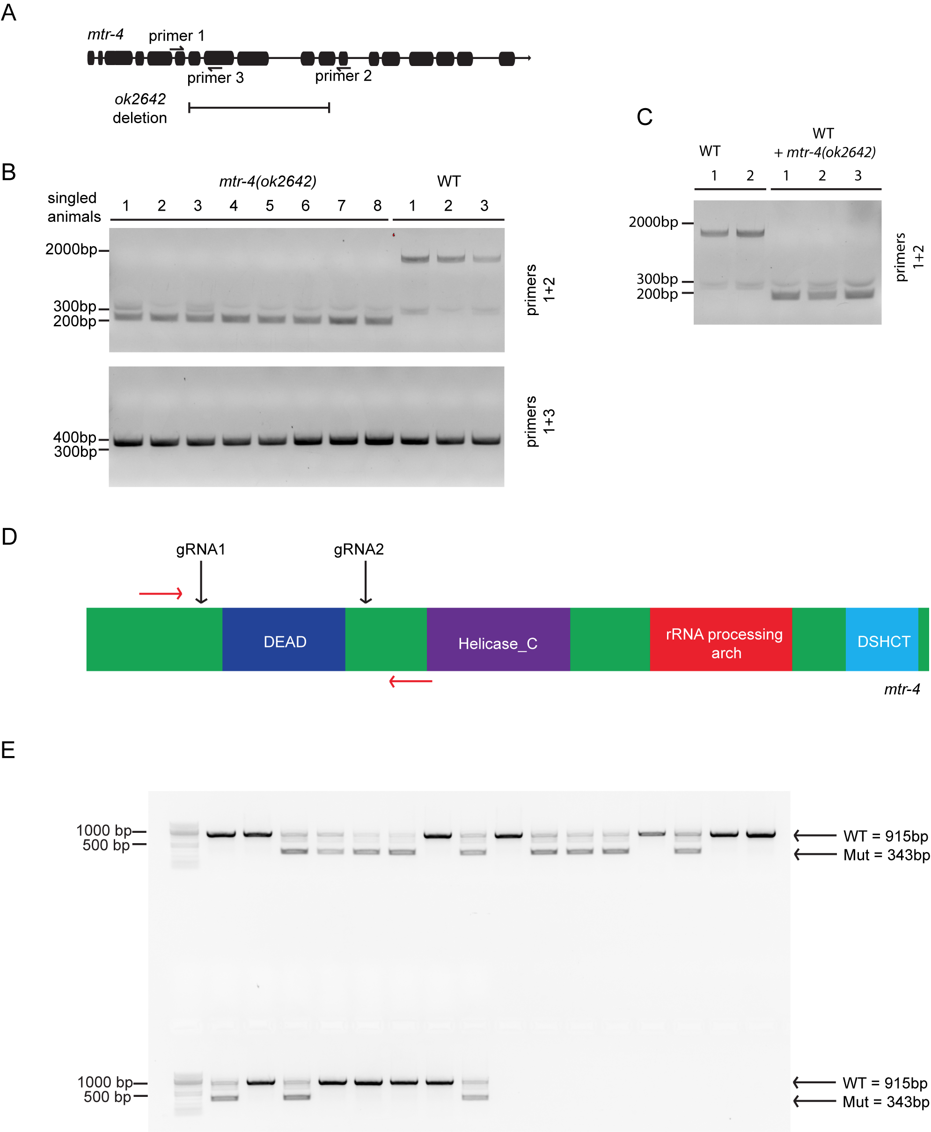
Supplemental Figure 4. Characterization of mtr-4 (ok2642) and attempts to identify a mtr-4 null allele. (A) Cartoon representation of mtr-4 gene. Solid blocks represent exons. Primers used in genotyping assay in (B-C) are indicated with arrows. Location of presumed ok2642 deletion is indicated. (B, upper panel) PCR-based detection of predicted wild-type (1797bp) and ok2642 (243bp) sized PCR products using primers 1 and 2. (B, lower panel) PCR-based detection of a predicted wild-type (378bp) sized PCR product in both wild-type and ok2642 animals using primers 1 and 3. (C) Mixing wild-type and ok2642 DNA at a 1:1 ratio causes only the shorter ok2642 deletion PCR product to be detected, possibly explaining why the longer WT PCR product is not observed in ok2642 animals shown in (B). (B-C) Together, these data suggest that ok2642 may harbor the predicted ok2642 deletion but also a wild-type copy of the mtr-4 gene. It seems reasonable to speculate that the PCR-based screening used to identify ok2642 selected for this type of complex mtr-4 locus rearrangement, as evidence presented below (and elsewhere in this work) indicate that a clean deletion would be lethal. (D) Cartoon representation of the MTR-4 protein as well as locations of guide RNAs used to delete the MTR-4 DEAD box helicase domain. Red arrows indicate genotyping primers used in (E). (E) PCR-based detection of the anticipated MTR-4 DEAD box helicase deletion in 24 progeny of an animal heterozygous for the DEAD box deletion. No progeny are homozygous for the deletion. Genotyping of an additional 36 animals failed to detect a homozygote. The data argue that the MTR-4 DEAD box deletion allele is likely lethal.

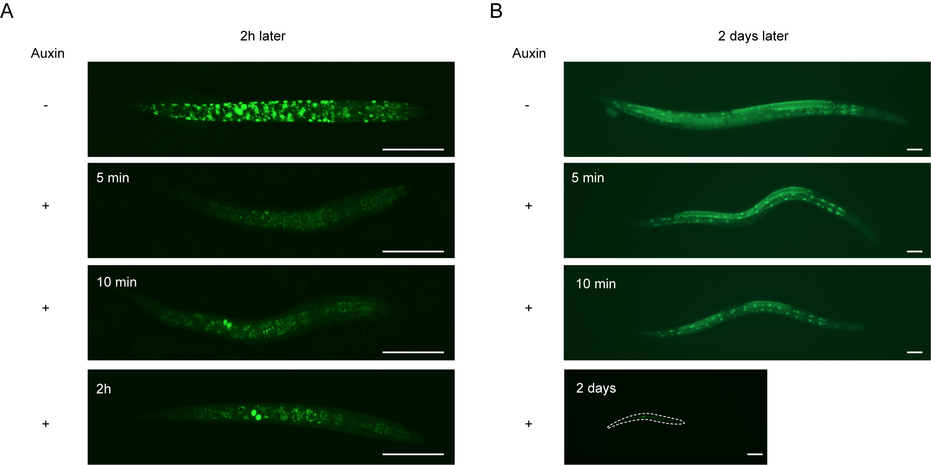
Supplemental Figure 5. Short-term 5-10 minute auxin exposure temporarily depletes degron::GFP::MTR-4 but is not sufficient to cause larval arrest. Animals were treated with -/+ 1mM auxin for indicated time, fluorescent images were taken 2h (A) or 2 days (B) post-treatment. Scale bar, 50μm. Dashed line indicates the shape of the arrested larval animal. Larva images were taken at 20x magnification, while adult images were taken at 10x.

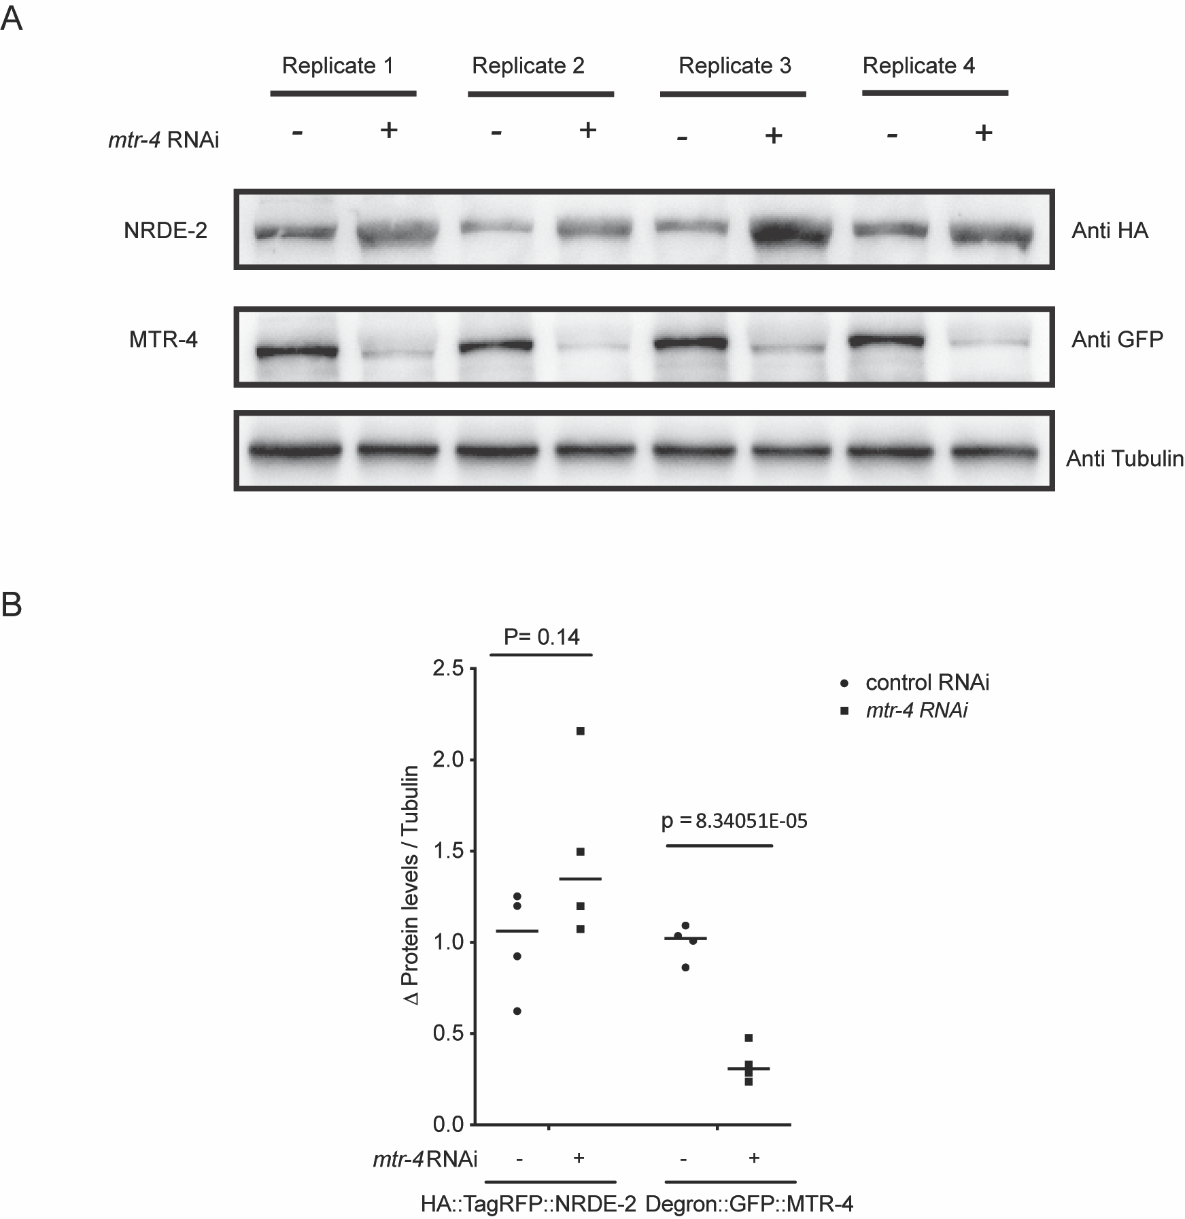
Supplemental figure 6. Loss of MTR-4 does not trigger a loss of NRDE-2. (A) Western blotting was used to monitor NRDE-2::3xFLAG::HA and 3xFLAG::GFP::MTR-4 levels in animals treated with +/- mtr-4 RNAi. Replicates 1 and 2 are technical replicates of Figure 5A. Replicates 1-4 are biological replicates. The data show that RNAi-mediated depletion of MTR-4 does not alter levels of NRDE-2. (B) Proteins level in (A) were quantified with imageJ. Results are expressed as a ratio relative to a Tubulin loading control. Error bars are +/- s.d. N=4. P value, student’s-t test, two-tailed.

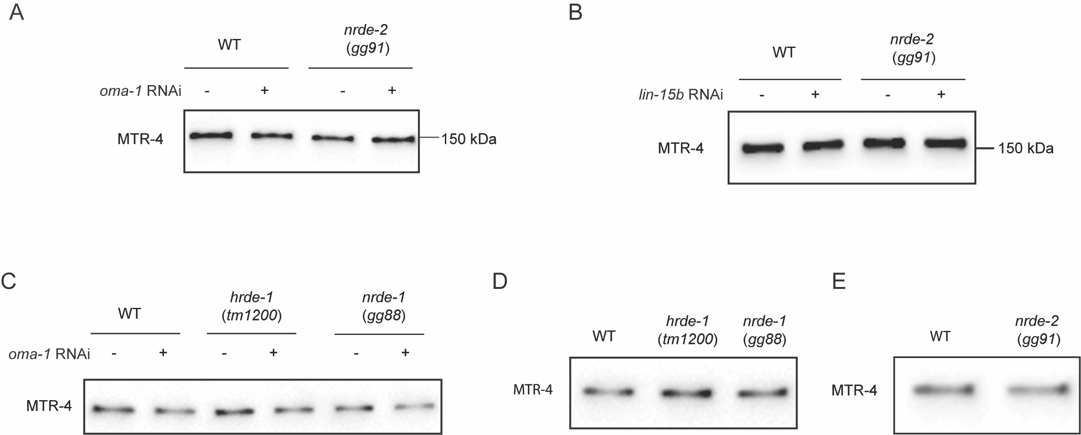

Supplemental figure 7. Controls showing that similar levels of MTR-4 were IP’ed for RIP experiments shown in the main text. (A) figure 5B, (B) figure 5C, (C) figure 6A, (D) figure 6C, (E) figure 6D.

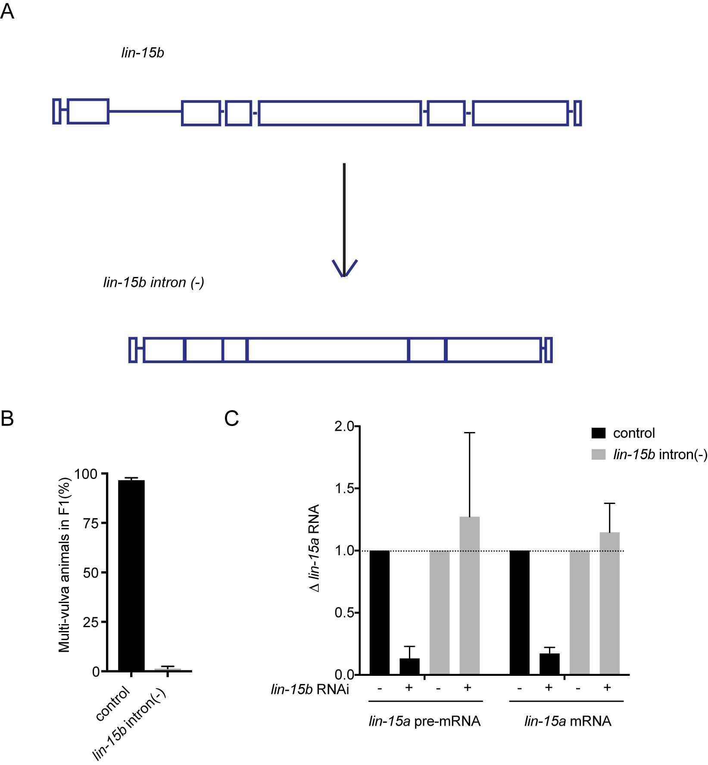
Supplemental figure 8. Removal of introns from the lin-15b gene causes lin-15b to become recalcitrant to cTGS. (A) Schematic of the lin-15b locus or the lin-15b intron(-) locus after introns 2-6 were removed by CRISPR/Cas9. (B) lin-15b RNAi-induced multi-vulva (Muv) formation is, like lir-1 RNAi, an “operon assay” that lets nuclear RNAi or cTGS be scored (Guang et al. 2008). lin-15b RNAi triggers a NRDE-dependent silencing of the downstream lin-15a gene, which induces Muv (Guang et al. 2008). An eri-1(mg366) genetic background was used for this analysis because eri-1(mg366) enhances RNAi, which allows Muv to be easily scored after lin-15b RNAi (Guang et al. 2008). eri-1(mg366) (control) or eri-1(mg366);lin-15b intron(-) (lin-15b intron(-)) animals were treated with lin-15b RNAi for two generations and % multi-vulva animals in F1 were scored. (C) WT (control) or lin-15b intron(-) animals were treated with control RNAi or lin-15b RNAi, total RNA was isolated and converted to cDNA. lin-15a is co-transcribed with lin-15b as part of an operon. lin-15a RNAs levels were quantified with qRT-PCR. Data from control RNAi was set at 1 and data from lin-15b RNAi was expressed as fold change compared with respective control RNAi. Error bars are +/- s.d. N=3.

Table S1. List of proteins identified by NRDE-2 IP-MS. Sheet 1 provides a list of proteins identified by 0 peptides from control extracts and more than 20 peptides from nrde-2::3xflag::ha extracts. Sheet 2 is a list of all proteins identified from each sample. For WT control, protein FDR is 5.68%, peptide FDR is 0.71%, and for nrde-2::3xflag::ha, protein FDR is 3.57%, peptide FDR is 0.73%.

Primers used in this study:

Primers for H3K9me3 ChIP:

Primer name | Primer sequence
oma-1 1F | TTGTTAAGCATTCCCTGCAC
oma-1 1R | TCGATCTTCTCGTTGTTTTCA
oma-1 2F | GTGAGTTTAACAAAATTCAAATGAAAA
oma-1 2R | AGTGGTGAAACGGGCAAAGT
C09G9.5 F | CCAACGAAGCTTTGTGGATA
C09G9.5 R | GCGTGTGGGAACCTAGAAAA
spr-2 F | AAACTTTCGCAATGTAACTCTTCC
spr-2 R | CTGGTAGTGCTGCGTACGTG
rad-26 F | CGATGAAAGAAGAGCAAGAAGAA
rad-26 R | TTTTCATGATAAAACACTGGGAAA
eft-3 | CCTGCAAGTTCAACGAGCTTA
eft-3 | TGAAAAACAAATTGGTACATAAACG

Primers for detecting lin-15b pre-mRNA after RIP:

Primer name | Primer sequence
lin-15b 1F | ACAGCACGACTTACATCAAACCC
lin-15b 1R | TGGTTGGAATGCATTTGGAATAG
lin-15b 2F | ATCTGGCGTTTTCGATTCATTAC
lin-15b 2R | CCCAAATTTCACAACTACATTTG
lin-15b 3F | CCTAACAATCATAAACTCTC
lin-15b 3R | TGTCTAATTTTCCACAGAAC
lin-15b 4F | GGCTCAACGGCTTATGTACAGTG
lin-15b 4R | GGAAATGAAACTGAGGTTCAGAA
lin-15b 5F | GCCCTCCGTCCACACATTATTGC
lin-15b 5R | CAAAATGTGCAATTTTAAAAACG
lin-15b 6F | GAGGAGGAAGAGTATGAAGAATC
lin-15b 6R | CAAAGCATATATTTTTCAAAAAC
lin-15a 1F | GCATTGGAACGGATGCTCTGCAG
lin-15a 1R | GGGAGAAAATCCTTAAAAAGCCA
lin-15a 2F | TCCGCTTTACTCATTCAAGAATT
lin-15a 2R | AATTTTCACAAGTGTCACAAGAC

Primers for detecting oma-1 pre-mRNA or mRNA after RNAi or RIP:

Primer name | Primer sequence
oma-1 mRNA F | GCTTGAAGATATTGCATTCAACC
oma-1 mRNA R | AACTGTTGAAATGGAGGTGC
oma-1 pre-mRNA 1F | GTGCGTTGGCTAATTTCCTG
oma-1 pre-mRNA 1R | CTGAATCGCGCGAACTTG
oma-1 pre-mRNA 2F | TGTCTCAAACTAATCCGAATGC
oma-1 pre-mRNA 2R | CAGGAAATTAGCCAACGCAC
eft-3 mRNA | CGAGCTTAAGGAGAAGGTTG
eft-3 mRNA | CCAGCATCTCCAGACTTGAG

