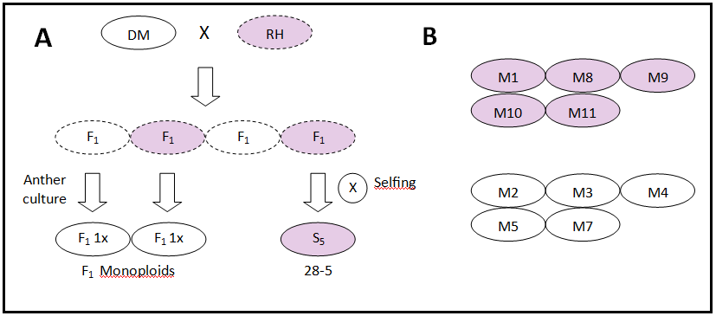
Supplementary Figure 1: Overview of the germplasm utilized in this study. Each oval's color corresponds to genotype flower color, solid outlines indicate (near) homozygosity while dashed indicate heterozygous background. A) DRH population and its derivatives (DM, RH the F₁ and the S₅ are all diploid (2n=2x-24) whereas the F₁ monoploids and the monoploids from the panel have 2n=1x=12). B) The monoploid panel published in Hardigan et al. (2016).

