Table S1 Illumina sequencing reads used for genome size estimation and the correction of the genome assembly
Library | Data (Gb) | Depth (×) | Q20 (%) | Q30 (%)
350 bp | 54.55 | 83.26 | 97.33 | 92.76
Total | 54.55 | 83.26 | --- | ---

Table S2 Size distributions of the PacBio subreads
Length (bp) | Number (bp) | Total Length (bp) | Average Length (bp)
500–2,000 | 638,299 | 769,627,686 | 1,205.75
2,000–4,000 | 613,551 | 1,806,954,490 | 2,945.08
4,000–6,000 | 469,478 | 2,330,983,492 | 4,965.05
6,000–8,000 | 397,190 | 2,771,110,809 | 6,976.79
8,000–10,000 | 350,922 | 3,151,254,832 | 8,979.93
10,000–12,000 | 315,116 | 3,459,904,616 | 10,979.78
12,000–14,000 | 279,637 | 3,629,020,526 | 12,977.61
14,000–16,000 | 244,232 | 3,657,754,402 | 14,976.56
16,000–18,000 | 215,024 | 3,651,178,915 | 16,980.33
>18,000 | 1,472,248 | 41,754,242,787 | 28,360.88
Total | 4,995,697 | 66,982,032,555 | 13,408

Table S3 Statistical details of the PacBio subreads
Type | Reads_num | Total_base (bp) | Read_N50 | Mean | Maximum
Sequel | 4,995,697 | 66,982,032,555 | 22,633 | 13,408 | 90,903

Table S4 The initial C. mollissima assembly, as generated by different tools
Assembly tools | WTGB | Canu | WTGB+Canu (merge)
Genome size (bp) | 782,890,668 | 994,461,872 | 793,805,471
Contig number | 2,527 | 4,217 | 1,381
Maximum contig length (bp) | 5,709,809 | 5,367,888 | 25,283,183
Contig N50 (bp) | 1,046,151 | 579,746 | 3,382,036
Contig N90 (bp) | 96,478 | 83,619 | 182,580
GC content (%) | 35.13 | 35.10 | 35.09

Table S5 Statistical details of the Hi-C library data
library-ID | Read Pairs Number | Base Number | GC Content (%) | ≥Q30 (%) | Depth
Hi-C01 | 370,041,098 | 110,833,450,402 | 37.66 | 91.85 | 170×

Table S6 Details of the alignment of the clean Hi-C data to the initial assembly
Mapping Type | Number | Ratio (%)
Total read pairs | 370,041,098 | 100
Mapped reads | 663,321,111 | 89.63
Unique mapped read pairs | 210,652,422 | 56.93

Table S7 Statistical details of all types of Hi-C sequencing pairs
Type | Number | Ratio (%)
Unique paired alignments | 210,652,422 | 100
Valid interaction pairs | 161,128,476 | 76.49
Dangling end pairs | 10,555,700 | 5.01
Re-ligation pairs | 2,518,240 | 1.2
Self-cycle pairs | 25,336,948 | 12.03
Dumped pairs | 11,113,058 | 5.28

Table S8 Evaluation using BUSCO
Species | Complete BUSCOs | Complete and single-copy BUSCOs | Complete and duplicated BUSCOs | Fragmented BUSCOs | Missing BUSCOs
chestnut | 1,492 (92.44%) | 1,433 (88.79%) | 59 (3.66%) | 24 (1.49%) | 98 (6.07%)

Table S9 Alignment of the Illumina reads to the C. mollissima genome assembly
Library | Total reads | Mapped reads | Mapped (%) | Properly mapped reads | Properly mapped (%)
350bp | 422,116,203 | 415,232,639 | 98.37 | 387,854,968 | 93.08

Table S10 Functional annotation of the predicted protein-coding genes
Database | Number of genes annotated | Percentage (%)
GO | 16,709 | 49.67%
KEGG | 9,388 | 27.91%
KOG | 19,248 | 57.22%
TrEMBL | 32,825 | 97.58%
Nr | 32,844 | 97.64%
All | 32,874 | 97.73%
GO: Gene Ontology; KEGG: Kyoto Encyclopedia of Genes and Genomes; KOG: eukaryotic orthologous groups of proteins; Nr：GenBank non-redundant protein database

Table S11 Castanea mollissima gene prediction
Method | Software | Species | Number of genes
Ab initio | Genscan | - | 23,855
 | Augustus | - | 35,934
 | GlimmerHMM | - | 27,074
 | GeneID | - | 42,283
 | SNAP | - | 14,071
Homology-based | GeMoMa | Arabidopsis thaliana | 24,250
 |  | Oryza sativa | 25,274
 |  | European ash | 25,855
 |  | Quercus suber | 42,632
RNA-seq | PASA | - | 29,117
 | TransDecoder | - | 46,795
 | GeneMarkS-T | - | 28,020
Integration | EVM | - | 33,638

Table S12 Statistical details of the identified genes
Software | Gene Num | GeneLen  (bp) | AveGeneLen(bp) | ExonLen  (bp) | AveExonLen(bp) | IntronLen  (bp) | AveIntronLen(bp)
EVM | 33,638 | 157,948,859 | 4,695.54 | 42,540,186 | 252.51 | 115,408,673 | 685.05

Table S13 Statistical details of the identified repeat sequences
Type | Number | Length（bp） | Percentage (%)
ClassI | 423,675 | 235,886,704 | 34.24
ClassI/DIRS | 13,697 | 12,004,658 | 1.74
ClassI/LARD | 12,837 | 3,961,957 | 0.58
ClassI/LINE | 123,740 | 46,315,237 | 6.72
ClassI/LTR/Copia | 111,135 | 59,762,237 | 8.67
ClassI/LTR/Gypsy | 136,445 | 106,363,325 | 15.44
ClassI/LTR/Unknown | 1,146 | 398,253 | 0.06
ClassI/PLE | 526 | 133,012 | 0.02
ClassI/SINE | 4,981 | 957,920 | 0.14
ClassI/TRIM | 2,422 | 1,458,016 | 0.21
ClassI/Unknown | 16,746 | 4,532,112 | 0.66
ClassII | 101,191 | 38,048,432 | 5.52
ClassII/Crypton | 9 | 637 | 0
ClassII/Helitron | 40,400 | 12,826,319 | 1.86
ClassII/MITE | 1,630 | 422,650 | 0.06
ClassII/Maverick | 1,218 | 362,292 | 0.05
ClassII/TIR | 54,312 | 23,681,234 | 3.44
ClassII/Unknown | 3,622 | 755,300 | 0.11
PotentialHostGene | 89,112 | 21,644,354 | 3.14
SSR | 720 | 160,173 | 0.02
Unknown | 278,155 | 71,100,097 | 10.32
Total | 892,853 | 366,839,546 | 53.24

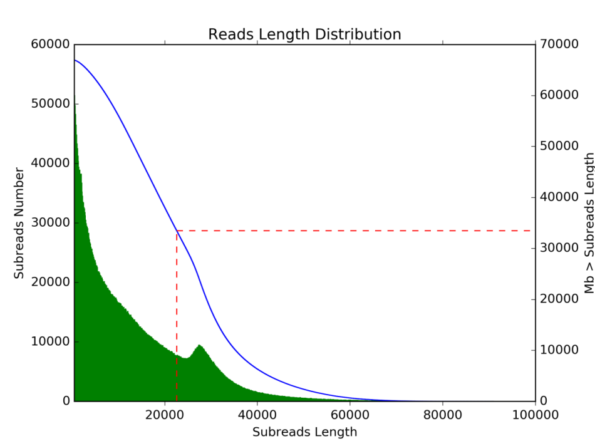
Fig S1. Distribution of subread lengths
The red dotted line represents the N50 length of subreads.

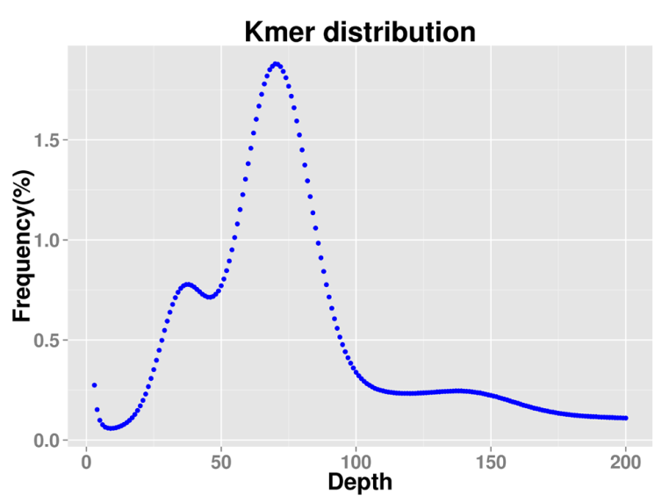
Figure S2 Nineteen-k-mer estimation of genome size
The genome size of Castanea mollissima was estimated based on Illumina genomic reads from insert size of ~350 bp library.

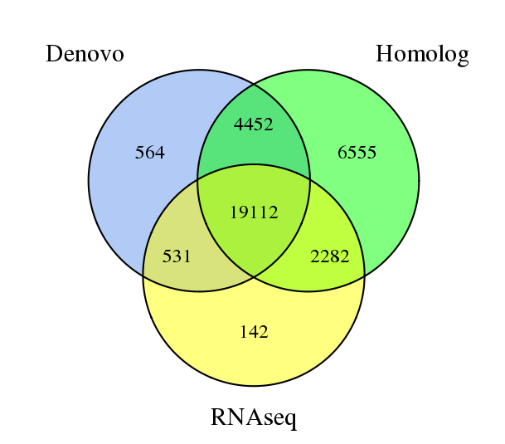
Fig S3 Differences in the genes predicted by the Ab initio, homolog, and RNA-sequencing methods

