Supplementary

Table S1. The mean and standard error of prediction accuracies within entire population.

Trait | Proportion of inference (standard variance)
 | 10% | 20% | 30% | 40% | 50% | 60% | 70% | 80% | 90%
HL | 0.327 (0.01) | 0.323 (0.007) | 0.315 (0.005) | 0.307 (0.005) | 0.293 (0.004) | 0.276 (0.004) | 0.253 (0.004) | 0.219 (0.005) | 0.171 (0.007)
HN | 0.499 (0.011) | 0.495 (0.007) | 0.495 (0.006) | 0.49 (0.005) | 0.48 (0.004) | 0.473 (0.004) | 0.464 (0.003) | 0.448 (0.004) | 0.419 (0.006)
HT | 0.694 (0.008) | 0.692 (0.005) | 0.688 (0.004) | 0.685 (0.003) | 0.676 (0.003) | 0.67 (0.003) | 0.663 (0.002) | 0.653 (0.001) | 0.643 (0.002)
HW | 0.406 (0.01) | 0.386 (0.006) | 0.379 (0.004) | 0.369 (0.004) | 0.355 (0.004) | 0.338 (0.003) | 0.313 (0.003) | 0.277 (0.004) | 0.234 (0.006)
HL = husk length, HN = husk layer number, HT = husk thickness, and HW = husk width.

Table S2. The mean and standard error of prediction accuracies within subpopulations.

Subpopulation | Trait | Proportion of inference (standard variance)
 |  | 10% | 20% | 30% | 40% | 50% | 60% | 70% | 80% | 90%
MIXED | HL | 0.354 (0.017) | 0.38 (0.012) | 0.375 (0.009) | 0.364 (0.006) | 0.353 (0.006) | 0.334 (0.005) | 0.299 (0.006) | 0.283 (0.006) | 0.21 (0.013)
 | HN | 0.37 (0.018) | 0.36 (0.012) | 0.34 (0.01) | 0.324 (0.008) | 0.296 (0.007) | 0.253 (0.008) | 0.208 (0.009) | 0.169 (0.012) | 0.107 (0.012)
 | HT | 0.352 (0.024) | 0.348 (0.017) | 0.35 (0.012) | 0.349 (0.009) | 0.335 (0.008) | 0.329 (0.006) | 0.32 (0.007) | 0.304 (0.008) | 0.217 (0.012)
 | HW | 0.353 (0.021) | 0.332 (0.012) | 0.327 (0.01) | 0.308 (0.008) | 0.308 (0.007) | 0.302 (0.006) | 0.284 (0.006) | 0.246 (0.009) | 0.191 (0.011)
NSS | HL | 0.091 (0.041) | 0.046 (0.024) | 0.044 (0.021) | 0.055 (0.015) | 0.055 (0.012) | 0.059 (0.012) | 0.059 (0.011) | 0.05 (0.012) | 0.015 (0.013)
 | HN | 0.291 (0.037) | 0.24 (0.027) | 0.245 (0.022) | 0.204 (0.019) | 0.232 (0.017) | 0.195 (0.017) | 0.166 (0.017) | 0.129 (0.018) | 0.075 (0.02)
 | HT | 0.394 (0.031) | 0.363 (0.022) | 0.343 (0.015) | 0.3 (0.016) | 0.217 (0.018) | 0.198 (0.017) | 0.128 (0.016) | 0.088 (0.016) | 0.03 (0.016)
 | HW | 0.326 (0.043) | 0.286 (0.028) | 0.203 (0.022) | 0.1 (0.018) | 0.095 (0.017) | 0.075 (0.013) | 0.034 (0.012) | 0.013 (0.011) | -0.01 (0.01)
SS | HL | 0.216 (0.07) | 0.207 (0.051) | 0.154 (0.041) | 0.148 (0.031) | 0.119 (0.03) | 0.084 (0.03) | 0.065 (0.031) | -0.007 (0.032) | NA
 | HN | 0.26 (0.066) | 0.358 (0.036) | 0.386 (0.025) | 0.382 (0.018) | 0.357 (0.018) | 0.349 (0.017) | 0.253 (0.024) | 0.121 (0.026) | NA
 | HT | 0.634 (0.045) | 0.697 (0.025) | 0.722 (0.016) | 0.726 (0.011) | 0.713 (0.012) | 0.692 (0.015) | 0.62 (0.025) | 0.358 (0.043) | NA
 | HW | 0.722 (0.042) | 0.706 (0.025) | 0.72 (0.016) | 0.72 (0.014) | 0.693 (0.012) | 0.682 (0.012) | 0.624 (0.02) | 0.466 (0.033) | NA
TST | HL | 0.259 (0.019) | 0.225 (0.013) | 0.206 (0.01) | 0.177 (0.009) | 0.146 (0.01) | 0.112 (0.01) | 0.071 (0.009) | 0.03 (0.008) | 0.007 (0.007)
 | HN | 0.258 (0.019) | 0.224 (0.012) | 0.193 (0.009) | 0.178 (0.007) | 0.166 (0.007) | 0.147 (0.007) | 0.131 (0.007) | 0.092 (0.008) | 0.05 (0.01)
 | HT | 0.394 (0.02) | 0.373 (0.011) | 0.347 (0.009) | 0.337 (0.008) | 0.324 (0.007) | 0.291 (0.007) | 0.246 (0.008) | 0.199 (0.008) | 0.124 (0.01)
 | HW | 0.283 (0.019) | 0.255 (0.012) | 0.209 (0.01) | 0.187 (0.009) | 0.156 (0.009) | 0.123 (0.009) | 0.081 (0.009) | 0.052 (0.009) | 0.01 (0.007)
Subpopulations: NSS = non-stiff stalk, SS = stiff stalk, TST = tropical-subtropical, and MIXED = admixed. Traits: HL = husk length, HN = husk layer number, HT = husk thickness, and HW = husk width. “NA” represents missing data under conditions where very few individuals remained in the testing or training population.

Table S3. The mean and standard error of prediction accuracies across subpopulations.

Subpopulation | Trait | Proportion of inference (standard variance)
 |  | 10% | 20% | 30% | 40% | 50% | 60% | 70% | 80% | 90% | 100%
MIXED | HL | 0.379 (0.018) | 0.404 (0.012) | 0.403 (0.009) | 0.399 (0.006) | 0.396 (0.006) | 0.387 (0.005) | 0.375 (0.004) | 0.369 (0.004) | 0.353 (0.003) | 0.328 (0)
 | HN | 0.321 (0.019) | 0.317 (0.013) | 0.301 (0.011) | 0.294 (0.009) | 0.269 (0.007) | 0.255 (0.006) | 0.238 (0.005) | 0.227 (0.004) | 0.222 (0.003) | 0.211 (0)
 | HT | 0.396 (0.021) | 0.396 (0.013) | 0.397 (0.01) | 0.389 (0.008) | 0.377 (0.007) | 0.365 (0.006) | 0.356 (0.005) | 0.336 (0.004) | 0.318 (0.004) | 0.289 (0)
 | HW | 0.367 (0.019) | 0.371 (0.01) | 0.374 (0.009) | 0.366 (0.007) | 0.367 (0.005) | 0.361 (0.005) | 0.344 (0.005) | 0.319 (0.005) | 0.293 (0.004) | 0.246 (0)
NSS | HL | 0.29 (0.035) | 0.284 (0.019) | 0.281 (0.014) | 0.284 (0.01) | 0.274 (0.01) | 0.274 (0.008) | 0.265 (0.007) | 0.258 (0.005) | 0.261 (0.004) | 0.256 (0)
 | HN | 0.304 (0.032) | 0.288 (0.02) | 0.322 (0.014) | 0.318 (0.011) | 0.336 (0.009) | 0.342 (0.007) | 0.35 (0.007) | 0.364 (0.005) | 0.375 (0.003) | 0.384 (0)
 | HT | 0.321 (0.04) | 0.272 (0.026) | 0.283 (0.019) | 0.255 (0.015) | 0.238 (0.012) | 0.236 (0.011) | 0.218 (0.009) | 0.202 (0.007) | 0.189 (0.005) | 0.153 (0)
 | HW | 0.348 (0.029) | 0.354 (0.019) | 0.324 (0.016) | 0.282 (0.014) | 0.272 (0.011) | 0.256 (0.011) | 0.239 (0.01) | 0.202 (0.009) | 0.19 (0.007) | 0.16 (0)
SS | HL | 0.117 (0.07) | 0.141 (0.048) | 0.214 (0.03) | 0.247 (0.019) | 0.266 (0.014) | 0.273 (0.013) | 0.281 (0.012) | 0.289 (0.008) | 0.294 (0.006) | 0.317 (0)
 | HN | 0.321 (0.062) | 0.341 (0.037) | 0.394 (0.024) | 0.396 (0.016) | 0.388 (0.012) | 0.394 (0.011) | 0.386 (0.009) | 0.386 (0.007) | 0.383 (0.006) | 0.376 (0)
 | HT | 0.542 (0.061) | 0.66 (0.035) | 0.718 (0.015) | 0.727 (0.01) | 0.722 (0.007) | 0.728 (0.005) | 0.723 (0.005) | 0.724 (0.003) | 0.724 (0.002) | 0.724 (0)
 | HW | 0.684 (0.046) | 0.707 (0.023) | 0.684 (0.017) | 0.674 (0.01) | 0.654 (0.007) | 0.642 (0.008) | 0.624 (0.007) | 0.603 (0.005) | 0.581 (0.005) | 0.549 (0)
TST | HL | 0.263 (0.02) | 0.241 (0.013) | 0.236 (0.01) | 0.211 (0.009) | 0.19 (0.007) | 0.155 (0.007) | 0.127 (0.006) | 0.092 (0.005) | 0.05 (0.005) | -0.02 (0)
 | HN | 0.22 (0.019) | 0.197 (0.011) | 0.181 (0.009) | 0.169 (0.007) | 0.161 (0.007) | 0.144 (0.006) | 0.136 (0.005) | 0.116 (0.006) | 0.081 (0.005) | 0.026 (0)
 | HT | 0.413 (0.018) | 0.383 (0.01) | 0.36 (0.009) | 0.354 (0.008) | 0.353 (0.007) | 0.339 (0.006) | 0.322 (0.005) | 0.301 (0.005) | 0.269 (0.005) | 0.241 (0)
 | HW | 0.303 (0.02) | 0.293 (0.012) | 0.266 (0.01) | 0.253 (0.008) | 0.243 (0.007) | 0.226 (0.007) | 0.206 (0.007) | 0.186 (0.006) | 0.152 (0.005) | 0.098 (0)
Subpopulations: NSS = non-stiff stalk, SS = stiff stalk, TST = tropical-subtropical, and MIXED = admixed. Traits: HL = husk length, HN = husk layer number, HT = husk thickness, and HW = husk width.

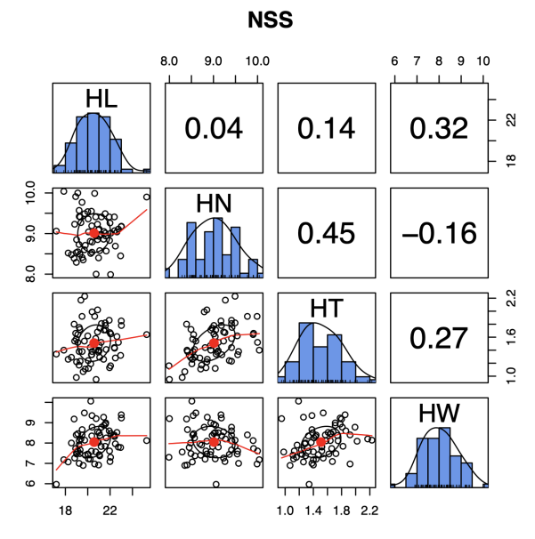
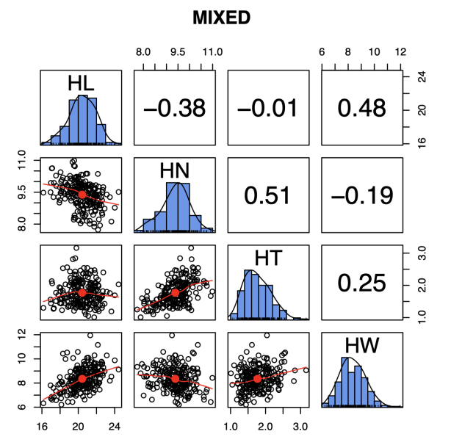
A
B

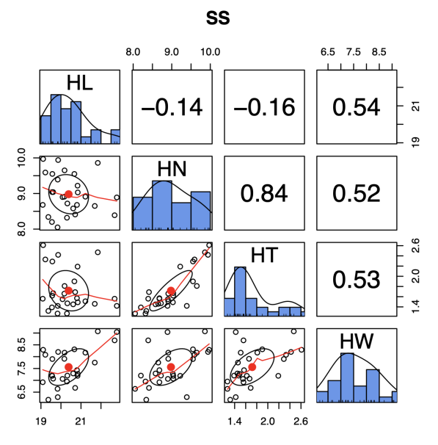
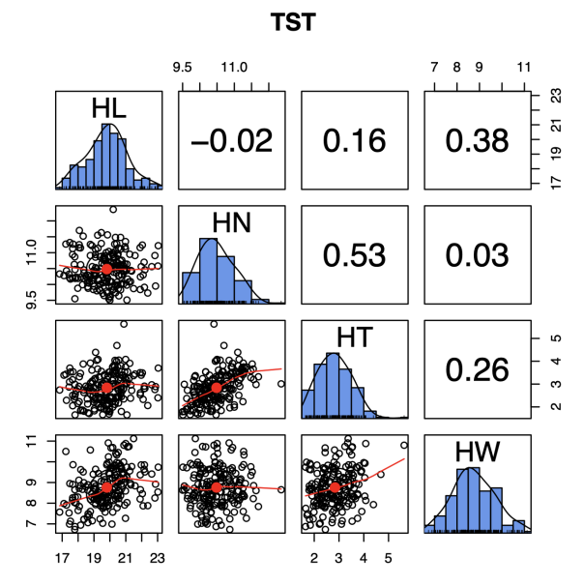
C
D

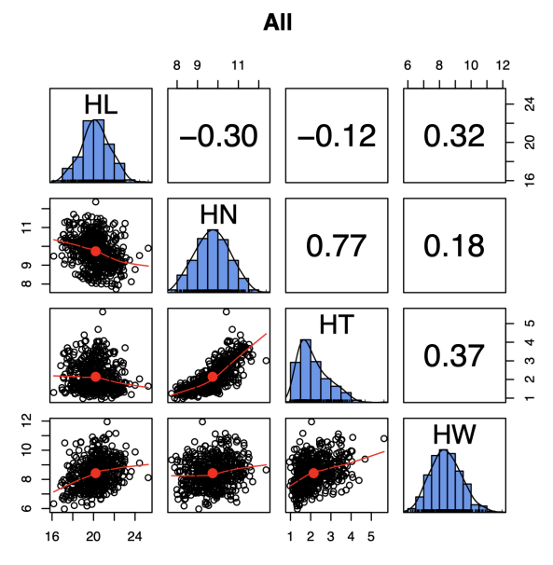
E

Figure S1. Genetic correlation and frequency distributions of the genomic estimated breeding values (GEBVs) of four husk traits in different subpopulations. (A) Admixed (MIXED) subpopulation. (B) Non-stiff stalk (NSS) subpopulation. (C) Stiff stalk (SS) subpopulation. (D) Tropical-subtropical (TST) subpopulation. (E) Whole association panel. The husk traits are husk length (HL), husk layer number (HN), husk thickness (HT), and husk width (HW). The unit of measure is cm for HL, HT, and HW. GEBVs of husk traits is calculated by genotype of the testing set with a training prediction model. The plots on the diagonal line exhibit the genotypic distribution of the GEBVs for each trait. Displayed below the diagonal line, are the scatter plots for GEBVs of each two husk traits; displayed above the diagonal line are Pearson correlation coefficients. The red line and red dot represent the lowest regression fitting curve and the correlation ellipse, respectively.

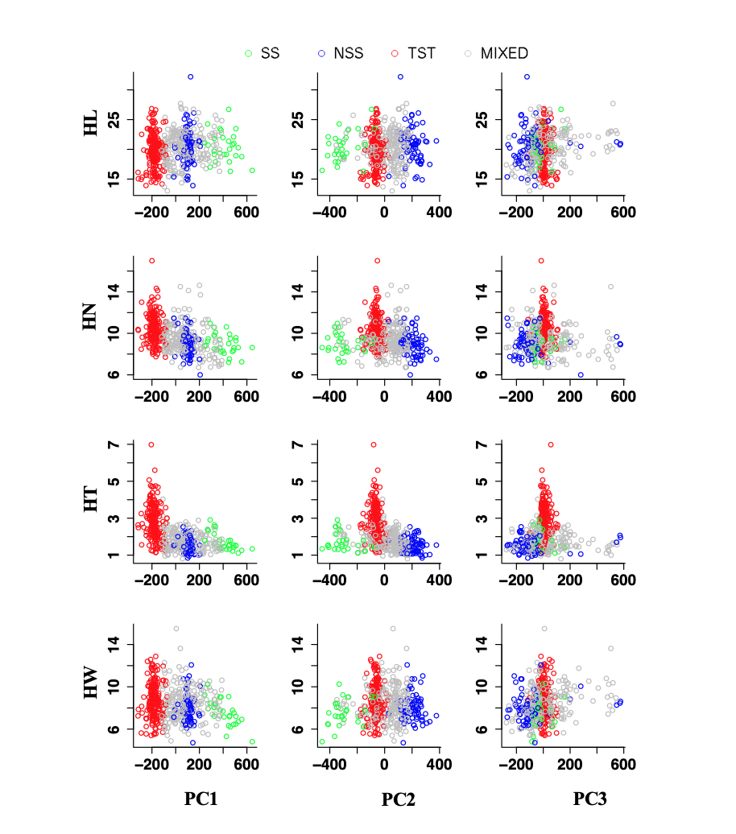
Figure S2. Relationships between husk traits and the first three principal components (PC). Each dot represents a maize line associated with one of four subpopulations: non-stiff stalk (NSS), stiff stalk (SS), tropical-subtropical (TST), and admixed (MIXED). The husk traits are husk length (HL), husk layer number (HN), husk thickness (HT), and husk width (HW). The unit of measure is cm for HL, HT, and HW.

