SUPPLEMENTAL MATERIAL

Table S1
Escherichia coli K-12 strains used in this work

Strains |  | recA | recN | Other relevant genotype | Source or derivation
GW5245 |  | 938::cat | + |  | (Marsh and Walker 1987)
N3071 |  | + | + | recB268::Tn10 | (Lloyd et al. 1987)
AB1157 backgroundª
AB1157 | + |  | + |  | (Dewitt and Adelberg 1962)
JC7623 | + |  | + | recB21 recC22 sbcB15 sbcC201 | (Kushner et al. 1971; Horii and Clark 1973; Lloyd and Buckman 1985)
SS12613 | + |  | ∆100::kan | recB21 recC22 sbcB15 sbcC201 | (Warr et al. 2019)
SS12978 | ∆100::kan |  | + | recB21 recC22 sbcB15 sbcC201 | SS4952 → JC7623^{f}
SS12991 | 4190 |  | + | ygaD1::kan recB21 recC22 sbcB15 sbcC201 | SS12986 → JC7623^{f}
SS13448 | 4190 |  | ∆100::kan | zfj-3131::Tn10 ygaD1::kan recB21 recC22 sbcB15 sbcC201 | SS12989 → SS12613^{g}
SS13458 | + |  | ∆200::frt | recB21 recC22 sbcB15 sbcC201 | Flipped version of SS12613 (pCP20)
SS13465 | 4190 |  | ∆200::frt | ygaD1::kan recB21 recC22 sbcB15 sbcC201 | SS12986 → SS13458^{f}
SS13499 | 4155,4190,4136::  gfp-918 (A206E) |  | + | ygaD1::kan recAo1403 recB21 recC22 sbcB15 sbcC201 | SS13493 → JC7623^{f}
SS13709 | + |  | + | gal-76::Tn10 ∆attB::sulAp-gfp recB21 recC22 sbcB15 sbcC201 | SS1465 → JC7623^{g}
SS13710 | + |  | ∆100::kan | gal-76::Tn10 ∆attB::sulAp-gfp recB21 recC22 sbcB15 sbcC201 | SS1465 → SS12613^{g}
SS13711 | 4190 |  | + | ygaD1::kan gal-76::Tn10 ∆attB::sulAp-gfp recB21 recC22 sbcB15 sbcC201 | SS1465 → SS12991^{g}
SS13712 | ∆100::kan |  | + | gal-76::Tn10 ∆attB::sulAp-gfp recB21 recC22 sbcB15 sbcC201 | SS4952 → SS13709^{f}
SS13719 | + |  | ∆200::frt | gal-76::Tn10 ∆attB::sulAp-gfp recB21 recC22 sbcB15 sbcC201 | SS1465 → SS13458^{g}
SS13720 | 4190 |  | ∆200::frt | ygaD1::kan gal-76::Tn10 ∆(attB)::sulAp-gfp recB21 recC22 sbcB15 sbcC201 | SS12986 → SS13719^{f}
SS13721 | 4155,4136::gfp-918 (A206E) |  | + | ygaD1::kan recAo1403 recB21 recC22 sbcB15 sbcC201 | SS11644 → JC7623^{f}
SS13723 | 4155,4136::gfp-918 (A206E) |  | ∆200::frt | zfj-3131::Tn10 ygaD1::kan recAo1403 recB21 recC22 sbcB15 sbcC201 | SS11770 → SS13458^{f}
SS13724 | 4155,4190,4136::  gfp-918 (A206E) |  | ∆200::frt | zfj-3131::Tn10 ygaD1::kan recAo1403 recB21 recC22 sbcB15 sbcC201 | SS13704 → SS13458^{f}
BW25113 background^{b}
BW25113 |  | + | + |  | (Datsenko and Wanner 2000; Baba et al. 2006)
SS4952 |  | ∆100::kan | + |  | Lab stock (Baba et al. 2006)
JC13509 background^{c}
JC13509 |  | + | + |  | (Sandler et al. 1996)
SS1465 |  | + | + | gal-76::Tn10 ∆attB:: sulAp-gfp | Lab stock
SS6321 |  | + | + | hupA::mCherry FRT ∆attB::sulAp-gfp | (Bhattacharyya et al. 2014)
SS7117 |  | + | + | ∆galK200::frt ∆attB::sulAp-mCherry | (Warr et al. 2019)
SS9510 |  | ∆100::kan | + | hupA::mCherry FRT ∆attB::sulAp-gfp | Lab stock
SS9988 |  | + | ∆100::kan |  | (Warr et al. 2019)
SS10168 |  | ∆200::frt | + | malE::Tn10-9 (cam) lexA3 | Lab stock
SS10191 |  | ∆200::frt | + | pKD46 malE::Tn10-9 (cam) lexA3 | Lab stock
SS10360 |  | + | ∆100::kan | hupA::mCherry FRT ∆attB::sulAp-gfp | (Warr et al. 2019)
SS11644 |  | 4155,4136::gfp-918 (A206E) | + | ygaD1::kan recAo1403 ∆galK200::frt ∆attB::sulAp-mCherry | Lab stock (Renzette et al. 2005)
SS11770 |  | 4155,4136::gfp-918 (A206E) | + | zfj-3131::Tn10 ygaD1::kan recAo1403 ∆galK200::frt ∆attB::sulAp-mCherry | Lab stock
SS12173 |  | ∆200::frt | + | lexA3 malE::Tn10 ∆galK200::frt  ∆attB::sulAp-mCherry | Lab stock
SS12334 |  | + | ∆100::kan | ∆galK200::frt ∆attB::sulAp-mCherry | (Warr et al. 2019)
SS12683 |  | + | ∆100::kan | pheA18::Tn10 | CAG12158 → SS9988^{g}
SS12943 |  | 4155,4136::gfp-918 (A206E) | ∆100::kan | zfj-3131::Tn10 ygaD1::kan recAo1403 ∆galK200::frt ∆attB::sulAp-mCherry | SS11770 → SS12334^{g}
SS12954 |  | ∆200::frt | + | pAK11 [SS10168] | This study^{h}
SS12986 |  | 4190 | + | ygaD1::kan malE::Tn10-9 (cam) lexA3 | This study^{i}
SS12990 |  | 4190 | + | ygaD1::kan hupA::mCherry FRT  ∆attB::sulAp-gfp | SS12986 → SS6321^{f}
SS13426 |  | + | ∆200::frt | hupA::mCherry FRT ∆attB::sulAp-gfp | Flipped version of SS10360 (pCP20)
SS13459 |  | 4190 | ∆200::frt | ygaD1::kan hupA::mCherry FRT  ∆attB::sulAp-gfp | SS12986 → SS13426^{f}
SS13491 |  | ∆200::frt | + | pAK18 [SS12173] | This study^{h}
SS13493 |  | 4155,4190,4136::gfp-918 (A206E) | + | ygaD1::kan recAo1403 malE::Tn10-9 (cam) lexA3 | This study^{i}
SS13497 |  | 4155,4190,4136::gfp-918 (A206E) | + | ygaD1::kan recAo1403 ∆galK200::frt  ∆attB::sulAp-mCherry | SS13493 → SS7117^{f}
SS13725 |  | 4155,4190,4136::gfp-918 (A206E) | ∆200::frt | zfj-3131 ygaD1::kan recAo1403 ∆galK200::frt ∆attB::sulAp-mCherry | SS13704 → SS12334^{g}
KL227 background^{d}
KL227 |  | + | + |  | (Singer et al. 1989)
CAG5052 |  | + | + | metB1btuB3191::Tn10 | (Singer et al. 1989)
MG1655 background^{e}
MG1655 |  | + | + |  | (Guyer et al. 1981; Jensen 1993; Blattner et al. 1997)
APS121 |  | + | + | ∆cynX::I-SceI_{CS}-kan ∆attB::P_{BAD} I-SceI | (Meddows et al. 2004)
CAG12158 |  | + | + | pheA18::Tn10 | (Singer et al. 1989)
CAG18642 |  | + | + | zfj-3131::Tn10 | (Singer et al. 1989)
SS2989 |  | + | + | ∆cynX::I-SceI_{CS}-kan ∆attB::P_{BAD} I-SceI recB268::Tn10 | Lab stock (Meddows et al. 2005)
SS12684 |  | + | + | pheA18::Tn10 ∆cynX::I-SceI_{CS}-kan  ∆attB::P_{BAD} I-SceI | CAG12158 → APS121^{g}
SS12685 |  | + | ∆100::kan | pheA18::Tn10 ∆cynX::I-SceI_{CS}-kan  ∆attB::P_{BAD} I-SceI | SS12683 → APS121^{g}
SS12857 |  | 938::cat | + | ∆cynX::I-SceI_{CS}-kan ∆attB::P_{BAD} I-SceI | Lab stock
SS12989 |  | 4190 | + | zfj-3131::Tn10 ygaD1::kan | SS12986 → CAG18642^{f}
SS13453 |  | 4190 | + | zfj-3131::Tn10 ygaD1::kan ∆cynX::I-SceI_{CS}-kan ∆attB::P_{BAD} I-SceI | SS12989 → APS121^{g}
SS13457 |  | + | ∆100::kan | ∆cynX::I-SceI_{CS}-kan ∆attB::P_{BAD} I-SceI | SS9988 → SS12685^{f}
SS13463 |  | 4190 | ∆100::kan | zfj-3131::Tn10 ygaD1::kan ∆cynX::I-SceI_{CS}-kan ∆attB::P_{BAD} I-SceI | SS12989 → SS13457^{g}
SS13704 |  | 4155,4190,4136::gfp-918 (A206E) | + | zfj-3131::Tn10 ygaD1::kan recAo1403 | SS13493 → CAG18642^{g}

ª AB1157 strain has the following genotype: F– thr-1 araC14 leuB6(Am) ∆(gpt-proA)62 lacY1 tsx-33 qsr'-0 glnX44(AS) galK2(Oc) λ– Rac-0 hisG4(Oc) rfbC1 mgl-51 rpoS396(Am) rpsL31(strR) kdgK51 xylA5, mtl-1 argE3(Oc) thiE1.
^{b} BW25113 is derived from BD792 strain and has the following genotype: F– Δ(araD-araB)567 ΔlacZ4787(::rrnB-3) λ– rph-1 Δ(rhaD-rhaB)568 hsdR514.
^{c} JC13509 is derived from SK362 strain and has the following genotype: F– lacMS286 Φ80dIIlacBK1 sulB103 argE4 his-4 thi-1 xyl-5 mtl-1 Sm^{R} T6^{R}. The lacMS286 Φ80dIIlacBK1 codes for two partial non-overlapping deletions of the lac operon (Konrad 1977; Zieg and Kushner 1977).
^{d} KL227 has the following genotype: Hfr λ– relA1 spoT1 metB1.
^{e} MG1655 stain has the following genotype: F– λ– rph-1.
^{f} Select for kanamycin resistance and then screen by PCR.
^{g} Select for tetracycline resistance and then screen by PCR.
^{h} Select for ampicillin and kanamycin resistance. Screen by PCR and DNA sequence analysis.
^{i} See Materials and Methods section for details on strain construction.

Table S2
Oligonucleotide primers used in this work
Name | Sequence (5’ to 3’) | Specificity
prSJS468 | AATCGCTGCGCCGTTTAAACAGGC | Forward primer in recA overlapping PmeI site
prSJS507 | TTTGCCACTGCCCGCGGTGAAGG | Forward primer in ygaD upstream of recA
prSJS563 | GCGTACCGCACGATCCAACAGGCG | Reverse primer in recX downstream of recA
prSJS853 | GTGGTATGCGTTACACCTTGAGTGC | Forward primer in ybhC near the λ attachment site
prSJS854 | GGCACTGGGTAGTTGTTAACTTACC | Reverse primer in ybhB near the λ attachment site
prSJS1090 | TCGTCGTTGACTCCGTGGCGGCACTGACGCCG | Forward primer upstream of recA K250
prSJS1091 | AAAATCTTCGTTAGTTTCTGCTACGCCTTCGC | Reverse primer downstream of recA K250
prSJS1100 | CGCTATCATCTACAGAGAAATCCGGCGTTGAGTTCGGG | Reverse primer in recA just after BlpI site
prSJS1378 | TACCATCTGAATCTGATTCATCCG | Forward primer upstream of recN
prSJS1379 | TTCGGGCCCGAGCAGTACGTGGC | Reverse primer downstream of recN
prSJS1594 | GCCCGAGCAGTACGTGGCTCATCTGTAATATGCCGATGATAATAGACCTTTCATCACTTTAAAACCTTTTGCTTTCCGGTCTTACGG | Reverse primer downstream of recN
pSJS1655A | GCAACGCCAACACCATCTTCCTGACG | Forward primer upstream of BsiWI site in ygaD in front of recA
pSJS1656A | CCATAATCGGTGCCGCGAGTTTACGTCG | Reverse primer in recX downstream of recA

Table S3
Plasmids used in this work

Plasmid | Description | Reference
pAK11 | pBR322 derivative with a BamHI fragment containing ygaD1::kan recA4190 (Q300R) with upstream and downstream chromosomal sequences, Amp^{R}, Kan^{R} | This study
pAK18 | pBR322 derivative with a BamHI fragment containing ygaD1::kan recAo1403 recA4155,4190,4136::gfp‐918 (A206E) with upstream and downstream chromosomal sequences, Amp^{R}, Kan^{R} | This study
pCP20 | expression of Flp recombinase, temperature sensitive replication, Amp^{R}, Cam^{R} | (Cherepanov and Wackernagel 1995)
pKD46 | expression of the λ Red system under control of arabinose-inducible promoter, temperature sensitive replication, Amp^{R} | (Datsenko and Wanner 2000)
pNR117 | pBR322 derivative with a BamHI fragment containing ygaD1::kan recA⁺ with upstream and downstream chromosomal sequences, Amp^{R}, Kan^{R} | Lab stock
pSJS1598 | pBR322 derivative with a BamHI fragment containing ygaD1::kan recAo1403 recA4155,4136::gfp‐918 (A206E) with upstream and downstream chromosomal sequences, Amp^{R}, Kan^{R} | Lab stock

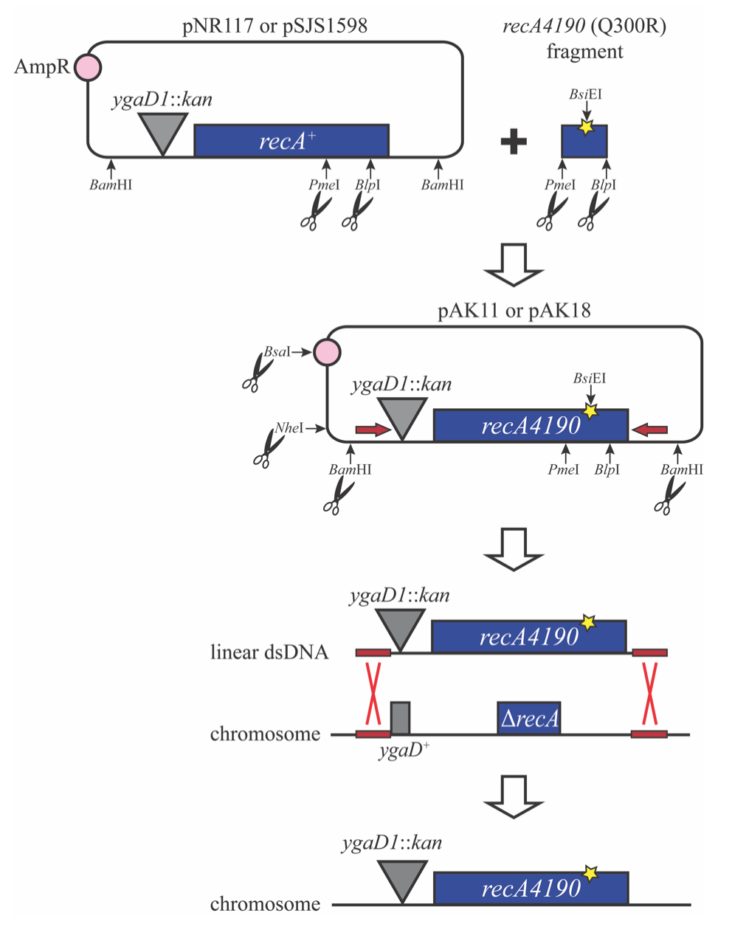

Figure S1. Construction of the recA4190 (Q300R) mutant. A recA4190 gene fragment carrying a novel BsiEI site was ligated with either pNR117 or pSJS1598 vector treated with PmeI and BlpI restriction enzymes. Resulting plasmids were designated as pAK11 and pAK18, respectively. Presence of the recA4190 (Q300R) mutation was verified by PCR and DNA sequencing. The pAK11 plasmid was further linearized by digestion with BamHI and BsaI, while the pAK18 plasmid was subjected to an additional digestion with NheI, which was followed by PCR amplification with primers prSJS1655A and prSJS1656A. Generated linear DNAs were recombined onto the chromosome of a strain carrying ∆recA via λ Red-mediated recombination as described elsewhere (Datsenko and Wanner 2000). Recombination that occurred between homologous arms highlighted in red lead to creation of successful recombinants that were selected for resistance to kanamycin and screened by PCR and sequencing.

LITERATURE CITED
Baba T., T. Ara, M. Hasegawa, Y. Takai, Y. Okumura, et al., 2006 Construction of Escherichia coli K-12 in-frame, single-gene knockout mutants: the Keio collection. Mol. Syst. Biol. 2: 2006.0008. https://doi.org/10.1038/msb4100050
Bhattacharyya B., N. P. George, T. M. Thurmes, R. Zhou, N. Jani, et al., 2014 Structural mechanisms of PriA-mediated DNA replication restart. Proc. Natl. Acad. Sci. 111: 1373–8. https://doi.org/10.1073/pnas.1318001111
Blattner F. R., G. Plunkett, C. A. Bloch, N. T. Perna, V. Burland, et al., 1997 The complete genome sequence of Escherichia coli K-12. Science 277: 1453–1462. https://doi.org/10.1126/science.277.5331.1453
Cherepanov P. P., and W. Wackernagel, 1995 Gene disruption in Escherichia coli: TcR and KmR cassettes with the option of Flp-catalyzed excision of the antibiotic-resistance determinant. Gene 158: 9–14. https://doi.org/10.1016/0378-1119(95)00193-a
Datsenko K. A., and B. L. Wanner, 2000 One-step inactivation of chromosomal genes in Escherichia coli K-12 using PCR products. Proc. Natl. Acad. Sci. U. S. A. 97: 6640–6645. https://doi.org/10.1073/pnas.120163297
Dewitt S. K., and E. A. Adelberg, 1962 The occurrence of a genetic transposition in a strain of Escherichia coli. Genetics 47: 577–585.
Guyer M. S., R. R. Reed, J. A. Steitz, and K. B. Low, 1981 Identification of a sex-factor-affinity site in E. coli as gamma delta. Cold Spring Harb. Symp. Quant. Biol. 45 Pt 1: 135–140. https://doi.org/10.1101/sqb.1981.045.01.022
Horii Z. I., and A. J. Clark, 1973 Genetic analysis of the recF pathway to genetic recombination in Escherichia coli K12: isolation and characterization of mutants. J. Mol. Biol. 80: 327–344. https://doi.org/10.1016/0022-2836(73)90176-9
Jensen K. F., 1993 The Escherichia coli K-12 “wild types” W3110 and MG1655 have an rph frameshift mutation that leads to pyrimidine starvation due to low pyrE expression levels. J. Bacteriol. 175: 3401–3407. https://doi.org/10.1128/jb.175.11.3401-3407.1993
Konrad E. B., 1977 Method for the isolation of Escherichia coli mutants with enhanced recombination between chromosomal duplications. J. Bacteriol. 130: 167–72.
Kushner S. R., H. Nagaishi, A. Templin, and A. J. Clark, 1971 Genetic recombination in Escherichia coli: the role of exonuclease I. Proc. Natl. Acad. Sci. 68: 824–827. https://doi.org/10.1073/pnas.68.4.824
Lloyd R. G., and C. Buckman, 1985 Identification and genetic analysis of sbcC mutations in commonly used recBC sbcB strains of Escherichia coli K-12. J. Bacteriol. 164: 836–44.
Lloyd R. G., C. Buckman, and F. E. Benson, 1987 Genetic analysis of conjugational recombination in Escherichia coli K12 strains deficient in RecBCD enzyme. J. Gen. Microbiol. 133: 2531–2538. https://doi.org/10.1099/00221287-133-9-2531
Marsh L., and G. C. Walker, 1987 New phenotypes associated with mucAB: alteration of a MucA sequence homologous to the LexA cleavage site. J. Bacteriol. 169: 1818–1823. https://doi.org/10.1128/jb.169.5.1818-1823.1987
Meddows T. R., A. P. Savory, and R. G. Lloyd, 2004 RecG helicase promotes DNA double-strand break repair. Mol. Microbiol. 52: 119–132. https://doi.org/10.1111/j.1365-2958.2003.03970.x
Meddows T. R., A. P. Savory, J. I. Grove, T. Moore, and R. G. Lloyd, 2005 RecN protein and transcription factor DksA combine to promote faithful recombinational repair of DNA double-strand breaks. Mol. Microbiol. 57: 97–110. https://doi.org/10.1111/j.1365-2958.2005.04677.x
Renzette N., N. Gumlaw, J. T. Nordman, M. Krieger, S.-P. Yeh, et al., 2005 Localization of RecA in Escherichia coli K-12 using RecA-GFP. Mol. Microbiol. 57: 1074–1085. https://doi.org/10.1111/j.1365-2958.2005.04755.x
Sandler S. J., H. S. Samra, and A. J. Clark, 1996 Differential suppression of priA2::kan phenotypes in Escherichia coli K-12 by mutations in priA, lexA, and dnaC. Genetics 143: 5–13.
Singer M., T. A. Baker, G. Schnitzler, S. M. Deischel, M. Goel, et al., 1989 A collection of strains containing genetically linked alternating antibiotic resistance elements for genetic mapping of Escherichia coli. Microbiol. Rev. 53: 1–24.
Warr A. R., A. N. Klimova, A. N. Nwaobasi, and S. J. Sandler, 2019 Protease-deficient SOS constitutive cells have RecN-dependent cell division phenotypes. Mol. Microbiol. 111: 405–422. https://doi.org/10.1111/mmi.14162
Zieg J., and S. R. Kushner, 1977 Analysis of genetic recombination between two partially deleted lactose operons of Escherichia coli K-12. J. Bacteriol. 131: 123–132.

