Supplementary Information.
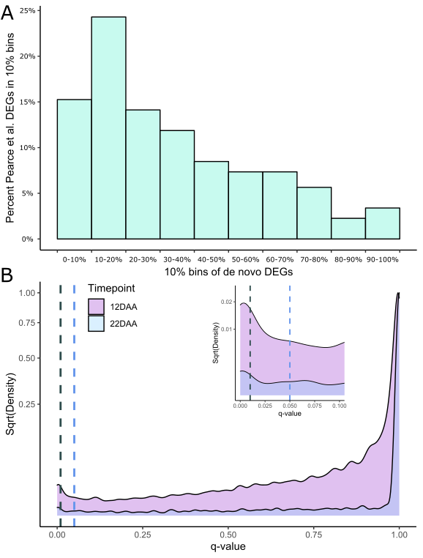
Supplementary Figure 1: A cut-off of q < 0.05 is appropriate to capture the majority of differentially expressed genes. A) The majority (53%) of differentially expressed genes (DEG) from Pearce et al. fall into the top 25% of the de novo DEG set [14]. 9% of the Pearce et al. DEGs fall into the bottom 25% of the de novo DEGs. DEGs are ranked based on q-value, where the lowest (most significant) q-value is ranked at the top. B) The distribution of q-values within the de novo DEG set produces a peak near 0. A cut-off of q < 0.01 (black dashed line) is not sufficient to capture the entirety of the peak, potentially leading to multiple Type II errors. A cut-off of q < 0.05 (blue dashed line) reduces the likely proportion of Type II errors, while still excluding the vast majority of analysed genes. The relevant section (q-value ≤ 0.1) is presented as an inset in the panel, highlighting the peak in q-value distribution around the two cut-off points.
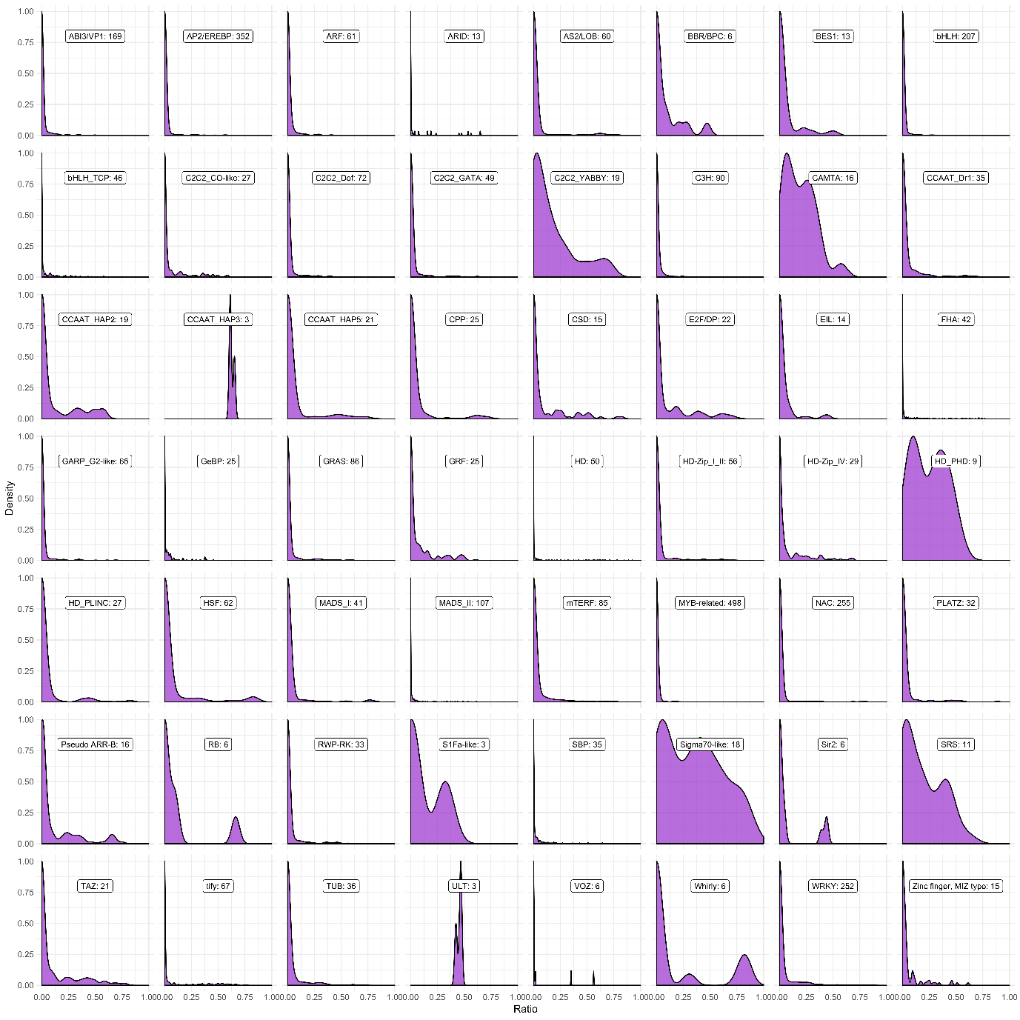
Supplementary Figure 2: Shared downstream targets between transcription factors in the same superfamily. Density distributions for the shared ratios of unique transcription factor pairs sampled from each of the 56 superfamilies tested closely recapitulate the density distribution seen for all random transcription factors (Figure 3A). Superfamilies with few members are less skewed right, due to the increased proportion of intra-triad comparisons included in the distribution.
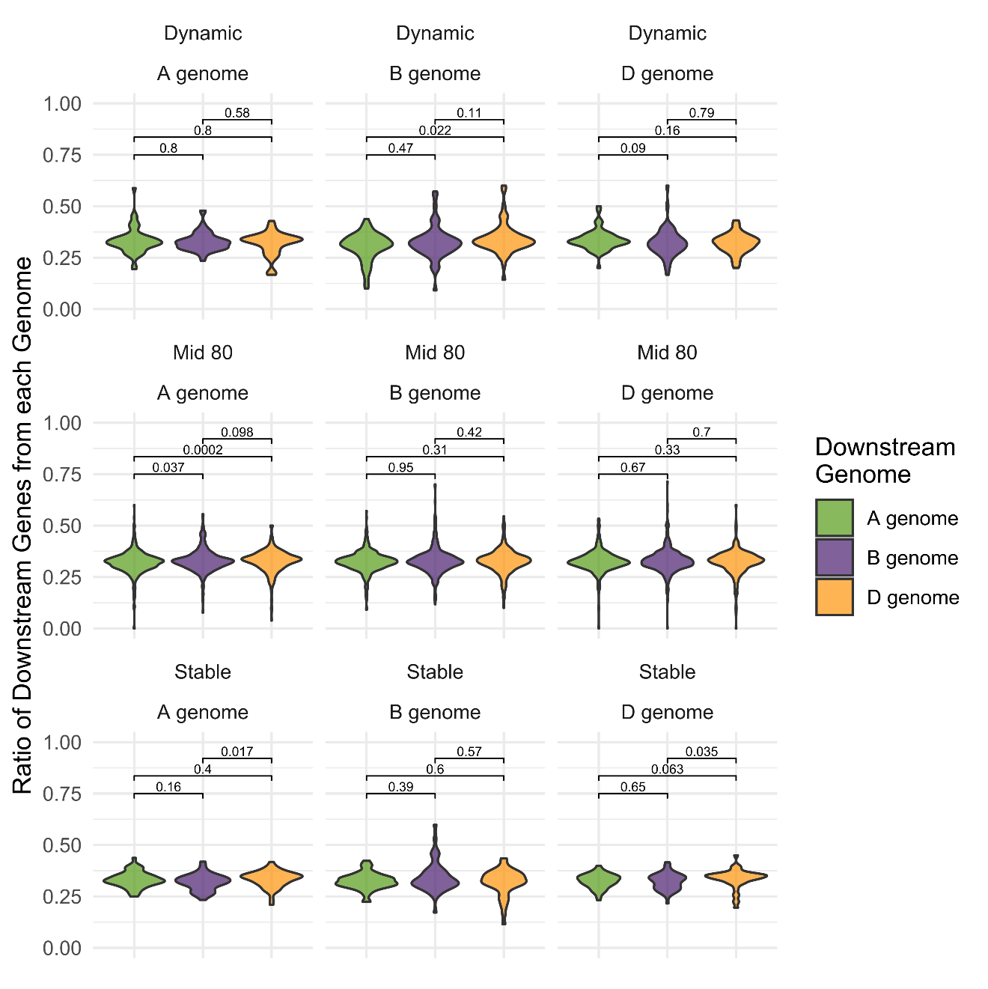
Supplementary Figure 3: No clear pattern is seen between transcription factor movement category and genome bias in downstream genes. Percentage of downstream genes from each genome is shown for all transcription factors, split by transcription factor genome and movement category. The p-value for each pairwise test between distributions is shown in each panel (Wilcox test).
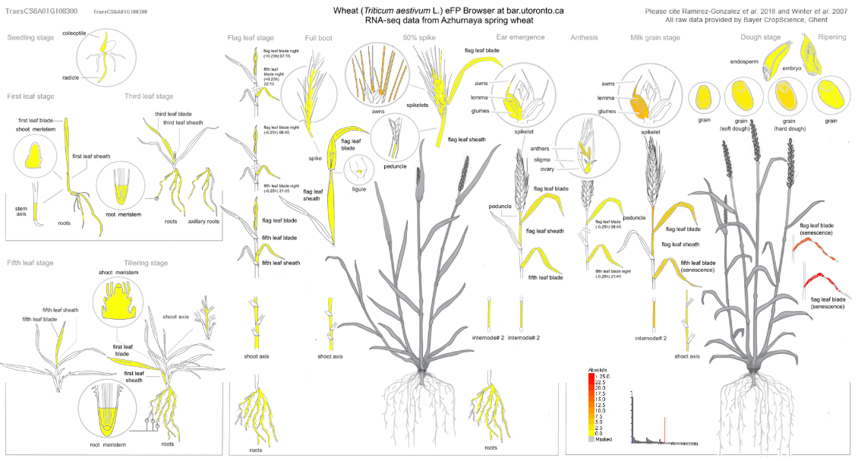
Supplementary Figure 4: NAM-A1 is expressed predominantly in the senescing flag leaf. Expression data from the developmental time course of the spring wheat variety Azhurnaya is displayed using the Wheat eFP browser (http://bar.utoronto.ca/efp_wheat/cgi-bin/efpWeb.cgi) [2]. NAM-A1 is predominantly expressed in the senescing flag leaf (up to approximately 50 TPM), but also in the peduncle (9.8 TPM) and the glumes (7.8 TPM) among other tissues.

