The genome sequence of the octocoral Paramuricea clavata – a key resource to study the impact of climate change in the Mediterranean

SUPPLEMENTARY INFORMATION

- Estimation of Ploidy Level
In order to determine the ploidy level of the red gorgonian (Paramuricea clavata) we have used Smudgeplot v0.2.1 (Ranallo-Benavidez et al. 2020), a k-mer based approach that allows profiling a genome by counting the frequency of different classes of heterozygous k-mers pairs. Following the author recommendations, we used the default k-mer length of 21. We first counted the 21-mers in the raw paired-end reads (PE400) with Jellyfish version 2.2.6 (Marçais and Kingsford 2011) and options: jellyfish count -m 21 -C -s 1000000000. Then we ran smudgeplot.py to determine the lower and upper coverage cut-offs. Initially, these were determined to be 54 and 2,700. The next step consisted in extracting the 21-mers with a coverage between 54 and 2,700. The extraction was performed using jellyfish dump -c -L 54 -U 2700 21mer_counts.jf. Then, we computed the k-mer pairs from the extracted or dumped 21-mers by running smudgeplot.py hetkmers. Finally, we produced a first smudgeplot using the coverage of the identified k-mer pairs (.tsv file).
The analysis Estimated Ploidy was 2 and reported that the lower coverage threshold used (54) was higher than half of the 1n coverage estimate (1n / 2 = 39.07). Therefore, we used as lower coverage threshold (1n / 2) – 10 to ensure the inclusion of the required k-mer pairs. The value of 1n was estimated more precisely by running Genomescope2 with k=21 and p=2 to be 84.4. Thus, we repeated the smudgeplot analysis with lower coverage limit of 32. The final result supports a diploid genome with a proportion of heterozygosity carried by paralogs (i.e non-diploid k-mer pairs) of 0.52 (see Figure S2, Table S1 and Table S2).

- Purging Alternative Haplotypes
Our first version of the genome free of contaminants and mitochondrion (pcla6) had a length of 711Mb and contig N50 of 15.85 Kb. It also presented a k-mer spectra that was symptomatic of a poor collapse of alternative haplotypes (Figure S3a) that could also be inflating the assembly size with respect to the real genome size. This is also reflected in the percentage of duplicated BUSCOs. In order to obtain a more haploid genome reference, we used Purge Haplotigs (Roach et al. 2018) as described in the main text. Figure S4 shows the genome coverage distribution obtained after mapping reads back to the pcla6 assembly. This was used to determine the coverage thresholds required to purge the alternative scaffolds from the assembly. As a result, the comparison of the KAT stacked histograms for the assembly before and after purging haplotigs suggests that we removed almost 50% of the alternative alleles from the heterozygous peak (Figure S3a and Figure S3b). This is also consistent with a reduction in the percentage of duplicated BUSCOs (Table S3).

Figure S1 – DNA extractions quality check. The quality of DNA extractions was checked using a Pippin Pulse electrophoresis instrument (Sage Science). This gel picture is representative of the quality of the DNA extractions for Paramuricea clavata. Here, the 1% agarose gel was loaded with 150ng of each DNA sample and run for 16h in 0.5X TBE running buffer. The markers used were: 1kb DNA extension ladder (Invitrogen; for sizing DNA fragments from 500 bp to 40 kb) and, CHEF DNA Size Standard (Bio-Rad Laboratories; for size estimation of DNA fragments of 4.9–98 kb). The sample AE0610 corresponds to the fragment section 5_27-10 used for the long read whole genome sequencing. The smearing pattern is likely due to poor quality DNA (e.g., fragmented), which may explain the low N50 value obtained for the long read whole genome sequencing.
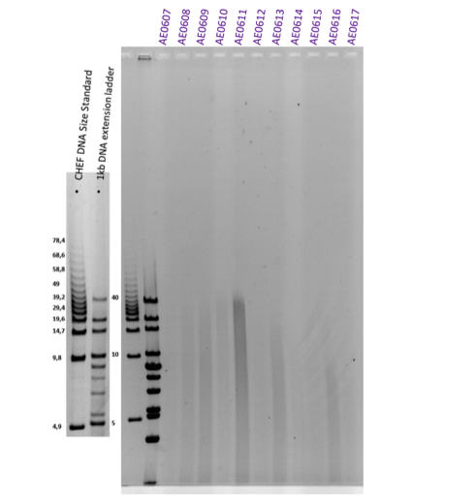

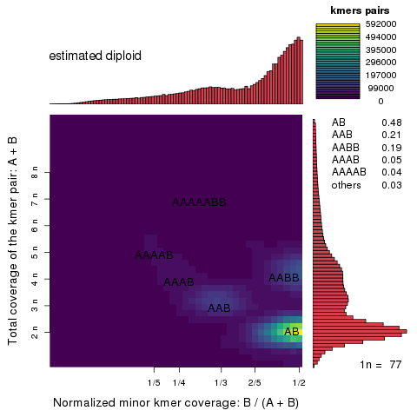
Figure S2. Smudgeplot of P. clavata genome extracting 21-mers from raw PE reads. Smudgeplot computed from raw PE reads showing the haplotype structure using heterozygous k-mer pairs. Here we used a k-mer length of 21. The color intensity reflects the approximate number of k-mers per bin. The most abundant is the diploid heterozygous k-mer pair AB.

A
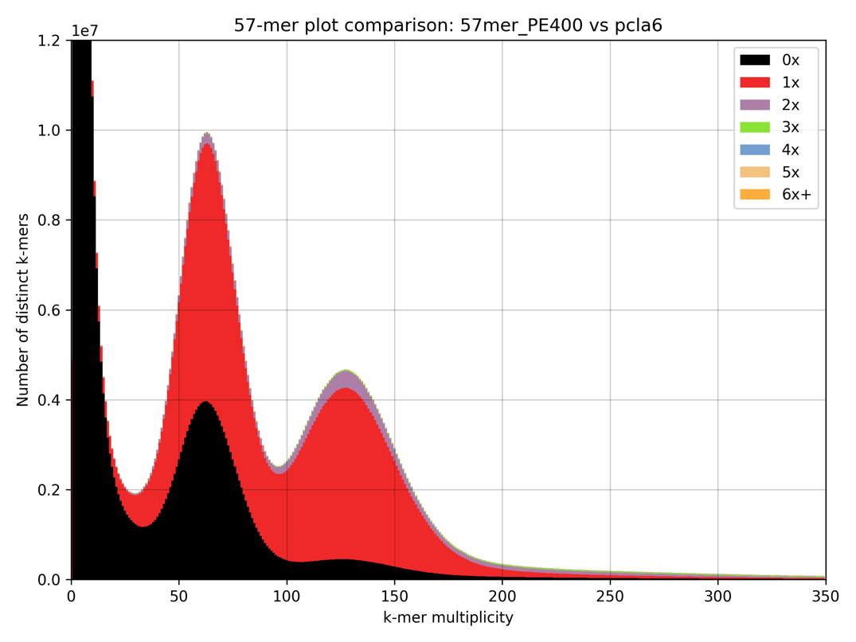
B
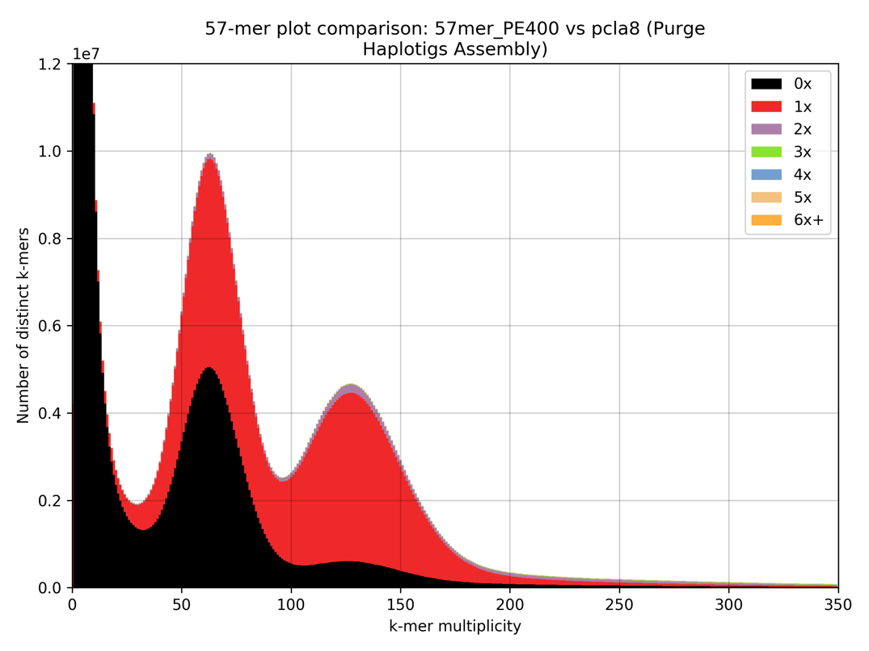
Figure S3. Stacked histograms for Pcla6 and Pcla8. Plots obtained with KAT v2.3.3 by comparing the filtered PE400 reads (no contaminants) with: a) the pcla6 assembly (before running Purge Haplotigs) and b) the pcla8 assembly (after running Purge Haplotigs).

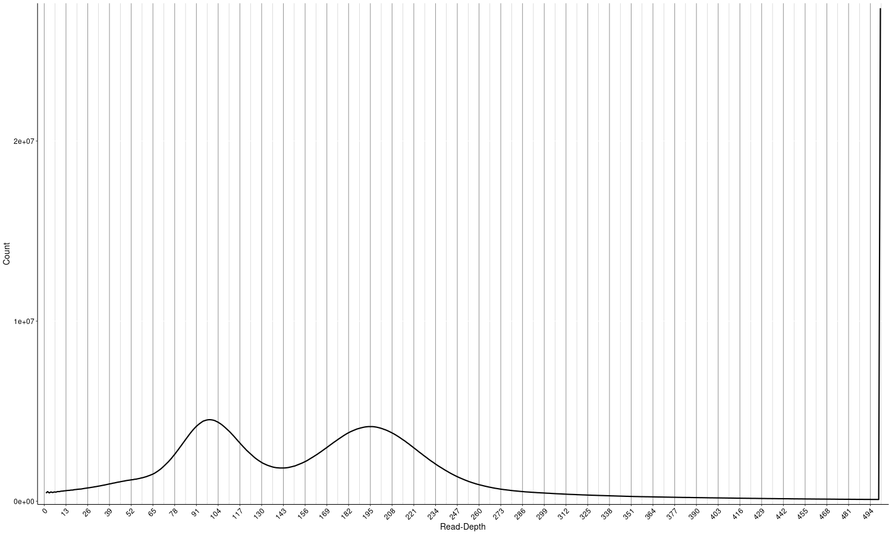
Figure S4. Coverage Histogram. Plot obtained with (Purge Haplotigs v1.1.0 by running the command Purge hist -b PE400.merged.bam -g pcla6.fa -d 500. This step determined the coverage cut-offs to guide the purging.

A
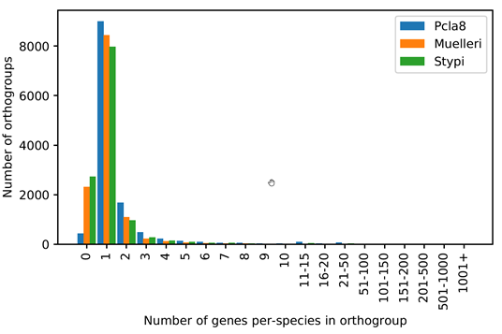
B
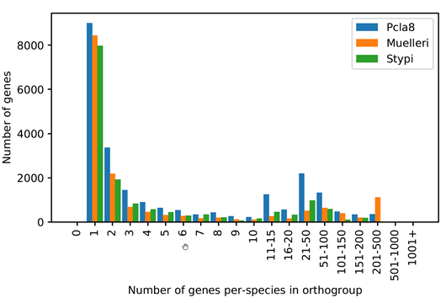
Figure S5. Number of orthogroups with a concrete number of genes per species (a) and

number of genes in orthogroups with a concrete number of genes per species (b).

Table S1. Proportion of heterozygosity in k-mer pairs with different genome copies

genome_copies | propotion_of_heterozygosity
2 | 0.48
3 | 0.21
4 | 0.24
5 | 0.04
6 | 0
7 | 0.03

Table S2. Summary of peaks detected by Smudgeplot

peak | kmers [#] | kmers [proportion] | summit B / (A + B) | summit A + B
AB | 11981969 | 0.48 | 0.49 | 163.7
AAB | 5376242 | 0.21 | 0.33 | 255.25
AABB | 4741549 | 0.19 | 0.49 | 328.49
AAAB | 1187013 | 0.05 | 0.26 | 328.49
AAAAB | 1069760 | 0.04 | 0.21 | 420.04
AAAAABB | 852228 | 0.03 | 0.33 | 511.59

AB are heterozygous k-mer pairs consistent with two haplotypes and diploid coverage

Table S3. Statistics of all Paramuricea clavata assemblies
Assembly | BUSCO statistics | Total Length | ctgN50 | scfN50 | NOTES
pcla1 | C:76.2%[S:71.8%,D:4.4%],F:8.8%,M:15.0% | 760,259,452 | 14,323 | 15,331 | Hybrid assembly with MASURCA_3.2.6. All PE400 2x250bp reads
pcla4 | C:75.8%[S:71.8%,D:4.0%],F:8.7%,M:15.5% | 724,624,315 | 15,858 | 19,717 | Hybrid assembly with MASURCA_3.2.6. Hard-trimmed PE400 library 2x150bp
pcla5 | C:77.0%[S:72.1%,D:4.9%],F:8.9%,M:14.1% | 712,445,758 | 15,851 | 19,721 | Bacterial decontamination
pcla6 | C:75.5%[S:71.2%,D:4.3%],F:8.8%,M:15.7% | 712,409,171 | 15,851 | 19,718 | Removal of mitochondrion scaffold
pcla7 | C:72.6%[S:68.4%,D:4.2%],F:11.0%,M:16.4% | 707,632,445 | 15,965 | 15,965 | Collapsed pcla6 contigs with pseudohaploid (e.g., Chen et al. 2019)
pcla8 | C:75.8%[S:73.4%,D:2.4%],F:9.4%,M:14.8% | 606,969,498 | 19,152 | 23,918 | Collapsed pcla6 scaffolds with Purge Haplotigs

BUSCO database used for all assemblies was metazoa_odb9 (n:978 BUSCOs)

Table S4. GO term enrichment of genes not assigned to orthogroups

GO.ID | Term | classicFisher
GO:0051276 | chromosome organization | 4.10E-10
GO:0060249 | anatomical structure homeostasis | 4.80E-10
GO:0000723 | telomere maintenance | 8.40E-10
GO:0032200 | telomere organization | 8.40E-10
GO:0042592 | homeostatic process | 2.00E-09
GO:0006259 | DNA metabolic process | 3.20E-09
GO:0065008 | regulation of biological quality | 1.30E-08
GO:1902589 | single-organism organelle organization | 2.00E-07
GO:0006996 | organelle organization | 1.40E-05
GO:0000712 | resolution of meiotic recombination intermediates | 4.10E-05
GO:0007131 | reciprocal meiotic recombination | 4.10E-05
GO:0035825 | reciprocal DNA recombination | 4.10E-05
GO:0045132 | meiotic chromosome segregation | 4.10E-05
GO:0051307 | meiotic chromosome separation | 4.10E-05
GO:0007126 | meiotic nuclear division | 4.50E-05
GO:0007127 | meiosis I | 4.50E-05
GO:0051321 | meiotic cell cycle | 4.50E-05
GO:1903046 | meiotic cell cycle process | 4.50E-05
GO:0001539 | cilium or flagellum-dependent cell motility | 4.60E-05
GO:0016043 | cellular component organization | 4.60E-05
GO:0006928 | movement of cell or subcellular component | 5.00E-05
GO:0040011 | locomotion | 9.20E-05
GO:0065007 | biological regulation | 0.00012
GO:0006508 | proteolysis | 0.00017
GO:0048584 | positive regulation of response to stimulus | 0.00017
GO:0051304 | chromosome separation | 0.00019
GO:0048870 | cell motility | 0.00024
GO:0051674 | localization of cell | 0.00024
GO:0002376 | immune system process | 0.00041
GO:0048583 | regulation of response to stimulus | 0.00041
GO:0016579 | protein deubiquitination | 0.00056
GO:0070646 | protein modification by small protein removal | 0.00056
GO:0098813 | nuclear chromosome segregation | 0.00096
GO:0051259 | protein oligomerization | 0.00098
GO:0051260 | protein homooligomerization | 0.00098
GO:0007154 | cell communication | 0.00099
GO:0006955 | immune response | 0.0011
GO:0006260 | DNA replication | 0.0013
GO:0002253 | activation of immune response | 0.00156
GO:0050778 | positive regulation of immune response | 0.00156
GO:0050776 | regulation of immune response | 0.00197
GO:0007059 | chromosome segregation | 0.00215
GO:0071840 | cellular component organization or biogenesis | 0.00272
GO:0002682 | regulation of immune system process | 0.0031
GO:0048518 | positive regulation of biological process | 0.00317
GO:0031347 | regulation of defense response | 0.00319
GO:0080134 | regulation of response to stress | 0.00319
GO:0002684 | positive regulation of immune system process | 0.0032
GO:0045087 | innate immune response | 0.00407
GO:0002218 | activation of innate immune response | 0.00424

Table S5. Microsatellite mapping

Microsatellite | F Primer | R Primer | Annotated Repeat Unit | Resolved Repeat Unit | Scafolds name | Position within protein | Protein name
Pcla-09 | Yes | Yes | CA | CA | pcla8_s015043
Pcla-10 | Yes | Yes | GT | GT | pcla8_s000816 | Intron | ATP-sensitive inward rectifier potassium channel 12-like
Pcla-12 | Yes | Yes | AC | AC | pcla8_s000450 | Intron | A disintegrin and metallo ase with thrombospondin motifs 16-like
Pcla-14 | Yes | Yes | CA | CA | pcla8_s000419
Pcla-17 | Yes | Yes | AC | AC | pcla8_s004585 | Intron | AT-rich interactive domain-containing 3C-like isoform X2
Par-d | Yes | Yes | (GTT)xGTGTC(GTT)y | (GTT)xGTGTC(GTT)y | pcla8_s000531 | Repeat in intron; 2 primers in exon | Collagen alpha-4(VI) chain
Par-a | Yes | Yes | GTT | GTT | pcla8_s004379 | Intron | methylmalonyl-CoA epimerase
PC3-81 | Yes | Yes | ACA | ACA | pcla8_s000481 | Repeat in intron; 1 primer in exon | hypothetical protein pdam_00015477
Pcla-20 | Yes | Yes | TTAT | TA | pcla8_s001445 | Intron | Protein_Alignment08754
Pcla-21 | Yes | Yes | ATA | ATA | pcla8_s006213 | 1 primer in exon | protein LOC113686782, partial
Pcla-22 | Yes | Yes | (ATCA)xATCC(ATCA)y | (ATCA)xATCC(ATCA) | pcla8_s003139 | Intron | protein AWC38_SpisGene675
Pcla-23 | Yes | Yes | TGC | TGC | pcla8_s011764 |  | adhesion G-coupled receptor D1-like
Pcla-24 | Yes | Yes | AATA | AATA | pcla8_s000905
Pcla-25 | Yes | Yes | TAA | TAA | pcla8_s010731
Pcla-26 | No | No | TAT | Not in the assembly
Pcla-27 | Yes | Yes | TTGA | TTGA | pcla8_s000419 | Repeat in intron; 1 primer in exon | fibrinogen C domain-containing protein 1-like isoform X1
Pcla-28 | Yes | Yes | ATGT | ATGT | pcla8_s003787 | Intron | PREDICTED: uncharacterized protein LOC107344584
Pcla-29 | Yes | Yes | TGCG | TGCG | pcla8_s004991 | Intron | tyramine receptor tyra-2

References
Chen, L.-Y., R. VanBuren, M. Paris, H. Zhou, X. Zhang et al., 2019 The bracteatus pineapple genome and domestication of clonally propagated crops. Nature Genetics 51 (10):1549-1558.
Marçais, G., and C. Kingsford, 2011 A fast, lock-free approach for efficient parallel counting of occurrences of k-mers. Bioinformatics 27 (6):764-770.
Ranallo-Benavidez, T.R., K.S. Jaron, and M.C. Schatz, 2020 GenomeScope 2.0 and Smudgeplot for reference-free profiling of polyploid genomes. Nature Communications 11 (1):1432.
Roach, M.J., S.A. Schmidt, and A.R. Borneman, 2018 Purge Haplotigs: allelic contig reassignment for third-gen diploid genome assemblies. BMC Bioinformatics 19 (1):460.

